This booklet belongs to:

Week I – Thursday

Day at a glance:
 | Jack in the box | Poem - The little land | Song - Inanay | Walking to and from school safely | Noughts and crosses
Estimated time | 15 mins | 15 mins | 10 mins | 15 mins | 15 mins
Resources required | A soft toy | Something to draw with and write on

Jack in the box
Learning goal: Children experience and share humour, happiness and satisfaction.
- Watch the video via this QR code and join in doing the actions. If you can’t watch, go to step 2.
2. Use a box and soft toy to play your own game of Jack in the box. Hide your soft toy inside a box, with the lid down. Sing a song and surprise! It jumps out of the box.
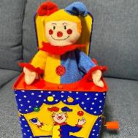
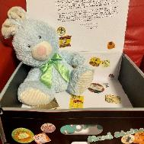

Is this activity too hard?
- Watch the video and enjoy.
- Do as many actions as you can.

Is this activity too easy?
- Decorate the box you used for your own Jack in the box toy.
- Why does the toy you put inside need to be a soft toy? What can you do if you don’t have a soft toy?

Poem – The little land
Learning goal: Children think imaginatively as they listen to a poem.
1. Find a comfy place to listen to this old poem written by Robert Louis Stevenson via the QR code. If you can’t listen, ask someone in your home to read you a story, and listen with your eyes closed.
2. Use your imagination as you listen, to make pictures in your mind.
3. Make an artwork of one of the pictures that came into your mind while you were listening

Is this activity too hard?
- Pretend to be a tiny mouse. Tell someone what you can see.

Is this activity too easy?
- Make an artwork of all the things you can remember from the poem.
- Create a poem using rhyming words.

Song- Inanay
Learning goal: Children show respect for and interest in Indigenous languages.
1. Listen to this song in Yorta Yorta language, via this QR code. If you can’t listen, go to step 5.
2. It’s about shooing a goanna away by saying 'choo'.
3. The song sounds like a nursery rhyme and you can see a baby being rocked to sleep in the video.
4. How did the song make you feel?
5. Does anyone sing songs to help you rest or go to sleep?
6. Ask an adult to sing a traditional lullaby or nursery rhyme to you.

Is this activity too hard?
- Sing along to a familiar nursery rhyme or lullaby with someone.

Is this activity too easy?
- Learn to sing the song.
- Pause the recording and see if you can say the words to the song without the music.

Take a break
Here are some things you might like to do:
- have a drink of water and a healthy snack
- play or have a rest
- go to the toilet and wash your hands
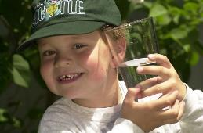
"Boy with glass of water, 2000" by Seattle Municipal Archives is licensed under CC BY 2.0
Photo by Any Lane from Pexels
Photo by Andrea Piacquadio from Pexels
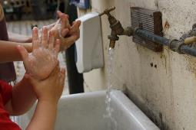
"Washing hands" by magnusfranklin is licensed under CC BY-NC 2.0

Walking to and from school safely
Learning goal: Children learn how to cross the road safely.
It's important to cross the road safely when you walk to and from school.
1. Watch the video via this QR code. If you can’t watch, talk with someone in your home about road safety.
2. What are the four things Ozzie said to remember when crossing the road? (stop, look, listen and think)
3. Ozzie also said you need to hold an adult's hand when you cross the road.
4. Wherever you can, cross the road at a pedestrian crossing or at the lights on a green 'walk' signal.

Is this activity too hard?
- Ask someone to practice walking to and from school with you.

Is this activity too easy?
- Make a sign or poster to help kids to remember to stop, look, listen and think when crossing the road.

Noughts and crosses
Learning goal: Children play a game which requires persistence and concentration.
- Play noughts and crosses with a friend.
- One person is the 'noughts' and draws only circles.
- The other person is the 'crosses' and draws only crosses.
How to play:
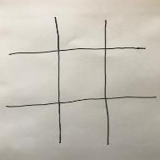
- Start by drawing four lines, two going up and down (vertical) and two going cross ways (horizontal).
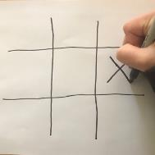
- Take it in turns drawing your symbol, either a circle or a cross.
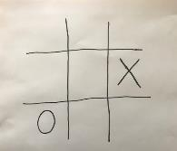
- Draw one symbol in each square. Keep going, taking it in turns.
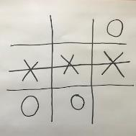
- The first person to draw three symbols in a row, draws a line across them and is the winner.

Is this activity too hard?
- Place counters or buttons on the paper in each square instead of drawing.

Is this activity too easy?
- Challenge someone else in your family!

Extra Learning activities
For families, this video explains how messy play helps child development.
Messy play helps kids to understand the world through their senses and provides sensory experiences that inspires curiosity.
Benefits of messy play are the development of:
- language (soft, smooth, lumpy)
- finger strength (squeezing, scooping, pinching)
- big muscles (stomping, jumping)
- hand-eye coordination (pouring, smoothing, cutting)
- social and emotional (share, open ended).
Ideas for messy play:
- sand and mud, with and without water
- ice, water, containers, spray guns
- scoops, spoons, pouring jugs, containers
- simple slime, goop, finger paint
- cooking, washing the car, watering.
© State of New South Wales (Department of Education), 2021
The copyright material published in this document is subject to the Copyright Act 1968 (Cth) and is owned by the NSW Department of Education or, where indicated, by a party other than the NSW Department of Education.
Copyright material available in this document is licensed under a Creative Commons Attribution 4.0 International (CC BY 4.0) licence.
See https://education.nsw.gov.au/about-us/copyright for further details.

