This booklet belongs to:

Week I – Monday

Day at a glance:
 | My school bag | Setting the table | Road signs | Exploring environments | Painting with natural materials
Estimated time | 20 mins | 15 mins | 30 mins | 15 mins | 20 mins
Resources required | Bag |  | Tape, toy cars, sticks, paper or cardboard | Something to draw with and on | Small rocks

My school bag
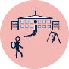
Learning goal: Children select and pack items into their school bag
You will take a bag with you to school each day. This activity will help you practice packing your school bag.
Watch the video about packing your bag via this QR code. If you can’t watch the video start at step 1.
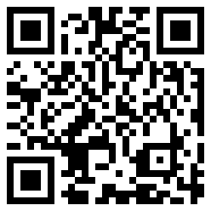
Practice packing your school bag:
- Find all the things that need to go in your bag.
- Unzip and open your bag.
- Place the biggest thing at the bottom of your bag.
- Put your drink bottle in the side pocket.
- Fold your jumper and put it in your bag.
- Place smaller things on top.
- Zip your bag up and you are ready for school!
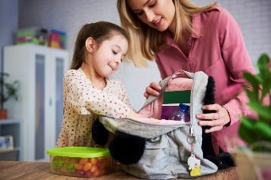
Image owned by the NSW Department of Education under the Copyright Act 1968 (Cth)​

Is this activity too hard?
- Ask someone to hold your bag open as you pack the things into it

Is this too easy?
- Check you have your name on your lunch box and water bottle.
- Draw a list of the things you will take to school in your bag each day.

Setting the table
Learning goal: Children cooperate and work collaboratively with others.
Watch the video about helping your family via this QR code. If you can’t watch the video, you can start at step 1.
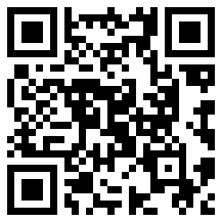
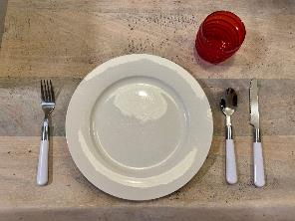
Help your family set the table for a meal:
- Count how many people will be at the table.
- Put one bowl or plate on the table for each person.
- Put one cup or glass on the table for each person.
- Decide which cutlery (knives, forks or spoons) will be needed and put these on the table.
- Put sauce on the table if it will be needed.
- Put a jug of water on the table.

Is this activity too hard?
- Ask someone to help you count out the bowls or plates and cups.
- Do one or two of these jobs while someone else helps to set the table.

Is this activity too easy?
Choose one or more of these extra tasks to help set the table:
- add some table decorations, such as a bunch of flowers from the garden
- make a place card with each person's name on it
- help serve the food.

Road signs
Learning goal: Children use signs and symbols to create meaning in their play.
- We see many road signs when we walk or drive around our community.
- Think of some that you have seen recently.
- Talk with someone about what each of these signs means:
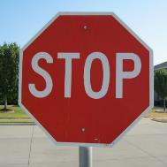
"stop sign" by Clover Autrey is licensed under CC BY 2.0

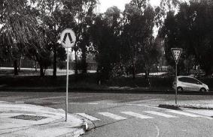
"walk sign, give way sign, road, trees in background" by Matthew Paul Argall is licensed under CC BY 2.0
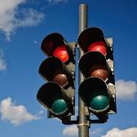
"A couple of red traffic lights against a blue sky" by Horia Varlan is licensed under CC BY 2.0

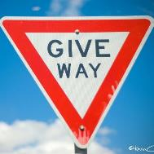
Give way" by Kevin-Cheng is licensed under CC BY-NC-ND 2.0

How to make a road with signs
- Create a long road. There are many ways to do this, for example:
  - draw it with chalk outside
  - place strips of tape on the floor
  - draw it on large paper or an opened out cardboard box
  - place long blocks or sticks together.
- Draw road signs to add to your road. If you want, you can cut these out and tape them onto sticks so they stand up like real ones.
- Drive your toy cars on the road. Make sure they follow the road rules!

Is this activity too hard?
- Ask someone to make you a 'stop' sign. As you drive your toy cars, make sure they stop on the stop sign.

Is this activity too easy?

Next time you are walking or driving in your community, count how many road signs you see.
- Can you find a sign you haven't seen before

Take a break
Here are some things you might like to do:
- have a drink of water and a healthy snack
- play or have a rest
- go to the toilet and wash your hands.
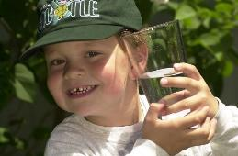
"Boy with glass of water, 2000" by Seattle Municipal Archives is licensed under CC BY 2.0
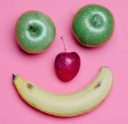
Photo by Any Lane from Pexels
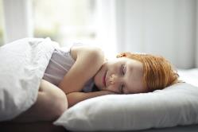
Photo by Andrea Piacquadio from Pexels
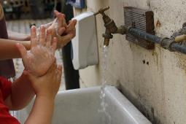
"Washing hands" by magnusfranklin is licensed under CC BY-NC 2.0

Exploring environments
Learning goal: Children use their senses and technology to explore natural and built environments.
Watch the video about nature via this QR code. If you can’t watch the video, you can follows steps 1 – 3 below.
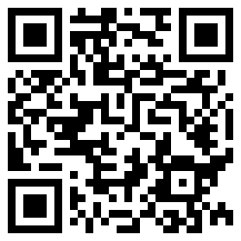
- Look out your window.
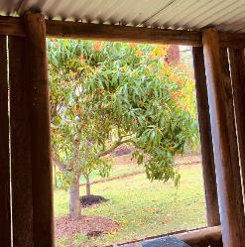
- What natural things can you see?
- What things can you see that have been made by people?
- If you have a smart phone handy, look at the interactive photo via the QR code below.
- Touch your screen and move it around.
- Look for objects that are natural and ones that are built by people.
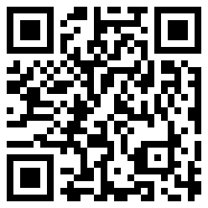

Is this activity too hard?
- Gather five things from your yard. Talk to someone about what things are made by people, and what things come from nature.

Is this activity too easy?
- Divide a piece of paper in half.
- Write human made' at the top of one half, and write 'natural materials' on the other half.
- Cut pictures of human made or natural things from a newspaper or catalogue and paste them on the correct side of the paper.
- Draw your own pictures of human made and natural things.

Painting with natural materials
Learning goal: Children show an increasing appreciation of the natural environment.
For thousands of years Aboriginal people have made paint using natural materials. This painting is of 'Bungil' is a very important to the Jardwadjali people of Victoria.
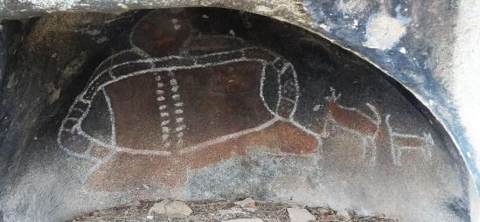
"The Grampians. Stawell. Bunjils Cave with Aboriginal rock painting. Aboriginal guide Bill Speedie from Brambuk Aboriginal Cultural Centre Halls Gap. Figure is mythical man Bunjil with two dingo dogs" by denisbin is licensed under CC BY-ND 2.0
Follow these instructions to make your own paint from rocks.
What you'll need:
- some small rocks
- something to paint on (rocks, bark, leaves, your hand)
- something to use as a brush (a stick, leaf, feather or your finger)
- water.
What to do:
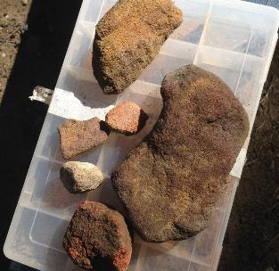
1 Gather suitable rocks
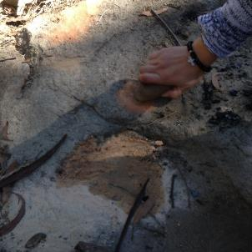
2 Grind the rock against another, add a little water to make a paste
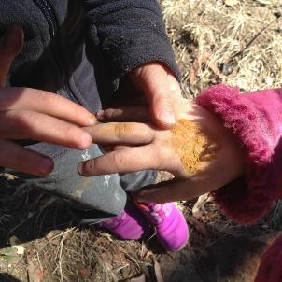
3 Decorate your hand with the paint
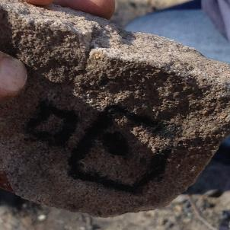
4 Use the paint to draw on other rocks

Is this activity too hard?
- If you have no rocks available, paint using the colours of the natural environment (shades of yellow, orange and brown).

Is this activity too easy?
- Try mixing a little bit of cooking oil into your paint. How did this change the paint?
- What other natural materials can you use to make paint? Have a go!

Extra learning activities
Explore the life cycle of a butterfly through the creative and performing arts via this QR code. If you can’t access the video, you can complete the activity below.
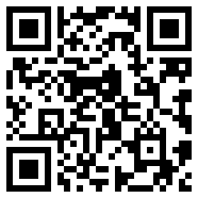
What you'll need:
- Paper (with a fold in it)
- Paint and brush to blob paint
- Scissors (optional)
What to do:
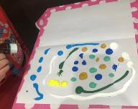
Place blobs of paint on paper that has been folded and opened
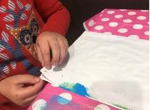
Fold the paper back again, and squish the paint with your open hand
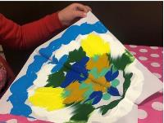
Slowly open the paper
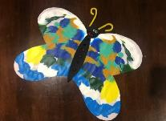
When dry, use scissors to cut your butterfly painting into the shape you like.
© State of New South Wales (Department of Education), 2021
The copyright material published in this document is subject to the Copyright Act 1968 (Cth) and is owned by the NSW Department of Education or, where indicated, by a party other than the NSW Department of Education.
Copyright material available in this document is licensed under a Creative Commons Attribution 4.0 International (CC BY 4.0) licence.
See https://education.nsw.gov.au/about-us/copyright for further details.
