This booklet belongs to:

Week I – Friday

Day at a glance:
 | Being polite at school | Washing up | Wanda the wanderer looks for flowers | Clock challenge | Fun exercises
Estimated time | 10 mins | 20 mins | 60 mins | 20 mins | 15 mins
Resources required |  |  | Something to draw with and on, soft toy | Small rocks and sticks

Being polite at school
Learning goal: Children learn how to greet and acknowledge teachers at school.
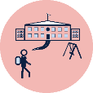
At school there will be a lot of new adults to interact with, including the principal, teachers and office staff. You should always be polite.
1. Watch the video about ways to say hello via this QR code. If you can’t watch the video, just go to steps 2 and 3.
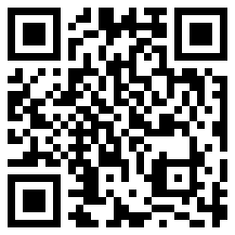
2. As you play today, make sure you are using polite words (please, thank you).
3. Talk with someone about what you could do if you make a mistake at school.
4. What did you see in the video about walking in the corridor?
5. How will you be polite during recess and lunch at school?
6. How will you be polite when you play with your friends at school?

Is this activity too hard?
- Who are some of the new adults you will talk to at school?

Is this activity too easy?
- What sorts of things would you like to share about yourself with your new teacher or adults at your school?

Washing up
Learning goal: Children recognise the contribution they make to shared activities.
- Watch the video about washing up via this QR code. If you can’t watch the video, go to step 2.
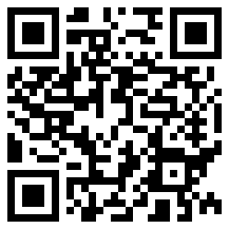
- Choose one of these tasks to do:
  - wash up some of your toys outside in a bucket
  - wash up your tea set inside in the sink
  - help wash up inside after a meal.

Is this activity too hard?
- Next time you have a bath, take some toys in to wash up.

Is this activity too easy?
- Help pack or unpack the dishwasher.

Wanda goes for a bushwalk
Learning goal: Children develop a sense of belonging to their community.
- Watch Wanda the wanderer go for an adventure in her community via this QR code. If you can’t watch the video, go to step 2.
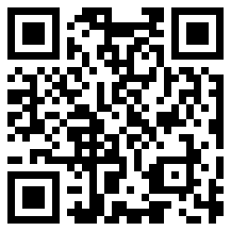
2. Choose your own travelling buddy to take on a walk in the bush or to a park.
3. Look for flowers as you walk.
3. Take pictures or do drawings of the flowers you see.
4. Let your teachers know what you and your buddy have been up to when you get back to preschool or daycare.
5. Look at all the different wildflowers Wanda found on her adventure:
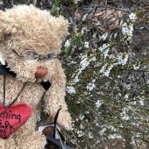
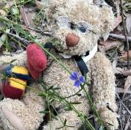
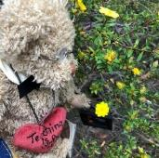
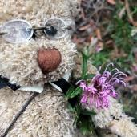
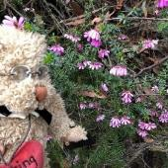
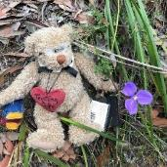
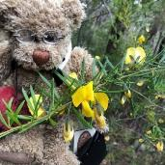
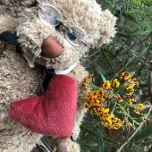

Is this activity too hard?
- Wanda found lots of flowers on her walk. Tell someone which one is your favourite and what you like about it.
- Say the colours of each of the flowers.

Is this activity too easy?
- Ask someone to help you write about your adventure in your journal.

Take a break
Here are some things you might like to do:
- have a drink of water and a healthy snack
- play or have a rest
- go to the toilet and wash your hands
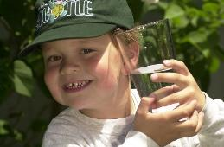
"Boy with glass of water, 2000" by Seattle Municipal Archives is licensed under CC BY 2.0
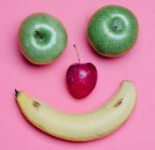
Photo by Any Lane from Pexels
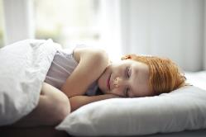
Photo by Andrea Piacquadio from Pexels
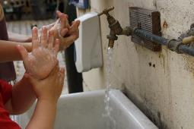
"Washing hands" by magnusfranklin is licensed under CC BY-NC 2.0

Clock challenge
Learning goal: Children develop the concept of time and use language to communicate their thinking.
Watch the video about making clocks via this QR code. If you can’t access the video, go to the instructions below to make your own clock.
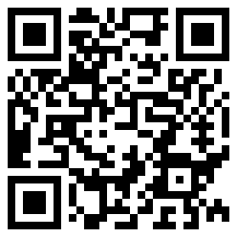
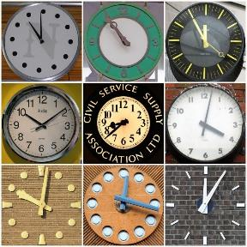
"Clocks 2" by Leo Reynolds is licensed under CC BY-NC-SA 2.0
How to make a clock:
1. Find 12 rocks or small pieces of paper.
2. Write the numbers 1 -12 on the rocks or paper.
3. Arrange them in a circle in order starting with 1.
4. Use two sticks or draw the two clock hands. One should be longer than the other.
5. Place the clock hands in the middle of the clock, like in the pictures.

Is this activity too hard?
- Look at a clock. Point to and say each number in order.

Is this activity too easy?
- Ask someone to help you make the clock show:
  - the time you go to bed
  - 3 o'clock
  - 8 o'clock
  - the time now.

Fun exercises
Learning goal: Children engage in complex movement patterns.
- Watch the video via this QR code and do the actions. If you can’t access the video, so some star jumps and running on the spot and go to step 2.
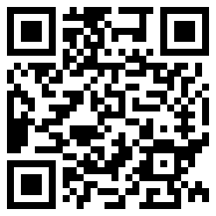
- What do you notice about your body after doing do exercise?
  - Do you get puffed?
  - Does your heart beat harder?
  - Do you feel thirsty?
- Which exercises do you find easy to do?
- Which exercises do you find tricky?

Is this activity too hard?
- Do just one part of each exercise, for example, just the arms or just the legs.
- Do the activities for a shorter time.
- Have someone put on your favourite music and move your body.

Is this activity too easy?
- Challenge yourself to practice that exercises you find most tricky.
- Make up an exercise routine and then teach it to someone else.

Extra learning activities
Join Mati and Dada on a marvellous journey in Venice with the artist, Canaletto via this QR code. If you can’t access the code, go the activity below which is from the online link.
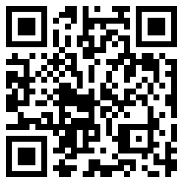
The artist called Canaletto was known for his sketches from different angles. Look out a window of your house. What do you see? Draw what you see. The artist called this scaraboto, meaning different angles of the same view.
Move to a different view. What do you see? Draw what you see. This is your second scaraboto.
Activity:
- Get a toilet roll or another roll that you can look through.
- Choose your favourite place, it could be your back yard or a park or your school. Your favourite place will be your veduta.
- Look through the roll, this is like the camera that Canaletto used, and create a scaraboto of your favourite place.
- When you have completed your sketch add people, animals and other interesting things to create a veduta to share with your family and friends
© State of New South Wales (Department of Education), 2021
The copyright material published in this document is subject to the Copyright Act 1968 (Cth) and is owned by the NSW Department of Education or, where indicated, by a party other than the NSW Department of Education.
Copyright material available in this document is licensed under a Creative Commons Attribution 4.0 International (CC BY 4.0) licence.
See https://education.nsw.gov.au/about-us/copyright for further details.

