This booklet belongs to:

Week H – Wednesday

Day at a glance:
 | How do you feel today? | Wanda the wanderer | Healthy at school | Listening walk | Why can't you hear in space?
Estimated time | 15 mins | 35-45 mins | 10 mins | 30 mins | 15 mins
Resources required |  | Something to draw on and with, a soft toy, a journal | Hand cream, pinch of salt |  | String, scissors, a metal coat hanger

How do you feel today?
Learning goal: Children explore feelings of joy and happiness.
- Watch the video, ‘How Do You Feel Today: Joy’, via this QR code. If you can’t watch the video, you can try steps 3, 4 and 5.
- The children were smiling and laughing. What do you think made them happy and joyful?
- What makes you feel happy and joyful?
- Draw yourself doing something that gives you joy.
- The children in the photos below look happy and joyful. Why do you think they might be feeling that way?
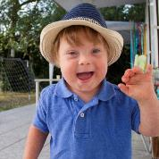
Image owned by the NSW Department of Education under the Copyright Act 1968 (Cth)​
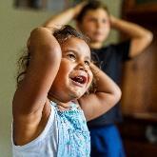
Image owned by the NSW Department of Education under the Copyright Act 1968 (Cth)

Is this activity too hard?
- Play a game that makes you happy.

Is this activity too easy?
- Find out what gives each person in your family joy.

Wanda the wanderer
Learning goal: Children explore places in their community.
This is Wanda the wanderer. She's going to go on some adventures in her community. Wanda just loves getting out and about!
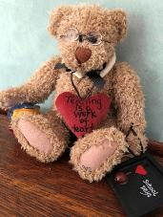
- Watch Wanda writing in her travelling journal via this QR code. If you can’t access the video, start at step 2.
- Choose a travelling buddy to go with you to fun places in your community.
- Take pictures or do drawings of you and your buddy on adventures. Ask someone to write down what you say in your journal.
- Let your teachers know what you and your buddy have been up to when you get back to preschool or day care.
- Come back each week and you will see what Wanda has been getting up to. Next week she is going on a bush walk!
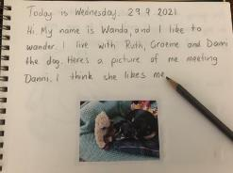
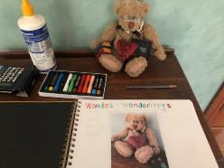
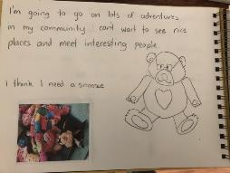

Is this activity too hard?
- Take your favourite soft toy to somewhere in your local community.
- Take photos of your soft toy doing different things.

Is this activity too easy?
- Draw some other places in your learning journal that you would like to take your travelling buddy.
- Can you join your places together with a walking trail? You can create a map of your walking trail.

Healthy at school
Learning goal: Children transfer good hygiene practices from one environment to another.
Keeping yourself healthy at school is important. When you go to school, you will need to remember to wash your hands, without being reminded.
- Do you know a hand washing song or routine from preschool or daycare?
- Watch the video 'The Wiggles handwashing song'. If you can’t watch the video go to step 3.
- Find out how long it really takes to make your hands clean:
- Rub a small bit of hand cream into your hands.
- Add a pinch of salt and gently rub this between your hands.
- The salt has spread on your hands, just like germs do. How hard do you think it is to wash germs away?
- Now count as you wash all the salt off your hands. Make sure you wash your hands really well.
- How long did it take to get all the salt off? This is how long it takes to wash your hands free from germs.

Is this activity too hard?
- Ask someone to help you wash your hands.

Is this activity too easy?
- Draw each of the hand washing steps shown in the video and create your own handwashing chart to follow.

Take a break
Here are some things you might like to do:
- have a drink of water and a healthy snack
- play or have a rest
- go to the toilet and wash your hands
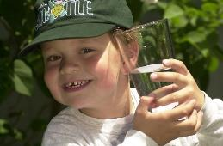
"Boy with glass of water, 2000" by Seattle Municipal Archives is licensed under CC BY 2.0
Photo by Any Lane from Pexels
Photo by Andrea Piacquadio from Pexels
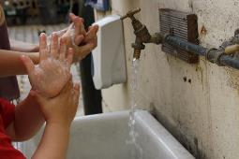
"Washing hands" by magnusfranklin is licensed under CC BY-NC 2.0

Listening walk
Learning goal: Children demonstrate mindful behaviours by focusing on sounds.
Choose somewhere to go for a walk. You might choose somewhere nearby in the bush, park or beach.
- What sounds do you think you will hear on your walk?
- When you start your walk, listen very carefully. You will need to stay quiet to hear the sounds.
- Stop often, and in different places. Close your eyes. What can you hear both near and far away?
- Talk to your walking buddy about what you hear and what is making each sound. Are the sounds made by people or machines or are they natural noises, such as the wind or birds?
These are some of the sounds you might hear on your walk:
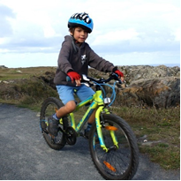
"Dominion MUG Mountain Bike Ride 2014" by guernseysports is licensed under CC BY-NC-ND 2.0
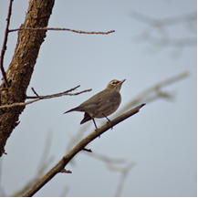
"Bird" by Dave Williss is licensed under CC BY 2.0
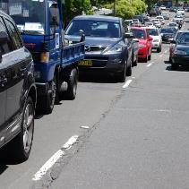
"Sydney Traffic Road Congestion" by neeravbhatt is licensed under CC BY-NC-SA 2.0
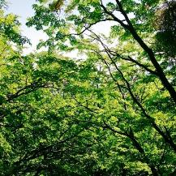
"Trees" by @Doug88888 is licensed under CC BY-NC-SA 2.0
Families can access information via this QR code about going on a listening walk.

Is this activity too hard?
- Copy the sounds you hear.

Is this activity too easy?
- Draw a sound map after the walk, showing where you walked and what sounds you heard along the way.

Why can’t you hear in space?
Learning goal: Children experiment with sound to build fundamental understandings.
For this activity you are going to make a musical instrument. Watch the video via this QR code, or read the instructions below.
What you need:
- a wire coat hanger
- string
- scissors.
What to do:
1. Cut two lengths of string.
2. Tie one piece of string to each side of the coat hanger.
2. Form a loop at the other end of each piece of string.
3. Slip each loop over the ends of your fingers and ask someone else to hit the coat hanger with a pen or stick.
4. Listen carefully, the coat hanger will make a very quiet sound.
5. Now, still with the loops over your fingers, put your fingers in your ears and hit the coat hanger again. What do you hear now? You may have to lean forward slightly to stop the coat hanger touching your tummy.
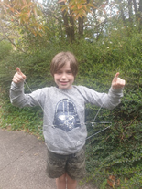
Photo courtesy of Hayley Bates, Little Scientists
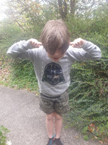
Photo courtesy of Hayley Bates, Little Scientists

Information for families about sound in space:
- For sound to travel from one place to another, it needs something to move through.
- Sound waves travel through vibrations, which means that the atoms or molecules need to touch each other to move the vibrations on.
- On Earth, air allows sound waves to move from one point to another.
- However, space is mostly a vacuum. Although there are some atoms floating around, they are VERY far apart, which means that there is no sound on the Moon.
Activity shared by Little Scientists Australia.

Extra learning activities
Explore vocal expression and the concept of pitch through this nonsense rhyme in episode one of Rhymes and Songs: Man in the moon via this QR code. If you can’t listen to the nonsense rhyme, the words are below for you to follow.
Nonsense rhyme
The man in the moon
Came down too soon
And asked the way to Norwich
He went by the south
And burnt his mouth
From eating cold plum porridge.
© State of New South Wales (Department of Education), 2021
The copyright material published in this document is subject to the Copyright Act 1968 (Cth) and is owned by the NSW Department of Education or, where indicated, by a party other than the NSW Department of Education.
Copyright material available in this document is licensed under a Creative Commons Attribution 4.0 International (CC BY 4.0) licence.
See https://education.nsw.gov.au/about-us/copyright for further details.

