This booklet belongs to:

Week H – Tuesday

Day at a glance:
 | Conversations about school | Draw a chicken | Shared story | Yoga | The moon landing
Estimated time | 15 min | 15 mins | 15 mins | 15-20 mins | 15 mins
Resources required |  | Something to draw and paint with and on

Conversations about school
Learning goal: Children share their thoughts and feelings about starting school.
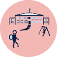
This animation is for families and children to watch together via this QR code. It suggests how to talk together about starting school. If you can’t access the video, you can use guiding questions below.
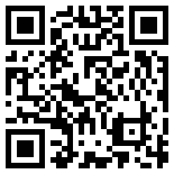
Talk with someone in your family about:
- how you are feeling about starting school
- what you will miss about preschool or being at home
- the things at school that will be the same as at home or preschool
- the things at school that will be different to home or preschool.

Draw a chicken
Learning goal: Children express their ideas through the visual arts.
Listen to an audio recording about chickens via this QR code. If you can’t listen to the recording, start at step 1.
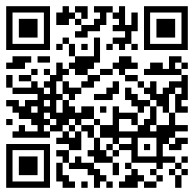
- Look carefully at the chickens below. What do you notice?
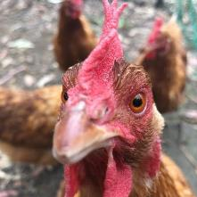
- A small round head, a sharp beak and two round eyes
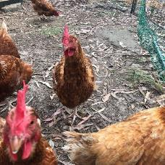
- An oval shaped body covered in feathers
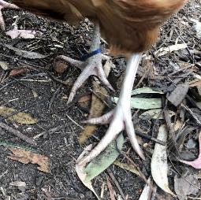
- Thin legs and clawed feet
2. Now draw your own chicken.
3. You might want to follow these steps:
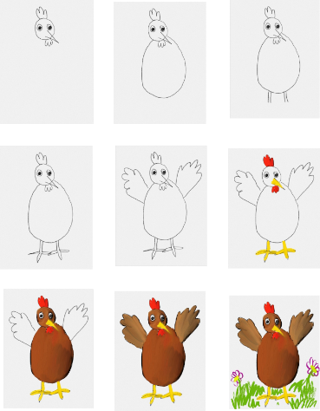

Is this activity too hard?
Draw a chicken's face:
- start by drawing a circle
- add two round eyes
- draw a sharp beak
- finally, add a red wattle.

Is this activity too easy?
- Can you think of another way to make a chicken? Try clay, play dough or natural materials.
- Draw a chicken doing different actions such as flapping its wings, scratching in the dirt or pecking at food.

Shared story
Learning goal: Children explore culture by engaging with Australian texts.
1. Listen to the story of 'Old Man Emu' by John Williamson and Simon McLean via this QR code. Sing along if you like. If you can’t listen to the story, see if you recognise any of the photos of Australian birds below.
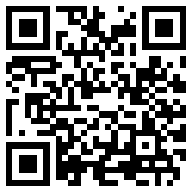
- Can you remember all the types of Australian birds in the story? The photos below will give you some clues.
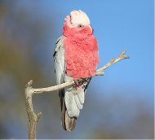
"Galah" by 0ystercatcher is licensed under CC BY-NC-SA 2.0
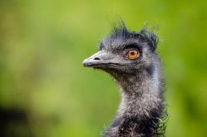
"emu" by Mathias Appel is marked with CC0 1.0
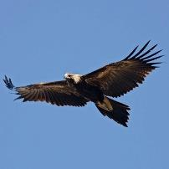
"Wedge-tailed Eagle" by 0ystercatcher is licensed under CC BY-NC-SA 2.0
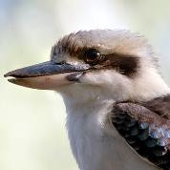
"Laughing kookaburra" by Bernard Spragg is marked with CC0 1.0
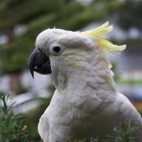
"cockatoos" by rggoldie is licensed under CC BY 2.0
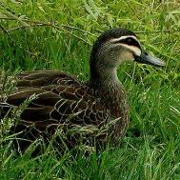
"australian duck" by alfarman is licensed under CC BY-NC 2.0
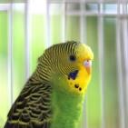
"BUDGIE-PERIQUITO" by cuatrok77 is licensed under CC BY-SA 2.0
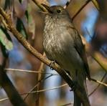
"Grey Shrike-thrush (Colluricincla harmonica)" by David Cook Wildlife Photography is licensed under CC BY-NC 2.0

Is this activity too hard?
- When you need to, pause the story and talk to someone about what is happening.

Is this activity too easy?
- Ask someone to help you write a list of the names of each of the birds.
- Make the sound each name starts with.
- What do you think it means to, 'run the pants of a kangaroo'?

Take a break
Here are some things you might like to do:
- have a drink of water and a healthy snack
- play or have a rest
- go to the toilet and wash your hands
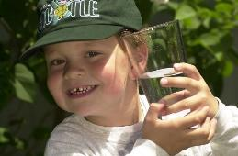
"Boy with glass of water, 2000" by Seattle Municipal Archives is licensed under CC BY 2.0
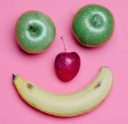
Photo by Any Lane from Pexels
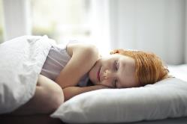
Photo by Andrea Piacquadio from Pexels
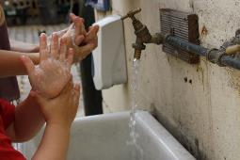
"Washing hands" by magnusfranklin is licensed under CC BY-NC 2.0

Yoga
Learning goal: Children engage in complex movement patterns.
Watch the video via this QR code and join in doing yoga. If you can’t watch the video, you can try following the stretches in the images below.
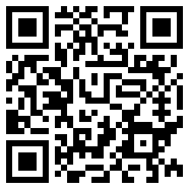
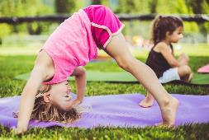
Image licensed under the iStock Getty Images Content License Agreement
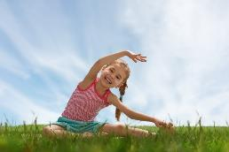
Image licensed under the iStock Getty Images Content License Agreement

Is this activity too hard?
With someone in your family helping, stretch your body in different ways:
- reach up to the sun
- sit down and hug your knees tight
- make yourself as wide as you can.

Is this activity too easy?
- Create some of your own animal poses.

The moon landing
Learning goal: Children engage in learning experiences with an older person.
- Talk to an older person to find out if they remember when people first landed on the moon. Did they watch the landing on TV?
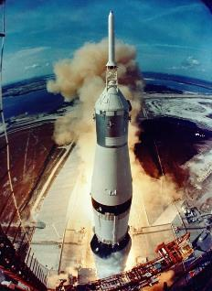
"Apollo 11 Liftoff (NASA, Moon, 6/18/09)" by NASA's Marshall Space Flight Center is licensed under CC BY-NC-ND 2.0
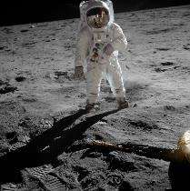
"Buzz Aldrin on the moon #tbt" by NASA's Marshall Space Flight Center is licensed under CC BY-NC 2.0
- Listen to a memory from Ruth via this QR code. She watched the moon landing when she was four years old. If you can’t listen to the memory, you can go to step 3.
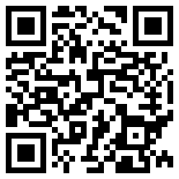
3. Ask the older person to tell you about how technology has changed during their lifetime.
4. The first two pictures below are of old TVs. Compare them to your TV at home now or to the last picture of a new TV.
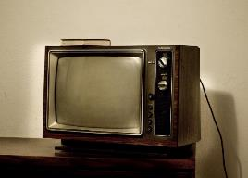
"yet another shot of the old tv in chinook motel" by gothopotam is licensed under CC BY 2.0
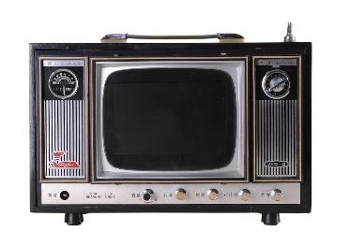
"Old TV digital picture Frame" by Jonas' Design is licensed under CC BY-NC-ND 2.
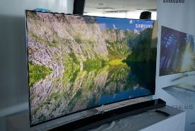
"Samsung Curved SUHD smart tv" by Andri Koolme is licensed under CC BY 2.0
Activity shared by Little Scientists Australia.

Extra learning activities
Learn to count through song and story.
Access the Early childhood literacy and numeracy resource via the QR code below. If you can’t access the QR code, you can follow the activity below.
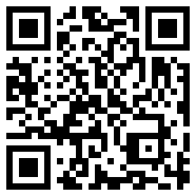
Learning about location and direction is important to introduce spatial language including: over, under, above, below, open, top, left, right, up, down, forwards, wide, wider, widest, loud, and louder. Sing the song below and follow the actions.
Open, shut them (finger rhyme)
Open, shut them
Open, shut them
Give a little clap
Open, shut them
Open, shut them
Lay them in your lap.
Creep them, creep them
Creep them, creep them
Right up to your chin
Open wide your little mouth
But do not let them in!
Shake them, shake them
Shake them, shake them
Shake them just like this
Roll them, roll them
Roll them, roll them
Blow a little kiss.
© State of New South Wales (Department of Education), 2021
The copyright material published in this document is subject to the Copyright Act 1968 (Cth) and is owned by the NSW Department of Education or, where indicated, by a party other than the NSW Department of Education.
Copyright material available in this document is licensed under a Creative Commons Attribution 4.0 International (CC BY 4.0) licence.
See https://education.nsw.gov.au/about-us/copyright for further details.
