This booklet belongs to:

Week H – Monday

Day at a glance:
 | The school library | Build an animal shelter | Prepare some food | Counting in Swahili | Story time from space
Estimated time | 20-25 mins | 10-15 mins | 10 mins | 10 mins | 30-45 mins
Resources required |  | Building blocks |  |  | Recyclables, craft

The school library
Learning goal: Children identify differences and similarities between home, their early childhood service and school.
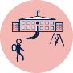
When you go to primary school, there will be a big library full of books. You will be able to borrow some of these books to read at home.
You may have borrowed books before from your preschool or a street or community library.
1. Look at these photos of school libraries.
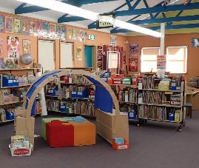
Kellyville Public School Library
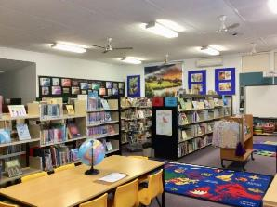
Pymble Public School Library
2. Talk to someone about what you see.
3. Do you see anything you already know about?
4. What questions do you have about your school library?

Is this activity too hard?
- Have someone read you a book.
- Look at the pictures in a book.
- Draw the front cover of your favourite book.
- Do you think your school library will have this book?

Is this activity too easy?
- If you have visited a library, draw some things you remember seeing.
- If not, ask someone to help you look for a photo of your school library on the school's website or social media.
- Make a library with books you have at home.

Build an animal shelter
Learning goal: Children develop an understanding of what animals need to be healthy and safe.

You can watch a video about chickens via this QR code, to remind yourself of what chickens need to be healthy and safe. If you can’t access the video, start at step 1.
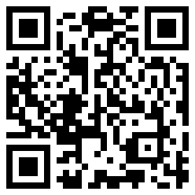
- Think about what other animals need to be healthy and safe.
- Use building blocks, Lego or Duplo to build an animal shelter or hutch. This could be for a chicken or for your favourite animal. Make sure you include somewhere for the animal:
  - to exercise
  - to rest and sleep comfortably
  - to be protected from other animals, the sun and rain
  - to access food and water.
If your shelter is for a chicken, you will need somewhere for them to lay their eggs.

Is this activity too hard?
- Build a house for one of your soft toys.

Is this activity too easy?
- Sometimes foxes break into chicken coops. Design a chicken coop that will keep the chickens safe from foxes.
- Explain to someone why your design will work.

Prepare some food
Learning goal: Children help prepare food for themselves and others.
Ask someone in your family how you can help them to prepare a meal today. It might be breakfast, lunch, dinner or a snack!
Some ways you might help include:
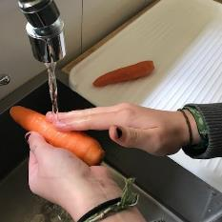
Wash the fruit or vegetables
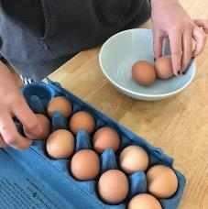
Count out the ingredients
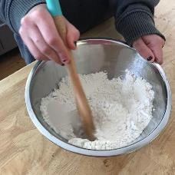
Mix the ingredients
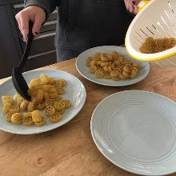
Serve the food
Before you start helping, remember to wash your hands! You can watch a handwashing song via this QR code. If you can’t watch the video, you can sing your own song while washing your hands.
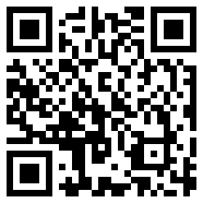

Is this activity too hard?
- Find each ingredient from the fridge or pantry.

Is this activity too easy?
- Try helping with something harder such as:
  - measuring out ingredients
  - making a sandwich
  - cutting up fruit for a fruit salad.

Take a break
Here are some things you might like to do:
- have a drink of water and a healthy snack
- play or have a rest
- go to the toilet and wash your hands
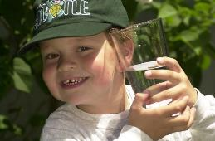
"Boy with glass of water, 2000" by Seattle Municipal Archives is licensed under CC BY 2.0
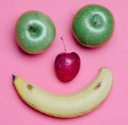
Photo by Any Lane from Pexels
Photo by Andrea Piacquadio from Pexels
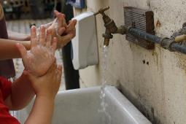
"Washing hands" by magnusfranklin is licensed under CC BY-NC 2.0

Counting in Swahili
Learning goal: Children understand that they can construct meaning in different languages.
Watch a video about counting in Swahili via this QR code. If you can’t access the video, someone might be able to read the numbers to you below or you can start at step 2.
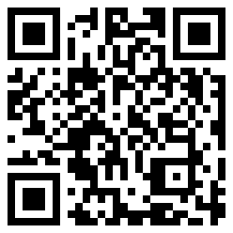
- Practice counting from one to five in Swahili.
1 moja
2 mbili
3 tatu
4 nne
5 tano
- There are many different languages in the world. Does your family speak another language?
- Practice counting from one to five in your home language. As you count, point to each of these numerals:

Is this activity too hard?
- Pause the video and practice the numbers by repeating them like owl does in the video.
- Ask someone to point to each number and say it in your home language for you to repeat.

Is this activity too easy?
- Can you count from one to five in any other languages?
- Count to five in Spanish via this QR code.
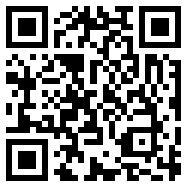
- Count to ten in Japanese via this QR code.
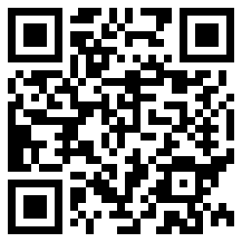

Story time from space
Learning goal: Children explore aspects of space discovery.
We are going to be learning about space. Space is everything in the universe beyond the top of the Earth's atmosphere.
- Listen to this story being told by an astronaut from space via this QR code. If you can’t watch the video, start at step 3.
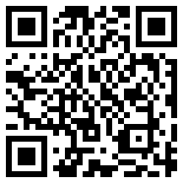
- Watch a second video about rockets launching into space via this QR code. As you watch, imagine you are going on a space mission.
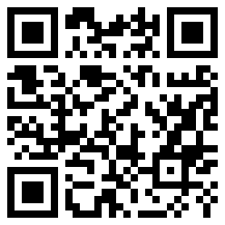
- Prepare for your mission by drawing:
  - what you will wear
  - the food you will take
  - the equipment you will need.
- Think about:
  - How will your rocket take off into space?
  - How will you eat while wearing your space suit?
  - Use building blocks or recycled boxes to build your rocket.
Activity shared by Little Scientists Australia.

Is this activity too hard?
- Sing Twinkle, Twinkle Little Star.
- As you sing, imagine you are an astronaut zooming amongst the planets and stars.

Is this activity too easy?
- Tell someone the names of the important features of your rocket; wings, fuselage, nose cone, windows, streamlined body.
- Explain to someone the features and how they are important in the build of the rocket.

Extra learning activities
- The Learning Potential website helps families support their child's learning. You can access the activities via this QR code. If you can’t access the QR code, you might like to try the activities below.
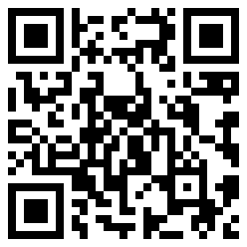

Activities
- Go on a treasure hunt (inside or outside) and find one red thing, one blue thing and one yellow thing.
- Mix paint colours together and create other colours.
- Cut shapes out of coloured paper and paste to create a picture.
© State of New South Wales (Department of Education), 2021
The copyright material published in this document is subject to the Copyright Act 1968 (Cth) and is owned by the NSW Department of Education or, where indicated, by a party other than the NSW Department of Education.
Copyright material available in this document is licensed under a Creative Commons Attribution 4.0 International (CC BY 4.0) licence.
See https://education.nsw.gov.au/about-us/copyright for further details.

