This booklet belongs to:

Week H – Friday

Day at a glance:
 | Friends at school | Make your own compost | Taking a mark in AFL | Painting | Bubbles are a sphere
Estimated time | 15 mins | 20 mins | 15 mins | 20 mins | 15 mins
Resources required | Something to draw with and on |  | Football | Mixing bowl, spoon, corn flour, food colouring | Bubble blowing mixture and wand

Friends at school
Learning goal: Children think about the friends they will have at school.
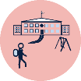
When you go to school, you might see friends from your street or from preschool. You might have lots of friends going to the same school as you, or you might only have a few. It will be exciting to make new friends at school too.
- Watch Bluey and her friends playing helicopters together at school via this QR code. If you can’t watch the video, you can start at step 3.
- Did Bluey and her friends share? Did they get on well?
- Think about the friends you will play with at your new school.
- Draw a picture of you with your friends at school.
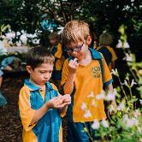
Image owned by the NSW Department of Education under the Copyright Act 1968 (Cth)
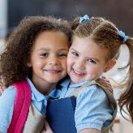
Image owned by the NSW Department of Education under the Copyright Act 1968 (Cth)​

Is this activity too hard?
- Talk with someone about the friends you already know who will be starting school with you.

Is this activity too easy?
- Ask someone to help you write a list of the names of the friends who will be starting school with you.

Make your own compost
Learning goal: Children consider simple ways to help the planet through composting.
Watch the video about making your own compost via this QR code. If you can’t watch the video, you can follow the steps below.
.
How to make compost:
- Ask someone to help you dig a hole in your garden.
- Put your garden scraps, some leaves, sticks and torn up paper into the hole.
- Wet your hole a little.
- Fill the hole up again with dirt.
- Remember where your compost is as this will make a great place to plant things.

Is this activity too hard?
- Ask someone to dig you a hole. Pour the food scraps in.

Is this activity too easy?
- Put a small piece of plastic in the hole with food scraps. Dig it up a few weeks later. What happened to the food scraps? What happened to the piece of plastic? Put the plastic in the bin.

Taking a mark in AFL
Learning goal: Children persist when faced with challenges.
Taking a mark in AFL means catching a kicked ball from a long distance, before it hits the ground.
It takes lots of practice to be able to take a mark.
Watch the video to see Little J take a mark via this QR code. If you can’t watch it, you can start at step 1.
Little J doesn't catch the ball the first time, but he keeps trying.
You can learn lots of new and exciting skills if you keep practicing.
- Have you ever tried to catch a kicked ball?
- How do you feel when you try something and it doesn't work the first time? You might feel sad, angry or frustrated.
- Find someone who can kick a ball to you and practice taking a mark like Little J did.
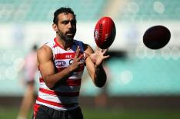
This Photo by Unknown Author is licensed under CC BY-ND

Is this activity too hard?
- Try throwing and catching a ball with someone. See how far apart you can stand and still catch the ball in your hands.

Is this activity too easy?
- Try throwing and catching a ball with someone with two hands and then one hand. Then move further apart for an extra challenge.
- Try kicking a ball between two objects.

Take a break
Here are some things you might like to do:
- have a drink of water and a healthy snack
- play or have a rest
- go to the toilet and wash your hands
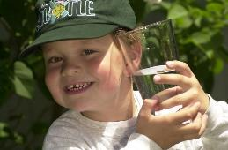
"Boy with glass of water, 2000" by Seattle Municipal Archives is licensed under CC BY 2.0
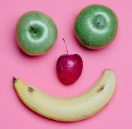
Photo by Any Lane from Pexels
Photo by Andrea Piacquadio from Pexels
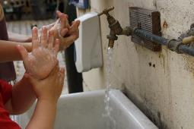
"Washing hands" by magnusfranklin is licensed under CC BY-NC 2.0

Painting
Learning goal: Children begin to form letters and numerals.
Let’s make chalk paint.
What you need:
- 2 cups of corn flour
- food colouring
- 2 cups of water
- a mixing bowl
- spoon
- muffin tins or small containers for each colour
- a paint brush.
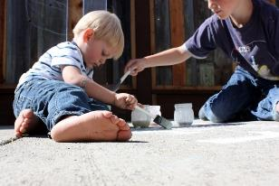
"Sidewalk Paint" by Wendy Copley is licensed under CC BY-NC-SA 2.0
What to do:
1. Put the corn flour into the mixing bowl.
3. Add the water and mix until it is very smooth.
4. Divide the mixture into your muffin tins or small containers.
5. Add food colouring and mix to make different colours of chalk paint.
6. Use your chalk paint to make pictures on concrete, a fence or paper.
7. Look at these numerals. Can you find the numerals that are on your mailbox? Copy and paint these.
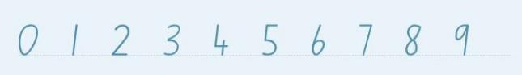
8. Find the letters in your name. Copy and paint these:
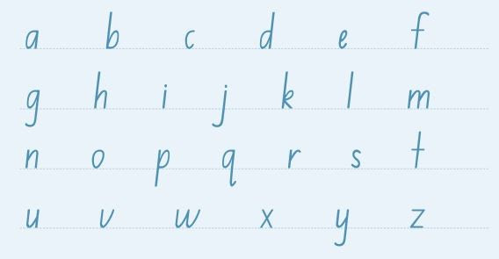
NSW Foundation Style Writing Guide

Is this activity too hard?
- Paint strokes or lines from top to bottom.
- Paint circles in a clockwise direction.

Is this activity too easy?
- Paint the words you already know.
- Copy some of the words from your favourite book.

Bubbles are a sphere
Learning goal: Children will experiment with cause and effect, and observe scientific phenomena by blowing bubbles.
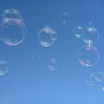
"Bubbles" by Stellajo1976 is licensed under CC BY 2.0
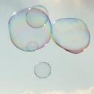
"Austria-02972 - Bubbles of Colour" by archer10 (Dennis) is licensed under CC BY-SA 2.0
Bubbles are fascinating! Watch the slow-motion video of bubbles floating and popping via the QR code. If you can’t watch you can start below at step 2.
- As you watch the video, notice each bubble's:
  - shape
  - colour
  - size.
- Use bubble mixture to blow some bubbles!
- Count how long a bubble will last before it pops.
- What do you think makes bubble pop?
- Try blowing harder. Does this change the bubble?
- Ask someone to video film you blowing a bubble.
- Look at the video in slow motion. Did the bubble's shape change?
Activity shared by Little Scientists Australia.

Is this activity too hard?
- Ask someone to hold the bubble wand as you blow.

Is this activity too easy?
- Investigate if you can make a square bubble by using a square blowing wand.

Extra learning activity
Made for families, this video shares some great tips on messy play via this QR code. If you can’t watch the video, there are some tips below for messy play.
Tips for messy play:
- Wear old clothes or a smock
- Use natural materials and water
- Put a sheet down
- Use outdoors for play in dirt, mud and water
- Have buckets of water for play and washing up
© State of New South Wales (Department of Education), 2021
The copyright material published in this document is subject to the Copyright Act 1968 (Cth) and is owned by the NSW Department of Education or, where indicated, by a party other than the NSW Department of Education.
Copyright material available in this document is licensed under a Creative Commons Attribution 4.0 International (CC BY 4.0) licence.
See https://education.nsw.gov.au/about-us/copyright for further details.

