This booklet belongs to:

Week G – Wednesday

Day at a glance:
 | Cooperating with friends | Keeping chickens safe | Throwing | School logo | Drama
Estimated time | 5 mins | 15-20 mins | 20 mins | 20 mins | 15-20 mins
Resources required | None | None | Six pairs of socks, a tissue and a target | Something to draw with and on | Dress up clothes

Cooperating with friends
Learning goal: Children understand how to co-operate and work with others.
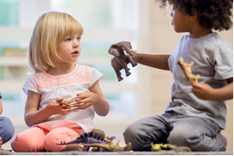
Image owned by the NSW Department of Education under the Copyright Act 1968 (Cth
1. Watch the video 'Keeko: Cooperating' about working together with friends. If you can’t watch the video, start at step 2.
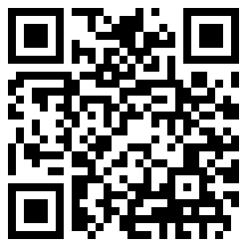
2. Keeko, bird and dog all worked together to reach the leaf. Talk to someone about these questions:
- Have you ever worked with a friend to do something like building a tower?
- What makes you feel good about working together with others?
- Who could you work with when you need help to do something?

Is this activity too hard?
- Use visuals to ask for help.
- Use signing to ask for help.
- Practice asking someone: 'Can you help me please?

Is this activity too easy?
- Work with a family member on a project, like digging a hole or building something.

Keeping chickens safe
Learning goal: Children explore how to keep chickens safe.
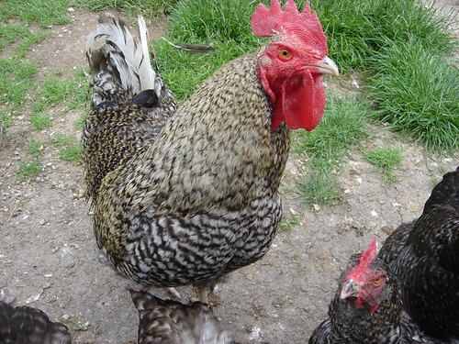
Chickens!" by Fitzrovia is licensed under CC BY-NC-ND 2.0
1. Listen to the story 'Chicken Licken' via this QR code. If you can’t listen to the story, start at step 3.
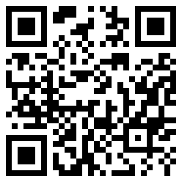
In the story, Chicken Licken had lots of friends, but she was so scared of the sky falling on her head that she got tricked by the fox.
- After the story, think about:
  - What do you think happened to Chicken Licken and her friends?
  - What else do you think chickens might be scared of?
  - What do you think chickens need to keep them safe?

- Think about what you know of chickens:
  - What do you think they eat?
  - What do they live in?
  - What do they need to keep them warm in the wind and rain?
  - What might be dangerous to chickens?
  - What do they need to keep them safe?
Clue: Foxes and Quolls like to eat chickens.
What could we do to make sure they can't eat them?
- strong fences
- latches on doors of hen house
- secure flooring so foxes can't dig under
- put chickens away at night because that's when foxes and quolls go hunting.

Is this activity too hard?
- Discuss with someone how we keep animals safe.
- Discuss with someone ways you stay safe.

Is this activity too easy?
- Draw a chicken coop that is designed to keep chickens safe. What needs to be included?
- Choose another animal and think about the safety needs of that animal.

Throwing
Learning goal: Children develop the fundamental movement skills of throwing.
Watch the video about throwing via this QR code. If you can’t access the video, you can follow the activity steps at step 2.
- Join in the throwing activity.
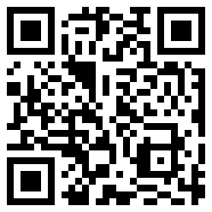
- Throwing activity:
  - Roll up six pairs of socks.
  - Set up a target, like a chair or a laundry basket.
  - Try throwing the socks to the target.
  - Count how many pairs of socks reached the target.

Is this activity too hard?
- Do a shorter section of the video.
- Use a larger object for throwing.
- Get someone to join you and throw a short distance to each other.

Is this activity too easy?
- Make up some other throwing challenges.

Take a break
Here are some things you might like to do:
- have a drink of water and a healthy snack
- play or have a rest
- go to the toilet and wash your hands.
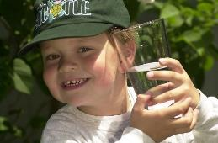
"Boy with glass of water, 2000" by Seattle Municipal Archives is licensed under CC BY 2.0
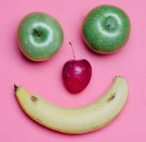
Photo by Any Lane from Pexels
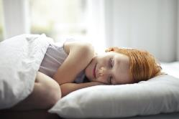
Photo by Andrea Piacquadio from Pexels
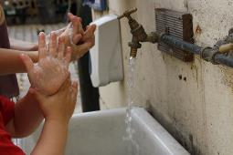
"Washing hands" by magnusfranklin is licensed under CC BY-NC 2.0

School logo
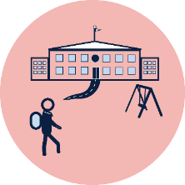
Learning goal: Children explore symbols on school logos.
Watch the video about symbols on school logos via this QR code. If you can’t watch the video, start at step 2.
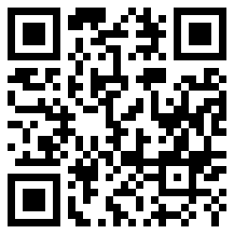
- Ask someone to help you find the logo of the school that you are going to. It might be on the:
  - school sign
  - school website
  - school uniform.
- Look at the logo and describe the colours, shapes and sizes.
- Do some more research and find out other things about your new school.
Here are some other school’s symbols:
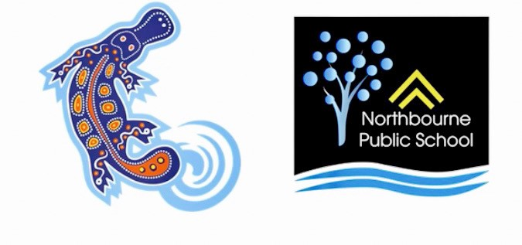
Image owned by the NSW Department of Education under the Copyright Act 1968 (Cth)
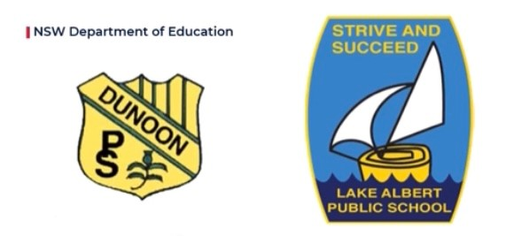
Image owned by the NSW Department of Education under the Copyright Act 1968 (Cth)

Is this activity too hard?
- Ask someone to take a photo of you holding the school logo.
- Talk about the colours of the school logo.
- Has your school logo got a picture?

Is this activity too easy?
- Can you draw your new school logo and use the correct colours?
- Are there words on your logo? What do they mean? Discuss this with someone.

Drama
Learning goal: Children use drama to express ideas and make meaning.
Let’s act out the story of 'Where the wild things are', by Maurice Sendak. It’s about the night Max dressed up and dreamed he sailed miles away and danced with the wild things, who are wild but friendly.
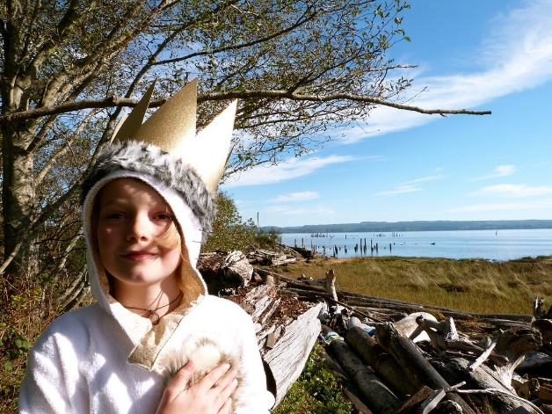
"Max From Where The Wild Things Are (Upgrayedd)" by kellyhogaboom is licensed under CC BY-SA 2.0
1. Decide which character you would like to be - Max or a wild thing. You can watch the story again if you like via this QR code.
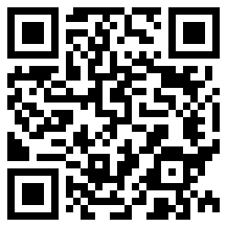
2. Find a costume to wear. You could use a big T-shirt to be a wild thing or use pyjamas like Max wears.
3. Act out the story remembering to show what happens at the start, middle and end.
4. Show your performance to your family or friends.

Is this activity too hard?
- Dress up as a character from your favourite book.
- Make appropriate facial expressions.
- Move like the character.

Is this activity too easy?
- Invite other members of your family or friends to be part of the performance. Can you help direct them, remembering the story line?

Extra learning activity
- Choose one of the everyday learner cards via this QR code:
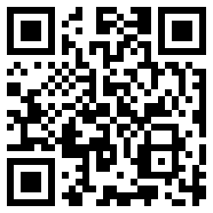
- If you can’t access the cards, you choose a favourite story book to read.
  - Can you remember what happened at the beginning, the middle and the end of the story?
© State of New South Wales (Department of Education), 2021
The copyright material published in this document is subject to the Copyright Act 1968 (Cth) and is owned by the NSW Department of Education or, where indicated, by a party other than the NSW Department of Education.
Copyright material available in this document is licensed under a Creative Commons Attribution 4.0 International (CC BY 4.0) licence.
See https://education.nsw.gov.au/about-us/copyright for further details.

