This booklet belongs to:

Week G – Tuesday

Day at a glance:
 | My family | What chickens need to be happy | How do you feel today? | Where is my school? | Crown making
Estimated time | 15 mins | 15-20 mins | 15 mins | 20 mins | 10-15 mins
Resources required | Family photos |  |  | Map of your local area | Cardboard, scissors, sticky tape, paper and pencils

My family
Learning goal: Children explore their own identity within the context of their family.
There are two ways you can create your family tree.
Option 1
- Find some photos of your family.
- Have a look at the photos and talk about who is in your family and your extended family.
- Arrange the photos as a family tree to show how everyone is connected.
Option 2
- Draw or print out a picture of a tree like the one in the image.
- Draw your family members or write their names. Cut them out in the shape of tree leaves.
- Add the tree leaves to your tree.
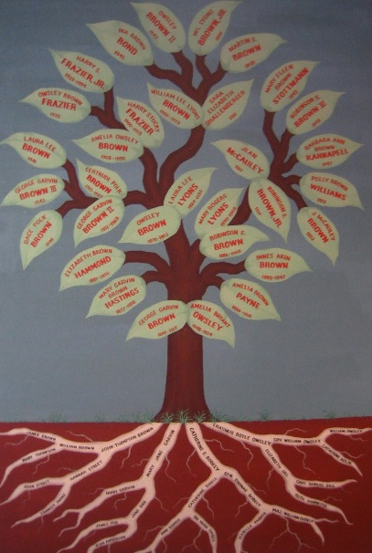
"family tree" by rick is licensed under CC BY 2.0

Is this activity too hard?
- Ask someone to tell you a story about your family.
- Draw a picture of yourself and your family members.
- Ask someone to write the names of your family members on the family tree.

Is this activity too easy?
- Draw lines on your tree to show how the family members are connected.
- Talk about what is the same and what is different about your family and other families you know.

What chickens need to be happy
Learning goal: Children explore what chickens need to thrive.
Yesterday we thought about what chickens need to be healthy. To be really healthy, living things also need things that make them happy.
You can watch a video about happy chickens via this QR code. If you can’t access the video, you can look at the pictures below to answer the questions.
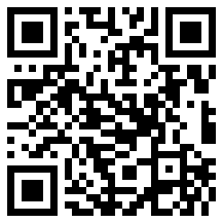
- What do you think makes chickens happy?
- Look at the pictures and the video to see what chickens love doing.
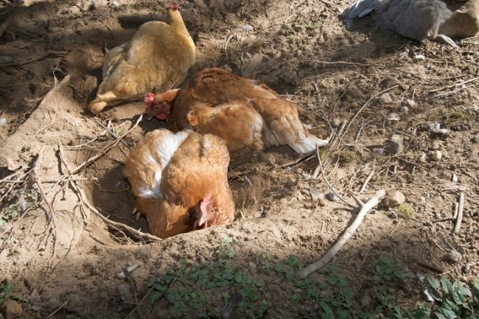
This picture by clango is licensed under CC BY-SA 2.0
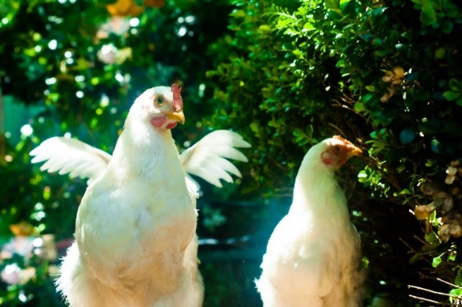
This picture by CarbonNYC [in SF!] is licensed under CC BY 2.0
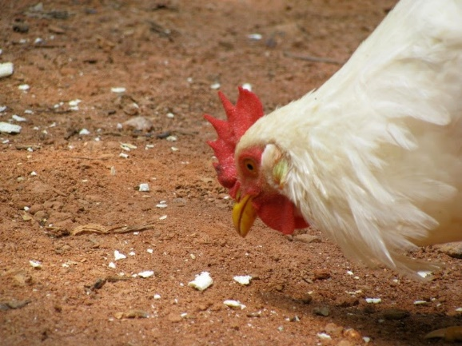
"Chicken pecking" by alex_ford is licensed under CC BY 2.0
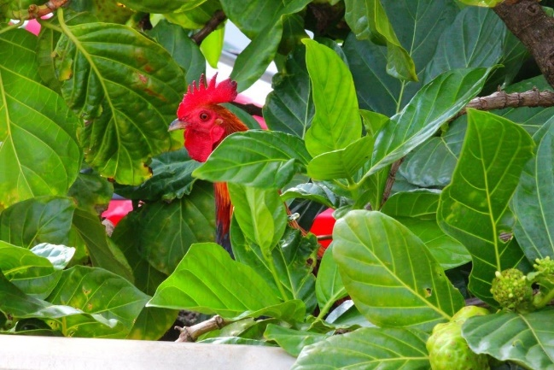
This picture by Peggy2012CREATIVELENZ is licensed under CC BY 2.0

Is this activity too hard?
- Pretend to be a chicken going exploring.

Is this activity too easy?
- Write or draw a list of all the things you know chickens love to do.
- Read or describe your list to another person.

How do you feel today? Peace
Learning goal: Children explore their feelings and consider what helps them feel calm.
- Watch the video ‘How do you feel today: Peace’ via this QR code. If you can’t access the video, you can start at step 2.
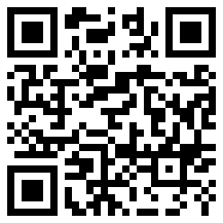
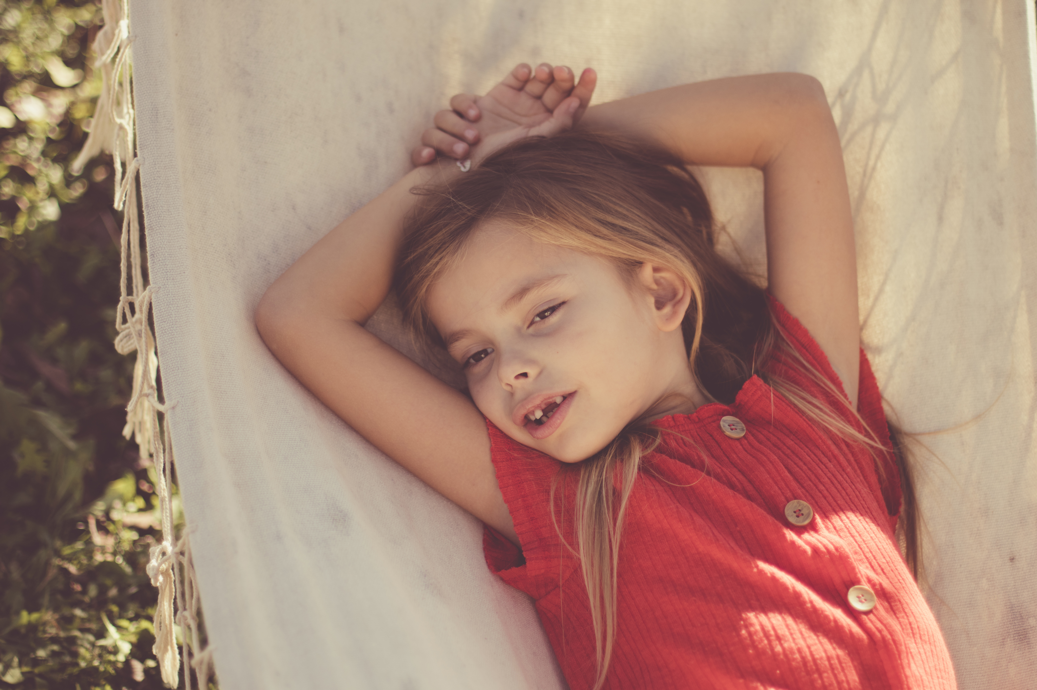
- Think about a place where you feel peaceful or calm.
- What do you like about it?
- What does it look like?
- Draw a picture of this place.
- Think about things that make you feel calm. They might include: breathing deeply, having a cuddle, listening to music, having a stretch, being with your friend, reading a book.
- Ask someone to help you write a list of those things.

Is this activity too hard?
- Sit in a quiet space outdoors:
  - look and listen
  - breathe slowly
  - tell someone how you feel.
- Sit and have a cuddle with someone, get them to tell or read you a story:
  - How do you feel?
  - tell the person.

Is this activity too easy?
- Design a calming space
  - What would it look like?
  - What would it sound like?
  - What would it smell like?
  - What would it feel like?

Take a break
Here are some things you might like to do:
- have a drink of water and a healthy snack
- play or have a rest
- go to the toilet and wash your hands
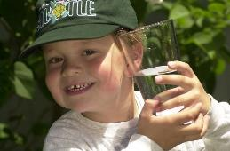
"Boy with glass of water, 2000" by Seattle Municipal Archives is licensed under CC BY 2.0
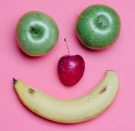
Photo by Any Lane from Pexels
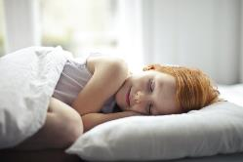
Photo by Andrea Piacquadio from Pexels
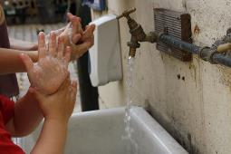
"Washing hands" by magnusfranklin is licensed under CC BY-NC 2.0

Where is my school?
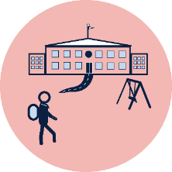
Learning goal: Children use technology to investigate maps of their local area.
- Ask someone to help you find a map of your local area from Google maps via this QR code. If you can’t access Google maps, try your local newsagent or fuel station for a map of your local area.

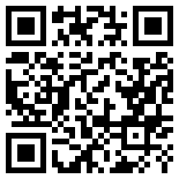
- Talk about your town/suburb on the map.
- Find your home and school on the map.
- Answer the following questions:
  - How will you go to school?
  - Is it a long way from home?
  - Will you walk or take a bus?

Is this activity too hard?
- Ask a grown up to drive or walk with you from your home to your school. Notice things along the way that you pass. For example, shops, park or signs.
- Draw your home and your school (if you have been there, or driven past) and make a line between the two.

Is this activity too easy?
- Map out the route between your home and school on Google maps or your printed map.

Crown making
Learning goal: Children use the creative arts to express ideas.
Let's make a crown like Max wore in the story 'Where the wild things are', by Maurice Sendak. If you would like to listen to the story again, you can access the QR code:
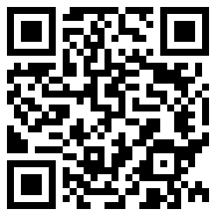
Follow the steps and photos below to make your crown:
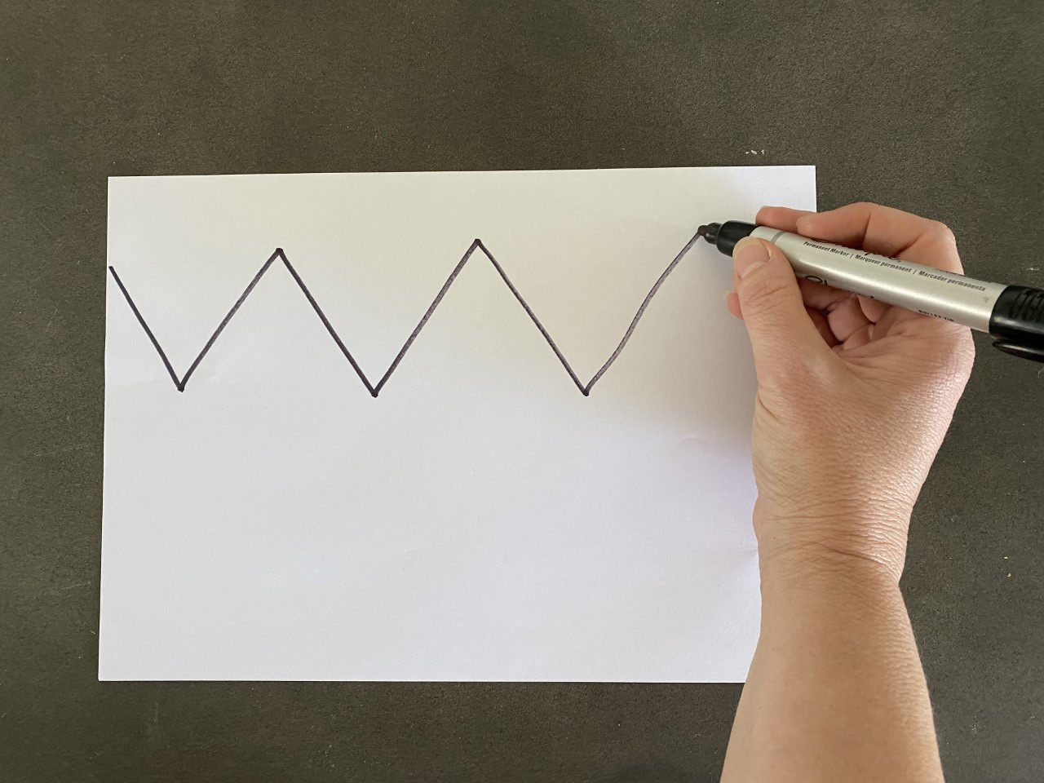
- Draw zig zags for the top of the crown.

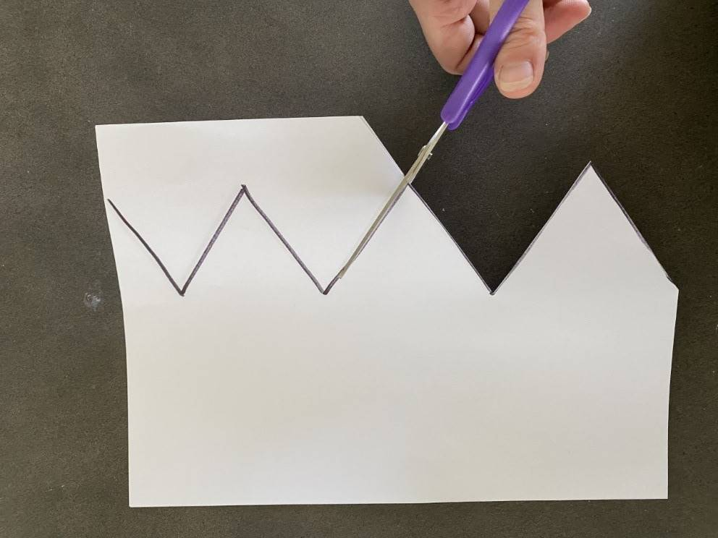
- Cut the crown out.

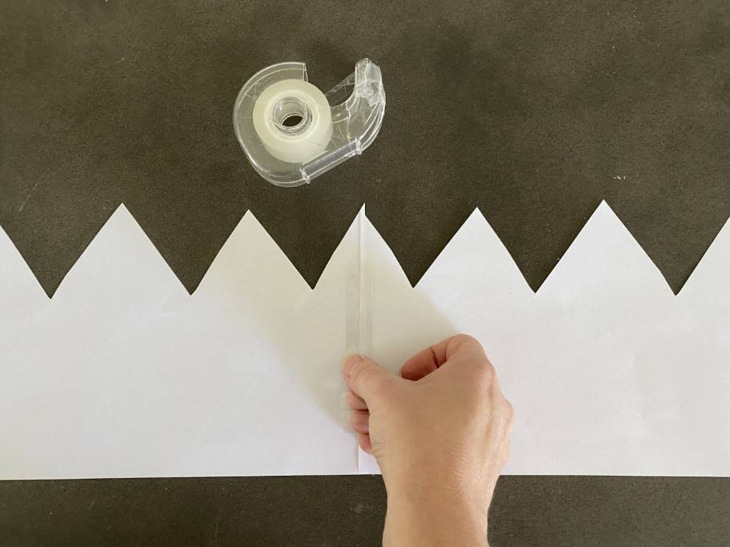
- Tape sections together to make it long enough.
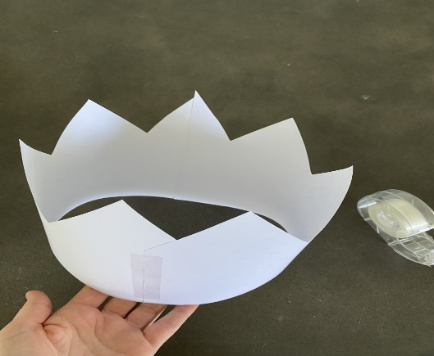
- Tape the ends together to form a crown.

Now you can wear your crown and pretend to be Max - King of the Wild Things!
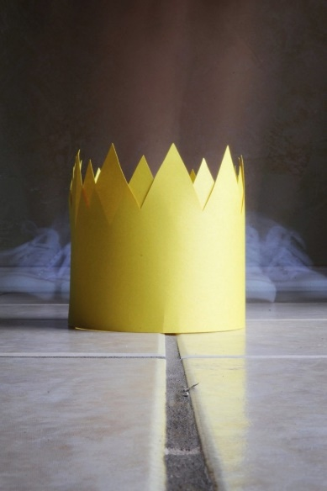
"Paper Crown pt. lll" by Valeria CL is licensed under CC BY-NC-SA 2.0
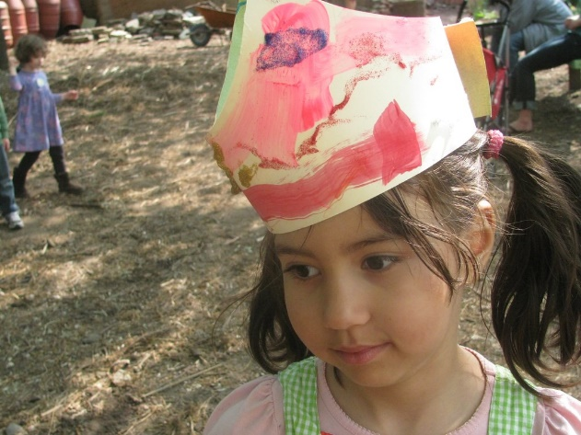
"Paper Crown I" by edenpictures is licensed under CC BY 2.0

Is this activity too hard?
- Have someone help you make a crown and decorate it.
- Draw a crown and add colour to it to make it special.
- Pretend to be Max from ‘Where the wild things are’

Is this activity too easy?
- Find pictures online of other crowns. Now add special details to your crown including jewels or sparkles.

Extra learning activities
- Watch the story “The little red hen and grains of wheat” via this QR code.
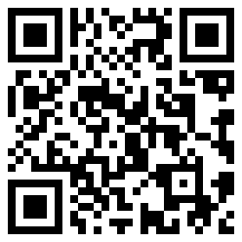
- Retell the story of little red hen by drawing or writing the words you know from the story. Remember to tell what happened at the beginning, middle and the end.

- If you can’t watch the story, choose a story book you have at home. Retell it by drawing or writing the words you know from the story. Remember to tell what happened at the beginning, middle and the end.
© State of New South Wales (Department of Education), 2021
The copyright material published in this document is subject to the Copyright Act 1968 (Cth) and is owned by the NSW Department of Education or, where indicated, by a party other than the NSW Department of Education.
Copyright material available in this document is licensed under a Creative Commons Attribution 4.0 International (CC BY 4.0) licence.
See https://education.nsw.gov.au/about-us/copyright for further details.
