This booklet belongs to:

Week G – Thursday

Day at a glance:
 | Fingers and toes | Chicken memory game | School uniform | Shadow sketches | Tell a story
Estimated time | 10-15 mins | 20-25 mins | 15-20 mins | 10-15 mins | 20 mins
Resources required | Something to draw with and on | Cardboard, scissors, glue | Uniform or dress up | Flower or leaf | Something to draw on and with

Fingers and toes
Learning goal: Children show interest in and respect for others.
Listen to the story ’Ten little fingers and ten little toes’ by Mem Fox via this QR code. Each of the babies are born in different places around the world.
- Find out where you were born:
- Were you born in a hospital or in a house or somewhere else like the babies in the book?
- Which country were you born in?
- Count how many fingers and toes you have like the images below.
- Draw a picture of a hand and foot.
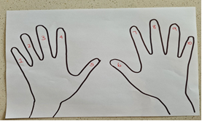
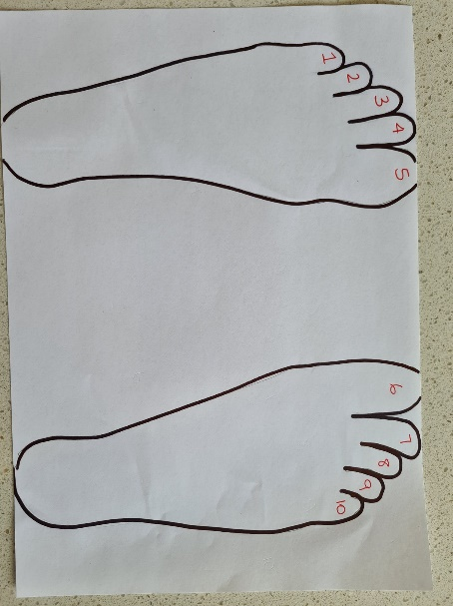
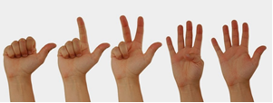
This photo by Unknown Author is licensed under CC BY-SA-NC

Is this activity too hard?
- Ask someone to look at some of your baby photos with you.
- Get someone to trace your hands and feet. You can decorate them.
- Can you count how many fingers you have on 1 hand?
- Get someone to count your fingers and toes with you.

Is this activity too easy?
- Trace around your fingers and number them from 1 to 10.
- You can do the same thing with your toes.

Chicken memory game
Learning goal: Children follow instructions to make and play a game.
- Download and print the pictures of chickens via this QR code. If you can’t download and print the pictures, you can follow the instructions below the picture of the chicken memory game.
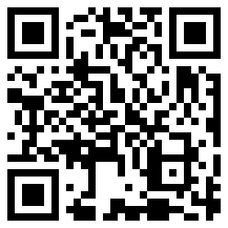
- Can you count them? There are two of every picture, which means we have 9 pairs of matching pictures.
- Paste both pages of pictures onto cardboard and cut out the pictures (or just cut the paper).
- You should have 18 pictures. Count them to make sure.
- Now you can play memory:
- Mix the pictures up, place them on the floor or table with the pictures face down.
- Take it in turns to turn a card over, then another.
- If they are a pair, you can keep them, if they are not a pair, place them back face down.
- Take turns with someone, or see how many times it takes for you to find all the matching pairs.
- Pick your favourite picture. Can you describe it to somebody in your family?
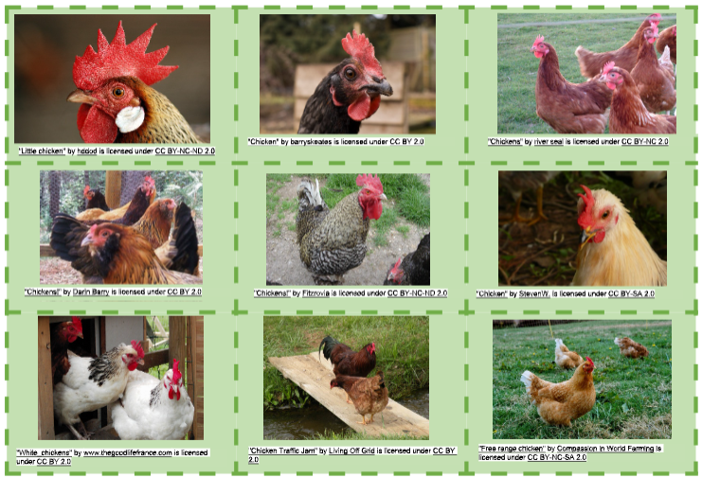
If you don’t have a printer:
- you can play memory with anything you have two pictures of.
- try playing memory with playing cards, or draw two of the same image, and make them into cards, some ideas for images are x o = +, or use letters or numbers.

Is this activity too hard?

Pick your favourite chicken picture. Can you describe it to somebody in your family?

Ask someone to help you make the memory cards. Can you match the pictures?

Is this activity too easy?
- Think of 6 words you know about chickens. Make a memory game with the words. Ask someone to help you write the words if needed.

School uniform
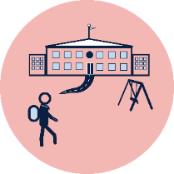
Learning goal: Children understand how to dress for school.
Your uniform is what you will wear to school every day.
- Ask someone in your house to help you find out about the uniform at your school.
- Why do you think you will wear different clothes at school to at preschool? For example, shoes and socks will keep you safe in the playground.
- What will you wear the same at school as you do at preschool? For example, a hat to stay sun safe.
- Practice or pretend to get dressed for school:
  - If you have your school uniform (or a sibling's) dress yourself and put on your shoes/socks. Does it have the school logo on it?
  - Choose some clothes and pretend they are your school uniform - practice getting ready for school.
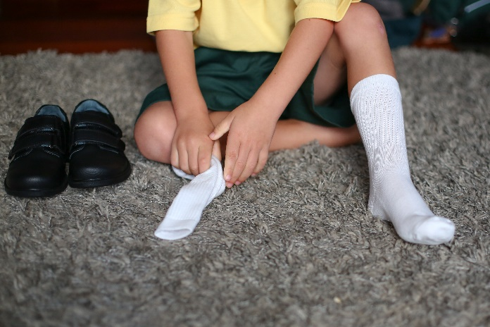
Image licensed under the iStock Getty Images Content License Agreement

Is this activity too hard?
- Get someone to look at the school website with you. Look at photos of the children at your school in their school uniform.
- What colour is your school uniform?
- Can you draw part of the school uniform. For example, your school hat.

Is this activity too easy?
- Can you draw yourself in your school uniform? Don’t forget shoes and socks, hat and your school bag.

Take a break
Here are some things you might like to do:
- have a drink of water and a healthy snack
- play or have a rest
- go to the toilet and wash your hands.
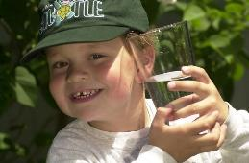
"Boy with glass of water, 2000" by Seattle Municipal Archives is licensed under CC BY 2.0
Photo by Any Lane from Pexels
Photo by Andrea Piacquadio from Pexels
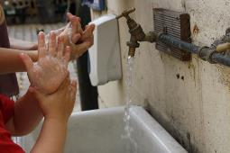
"Washing hands" by magnusfranklin is licensed under CC BY-NC 2.0

Shadow sketches
Learning goal: Children learn about shapes and textures of natural objects and represent these in their drawings.
- See if you can find a flower, leaf, nut, bottle brush or pine cone.
- Hold it above some paper like in the video and draw its shadow.
- Compare your drawing with the object. Does it look the same or different?
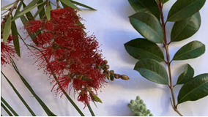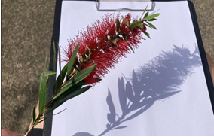
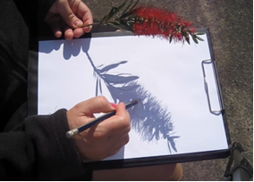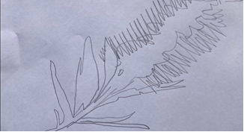

Is this activity too hard?
- Ask someone to do the outline and then colour it in yourself.
- Ask someone to hold the flower for you while you trace the shadow.

Is this activity too easy?
- You might like to colour or paint your sketch!
- Can you see similar shapes in your sketch? Describe how they are different.

Tell a story
Learning goal: Children use drawings to tell a story.
Let's tell the story of 'Where the wild things are', by Maurice Sendak, using your own drawings.
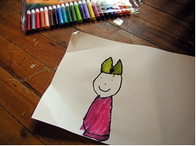
Princess Peach" by massdistraction is licensed under CC BY-NC-ND 2.0
You can listen to the story again via this QR code. If you can’t access the story, you can look back over the week at the other ‘Where the wild things are’ activities.
- Remember to include Max and the wild things in your drawings.
- You could draw Max sailing to the land of the wild things and when they were all dancing in the forest.
- Share this with your family when you have finished.
- You can describe what is happening in each picture, just like an author.

Is this activity too hard?
- Draw Max or one of the wild things.

Is this activity too easy?
- Record yourself telling the story of 'Where the wild things are'.
- Can you think of a different ending to the story?

Extra Learning activities
Watch ‘Five little piggies’ and learn about being safe near the road via this QR code. If you can’t watch the video, you can talk with someone in your home about being safe near the road. The points below might help.
How can you be safe near the road?
- Stay close to the adult that is with you, holding hands.
- Watch and wait near the crossing with an adult for the light to change to green.
- Watch and wait at school crossings, where a crossing helper will help you walk across the road, still holding hands with an adult.
© State of New South Wales (Department of Education), 2021
The copyright material published in this document is subject to the Copyright Act 1968 (Cth) and is owned by the NSW Department of Education or, where indicated, by a party other than the NSW Department of Education.
Copyright material available in this document is licensed under a Creative Commons Attribution 4.0 International (CC BY 4.0) licence.
See https://education.nsw.gov.au/about-us/copyright for further details.

