This booklet belongs to:

Week G – Monday

Day at a glance:
 | All about me | What chickens need to be healthy | Plan a meal | My ideal pet | Shared story
Estimated time | 15-20 mins | 15-20 mins | 15-20 mins | 5-10 mins | 15-20 mins
Resources required | None | None | Something to draw with and on. | None | None

How I feel about school
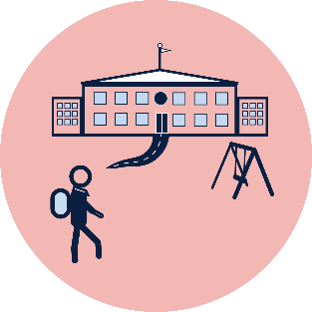
Learning goal: Children identify feelings and share aspects of who they are with others.

What would you like your teachers and friends at school to know about you?

What is your favourite thing to play with?

Who do you live with?

How do you get to school?

Who do you visit on weekends?

How are you feeling about starting at your new school?

Pick one of the feeling faces below.

Tell someone in your family about how you are feeling.

Is this activity too hard?
- Get someone to help you collect some photos of you that tells your story.
- Think about how you feel about starting school.
- If you are excited or happy what is it that you are looking forward to? Tell someone.
- Make a plan with a trusted grown up to help with feelings such as unsure, worried or scared.
- Think about something that makes you happy and tell someone.

Is this activity too easy?
- Draw a picture of yourself and the things that you like doing
- Can you add to the picture some of your ideas about what you think school will be like?

What chickens need to be healthy
Learning goal: Children explore how to care for chickens.
Think about what you know about chickens.
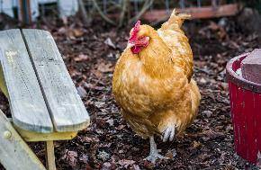
"Ruby, My Wife's Pet Chicken" by kla4067 is licensed under CC BY-SA 2.0
- What do you think they eat?
- What do they live in?
- What do they need to keep them warm in the wind and rain?
- What might be dangerous to chickens?
- What do they need to keep them safe?
- Imagine that you are a chicken. What would you like to live in?
Watch the video via this QR code to see what chickens need to be healthy and happy. If you can’t watch the video, you can look at the pictures below and talk about what you can see.
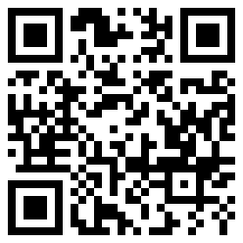
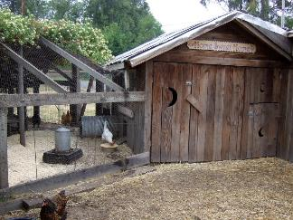
Photo by Terrie Schweitzer is licensed under CC BY-NC-SA 2.0
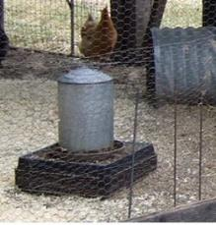
Photo by Terrie Schweitzer is licensed under CC BY-NC-SA 2.0
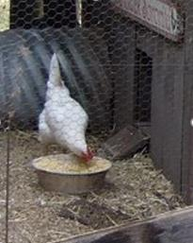
Photo by Terrie Schweitzer is licensed under CC BY-NC-SA 2.0

Is this activity too hard?
- Pretend to be a chicken eating food and having a drink of fresh water while living safely in a coop.
- Get someone to read a story about chickens.

Is this activity too easy?
- Draw a picture of a chicken and all the things it needs.

Plan a meal
Learning goal: Children consider the health needs of themselves and others when preparing food.
- Watch the video about visiting an orchard and preparing juice. If you can’t watch the video, start at step 2.
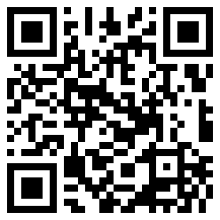
- Think about a meal that you would like to make:
- Is it for a snack, breakfast, lunch, dinner?
- How many people will be eating?
- Will everyone like that food?
- Plan your meal:
- What ingredients you will need?
- How long will it take?
- Draw all the things that you will need for the meal
- Work with a family member to make the meal.

Is this activity too hard?
- Try some new food.
- Make some choices about the food that you would like to eat.
- Help a family member choose a meal.

Is this activity too easy?
- Plan a whole day of food for your family.
- Ask a family member for a family recipe. Ask them the story of the recipe.

Take a break
Here are some things you might like to do:
- have a drink of water and a healthy snack
- play or have a rest
- go to the toilet and wash your hands
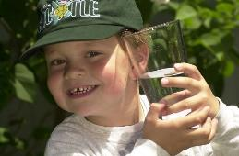
"Boy with glass of water, 2000" by Seattle Municipal Archives is licensed under CC BY 2.0
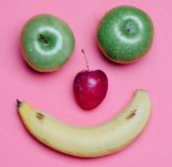
Photo by Any Lane from Pexels
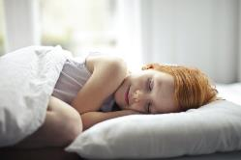
Photo by Andrea Piacquadio from Pexels
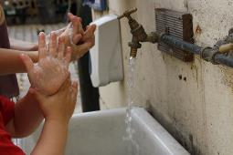
"Washing hands" by magnusfranklin is licensed under CC BY-NC 2.0

My ideal pet
Learning goal: Children explore ideas and think critically about their choices.
Listen to the audio about an ideal pet via this QR code. If you can’t listen, someone in your home might be able to read the transcript for you.
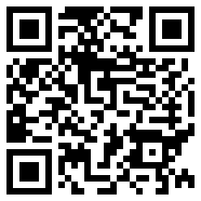

Ideal pet audio transcript
We’re now going to think about our ideal pet. So, if you could have any animal at all as a pet, what would you like?
Now I want you to think of why you want this animal. And you’re going to go and find someone in your family and you are going to tell them what pet you would like and 3 reasons why you would like this pet.
Now let me tell you all about my ideal pet. My ideal pet is a chicken. Now I know that sounds like a pretty boring ideal pet, but here are my three reasons:
- Reason 1: chickens eat all of the scraps so I wouldn’t have to throw out my leftover vegetables, fruit or bread. My chickens would eat that.
- Reason 2: the chickens give me eggs and I love eggs! I use so many eggs in cooking and on toast so they will make me an ideal pet to give me my eggs.
- Lastly, my third reason why I would love a chicken is I don’t need to take them for a walk. They are really easy to look after. I would just let them out during the day, they would peck the grass - so I wouldn’t have to mow the grass as much - and I don’t need to walk them!
So, they’re my 3 reasons for wanting a pet chicken.
Your job is to go and find someone in your family and tell them the 3 reasons you would like your ideal pet.

Activity
- Think about your ideal pet.
- Find someone to tell about your ideal pet. The photos below might give you some ideas.
- What are three reasons you would like this pet?
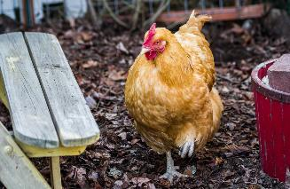
"Ruby, My Wife's Pet Chicken" by kla4067 is licensed under CC BY-SA 2.0
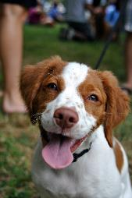
"Pride of Pets Dog Show, 2011" by angela n. is licensed under CC BY 2.0
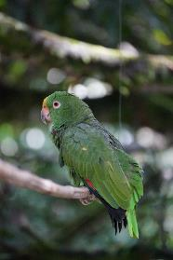
"Pet Parrot" by jjmusgrove is licensed under CC BY 2.0
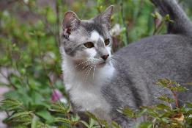
"Our Pet Cat Mancha" by Jay Woodworth is licensed under CC BY 2.0

Is this activity too hard?
- Choose your favourite pet from the photos.

Is this activity too easy?
- Draw a picture of your ideal pet and the things it would need to live with you.

Shared story- Where the wild things are
Learning goal: Children use images to make predictions.
- Look at the cover of this book.
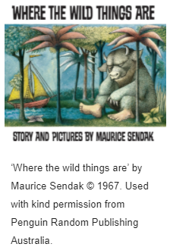
Answer these questions:
  - What do you think the story might be about?
  - Can you see any clues?
  - Is there a character on the cover?
  - Do you think it will be an interesting story?
  - What might happen?

- Now look at this picture from the story. It shows two wild things.
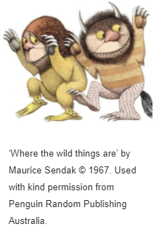
  - Does it give us more clues about the story?
  - Do you think the wild things are friendly?
  - Why do you think that?

- Listen to the story, 'Where the wild things are' by Maurice Sendak, via this QR code.
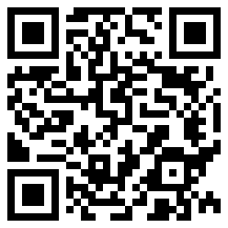
- After the story, answer these questions:
- Think about what happened at the start, in the middle and at the end.
- What was your favourite part?
- Would you like to sail somewhere or have you already?
- What fun things would you get up to with the wild things?

Is this activity too hard?
- Show your family the pictures and ask them to help you imagine what the story could be about.
- Ask someone in your family to listen to the story with you. Talk about the different sections and your favourite parts together.
- Do some stomping and dancing like a wild thing.

Is this activity too easy?
- Pretend you are the author and make up your own story to match the picture of the cover. Share your story with someone in your family.

Extra learning activities
Access more learning activities from the early childhood literacy and numeracy resource via this QR code. If you can’t access the QR code, you can do the song and activity below.
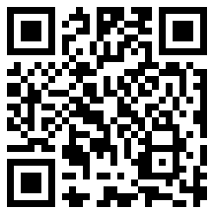
- Count to five using your fingers.
- Sing Johnny works with one hammer

Johnny works with one hammer (action song)
Johnny works with one hammer (children hammer with one hand)
One hammer, one hammer
Johnny works with one hammer, Johnny works with two.
Johnny works with two hammers … (children hammer with two hands)
Johnny works with three hammers … (children hammer with two hands and one leg)
Johnny works with four hammers … (children hammer with both hands and both legs)
Johnny works with five hammers (children hammer with both hands, both legs and head)
Five hammers, five hammers
Johnny works with five hammers
Johnny’s work is DONE!
- After the rhyme hold up your fingers and count them.
- Have a collection of items for example sticks, leaves, stones, toys, cars and count out 5 items from the collection, saying the next number as you pick up each item. If you find this easy, use 10 items.
© State of New South Wales (Department of Education), 2021
The copyright material published in this document is subject to the Copyright Act 1968 (Cth) and is owned by the NSW Department of Education or, where indicated, by a party other than the NSW Department of Education.
Copyright material available in this document is licensed under a Creative Commons Attribution 4.0 International (CC BY 4.0) licence.
See https://education.nsw.gov.au/about-us/copyright for further details.

