This booklet belongs to:

Week F – Wednesday

Day at a glance:
 | Recycling | Shared story | Dancing wand | Peg play | Paper tower
Estimated time | 5-10 mins | 10-15 mins | 10-15 mins | 10-15 mins | 15-20 mins
Resources required | None | Something to draw with and on | Stick and a scarf or ribbon | Pegs and string | Paper, tape, string, ruler, scissors

Recycling
Learning goal: Children develop an understanding of recycling.
- Watch the video ‘Recycling’ via this QR code, to find out where milk bottles go after you put them in the recycling bin. If you can’t watch, you can start at step 2.
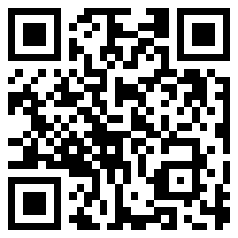
- What colour bins do you have at home?
- Draw your bins and what goes inside each.
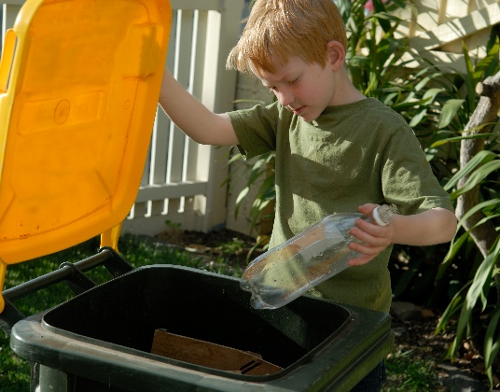
Image owned by the NSW Department of Education under the Copyright Act 1968 (Cth)

Is this activity too hard?
- Have someone fill bottles up with coloured water.
- Add some interesting objects inside, such as rice, small figurines or beads.
- Tape the lid shut.
- Tip and turn the bottle and watch the objects.
This is a different way to recycle things.

Is this activity too easy?
- Help a family member sort your rubbish and recycling into the correct bins.
- Think of ways you might reuse some recyclable containers.

Shared story
Learning goal: Children use actions and create a map to demonstrate their understanding of a story.
Listen to the story about a crocodile via this QR code. If you can’t listen, you could draw a map of your backyard with a crocodile hiding somewhere.
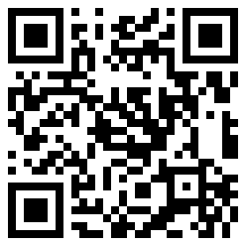
- Copy the storyteller to do the actions.
- Draw a map which shows where the old man went to find the crocodile. He started at his house and then went:
  - out the front door
  - down the garden path
  - out the garden gate
  - across the field of tall grass
  - up the hill
  - down the hill
  - across the big dark river.

Is this activity too hard?
- Snap your hands like a crocodile.
- Pretend to be a crocodile.
- Draw a crocodile.
- Have someone draw a map of your backyard. Tell them what needs to go on the map.

Is this activity too easy?
- Draw another map of places you go to when you leave your house, like the shops, preschool or a friend's house.

Dancing wand
Learning goal: Children combine big and small movement patterns to dance.
- Make a long wand out of materials such as wool, long strips of fabric, ribbon, string, scarves etc.
- Tie together and attach the wand to a handle made from a stick or wooden spoon.
- Listen to the music via this QR code, and dance with your wand. If you can’t listen to the music, you can listen to music you have at home.
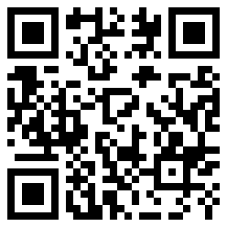
  - Make your wand go up and down and from side to side.
  - Make your wand go around and around.
  - Make your wand move slowly and then fast.

Is this activity too hard?
- Find a piece of ribbon, scarf or anything you can wave around and dance along to the music.

Is this activity too easy?
- Try holding a wand or material in both hands and move them at the same time.

Take a break
Here are some things you might like to do:
- have a drink of water and a healthy snack
- play or have a rest
- go to the toilet and wash your hands.
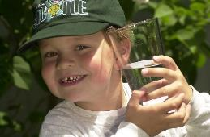
"Boy with glass of water, 2000" by Seattle Municipal Archives is licensed under CC BY 2.0
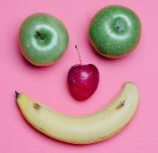
Photo by Any Lane from Pexels
Photo by Andrea Piacquadio from Pexels
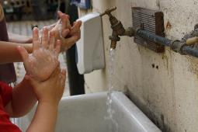
"Washing hands" by magnusfranklin is licensed under CC BY-NC 2.0

Peg play
Learning goal: Children develop numeracy concepts.
- Gather together as many pegs as you can.
- Complete these tasks using the pegs:
  - sort the pegs into groups of colours
  - count the pegs
  - divide your pegs into two equal groups
  - peg the pegs along the edge of a piece of cardboard or fabric in a pattern
  - arrange the pegs to make them look like numbers
  - measure how many pegs long your leg is.
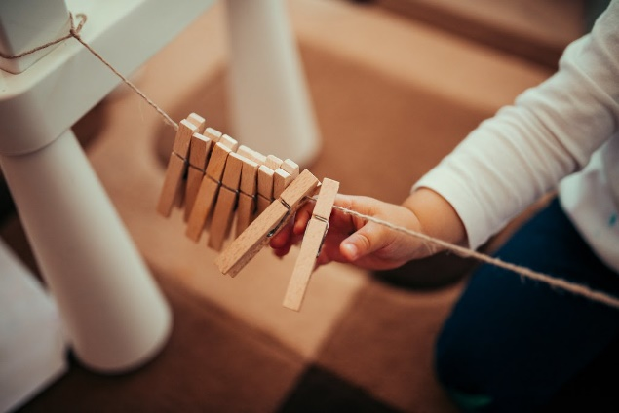
"Little girl playing with clothes pegs on a small clothes line" by Ivan Radic is licensed under CC BY 2.0

Is this activity too hard?
- Pinch a playdough snake between your thumb and fingers to break into segments. Count the number of pieces.
- Use tongs to pick up objects and sort them into colour groups.
- Touch the pegs while someone counts for you.

Is this activity too easy?
- Arrange pegs to write out some of the letters of your name.
- Make some piles of pegs and count them. Add some pegs to your piles. How many do you have now? Now take away some pegs. How many do you have now?

Paper tower
Learning goal: Children use persistence and experimentation to complete a challenge.
- Collect your paper, tape, string, scissors and ruler for a STEM challenge.
- Watch the video via the QR code, and join in the activity to build a tall tower. If you can’t access the video, use the materials to create a tall tower, like in the picture below. Newspaper can be rolled up and held together with tape.
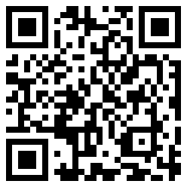
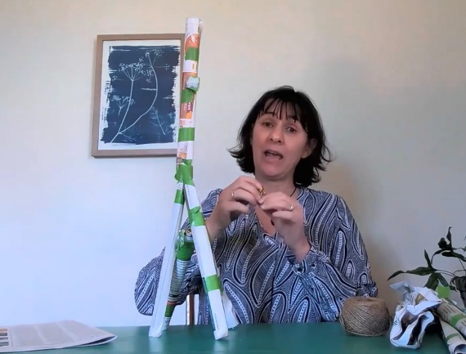
- The tower must be able to hold a small toy at the top.
- You can only use the materials on the list.
- Your tower needs to be able to stand up by itself.
- The ruler is only for measuring and cannot be used in the tower structure.

Is this activity too hard?
- Use tape and cardboard cylinders to create something.
- Have someone help you make the tower. See what you can balance on it.
Is this activity too easy?
- Make another tower that can hold more than one toy at the top. How many toys can it hold? Is it taller or shorter than your first tower?

Extra learning activities
Listen to Play School Story Time in Italian, Japanese, Cantonese, Mandarin and Arabic, via this QR code. If you can’t listen, you can find your favourite book to read or ask someone in your home if they know any words from another language that you can learn.
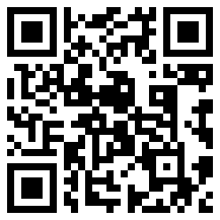
© State of New South Wales (Department of Education), 2021
The copyright material published in this document is subject to the Copyright Act 1968 (Cth) and is owned by the NSW Department of Education or, where indicated, by a party other than the NSW Department of Education.
Copyright material available in this document is licensed under a Creative Commons Attribution 4.0 International (CC BY 4.0) licence.
See https://education.nsw.gov.au/about-us/copyright for further details.
