This booklet belongs to:

Week F – Tuesday

Day at a glance:
 | Sensory sensation | Your name | Sun safety | Shapes | Pease pudding
Estimated time | 5-7 mins | 5-10 mins | 10-15 mins | 10-15 mins | 15-20 mins
Resources required | None | Something to write with and on | Items for sun safety | Scissors and glue | Wooden spoon and saucepan

Sensory sensation
Learning goal: Children use their senses to explore their environment.
Listen to the instructions via the QR code or read them below.
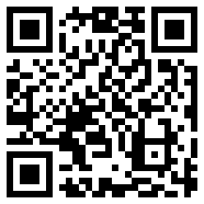
- Take a big breath in and a big breath out. What are five things you can see around you?
- Take another big breath in, and out. What are four things you can touch around you? Say them out loud as you touch them.
- Another big breath in and out. Name three things that you can hear around you.
- Big breath in and big breath out. What are two things that you can smell right now?
- Last breath in and out. What is something you can taste right now?

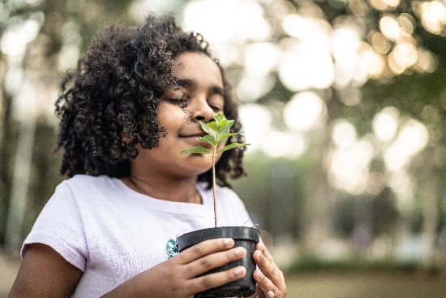
Image owned by the NSW Department of Education under the Copyright Act 1968 (Cth)

Is this activity too hard?
- Pause the audio after each step to allow more time to think.
- Ask someone to sit with you and look for examples of what you can see, touch, hear, smell and taste together.
- Collect some objects to explore each of your senses, for example herbs, lavender, bark, leaves, sticks, fruit.

Is this activity too easy?
- Draw some items for each sense.
- Play 'I spy' with someone.
- Describe a piece of fruit using all of your senses.

Your name
Learning goal: Children develop phonological awareness.
- Write or copy your name.
- Clap your name. How many syllables are in your name?
- Find three things which start with the same sound as your name.
- Make up three silly words that rhyme with your name.
- Repeat the steps using someone else in your family’s name.
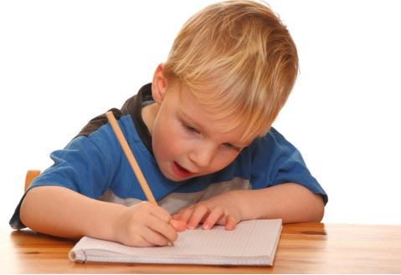
This photo by Unknown Author is licensed under CC BY-SA

Is this activity too hard?
- Use a sand tray (tablet computer, finger paint or shaving cream also work) to make:
  - circles and lines with your finger
  - the first letter of your name.

Is this activity too easy?
- Try writing your middle and last name too.
- Draw a family picture and write everyone's name.

Sun safety
Learning goal: Children understand how they can keep themselves safe in the sun.
- Listen to the song 'You've gotta be SunSmart', via this QR code, about keeping yourself safe in the sun. If you can’t listen, you can start at step 3.
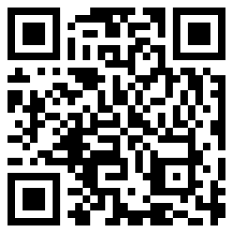
- Watch the children in the second video, via the QR code, getting ready to play outside.
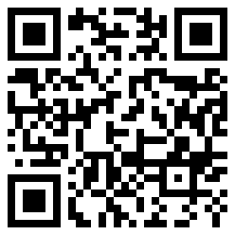
- Find the items in your house that you need to play outside:
  - hat
  - sunscreen
  - a t-shirt that covers your shoulders
  - sunglasses.
- Draw yourself playing in the shade with your hat on.
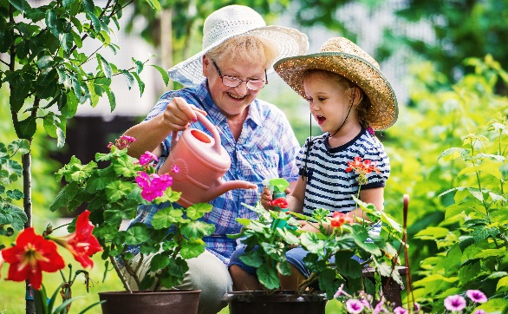
Image owned by the NSW Department of Education under the Copyright Act 1968 (Cth)

Is this activity too hard?
- Ask someone to help you get ready for outside play.
- Go out and have fun safely. Get someone to take a photo.
- Tell another person how you are being sun safe in this photo.

Is this activity too easy?
- Set up your own sunscreen station with some drawings, photos and signs about sun safety.

Take a break
Here are some things you might like to do:
- have a drink of water and a healthy snack
- play or have a rest
- go to the toilet and wash your hands.
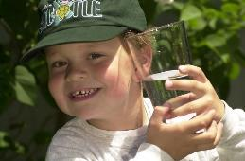
"Boy with glass of water, 2000" by Seattle Municipal Archives is licensed under CC BY 2.0
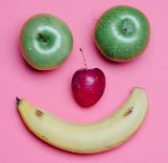
Photo by Any Lane from Pexels
Photo by Andrea Piacquadio from Pexels
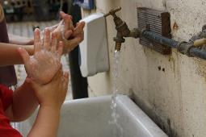
"Washing hands" by magnusfranklin is licensed under CC BY-NC 2.0

Shapes
Learning goal: Children express their ideas and describe shapes.
Find some coloured paper, scissors and glue.
- Watch the video of children cutting out shapes via this QR code. If you can’t watch, you can start at step 2.
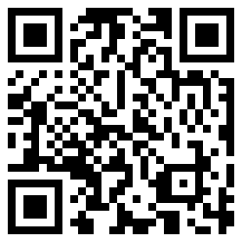
- Cut out different shapes from the paper.
- Glue the shapes down to create a picture. If you don't have glue, you can put your shapes on the table to create a picture.
- Tell someone about your picture:
  - What have you made?
  - What colours did you use?
  - What shapes did you use?

Is this activity too hard?
- Have someone cut out some shapes. Use these shapes to make a collage.
- Draw some shapes.
- Make some shapes with playdough.

Is this activity too easy?
- Label your picture using shape and colour names.
- Make another picture and see if you can add more details.

Pease pudding hot
Learning goal: Children engage with rhyme and rhythm through singing.
- Find a saucepan and wooden spoon.
- Watch the video via this QR code and join in the activities. If you can’t watch you can use a saucepan and wooden spoon to keep the beat to a favourite song.
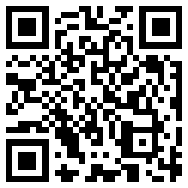
- Sing the songs and keep the beat on your saucepan.
- Make up some rhythms on your saucepan.
- Show your facial expression when:
  - London bridge is falling down
  - you eat an imaginary cold pea pudding
  - you eat a hot pea pudding
  - you eat a pudding that is just right.

Is this activity too hard?
- Watch the video and enjoy listening to the songs.
- Clap your hands along to the video.

Is this activity too easy?
- Make up your own beat on the saucepan.
- Use two wooden spoons to make a beat.
- Draw your facial expressions in the different parts of the song.

Extra learning activities
Learn about the lives of children living in different countries.
- Open ‘Where in the world?’ via this QR code. If you can’t access the QR code, you can try the activity below.
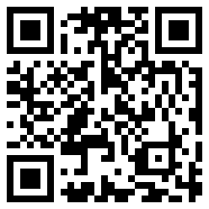
Activity
During the video, a young girl from Ghana called Tyra enjoys singing and dancing at school on Friday. She ate all the lunch that the teachers gave her. Draw a picture to let Tyra know what you enjoy eating for lunch at school.
© State of New South Wales (Department of Education), 2021
The copyright material published in this document is subject to the Copyright Act 1968 (Cth) and is owned by the NSW Department of Education or, where indicated, by a party other than the NSW Department of Education.
Copyright material available in this document is licensed under a Creative Commons Attribution 4.0 International (CC BY 4.0) licence.
See https://education.nsw.gov.au/about-us/copyright for further details.

