This booklet belongs to:

Week F – Thursday

Day at a glance:
 | Stone stack | Poetry | Fruit sticks | Numberblocks | Playdough dinosaurs
Estimated time | 10-15 mins | 5-10 mins | 10-15 mins | 10-20 mins | 10-20 mins
Resources required | Stones | None | Skewers | None | Playdough, sticks and other craft materials

Stone stack
Learning goal: Children show an increasing awareness of and respect for the natural environment.
- Watch the video ‘How to make a stone stack’ via this QR code. If you can’t watch the video you can start at step 2.
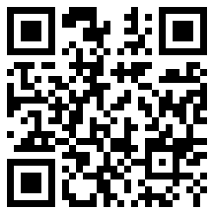
- Go for a walk with someone in your family to collect some flat stones.
- Make a stone stack.
- Find out the answer to these questions:
  - What happens if you start your stack with the smallest stone?
  - What happens if you start your stack with the biggest stone?
- If you don't have any stones, think about what else you could stack, perhaps pillows and cushions or soft toys.

Is this activity too hard?
- Find as many stones as you can.
- See if you can stack two or three stones.

Is this activity too easy?
- Try the same activity with other items from nature.

Poetry
Learning goal: Children use their imagination to enjoy a poem.
- Find somewhere to sit back and get comfy.
- Close your eyes and listen to the poem via this QR code. If you can’t listen ask someone to read a story to you, close your eyes to listen to the words and imagine the story in your mind.
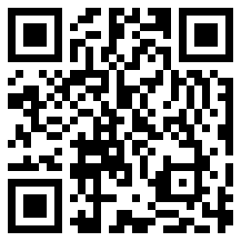

Is this activity too hard?
- Ask someone to read you a story.

Is this activity too easy?
- Draw a picture of what you were imagining when listening to the poem.

Fruit sticks
Learning goal: Children make themselves a healthy snack.
- Ask someone to help you cut up fruit into small pieces.
- Thread each piece onto a paddle pop stick or kebab stick.
- Eat your healthy snack.
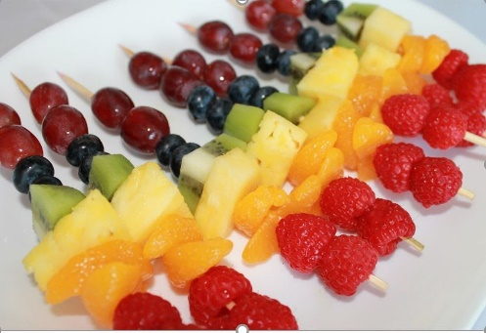
This Photo by Unknown Author is licensed under CC BY-SA-NC
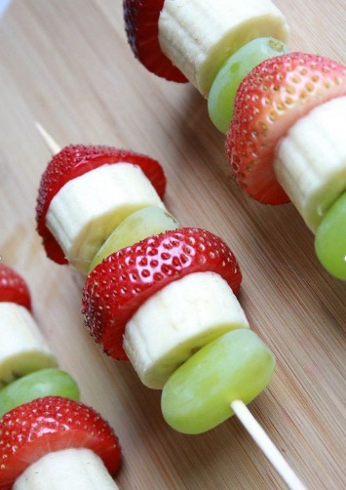
This Photo by Unknown Author is licensed under CC BY-NC-ND

Is this activity too hard?
- Eat your cut up fruit off a plate instead.
- Try a fruit that you haven't eaten before.
- Ask someone to make you a fruit smoothie.

Is this activity too easy?
- Make a repeating pattern with your fruit.
- Try a new fruit that you don't usually eat.

Take a break
Here are some things you might like to do:
- have a drink of water and a healthy snack
- play or have a rest
- go to the toilet and wash your hands.
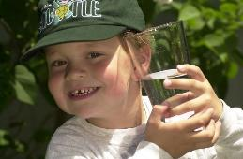
"Boy with glass of water, 2000" by Seattle Municipal Archives is licensed under CC BY 2.0
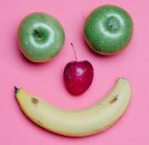
Photo by Any Lane from Pexels
Photo by Andrea Piacquadio from Pexels
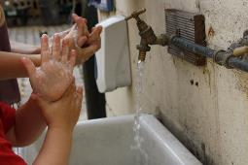
"Washing hands" by magnusfranklin is licensed under CC BY-NC 2.0

Numberblocks
Learning goal: Children learn to count with one to one correspondence.
- Watch the video about numbers 1, 2 and 3 via this QR code. If you can’t watch you can start at step 2.
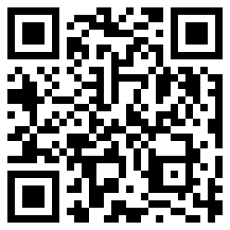
- Have a look around your house. Where can you find the numbers 1, 2 or 3?
- You might want to take a photo of each number and try to write the numbers yourself.
- Look at the picture below.
- How many plants are in the photo?
- How many children are in the photo?
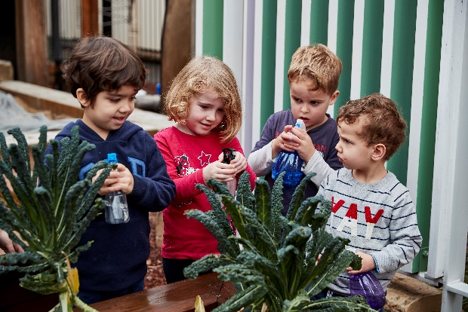
Image owned by the NSW Department of Education under the Copyright Act 1968 (Cth)

Is this activity too hard?
- Have someone count for you as you point to the objects.
- See how far you can count.
- Count how many toys you have in front of you.

Is this activity too easy?
- Count how many rooms are in your house.
- Count how many people are in your family.
- What else can you count?

Playdough dinosaurs
Learning goal: Children use the arts to represent their thinking and express ideas.
- Watch the video of children making dinosaurs from playdough via this QR code. If you can’t watch, you can start at step 2.
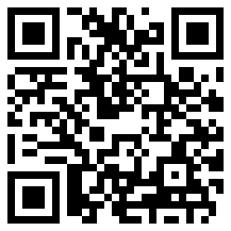
- Have a go at making your own dinosaur from playdough.
- Push small sticks or craft materials into your dinosaur.
If you need to, look at the photos of dinosaurs below to give you some ideas.
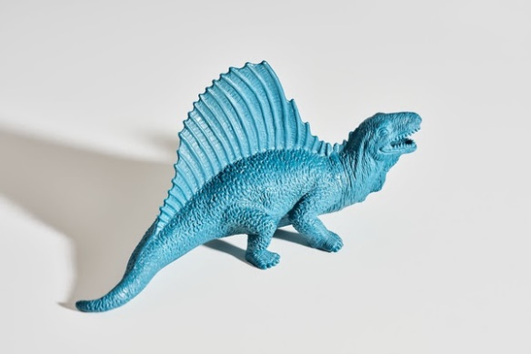
"Dinosaur Toy" by danielfoster437 is licensed under CC BY-NC-SA 2.0
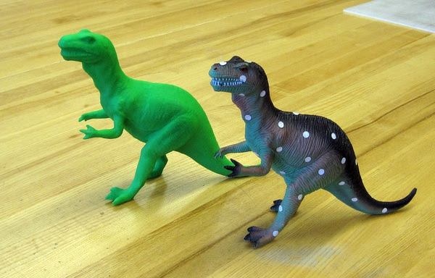
"Spotted dinosaur toy and the 3-D printed reproduction at the Art Institute of Chicago" by benchilada is licensed under CC BY-NC-SA 2.0
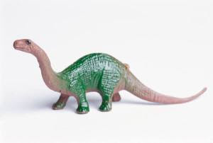
This Photo by Unknown Author is licensed under CC BY-NC

Is this activity too hard?
- If you own a toy dinosaur, use its feet to print in the playdough.
- Draw or paint your dinosaur.

Is this activity too easy?
- Create a place for your dinosaur to live with playdough and craft materials. What do you think it would need?

Extra learning activities
This play and learning video is for families. It shows that learning opportunities are everywhere and that you can use everyday items in many ways to help your child learn different things.
You can watch the video via this QR code. If you can’t watch the video, you can follow the suggested steps below.
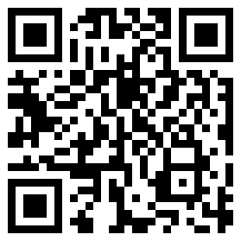
- Sort pencils into colour groups.
- Read a favourite story and draw pictures together about your favourite part.
- Find letters in your name around the house, on labels, magazines and books.
- Read, using your finger to point at the words as you say them.
© State of New South Wales (Department of Education), 2021
The copyright material published in this document is subject to the Copyright Act 1968 (Cth) and is owned by the NSW Department of Education or, where indicated, by a party other than the NSW Department of Education.
Copyright material available in this document is licensed under a Creative Commons Attribution 4.0 International (CC BY 4.0) licence.
See https://education.nsw.gov.au/about-us/copyright for further details.
