This booklet belongs to:

Week F - Monday

Day at a glance:
 | Friends | Shared story | Bouncing and dribbling | Patterns | Goop
Estimated time | 15-30 mins | 10-15 mins | 20-30 mins | 15-20 mins | 15-20 mins
Resources required | Something to draw on and with | None | Medium ball that bounces | Coloured cups, pegs, blocks or toys | Cornflour and water

Friends
Learning goal: Children reach out to others for company and friendship.
Watch the video via this QR code, and think about your friends. If you cannot access the QR code, you can talk about the questions below with someone in your home.
- Do you have a special friend? Sometimes, our cousins are also our friends.
- What would you like to do with your friend next time you are able to see them?
- Draw or paint a picture of you and your friend having fun together.
- Have you spoken to your friend lately? If not, you might like to phone or video call your friend to chat.

Image owned by the NSW Department of Education under the Copyright Act 1968 (Cth)

Is this activity too hard?
- Have someone show you photos of you and your friend. Get them to tell you what was happening in the photos.
- Tell someone about your friend. Tell them something that you did together.
- Find a photo of your friend and draw them.

Is this activity too easy?
- Make a card or write a letter to your friend and ask someone to help you post it.

Shared story
Learning goal: Children consider and discuss a story character's feelings.
‘Bluey: The Creek’
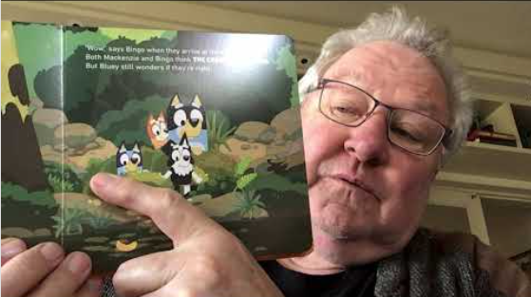
This story talks about Bluey visiting a creek with his friends, and the creek feels very different to the playground. Bluey feels scared. Soon after, her friends make her feel comfortable by playing games by the water, watching dragonflies and making dams. After some time, Bluey loves the creek and thinks it is beautiful. Her friends helped her not to be scared of the creek anymore.
- Listen to the story 'Bluey: The Creek’ via this QR code. If you can’t listen you can talk about the storyline with someone in your home and see the questions at step 2.
- Talk to someone about these questions:
- Have you been to a creek?
- At the beginning of the story Bluey was scared of the creek. Why do you think Bluey was scared?
- Are there any places that scare you?
- How do you think Bluey felt about the creek at the end of the story?

Is this activity too hard?
- Think about a time that you found something scary.
- What did you do to feel less scared?
- Did someone help you feel safe?
- When have you been brave?

Is this activity too easy?
- Draw or paint a picture of a place that made you feel scared.
- Write, or ask someone to write, the words on the picture of how that place made you feel.
- Think about what helps you feel less scared.
- Tell someone about a time that you were brave.

Bouncing and dribbling
Learning goal: Children learn to bounce and dribble a ball.
- Find a medium sized ball that bounces.
- Watch the ‘Bouncing and Dribbling’ video via the QR code, and follow the instructions. If you can’t watch the video, you can start at step 3.
- Hold the ball with both hands and drop it so it bounces back. Catch it with both hands. Practice a few more times.
- Now hold the ball with both hands and push the ball down so it bounces back harder. Catch it with both hands. Practice a few more times.
- Now hold the ball with both hands, push it down and as it comes back up, see if you can hit it back down with both hands and then with one hand.
- How many times can you push the ball down and keep it bouncing with one hand?

Is this activity too hard?
- Use a balloon on a string to bounce in time to some music.
- Move to some music using bouncy movements. Bounce your hands in your lap. Bounce your feet on the ground. Nod your head.
- Bounce a ball to someone else.

Is this activity too easy?
- Try running and bouncing a ball at the same time.

Take a break
Here are some things you might like to do:
- have a drink of water and a healthy snack
- play or have a rest
- go to the toilet and wash your hands
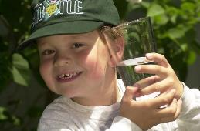
"Boy with glass of water, 2000" by Seattle Municipal Archives is licensed under CC BY 2.0
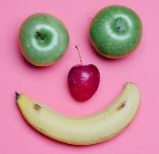
Photo by Any Lane from Pexels
Photo by Andrea Piacquadio from Pexels
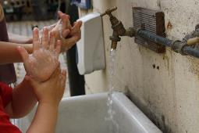
"Washing hands" by magnusfranklin is licensed under CC BY-NC 2.0

Patterns
Learning goal: Children identify and create patterns.
- Watch the video ‘What comes next?’ via this QR code. If you can’t watch, you can start at step 3.
- Copy the patterns on the video using your own fruit or other items.
- Now make some of your own patterns. You might like to make a:
  - colour pattern, using blocks, pencils, cups or toys (blue, green, red, blue, green, red)
  - movement pattern, using steps or body movements (jump, jump, stomp, jump, jump, stomp)
  - sound pattern, using your hands to make music (clap, clap, rest, clap, clap, rest).
- After you have made each pattern tell someone about it.

Is this activity too hard?
- Get someone to make you a fruit pattern. Taste the different fruit.
- Make your patterns with someone else.

Is this activity too easy?
- Teach someone about a pattern you have made.

Goop
Learning goal: Children explore and investigate the properties of a substance.
- Follow the recipe to make goop, via the QR code. If you can’t read the instructions, you can follow the recipe below.
- Play with your goop.
- How can you make your goop hard?
- How can you make your goop runny?
Goop recipe
You will need:
- Cornflour (300g)
- Two cups of water
How to make it:
- Add half of the cornflour to 2/3 cup of water.
- Mix smoothly and slowly. Do not mix quickly as the mixture will thicken making the mixing difficult.
- Add more cornflour and/or water until it is the consistency of honey.
- Squeeze the mixture and it will become hard.
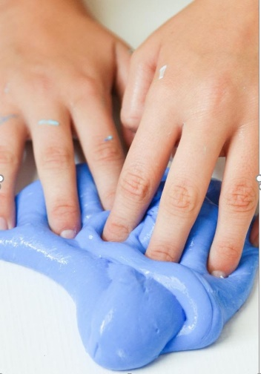
This Photo by Midget Momma is licensed under CC BY-SA-NC

Is this activity too hard?
- Have someone make the goop for you.
- Let the goop run through your fingers.
- Press the goop hard.
- Hide some toys in the goop and then find them with your hands.

Is this activity too easy?
- Make different shapes with the hard and runny goop.

Extra learning activity
- Use the Chrome music lab to make a melody via this QR code. If you can’t access the QR code you can start at step 3.
Click on the squares and then press 'play' to hear your melody.
- If you want to hear different instrument sounds, try the song maker via this QR code. If you can’t access the QR code you can start at step 3.
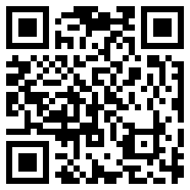
- Listen to your favourite music or song. Can you hear some different instruments?
  - Can you hear drums?
  - Can you hear piano?
  - Can you hear guitar?
© State of New South Wales (Department of Education), 2021
The copyright material published in this document is subject to the Copyright Act 1968 (Cth) and is owned by the NSW Department of Education or, where indicated, by a party other than the NSW Department of Education.
Copyright material available in this document is licensed under a Creative Commons Attribution 4.0 International (CC BY 4.0) licence.
See https://education.nsw.gov.au/about-us/copyright for further details.

