This booklet belongs to:

Week E – Tuesday

Day at a glance:
Tuesday | Rhythm and movement | Ordinal numbers | Car safety | Tigers | Colour mixing
Estimated time | 15-20 mins | 20-25 mins | 10-15 mins | 20-25 mins | 15-20 mins
Resources required | Two sticks or pencils | Small toys | None | Something to draw with and on | Red, yellow, blue and white paint and paintbrush

Rhythm and movement
Learning goal: Children move rhythmically and develop self-regulation.
For this activity you will need two sticks or pencils that you can tap together.
Watch this video and follow the instructions to get your brain ready for learning today. If you can’t watch the video, you might like to listen to your favourite song and tap along with the beat.
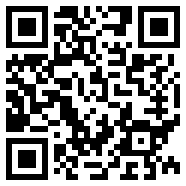

Is this activity too hard?
- Listen to the music and move a body part in time.
- Sing a favourite song. As you sing, tap or clap the beat.

Is this activity too easy?
- Use your tap sticks to compose your own rhythm patterns.
- Make a tapping rhythm to go with your name.

Ordinal numbers
Learning goal: Children describe position using ordinal numbers.
Watch this video about numbers via this QR code. If you can’t watch the video you can do the options below.
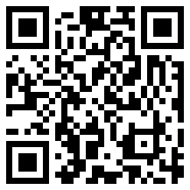
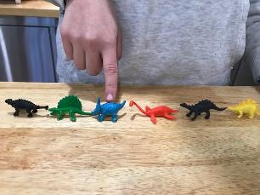
Choose one or more of these activities to practice using ordinal numbers:
- Line up six toys. Who is first in line? Who is second, third, fourth in line?
- Race your toy cars. Which one came first? Which one came 2nd?
- Draw what you do first when you wake up. Next, draw what you do second after waking up. Finally, draw what you do third after waking up.

Is this activity too hard?
- Line up three toys. Point to each and listen to someone say first, second or third.
- Line up three toys. Point to each and echo someone to say first, second or third.

Is this activity too easy?

Line up 10-20 small toys. Say which position each is in.
- Make labels for positions and put them next to the toys in line.

Car safety
Learning goal: Children show an increasing awareness of how they can keep themselves safe.
Listen to the song ‘Going for a drive in the car today’ via this QR code. If you can’t listen to the song, you can talk with someone and start at step 2.
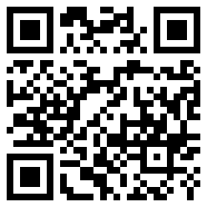
- Where do you go in the car?
- Who helps you click clack your seat belt?
- Draw yourself in the car with your seat belt on or talk to some about why it is important to buckle up safely.
You might also like to listen to this story to hear who is buckled up safely.
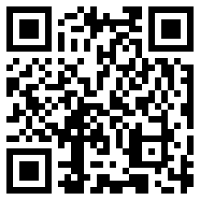

Is this activity too hard?
- Arrange some chairs or boxes to make a pretend car. Before you start driving, make sure you buckle up your seat belt.
- Ask someone to play the game with you or get some teddy bears. Make sure everyone buckles up their seat belt before the driver drives.

Is this activity too easy?
- How else do you keep yourself safe in the car?
- Make up a song that will help you to remember the safety rules. You might include things like:
  - keeping your arms and hands inside the car
  - getting out the door on the footpath side.

Take a break
Here are some things you might like to do:
- have a drink of water and a healthy snack
- play or have a rest
- go to the toilet and wash your hands.
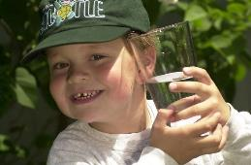
"Boy with glass of water, 2000" by Seattle Municipal Archives is licensed under CC BY 2.0
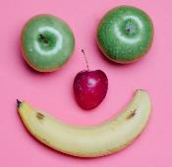
"Photo by Any Lane from Pexels”
Photo by Andrea Piacquadio from Pexels
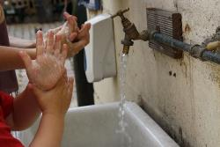
"Washing hands" by magnusfranklin is licensed under CC BY-NC 2.0

Tigers
Learning goal: Children gain meaning from a factual text and respond through the creative arts.
Join Big Ted on a zoo adventure. You can access his adventure via this QR code. If you can’t watch it, you can start at step 2.
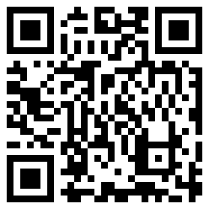
- What did you learn about tigers?
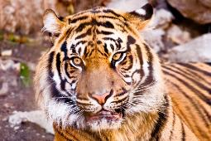
"Tiger" by WSK_2005 is licensed under CC BY-NC 2.0
- Do you have a book at home with a tiger in it? Read it with a family member.
- Choose how you would like to make a tiger. You can draw, paint or use playdough or craft materials.
- Make your tiger, remembering that tigers have striped fur, shining green eyes and a very long tail.
You can watch a video via this QR code if you would like to learn more about tigers.
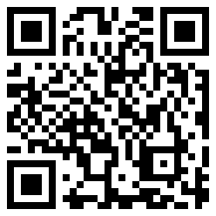

Is this activity too hard?
- Look at pictures of tigers via this QR code. If you can’t open the pictures, can you find any books in your home that have a tiger in them?
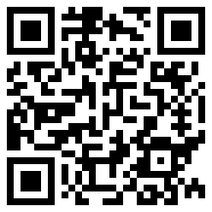
- Roar like a tiger.
- Pretend to be a tiger with a long tail and sharp claws

Is this activity too easy?
- Read ten terrific tiger facts via this QR code.
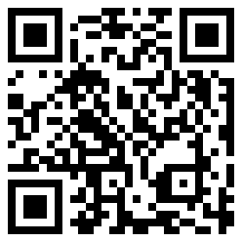
- Tell someone which fact you found most interesting.

Colour mixing
Learning goal: Children make predictions and investigate to complete a challenge.
For this activity you will need some blobs of paint; red, yellow, blue and white. You will also need something to mix your paint on, like a plastic lid or plate.
- Mix a little bit of blue and red together with your brush. What new colour did you create?
- How can you make green? Have a try. Were you successful? What colours did you use?
- Now try and make light blue.
- What colour do you think you will make if you mix yellow and red together? Have a try and see.
- After all your work, have fun painting a picture.
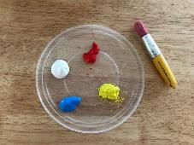
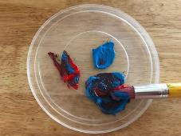

Is this activity too hard?
- On a tray or bench, mix shaving cream and one colour of paint together with your hands.
- Try adding different colours and watch the changes. Food colour is great for this.

Is this activity too easy?
- How many different shades of blue can you create?
- How many different shades of green can you create?

Extra learning activities
Open the video ‘Where in the world?’ via the QR code below to learn about the lives of children living in different countries. If you can’t access the video, you can try the suggestion below.
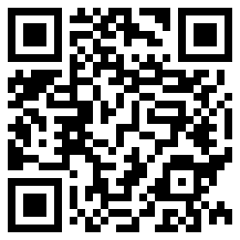
One of the stories in this video talks about a child in Vietnam who cooks her Mum’s favourite lunch with her Granddad. Can you talk to someone in your family about making a favourite lunch for someone?
© State of New South Wales (Department of Education), 2021
The copyright material published in this document is subject to the Copyright Act 1968 (Cth) and is owned by the NSW Department of Education or, where indicated, by a party other than the NSW Department of Education.
Copyright material available in this document is licensed under a Creative Commons Attribution 4.0 International (CC BY 4.0) licence.
See https://education.nsw.gov.au/about-us/copyright for further details.

