This booklet belongs to:

Week E – Thursday

Day at a glance:
Thursday | Handwashing | Helping at home | Keepy uppy | Shared story | Building with spaghetti
Estimated time | 5-10 mins | 15-20 mins | 10 mins | 15-20 mins | 20-25mins
Resources required | None | None | Pair of socks | Something to draw with and on | Playdough, spaghetti, something to draw with and on

Hands washing
Learning goal: Children have good hygiene habits
How do we look after ourselves?
- Have you been remembering to wash your hands before you eat?
- What about after using the toilet?
- What about after patting animals?
- Have you been remembering to wash your hands after blowing your nose or sneezing?
Listen to the three hand washing songs via the QR codes. Watch your favourite or watch them all. If you can’t watch them, you could ask someone in your home to help you make up a song or try singing the song below the QR codes.
If you like Little J and Big Cuz, listen to this first song.
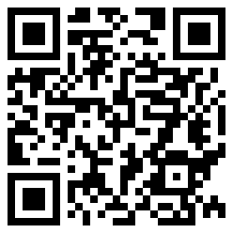
If you like Play School, listen to this second song.
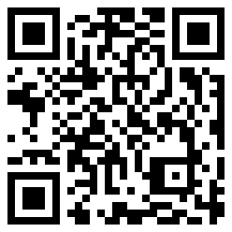
Finally, choose this third song to view a hand washing song in Auslan.
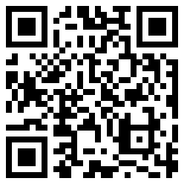

The Handwashing Song
Squirt some soap and rub it in,
Don’t forget to count to ten,
1, 2, 3, 4, 5, 6, 7, 8, 9, 10 is it,
Now the soap has done the trick,
Wash your hands and you won’t get sick.

Helping at home
Learning goal: Children contribute to their family by helping to look after the home.
Pick one of these jobs to do at home to help your family:
- when the washing is dry, match the sock pairs together
- help make a meal
- pack your toys away
- help in the garden by watering the plants, raking leaves or pulling out weeds
- feed your pet or refill their water bowl
- sweep your verandah or a path outside
- put bottles, tins or cardboard in the recycling bin.
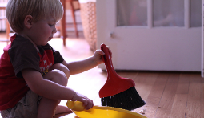
Image by theloushe is licensed under CC BY-NC-ND 2.0

Keepy uppy
Learning goal: Children develop eye hand coordination.
Follow the video instructions for hitting bundled socks in the air via the QR code. If you can’t watch the video, you can use a pair of socks bundled tight and hit them in the air using one hand at a time.
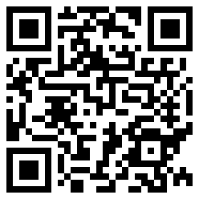
- Can you count how long you keep the socks in the air without dropping them?

Is this activity too hard?
- Attach the socks to a string or rope and hang them from a tree or washing line. Hit the socks to keep them in the air as long as you can.
- Use a balloon hanging on a string instead of socks.

Is this activity too easy?
- Instead of the socks, keep a balloon in the air for as long as you can.
- Challenge someone in your family to see who can hit the socks or balloon the most times. Count out loud each time you hit them.

Take a break
Here are some things you might like to do:
- have a drink of water and a healthy snack
- play or have a rest
- go to the toilet and wash your hands.
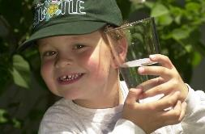
"Boy with glass of water, 2000" by Seattle Municipal Archives is licensed under CC BY 2.0
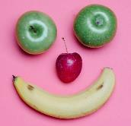
" Photo by Any Lane from Pexels
Photo by Andrea Piacquadio from Pexels
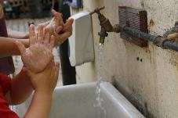
"Washing hands" by magnusfranklin is licensed under CC BY-NC 2.0

Shared story
Learning goal: Children demonstrate their understanding of a text through drama.
Listen to the story 'The very hungry caterpillar' by Eric Carle via the QR code. If you can’t listen to the story, you can start at step 2.
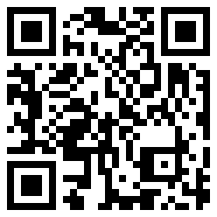
- Pretend you are the very hungry caterpillar:
  - pop out of an egg
  - eat all the food, growing bigger as you do so
  - go to sleep at night with a stomach ache
  - wake up
  - eat through one nice, green leaf
  - turn into a cocoon
  - have a sleep in your cocoon
  - emerge from your cocoon as a beautiful butterfly.

- Draw some caterpillars munching through a leaf. You can also draw a beautifully coloured butterfly.
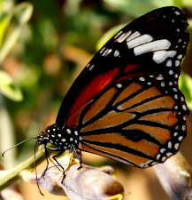
"Monarch Butterfly" by Sudhamshu is licensed under CC BY 2.0

Is this activity too hard?
- Make a caterpillar with your hands. Make the caterpillar wriggle.
- Make a butterfly with your hands. Make the butterfly fly.
- Ask someone to demonstrate hand movements to copy.

Is this activity too easy?
- Draw what the caterpillar ate (you might need to listen to the story again to help you remember). Make sure you draw the right number of each food.
- Write the number under the drawings of each foods.
- Draw the life cycle of a butterfly.

Building with spaghetti
Learning goal: Children develop skills of investigation and experimentation.
You can watch the activity video via the QR code. If you can’t watch the video, you can start at step 1.
- Look at the picture below from the video.
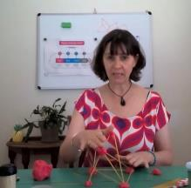
- Sketch some ideas of buildings you would like to build.
- Make a building using playdough and raw spaghetti, like in the photo.
- If your building doesn't stand up, you will need to try something different.

Is this activity too hard?
- Build using a different material such as paddle pop sticks or Duplo.
- Use some natural materials in the garden to build.

Is this activity too easy?
After you have built a building that stands up by itself, extend it so it is higher or wider.

Extra learning activities
If you have the book ‘Handa’s surprise’ at home, predict what the story is about from the cover. If not, you can use the QR code to watch the story together
‘ 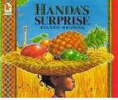
Text: Browne, E. 1995, Handa’s surprise, Walker, London.
If you can’t listen to the story, here is an activity you could try that is related to the story:
- Make a fruit salad. Use a mix of familiar fruits, and if possible, some unusual fruits your child/children might not have tried, such as starfruit, dragon fruit, persimmon, longan, rambutan or guava.
- Encourage your child/children to use their senses to observe the fruit when it is whole – its colour, size, shape, skin texture, hardness/softness and smell.
© State of New South Wales (Department of Education), 2021
The copyright material published in this document is subject to the Copyright Act 1968 (Cth) and is owned by the NSW Department of Education or, where indicated, by a party other than the NSW Department of Education.
Copyright material available in this document is licensed under a Creative Commons Attribution 4.0 International (CC BY 4.0) licence.
See https://education.nsw.gov.au/about-us/copyright for further details.

