This booklet belongs to:

Week E – Friday

Day at a glance:
Friday | Tiddalick | Spider webs | Wombat wobble | Sand castle | Tell a story
Estimated time | 10-15 mins | 25-30 mins | 5-10 mins | 25-30 mins | 15-20 mins
Resources required | None | 3 or 4 sticks, wool | None | Something to draw with and on | A soft toy

Tiddalick the Frog
Learning goal: Children begin to understand the concept of fairness.
Listen to the Aboriginal dreaming story of 'Tiddalick the Frog' via the QR code. If you can’t listen to the story, you can start at step 2.
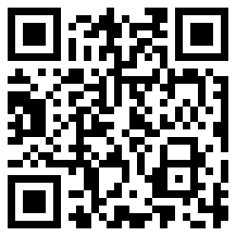
- Answer these questions about the story:
  - Why were the animals upset with Tiddalick?
  - Was it fair that Tiddalick drank all the water?
  - How could Tiddalick have been fairer?

- In the story, Tiddalik the frog is so thirsty that he drinks all the water in the streams, then the rivers and finally the billabongs. The other animals - Kookaburra, Koala, Dingo, Emu and Kangaroo - have no water to drink and don't know what to do. They are upset with Tiddalik, so they come together to make up a plan. After many different ideas, they finally tickle him and he laughs so hard that all the water comes spurting back out of his belly and refills all the streams, rivers and billabongs.
  - Can you draw Tiddalick the frog, with a big belly full of water?
  - Can you draw some of the animals with an upset face?

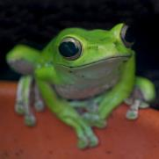
"Happy Green frog" by @Doug88888 is licensed under CC BY-NC-SA 2.0

Is this activity too hard?
- Pretend to be a frog.
- Pretend you are Tiddalick drinking all the water.
- Now pretend to be the other animals who are upset. Make a sad face.
- What other faces can you make? Try happy, surprised and angry.

Is this activity too easy?
- Talk with someone about other situations which are unfair.
- Use animal puppets to retell the story of Tiddalick the frog.
- What could you do in an unfair situation?

Spider web
Learning goal: Children manipulate materials to represent a spider's web
Have you ever seen a spider's web? What did it look like? Watch a spider weave a web via the QR code. If you can’t watch the videos, start at step 2.
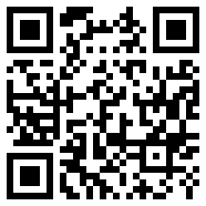
- Watch this video to learn how to make a spider web via this QR code.
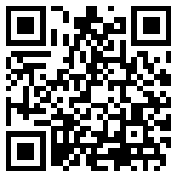
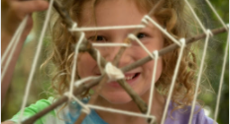
Still from Video attribution: ABC iView. 'Go Wild For Maths: Web Challenge'.
- Find a spider web outside to look at. Always remember not to touch them.
- Follow these instructions to make a spider's web.
You will need:
- 3-4 sticks or paddle pop sticks
- string or wool.
What to do:
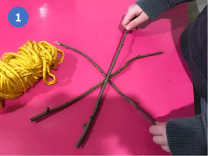
1. Lay the sticks across one another.
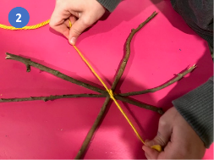
2. Tie the sticks together in the middle and wind the wool around a few times.
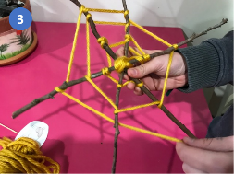
3. Going round and round, weave your string or wool around each stick.
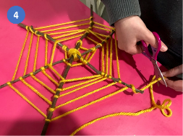
4. When you are finished, cut the string and tie a knot.

Is this activity too hard?
- Use only two sticks.
- Sing Incy Wincy Spider using your hands.
- Spread shaving cream on a table and use your finger to make a spider web pattern. Or use a sand tray.
- Go outside with someone and look for spider webs. Remember not to touch.

Is this activity too easy?
- Use more sticks to create a more complex web.
- Use different coloured wool to create a 'patterned' spider web.
- Make a spider to place on your web.

Wombat wobble
Learning goal: Children perform movement patterns.
Watch the video of Wombat Wobble via this QR code, and follow the actions.
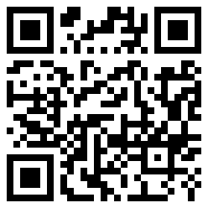
If you can’t watch the video, play a favourite song and do some animal actions:
- jump like a kangaroo
- fly like a cockatoo
- wobble like a wombat.

Is this activity too hard?
- Use your hands only to do the actions.
- Move around as you listen to the song.

Is this activity too easy?

Create movements for these animals:
- dolphin
- kitty cat
- flying fox
- lizard

Take a break
Here are some things you might like to do:
- have a drink of water and a healthy snack
- play or have a rest
- go to the toilet and wash your hands.
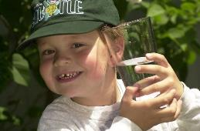
"Boy with glass of water, 2000" by Seattle Municipal Archives is licensed under CC BY 2.0
"Photo by Any Lane from Pexels
Photo by Andrea Piacquadio from Pexels
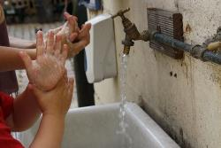
"Washing hands" by magnusfranklin is licensed under CC BY-NC 2.0

Sandcastle
Learning goal: Children describe what they can see.
Have you ever made a sandcastle? Look carefully at this photo of a sandcastle.

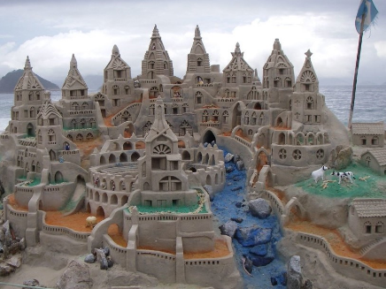
"Another Sand Castle" by NomadicEntrepreneur is licensed under CC BY-NC 2.0
- Talk to someone about what you can see:
  - What shapes can you see?
  - Where can you see curving lines?
  - Where can you see straight lines?
  - Which part of the castle do you like best?
  - Did you notice anything else about the castle?
  - What's a question would you like to ask the person who made this castle?
- Draw or make your own castle. You might choose to make your castle out of playdough, blocks, Lego, Duplo or craft materials.

Is this activity too hard?
- Use playdough or kinetic sand on a small tray.

Is this activity too easy?
- Plan your castle with a list of items and a drawing.
- Make some puppets for your castle. Think about who would live in the castle and what they would do.
- Make a story up about your castle.

Tell a story
Learning goal: Children use their imagination and creativity to tell a story.
"Teddy Bear Photoshoot 13" by longzijun is licensed under CC BY-NC 2.0
- Find your favourite soft toy.
- Set him or her up in different places or scenes, for example, going for a walk outside or playing with blocks.
- Ask someone to help you take a photo of your toy in each place or scene.
- Looking at each of the photos, tell a story about your toy. For example, 'One day Teddy got up and ate her breakfast. Then she decided to go for a play outside.'
- If you have a printer, print the photos. Cut them out and glue them down to make a small booklet. Ask someone to write down the words of your story. If you don’t a printer, you could draw your story instead.

Is this activity too hard?
- Ask someone to tell you a story about teddy bears.
- Set up a teddy bears picnic.

Is this activity too easy?
- Try the same activity with other toys.
- Tell a story about a family adventure.

Extra learning activities
Practice counting and learn about two dimensional shapes.
Open the “Numberblocks” activities via this QR code here. If you can’t access the QR code, you can do the activity below.
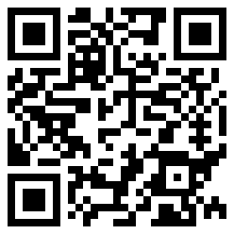
- How many shapes can you find that have four sides and four corners?
- How many shapes can you find that have three sides and three corners?
- Draw pictures of your discovery. Count the sides and the corners.
© State of New South Wales (Department of Education), 2021
The copyright material published in this document is subject to the Copyright Act 1968 (Cth) and is owned by the NSW Department of Education or, where indicated, by a party other than the NSW Department of Education.
Copyright material available in this document is licensed under a Creative Commons Attribution 4.0 International (CC BY 4.0) licence.
See https://education.nsw.gov.au/about-us/copyright for further details.

