This booklet belongs to:

Week D– Wednesday

Day at a glance:
Wednesday | Feelings | Growing carrots | Healthy snacks | Penguins | Scavenger hunt
Estimated time | 15-20 mins | 15-20 mins | 15-20 mins | 20-25 mins | 20-25 mins
Resources required | Something to draw with and on | Carrot tops, saucer | Something to draw with and on | none | none

Feelings
Learning goal: Children recognise their own feelings and develop coping strategies.
Listen to the story Let’s Go, Little Roo via this QR code. If you can’t listen to the story, you can do step 2.
- Little Roo is afraid of new and different places.
- Talk with someone about what makes you afraid. What do you do when you feel afraid? What helps you feel less afraid? Tell your family how they can help you when you feel afraid.
- At the end of the story Little Roo didn’t want to go home from the park. Draw what you think Little Roo and Wallaby might do together at the park.

Is this activity too hard?
- Do any of these things makes you feel afraid:
  - going to new places?
  - the dark?
  - dogs?
  - loud noises?

Is this activity too easy?
- Tell someone all the things you can do to help you feel better when you are afraid.
- Ask them to write the things down in a list.

Growing carrots
Learning goal: Children investigate their world and make predictions.
How to grow carrots:
- Cut the ends off some carrots.
- Place the carrot tops on a plate.
- Pour a small amount of water onto the plate.
- Put your plate somewhere where it will get sunlight.
- Add more water to the plate if it dries out.
- Watch and wait to see what will happen to the carrot tops.
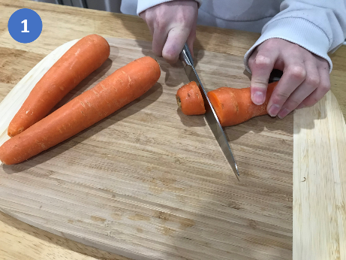
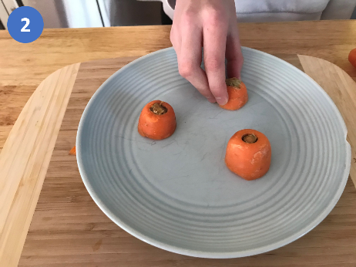
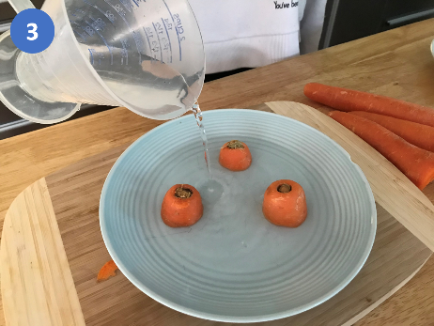
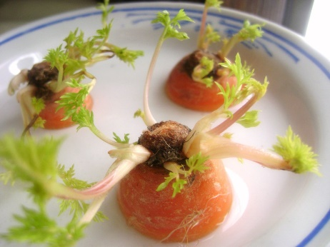
"Sprouted Carrot Tops" by wisdomlight is licensed under CC BY 2.0
Make some predictions:
- What do you think will happen to your carrot tops?
- How long do you think this will take?
- Why do you think it is important to keep water in the plate?

Is this activity too hard?
- Find some plants that need to be watered and water them.

Is this activity too easy?
- Try growing potatoes:
- Keep an old potato somewhere out of the sun.
- Wait for the potato to grow a "sprout".
- Dig a hole in soil and place the potato in it, with the sprout facing upwards.
- Cover the potato in soil.
- Water the potato.
- Wait for the potato to grow.
Try growing cress:
- Spread tissues out on a plate or tray.
- Pour water over the tissues to dampen them.
- Sprinkle cress seeds over the tissues.
- Put the seeds in a sunny spot.
- Keep the tissues damp.
- After the seeds have grown, cut the shoots off and eat them in a salad or healthy sandwich.

Healthy snacks
Learning goal: Children understand that eating healthy foods helps them stay healthy.
- Look at the pictures below of healthy snacks. These foods all keep your body strong and healthy.
- Say the name of each of the foods. Which do you like to eat?
- Draw the healthy snacks you eat.
- Ask someone to write the name of each of the foods on your drawing.
- Ask someone in your family what their favourite healthy snack is.
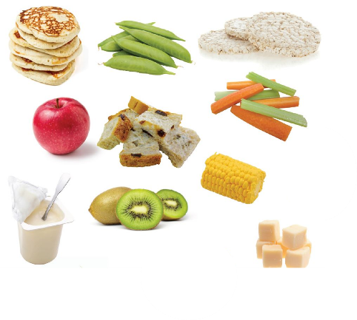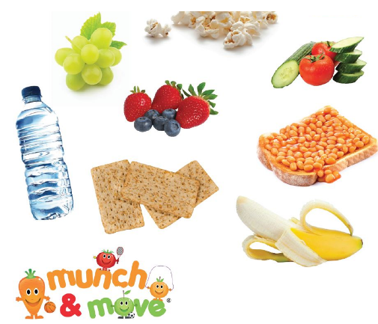
Image developed & designed by Health Promotion Service, Western Sydney Local Health District. 'Healthy lunchbox snacks'
Families can access a fact sheet via this QR code. It has information about choosing healthy snacks:

Is this activity too hard?
- Ask someone in your home to help you choose a healthy snack to eat.

Is this activity too easy?
- Use a tally to record how many healthy snacks you eat this week.

Take a break
Here are some things you might like to do:
- have a drink of water and a healthy snack
- play or have a rest
- go to the toilet and wash your hands.
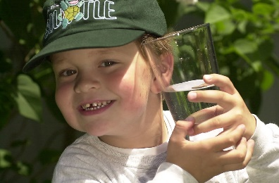
"Boy with glass of water, 2000" by Seattle Municipal Archives is licensed under CC BY 2.0
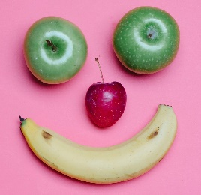
Photo by Any Lane from Pexels
Photo by Andrea Piacquadio from Pexels
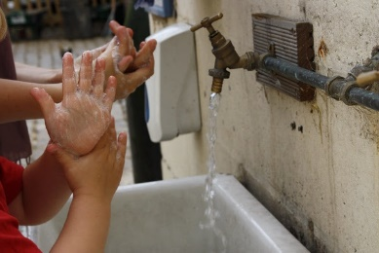
"Washing hands" by magnusfranklin is licensed under CC BY-NC 2.0

Penguins
Learning goal: Children engage with factual texts, responding through comment and questions and develop respect for the environment.
Watch this video about the Gentoo penguin via this QR code. If you can’t watch the video, you can look at the picture below of Gentoo penguins.
- What did you learn about the gentoo penguin?
  - (They live on islands. They live in big colonies. They build nests. They go fishing. They are the fastest penguins underwater. Both parents look after the chicks.)
- If you are interested, there are two more videos about penguins that you can access via these QR codes.:
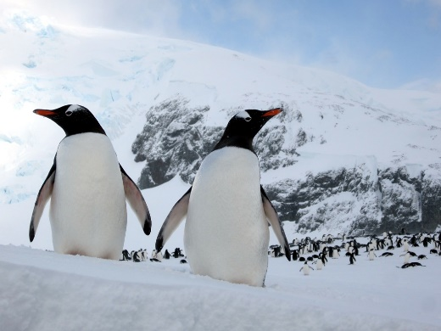
"Gentoo Penguins" by D-Stanley is licensed under CC BY 2.0
- What colours can you see on the Gentoo penguins?
- Where do you think they might live?

Is this activity too hard?
- Enjoy the video and then draw a picture of a penguin swimming in the ocean.

Is this activity too easy?
- Do you have any questions about penguins? If so, ask someone in your family to help you research on their phone or computer.

Scavenger hunt
Learning goal: Children describe key numeracy concepts.
- Have a look around your home or outside to find:
  - something heavy
  - something light
  - two things of an equal weight (hold an object in each hand to test if they are of equal weight).
- This time, find:
  - something long
  - something short
  - two things of an equal length (place the two things side by side to compare their length).
- Tell someone about what you have found.
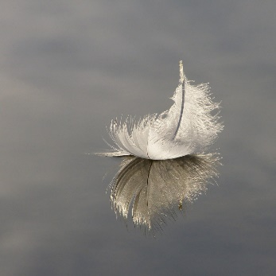
"Feather 1" by treehouse1977 is licensed under CC BY-SA 2.0
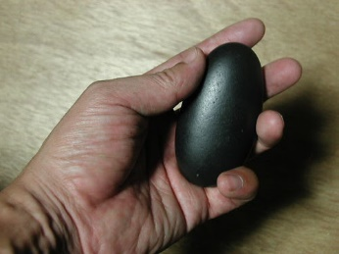
"holding stone" by tamaki is licensed under CC BY-NC-ND 2.0

Is this activity too hard?
- Make two playdough balls that are the same size.

Is this activity too easy?
- Put 3-4 things in order from the lightest to the heaviest.
- Put 3-4 things in order from the shortest to the longest.
- Find something that is both big and light.
- Find something that is both small and long.

Extra learning activities
- Open ‘Art with Mati and Dada- Rembrandt’ via this QR code, if you can’t access the QR code go to step 2
- Here are some sketches below from the video by the artist called Rembrandt.
- What do you notice about the artworks?
  - What words can you use to describe the man’s facial expressions, for example ‘happy’ or ‘disappointed’?
  - Talk to someone about your idea.
- Can you create a self-portrait of your own? Look in the mirror and draw your face.
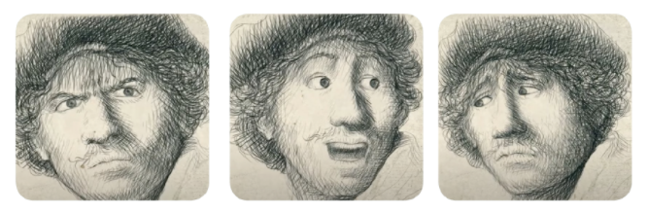
© State of New South Wales (Department of Education), 2021
The copyright material published in this document is subject to the Copyright Act 1968 (Cth) and is owned by the NSW Department of Education or, where indicated, by a party other than the NSW Department of Education.
Copyright material available in this document is licensed under a Creative Commons Attribution 4.0 International (CC BY 4.0) licence.
See https://education.nsw.gov.au/about-us/copyright for further details.

