This booklet belongs to:

Week C– Wednesday

Day at a glance:
Wednesday | Name writing | Overarm throw | Singing | Halves | Helping your family
Estimated time | 15-20 mins | 20-25 mins | 20-25 mins | 15-20 mins | 10-15 mins
Resources required | Something to write with | A small ball | Someone to sing with | Sandwich items, safe knife | None

Mindfulness
Learning goal: Children mindfully connect to nature and are mindful of their environment.
- Sit with your legs crossed.
- Close your eyes and stay very still.
- Listen carefully:
  - What can you hear? How many different things can you hear?
  - Stay still and listen as long as you can.
- Now go outside or close to a window.
- Close your eyes, sit very still and listen again:
  - What sounds can you hear in the environment? Can you hear any sounds of nature?

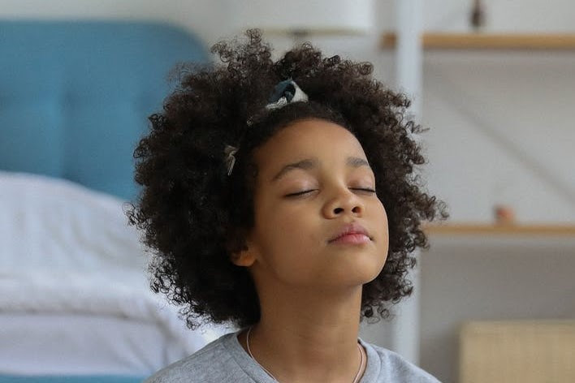
pexels.com by Monstera
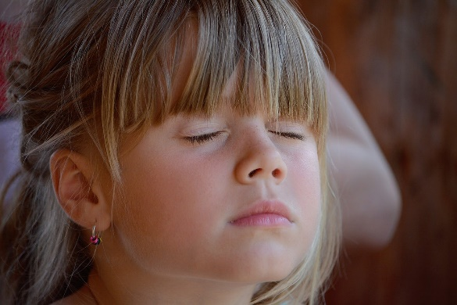 CC0 Public Domain maxpixel.net

Is this activity too hard?
- Sit still, close your eyes and count ten breaths.

Is this activity too easy?
- As you sit, also notice what you can feel and smell.

Name writing
Learning goal: Children use approximations of letters and words to convey meaning.
- Have a look around your home. Where can you find your name?
- Ask someone to write your name in large letters.
- Trace over your name a number of times using different colours.
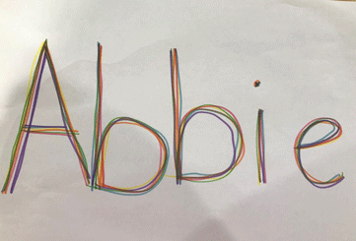
- Which letter does your name start with? Make the letter your name starts with, using playdough or small stones.

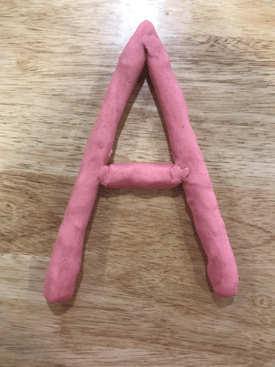
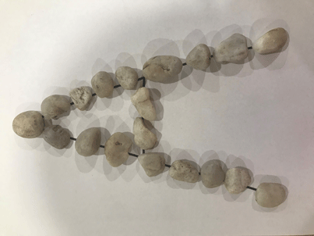

Look around you, what things can you see that start with the same letter as your name? For example, Sam starts with 'S'. Sun and smile also start with 's'.

Is this activity too hard?
- Ask someone to write your name in very large letters. Trace over each letter with your finger.
- Place small objects over the first letter of your name.
- Make the first letter of your name using play dough.

Is this activity too easy?
- Write your name by yourself. Write your surname also.
- Write the names of people in your family.
- Say funny things using the first sound of your name. For example, Sam smiles at the sun, Jasmine jumps on jelly.

Overarm throw
Learning goal: Children develop the fundamental movement skill of overarm throwing.
Watch the video to learn how to do an overarm throw. You can watch the video via this QR code.
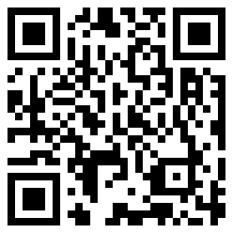
Video attribution: NSW Health (14 June 2017), 'Overarm throw - Munch & Move' [video]. NSW Health Channel, YouTube, accessed 30 August 2021
If you can’t watch the video, ask someone in your home to help practise throwing overarm and follow along with the steps below:
- Choose a target, such as a mark on a tree something hanging from a clothesline or ask someone in your home to help you make a safe target indoors.
- Stand back from the target.
- Throw your ball or socks at the target using an overarm throw.

Is this activity too easy?
- Use a larger target.
- Stand closer to the target.

Is this activity too easy?
- Stand further away from the target.
- Throw using your other arm.
- How many times can you hit the target out of ten throws?

Take a break
Here are some things you might like to do:
- have a drink of water and a healthy snack
- play or have a rest
- go to the toilet and wash your hands.
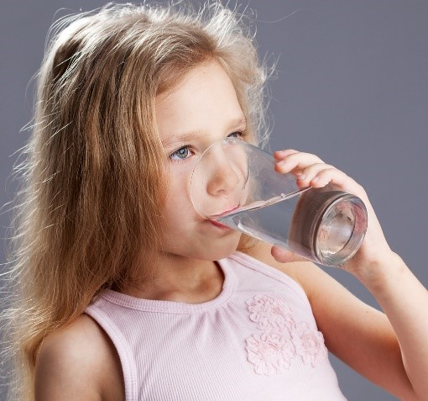
“Child drinking water from glass" by aqua.mech is licensed under CC BY 2.0

Singing
Learning goal: Children sing songs.
- Watch the video of Julia singing, 'Little Miss Muffet'. You can access the video via this QR code:
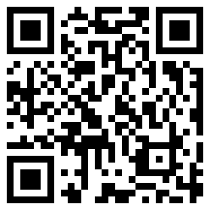
- Follow Julia's instructions to crawl like a spider.
- Follow Julia's instructions to tap the beat.
If you can’t watch the video of Julia singing Little Miss Muffet, ask someone in your home if they can sing a nursery rhyme with you.

Is this activity too easy?
- Simply listen to the song and enjoy!

Is this activity too easy?
- Sing 'Little Miss Muffet' without any help.
- Listen to the song again. What rhyming words did you hear?

Halves
Learning goal: Children develop an understanding of fractions through play.
Make a sandwich with help from someone in your home.
- Cut the whole sandwich into two halves.
  - Check if the two halves are equal.
  - Is there a different way you could have cut your sandwich into two halves?
- With help from someone, try cutting other things in half, for example, a playdough snake or a piece of fruit.

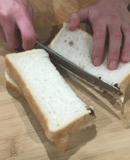
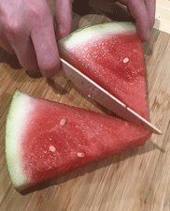
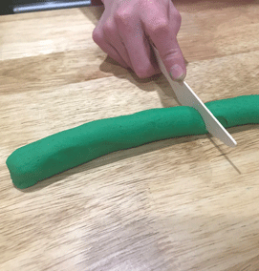

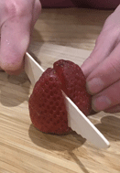

- Now try dividing a collection of objects in half. You could use collections of things like small toys, pegs or paper clips.
  - How did you divide the collection in half? Were any things left over?
  - Is each half equal? How do you know?

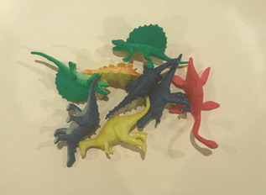
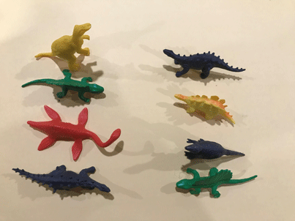

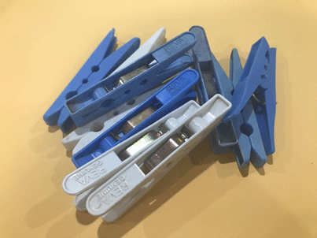
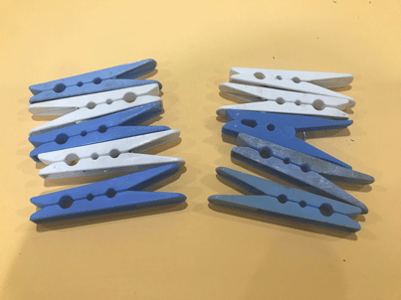

- If you want to learn more about halves, watch the video, ‘Who's got the biggest half?’ You can watch the video via this QR code.
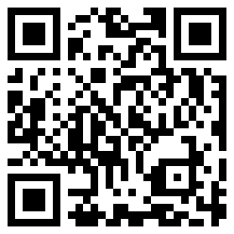
- If you can’t watch the video, you can practise cutting playdough in half.

Is this activity too easy?
- Make different playdough shapes, use a knife to cut each in half.

Is this activity too easy?
- Cut things into four equal parts, these are called quarters.
- Divide collections of objects into four equal groups.

Helping your family
Learning goal: Children respect and care for natural and constructed environments.
- Pick one of these jobs to do to help your family:
  - when the washing is dry, match the sock pairs together
  - help make a meal
  - pack your toys away
  - help in the garden by watering the plants, raking leaves or pulling out weeds
  - feed your pet or refill their water bowl
  - sweep your verandah or a path outside
  - put bottles, tins or cardboard in the recycling bin.
- Talk to someone in your home about how you helped, and what you did.
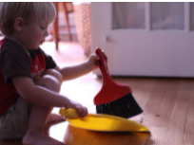
Image by theloushe is licensed under CC BY-NC-ND 2.0
You might find other ideas from the everyday routine cards on the department’s Resources for families page.
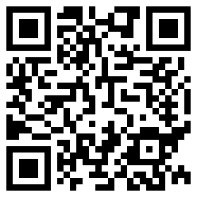

Extra learning activities

Have fun with these ABC Kids games.
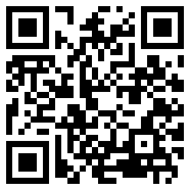
Other fun activities include:
- Ask someone in your home to help you find some sheets or towels to create a cubby house, inside or out. What will you choose to take into your cubby house? Will you take books?
- Can you see your shadow on the ground? What happens when you move? Does your shadow move with you?
© State of New South Wales (Department of Education), 2021
The copyright material published in this document is subject to the Copyright Act 1968 (Cth) and is owned by the NSW Department of Education or, where indicated, by a party other than the NSW Department of Education.
Copyright material available in this document is licensed under a Creative Commons Attribution 4.0 International (CC BY 4.0) licence.
See https://education.nsw.gov.au/about-us/copyright for further details.
