This booklet belongs to:

Week C– Tuesday

Day at a glance:
 | Skipping | Drama | Count and build | Science
Estimated time | 25-30 mins | 15-20 mins | 20-25 mins | 20-25 mins
Resources required | A red and green card or object | Mirror | Dice, Lego or blocks | Container, sand, small objects

Acknowledgement of Country
Learning goal: Children develop a deeper understanding of Aboriginal culture.
- Watch this video of Play School. You can access it via this QR code. If you can’t watch the video, then start at step 2.
In it, Luke, Miranda and Hunter give an Acknowledgement of Country celebrating Australia’s First Peoples.
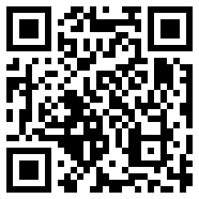
- Do you know how to say 'hello' in an Aboriginal language?
- Learn how to say 'hello' in Dharug in this Dharug language lesson. Watch it via this QR code. If you can’t watch the video, you can see it written below.
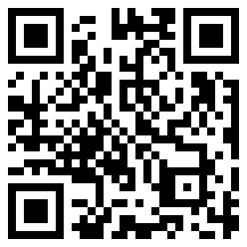
Hello in Dharug: ‘Warami’. It is pronounced: wor-ra-mee

Shared story
Learning goal: Children listen to and respond to rhyme in context.
- You can listen to the story via this QR code. If you can’t listen to the story, you can start at step 3.
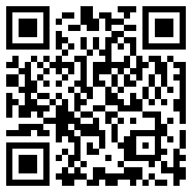
Video attribution: Penguin Books Australia (6 July 2020), 'Hairy Maclary from Donaldson's Dairy by Lynley Dodd | Read Aloud by Morris Gleitzman' [video]. YouTube, accessed 29 August 2021
- Listen out for the rhyming words in the story. Rhyming words end the same, for example:
- Maclary and dairy
- morse and horse
- pots and spots.
- Ask someone to read you this poem:
I have ten little fingers and ten little toes.
Two little arms and one little nose.
One little mouth and two little ears.
Two little eyes for smiles for tears.
One little head and two little feet.
One little chin and that's me complete.
- Say and point to the words which rhyme. Remember, rhyming words end the same.
Is this activity too hard?
Ask someone to listen to the story with you.
Listen for the rhyming words together.
Is this activity too easy?
Think of pairs of words which rhyme, for example, bat and hat; mug and bug; ham and Sam. How many pairs can you think of?
From now on, whenever you hear a story, keep an ear out and listen for rhyming words.

Skipping
Learning goal: Children develop the fundamental movement skill of skipping.
- Watch this video which explains how to skip. Have a try! If you can’t watch this video, you can start at step 3.
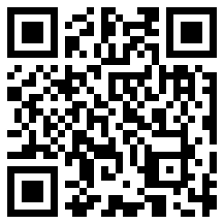
Video attribution: NSW Health (14 June 2017), 'Skip - Munch & Move' [video]. NSW Health Channel, YouTube, accessed 29 August 2021
- If you have someone to play with, play a skipping game of, 'Red light, green light'. Watch the video to learn how to play via this QR code. If you can’t watch the video, follow the steps below.
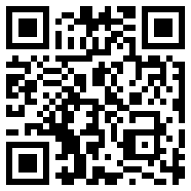
Video attribution: NSW Health (14 June 2017), 'Skip red light green light - Munch & Move' [video]. NSW Health Channel, YouTube, accessed 29 August 2021.
- How to play ‘Red light, green light’:
- One person is the traffic controller. They hold two cards (or objects), one red and one green.
- Everyone else stands back behind a marker.
- When the traffic controller shows the green card, everyone else skips towards them.
- When the traffic controller shows the red card, everyone must freeze.
- The first person to touch the traffic controller becomes the new controller and the game starts again.
Is this activity too hard?
- Instead of using the red and green signal, use the voice signals of 'stop' and 'go'.
- Instead of skipping, everyone walks or runs towards the traffic controller.
Is this activity too easy?
- As the traffic controller shows the green signal, they call out how everyone must move towards them, for example, crawl, tip-toe, two-footed jump.
- If anyone moves after the controller has called out 'freeze', they must go back to the beginning.

Take a break
Here are some things you might like to do:
- have a drink of water and a healthy snack
- play or have a rest
- go to the toilet and wash your hands.
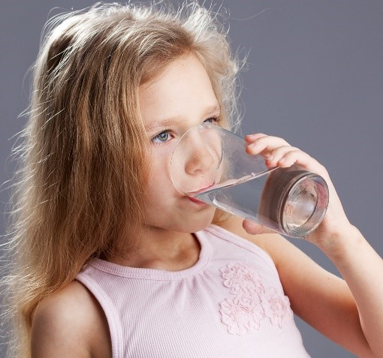
“Child drinking water from glass" by aqua.mech is licensed under CC BY 2.0

Drama
Learning goal: Children use drama to express themselves and make meaning
- Watch the video, Charlotte will show you how to play emotional mirrors, action mirrors and do this/do that. You can watch this video via this QR code. If you can’t watch the video, you can start at step 3.
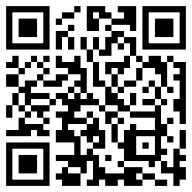
- Follow along with Charlotte and have a go.
- Practice in front of a mirror, look at your reflection. It’s the same looking back, no matter what your actions are.
- With someone in your house, pretend to be a mirror and copy each other’s actions. Take turns at doing and copying the actions.

Count and build
Learning goal: Children explore mathematical concepts of counting and measurement.
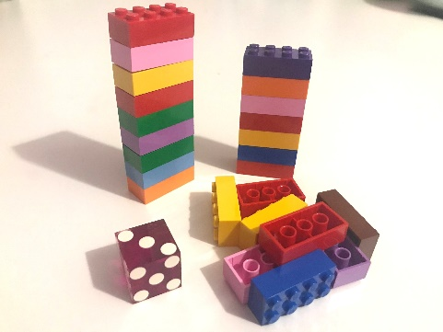
Play a game of Count and build following the steps below:
- Each person takes a turn to:
- roll the dice
- count the dots on the dice
- count out that many pieces of Lego, Duplo or blocks
- start building a tower with those pieces of Lego, Duplo or blocks.
- Continue taking it in turns rolling the dice, counting and then adding that many blocks onto your tower.
- After both people have rolled the dice five times, measure whose tower is the tallest. The person with the tallest tower is the winner.
Is this activity too hard?
- Ask someone in your family to help you count the dots.
Is this activity too easy?
- Rather than just one dice, roll two or three dice at the same time
- Include a rule that the tower has to be in a colour pattern.

Science and sensory play
Learning goal: Children use their senses to explore properties of natural and man-made objects.
You will need some other materials to help set up this activity:
- container filled with something, for example, water, sand, small pebbles or rice
- various small objects, for example, containers, spoons, toy cars, animal figurines or stones.
- Run your hands through the container.
- How do the objects feel? What sounds do they make?
- Get some things to play with in the container, for example, small containers, spoons, toy cars, animal figurines or stones.

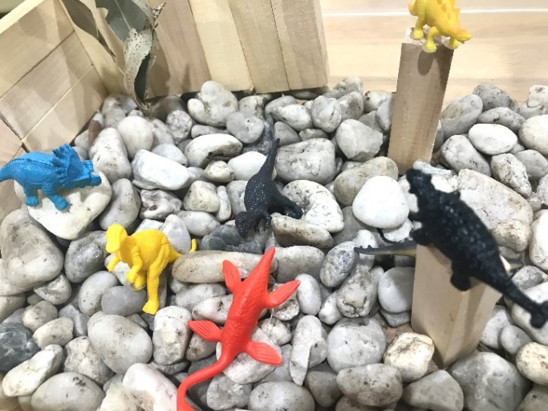
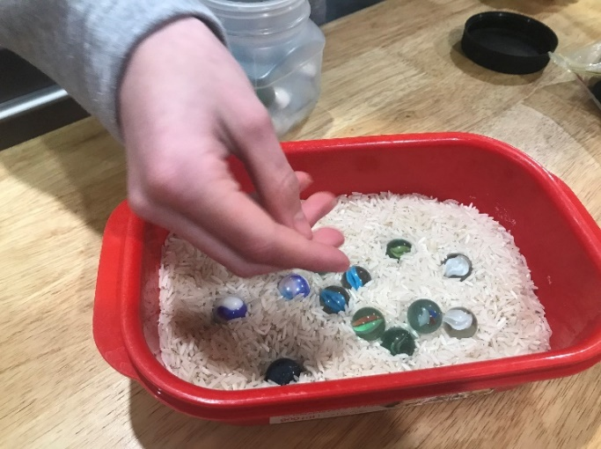

Extra learning activities
You can access extra learning about different ways of connecting with the world via this QR code:
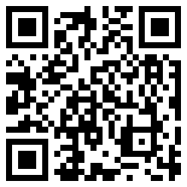
© State of New South Wales (Department of Education), 2021
The copyright material published in this document is subject to the Copyright Act 1968 (Cth) and is owned by the NSW Department of Education or, where indicated, by a party other than the NSW Department of Education.
Copyright material available in this document is licensed under a Creative Commons Attribution 4.0 International (CC BY 4.0) licence.
See https://education.nsw.gov.au/about-us/copyright for further details.
