This booklet belongs to:

Week C – Thursday

Day at a glance:
Thursday | Shared story | Puppet show | Health | Sorting | Science and water play
Estimated time | 15-20 mins | 15-20 mins | 5-10 mins | 15-20 mins | 25-30 mins
Resources required | Draw utensils, paper, ruler | Draw utensils, paper, ruler | Glass of water | Small items to sort and group | Something to make a boat from, water

Family heritage
Learning goal: Children develop strong foundations in both the culture and language/s of their family.
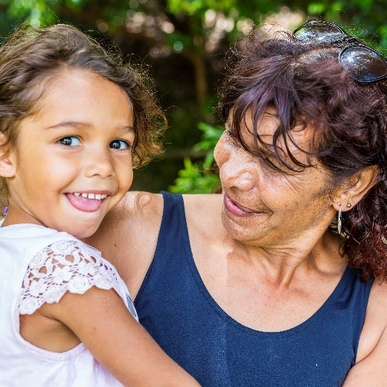
Image owned by the NSW Department of Education under the Copyright Act 1968 (Cth)​
- Talk to a parent, grandparent, aunt or uncle (in person or on the phone).
- Ask them questions to find out about your family, for example:
- Where were you born?
- If you were born overseas, what does this country’s flag look like?
- If you are Aboriginal, what is your Country?
- Where did you grow up?
- What language/s do you speak?
- What are some favourite family foods?
- What games did you play when you were young?

Is this activity too hard?
- Draw your extended family.
- If your family member speaks a language other than English, ask them to sing you a song in that language.

Is this activity too easy?
- Ask your family member to point out locations on a map that are significant to your family.
- If your family member speaks a language other than English, ask them to tell you a story in this language.
- Record the information your family member tells you in a drawing or painting.

Shared story
Learning goal: Children join in the repetitive language of a familiar story.
- Listen to this story of, 'The three Billy Goats Gruff' via this QR code. If you can’t listen, perhaps someone in your home knows this story.
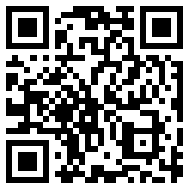
Video attribution: Oxbridgebaby (21 July 2011), 'The Three Billy Goats Gruff - Animated Fairy Tales for Children' [video]. Youtube. Accessed 1 September 2021.
- As you listen, join in saying parts of the story, for example, join the troll to say:
- Who's that tripping over my bridge?
- And where are you going?
- I'm coming to gobble you up!

Is this activity too hard?
- Join in saying, 'trip, trap, trip, trap, trip, trap' or slapping your knees, each time one of the Billy Goats Gruff crosses the bridge.

Is this activity too easy?
- Listen to the story again, joining in saying as much of it as you can.

Puppet show
Learning goal: Children re-enact a well-known story .
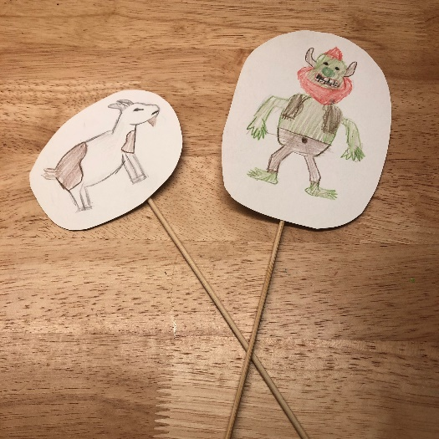
- Ask someone in your home if they know the story ‘Three Billy Goats Gruff’ to tell you. If not, share a story from a book you have at home.
Draw the characters from the 'Three Billy Goats Gruff' story, or your home story.
- Cut each character out and tape it onto something long and thin, such as a chopstick or ruler, to make a puppet.
- Make a bridge out of boxes, duplo or books.
- Retell the story, getting each of your Billy Goats Gruff to cross the bridge.

Is this activity too hard?
- Draw one of the Billy Goats Gruff. Cut it out to make a puppet. Make your goat cross a "river" and say, 'trip, trap, trip, trap, trip, trap'.

Is this activity too easy?
- Paint or draw a backdrop for your puppet show which includes the hill and river.

Take a break
Here are some things you might like to do:
- go to the toilet and wash your hands
- have a drink of water and a healthy snack
- play or have a rest.
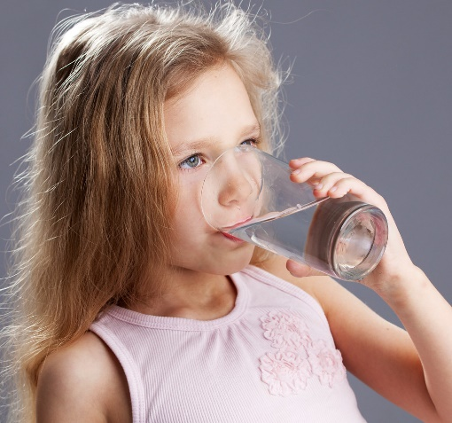
“Child drinking water from glass" by aqua.mech is licensed under CC BY 2.0

Drinking water
Learning goal: Children recognise and choose healthy drinks.
If you are thirsty, you need to have a drink. Water is a good choice as it does not have any added sugar. Water is also important for good health. Our bodies need 4-5 cups of water each day to work properly.
How could you find out how much water you drink each day?
Watch the video via the QR code or ask someone in your home about the healthy amount of water to drink each day.
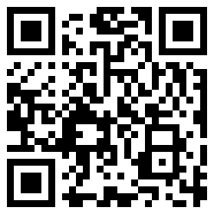
Video attribution: Good for kids (3 March 2020), 'Choose water to drink' [video]. YouTube, accessed 1 September 2021.

Sorting
Learning goal: Children sort, categorise, order and compare collections.
- Watch this video about sorting collections. You can access the video via this QR code. If you can’t watch the video, start at step 2.
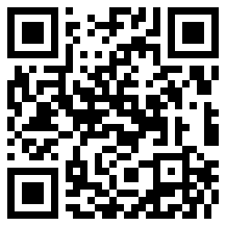
- Find some small toys and sort them into groups (maybe colour or size)
- Tell someone how you have organised your toys.
- Sort all the things you use to draw with. How did you sort your drawing things?

Is this activity too hard?
- Sort your blocks or lego by colour.
- Sort your pencils by length.

Is this activity too easy?
- Sort your books out. If you keep them on a shelf rearrange them into groups on the shelf or into containers. Tell someone how you have sorted your books.

Science and water play
Learning goal: Children use play to investigate and solve problems
- Find something to make a boat that will float. It could be foil from the kitchen, some lego blocks or a stick from outside.
- Test your boat in a container of water or in the bath.
- If your boat didn't float, change it and try again.
- After your boat floats, test how much it can carry before it sinks.
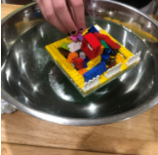
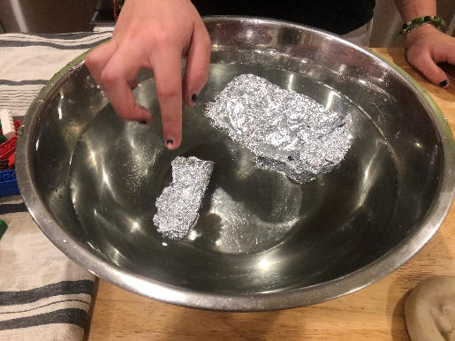

Is this activity too hard?
- Test different objects to see what sinks and what floats.

Is this activity too easy?
- Make a wide boat and a thin boat. Which floats better?
- Make another boat out of a different material.
- How many blocks or small stones can it hold before sinking?

Extra learning activity
Learn about the tropical frogfish by accessing the activity via this QR code:
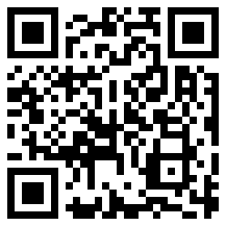

If you can’t access the activity, you can draw some fish that you have seen before. Can you remember? Have you seen fish in a fish tank? Were they brightly coloured?

© State of New South Wales (Department of Education), 2020
The copyright material published in this document is subject to the Copyright Act 1968 (Cth) and is owned by the NSW Department of Education or, where indicated, by a party other than the NSW Department of Education.
Copyright material available in this document is licensed under a Creative Commons Attribution 4.0 International (CC BY 4.0) licence.
See https://education.nsw.gov.au/about-us/copyright for further details.

