This booklet belongs to:

Week C– Monday

Day at a glance:
Monday | Feelings | Birdie and the virus | Dancing | Collage | Shop play
Estimated time | 15-20 mins | 15-20 mins | 25-30 mins | 30- 35 mins | 20 mins - ongoing
Resources required | Something to draw with and on | Hygiene activity (no resources) | Music to listen to if QR code unavailable | Collection of recyclables or craft materials | Coins - either real or toy money

Feelings
Learning goal: Children identify feelings and how they and others respond to those feelings.
- Look at the photos of the children’s faces on the next page.
  - Tell someone your answers to these questions:
  - How do you think each is feeling?
- Why might each child be feeling that way?
- Find something to draw on.
  - On one side, draw something that makes you happy.
  - On the other side, draw something that makes you sad.
  - Tell someone about your picture.
- Join in singing, 'If you're happy and you know it'. You can access the song via this QR code.
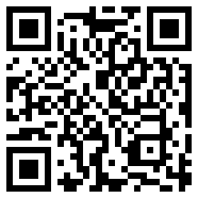
Video attribution: Super simple songs- Kids songs (25 January 2019), 'If you're happy and you know it' [video]. Youtube. Accessed 27 August 2021

Is this activity too hard?
- Try playing with someone in your family, take it in turns making happy and sad faces.
- Try to guess what feeling the other person's face is showing.

Is this activity too easy?
- Try changing the words of, 'If you are happy and you know it' to make a new song about a different feeling.
- Try making your face show you are feeling tired, angry, surprised or confused.

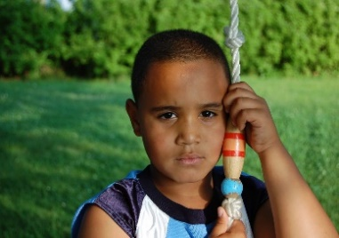
"Sad" by tamckile is licensed under CC BY 2.0
"Innocent Smile" by eizus is licensed under CC BY 2.0
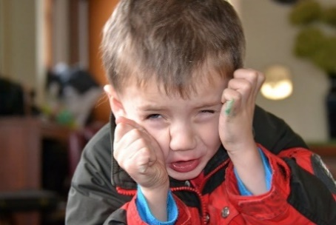
"Sad Face" by Tobyotter is licensed under CC BY 2.0
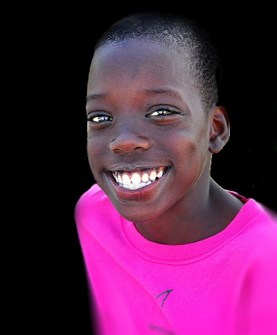
"Peace and Unity for the New Year" by daystar297 is licensed under CC BY-NC 2.0
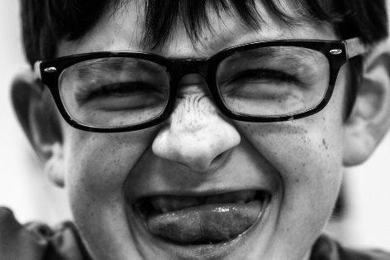
"Junior Nutty Professor" by ksunderman is licensed under CC BY 2.0
"Outdoor portrait of a cute little indian boy" by Nithi clicks is licensed under CC BY 2.0

Birdie and the virus
Learning goal: Children understand personal care and hygiene to keep themselves and others safe.
- Listen to this story about Birdie and the virus. You can listen to the story via this QR code. If you can’t listen to the story, you can start at step 2.
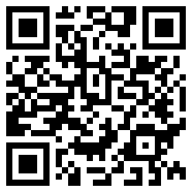
Video attribution: Children's Health Queensland. (2020). 'Birdie and the virus' [video]. Queensland Government.
- The story talks about getting sick and not being able to play with friends. How do you feel when you can't go out and play with your friends?
- Listen to this song to remind you how we can all help stop the spread of disease. You can access the song via this QR code:
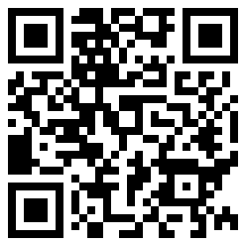
Video attribution: Children's Health Queensland. (2020). 'Birdie and the virus sing along' [video]. Queensland Government.
- Finally, watch Isabella washing her hands. You can access the video via this QR code. If you can’t watch this video, wash your own hands and count to 10.
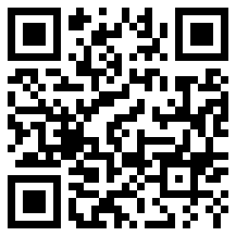

Dancing
Learning goal: Children engage in increasingly complex movement and coordination through dance.
- Listen to ‘I love to move’ via this QR code. If you can’t listen to the song, you can start at step 2 using your own song.
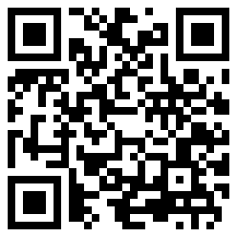
Munch & Move music. 'I love to move' [song]. NSW Government.
- Practice moving in different ways:
  - march
  - slide
  - gallop
  - shake.

Is this activity too hard?
- Try playing the song or your favourite piece of music and have fun moving in any way you want.

Is this activity too easy?
- Try to see how else you can move.
- Try playing your favourite piece of music and make up a dance routine.

Take a break
Here are some things you might like to do:
- go to the toilet and wash your hands
- have a drink of water and a healthy snack
- play or have a rest.
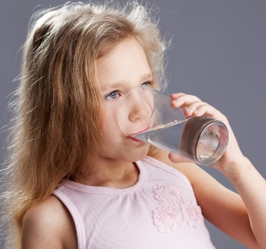
“Child drinking water from glass" by aqua.mech is licensed under CC BY 2.0

Collage
Learning goal: Children use creative arts to express ideas and make meaning.
Some more ideas for this activity:
- a collection of recyclable or craft materials, for example:
  - cardboard or paper
  - scraps of fabric or wool
  - old magazines or shop catalogues
  - wrapping paper or ribbon
  - foam, straws or stickers.
- scissors
- sticky tape or glue
What to do:
- Look at your materials and think about what kind of artwork you could make with them.
- Glue or tape the materials onto the cardboard or paper to create your artwork.
- Tell someone about what you have created and ask them to write down what you say.

Is this activity too hard?
- Ask someone to help you with gluing and taping down the materials.

Is this activity too easy?
- In your artwork, recreate a character or scene from a favourite book or TV show.

Coins
Learning goal: Children develop an understanding of coins through play.
1. Watch the video about Australian notes and coins. You can access the video via this QR code. If you can’t watch the video, start at step 2.
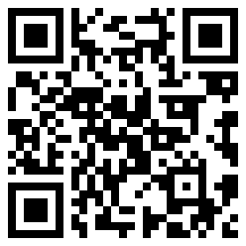
2. Ask someone in your home to help you find each of the Australian coins.
3. Sort the coins into groups. How did you sort them? Try sorting the coins in a different way.
4. Does anyone in your house have coins from a different country? Ask them to tell you the names of these coins.

Is this activity too hard?
- Try matching the coins which are exactly the same together.

Is this activity too easy?
- Try drawing or do a crayon rubbing of each coin to make a picture of it.
- Write the names of each of the coins next to them.
- Line the coins up in order, from the least valuable to the most valuable.

Shop play
Learning goal: Children become aware of the relationship between symbols and real objects.
Let’s set up a shop in your home. Find a space and ask someone in your home for help.
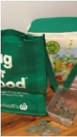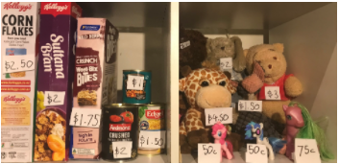

What you need:
- paper, pencil and sticky tape
- toy money or real coins in a small box
- shopping bags
- something to "sell" in your shop, for example, empty food boxes, tins or small toys.

What to do:
- To set the shop up in your home:
  - Get someone to help you write the prices on the different items.
  - Display your items in a box or on a shelf.
- Invite someone in your family to come to the shop to buy some things.

Extra learning activity
- Learn to count through this action song.
Five little speckled frogs
Five little speckled frogs,
Sat on a speckled log,
Eating the most delicious bugs, yum, yum.
One jumped into the pool,
Where it was nice and cool.
Then there were four speckled frogs. (continue until only one frog is left)
One little specked frog,
Sat on a speckled log,
Eating the most delicious bugs, yum, yum.
He jumped into the pool
Where it was nice and cool.
Now there are no speckled frogs
Actions to do while singing:
- Hold your fingers up while we are singing the song.
- Rum your tummy for ‘yum yum’
- Drop your thumb (or finger) when the frog jumps into the pool
- Let’s count how many left, how many can you count?
- Repeat throughout the song until 1 finger is left
- Let’s count all our fingers now
© State of New South Wales (Department of Education), 2021
The copyright material published in this document is subject to the Copyright Act 1968 (Cth) and is owned by the NSW Department of Education or, where indicated, by a party other than the NSW Department of Education.
Copyright material available in this document is licensed under a Creative Commons Attribution 4.0 International (CC BY 4.0) licence.
See https://education.nsw.gov.au/about-us/copyright for further details.

