This booklet belongs to:

Week C – Friday

Day at a glance:
Friday | Word awareness | Dress ups | Sketching shape figures | Bird watching
Estimated time | 15-20 mins | 25-30 mins | 20-25 mins | 25-30 mins
Resources required | Five objects or small toys | Some old dress up clothes | Small sticks | Notepad and pencil

Communicating in different ways
Learning goal: Children notice and react in positive ways to similarities and differences among people.
Listen to the story “Hooray for fish!” via this QR code. If you can’t listen, you can start at step 3.
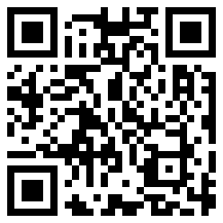
- Notice how the storyteller communicates using Auslan sign language.
- Follow along and try out some of the signs yourself.
- Look at the photos below. Have you seen someone doing sign language on the television or somewhere else?
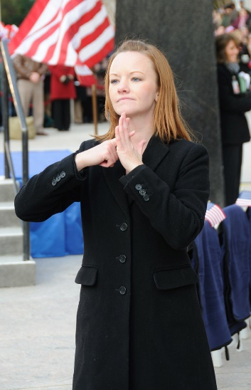
"Sign Language Interpreter" by Scott Ableman is licensed under CC BY-NC-ND 2.0
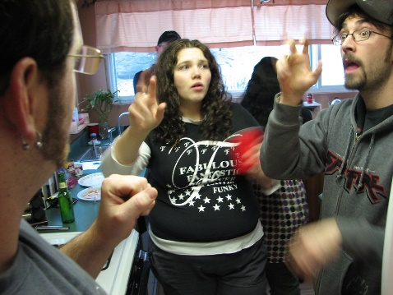
"Natural American Sign Language" by daveynin is licensed under CC BY 2.0

Is this activity too hard?
- Choose your own story and ask someone to read it to you.

Is this activity too easy?
- Did you hear any rhyming words in the story?

Word awareness
Learning goal: Children listen and respond to sounds and patterns in speech.
- Watch the video if you can.
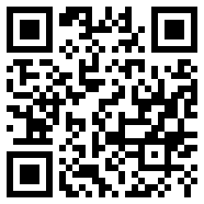
- Find five toys or objects and line them up on a table.
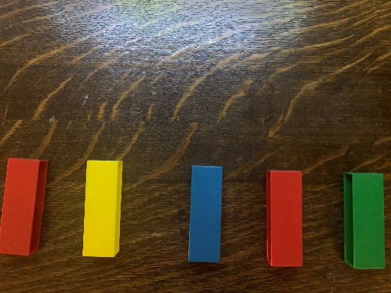
- Ask an adult in your home to help you say some short sentences such as:
- I like dogs.
- I like games.
- As you say each word, move a toy or object. If you say “I like dogs”, you will have three toys or objects moved forward.
- Count the toys or objects that you moved forward.
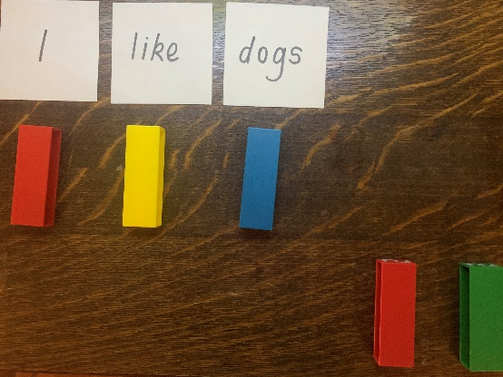
- That tells you how many words you have said in your sentence.

Is this activity too hard?
- How many types of animals do you know?
- How many types of fruit do you know?

Is this activity too easy?
- Say a well known rhyme, such as, 'This little piggy went to market' one phrase or sentence at a time.
- Count how many words you say.

Let’s all move together!
Learning goal: Children respond to movement through dance and drama.
- Listen to the song via this QR code. If you can’t listen, you can start at step 2.
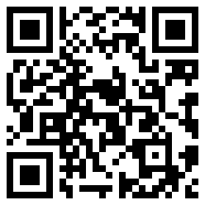
- Follow the instructions to:
- jump like a kangaroo
- gallop like a horse
- leap like a lion
- hop around the room
- dance like a monkey in the zoo.
If you enjoyed that dance, try the 'Native Animal Song' via this QR code:
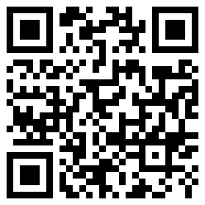
If you can’t listen, make up a song while you do the actions.
- Jump around like a kangaroo and sing “I’m a kangaroo, I jump, jump, jump”.
- Gallop around like a horse and sing “I’m a horse, I gallop, gallop, gallop”.

Take a break
Here are some things you might like to do:
- have a drink of water and a healthy snack
- play or have a rest
- go to the toilet and wash your hands.

Dress ups
Learning goal: Children use play to investigate, imagine and explore ideas.
- Collect some dress up materials and put them in a box.
- Think about what or who you might like to dress up as.
- Get dressed in whatever outfit you like.
- Tell someone about your outfit. Are you pretending to be someone?
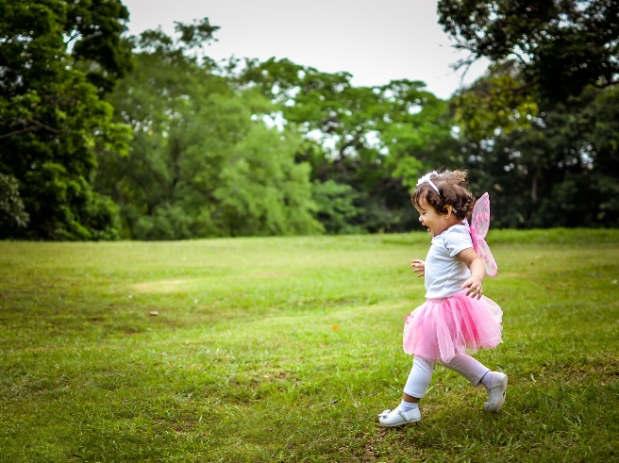
Image by Luis Navas from Pixabay under “Free for commercial use No attribution required”

Shape pictures
Learning goal: Children represent and communicate their thinking.
- Watch the video clip via this QR code. If you can’t watch the video, you can start at step 2.
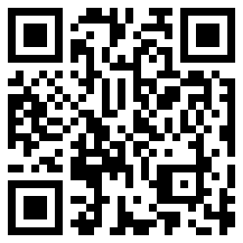
- Go for a walk outside to collect some twigs or small sticks.
  - Use your twigs to make some shapes.
  - Say the names of the shapes.
  - How many sticks did you need to make each shape?
- What else can you make with your sticks?

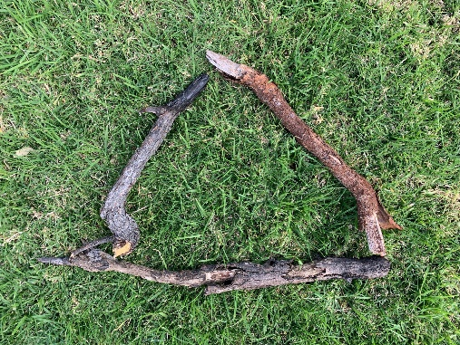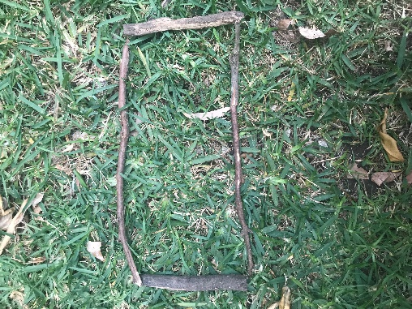
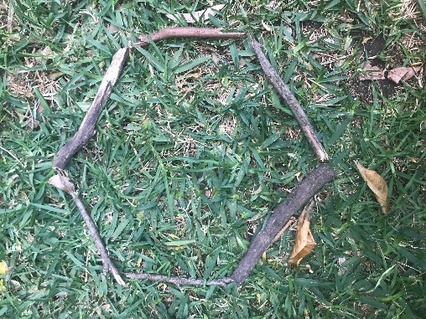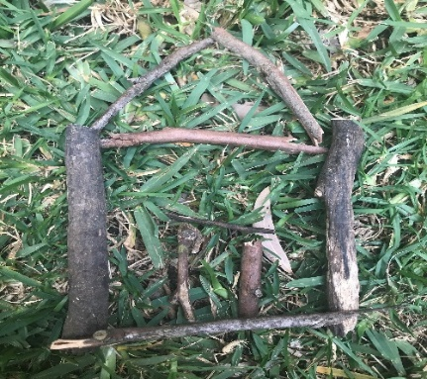

Is this activity too hard?
- Ask someone to make a shape.
- Copy their shape.

Is this activity too easy?
- How many different shapes can you make with four sticks?
- What can you make with ten sticks?

Bird watching
Learning goal: Children explore their environment.
Go for a walk with your family. If you can't go for a walk, look out your window or go out to your yard or balcony.
- Look for birds.
- Keep a tally or draw the birds you see.
- Which of the birds in the photos below did you see?
- Which bird did you see the most of?
- What were the birds you saw doing? Were they perching, flying or feeding?
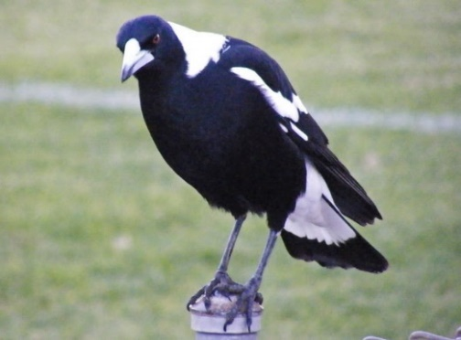
"MAGPIE" by NAPARAZZI is licensed under CC BY-SA 2.0
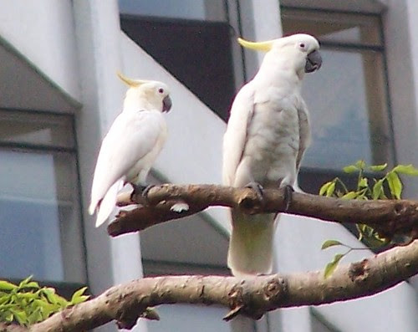
"Yellow-crested and Sulphur-crested Cockatoo" by CharlesLam is licensed under CC BY-SA 2.0
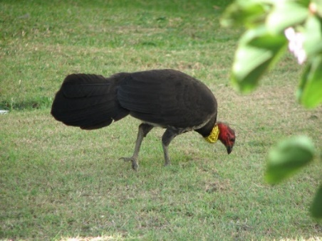
"Scrub Turkey" by Matthew Kenwrick is licensed under CC BY-NC-ND 2.0
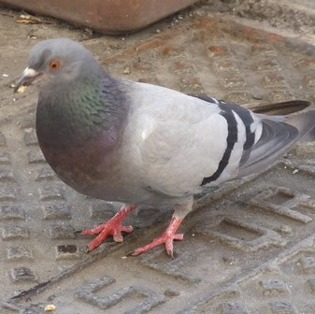
"Pigeon Eating" by Sean MacEntee is licensed under CC BY 2.0
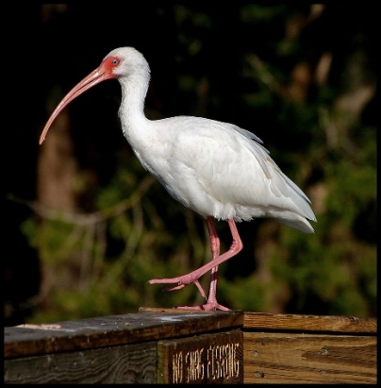
"White Ibis" by twoblueday is licensed under CC BY 2.0
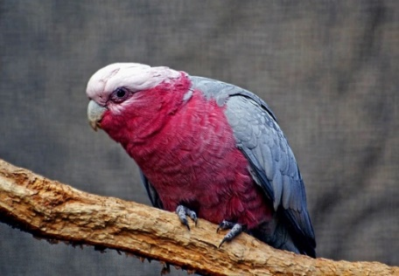
"Galah. (Eolophus roseicapilla)" by Bernard Spragg is marked with CC0 1.0
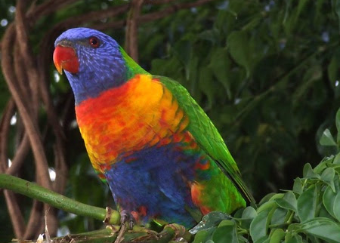
"rainbow lorikeet" by Vanessa Pike-Russell is licensed under CC BY-NC-ND 2.0
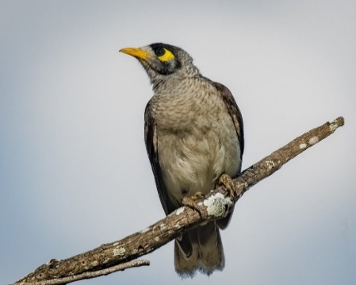
"Noisy Miner" by PaulBalfe is licensed under CC BY 2.0

Extra learning activities
You can open Story time - Alpacas with maracas, via this QR code. If you can’t open Story time, you can choose a book of your own and read to some toys.
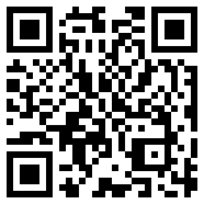
© State of New South Wales (Department of Education), 2021
The copyright material published in this document is subject to the Copyright Act 1968 (Cth) and is owned by the NSW Department of Education or, where indicated, by a party other than the NSW Department of Education.
Copyright material available in this document is licensed under a Creative Commons Attribution 4.0 International (CC BY 4.0) licence.
See https://education.nsw.gov.au/about-us/copyright for further details.

