This booklet belongs to:

Week B – Wednesday

Day at a glance:
Wednesday | Healthy Habits | Shared reading | Favourite colours | Patterns | Obstacle course
Estimated time | 10 mins | 15 – 20 mins | 5 mins | 20 mins | 15 – 20 mins
Resources required | Something to draw on | something to draw on and with, book | None | Natural materials | Obstacle course materials

Healthy habits
Learning goal: Children understand that eating healthy foods helps them stay healthy.
You can watch the video via this QR link. If you can’t watch the video, look at the picture and answer the questions below.
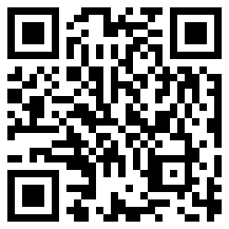
Maria talked about things we can do to be strong and healthy. She said:
- eat healthy food
- drink lots of water
- get plenty of sleep
- go for walks in the park.
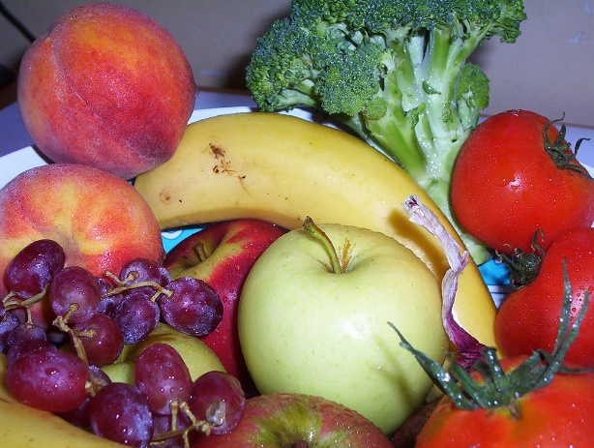
"Fresh fruit and vegetables" by Mundoo is licensed under CC BY-NC-ND 2.0
One way to remember to eat healthy food, is to “eat a rainbow”. This means eating fruit and vegetables that are all the colours of the rainbow.
- What foods do you eat that are red?
- What foods do you eat that are orange?
- What about foods that are green, blue and purple?

Shared reading
Learning goal: Children make connections between the characters of the story and their lives.
You can watch the story via this QR code.
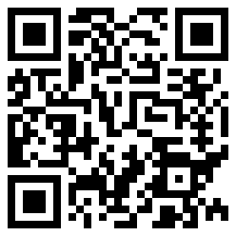
Zion, Gene. 1992, Harry the Dirty Dog / Gene Zion, Penguin Books Australia
- Listen to the story, 'Harry the Dirty Dog' by Gene Zion.
- Do you have a dog or does someone you know, have a dog?
- Is it a cheeky dog, like Harry? If so, what cheeky things does it do?
- What might have happened if Harry didn't have a bath?
- Draw a dog you know. You can use a picture if you can't think of a dog.
- Tell someone about the dog you have drawn.
If you can’t watch the story you can follow the steps below:
- Choose a book that you have at home.
- Talk about the front and back cover of the book, is the writing different on the front cover? How many words are on the front cover? Are there pictures? What do you think the book is about?
- Begin reading the book. When you see a picture you like, pause the story and talk with someone about what is happening in the picture. What do you think will happen next?
- Finish the story and discuss what happened:
  - What do you think would have happened if….”
  - Extend the story by drawing a picture of each of the story characters (the people and animals in the story).

Favourite colours
Learning goal: Children share their favourite and least favourite colours.
You can watch the video via this QR code and join in the activity. If you can’t watch the video, you can start at step 2.
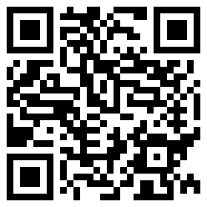
- How many objects did you find?
- What is your favourite colour?
- Ask someone in your family what their favourite colour is.
- Is there a colour you don't like? What is it? Why don't you like it?

Patterns
Learning goal: Children manipulate objects to make patterns and use mathematical language to describe their patterns.
- Look at the photos below. What do you see?
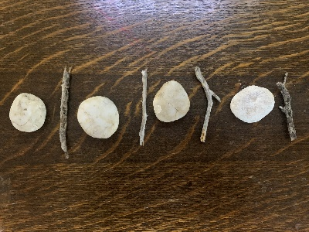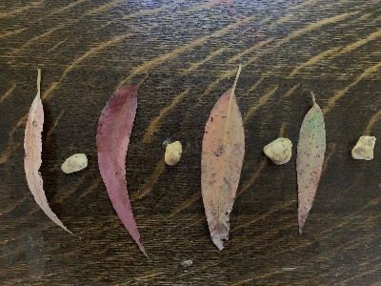
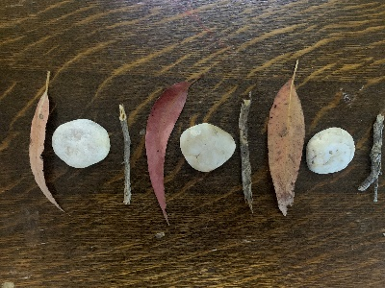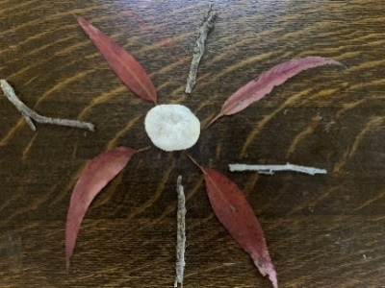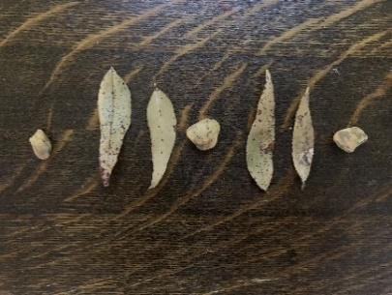
- Go outside and collect natural materials from the ground, such as leaves, sticks or small stones. If you can’t go outside, look inside your home for some things to make a pattern.
- Look at the photos below and arrange your materials in a pattern.
- Tell someone about your pattern.
- Try making a harder pattern.
- Ask someone to make a pattern for you to copy.

Want to learn more?
Make patterns:
- using coloured blocks or Lego
- using beads or buttons
- by drawing different shapes.

Obstacle course
Learning goal: Children develop gross motor skills
You can watch the video via this QR code. If you can’t watch the video, you can start at step 2.
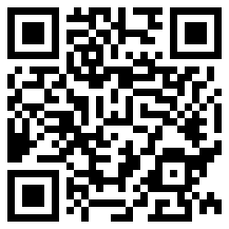
- Watch the video.
- Make an obstacle course in your backyard, lounge room or anywhere with enough space that you can safely move around. Use materials from your home, such as buckets, towels, ropes, pegs, pillows, blankets.
- Complete your obstacle course.
- Do your obstacle course again, this time in the other direction.
- Now try skipping around your obstacle course.

Want to learn more?
- Draw a map of the obstacle course you made.
- In your map, include the start and finish lines.
- Include arrows to show the direction people should move.

Virtual excursion
Learning goal: Children view multimedia text to broaden their understanding of the world in which they live.
You can watch the video via this QR code. If you can’t watch the video you can look at the photos below and start at 2b.
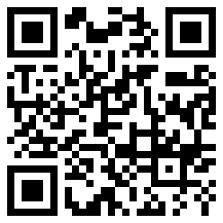
- Watch the video about Bailey, the dog who works at the Australian National Maritime Museum.
- Answer the following questions:
- What is Bailey's job?
- Did you know that dogs could have jobs?
- Do you know of any other jobs that dogs have? The pictures below will give you a clue.
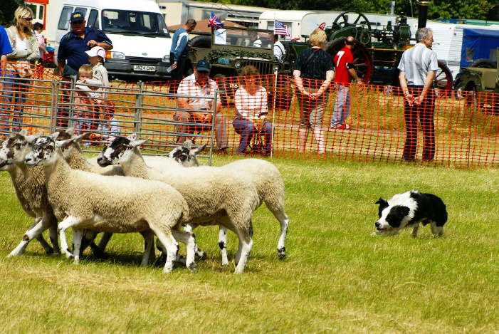
Sheep Dog Display" by Martin Pettitt is licensed under CC BY 2.0
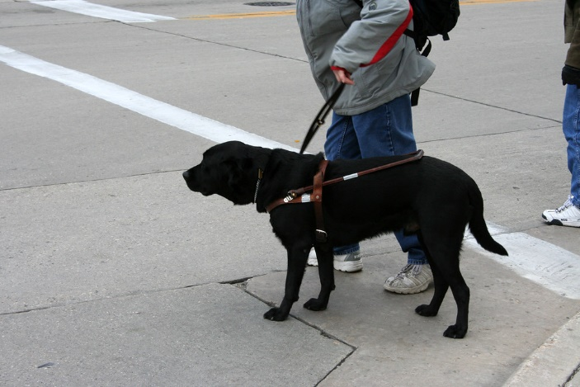
"Seeing eye dog" by WELS.net is licensed under CC BY-NC 2.0

Extra learning activities
You can watch the video via this QR code: Play animated videos with the words and tunes of popular children’s songs and nursery rhymes with ‘Baby Karaoke’
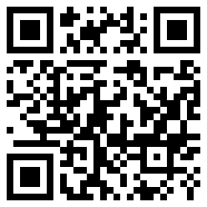
© State of New South Wales (Department of Education), 2021
The copyright material published in this document is subject to the Copyright Act 1968 (Cth) and is owned by the NSW Department of Education or, where indicated, by a party other than the NSW Department of Education.
Copyright material available in this document is licensed under a Creative Commons Attribution 4.0 International (CC BY 4.0) licence.
See https://education.nsw.gov.au/about-us/copyright for further details.

