This booklet belongs to:

Week B – Thursday

Day at a glance:
Thursday | What can you see? | Shared reading | Noticing patterns and symbols | Kicking | How do objects move?
Estimated time | 10 - 15 mins | 15 mins | 5 – 10 mins | 15 - 20 mins | 15 – 20 mins
Resources required | something to draw with and draw on | None | None | A ball and another object | Books, cardboard, items to roll

What can you see?
Learning goal: Children repeat the actions of others and identify the distance between objects.
You can watch the video via this QR code.
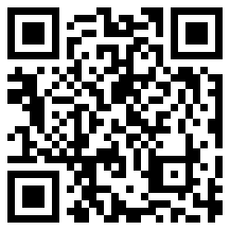
If you can’t watch the video, you can start at step 2.
- Join in the activity on the video.
- Look for the thing furthest away from you.
- Look for the thing closest to you.
- Choose something close to you. Look at it closely. What can you see and feel?

Shared reading
Learning goal: Children use drawing to express ideas and make meaning of stories.
Watch the story via this QR code
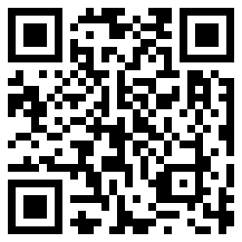
Where the forest meets the sea, by Jeanine Baker
Find some before and after the story activities to complete via this QR code:
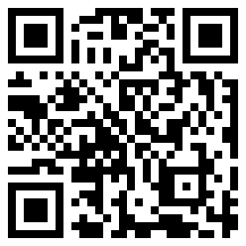
If you can’t access the story and activity, you can follow these steps instead:
- Think about a forest with lots of tall trees. Is it very green?
- Think about your forest as a rainforest. Lots of animals and birds live there and the weather is warm
- Draw some of the thing you have thought about. What else can you imagine in your rainforest?
- Are there a lot of colours in your rainforest? Maybe you can think about a brightly coloured bird.

Noticing patterns and symbols
Learning goal: Children begin to recognise patterns and symbols and the connections between them.
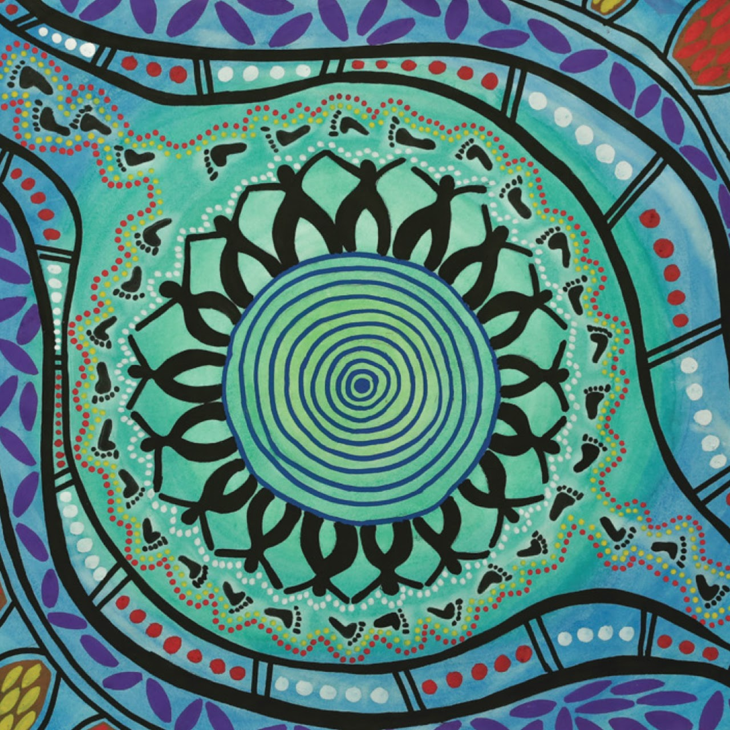
This artwork was commissioned for the department’s Reconciliation Action Plan. It was created by Suzanna Bulai, a student at Boggabilla Central School which is on Gamilaraay Country near the Queensland border in the North East of NSW.
Look at the picture of the Aboriginal symbols. Tell someone:
- What can you see?
- What colours can you see?
- Why do you think there are some small circles and some big circles?
- What do you think the blue wavy parts are?

Kicking
Learning goal: Children use gross motor skills to move their body in particular way.
Watch the video via this QR code and join in the activities. If you can’t watch the video, follow the steps below instead:
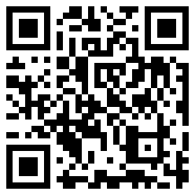.
- Take a ball outside and find some space.
- If you can’t go outside, find a space in your home with an adult and find a soft ball you can use to practise kicking
- Set up a toy or object a bit away from you
- Softly kick the ball and see if you can knock the toy or object over.
- Set up two toys or objects and see if you can kick the ball between them and score a goal.

How do objects move?
Learning goal: Children experiment with cause and effect, trial and error, and motion
You will need:
- a ball, water bottle, plastic cup, toy car – whatever you can find
- 3-4 books to make a stack
- a big book, piece of cardboard or chopping board to create a ramp
- something to draw on and something to draw with.
Steps
- Pile the books on top of each other
- Lay the board or big book on the pile of books as in the picture below.
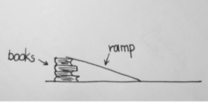
- Hold one of your items at the top of the ramp and let it go.
- Tell someone:
  - What did you notice?
  - Did the object roll down the ramp?
  - Did the object fall off the ramp?
  - Did the object not move?
- Find different shaped objects for your investigation. Think about what rolls down easily, what slides down and what doesn’t move.

Want to learn more?
- Draw a picture of your ramp.
- Draw what items rolled down the ramp and which items rolled off your ramp?
- What do you think will happen if you stack more books? Try it to find out!
- What do you think if you take away some books? Try it and find out!

Extra learning activities
For more learning experiences with counting, you can access resources via this QR code.
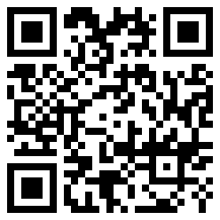
If you can’t look at the activities, here is an extra activity you can do:
Counting apples (finger rhyme: Tune 10 green bottles)
Five red apples
Hanging on a tree (five fingers held up)
The juiciest apples you ever did see!
The wind came past
And gave an angry frown (shake head and look angry)
And one little apple came tumbling down.
Four red apples … (continue the rhyme)
Engaging with the counting to support learning
- When singing this rhyme encourage your child/children to hold their fingers up when singing.
- As your child drops a finger when each apple drops, drop a finger and count each finger that is left and say the number of fingers left standing.
- Ask your child/children how many apples are left each time?
- After singing the song, put five fingers up and get your child to count each finger saying the number as they count.
© State of New South Wales (Department of Education), 2021
The copyright material published in this document is subject to the Copyright Act 1968 (Cth) and is owned by the NSW Department of Education or, where indicated, by a party other than the NSW Department of Education.
Copyright material available in this document is licensed under a Creative Commons Attribution 4.0 International (CC BY 4.0) licence.
See https://education.nsw.gov.au/about-us/copyright for further details.

