This booklet belongs to:

Week B – Monday

Day at a glance:
Monday | Family drawing | Describing things | Speaking Spanish | Dancing | Building challenge
Duration | 10-15 mins | 15 mins | 15 mins | 10 - 20 mins | 15-20 mins
Resources required | something to draw with and draw on | none | none | none | LEGO or blocks or boxes

Family drawing
Learning goal: Children sense and respond to a feeling of belonging.
You can access the video via this QR code:
- Draw a picture of your special family and friends.
- If you have pets, you can draw them too.
- Put your picture on your desk or where you are doing your learning to remind you of who you care about and who cares for you.

Describing things
Learning goal: Children respond verbally and non-verbally to what they see, hear, touch, feel and taste.
You can access the video via this QR code:
- Watch the video and join in the activity.
- If you can’t watch the video, look at the photo below and start at step 1.
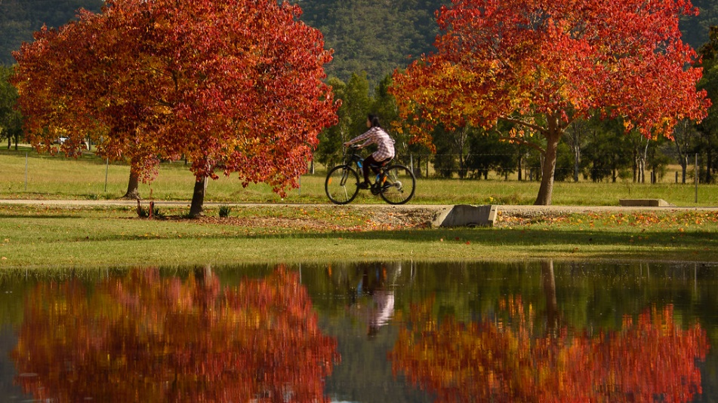
"Visions of Red" by Rodney Campbell is licensed under CC BY-NC-ND 2.0
- Describe this picture. Remember to use describing words, such as orange, crunchy, dry and beautiful:
  - I can see...
  - I can hear...
  - I can smell...
  - I can feel...
  - The leaves are like...
- Now it's your turn. Think of different things, or find things in your home, that you can:
  - See
  - Hear
  - Smell
  - Feel.
- Find a leaf.
  - Is it the same colour as the ones in the photo?
  - Does it smell?
  - Does it feel crunchy, smooth or spiky?

Speaking Spanish
Learning goal: Children broaden their understanding of the world in which they live.
You can access the video via this QR code. If you can’t watch the video start at step 2 below.
- Watch the video and join in the activity.
- What language or languages do you speak?
- If you speak a language other than English, do you know the words for the different sports mentioned in the video
  - Basketball
  - Soccer
  - Swimming
  - Table tennis
  - Athletics

Dancing
Learning goal: Children engage in physical activity to stay healthy.
Watch the video and join in. You can access the video via this QR code:
If you can’t watch the video, play your favourite song and dance!

Building challenge
Learning goal: Children persist to complete a task.
Choose one or more of these challenges to complete:
- Build two towers, each out of different materials. Make the towers exactly the same height.
- Build a home for a snake.
- Build a shed for a long, thin car and a tall car.
- Build a bridge.
- Build a house with four windows and two doors.
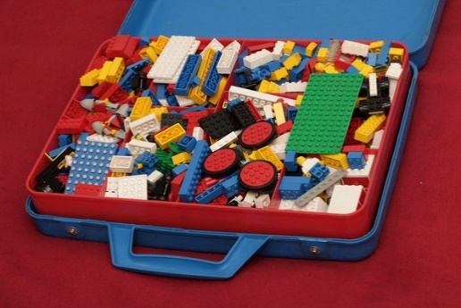
"Old School Lego #1" by pasukaru76 is marked with CC0 1.0
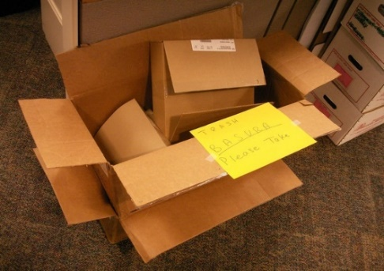
"Basura bilingüe" by Daquella manera is marked with CC0 1.0

Extra learning activities
Learning how to do a perfect composition with a camera is easy with Dorothea beside you. You can access the activity via this QR code. If you can’t access the QR code, complete the activity below.
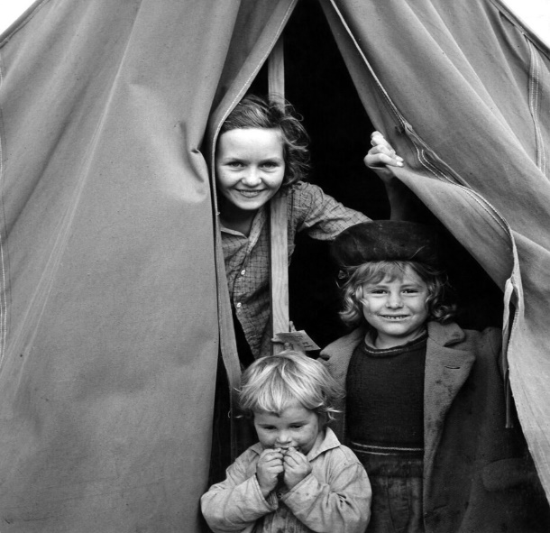
Dorothea Lange, circa 1936
- Look at the photo
- Discuss these questions with a friend or family member.
  - What did you look at first in the photo?
  - What is happening in the photo? What do you think could be happening around the children that the photo does not show?
  - Why do you think the photographer did not include the whole tent in the photo? How are the children positioned in the tent?
  - What does the photo tell you about the children’s lives? Do their facial expressions give you any clues?
© State of New South Wales (Department of Education), 2021
The copyright material published in this document is subject to the Copyright Act 1968 (Cth) and is owned by the NSW Department of Education or, where indicated, by a party other than the NSW Department of Education.
Copyright material available in this document is licensed under a Creative Commons Attribution 4.0 International (CC BY 4.0) licence.
See https://education.nsw.gov.au/about-us/copyright for further details.

