This booklet belongs to:

Week B – Friday

Day at a glance:
Friday | Happy memories | Shared reading | Bounce the ball | Using your senses | What do you see?
Estimated time | 10 - 15 mins | 20 - 25 mins | 5 mins | 5 – 10 mins | 10 – 15 mins
Resources required | something to draw with and draw on | a book, something to draw with and draw on | None | None | something to draw with and draw on

Happy memories
Learning goal: Children sense a feeling of belonging when remembering something happy.
You can watch the video via this QR code and join in the activity. If you can’t watch the video you can start at step 2.
- After watching the video, draw a picture of one of your happiest memories.
- Think about one of your happy memories. Is it in a photo or a nice thought in your head?
- Draw a picture of your happy memory.

Shared reading
Learning goal: Children transfer ideas and make representations from the story.
- Listen to the story via this QR code.
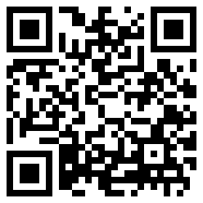
‘Back to Sleep' by Zoë Foster Blake
- After listening to the story:
  - draw a picture of Finn, the little boy from the story
  - draw one place you remember from the book.
If you can’t access the QR code, complete the following steps instead:
- Choose a book that you have at home.
- Talk about the front and back cover of the book, is the writing different on the front cover? How many words are on the front cover? Are there pictures? What do you think the book is about?
- Begin reading the book. When you see a picture you like, pause the story and talk with someone about what is happening in the picture. What do you think will happen next?
- Finish the story and discuss what happened:
  - “What do you think would have happened if….”
  - Extend the story by drawing a picture of each of the story characters (the people and animals in the story).

Bounce the ball
Learning goal: Children will use their developing coordination skills to bounce the ball.
You can listen to the Munch and Move 'Bounce the ball' song via this QR code. If you can’t listen to the song,, you can use music from your home.
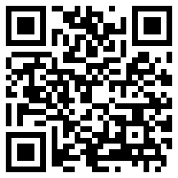
- Find a ball or something to bounce.
- Bounce your ball along with the music.

Using your senses
Learning goal: Children are able to engage with two complex ideas - counting and using different senses.
Watch the video via this QR code and join in the activities
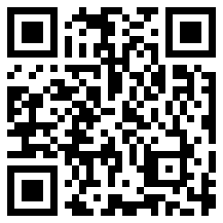
If you can’t watch the video, you can follow these steps below:
- Look around your house and try to find:
  - five things you can see
  - four things you can hear
  - three things you can feel
  - two things you can smell
  - one thing you can taste.
- Can you draw all the things you used your senses with?

What do you see?
Learning goal: Children use the creative arts to express ideas about what they see
- Look carefully at the picture below.
- Tell someone about what objects, colours and shapes you can see.
- Using some coloured pencils, have a go at drawing this picture.
Image by Kohji Asakawa from Pixabay

Want to learn more?
- Look out a window of your house. What do you see? You might see trees, grass and/or buildings.
2. Draw what you see.

Extra learning activities
For more learning, you can access resources via this QR code.
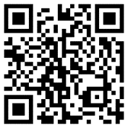
If you can’t access the QR code, you can try the following activity. Have an adult or a family member sing along with you.
Hokey Pokey (song)
You put your left foot in
You put your left foot out
You put your left foot in
And you shake it all about.
You do the hokey pokey
And you turn around
That’s what it’s all about (repeat using different body parts).
© State of New South Wales (Department of Education), 2021
The copyright material published in this document is subject to the Copyright Act 1968 (Cth) and is owned by the NSW Department of Education or, where indicated, by a party other than the NSW Department of Education.
Copyright material available in this document is licensed under a Creative Commons Attribution 4.0 International (CC BY 4.0) licence.
See https://education.nsw.gov.au/about-us/copyright for further details.

