This booklet belongs to:

Week A Tuesday
Things you need:
- something to draw on
- something to draw with
- a range of empty containers or boxes
- items to fill the containers such as water, sand, small stones or pebbles.

Leaf drawing
Learning goal: Children are able to closely observe and draw a leaf in detail.
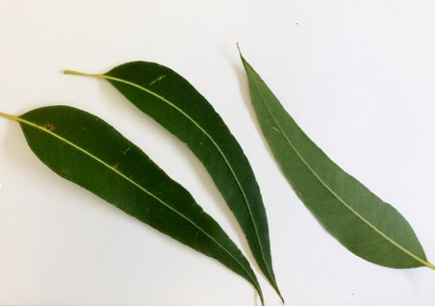
Geekstreet, CC BY-SA 4.0, via Wikimedia Commons
- Find a living plant or tree. If there is no plant or tree near you, look at the picture.
- Look very closely at one of the leaves on the plant or tree.
- Make sure you don't pick the leaf, as it is alive.
- Talk with someone about the leaf you are looking at:
  - What colour is it?
  - What shape is it?
  - Does it smell?
  - How does it feel?
  - What else do you notice about the leaf?
- Draw the leaf.

Shared reading
Learning goal: Children are able to talk about what is happening in a story.
- Choose a book that you have at home. Talk about the front and back cover of the book.
  - Is the writing different on the front cover?
  - How many words are on the front cover?
  - Are there pictures?
  - What do you think the book is about?
- Begin reading the book. When you see a picture you like, pause the story and talk with someone about what is happening in the picture.
  - What do you think will happen next?
- Finish the story and discuss what happened:
  - What do you think would have happened if….?
  - Extend the story by drawing a picture of each of the story characters (the people and animals in the story).

Which container holds the most?
Learning goal: Children talk about volume and capacity as they experiment filling and emptying containers.
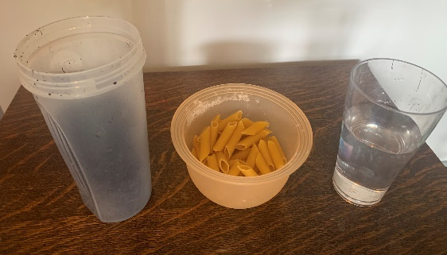
- Find some empty containers or boxes and something to fill them with. You might use sand, dirt, rice or water.
- Have fun filling each container and then tipping between them. Talk with someone about:
  - Which container holds the most?
  - Which container holds the least?

Want to learn more?
- Find some small objects, such as stones, Lego pieces or toy cars.
- Pick one of your containers. Guess how many of the small objects are needed to fill the container.
- Have a go, counting each object as you put it into the container.
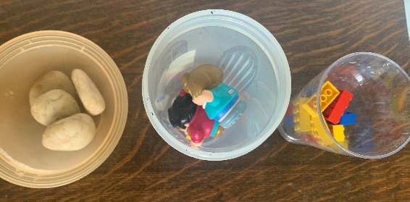
- Try again with a different container.

Further activity
Can you draw your containers? Circle the one that is the tallest.

Hide and seek
Learning goal: Children follow game rules and cooperate to successfully play with others
Find a safe place and set a boundary to play in.
How to play:
- One person closes their eyes and counts to 10 slowly.
- Everyone else quietly hides.
- When the person counting has finished, they open their eyes and call out, 'Ready or not, here I come'.
- When the people hiding are all found, the first person found becomes the person who closes their eyes and counts.
Brajerack is a traditional Aboriginal game of Hide and Seek, learn more via this QR code.

Body percussion patterns
Learning goal: Children use body percussion to copy and create simple patterns.
Sing together, ‘If you’re happy and you know it clap your hands’.
If you’re happy and you know it, clap your hands.
If you’re happy and you know it, clap your hands.
If you’re happy and you know it, then you really ought to show it.
If you’re happy and you know it, clap your hands.
Continue with body parts and different body percussion:
- …stomp your feet
- …tap your knees
- …slap your thighs
- …rub your hands
- …knock your knees.

Want to learn more?
- Create your own song using your body parts as percussion.
- Ask someone in your family to copy your pattern.
- Play your favourite song and perform body percussion to it.
© State of New South Wales (Department of Education), 2021
The copyright material published in this document is subject to the Copyright Act 1968 (Cth), and is owned by the NSW Department of Education or, where indicated, by a party other than the NSW Department of Education.
Copyright material available in this document is licensed under a Creative Commons Attribution 4.0 International (CC BY 4.0) licence.
See https://education.nsw.gov.au/about-us/copyright for further details.

