This booklet belongs to:

Week A - Thursday
Things you need:
- something to draw with
- something to draw on
- chalk to draw on the ground outside (or tape/ribbon if inside).

Helping around the house
Learning goal: Children recognise the contributions they make to shared projects and experiences.
Plan to help someone in your house with an everyday task such as making lunch
Tell someone how you will help them
- How do you think you will feel after helping?
- How else could you help your family around your home?
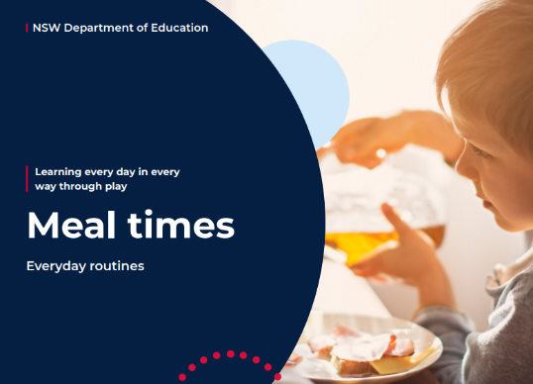
Ongoing learning activities during meal times:
- Ask your child to pour their own cereal, butter their toast or pour their own glass of milk or water.
- Ask your child to set the table and count the number of plates, cups, knives and forks that need setting.
- During meal times, ask the family questions and have conversations about everyone’s day.
- Talk about the colours, shapes and patterns you see on your plate or in your lunchbox.
- Talk about how food looks, smells, feels and sounds.
- Find pictures of food in catalogues and talk about foods your child likes and dislikes, and how nutrients in food help the body to grow and be strong,
You can access the everyday routine cards via this QR code:
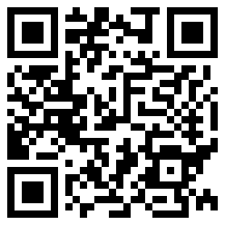

Shared reading
Learning goal: Children are able to identify what happened at the beginning, middle and end of a story.
- Listen to the story, ‘There’s a sea in my bedroom’ by Margaret Wild.
- You can access the story via this QR code:
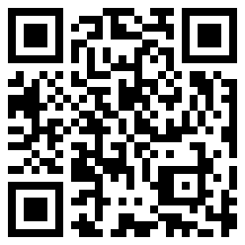
After listening to the story, talk to someone about what happens in the story at the beginning, middle and end.
- Find some paper and draw what happens at the beginning, middle and end of the story

Hopping fun
Learning goal: Children show enthusiasm for participating in physical activity.
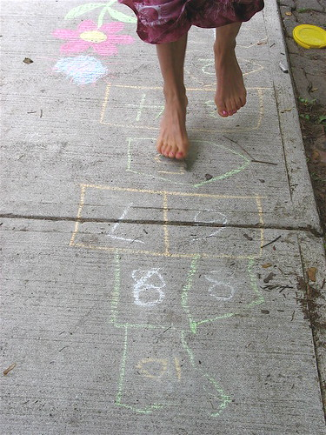
"Hop Scotch Hop" by Sue Richards is licensed under CC BY-ND 2.0
- Create a hop scotch pattern with chalk or if inside use tape or ribbon on the ground.
- Use a small stone to roll across the pattern.
- Identify the number and hop to the square.
- Remember if it is the double squares, you will need to jump.
Where does food come from?
Learning goal: Children develop an increased understanding of where food comes from.
- Use the QR code to view the video 'Living world'. If you can’t view the video, just start at step 2.
- Look inside your fridge or freezer.
- Draw 5 food items that come from a plant and 5 food items that come from an animal.
- Tell an adult about what you have drawn.
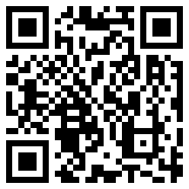
© State of New South Wales (Department of Education), 2021
The copyright material published in this document is subject to the Copyright Act 1968 (Cth) and is owned by the NSW Department of Education or, where indicated, by a party other than the NSW Department of Education.
Copyright material available in this document is licensed under a Creative Commons Attribution 4.0 International (CC BY 4.0) licence.
See https://education.nsw.gov.au/about-us/copyright for further details.

