This booklet belongs to:

Week A - Monday
Things you need:
- something to draw with
- something to draw on
- post it notes, LEGO or building blocks
- mirror.

Stretching
Learning goal: Children understand that stretching and moving is part of being healthy.
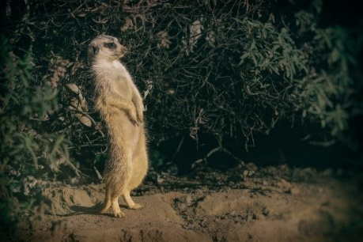
Image licensed under CC BY 2.0 "Cat nap yoga" by jessicafm
- Stand on your toes and stretch up like this meerkat.
- Count ten big breaths.
- Have a rest and then try again.
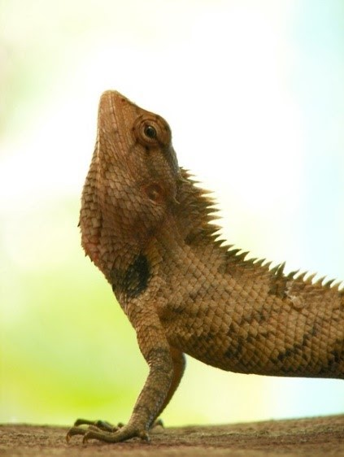
Image licensed under CC BY 2.0 "YOGA in nature's way" by Tony George
- Lay on the floor and arch your back like this lizard.
- Count ten big breaths.
- Have a rest and then try again.
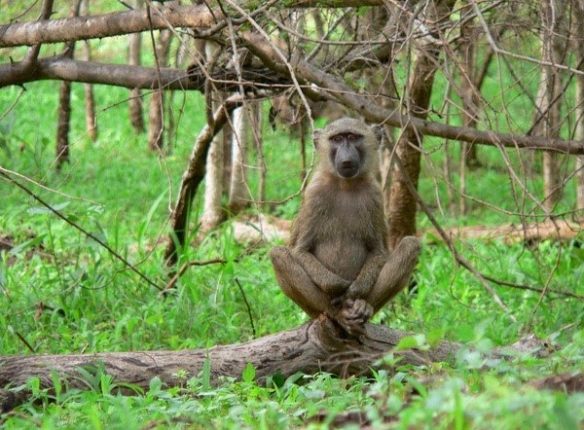
Image licensed under CC BY 2.0 "Safari in Mole" by Stig Nygaard
- Sit on your bottom and push your feet together like this baboon.
- Count ten big breaths.
- Have a rest and then try again.
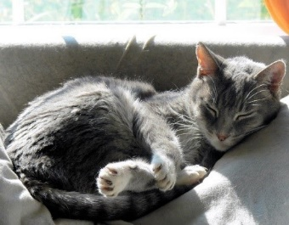
Image licensed under CC BY 2.0 "Cat nap yoga" by jessicafm
- Now it’s time to rest.
- Curl your body up like this sleepy cat and stay very still.
- Close your eyes and purr like a cat

Shared reading
Learning goal: Children are able to talk about and recall what has happened in the story.
Read the story, ‘Belinda’ by Pamela Allen.
“Allen, Pamela. 2013, Belinda / Pamela Allen, Puffin Books Melbourne”
Access the story via this QR code.

Want to learn more?
- Draw a picture of each of the story characters (the people and animals in the story).
- Ask someone to write the name of each of the characters for you. Read and copy each of the names.

Face drawing
Learning goal: Children recognise similarities and differences.
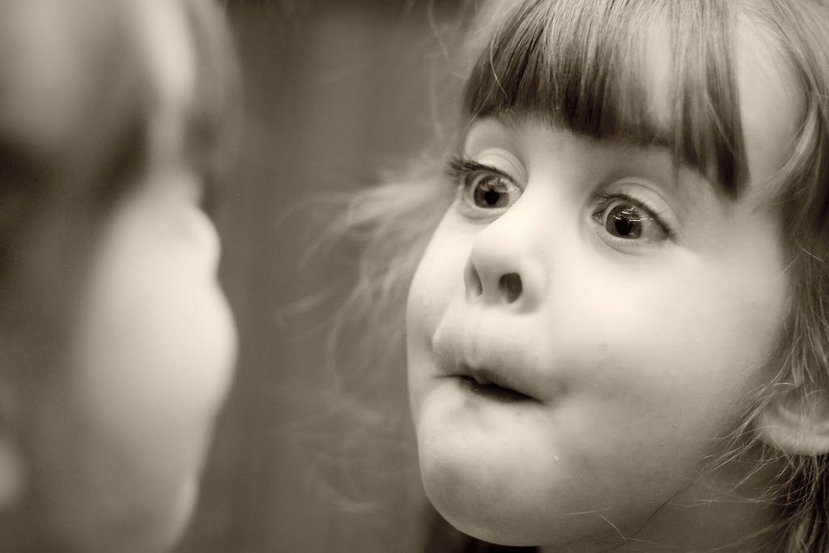
"Grace - Mirror" by phil41dean is licensed under CC BY 2.0
- Think about one of your friends or someone in your family:
  - Which features or parts of their face are the same as yours?
  - Which of their features or parts of their face are different?

How to draw your face:
- Look at your face in the mirror.
- Look carefully at your hair, skin, ears, eyes, mouth and nose.
- Start with the outline of your head.
- Draw each of your features to complete your face.

Other ways to make your face:
- draw with chalk on cement or a big rock
- flatten out sand or soil and then draw with a stick
- gather leaves and small sticks from the ground and arrange them
- use a computer drawing program, such as 'Paint'.

Counting
Learning goal: Children are able to count a group of objects and say how many are in the group.
Rote counting: When children memorise the name of numerals and can recite them, for example: as they walk up the stairs, count some toys, count the number of grapes in their bowl.
One-to-one correspondence: When children count each object separately and assign a counting word to the object.

Building towers
You will need these items to play:
- Number cards for each player with 2, 4, 5 and 3 on them.
- a dice
- some building bricks.
To set up the game, arrange the post it notes with numbers as in the picture.
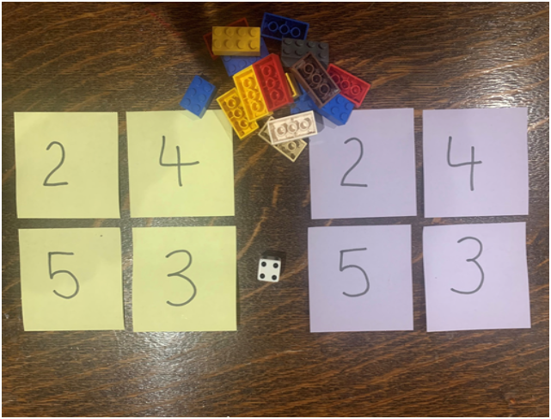
- Take turns to roll your dice and get that number of bricks to build up your towers.
- Towers can be built up in any way you choose.
- Build up your towers until one of you gets the exact roll to complete the last tower.
Talk about how many you have and how many more you need.
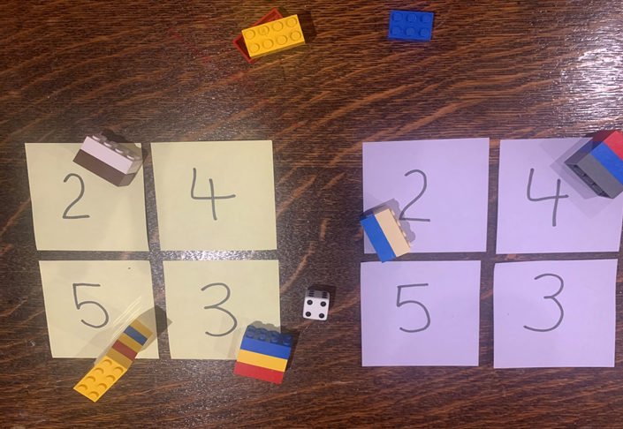

Want to learn more?
- Try playing the game in reverse by starting with complete towers. Take away blocks for each roll, until there are no blocks left. You could also play the game with larger numbers.
- Draw your block towers, count out loud and write the number that matches the tower.
- Think of the tallest tower that you built. What number of blocks did you use?

Music
Learning goal: Children join in singing a repetitive song
- Find some spoons or something similar in the kitchen.
- Find a big plastic container or something similar to use as a drum.
- Experiment with different sounds, play with a family member.

Johnny works with one hammer
- Think of a song you may know with counting, such as, ‘Johnny works with one hammer’.
- Hit the drum in time with the song, a friend or adult can clap and count the beat.
- Sing the action song without your music and use your hands.
Johnny works with one hammer (children hammer with one hand)
One hammer, one hammer
Johnny works with one hammer, Johnny works with two.
Johnny works with two hammers … (children hammer with two hands)
Johnny works with three hammers … (children hammer with two hands and one leg)
Johnny works with four hammers … (children hammer with both hands and both legs)
Johnny works with five hammers (children hammer with both hands, both legs and head)
Five hammers, five hammers
Johnny works with five hammers
Johnny’s work is DONE!

‘Five little ducks’ (finger rhyme)
- When singing this rhyme encourage your child/children to hold their fingers up when singing.
- As your child drops a finger when each duck goes away, count each finger that is left and say the number of fingers left standing.
- Ask your child/children how many ducks are left each time?
- After singing the song, put five fingers up and get your child to count each finger saying the number as they count.
Five little ducks went out one day (hold up five fingers)
Over the hills and far away (hold arm across body and tuck fingers behind shoulder on the opposite side of the body)
Mother Duck said, ‘Quack, quack, quack, quack’ (use other hand to make a Mother Duck beak; open and close hand to quack)
But only four little ducks came back. (bring first hand back to the front with four fingers showing) (continue until no little ducks came back)
Poor Mother Duck went out one day,
Over the hills and far away, Mother Duck said ‘Quack, quack, quack, quack’ And all of those five little ducks came back.

Extra learning activities
For more learning experiences about exploring identity refer to the family resource booklet.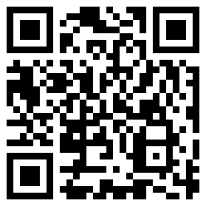
© State of New South Wales (Department of Education), 2021
The copyright material published in this document is subject to the Copyright Act 1968 (Cth) and is owned by the NSW Department of Education or, where indicated, by a party other than the NSW Department of Education.
Copyright material available in this document is licensed under a Creative Commons Attribution 4.0 International (CC BY 4.0) licence.
See https://education.nsw.gov.au/about-us/copyright for further details.

