This booklet belongs to:

Week A - Friday
Things you need:
- Something to draw on
- Something to draw with
- Scissors

Exploring with our senses
Learning goal: Children use their senses to explore their environment.
We’re going to explore our senses. What is happening in each picture? Discuss what senses are being used?
Smell
What do you think the plant smells like? Are there plants in your garden that you can smell?
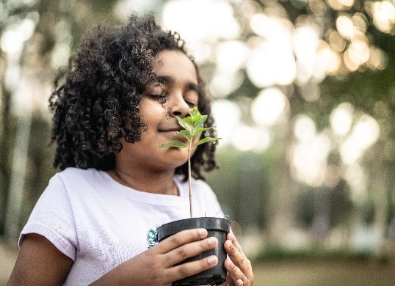
Image licensed under the iStock Getty Images Content License Agreement
See
What is the child looking at? What are they using? Do you think they can see the flower better?
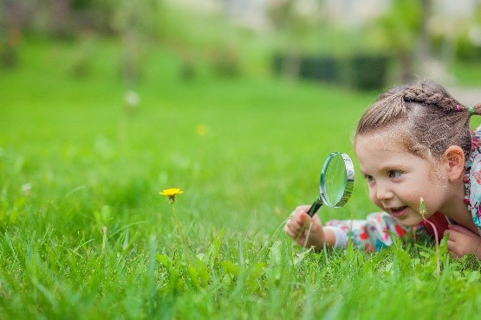
Image licensed under the iStock Getty Images Content License Agreement

Taste
Vegetables are healthy. What do you think they might taste like? What is your favourite vegetable?
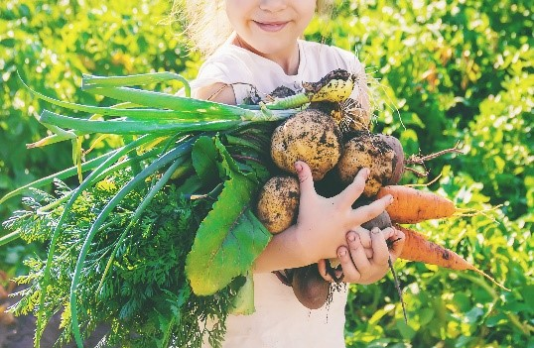
Image licensed under the iStock Getty Images Content License Agreement
Hear
The child is listening to the story. Close your eyes and listen to the sounds around you.
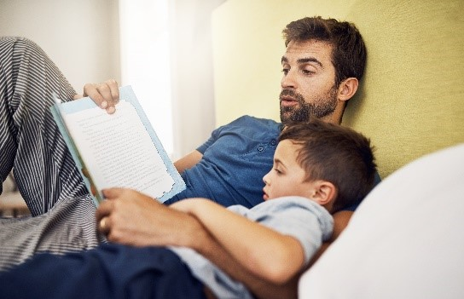
Image licensed under the iStock Getty Images Content License Agreement
Feel
This child’s feet are feeling the bark on a tree. Do you think this feels rough or smooth? What can you find that feels rough and smooth?
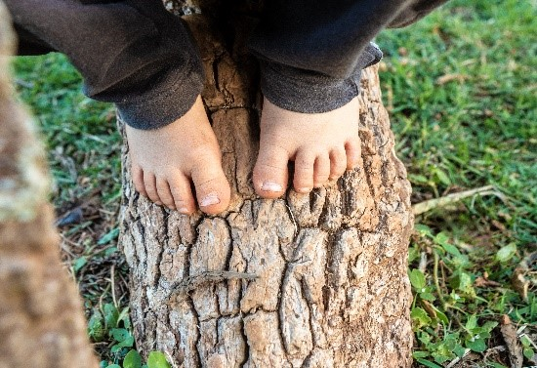
Image licensed under the iStock Getty Images Content License Agreement

Shared reading
Learning goal: Children listen to and respond to sounds in stories
Scan the QR code to Watch Grandpa Honeyant Storytime, Caar Caaaar
- Before the story: In the story ‘Caar Caaaar’, you will see and hear lots of animals. Draw three animals that you know. What sounds do they make?
- Listen to the story. Select the picture to follow the link and view the video.
- After the story: Wow! That was a busy story full of lots of sounds. Time to go on a sound hunt. Move around a room or go for a walk with a family member. Draw, write or make the sounds that you hear.

Want to learn more?
- Close your eyes and picture all the sounds that you heard. Can you make up a story about these sounds? Draw the beginning, middle and end of your story.
- Perform or read your story to a friend or family member. Ask them what sounds they heard.

Moving and relaxing
Learning goal: Children move their bodies confidently and explore and respond to their world.
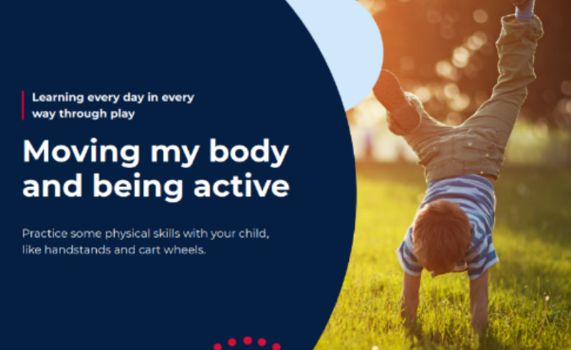
- If you have space outside, practice a handstand or cartwheel or try one of the other ideas on this activity card using the QR code.

- Lay on the grass and look up or look out the window. What pictures can you make out of the clouds?
- Tell your family about what you can see.

Puzzle
Learning goal: Children manipulate objects and experiment with many solutions.
Let's make a tangram.
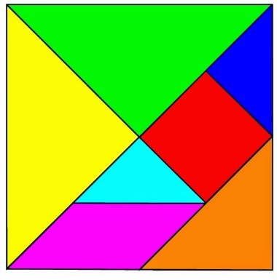
You will need:
- paper
- scissors
- an adult to help.

- Watch the clip to learn how to make a tangram via the QR code.
- Put the tangram back together like you are doing a puzzle.

Feelings
Learning goal: Children express their feelings and begin to recognise how others might be feeling.
- How do you think the children in this photo are feeling?
- Draw how you are feeling today.
- Find some photos of you and your family.
- What do you notice about the photos? What words can you use to describe the facial expressions? Do you think they are happy, sad or excited? Talk to someone about your ideas.
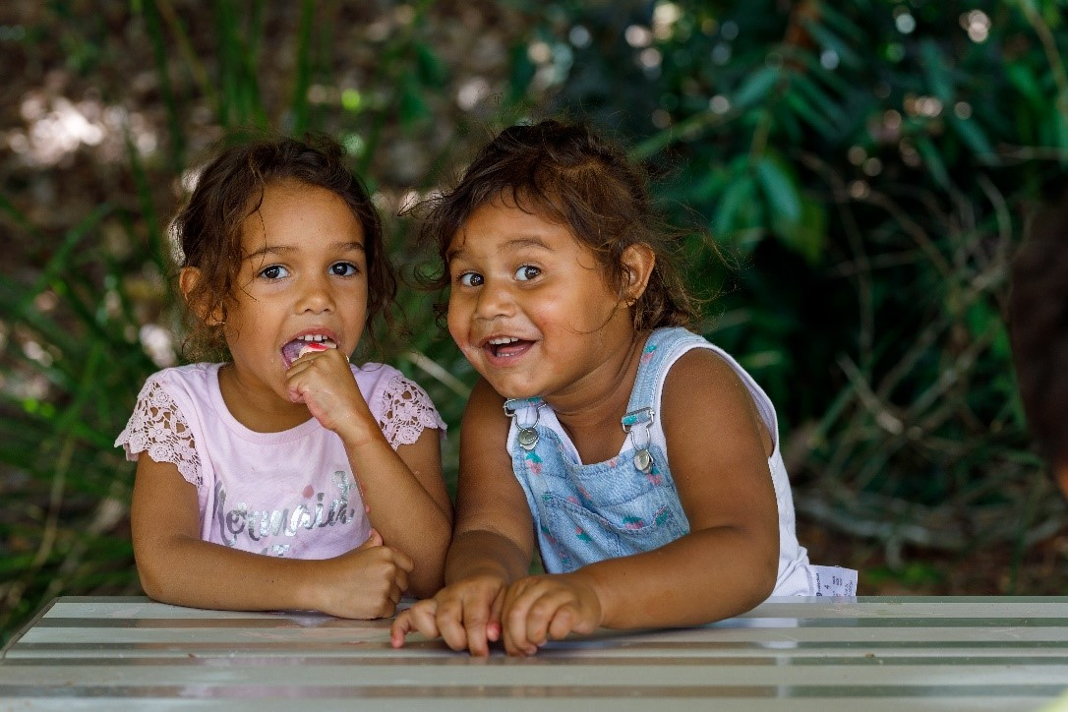
Image licensed under the iStock Getty Images Content License Agreement

Want to learn more?
- Look at yourself in a mirror.
- Draw your own face, a self-portrait, showing how you are feeling at the moment. You might be happy, sad, tired or angry.
© State of New South Wales (Department of Education), 2021
The copyright material published in this document is subject to the Copyright Act 1968 (Cth) and is owned by the NSW Department of Education or, where indicated, by a party other than the NSW Department of Education.
Copyright material available in this document is licensed under a Creative Commons Attribution 4.0 International (CC BY 4.0) licence.
See https://education.nsw.gov.au/about-us/copyright for further details.

