Student led technology for teachers
This resource provides the scaffold for teachers in to implement a small group class project around the student use of technology.
The objectives are to:
- Inform teachers where students are at with using technology
- Surface new digital education tools that teachers might consider using
- Deepen student awareness about benefits and risks of technology they use
- Improve digital literacy for students

The content for the technology seminar project is divided into two main sections. These are:
- Analysis of online tools/apps for:
    - Creating
    - Social communication
    - Entertainment
- Educational recommendations

This is a small group project which can be delivered in a range of formats such as jig saw groups or whole group presentations. The project can be implemented across a range of year groups.

The project has three phases: Investigate, Create, Present.

Resources required:
The following digital resources are linked in the document. They can be distributed digitally, or printed for individual student use.
- Brainstorming templates
- Jigsaw templates
- KWHL template and sample
- Google Search skills
- Digital devices for student research

Purpose

This is a small project where students present their research on technology to teachers.
This may be done in the following ways:
- To their class teacher and class
- To their class teacher, class and other available teachers
- Presentations recorded and distributed via school intranet
- To staff meetings or Executive.
The project is flexible and can be modified for your cohort. For example, included in the resource is a video scaffold for how the presentation could be made into a TV journalism story.

Success Criteria
- Students demonstrate awareness around about the risks and benefits of their technology use
- Teachers are informed about their students skills and awareness around technology

The day in a life of technology use
Choose the appropriate Driving Question from the list below for your student group:

Driving Question:
- What do teachers need to know about our technology use?
- How can we inform/persuade teachers to embed our technology into learning?
- How can we persuade teachers that our technology use is safe, respectful and responsible?
- How can we persuade teachers that we know how to use technology safely, respectfully and responsibly?

Unit questions and discussion starters
The following questions/statements are listed as possible discussion starters.
- Why is technology important for students?
- Why should schools embed a range of technology into learning?
- How should we use technology at school?
- How can technology improve or detract from our student learning experiences?
- Are we students too reliant on technology?
- Are we students too passive in our use of technology?
- What do students value more in using technology: creativity, communication, or entertainment?
- Students use technology in a limited way for learning.
- What we love and hate about technology use at school.

Investigate

Investigate the use of devices and online tools/apps for:
- Creativity
- Social Communication
- Entertainment
In your investigation choose from the list of apps generated through class brainstorm or add to the list by seeing your teacher. Make an informed educational recommendation based on your research.
You may wish to think about possible benefits or if there are risks in using the tools or apps

Create
In small groups, create a presentation addressing the questions and your chosen apps.
You may wish to divide your presentation into sections such as: Benefits, Risks, and Recommendations; so each member can prepare and present part of the research.
Include a slide deck of no more than 5 slides.

Present
Present your research to your teacher and class.
Other presentation options include:
- To the class teacher, class and other available teachers
- Presentations recorded and distributed via school intranet
- To staff meetings or Executive.
- Via TV journalism project (see basic scaffold provided)

Investigate
Activity 1
Brainstorm
As a class, brainstorm the apps students use for:
- Entertainment
- Social communication
- Creativity
You may wish to choose from one of the brainstorming templates from below:
Brainstorming templates:
https://app.education.nsw.gov.au/digital-learning-selector/LearningActivity/Card/542?clearCache=ffd017e4-f001-4732-fb07-3556a5d3864
Once you have brainstormed the categories, divide students into groups of 4. Each group chooses one app per category. You may wish to use the jigsaw template to record the groups and the different apps they are researching.
Jigsaw presentation template
You may wish to use the jigsaw template from the Digital Learning Selector.
https://app.education.nsw.gov.au/digital-learning-selector/LearningActivity/Card/546
Activity 2
This teacher led activity models what students will need to do for activity 3.
KWHL template:
https://app.education.nsw.gov.au/digital-learning selector/LearningActivity/Card/562#.X0RUTtNIMRg.link
Fill in the first two columns about a selected app or online tool to model what students need to do. You may wish to use the sample KWLH chart.

Sample KWLH
Screenshot of ppt sample template below. Complete columns 1 & 2 as a demonstration. Show column 3 post students completing the first two columns on their own for their specific apps/devices.
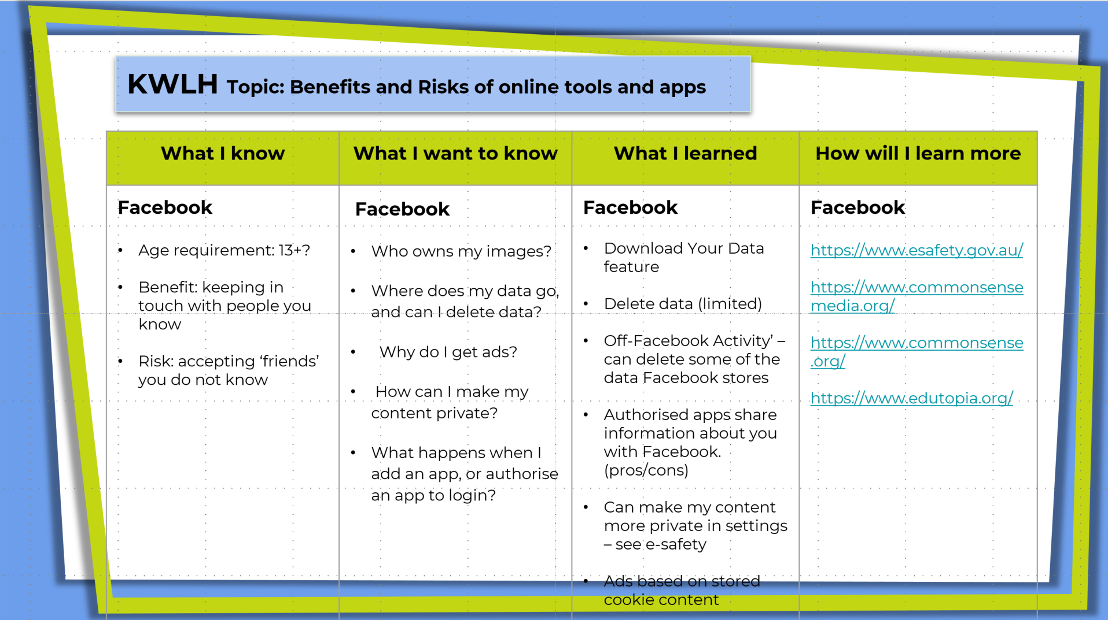

What I KNOW | What I WANT to know | What have I LEARNED? | HOW will I learn more?
Facebook  - Age requirement: 13+?  - Risk: accepting ‘friends’ you do not know  - Benefit: keeping in touch with people you know | Facebook  - Who owns my images?  - Where does my data go, and can I delete data?  - Why do I get ads?  - How can I make my content private?  - What happens when I add an app, or authorise an app to login? | Facebook  - Download Your Data feature  - Delete data (limited)  - ‘Off-Facebook Activity’ – can delete some of the data Facebook stores  - Authorise apps –share information with Facebook. May consider avoiding Facebook as a login for different companies  - Can make my content more private in settings – see e-safety  - Ads are based on stored cookie information | Facebook  [Complete after investigating]

Activity 3
Distribute KWHL template (Digitally or paper based)
https://app.education.nsw.gov.au/digital-learning-selector/LearningActivity/Card/562#.X0RUTtNIMRg.link
Step 1
In groups, students investigate apps identified in the whole class brainstorm activity. They investigate at least one app for each of the categories:
- Creativity
- Entertainment
- social communication
In small groups, students create a KWLH chart. In the KWLH chart they write down what they know about the risks and benefits of those apps.
Step 2
Inform students that they will now research the questions they identified in the 2nd column.
Show completed Facebook sample ‘What I have learned’
Distribute Google Search Skills resource. Demonstrate how to search. For example, show a basic search compared to searching only a specific site.
Step 3
Students research and complete the third and fourth columns.

Create
In small groups, use your KWHL chart to create a presentation addressing the question and your chosen apps. In your presentation, ensure that you outline the benefits and risks of devices and online tools/apps as well as provide an educational recommendation.
Divide your presentation into appropriate sections [Benefits, Risks, Recommendations] so each member can present part of the research.
Include a slide deck of no more than 5 slides.
Jigsaw presentation template
You may wish to use the jig saw template from the Digital Learning Selector.
https://app.education.nsw.gov.au/digital-learning-selector/LearningActivity/Card/546

Tips for a good presentation
When creating your presentation, keep in mind the following three tips:
- Keep it simple – avoid animations and transitions where possible
- Limit the amount of text. Only include essential details
- Use appropriate charts or infographics

Other create options
- Create an investigate TV report
- Design and build a website with embedded multimedia content (Google Site or other)

Present
Present your research to your teacher.

Other options:
Select a presentation to go to the Executive, or Staff meeting
Video a presentation and distribute on the staff intranet
Modify the project presentation – Students create a news story on their research. See video scaffold

Resource: Google Search Skills
The following items show how to use a search engine.

Simple search
Type in key words and phrases: For example, Facebook privacy

Search for a specific site
Put "site:" in front of a site or domain. For example, site:youtube.com or site:.gov.

Combine searches
Put "OR" between each search query. For example, marathon OR race.

Search for an exact match
Put a word or phrase inside quotes. For example, "tallest building".

Exclude words from your search
Put - in front of a word you want to leave out. For example, jaguar speed –car
Useful sites:
https://www.esafety.gov.au/
https://www.commonsensemedia.org/
https://www.commonsense.org/
https://www.edutopia.org/

Resource: Suggested Apps list
The following apps are selected from the e-safety site. This is an appropriate selection of apps from their e-safety guide rather than all the apps they mention.

Apps from the e-safety guide
Zoom  Houseparty  TikTok  Instagram  Snapchap  Omegle  Roblox  Minecrat  Facebook  Animal Jam  Blackboard Collaborate  Blogger  Dubsmash | Edmodo  Episode  Facey  Flickr  Periscope  Reddit  Scrabble Go  Spot-a-friend  Tumblr  Twitter  Twitch  WeChat  WhatsApp
The following apps have been tagged as creativity apps, some may have educational value. They are provided as other possible apps to investigate.
Creativity Apps
BrainSparker  SimpleMind  Coffitivity  Unstuck  Curator  Adobe XD  Lingo  Duolingo | Bez  SketchBook Pro  Blek  Ideament  Notability  Tayusai Sketches  Procreate  Boomerang
You can find a list of creativity apps from common sense media. The list is ordered by age appropriateness, from youngest to oldest.
https://www.commonsensemedia.org/lists/best-creative-apps
The Department of Education also has some apps listed on its Antibullying page

Video script scaffold
- Introduction [introduce and outline the story. Generally walking to camera]
Today we…

- Background [provide some background purpose for the story. Images could include people using apps – b-roll]

- Expert interview 1 [Medium shot: expert providing key parts of your findings – cut between interview and b-roll]
The facts are clear…

[May need journalist to link the interviews]
- Expert interview 2 [Medium shot: expert providing key parts of your findings – cut between interview and b-roll]
The benefits of…

- Journalist Conclusion [Highlight key findings and provide a recommendation ]
We can conclude that…

Video production resource
Learn how to edit and produce video via The Student Filmmaker resource

Pilot evaluation
- What year group did you use the resource for? [click and select]
- What worked in the resource? [open text]
- What didn’t work in the resource? [open text]
- How appropriate was the resource for your year group? [click and select]
- Where were the gaps in the resource that you needed to fill? [open text]
- What presentation method did your students use? [click and select]
- Do you have any feedback on tcreate and present options? [open text]

