Introducing the physical domain:

a discussion paper for school leaders and teachers
High potential and gifted education P-12
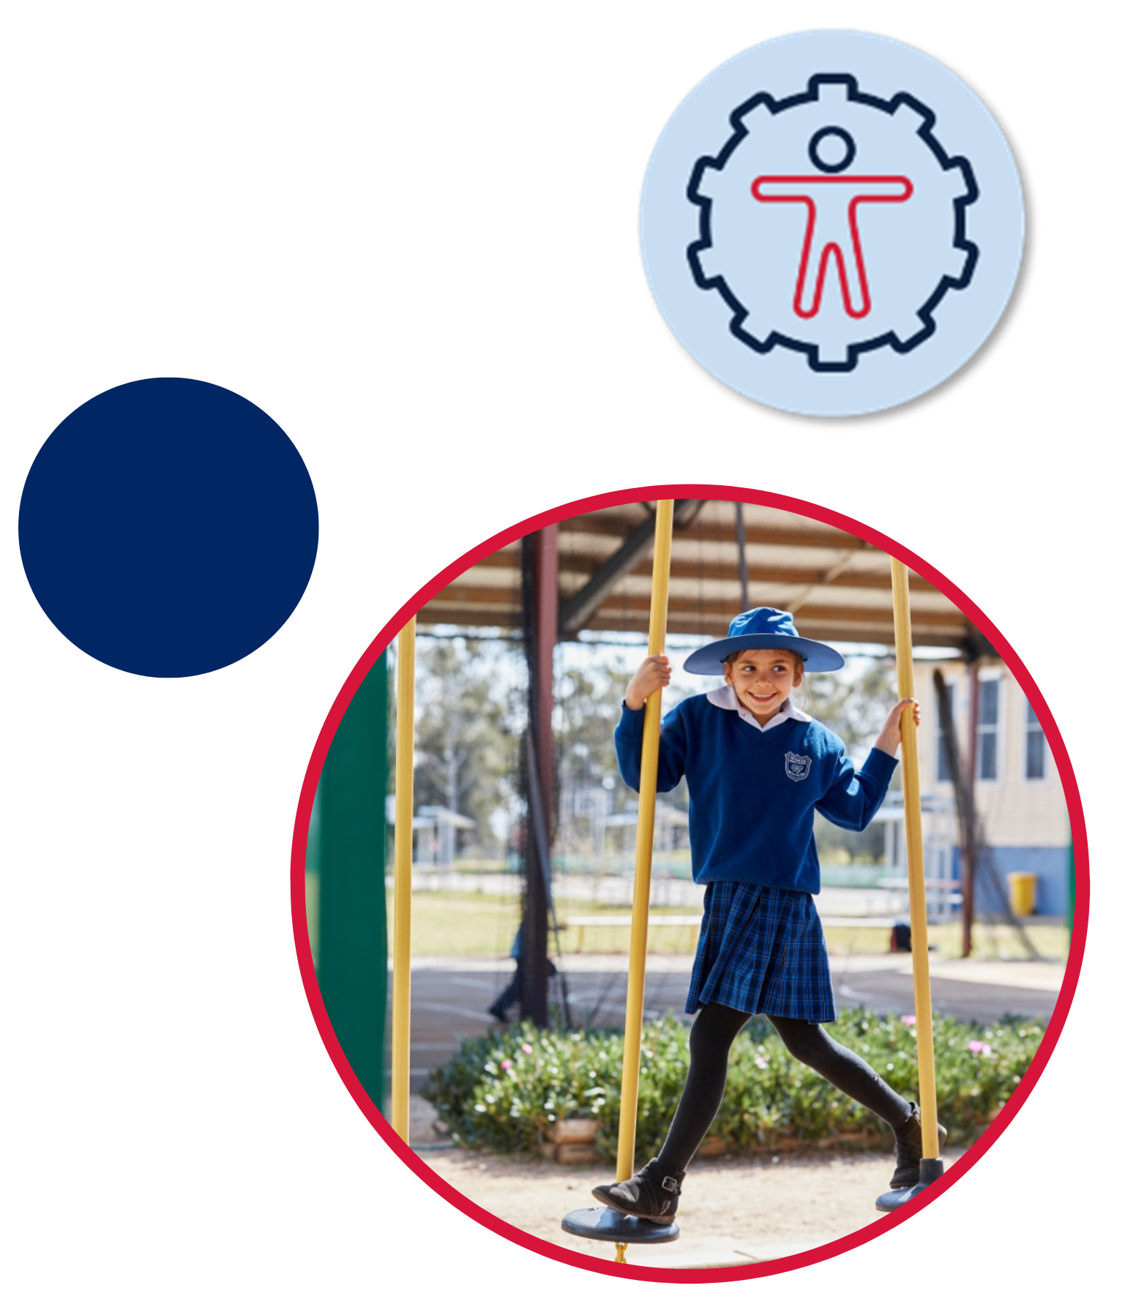

Contents
Introduction 3
What is the physical domain? 4
Finding high potential in the physical domain 6
Talent development in the physical domain 9
Talent development in the physical domain and disability 13
Practical strategies for schools 15
Practical strategies for teachers 19
Opportunities beyond the school 23
Conclusion 25
Appendices 26
Appendix A – Françoys Gagné's DMGT (DMGT 2.0 2009) 26
Appendix B – supporting high potential and gifted education 27
Appendix C – examples of non-sport and sport specific instruments 28
Appendix D – instruments to assess high potential in the physical domain 29
Appendix E – characteristics leading to career opportunities 30
Appendix F – talent development trajectories 32
Appendix G – HPGE Policy Evaluation and Planning Tool Version 2.0 33
References 36

The NSW Department of Education would like to acknowledge the contribution of University of New South Wales and A/Professor Jae Yup Jared Jung, Director GERRIC, in the development of this paper and for the authorship of the systematic literature review: ‘Physical giftedness/talent: A systematic review of the literature on identification and development’.

Introduction
This paper is a synthesis of the research and practice associated with educating and supporting high potential and gifted students in the physical domain. It has been developed to supplement other domain discussion papers and the Revisiting Gifted Education literature review.
The department utilises an adapted version of Françoys Gagné's Building gifts into talents: Brief overview of the DMGT 2.0 (DMGT 2.0, 2009). This model describes 4 domains of potential: creative, intellectual, physical and social-emotional (Appendix A).
Students may have high potential in one or more domains. While this paper focuses on the physical domain, it is important to note that the domains do not stand in isolation but relate to and interact with each other.
As with all domains of potential, high expectations and effective, explicit, evidence-based teaching create optimal learning environments where all students are challenged and engaged to achieve educational potential.
The physical domain explored in this paper is supported by other policies, frameworks, and documents (Appendix B).

What is the physical domain?
The NSW Department of Education defines the physical domain of potential as natural abilities in muscular movement and motor control. (Gagné 2009; Farley et al. 2022). Signs of high potential in the physical domain may include:
- power
- speed
- muscular strength
- endurance
- flexibility
- speed of reflexes
- agility
- coordination and balance.
These signs are not a checklist to be ticked off. They should be understood as signposts to alert school leaders and teachers to students with high potential. Some signs or indicators may be hidden. For instance, disability or underachievement may exclude or disguise indicators of high potential.
Research raises questions as to what extent students in the physical domain are being assessed, identified, and supported (Jung 2022; Lovell et al. 2019; Prieto-Ayuso et al. 2021; Tranckle and Cushion 2006). This research questions the:
- rigour and defensibility of identification processes
- degree of support for the range of physical disciplines
- level of ongoing support provided to identified students.
A reliance on external bodies for identification and support in the physical domain (Jung 2022; Lovell et al. 2019; Prieto-Ayuso et al. 2021; Tranckle and Cushion 2006) suggests the importance of teacher professional learning to effectively assess, identify and support students.
A review commissioned by the NSW Department of Education (Jung 2022) identified key findings related to identification and development of high potential students in the physical domain:
- Gagné’s (2003; 2009) Differentiated Model of Giftedness and Talent is commonly recommended by academics to guide identification and support of students with high potential in the physical domain (Bailey and Morley 2006; Tranckle and Cushion 2006).
- Multiple studies have been devoted to gaining an understanding of anthropometric (measurements of standing height and body mass) and physical performance profiles of young athletes across a range of disciplines including soccer, Australian football, handball, volleyball, gymnastics, rugby league, and ice hockey.
- Characteristics such as speed, aerobic capacity and motor coordination are important predictors of future success in some sports. The significance can differ between sports and may be non-linear and age dependent.
- Biological maturation and the relative age effect (for example, timing of birth within an age category) may affect the talent identification process. There is a common misconception that early maturers and older students are more likely to have high potential. This demonstrates the need for ongoing assessment and identification.
- Identification ideally incorporates both objective and subjective assessments.
- Several non-sport specific and sport-specific identification instruments are useful in the identification of high potential and gifted students in the physical domain (with examples listed in Appendix C.
- Assessments which include a range of characteristics provide a more holistic perspective to inform talent development. Examples of assessment instruments include anthropometric, physical performance, motor coordination, sports-specific technical skills, cognitive, psychological, tactical, and social (Appendix D).
- Programs that support wellbeing and motivation, including mentor programs, are beneficial in developing talent in the physical domain.

Finding high potential in the physical domain
Knowing students well can assist teachers with recognising high potential in the physical domain. Teachers can create opportunities to observe the relative ease and speed of learning when compared to age peers that may indicate high potential (Gagné 2020). However the impact of early maturation within an age group can lead to students being misidentified (Furley and Memmert, 2016; Peña-González et al., 2021; Till et al., 2017; Toum et al., 2020; Towlson et al., 2017).
School leaders and teachers can look for high potential through positive indicators. Recognising natural abilities in the physical domain through counterproductive behaviours should also be considered.
Teachers can look for characteristics such as growth mindset, motivation, and persistence, (Olszewski-Kubilius et al., 2020). Characteristics may include the ability to cope, balance interests and views of self and others (Baltes and Staudinger, 2000). This is an example of how domains of potential (such as the social-emotional domain) may intersect and relate to the physical domain.
The definition, signs or indicators and characteristics of high potential in the physical domain are summarised in Figure 1.
Figure 1 – Physical domain definitions, signs, and characteristics
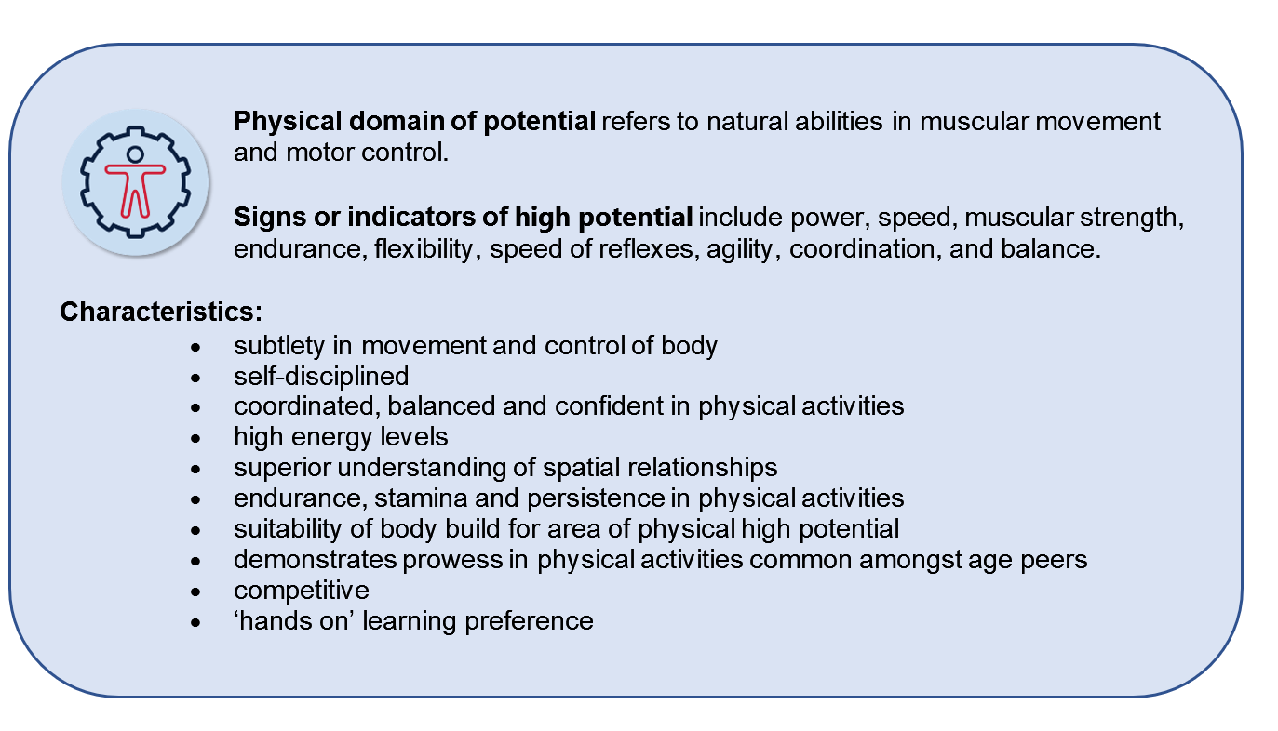
Image adapted from Gagné 2009; NSW Department of Education, 2023.
It is important to note that these characteristics should be used as one source of evidence when recognising high potential. This is not an exhaustive list, nor is it a checklist.
High potential in the physical domain may be observed in a range of contexts, such as sport, dance and performance. High potential students in the physical domain may have a variety of possible career opportunities or future interests (Appendix E).
The school plays an integral role in both identifying and maximising inclusion of students from all backgrounds (Pion, Segers, et al. 2015). Assessing potential through formative assessment provides teachers with an understanding of student ability over time. Appropriate training for teachers is important for effective identification of high potential in the physical domain (Jung 2022). Multiple identification criteria are recommended (Dobbin et al. 2019; Dugdale et al. 2020; Lidor et al. 2007). These may include:
- physical performance
- motor coordination
- specific technical skills
- cognitive, psychological, tactical and social characteristics
- anthropometric measurements (human body size).
Assessment of characteristics such as speed, aerobic capacity and motor coordination, have often been recognised as predictive of future success.
As mentioned, early physical maturation and/or having an early birth date within an age category may lead to the misconception that a student has higher potential than peers due to body size (anthropometrics) and physical performance characteristics (Furley and Memmert 2016; Peña-González et al. 2021; Till et al. 2017; Toum et al. 2020; Towlson et al. 2017). Students who develop later may not be recognised or re-assessed for indications of high potential. Strategies to address this include:
- teacher professional learning about biological maturation and the relative age effect (Andronikos et al. 2016; Coutts et al. 2014)
- identification of high potential based on maturity categories rather than age categories (Lovell et al. 2019; Peña-González et al. 2018)
- a focus on characteristics less influenced by biological maturation or relative age (for example, motor competence, sports-specific skills and other technical skills) in identification processes (Andronikos et al. 2016; Toum et al. 2020; Votteler and Höner 2014)
- the establishment of development pathways targeted specifically at late maturers (Myburgh et al. 2016)
- a greater focus on long term performance in the identification process (Andronikos et al. 2016; Coutts et al. 2014; Helsen et al. 2005)
- avoidance of over reliance on early identification (Andronikos et al., 2016)
- using a range of instruments to assess high potential in the physical domain (Appendix D)
- a combination of established and alternative approaches such as auditions, tryouts and rating scales.

Talent development in the physical domain
Talent development is the process by which a student’s potential is developed into high achievement in a specific domain or field of endeavour (HPGE Policy 2019).
Professor Françoys Gagné (adapted DMGT 2.0 Appendix A) describes the influence of internal and external catalysts during talent development. Schools can play an integral role by being:
- a catalyst in the talent development process
- aware of catalysts which may impact the development of talent.
Natural physical abilities can be nurtured or hindered under the influence of a range of catalysts including:
- age and physical size
- systematic practice and training
- motivation and perseverance
- scaffolding and explicit teaching
- resource and/or equipment availability
- lack of access to appropriate provisions and resources, such as enrichment, grouping or acceleration
- lack of opportunities
- mindsets and wellbeing, including significant events or trauma
- opportunities which enable a high level of challenge
- remote or isolated location
- low socio-economic background
- social and/or cultural norms or expectations
- influence of significant others (mentors, family, teachers, peers, role models)
- ‘forced-choice dilemma’ where students are torn between acceptance and the pursuit of high achievement (Jung et al. 2012)
- chance factors.
Talent development that is hindered may lead to:
- underachievement
- challenging behaviours and attitudes
- disengagement and withdrawal
- school refusal
- questioning of authority
- low self-esteem or low resilience
- mental health challenges such as anxiety
- maladaptive perfectionism.
Olszewski-Kubilius et al. (2020) noted that teachers can explicitly address counterproductive behaviours which may hinder talent development through:
- an understanding of maladaptive perfectionism and a focus on social-emotional learning that promotes a growth mindset, goal management and positive self-concept
- an understanding of asynchronous development across and within domains
- holistic provision of appropriate strategies
- explicit teaching of social-emotional skills at point of need.
Within the physical domain, disciplines may have different trajectories (Appendix F) which affect windows of opportunity for talent development (Subotnik et al. 2011:39). Some disciplines may require early identification and have a limited time span for talent development. Other disciplines such as performing arts are not as time restricted. It is essential that schools are aware of these different windows of opportunity.
Opportunities need to be appropriately pitched to student capabilities. Taylor and Collins (2019) noted the importance of appropriate challenge, a progressive increase in demands, and adequate support for transitions into higher developmental levels such as accelerated contexts. Support could include regular check-in sessions with a mentor or school counsellor.
To provide appropriate levels of challenge, specific educational interventions can include modifications to standard game rules, changes to the size of pitch, and the introduction of handicaps (Renshaw and Chow 2019). Interventions should be purposefully designed to:
- promote development in a wide range of skills from current levels (Portenga 2017)
- acknowledge individual variations in the talent development trajectory (Phillips et al. 2010)
- be accompanied by continued encouragement and opportunities for appropriate training and nurturance (Bailey and Morley 2006).
A range of non-sport specific and sport-specific talent development interventions can be effective for high potential and gifted athletes. Programs designed to promote lifelong physical activity and talent development in children are examples of effective non-sport specific intervention (Collins et al. 2010). An example of an effective sport specific intervention is a small-sided games program designed to develop bio motor abilities (such as speed, agility, power and aerobic capacity) in soccer (Suraci et al. 2021).
Data and ongoing assessment can inform talent development. Consider domain-general interventions designed to support and enhance the cognitive, psychological, tactical and social characteristics/skills of physically gifted students. Holt et al. (2012) found the following interventions effective:
- the development of self-set goals, including discipline-specific aspirational benchmarks
- peer assessments of performance
- group rewards for meeting goals.
Explicit teaching of social-emotional skills can also assist with talent development in the physical domain. Resilience building through disruption scenarios includes demands such as:
- last minute changes to location
- rewards and consequences
- physical strain
- stronger competition
- injury to self or team members
- distractions such as audience behaviours or heavy rainfall
- perceived unfairness
- restrictions.
These examples identified by Kegelaers et al. (2020) promote increased familiarity with pressure and greater awareness of possible reactions to adverse situations.
Personal psychological strength skills (Subotnik 2011) also include:
- self-regulation
- confidence
- motivation/commitment to training
- coping (Taylor and Collins 2019; Gonçalves et al. 2014).
These skills promote 'active, strategic, self-aware, reflective, and motivationally driven' practice in physical talent development (Portenga 2017:126). Abbott and Collins suggest that promotion of such psycho-behavioural skills, along with motor skills may 'enable all pupils to achieve their sporting potential whilst also equipping them for the pursuit of excellence in other spheres' (Abbott and Collins 2002:175).

Talent development in the physical domain and disability
School leaders have a responsibility to ensure all students are supported to perform to the best of their ability. This includes identifying and supporting professional learning needs of staff to support the inclusion of students with disability, as outlined in the Inclusive Education for students with disability policy.
A student’s learning disability may not necessarily impede talent development in the physical domain. For Olympic swimmer Michael Phelps, ADHD (attention deficit hyperactivity disorder) was a catalyst in his talent development. Phelps explains in paragraph 10 of an article published by Understood, ‘I could go fast in the pool, it turned out, in part because being in the pool slowed down my mind. In the water, I felt for the first time, in control’ (Understood n.d.). The department’s illustrations of practice for Brooke, Tilly and Tate are examples of useful professional learning resources to enhance staff understanding of high potential and gifted students with disability.
High potential and gifted students with disability in the physical domain require programs that focus on talent development and strengths. For programs to be inclusive of a student’s high potential they should:
- provide appropriate and reasonable support and adjustments to allow access to the same opportunities as other students
- ensure similar opportunities for advanced learning and development are available as would be provided to other high potential and gifted students
- provide personalised adjustments based on assessed needs of the student in consultation with the student, their parents and carers, the school support team and external providers when required.
Teachers of high potential and gifted students with disability in the physical domain can:
- follow the same procedures for disability support as outlined under Every Student, Every School and other relevant policies and procedures
- collaborate with students, their families, and external providers such as medical professionals, to share diagnostic and achievement information that helps build learning plans which address talent development and adjustments for disability
- provide additional support addressing the complexity of both disability and high potential, including enhanced individual learning plans and support through their school services teams.
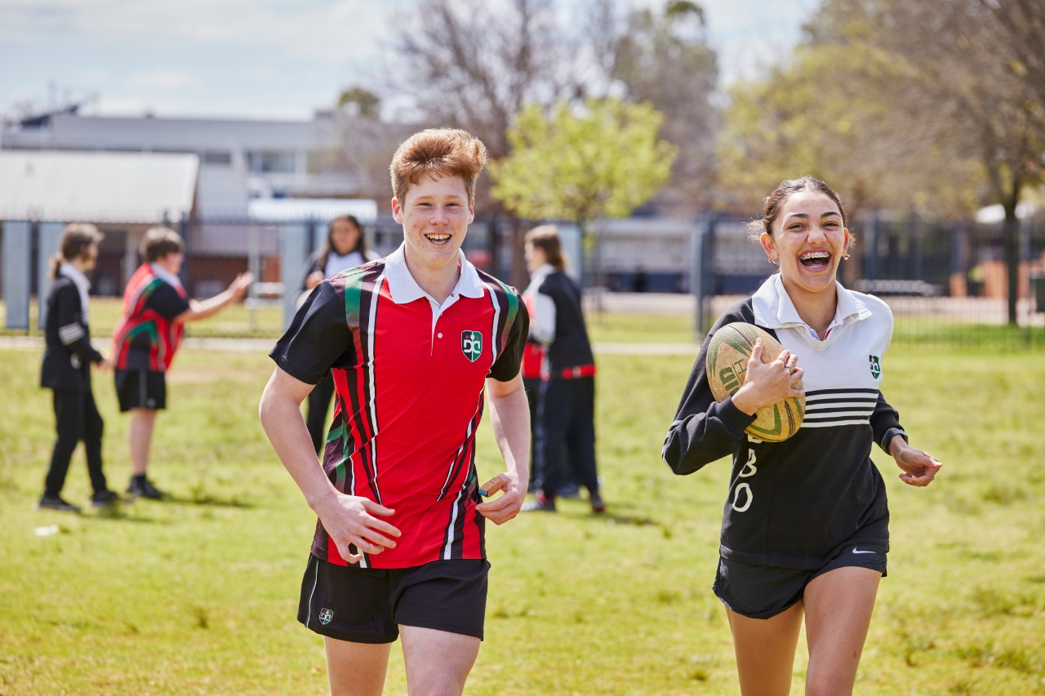

Practical strategies for schools
Whole school practices ensure smooth transition from high potential to high performance. Schools should proactively plan to embed whole-school practices and programs in the physical domain. The HPGE Evaluation and Planning Tool provides practical strategies to assist schools with whole school planning (Appendix G).
Schools are responsible for providing access to professional learning, including knowledge of identification strategies, and teaching and learning strategies. Teachers should be provided with:
- training in developing high potential and giftedness in the physical domain
- relevant knowledge about strategies to support talent development
- organised time to support high potential and gifted students, and recognition of the importance of talent development within school settings (Prieto-Ayuso et al. 2021).
School leaders should actively seek online and face-to-face professional learning opportunities and teaching resources. To develop talent in sport, for example, the School Sport Unit has both teaching resources and online professional learning.
School programs should include appropriate levels of challenge and support. Effective programs include:
- high expectations from school leaders, teachers, peers and the students themselves to ensure maximisation of potential
- self-reflection and feedback to develop a growth mindset and assist in guiding student choices and promoting engagement
- measurement of the evidence of impact related to procedures, programs and practices to inform next steps
- explicit teaching to maximise new learning of physical skills at any level. While students with high potential in the physical domain may display advanced learning compared to their age peers, research indicates the benefits of explicit teaching for them when learning a new skill (Martin 2017)
- deliberate practice through a broad range of real-world contexts for new learning to become automatic. Varied contexts are important, for example consider the different ways one student might engage with problem-solving in the physical domain with a younger student, a peer, an older student or an adult
- extension of skills and knowledge so skills can be applied within the classroom, across the school and in the broader community
- individual goal setting, peer assessments of performance and group rewards for reaching goals (Holt et al. 2012 in Jung 2022) and both structured 'practice' activities and unstructured 'play' activities
- social-emotional development that explicitly assists students to cope with stresses, perfectionism, family or team pressure
- professional learning opportunities for teachers, counsellors and carers to identify and support psychological issues which may be demonstrated through behaviours such as anxiety, perfectionism or depression (Hill et al. 2016 in Jung 2022).
Examples of school procedures, programs and practices for talent development in the physical domain include:
- access to mentors, such as peer mentoring and mentors from student’s area of interest, leadership of a group or extracurricular activity
- opportunities to observe other students with higher ability. For example, dance and drama workshops and performances, sports training sessions or games
- general physical skills criteria in team or performance group selection; this can aid identification of potential in students who may not have previously had access to specific training in that discipline
- expert discussion or interest-based groups with other like-minded individuals, across schools or externally
- grouping with others of similar capabilities and developmental levels including provisions such as acceleration with age peers or into higher age year groups
- support for transition into higher development levels (Taylor and Collins 2019)
- interventions to support and enhance the whole student including cognitive, psychological, tactical and social-emotional skills
- career choices and mentoring for secondary students to plan and constructively work towards their career aspirations (Hébert 2011)
- career pathway support, including internships and role models, student voice at staff, school, and community meetings
- vocational training (VET in-school or in partnership with other schools)
- student-led community programs
- pull out programs or individualised education/training programs specifically tailored to the student’s needs (Bailey and Morley 2006)
- extra-curricular activities such as master classes in sport, drama, or dance
- integrated curriculum opportunities such as HSC workshops
- school teams for intra-and inter-school opportunities
- nominations for talent development programs from departmental organisations such as the Sports Unit or external providers
- drawing on teachers', older peers’ or alumni talents and expertise
- capitalising on external bodies that deliver complimentary in-school experiences
- viewing and discussing illustrations of practice about the physical domain
- appropriate challenge, progressive increase in demands (Taylor and Collins 2019) which may include:
- modification to standard game rules, changes to the size of pitch and the introduction of handicaps (Renshaw and Chow 2019)
- the Sport Australia’s CHANGE IT model, the Australian Sports Commission TREE model and Professional Skills Programs
- changes to location, stronger competition, distraction, and restrictions to increase familiarisation with pressure, greater self-awareness and resilience (Kegelaers et al. 2020).
While these activities may seem to preference older students, it is essential to ensure that opportunities are available for students from all backgrounds, and across all year groups. Younger students can be afforded the same level of opportunity, however they may require further explicit teaching and support (Taylor and Collins 2019).
Exposing students to different options over time can be relevant for students who do not have access to the range of opportunities due to geographic isolation or disadvantage and may include performance opportunities.
Formative assessment is crucial in identifying the ongoing needs of students to ensure talent trajectories continue. It assists school leaders and teachers to recognise those who may be at risk of disengagement. It allows teachers to identify barriers and develop strategies to re-engage students.
Ongoing assessment assists with the development of aspirational benchmarks for future performance. Monitoring, evaluation and student self-assessment are essential in developing the sustainable effectiveness of any procedure, program or practice.
Multiple criteria assessment instruments (Appendix D) can assess individual student’s diverse characteristics in the physical domain (for example, anthropometric, physical performance, motor coordination, sports-specific technical skills, cognitive, psychological, tactical and social skills).

Practical strategies for teachers
Figure 2 illustrates the development of high potential into high performance through a systematic development process.
Figure 2 – The talent development process
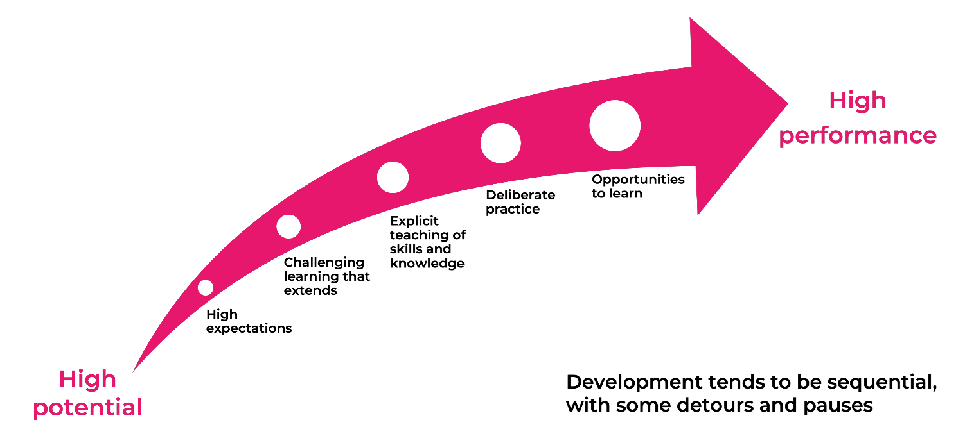
Teachers can capitalise on interests, strengths and areas where students may need support for talent development. A pro-active and systematic approach (Jung 2022) allows teachers to provide appropriate challenge and opportunities.
To support students with talent development, teachers should be familiar with students’ passions to build on motivation. Teachers can then develop students’ skills, knowledge and values which support development in the physical domain. These may include:
- resilience
- confidence
- value of constructive criticism
- good sportsmanship.
Teachers can consider sharing student stories of talent development or interviews and/or autobiographies of talented performers within the physical domain. This assists students to develop a more individualised method, style or approach (Subotnik, R. et al. 2011).
Student and parent/carer surveys and discussions can be critical in discovering student passion and interest in the physical domain. Student potential could otherwise go unrecognised if that interest is not offered within a curriculum, for example, drumming, a specific dance genre such as ballroom dancing, and sports such as horse-riding or rowing. Knowing student interests can allow schools to offer opportunities for representation at regional and zone competitions, and community events. Information should be shared across the school so all staff can engage students through their interests.
Establishing a risk-free learning environment can maximise learning through experience and error (see Differentiation adjustment tool – learning environment). Content can be enriched or accelerated, learning processes scaffolded and more student-directed teaching can occur (Tomlinson 2014; Smith 2009, 2017b; Van Tassel-Baska 2013).
Ongoing assessment is necessary to identify student needs and helps to ensure that high potential is not overlooked. For example, in PDHPE this may include ongoing tests to track improvement in fitness elements such as cardiovascular fitness, flexibility, hand-eye co-ordination and strength. These can demonstrate a rapid rate of learning whereas performance of previously identified students may remain more constant as their ability was more strongly linked to prior experiences.
Key questions for teachers to consider include:
- How can student motivation be positively focused?
- How can opportunities be provided for demonstration of high potential or achievement?
- What provisions have been put in place? How effective are they? For example, a mentoring process, monitoring of an advanced learning pathway or independent learning contract.
- Are there socio-economic or geographical factors which may impede talent development? For example, accessing training in a rural area or by public transport, required adult supervision for training or events, and cost of equipment, coaching and attendance at regional or national competitions or performances.
- How can opportunities be provided for like-minded peers to work together within and outside of the classroom? This may include opportunities to develop technical skills, train, compete or perform with others of similar ability or older student mentors.
- How can students be provided opportunities to excel in disciplines not offered by the school? For example, circus skills, fencing, archery or ballet.
- How else might students be extended to improve endurance, flexibility, strength, and coordination? For example, using a different discipline for cross training such as a dance genre or performance area, self-defence or sport.
- How are all students informed of opportunities within and outside of the school? For example: interschool sport knockouts, PSSA (Primary Schools Sports Association) and CHS (Combined High Schools Sports Associations) competitions, zone teams regional and state dance festivals, external performances, clubs, training days and specialist workshops
- Does the student possess resilience, a positive temperament and perseverance? How can this be further developed?
- Does the student have a health issue that could impact participation and /or performance? For example, asthma, eczema or chronic fatigue to manage.
- Does the student have a disability that could impact on their talent development? What adjustments need to be made?
- Are there identified skills or gaps that need to be developed? For example, choreography, technique, tactics or decision making.
- Are there cultural, language and/or social factors that may support or impede talent development? For example, some cultures value team sports or group performances over individual sports and solo performances.
- What are the impacts of family, peers, coaches and teachers?
Providing self-assessment opportunities for students is essential in supporting development of potential in the physical domain. Strategies for self-reflection include:
- scoring activities recording how many times a student meets a target/goal
- student-led progressive overload (gradually increasing weight, frequency or repetitions)
- charts or tables recording progress over time
- photos, audio or video footage for analysis of targeted skills or technique needing improvement
- peer and teacher feedback unpacked with the student
- student learning portfolios.
Teachers can assist students in active self-reflection and self-management for improved performance. Students will need to be explicitly taught how to increase resilience and cope with setbacks and perceived failures such as injuries, illness, bias and poor performance.

Opportunities beyond the school
Schools play a crucial role in informing students, parents and carers about opportunities to foster talent development outside of the school.
For sport this could include:
- talent identification programs
- information about upcoming events through the NSW Institute of Sport or the School Sport Unit
- Australian Olympic Committee opportunities
- Netball Australia coaching
- Schools Rugby League support
- older students complete a coaching course and then coach students from a feeder primary school
- representative school sports pathways (zone, regional, state and national) for many sports, including tennis, rugby, swimming and golf.
Identification programs and testing days measure students’ physical attributes and skills and can lead to suggestions for sports that they may be suited to but may never have previously considered. There are also many competitions such as eisteddfods, auditions for state dance troupes, and opportunities to perform at community events. These develop talent through high challenge and the opportunity to learn with like-minded peers.
The Arts unit provides information about opportunities beyond school for students with high potential in dance and drama through the Schools Spectacular and their connections program. They also offer professional learning opportunities for teachers to offer challenge to students, for example, in dance disciplines. Online auditions are held for the Aboriginal Dance Ensemble as part of School Spectacular. Selected students work with high profile Aboriginal performing artists to create a performance. Bangarra Dance Theatre’s partnership with the arts unit (NSW) is designed to develop cultural awareness, as well as dance and performance skills in Aboriginal and Torres Strait Islander students.
Facilitating shared enrolment or partial attendance can support physical pursuits when the school is unable to offer the appropriate level of talent development. Partnerships with organisations such as universities can provide additional expertise and role modelling for students and teachers. Schools could host past students as coaches, mentors or inspirational speakers.
Schools can liaise with local sporting, gymnastic, self-defence, drama or dance clubs and associations to see if they can provide information or demonstration sessions. Students can also be made aware of eisteddfods, regional and state festivals, and community events. Community members could be invited to share expertise or skills.
As an example of a national sporting pathway framework, The Australian Institute of Sport (AIS) has developed the Foundations, Talent, Elite and Mastery framework (FTEM framework). This provides a practical tool to assist stakeholders, for example, teachers, parents, coaches, and national sports bodies, to review, plan and support talent development in athletics.

Conclusion
School leaders and teachers play a crucial role in assessing, identifying needs and supporting the talent development of high potential and gifted students in the physical domain.
Consideration of student diversity, individual competencies, learning environments and educational expertise is required when identifying the needs of high potential students. This consideration enables effective planning for physical domain talent development programs, practices, and procedures.
Talent development in the physical domain can be achieved through authentic and inclusive approaches that are flexible, strength-based, deliberate, and developmental or growth-orientated (McCluskey 2018).

Appendices

Appendix A – Françoys Gagné's DMGT (DMGT 2.0 2009)
In his Differentiated Model of Giftedness and Talent (see Figure 3 adapted DMGT), Gagné defines 4 domains of giftedness, of which being physically gifted is one. Gagné’s DMGT 2.0 (2009) describes high potential and gifted students in the physical domain as those who typically demonstrate natural abilities in muscular movement and motor control; that is, 'muscular (GM) abilities devoted to large physical movements and abilities representing motor control and reflexes (GR)'. However, 'both usually contribute to complex physical activities, for example, tennis, baseball, gymnastics' (Gagné 2009:65).
Figure 3 – Gagne's Adapted Differentiated Model of Giftedness and Talent (DMGT) 2.0 (2009), NSW Department of Education (2019)
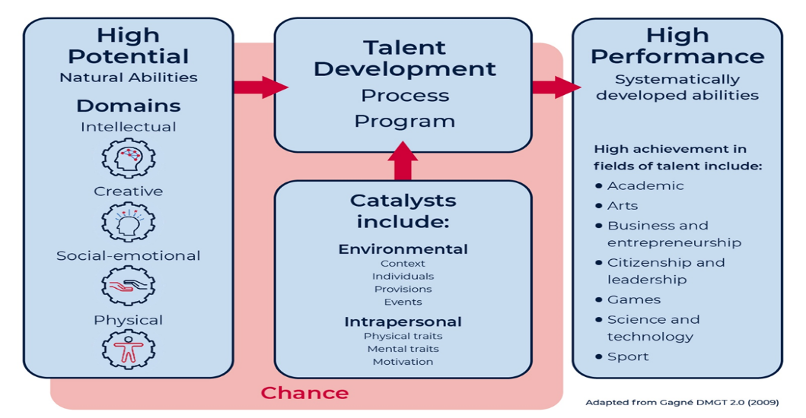
Natural abilities can develop throughout a person’s life. For high potential and gifted students, they are more likely to manifest in the younger years where limited systematic activities have begun to transform ability into developed competencies or mastery.
The talent development process involves movement from novice to expert. The ease and speed at which this occurs provides evidence of high potential (Gagne 2020).

Appendix B – supporting high potential and gifted education
The New South Wales Education Act 1990: every child should be assisted to achieve to his/her educational potential, and opportunities should be provided for every child with special abilities (New South Wales Education Act 1990 [NSW] s. 4. [Austrl.]).
School Excellence Framework: there is a need to pursue ‘excellence and the provision of high-quality educational opportunities for each and every child’ (New South Wales Government 2017:1).
Wellbeing Framework for Schools: one of the specified areas for focus in the Wellbeing Framework for Schools is the promotion of physical wellbeing among students (New South Wales Department of Education and Communities 2015).
New South Wales Department of Education curriculum: Personal Development, Health and Physical Education (PDHPE) is one of the Key Learning Areas of the New South Wales Curriculum (New South Wales Education Standards Authority 2021).
New South Wales physical literacy continuum K-10: New South Wales Department of Education 2022.
New South Wales High Potential and Gifted Education Policy: High potential and giftedness in the physical domain is one of the 4 domains (intellectual, creative, social-emotional and physical) addressed in the New South Wales High Potential and Gifted Education Policy (New South Wales Department of Education 2019).
Inclusive Education for students with disability Policy: New South Wales Department of Education (2022).
Every student, Every School: learning and support (New South Wales Department of Education March 2012).

Appendix C – examples of non-sport and sport specific instruments
Examples of non-sport identification instruments:
- Flemish Sports Compass comprising 22 tests of anthropometrics, physical performance and motor co-ordination (Pion, Segers, et al. 2015)
- the Körperkoordinations Test für Kinder (KTK); a motor battery that comprises subtests in walking backwards, moving sideways, jumping sideways and hopping for height (Kiphard and Schilling 2007)
- Developing the Potential of Young People in Sport is an educational program designed to promote lifelong physical activity and talent development in children (Collins et al. 2010).
Examples of sports-specific identification instruments:
- a judo-specific ability test (comprising 10 stations that each assess a physical ability or skill) described in Lidor, Melnik et al. (2005)
- an Australian football kicking assessment outlined in Bonney et al. (2020)
- small-sided games, which have been demonstrated to be useful in the development of bio motor abilities (such as, speed, agility, power and aerobic capacity) in soccer (Suraci et al. 2021).

Appendix D – instruments to assess high potential in the physical domain
Table 1 – instruments to assess high potential in the physical domain
Key indicator | Instrument example
- anthropometrics (height) | - stadiometer
- anthropometrics (body mass) | - weighing scale
- physical performance (speed) | - stopwatch to assess time over a standard distance
- physical performance (flexibility) | - sit-and-reach and other similar tests
- physical performance (strength) | - dynamometer
- physical performance (endurance) | - Yo-Yo intermittent endurance test
- physical performance (power) | - medicine ball throw
- motor co-ordination | - Körperkoordinations Test für Kinder (KTK)
- sports-specific technical characteristics/skills | - service accuracy at rest test (volleyball; Lidor et al. 2007)
- cognitive characteristics/skills | - IQ tests (WISC-V or Stanford Binet 5)
- psychological characteristics/skills | - coach ratings of confidence, competitiveness, X-Factor, and positive attitude (Towlson et al. 2021)
- tactical characteristics/skills | - coach observations of game intelligence on criteria including decision making, positioning, anticipation, and timing (Falk et al. 2004)
- social characteristics/skills | - performance appraisal interviews (Kilger and Jonsson 2017)

Appendix E – characteristics leading to career opportunities
Table 2 – characteristics of high potential in the physical domain exhibited within school and over time
As students: | Within a range of disciplines over time:
- coaching or mentoring  - involvement in multiple extra-curricular activities, for example, dance and martial arts  - fitness advocates leader/captain of physical activity or sport  - strong self-reflection skills  - goal orientated  - high motivation  - resilience  - team orientation  - creative  - analytical  - passionate advocate in a physical field | - acrobatics  - actors  - aerialists  - biomechanics  - community leaders  - choreographer  - choreography  - coaching, refereeing, umpiring  - community leader  - dancer professional  - dance instructor  - data analysis (sport)  - debater  - drama coach  - event management  - exercise physiology  - gym instructor  - lifeguard  - master builder/craftsman  - personal trainer  - physiotherapist  - professional sportsperson (pathways depend on individual sport)  - social influencer  - sports development (development officer)  - sports medicine  - sports nutrition  - sports recruitment (scouting)  - sports science (biomechanics, skill acquisition, performance analysis and so on)  - sports management, administration, management  - sports media/communication/social media  - stunt performer  - teachers  - team management
Adapted from Gagné (2020).

Appendix F – talent development trajectories
Domains of potential can have different entry points, peaks and endings due to the range of physical, intellectual and cultural demands (Subotnik et al. 2011:39). Some require early exposure and identification in early childhood. Others have short windows for performance and productivity, for example high impact sports. Some begin later in adulthood and have no fixed end point. Understanding trajectories is critical so that windows of opportunity for talent development are not missed.
Trajectories require various kinds of teachers and coaches, flexibility and expertise.

Appendix G – HPGE Policy Evaluation and Planning Tool Version 2.0
The HPGE Policy Evaluation and Planning Tool (EP Tool) is designed to support schools in effective implementation of the High Potential and Gifted Education (HPGE) Policy.
Using the tool, school leaders and teachers:
- evaluate the HPGE Policy against the School Excellence Framework v2 (SEF)
- integrate the HPGE Policy into Strategic Improvement Plans (SIP).
Some sources of evidence for policy statements pertaining to the physical domain are included in Table 3, however the EP Tool document should be read in its entirety.
Table 3 – physical domain examples of evidence
Policy point/s | Policy content | Examples from the EP Tool
1.1.1 | High expectations and effective, explicit, evidence-based teaching create optimal learning environments where all students are challenged and engaged to achieve their educational potential. | Build a culture of high expectations across the physical domain which focuses on the process of talent development.  Develop procedures to ensure students are provided opportunities to participate in a diversity of representative sport at all levels.
1.2 | Assessment and data are used in an ongoing manner to inform learning and teaching across all domains of potential: intellectual, creative, social-emotional, and physical. | Physical fitness testing should be conducted in accordance with curriculum guidelines.  Develop and use objective, valid, and reliable criteria in selection trials, goal setting and monitoring of student progress in the physical domain.
1.3 | High potential and gifted students from all backgrounds have access to quality learning opportunities that meet their needs and aspirations. | All high potential and gifted students, including students who experience disadvantage, are given equitable access to be able to engage and participate at all levels of representative teams.  Targeted sports role model mentorships can be connected to the diverse backgrounds of students in the school. For example, Aboriginal professional sports people, disability, geographical location.
1.4 | High potential and gifted students across all domains require evidence-based talent development to optimise their growth and achievement. | Develop mentoring programs with experts through sporting organisations and/or between school settings such as primary to secondary  Provide and promote opportunities for advanced learning pathways in above-level or above-age training and/or competition.
1.5 | Learning environments which support the social-emotional development and wellbeing of high potential and gifted students enable them to connect, succeed and thrive. | Schools and communities can form partnerships with sporting organisations to share expertise and resources.  Schools can ensure high potential and gifted students participate in a broad range of activities to encourage informed decisions about areas of interest and passion.
1.6 | Engagement with quality research and ongoing professional learning builds teacher and leadership capacity to improve growth and achievement for all high potential and gifted students. | Staff have professional coaching or credentials/experience in the physical domain that support explicit talent development programs.  Specialised training/ability can meet needs of high potential students within the physical domain.
1.7 | The department supports differentiated and evidence-based procedures, programs and practices for growth and achievement of all students, including high potential and gifted students | Schools support continuity of learning for students involved in training, competition, or other roles outside of school through flexible attendance.  Evaluating community grants in sport can enhance talent development programs, particularly for students who experience disadvantage and may have limited opportunities.

References
Abbott A and Collins D (2002) ‘A theoretical and empirical analysis of a ‘state of the art’ talent identification model’, High Ability Studies, 13(2):157–178, doi:10.1080/1359813022000048798.
Andronikos G, Elumaro AI, Westbury T and Martindale RJ (2016) ‘Relative age effect: Implications for effective practice’, Journal of Sports Sciences, 34(12):1124–1131, doi:10.1080/02640414.2015.1093647.
Bailey R and Morley D (2006) ‘Towards a model of talent development in physical education’, Sport, Education and Society, 11(3):211–230, doi:10.1080/13573320600813366.
Baltes PB and Straudinger UM (2000) ‘Wisdom: A metaheuristic (pragmatic) to orchestrate mind and virtue towards excellence’, American Psychologist, 55(1):122–136, doi:10.1037/0003-066x.55.1.122
Bonney N, Berry J, Ball K and Larkin P (2020) ‘Validity and reliability of an Australian football small-sided game to assess kicking proficiency’, Journal of Sports Sciences, 38(1):79–85, doi:10.1080/02640414.2019.1681864.
Collins D, Martindale R, Button A and Sowerby K (2010) ‘Building a physically active and talent rich culture: An educationally sound approach’, European Physical Education Review, 16(1):7–28, doi:10.1177/1356336X10369196.
Coutts AJ, Kempton T and Vaeyens R (2014) ‘Relative age effects in Australian Football League national draftees’, Journal of Sports Sciences, 32(7):623–628, doi:10.1080/02640414.2013.847277.
Dobbin N, Highton J, Moss SL and Twist C (2019) ‘The discriminant validity of a standardized testing battery and its ability to differentiate anthropometric and physical characteristics between youth, academy, and senior professional rugby league players’, International Journal of Sports Physiology and Performance, 14(8):1110–1116, doi:10.1123/ijspp.2018-0519.
Dugdale JH, Sanders D, Myers T, Williams AM and Hunter AM (2020) ‘A case study comparison of objective and subjective evaluation methods of physical qualities in youth soccer players’, Journal of Sports Sciences, 38(11–12):1304–1312, doi:10.1080/02640414.2020.1766177.
Falk B, Lidor R, Lander Y and Lang B (2004) ‘Talent identification and early development of elite water-polo players: A 2-year follow-up study’, Journal of Sports Sciences, 22(4):347–355, doi:10.1080/02640410310001641566.
Farley JB, Keogh JWL, Woods CT and Milne N (2022) ‘Physical fitness
profiles of female Australian football players across five competition levels’, Science and Medicine in Football, 6(1):105–126, doi:10.1080/24733938.2021.1877335.
Furley P and Memmert D (2016) ‘Coaches’ implicit associations between size and giftedness: implications for the relative age effect’, Journal of Sports Sciences, 34(5):459–466, doi:10.1080/02640414.2015.1061198.
Gagné F (2003) ‘From gifts to talents: The DMGT as a developmental model’, in Sternberg RJ and Davidson JE (eds) Conceptions of giftedness, 2nd edn, 98–119, Cambridge University Press.
Gagné F (2009) ‘Building gifts into talents: Detailed overview of the DMGT 2.0’, in MacFarlane B and Stambaugh T (eds) Leading change in gifted education: The festschrift of Dr Joyce Van Tassel-Baska, Prufrock Press.
Gagné F (2020) Differentiating giftedness from talent: The DMGT perspective of talent development (1st edn), United Kingdom, Routledge.
Gonçalves CE, Carvalho, HM and Diogo FL (2014) ‘A multilevel approach to the path to expertise in three different competitive settings’, Journal of Sports Science and Medicine, 13(1):166–171.
Hébert TP (2011) Understanding the social and emotional lives of gifted students, Prufrock Press Inc, Waco Texas.
Helsen WF, Van Winckel J and Williams AM (2005) ‘The relative age effect in youth soccer across Europe’, Journal of Sports Sciences, 23(6):629–636. https://doi.org/10.1080/02640410400021310
Hill A, Macnamara A, Collins D and Rodgers S (2016) ‘Examining the role of mental health and clinical issues within talent development’, Front. Psychol, 6:2042, doi:10.3389/fsyg.2015.02042.
Holt JE, Kinchin G and Clarke G (2012) ‘Effects of peer-assessed feedback, goal setting and a group contingency on performance and learning by 10–12-year-old academy soccer players’, Physical Education and Sport Pedagogy, 17(3):231–250, doi:10.1080/17408989.2012.690568.
Jung J (2012) ‘The forced-choice dilemma: a model incorporating idiocentric/allocentric cultural orientation’, Gifted Child Quarterly, 56(1):15–24.
Jung J (2022) ‘Physical giftedness/talent: A systematic review of the literature on identification and development’, Frontiers in Psychology, 13, doi:10.3389/fpsyg.2022.961624.
Kegelaers J, Wylleman P and Oudejans RR (2020) ‘A coach perspective on the use of planned disruptions in high-performance sports’, Sport, Exercise, and Performance Psychology, 9(1):29–44, doi:10.1037/spy0000167.
Kilger M and Jonsson R (2017) ‘Talent production in interaction: Performance appraisal interviews in talent selection camps’, Communication and Sport, 5(1):110–129, doi:10.1177/2167479515591789.
Kiphard EJ and Schilling F (2007) Körperkoordinations Test für kinder: KTK. Beltz-Test.
Lidor R, Hershko Y, Bilkevitz A, Arnon M and Falk B (2007) ‘Measurement of talent in volleyball: 15-month follow-up of elite adolescent players’, Journal of Sports Medicine and Physical Fitness, 47(2):159–168.
Lidor R, Melnik Y, Bilkevitz A, Arnon M and Falk B. (2005) ‘Measurement of talent in judo using a unique, judo-specific ability test’, Journal of Sports Medicine and Physical Fitness, 45(1):32–37.
Lovell R, Fransen J, Ryan R, Massard T, Cross R, Eggers T and Duffield R (2019) ‘Biological maturation and match running performance: A national football (soccer) federation perspective’, Journal of Science and Medicine in Sport, 22(10):1139–1145, doi:10.1016/j.jsams.2019.04.007.
Martin AJ, Cummings TM, O'Neill SC and Strnadova I (2017) ‘Social and emotional competence and at-risk children's wellbeing, the roles of personal and interpersonal agency for children with ADHD, emotional and behavioural disorder, learning disability, and developmental disability’, in Frydenberg E, Martin A and Collie E (eds) Social and Emotional Learning in Australia and the Asia-Pacific: Perspectives, Programs and Approaches, (123–145) Springer, Singapore.
McCluskey KW (2018) ‘Gifted education: The future awaits’, in Wallace B, Cisk D and Senior J (eds) The SAGE Handbook of Gifted and Talented Education (553–565), SAGE Publications, doi:10.4135/9781526463074.n44.
Myburgh GK, Cumming SP, Silva MCE, Cooke K and Malina RM (2016) ‘Maturity-associated variation in functional characteristics of elite youth tennis players’, Paediatric Exercise Science, 28(4):542–552, doi:10.1123/pes.2016-0035.
New South Wales Department of Education (2019) High potential and gifted education, NSW Department of Education website, accessed 12 May 2023. education.nsw.gov.au/teaching-and-learning/high-potential-and-gifted-education
New South Wales Department of Education (2022) Inclusive Education for students with disability, NSW Department of Education website, accessed 12 May 2023 education.nsw.gov.au/policy-library/policies/pd-2005-0243?refid=285843
New South Wales Department of Education and Communities (2015) Wellbeing Framework for Schools, NSW Department of Education website, accessed 12 May 2023. education.nsw.gov.au/student-wellbeing/whole-school-approach/wellbeing-framework-for-schools
New South Wales Government (2017) School Excellence Framework, NSW Department of Education website, accessed 12 May 2023. education.nsw.gov.au/teaching-and-learning/school-excellence-and-accountability/sef-evidence-guide/resources/about-sef
New South Wales Education Act 1990 (NSW) (Australia).
Olszewski-Kubilius P, Subotnik RF, Worrell FC, Wardman J, Tan LS and Lee SY (2020) ‘Socio-cultural perspectives on the talent development megamodel’, in Smith SR (ed), International Handbook of Giftedness and Talent Development in the Asia-Pacific, Springer International Handbooks of Education Singapore.
Peña-González I, Fernández-Fernández J, Moya-Ramón M and Cervelló E (2018) ‘Relative age effect, biological maturation, and coaches’ efficacy expectations in young male soccer players’ Research Quarterly for Exercise and Sport, 89(3):373–379, doi:10.1080/02701367.2018.1486003.
Peña-González I, García-Calvo T, Cervelló EM and Moya-Ramón M (2021) ‘The coaches’ efficacy expectations of youth soccer players with different maturity status and physical performance’, Journal of Human Kinetics, 79(1):289–299, doi:10.2478/hukin-2021-0083.
Phillips E, Davids K, Renshaw I and Portus M (2010) ‘Expert performance in sport and the dynamics of talent development’, Sports Medicine, 40(4):271–283, doi:10.2165/11319430-000000000-00000.
Pion JA, Segers V, Fransen J, Debuyck G, Deprez D, Haerens L, Vaeyens R, Philippaerts R and Lenoir M (2015) ‘Generic anthropometric and performance characteristics among elite adolescent boys in nine different sports’, European Journal of Sport Science, 15(5):357–366, doi:10.1080/17461391.2014.944875.
Portenga S (2017) ‘Athletic talent development from theory to practice: The self-regulated talent development process’, in Plucker JA, Rinn AN and Makel MC (eds), From giftedness to gifted education: Reflecting theory in practice (115–148), Prufrock.
Prieto-Ayuso A, León MP, Contreras-Jordán OR and Morley D (2021) ‘Spanish physical education teachers’ perceptions of talent development’, European Physical Education Review, Advance online publication, doi:10.1177/1356336X211010838.
Renshaw I and Chow JY (2019) ‘A constraint-led approach to sport and physical education pedagogy’, Physical Education and Sport Pedagogy, 24(2):103–116, doi:10.1080/17408989.2018.1552676.
Smith SR (2017b) ‘Model of dynamic differentiation (MoDD): Innovation Education for talent development’, in Yamin TS, McCluskey KW, Lubart T, Ambrose D, McCluskey KC and Link S (eds) Innovation Education (41–66), International Centre for Innovation in Education (ICIE), Ulm, Germany.
Subotnik RF, Olszewski-Kubilius P, and Worrell FC (2011) ‘Rethinking giftedness and gifted education: a proposed direction forward based on psychological science’, Psychological science in public interest, 12(1):3–54.
Suraci BR, Quigley C, Thelwell RC and Milligan GS (2021) ‘A comparison of training modality and total genotype scores to enhance sport-specific bio motor abilities in under 19 male soccer players’, The Journal of Strength and Conditioning Research, 35(1):154–161, doi:10.1519/JSC.0000000000003299.
Taylor J and Collins D (2019) ‘Shoulda, Coulda, Didnae—Why Don’t High-Potential Players Make it?’ The Sport Psychologist, 33(2):85–96, doi:10.1123/tsp.2017-0153.
Till K, Morley D, O’Hara J, Jones BL, Chapman C, Beggs CB, Cooke C and Cobley S (2017) ‘A retrospective longitudinal analysis of anthropometric and physical qualities that associate with adult career attainment in junior rugby league players’, Journal of Science and Medicine in Sport, 20(11):1029–1033, doi:10.1016/j.jsams.2017.03.018.
Tomlinson CA (2014) The Differentiated Classroom (2nd edn), Association for supervision and curriculum development, Reston, VA.
Toum M, Tribolet R, Watsford ML and Fransen J (2020) ‘The confounding effect of biological maturity on talent identification and selection within youth Australian football’, Science and Medicine in Football, 5(3):1–9, doi:10.1080/24733938.2020.1822540.
Towlson C, Cobley S, Midgley AW, Garrett A, Parkin G and Lovell R (2017) ‘Relative age, maturation and physical biases on position allocation in elite-youth soccer’, International Journal of Sports Medicine, 38(3):201–209, doi:10.1055/s-0042-119029.
Towlson C, MacMaster C, Gonçalves B, Sampaio J, Toner J, MacFarlane N, Barrett S, Hamilton A, Jack R, Hunter F, Myers T, Abt G (2021) ‘The effect of bio-banding on physical and psychological indicators of talent identification in academy soccer players’, Journal of Science and Medicine in Football, doi:10.1080/24733938.2020.1862419.
Tranckle P and Cushion CJ (2006) ‘Rethinking giftedness and talent in sport’, Quest, 58(2):265–282, doi:10.1080/00336297.2006.10491883.
The Understood Team (n.d.) ‘How Michael Phelps’ ADHD helped him make Olympic history’, Understood, accessed 6 April 2023.
Van Tassel-baska J (2013) ‘The integrated curriculum model’, in Callahan C and Hertberg-Davis H (eds) Fundamentals of Gifted Education considering multiple perspectives (315–326), Routledge, New York, NY.
Votteler A and Höner O (2014) ‘The relative age effect in the German Football TID Programme: Biases in motor performance diagnostics and effects on single motor abilities and skills in groups of selected players’, European Journal of Sport Science, 14(5):433–442, doi:10.1080/17461391.2013.837510.

© State of New South Wales (Department of Education), 2023
The copyright material published in this resource is subject to the Copyright Act 1968 (Cth) and is owned by the NSW Department of Education or, where indicated, by a party other than the NSW Department of Education (third-party material).
Copyright material available in this resource and owned by the NSW Department of Education is licensed under a Creative Commons Attribution 4.0 International (CC BY 4.0) licence.
This licence allows you to share and adapt the material for any purpose, even commercially.
Attribution should be given to © State of New South Wales (Department of Education), 2023.
Material in this resource not available under a Creative Commons licence:
- the NSW Department of Education logo, other logos, and trademark-protected material
- material owned by a third party that has been reproduced with permission. You will need to obtain permission from the third party to reuse its material.
Links to third-party material and websites
Please note that the provided (reading/viewing material/list/links/texts) are a suggestion only and implies no endorsement, by the New South Wales Department of Education, of any author, publisher, or book title. School principals and teachers are best placed to assess the suitability of resources that would complement the curriculum and reflect the needs and interests of their students.
If you use the links provided in this document to access a third-party's website, you acknowledge that the terms of use, including licence terms set out on the third-party's website apply to the use which may be made of the materials on that third-party website or where permitted by the Copyright Act 1968 (Cth). The department accepts no responsibility for content on third-party websites.

