Working together – schools and prequalified specialist allied health and/or behaviour support providers

Template / First meeting

This is a template that you may choose to use and adapt, and includes some prompts for consideration on running a successful meeting.

<Delete this first page>
The template section, from page 2, can be used to take notes prior to the meeting on things to be discussed or agreed on, or during the meeting as a record. In our resource pack there is also a blank template version that can be used as your final record/agreement after the meeting.

A guide to running a successful meeting:

Agenda – make sure an agenda is circulated before the meeting and that there is a clear purpose. One way to structure an agenda for your meeting invite is to address these things:
  - Context – this may be the context of your school, or details of students. You are setting the scene.
  - Purpose – what is the reasons for this meeting?
  - Outcomes – what are you collectively trying to achieve in this meeting?

Attendees – who is attending and what is their role in this meeting?
Identify who will be facilitating and who will be taking notes

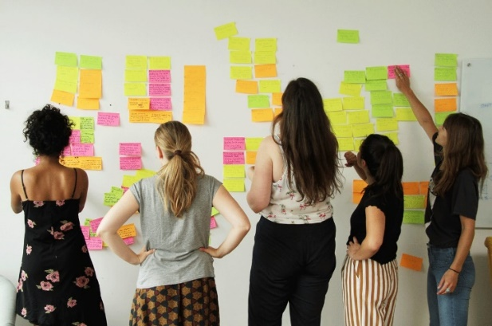
Sharing outcomes – use our blank template, or a final version of this document to document the agreements from the meeting. Circulate this to all relevant parties so that everyone is on the same page. The below template can be adjusted as you see fit, with changes to timing. You may want to use butcher’s paper and post it notes for each discussion section. A photo can be taken at the end.
Figure 1 - group of people using post it notes to brainstorm

Key Information

School name:
Contact details:
Provider name:
Contact details:

School type:
☐ Pre-School ☐ Primary School

☐ High School ☐ SSP

Type of services:
☐ Occupational Therapy ☐ Speech Therapy ☐ Exercise Physiology

☐ Behaviour Supports ☐ Physiotherapy

Agreed goals or outcomes
What do you want to achieve from this piece of work?

Scope of work
Dot points on what the agreed deliverables and pieces of work are.

Roles and responsibilities
What is the piece of work, the tasks within it, and who is responsible for delivering it? This can cover things like the therapies being delivered, as well as the reporting involved.

Communication

Here you may want to agree on some Guiding Principles for when you’re working together:

To be considered:
- Meeting/Call times: how often will we check in? When will documentation be shared?
- Who needs to be invited and informed about different things?
- Communications platforms: do you want to use the phone? Email? Other?
- If the project is being delivered via telehealth, what technology requirements are there? Are there other platforms, tools or equipment that may be required?
- Escalation contacts and issue management procedures – who is the contact if there are any issues to resolve.

Timelines and key dates
When does the work need to be delivered?
Are there any key dates that the provider and/or school needs to be aware of that might impact the work?

Reporting and evaluation

Agreed metrics for measuring success and impact.

Reporting expectations:
- When: Dates
- Who is reporting on what

Process for evaluation.

Questions
Any other questions?

