Student -SITHCCC005 Prepare dishes using basic methods of cookery
Application This unit describes the performance outcomes, skills and knowledge required to use a range of basic cookery methods to prepare dishes.

Elements 1. Select ingredients
2. Select, prepare and use equipment
3. Portion and prepare ingredients
4. Cook dishes
5. Present and store dishes.
Assessment requirements for SITHCCC005 Prepare dishes using basic methods of cookery are detailed in the Training Package.

Key Terms

Term | Definition
Cartouche | a circle of greaseproof paper used to  cover the surface of food to stop it from drying out or  discolouring
Chinois | a conical-shaped strainer
commodities | General foods (e.g. meat, vegetable and dairy products) commonly  used in commercial kitchens
Court bouillon | an acidic, aromatic liquid used for  poaching
Deglazing | adding liquid such as stock or wine to a pan to loosen and dissolve food sediments on the bottom
Larding | the insertion of pork back fat or bacon fat  into joints or cuts of meat to improve the flavour and  moisture content
Trussing | the wrapping of meat using twine or elastic  net to make it hold its shape and allow even cooking
Waste minimisation | reducing the amount of food discarded or not used to keep costs low  and refuse to a minimum

Assemble and prepare ingredients for menu items
- Ingredients are identified correctly, according to standard recipes.
- Ingredients are the correct quantity, type and are assembled and prepared in required form and time frame.
Criteria for selecting quality ingredients
Food is prepared according to weight, amount and/or number of portions, including:
Dairy products are correctly handled and prepared as required for menu items.
Dry goods are measured, sifted where appropriate and used as required for menu items.
Fruit and vegetables are cleaned, peeled and/or prepared as required for menu items. The Sydney markets website contains information about the many different fruits and vegetables available in the marketplace including a description, their availability, uses and storage.
General food items preparation as required for menu items. Some examples include sandwiches, garnishes, coatings and batters.
Prepare meat, seafood and poultry.
- Meat trimmed, minced or sliced and prepared correctly.
- Fish and seafood cleaned and prepared and/or filleted correctly.
- Poultry trimmed and prepared correctly.

Major food types and their characteristics

Dairy products, dry goods, frozen goods, fruit, meat, poultry, seafood, vegetables and general food items (batters, coatings, condiments and flavourings, garnishes, oils, sauces):

Activity:

- Select two of the above food types and identify the following (note: this activity can be completed for all of the major food types listed):

- Example
- Characteristics
- Indicators of freshness and quality
- Use in different dishes
- Effects of different cookery methods
- Handling and storage

- What are the characteristics of poached food?

Standard recipe cards
What is a recipe?
A recipe is a formula, which lists all the ingredients required, and the method necessary to prepare a dish. A standard recipe is one which has been tested, and produces the quantity and quality required for the establishment. Standard recipes allow for consistency – the dish can be produced the same over and over, despite what staff are rostered on that day.

Standard Recipe Cards (SRC)
In commercial kitchens recipes are printed as Standard Recipe Cards, which contain detailed information on a specific recipe.
Some of the information found on a Standard Recipe Card identifies includes ingredients required to produce the dish, method of preparation, unit cost. The SRC’s contain much more information than this.
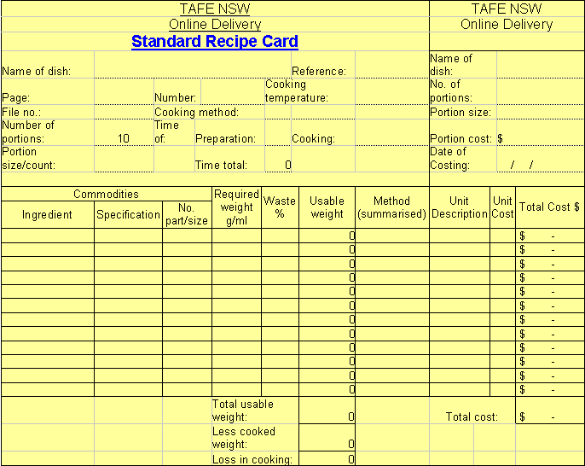
As a cook or chef in a commercial kitchen you will be given SRC's to follow when you are preparing dishes. You will need to be familiar with the contents and how to read or interpret the information on the cards.

Vegetable Preparation and Cuts
Many culinary terms used to describe techniques and products produced in commercial kitchens are French in origin, forming the universal language of kitchens worldwide. The preparation of these basic ingredients is the cornerstone of a well-organised kitchen.

Activity Identify Culinary Terms
The following table is all mixed up. Match the culinary terms with their correct definition or description and uses.

Activity Identify Culinary Terms
Activity: The following table is all mixed up. Match the culinary terms with their correct definition or description and uses.
CULINARY TERM | DEFINITION OR DESCRIPTION | USES
Bouquet garni | 3mm x 3mm x 40mm strips of vegetables | Used for garnishing and flavour
Brunoise | Thin, uniformly shaped 15mm squares, triangles or rounds of vegetables | Commonly used as vegetable and meat stuffing – for example,  stuffed capsicum or zucchini
Chiffonnade | Vegetables cut into barrel shapes usually 5mm in length | Used in a fruit cocktail
Duchess | 1mm diced tomato flesh free from peel and seed | Diced fruit for fruit salad
Duxelle | Food cut into fine shred | Used to flavour stocks
Jardinière | Outer skin of citrus fruit which is free from pith | To garnish a consommé or sauce
Julienne | Bundle of herbs and aromatic vegetables | Piped using a star tube in a rosette and baked
Macedoine | 8mm dice of vegetables or fruits | Used to garnish omelettes or pasta dishes
Mirepoix | Small dice (3mm x 3mm) | Used to flavour stocks, soups, sauces and meat dishes
Paysanne | Roughly diced vegetables in equal quantities | Used as a plate garnish on entrees or main courses
Segment | Puree of potato with butter and egg yolk seasoned with salt, pepper, nutmeg | Used as a garnish
Tomato Concasse | Mixture of cooked brunoise of onion, mushroom and chopped parsley | Used in minestrone or as a peasant-style garnish
Turned | 4mm x 4mm x 20mm batons of vegetables | Carrot crudités
Zest | Uniform pieces of citrus that are free from pith and pips | Salads (e.g. coleslaw) and garnishes
- Web quest
Identify various vegetable cuts and preparation techniques used in dishes depicted in different restaurants you have discover on your web quest.
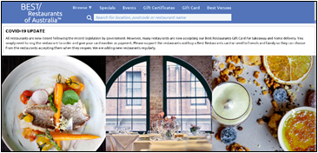
Best Restaurants of Australia is a good place to start.
The Restaurant and Catering Association website also provides links to a variety of Restaurants and Caterers.
Use the tables below to compile the information from your web quest.
Name of Cut & Dish | Description | Uses
1. Slice
2. Chop
3. Shred
4. Dice
5. Crush
6. Julienne
7. Brunoise
8. Jardiniere
9. Macedoine
10. Paysanne
11. Turning
12. Others

Activity
Open the Standard Recipe Card (Excel spreadsheet help file)
Roll your mouse over the recipe card to find out more information about each part of the card and the information that should be inserted in the various sections of the SRC.
What information does the standard recipe card include?
List the information in your notebook.
Print out the Standard Recipe Card (Excel spreadsheet) or save a copy to your computer. If you save the file you can complete the standard recipe card on the computer otherwise complete the printed version.
Link to the recipe file and practice completing the standard recipe card for 6 recipes.

Activity
- Identify and explain culinary terminology as listed within the recipes.
- What are the methods of cookery used? What equipment is suitable for this method of cookery?

Recipe file (recipes supplied by Futura)
Croútons – Basic preparation
Ingredients |  | Method | No of serves: Bulk
1 loaf | stale bread | - Remove the crust from the bread and cut into shapes.  - Dice, heart shapes or round shapes are used.  - Pan fry in clarified butter until golden.  - Place on absorbent paper and use.  - You will find that they absorb a fair amount of butter.  - You can add other ingredients such as garlic to the croútons for added flavour.  - Leftovers can be used for breadcrumbs. Place in a bowl cutter or blender.  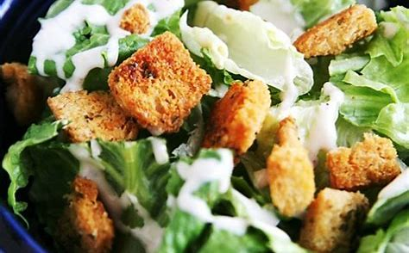

Minestrone – an Italian style soup
Ingredients |  | Method | No of serves: 12
600 g  1  100 g  100 g  2  1  50 g  50 g  50 g  1  100 g  2000ml  80 g | Mixed vegetables  Carrots, Celery, Leek, Turnip, Cabbage, Potato  Onion  Butter  Bacon or pancetta  Garlic cloves  Bouquet garni  Shelled peas  Beans  Cauliflower  Rosettes  Tomato  Tomato paste  Stock  Spaghetti  Seasoning  Fresh sage Thyme  Parmesan  Bread sticks | - Cut the vegetables into paysanne.  - Dice the onion and sweat in the oil.  - Add the bacon and vegetables and sweat without colour.  - Add the tomato paste, squashed garlic and herbs.  - Roast lightly. Add the stock and bouquet garni and cook slowly for twenty (20) minutes.  - Add the beans, peas, concassé and cauliflower and cook for another ten (10) minutes.  - Add the boiled pasta and adjust the seasoning.  - Place in the hot soup bowl.  - The soup can be garnished with toasted bread and /or fresh herbs.  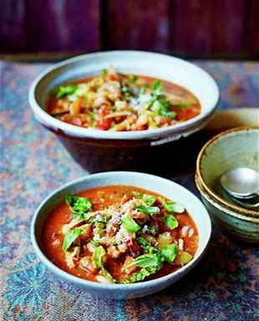  - Serve parmesan on the side.
Crème Anglaise
Ingredients |  | Method | No of serves: Bulk
10  1000ml  130g  1 | Egg yolks  Milk  Caster sugar  Vanilla pod | - Separate the eggs and whip the yolks with the sugar.  - Heat the milk with the split pod and add gradually to the egg yolk mixture.  - Return to the heat and thicken until it coats the back of the spoon. Strain and cool.  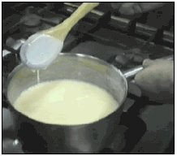

Answers:
Review Questions
- Explain the difference between braising and stewing.
- What time management issues should be considered when braising foods?
- Describe two methods of cookery to floor staff to increase their product knowledge.
- You are required to select and prepare the appropriate vegetables and herbs for a basic beef stock. Describe the uses for the beef stock. Describe uses for a beef stock.
- When blanching and refreshing a green vegetable, what timing issues need to be considered?
- The chef has indicated that crumbed veal is on the menu today. List all the ingredients you would use for crumbing and describe the process you would use.
- A large pot of pumpkin soup needs to be pureed. List the equipment you would use to achieve this.
- Describe safety issues to be considered when deep-frying foods.
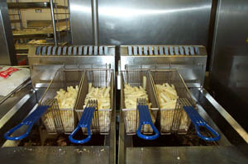
The following websites provide valuable information relevant to this unit.
NESA Hospitality Mind map - Basic Methods of Cookery
William Blue College of Hospitality Management HSC Revision Day 26 September 2018 - Live stream Session 3 - Kitchen Operations & Commercial Cookery https://youtu.be/GmE1Pl2-Zg0

