Retail Services
Mandatory Focus Area: Working in the industry
Welcome: this module will assist you to review and revise the content of the mandatory focus area: Working in the industry. Each focus area prescribes the scope of learning for the HSC and is drawn from associated units of competency.
You will have studied both these competencies, which together address the scope of learning:
SIRXIND001 Work effectively in a service environment
SIRXCOM002 Work effectively in a team
OR you will have studied the following competency, which also addresses the scope of learning:
SIRCIND001 Work effectively in a community pharmacy
This module is broken up into:
- Important notes
- Key terms and concepts
- Activities
- Putting the theory into practice
- HSC Focus Areas
How to use the resource
Work through the notes and the suggested activities in any order. Great revision techniques include working through how a problem is solved, explaining the concept, testing yourself and retrieving information from your memory. Spread your revision over a number of sessions rather than sitting at one subject for lengthy periods. Discuss your responses with your teacher, fellow students or an interested family member.
All images, apart from those acknowledged, are © NSW Department of Education.

Important Notes
You should use the information here as a prompt and guide when revising your study notes or text-book information or other resources provided by your teacher.
You can also access specific information at Fair Work, Anti-Discrimination Board of NSW, Industrial Relations NSW, Australian Council of Trade Unions, Australian Retailers Association and/or National Retail Association.
You will have studied either BOTH of the following (two) competencies -
SIRXIND001 Work effectively in a service environment describes the performance outcomes, skills and knowledge required to work effectively in the retail environment by integrating knowledge of workplace rights and responsibilities, organisational policies and procedures into daily work activities.
SIRXCOM002 Work effectively in a team describes the performance outcomes, skills and knowledge required to communicate and work cooperatively with both peer and senior team members to contribute to the achievement of team goals.
OR you may have studied SIRCIND001 Work effectively in a community pharmacy which describes the performance outcomes, skills and knowledge required to work effectively in a community pharmacy by integrating knowledge of workplace rights and responsibilities, organisational policies and procedures and by using effective work practices to plan and organise daily work activities.
The outcomes of the Retail Services HSC mandatory focus area ‘Working in the industry’ require that the student:
- examines the nature of retail services industries
- demonstrates an understanding of working in a retail services industry
- explains how to communicate and work effectively with others in a community pharmacy/ retail workplace
- applies industry and workplace standards to ensure quality work outcomes
- explores how misunderstandings and conflict may be avoided or effectively managed in a range of situations common to community pharmacy/retail work environments.

Key terms and concepts
You can use the following information to revise the key terms and concepts from this unit of competency. Perhaps you could:
- Copy the table into your own file, remove all the key terms, then fill in the blanks (without peeking at the original file) with your own answers.
- Copy the table into your own file and remove the definitions. Write a definition in your own words – it doesn’t have to word perfect but should show you understand the concept.
- You could add an example of this term or concept which is relevant to the Retail Services environment. If the key term was ‘indirect discrimination’ your retail example might be ‘It could be indirect discrimination if the only way to enter your store is via a set of stairs because people with disabilities who use wheelchairs would be unable to enter the building’ or for ‘positive discrimination’ your example might be ‘In NSW, holders of a Seniors Card can purchase a Woolworths WISH eGift Card at 5% discount’.

Key term or concept | and Definition
Assertive | Confident and direct when trying to get what one wants or saying what one wants to say.
Award | A legal document, which specifies the minimum conditions under which employees are employed.
Bullying | Repeated unreasonable behaviour towards another person or group which creates a risk to health and safety.
Closed questions | Closed questions are those that have one correct answer or that give limited options to the respondents to answer.
Code of Conduct | An organisation’s code of conduct is an outline of what is considered appropriate behaviour and what is considered inappropriate behaviour.
Complaint handling | A process to resolve complaints of discrimination and harassment can improve staff satisfaction and help avoid complaints to external agencies or other legal action. A good complaint process will be fair, confidential, transparent, accessible and efficient.
Conflict management | The process of limiting the negative aspects of conflict while increasing the positive aspects of the situation.
Contract | A legally binding agreement that recognises and governs the rights and duties of the parties to the agreement.
Direct Discrimination | Direct discrimination happens when a person, or a group of people, is treated less favourably than another person or group because of their background or certain personal characteristics.
Duty statement | A document which describes the expected activities and responsibilities of a particular job.
Equal Employment Opportunity (EEO) | In Australia, national and state laws cover equal employment opportunity (EEO) and anti-discrimination in the workplace.
Employee entitlements | Basic conditions under an award or agreement - annual holidays, sick leave etc.
Enterprise agreement | Enterprise agreements and other registered agreements set out minimum employment conditions and can apply to a business, a group of businesses or an individual employee.
Ethics | A set of principles of ‘right’ conduct; behaviour which is appropriate and follows company procedures and policies.
Etiquette | The customary code of polite behaviour in society or among members of a particular profession or group.
Fair Work Act 2009 | The Fair Work Act 2009 is legislation which covers the rights and responsibilities of employees, employers and employees’ organisations in relation to employment.
Fair Work Commission | The Fair Work Commission is Australia’s national workplace relations tribunal.
Flexible work arrangements | Flexible work arrangements can include changing hours of work, changing patterns of work, changing the place of work etc to allow employees to manage family responsibilities.
Grievance | Conflict between an employee and employer or an employee and another employee.
Harassment | When a person is treated less favourably on the basis of certain personal characteristics, such as race, sex, pregnancy, marital status, breastfeeding, age, disability, sexual orientation, gender identity or intersex status.
Indirect Discrimination | Indirect discrimination occurs when there is a rule or requirement that is the same for everyone but unfairly affects people who have one of the characteristics protected by New South Wales law.
Leave form | A form completed for any absence from work.
Listening effectively | Hearing the message being sent, making meaning of it and responding in a way that lets the sender know you truly understand.
Multi-culturalism | The presence of, or support for the presence of, several distinct cultural or ethnic groups within a society.
Open questions | Open questions do not have a perfect answer and require a person to come up with additional details and information.
Organisation chart | A diagram or ‘map’ that shows how responsibilities are organised in a business, lines of reporting etc.
Paraphrasing | Expressing the meaning of (something written or spoken) using different words, especially to achieve greater clarity.
Passive | Not reacting visibly to something that might be expected to produce an emotion or feeling; accepting or allowing what happens or what others do, without active response or resistance.
Policies and procedures | Workplace policies and procedures articulate an organisation’s mission and values and set standards for employee behaviour and performance.
Positive Discrimination | Positive discrimination aims to foster greater equality by supporting groups of people who face, or have faced, entrenched discrimination allowing them similar access to opportunities as others in the community. Also referred to as ‘positive measures’ or ‘special measures’.
Roster | A document setting out the days and times each staff member is required to work.
Superannuation | Money put aside during an employee's working life for use after retirement.
Task management | The process of managing a task through its life cycle. Helps individuals achieve goals, or groups of individuals collaborate and share knowledge for the accomplishment of collective goals.
Teamwork | Good teamwork is usually the result of a shared or common goal to strive for, mutual trust and respect and effective communication. A commitment from everyone on the team is required in order for the team to succeed.
Time management | The process of organising and planning how to divide your time between specific activities. Good time management enables you to work smarter rather than harder.
Uniform | Appropriate, practical clothing designed for an employee to wear as they perform their work duties; often allocated to an employee as part of their employment terms and conditions or employment contract.
Union | An organisation of employees, which acts collectively for mutual protection and assistance.
Voice tonality | the characteristic style or manner of expressing yourself orally eg her manner of speaking was quite abrupt’; ‘he spoke in a nervous tone’

Activities
- What is the difference between discrimination, harassment and bullying?
Use the links to research and construct a table to remind yourself of definitions, key points and examples. Add as many rows as you need.
Discrimination, harassment and bullying
Discrimination | Harassment | Bullying

- Fill in the blanks, using the words provided.
Use these words
conflicts | official | alcohol | ethical
confidential | document | treatment | work
workplace | disciplinary | email | dress
According to Workplacelaw.com.au a Code of Conduct is essentially a
( ) that establishes behavioural and ( ) standards for employees in a particular ( ) and confirms the business’ ( ) position on a range of issues.
For example, a Code of Conduct might have policies on:
    - Employee (including management) ( ) of other employees and the business’ clients
    - Business ethics and ( ) of interest
    - Drug and ( ) use
    - Internet and ( ) use
    - ( ) information
    - Quality of ( )
    - ( ) codes; and
    - Health and safety.
A Code of Conduct should also outline that breaches of the Code may result in
( ) action.
- Read each scenario and decide the correct answer:
Scenario 1
Alan is confined to a wheelchair. He works as a web site content developer and his manager often makes disparaging remarks about the quality of his work. The manager has also had to speak with Alan about his frequent tardiness and violations of the company’s dress code. Would this be considered harassment?
  - Yes, because the manager is discriminating because of Alan’s impairment
  - No, because the manager speaks about work performance, not disability
  - No, because Alan has the right to wear whatever he likes if he has a disability
  - Yes, because Alan should be given some extra leeway due to his disability

Scenario 2
Augustine is a 45-year-old refugee from an Eastern European country. Her supervisor calls everyone by a ‘nickname’ because he thinks it makes everyone feel welcome. The supervisor uses the nickname ‘Babushka’ for Augustine because of the bright scarves she wears as part of her traditional dress.
Is this an example of harassment?
- Yes, because the harassment is aimed at Augustine’s country of origin
- No, because the supervisor calls everyone by a nickname
- No, because the derogatory comments are not meant maliciously
- Yes, because the supervisor is discriminating against Augustine because of her age and her status as a refugee
Scenario 3
Maria emigrated, as a child, from Peru with her family. She works as a sales consultant in your organisation. She tells you that some co-workers have been using racially derogatory language toward her, as well as making jokes at her expense. She’s ignored them as much as possible, but once burst into tears in front of them. The co-workers didn’t apologise and continue to mock her, her accent and her nationality. Is this an example of harassment?
  - No, because the comments are not severe even though they’re directed at Maria on the basis of race and national origin
  - No, because her co-workers’ behaviour doesn’t compromise Maria’s work
  - Yes, because the comments and jokes are targeted at Maria’s race and national origin, and the incidents keep occurring even though it’s clear they upset Maria
  - Yes, because her co-workers continue to harass her after she burst into tears

- This clip ‘Myths about working conditions ‘ from FairWork is fun to watch and might help you remember some facts. Fairwork.gov.au provides 15 minute training courses on workplace basics: complete any that you need to revise. Using F5 reloads the page.

- Fair Work.gov.au also provides advice about a range of employment entitlements.
List each in a table, adding rows and making notes as you go. The first one is started for you.
Employment entitlements
Types of employees - full-time, part-time, casual, fixed term, shiftwork, daily hire, probation, outworkers

- Summarise characteristics of a good team and a good team member.
The information here is useful.
Image licenced under CC0. The original version can be found on Pixabay

- The General Retail Industry Award 2010 covers employers throughout Australia in the general retail industry and their employees in a wide range of classifications. Note: The National Employment Standards (NES) make up the minimum entitlements for employees in Australia. The General Retail Award mentions them in many places.
  - Outline (from the table of contents) the six Parts of the Award
  - What does the award say about overtime (29.1a and 29.1b)?
  - What does the award say about personal/carer’s leave (33.1, 33.2, 33.3)?
  - Use information from the award to fill in the following (31.1a)
Hours worked | Rest Break | Meal Break
Less than 4 hours work
4 hours work but not more than 5 hours
Work more than 5 hours but less than 7 hours
Work more than 7 hours but less than 10 hours

  - Summarise 31.1(b) through (g)

- Click on the link and scroll down the page to watch the video ‘How minimum wages work’. Have a look at the topic ‘Junior pay rates’ and identify what to do if you think there is an error in your pay.

- Read about superannuation then take the quiz ‘Superannuation’ at the bottom of the page.

- Research: Are awards legally binding? Why or why not? What role do unions play in award agreements?

- Have a break by completing this find-a-word activity – you may need to print this page.

Find these words
behaviour | bullying | conduct | counselling | customer
discipline | discrimination | employment | flexible | handbook
harassment | inappropriate | leave | listening | organisation
paraphrasing | policies | procedures | reputation | responsibilities
retail | roster | team | uniform | work

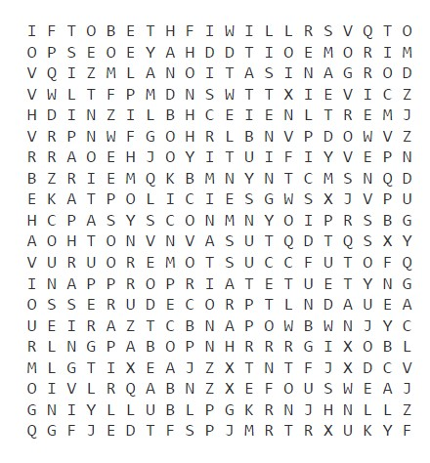

- Equal pay for equal work. Click and read this article then complete the quiz ‘Equal Pay quiz’ at the bottom of the page.
- The following article comes from the ACTU worksite. Read it and answer the questions that follow.

It could be fashion. It could be a loud statement of your individuality. It could be both. Fashion and work can collide when your boss isn’t happy with the way you look. But who’s right and what’s fair?
Employers can set ‘reasonable dress standards’ but that doesn’t take away their responsibility to treat you fairly.
According to the Equal Opportunity Commission, employers can set a reasonable standard of appearance that suits their industry as long as they don’t discriminate.
An employer is allowed to ask you to remove piercings, cover tattoos, be clean shaven or tie your hair back, so long as all dress codes:
- be applied equally to men and women
- relate to the job
- allow workers to follow their cultural or religious beliefs
- be fair to people with disabilities.
An employer must also follow health and safety or food hygiene regulations – this might involve dress codes.
  - Discuss ‘reasonable dress standards’, keeping in mind the following aspects:
    - Uniforms
    - Health and safety
    - Food handling
    - Dealing with customers and clients
  - What are the advantages and disadvantages of wearing a uniform?
  - Can a workplace dress code violation lead to dismissal? You can look up some examples here.

- Correctly match the two halves of each sentence. Draw a line between each or rewrite (or cut and paste) the correct sentences, in full, below the table.
Match each half of the sentence correctly
Your employer can require you to work reasonable additional hours | in a manner that is ‘harsh, unjust or unreasonable’.
Your employer must consider a request for flexible working arrangements | is secured by new federal laws.
Employees are entitled to 12 months unpaid parental (or adoption) leave | to work a public holiday.
You are entitled to Notice of termination | and can only refuse on reasonable business grounds.
Existing long service leave | and must leave employees better off overall than they would be if the award applied.
You have the right to reasonably refuse | but you have the right to refuse unreasonable hours.
An enterprise agreement must be genuinely agreed to by the majority of employees at the workplace, | and redundancy pay.
Your employer should not dismiss you | For each parent after the birth (or adoption) of a child.

- Using ACTU Factsheet information and, where you can, reference to the Fair Work Act 2009, explain what is ‘wrong’ in the following (imaginary) conversation.

Worker: You’ve given me a shift on Friday and I have other plans.
Supervisor: The shifts are already set.
Worker: But I let you know last week I had other plans.
Supervisor: The shifts are already set.
Worker: Well, I can’t come in on Friday.
Supervisor: I don’t have time to put up with this; you’re fired.

- Provide a definition and an example (preferably retail) for each of the following business structures:
Business structures
 | Chain | Cooperative | Department store
Definition
Example
 | e-commerce | owner-operated | speciality
Definition
Example

- Define ‘franchise’ and identify some examples of franchise opportunities in retail.
- Consider ways a retailer could reduce their impact on the environment.
Provide examples of measures you have seen implemented in the retail sector. Add as many rows as you need.
Reducing environmental impact
Issue | Reducing the impact on the environment

- Effective team communication strategies are a focus of the competency SIRXCOM002 Work effectively in a team. Draw up your own diagram to summarise effective communication in a retail environment.
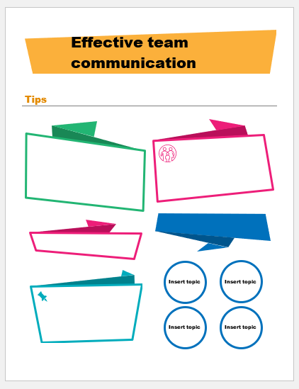

Putting the theory into practice
The following questions are from past years’ NSW HSC examination papers for this subject. HSC exams are intended to be rigorous and to challenge students of all abilities. To better understand a question, you should look for key words and identify the aspect of the course to which these relate. You are then in a position to formulate your answer from relevant knowledge, understanding and skills.
All questions in ‘Putting the theory into practice’ are acknowledged © 2019 NSW Education Standards Authority (NESA) for and on behalf of the Crown in right of the State of New South Wales.

Multiple Choice
- Which of the following best defines chain stores?
- Stores selling a range of general products online
- Stores with multiple locations and common products
- Stores divided into many departments selling leading products
- Stores that sell a particular range of goods and related products

- The table shows Kim’s rostered hours each week.
If the hourly rate is $24.12, how much does Kim earn in a week?
Monday | Wednesday | Friday
3 pm – 6 pm | 8 am – 12 pm | 11 am – 3 pm

- $265.10
- $265.32
- $337.40
- $337.68

- What is the primary role of professional associations in the retail services industry?
- To maintain standards and represent the industry
- To maintain relationships between employers and unions
- To negotiate enterprise agreements and awards for the industry
- To establish minimum qualifications for employment and training
- Which of the following is a distinctive feature of a department store?

- Being owner operated
- Stocking expensive items
- Offering a delivery service
- Selling a range of product categories

- An experienced checkout operator is not happy with the work of a new checkout operator. What is the first step that the experienced checkout operator should take?

- Advise the union
- Inform the store manager
- Talk to the new checkout operator
- Discuss the issue with other checkout operators

- Which of the following strategies would most effectively help retail employees maintain a balance between work and life?

- Providing mentoring
- Introducing job rotation
- Applying flexible rostered hours
- Implementing equal employment opportunity

- The employees in a retail workplace are collectively negotiating their terms of employment with the employer. The negotiated employment terms and conditions should be set out in

- an award.
- a contract.
- an agreement.
- an arrangement.
- In a retail workplace, only authorised staff members are allowed access to the workers compensation details of the business. Which regulatory requirement has been applied?

- Privacy
- Fair work
- Workplace safety
- Equal opportunity

- This statement was obtained from a workplace document.
Our aim is to provide customers with the highest standard of service and ensure that the store consistently meets the expectations of customers.
What type of document would be most likely to contain this statement?
- Goal statement
- Role statement
- Mission statement
- Organisational statement

- Which of the following is LEAST important for a team to work effectively?

- Gender balance
- Ability to work together
- Clearly defined vision and goals
- Positive monitoring and review processes

- In which of the following areas is e-retailing most likely to benefit retail services industries?

- Reducing advertising costs
- Improving customer service
- Broadening the market base
- Strengthening security of payment

- What is the main purpose of a curriculum vitae?

- To prepare an individual for an interview
- To outline the competencies achieved by an individual
- To document an individual’s skills and experience for a position
- To advertise the skills and experience an individual requires for a position

- Two workers are in conflict about who will be responsible for the closing shift on Friday afternoons. What would be the first step the two workers could use to manage this conflict?

- Arbitration
- Conciliation
- Mediation
- Negotiation

- A sales assistant is told that they will never be rostered on to supervise the change rooms in a retail outlet because of their sexuality. What form of discrimination does this represent?

- Direct
- Indirect
- Open
- Psychological

- Which of the following is NOT an element of quality assurance in retail services?

- Receiving feedback
- Time management
- Comparison to a standard
- Continuous monitoring of procedures

Questions from Section II
These questions should be answered in the suggested number of lines (handwritten in the exam) as it gives a guide to the length of your response. Plan out your answer and key points before you commence.
Question 1
  - What is a franchise? Provide ONE example. (2 marks)

  - In a department store, two employees have been arguing about the right to use a certain display area. Explain TWO different conflict management approaches that could be applied to resolve this issue. (5 marks)

Question 2
- Why is it important for a retailer to maintain an accurate roster? (2 marks)

- How is casual employment different from part-time employment in retail services industries? (3 marks)

- Explain the potential consequences for a retailer if it does not provide adequate staffing during busy trading hours. (5 marks)

Question 3

- Describe how working under an award could benefit employees in the retail services industry. (3 marks)

- How does Australian consumer law affect the selling of products and services in the retail services industry? (4 marks)

Question 4

- Identify ONE technological advancement retailers have introduced to provide customer service. (1 mark)

- State ONE advantage and ONE disadvantage of a technological advancement a retailer has introduced in customer service. (2 marks)

- Outline the limitations of a retailer using social networking technologies.
(3 marks)

Question 5

A local supermarket recently published the following new addition to their code of conduct.
Employees need to ensure that personal electronic devices are not used in customer-facing environments, except when it is for the benefit of our customers. Employees are not to use personal electronic devices when undertaking activities that may harm themselves or customers.

- What organisation could employees approach for advice if they had a concern about this addition to their code of conduct? (1 mark)

- What is the purpose of this addition to the code of conduct for both the employer and the employee? (4 marks)

Questions from Section III
The Section III question in the HSC is worth 15 marks -
- There will be one extended response question.
- The question will have an expected length of response of around four pages of an examination writing booklet (approximately 600 words)
- Your answer will be assessed on how well you:
- demonstrate knowledge and understanding relevant to the question
- communicate ideas and information using relevant workplace examples and industry terminology
- present a logical and cohesive response
You should allow about 25 minutes for a question in Section III of the exam.
You will note that these questions usually require you to bring together knowledge from several areas of study/competencies to do justice to the answer.

In each of the following, map out your answer using post-it notes or a sheet of paper. Pay particular attention to incorporating a variety of aspects of your Retail Services curriculum into the plan. Consider why we have included this question within this Working in the industry module and what other areas of study you would need to draw upon.

Question 1 (15 marks)
Discuss strategies that can be used to deal with harassment in the retail services workplace.

Question 2 (15 marks)
Discuss how emerging technologies have affected work practices and service delivery in retail services industries.

HSC Focus Areas
For the purposes of the HSC, all students undertaking the 240 HSC indicative hours course in Retail Services must address all of the mandatory focus area content.
The scope of learning describes the breadth and depth of the HSC Content and has been grouped together into key ideas/areas. The scope of learning describes the minimum content that must be addressed, and the underpinning knowledge drawn from the associated unit(s) of competency.
The (four) Retail Services Curriculum Framework mandatory focus areas are:
- Customer service
- Safety
- Sales and security
- Working in the industry
Check to make sure which one of the stream focus areas you are studying. The three Retail Services Curriculum Framework stream focus areas are:
- General selling
- Food selling
- Community pharmacy

The outcomes of the Retail Services HSC mandatory focus area ‘Working in the industry require that the student:
- examines the nature of retail services industries
- demonstrates an understanding of working in a retail services industry
- explains how to communicate and work effectively with others in a community pharmacy/ retail workplace
- applies industry and workplace standards to ensure quality work outcomes
- explores how misunderstandings and conflict may be avoided or effectively managed in a range of situations common to community pharmacy/retail work environments.

How to use the scope of learning (which follows over):
- draw up your own mind map showing the connection between the various concepts listed; examples appear on the last page of this module
- use the key terms and concepts to add to your mind map
- add examples or case study prompts to show how the concept is applied in the Retail working environment
Creating a mind map is a great way to organise your knowledge and understanding of the content of a topic. You could use software such as a hierarchy chart, download ‘MindNode’ or similar or use a large sheet of paper (or several A4 sheets taped together)!
Try to make the connections which allow you to provide a nuanced answer to questions eg everything in this clip could be enhanced with an example from the retail environment.
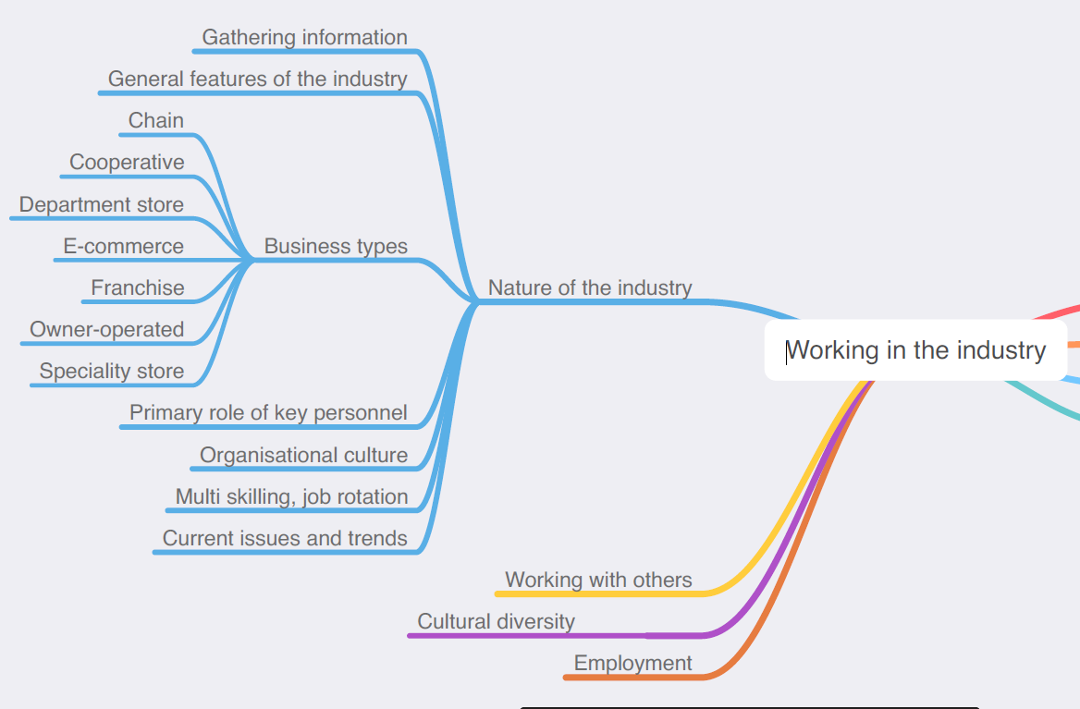

The following information is taken directly from page 37 ff of Retail Services Curriculum Framework Stage 6 Syllabus (NSW Education Standards Authority) for implementation from 2020. © 2019 NSW Education Standards Authority (NESA) for and on behalf of the Crown in right of the State of New South Wales.

nature of the industry
- sources of information that can be used when gathering current and emerging information on retail services industries:
- colleagues and manager/supervisor/team leader
- experienced industry personnel
- industry bodies and professional associations
- internet
- journals
- libraries
- training courses
- unions
- workplace documents and manuals
- general features of retail services industries, including their relationship to other industries
- business types within retail services industries including:
- chain
- co-operative
- department store
- e-commerce
- franchise
- owner-operated
- specialty store
- departments/functional areas within a community pharmacy/retail workplace, the tasks performed by these departments/functional areas and the interrelationship between the areas
- primary role and duties of key personnel within a community pharmacy/retail workplace
- meaning of organisational culture
- for a community pharmacy/retail workplace, knowledge of the:
- organisational structure
- chain of command
- goals, values and standards
- opportunities for multiskilling/job rotation in a retail services industry
- current issues and trends affecting retail services industries and implications for a community pharmacy/retail workplace, own work practices and delivery of service
- current and emerging technologies in retail services industries:
- examples
- effect on operational duties and service delivery
- role in development of new and improved work practices
- selection and use of technology appropriate to day-to-day work activities and work tasks

employment
- career pathways across retail services industries and the knowledge and skills required for different job roles
- preparation to enter a career path in a retail services industry, including:
- letter
- curriculum vitae/résumé
- interview preparation and performance
- the purpose and intent of the Fair Work system and its application to a community pharmacy/retail workplace and job role
- types of employment in retail services industries:
- full-time
- part-time
- casual
- contract
- the difference between an award, agreement and contract and how they apply to workers in retail services industries
- investigate the employment terms and conditions for a community pharmacy/retail job role
- working knowledge of employer and employee rights and responsibilities in relation to employment
- purpose of a code of conduct and value for the industry and worker
- equal employment opportunity (EEO):
- principles
- intent of EEO legislation
- reciprocal rights and responsibilities of employers and employees
- workplace policy and procedures relating to EEO
- primary role/function(s) of a range of key industry bodies for both employers and employees:
- employer groups
- professional associations
- unions
- employee groups
retail services worker
- community pharmacy/retail worker:
- personal attributes and work ethic valued by the industry
- interpersonal skills beneficial to an individual working in a community pharmacy/ retail workplace
- importance of personal presentation and standards of personal hygiene
- presentation standards for a community pharmacy/retail workplace and job role
- behaviour to support a safe and sustainable work environment

retail services worker cont/d
- how personal values, opinions and ethics can affect everyday work and the workplace
- duties and responsibilities:
- for a community pharmacy/retail job role
- relationship between individual worker and the team/work group
- difference between individual and workplace goals and plans
- working within scope of responsibility and/or level of authority:
- taking initiative
- problem-solving
- decision-making
- seeking assistance when needed
- feedback:
- value of feedback to an individual worker, the workplace and the industry
- types of feedback:
- formal and informal
- direct and indirect
- strategies for obtaining and interpreting feedback from supervisor(s), colleagues and customers
- dealing with positive and negative feedback
- responsibility of the worker to use personal reflection, seek and provide feedback and improve
- importance of work/life balance and strategies to maintain that balance
work practices
- an understanding that work practices and experiences differ between workplaces
- how work practices are implemented and maintained in accordance with industry standards and workplace policy and procedures
- the value of work standards
- work standards for a retail services industry and a community pharmacy/retail workplace and job role
- implications of non-adherence to work standards
- effect of poor work practices on colleagues, customers, a workplace and the industry
- tasks typical to a community pharmacy/retail workplace (routine, rostered and non-routine)
- access and use a range of sources containing information relating to work responsibilities (work instructions)
- strategies for understanding and clarifying work instructions
- a range of opportunities to read, interpret and follow instructions for work tasks of varying degrees of difficulty

work practices cont/d
- time management and task management:
- principles
- techniques
- prioritising
- constraints
- planning and preparation for a range of tasks/activities applicable to daily work routines in a community pharmacy/retail workplace
- current environmental issues affecting retail services industries
- strategies to work in an environmentally sustainable manner in a community pharmacy/ retail workplace
- meaning of quality assurance and an overview of the role of employees
- recording and reporting in a retail services industry:
- workplace policy and procedures applying to record-keeping and reporting
- legislative requirements for confidentiality and privacy
- lines of communication and reporting typical of a community pharmacy/retail workplace
working with others
- importance of developing collegial work relationships
- communication in the workplace with colleagues and customers:
- communication process/cycle
- workplace examples of types of communication:
- verbal
- non-verbal
- written
- effective verbal, non-verbal and written communication
- effective questioning and listening techniques
- barriers to effective communication and strategies to overcome them
- importance of teamwork when working in a community pharmacy/retail workplace:
- meaning of ‘team’ and ‘teamwork’
- characteristics of effective teamwork
- benefits of teamwork to the workplace
- examples of teams or work groups and their area(s) of responsibility
- supporting others to achieve team/work group goals and tasks
- delivering quality work outcomes through teamwork and work groups
cultural diversity
- concepts of cultural diversity, cultural awareness and inclusiveness
- workplace diversity:
- benefits

cultural diversity cont/d
- need for tolerance in the workplace
- importance of respect and sensitivity
- proactive strategies for promoting workplace diversity and accommodating individual differences
- culturally appropriate work practices
- effective cross-cultural communication skills
anti-discrimination
- bullying and harassment in the workplace:
- indirect
- direct
- types:
- verbal
- physical
- psychological
- sexual
- principles of anti-discrimination
- intent of anti-discrimination legislation
- rights and responsibilities of employers and employees in relation to anti-discrimination
- workplace policy and procedures relating to anti-discrimination
- strategies to eliminate bias and harassment in the workplace
- consequences, including legal ramifications, of discriminatory workplace behaviour
- recourse available to individuals in the event of inappropriate workplace behaviour
misunderstandings and conflict
- the difference between being passive, aggressive and assertive
- causes of misunderstandings and conflict when working with others and in the delivery of service
- the extent to which conflict can be a positive or negative experience
- conflict management:
- conflict-resolution techniques
- different approaches to conflict management, including problem-solving, negotiation and mediation
- workplace policy and procedures regarding management of conflict
- identify own response to misunderstandings and conflict and evaluate personal approach to management and resolution of conflict
- identify when it is appropriate to seek assistance when misunderstandings or conflict arise and whose assistance should be sought when conflict escalates

