RETAIL SERVICES
Mandatory Focus Area: Sales and Security
Welcome.
This module will assist you to review and revise the content of the mandatory focus area: Sales and Security. Each focus area prescribes the scope of learning for the HSC and is drawn from associated units of competency.
You will have studied all three of these competencies, which together address the scope of learning for ‘Sales and Security’:
SIRXRSK001 Identify and respond to security risks
SIRXSLS001 Sell to the retail customer
SIRXSLS002 Follow point-of-sale procedures
This module is broken up into:
- Important notes
- Key terms and concepts
- Activities
- Putting the theory into practice
- HSC Focus Areas
How to use the resource
Work through the notes and the suggested activities in any order. Great revision techniques include working through how a problem is solved, explaining the concept, testing yourself and retrieving information from your memory. Spread your revision over a number of sessions rather than sitting at one subject for lengthy periods. Discuss your responses with your teacher, fellow students or an interested family member.
All images, apart from those acknowledged, are © NSW Department of Education.

Important notes
You should use the information here as a prompt and guide when revising your study notes or text-book information or other resources provided by your teacher. You can also access industry specific information at ACCC, Australian Consumer Law, NSW Police, NSW Fair Trading and Australian Retailers Association.
You will have studied ALL THREE of the following competencies.
The unit SIRXRSK001 Identify and respond to security risks describes the performance outcomes, skills and knowledge required to identify security risks related to customers, team members, merchandise and money, and take appropriate action, within scope of job role, to eliminate or minimise those risks.
The unit SIRXSLS001 Sell to the retail customer describes the performance outcomes, skills and knowledge required to deliver quality customer service and sell to retail customers. It requires the ability to determine customer needs, match products and services to their needs, and facilitate a sale.
The unit SIRXSLS002 Follow point-of-sale procedures describes the performance outcomes, skills and knowledge required to follow point-of-sale work systems, process transactions and complete sales.
The outcomes of the Retail Services HSC mandatory focus area ‘Sales and Security’ require that the student:
- understands the techniques and workplace procedures for selling products and services
- explains point-of-sale handling procedures
- explains strategies for theft prevention and minimising security risks and loss of stock in a community pharmacy/retail work environment
- understands the importance and application of legislative requirements, industry standards and workplace policy and procedures for sales and security in a community pharmacy/retail work environment.

Key terms and concepts
You can use the following information to revise the key terms and concepts from this unit of competency. Perhaps you could:
- Copy the table into your own file, remove all the key terms, then fill in the blanks (without peeking at the original file) with your own answers.
- Copy the table into your own file and remove the definitions. Write a definition in your own words – it doesn’t have to word perfect but should show you understand the concept.
- You could add an example of this term or concept which is relevant to the retail environment. If the key term is ‘shrinkage’ your retail example might be ‘the shelving which displayed glassware collapsed and several sets, cracked or broken, could not be sold.
Key term or concept | and Definition
Active listening | … occurs when you tune into what someone is saying and how they are saying it. It involves nonverbal signals and reflective questioning.
Add-on Sale | An extra item sold with a purchase eg a paintbrush with paint, a cake with your coffee. The product could be something unrelated to original purchase eg a new product.
Add-on selling | Suggesting that a customer purchase additional product/s to increase sales eg asking a customer if they would like to purchase socks with shoes.
Authorisation | Permission or approval, usually of a purchase amount.
Benefits | The ‘benefits’ answer a customer’s question – ‘what can it do for me?’ Benefits are often non-tangible and appeal to the emotions and rationale of the customer.
Buying signals | Things a customer says or does to indicate they are ready to make the purchase.
Cash drawer | A drawer for storing cash and other valuables usually attached to a cash register.
Cash float | The amount of cash placed in registers at the beginning of a shift or workday.
Cash handling | The procedure of receiving, changing, safely storing and issuing cash through POS (point of sale) equipment.
Cash handling procedures | A set of guidelines which govern the handling, receipting, depositing and reporting of all cash operations.
Cash register | Electronic device used to calculate financial transactions. Most cash registers consist of a keyboard that is used to input entries, a scanner of some sort, a drawer that is used to hold cash, and a printing device for receipts.
Cheque | A written order directing a bank to pay money.
Closed questions | … are used to get specific information from a customer. They usually require a yes or no answer.
Closing techniques | Techniques used by a salesperson to close the sale. They should leave the customer with a positive impression.
Code of practice | A Code of Practice is a document prepared to provide practical guidance on how to comply with a general duty or specific duties.
Complementary products | … go with or add to another purchase (see add-on sales). They are related to the item in some way, eg cheese with crackers.
Credit card | A small plastic card issued by a bank, building society, etc allowing the holder to purchase goods or services on credit.
Customer account | A customer account record holds data about a customer, including name, order data, billing information, interaction information and credit information.
Customer objections | Questions or statements that the customer may make to indicate that they may be unsure about the purchase. They usually refer to price, time or merchandise.
Debit card | Allows a customer to purchase goods or services, but unlike a credit card, the money is immediately transferred directly from the cardholder's bank account when performing any transaction.
Denominations of change | Change might be given using the available denominations - $100, $50, $20, $10 or $5 polymer notes or any combination of 5c, 10c, 20c, 50c, $1 or $2 coins.
Electronic Article Surveillance (EAS) | EAS systems are small electronic tags, used for security and which must be removed at point of sale.
EFTPOS | An acronym for Electronic Funds Transfer Point Of Sale; an electronic payment system involving electronic funds transfers based on the use of payment cards, such as debit or credit cards, at payment terminals.
Exchange | To take something back to a shop where it was bought and get something else instead
External theft | Theft by somebody from outside the business or organisation, eg customers
Features | Things that are tangible about the item. The way it smells, feels, looks, tastes etc.
Follow-up action | May take the form of formal documentation or be as simple as a phone call to check the customer is happy.
Gift voucher | A card or piece of paper that can be exchanged in a store for goods of the value that is printed on it/assigned to it.
Greeting approach | Approaching customers with a friendly greeting that may open the opportunity to make a sale, eg ‘Hi, it’s great weather out today.’
Handling customer complaints | The process followed to resolve customer complaints effectively and efficiently.
Internal theft | Theft by someone within the business or organisation, eg cleaning staff.
Lay-by | A system of payment where a buyer pays a deposit on an article, which is reserved until he or she has paid the full price
Merchandise approach | The way that you approach a customer who is interested in a particular item eg ‘Hi, do you play a lot of soccer?’
Open questions | … provide the opportunity for the customer to provide as much information as possible.
Point-of-sale terminal | Point of sale equipment.
Processing exchanges and returns | Exchanges refer to swapping goods that are unsuitable. Returns can be processed by giving a customer a refund or store credit.
Product knowledge | Specific information about a product that the salesperson can use to help sell the product.
Reflective techniques | Questions that a salesperson may ask to clarify the information they have been given or to indicate they have been listening to what the customer is saying.
Refund | Pay back (money), typically to a customer who is not satisfied with goods or services bought.
Sales documentation | Documentation that records sales, such as a receipt, invoice, refund slip etc.
Sales orders | Orders made by the business to a supplier of goods.
Scanner | A scanner reads different types of barcodes and labels
Security system | Procedures or equipment designed to reduce the incidence of theft
Selling up | Selling an item that is priced higher than that originally requested by the customer eg an automatic rather than a manual car.
Service approach | When a customer appears to know what they want or are in a hurry you would use this approach. You should avoid asking ‘Can I help you?’ but rather ‘Is there something I can help you with today?’
Shrinkage | The difference between what stock you should have according to records and what stock you actually have.
Vendor theft | Theft by the supplier or deliverer.
Workplace policy and procedures | Policies and procedures outline the requirements for complying with both external and internal compliance requirements.

Activities
- You’ve started working in the ‘babies and kids’ section of your local store where kids’ clothing, toys and children’s furniture are sold. Where would you find more out about the products on sale? List at least three sources.
Research these products at the Australian Competition and Consumer Commission (ACCC) and identify at least two safety concerns in each category. Use the table below.

Product | Where could I find out more about products? | Safety Concerns identified
Children’s clothing
Toys
Children’s furniture

- Make a list of the sorts of product information you need to know in order to be able to answer customer questions eg if you were asked ‘what are the advantages of this product over that product?’

- Australian Consumer Law has developed a guide for business on ‘Sales Practices’. Open this document and research the following:
  - Multiple pricing and how the supplier must respond; include penalties for failure to comply
  - Component pricing and how the supplier must respond; include penalties for failure to comply
  - Proof of transaction

- Find illustrations of each of the following POS equipment. Make sure you watch out for copyright.
Types of POS equipment
Calculator | Cash drawer | Cash register | EFTPOS terminal
Electronic scales | Numerical display board | POS terminal | Scanner
Security detacher | POS marketing/promotion | Wrapping/packaging materials | Surveillance device

- The two illustrations below comment on aspects of selling. Use them to create some guidelines for a new employee on selling techniques.
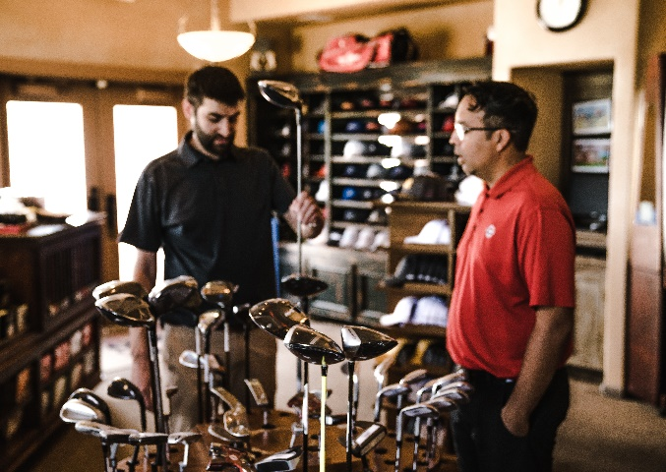
Image licenced under CC0. The original picture from Jopwell can be located on pexels.
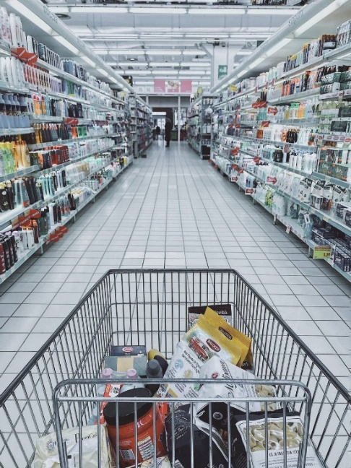
Image licenced under CC0. The original picture from Oleg Magni can be located on pexels.

- The ACCC has a list of examples of ‘false or misleading claims’. Give three examples and explain why there are laws in place to protect you from being misled about the products and services you buy. As part of your answer mention ‘puffery’.
- Complete the following to show your understanding of ‘approaching’ the customer.
The ‘greeting’ approach:
The ‘merchandise’ approach:
The ‘service’ approach
- Open-ended, closed and reflective questions are also covered in ‘Customer Service’. Indicate if the following are ‘open’, ‘closed’ or ‘reflective’ questions.
 | Open | Closed | Reflective
Have you ever used this brand before?
Who were you buying the present for?”
You gave the impression earlier that this occasion will be very special. Would you like to start with our more exclusive products?
How do you think you will use the product?”
Is it for a gift?
Which style or colour works best with your décor?
You mentioned a problem with your wrist. Would a light-weight model be better for you?
What do you think of this season’s colour range?”
What size were you looking for?
As you’ll be travelling a lot would you like to see our heavy duty range of suitcases?

- Fill in the blanks, using the words provided.
Use these words
report | encourage | redeemed | loyalty
expire | flight | emails | charges
discounts | improve | marketing | purchases
personal | protect | cheapest | web

Customer loyalty schemes
Customer loyalty schemes are ( ) and promotional tools used to ( ) consumers to have a connection to a particular brand and encourage repeat business. Consumers often join these schemes to earn ( ) or points, which can be ( ) for rewards including goods and services. In 2019, the ACCC reviewed various customer loyalty schemes and released a ( ) that outlined its findings and recommendations. It called on loyalty schemes to ( ) their data practices and communications with their members, and recommended changes to consumer and privacy laws to better ( ) consumers.
Tips for consumers
- Loyalty schemes don’t exist just to reward you for your ( ). If you join a loyalty scheme, the operator might end up knowing more about you than you want them to.
- Remember, ( ) information could be collected about you when you sign up and make purchases, combined with information gathered from other sources, including your social media and ( ) browsing habits. This can build a detailed profile about you, which may be used to send you targeted advertising.
- If you’re already a member of a loyalty scheme, be wary of making
( ) you wouldn’t usually make just to earn more points.
- Weigh up the cost of redeeming your points. You may ultimately be better off simply shopping around if you’re looking for the ( ) way to get a particular product or service.
- When redeeming frequent flyer points to book a ( ) be aware that you might have to pay taxes and other charges on top of using your points. In some cases, the cost of purchasing an airfare without using points might be similar to the taxes and ( ) you’ll pay when using points to book a flight.
- Find out whether the points you’ve earned in the loyalty scheme will___________. Many loyalty schemes have conditions where the points will expire if you don’t continue to participate in the program.
- If you decide to join a loyalty scheme, pay attention to any notices or __________ you receive, as these often describe changes to the program.
- What are ‘customer objections’ and how would you attempt to overcome them?
- Write a definition and give an example of each of the following:
  - Cross-selling
  - Suggestive selling
  - Top down selling
  - Up selling
- Fill in a suggested question, action or comment to use when closing a sale.
Technique | Using a question, action, comment eg
Direct Order - this involves using a closed question.
Active - helping the customer to decide to buy
Steps - letting the customer decide one step at a time
Alternative - offering a choice.
Difficulty - used when deadlines apply
Assumptive – you assume the customer is making the purchase

- How can feedback from customers, your supervisor and your own personal evaluation be used to improve future sales and customer service?
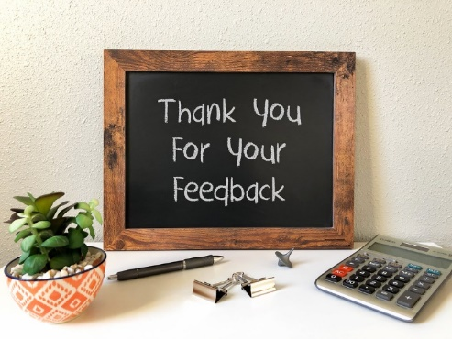
‘Thank You For Your Feedback’ by Got Credit is licensed under CC BY 2.0
- When thinking about shrinkage we often just think about theft. What other examples can you give that contribute to shrinkage in the retail industry. Think beyond just ‘the customer’. Fill in the table below:

Error | Waste | Theft

- NSW Police has excellent information about shoplifting and its prevention. Use this site to research and present a set of recommendations to reduce shoplifting in a retail environment. Make sure you include:
- Store layout and design
- Staff education and training
- Business policy and procedure
- There is some confusion about powers of ‘citizen’s arrest’. Prepare a short presentation, based on the information from NSW Police, regarding Citizens Arrest powers and how these apply in a retail environment.

- In late 2016, Coles implemented several measures (in some locations) to reduce shoplifting, including new security screens.

This is a great case study example; read the article and summarise why Coles was changing their practices, what they implemented and how this would help.

- According to Fair Trading NSW -
‘Bag checks are voluntary. Retailers can only conduct a bag check if you agree. However, if you refuse to allow a check, you may be asked to leave the shop and not return until you agree to a bag check’.
Complete the table below; add lines if needed.
Your rights as a customer | Guidelines that protect the retailer

- A news report from WA in 2019 looked at a spike in shoplifting. Watch the news item, then list ways that shoppers might attempt to shoplift. Try to list at least 10 methods.
- Did you know that there are restrictions as to how much coin is ‘too much’? Have a look at this article from Reserve Bank of Australia and note the key points. How might this impact you if you were working on a checkout?
- Why is it important to understand your organisation’s policies and procedures at POS? Use examples of the sorts of things covered in such documents.
- Create a graphic to summarise the categories of theft common to retail industries.
- Electronic Article Surveillance (EAS) systems are designed to help retailers increase their sales and profits by reducing shoplifting and increasing open merchandising opportunities. Write a definition of the following overt and covert security measures. The first one is done for you.
EAS Systems
Electronic Article Surveillance (EAS) systems | Comprised of detection systems at the checkout or exit of a store, the systems work with small electronic tags or labels that are affixed to merchandise. These tags or labels are either deactivated or removed at the point of purchase. If merchandise is removed from the store with an active label or tag still applied, an alarm will sound alerting the sales associates.
alarm system
security tags
mirrors
secure areas
surveillance device
security person

- Match the problem to the solution. Draw a line between each or rewrite (or cut and paste) the correct solutions into your own table below.
Solving security problems
Removing stock after closing time | All breakages reported to a supervisor. Records should be kept of all breakages
Removing cash from POS terminals | Ensure stockroom doors cannot be opened from the outside of the building
Undercharging friends and family on sales made, Giving discounts to friends | All foods that are in possession of the employee must have proof of purchase
Altering documentation | Discourage visits to staff by groups of friends
Deliberately damaging stock so it can be bought at discount | Have supervisors check off all returns, refunds and other documentation
Reducing/changing prices on stock for personal gain | Establish policies and procedures for the handling of cash and POS equipment
Eating items from stock and not paying | Undertake spot checks of staff bags, including those of management
- Practice these numerical calculations common to the retail workplace.
  - Which of the following is correct?
    - ¼ = .25 = 25%
    - 1/100= 0.1 = 10%
    - ¾ = .75 = 7.5%
  - Round 507 to the nearest 100
  - What is the correct answer to the following question? 609+0=
    - 6090
    - 609
    - 6091
  - Mr Phillips order 3 plants that each cost $75. You tell him delivery will cost $50. What steps will you take to work out the total cost?
    - 3 x $75 + $50 =
    - $50 x 3 + $75 =
    - $75 + $50 x 3 =
  - If today’s cash receipts were $2780.00 and we started the day with a cash float of $650.00, how much will be in the till at the end of the day?
    - $2130.00
    - $3430.00
    - $4080.00
  - The following is an example of a cash float. How much should there be in:
    - Coins
    - Notes
    - In total
Notes | Number | Amount | Coins | Number | Amount
$100.00 | 1 | $100.00 | $2.00 | 15 | $30.00
$50.00 | 4 | $200.00 | $1.00 | 25 | $25.00
$20.00 | 10 | $200.00 | $0.50 | 20 | $10.00
$10.00 | 15 | $150.00 | $0.20 | 40 | $8.00
$5.00 | 10 | $50.00 | $0.10 | 40 | $4.00
 |  |  | $0.05 | 40 | $2.00
Total Notes |  |  | Total Coins
Total Float

Putting the theory into practice
The following questions are from past years’ Retail HSC examination papers. HSC exams are intended to be rigorous and to challenge students of all abilities. If you have difficulty understanding a question you should look for key words and identify the aspect of the course to which these relate. You are then in a position to formulate your answer from relevant knowledge, understanding and skills.
All questions in ‘Putting the theory into practice’ is acknowledged © 2019 NSW Education Standards Authority (NESA) for and on behalf of the Crown in right of the State of New South Wales.

Multiple Choice
- Security staff detain an individual who has left a shop with a stolen item. Which strategy to minimise theft is being used by the shop?
  - Apprehension
  - Detection
  - Deterrence
  - Prevention
- A store is having a promotion on shirts. How much would a customer pay when buying two shirts?
SALE
All shirts — $38.80 each
Buy TWO get the second one at 25% off the marked price

  - $48.50
  - $58.20
  - $67.90
  - $77.60

- A salesperson asks a customer, ‘Are you ready to buy the television?’
Which of the following techniques is being used to close the sale?
  - Steps
  - Active
  - Assumptive
  - Direct order

- Which of the following retail documents is used to record the type of stock, the price and the way the payment has been made?
  - An invoice
  - An order form
  - An inventory list
  - A transaction docket
- A retail store offers staff a 5% bonus on sales achieved. A salesperson has sold $4223 worth of products. What bonus should the salesperson receive?
  - $21.11
  - $42.23
  - $211.15
  - $422.30
- The main purpose of a warranty is to provide
  - a record of sales to the supplier.
  - proof of purchase to the retailer.
  - product information to the sales assistant.
  - assurance of product quality to the customer.
- The shelf price of a can of baked beans at a supermarket is $1.29 but the item scans at $1.99. A customer wants to purchase four cans of baked beans. According to the industry code of practice, how should the customer be charged?
  - All items at the lower price
  - All items at the higher price
  - First item free and all other items at the lower price
  - First item free and all other items at the higher price

- A person has repeated urges to steal without regard for need or profit.
What type of theft is this?
  - Amateur
  - Medical
  - Opportunist
  - Professional
- A customer purchases a mobile phone. At the time of purchase, the sales assistant offers the customer a protective case at a reduced price.
Which of the following sales techniques is the assistant using?
  - Cross-selling
  - Top down
  - Up-selling
  - Upsizing
- Which of the following is NOT covered by Australian consumer law?
  - Product safety
  - Door-to-door sales
  - Lay-by agreements
  - Point-of-sale procedures
- In NSW, according to industry codes of practice, a store can search a customer’s bag when
  - a staff member suspects a customer of theft.
  - an employee is placed at each entry of the store.
  - the store has a sign at each entry stating that bag searches are a condition of entry.
  - the store has a trained security guard and a sign at each entry stating that bag searches are a condition of entry.
- A customer has purchased three products each priced at $150.00 from a store that offers 10% discount on the first product purchased, 15% on the second and 20% on the third.
How much did the customer pay?
  - $382.50
  - $360.00
  - $247.50
  - $202.50

- This information was obtained from a point-of-sale document.
Codes
1 = incorrect size | 2 = faulty item | 3 = wrong colour | 4 = wrong item
What type of document would be most likely to contain this information?
  - Invoice
  - Stock list
  - Order form
  - Exchange slip

- On a particular day, the total cash sales are $751 and the total non-cash sales are $1322.
If the float for the day is $350, how much money should be in the cash register drawer at the end of the day?
  - $401
  - $1101
  - $2073
  - $2423

- Which of the following are all examples of unknown shrinkage in a retail environment?
  - Point-of-sale errors, waste, spoilage, customer theft
  - Vendor fraud, out-of-date stock, breakages, armed hold-up
  - Point-of-sale errors, employee theft, breakages, armed hold-up
  - Vendor fraud, employee theft, paperwork errors, customer theft

Questions from Section II
These questions should be answered in the suggested number of lines (handwritten in the exam) as it gives a guide to the length of your response.
Plan out your answer and key points before you commence writing.
Question 1
- Explain how the counting of merchandise can be used to minimise the loss of stock. (2 marks)

- Using examples, explain why both overt and covert security measures are needed in the retail services industry. (4 marks)

Question 2

A pallet of boxes containing stock is received by a retail store.

- What should be checked when the delivery arrives at the store?
(2 marks)

- Explain how the stock received should be handled and stored to minimise loss. (4 marks)

Question 3
- Outline a potential impact on an employee of a security breach in a community pharmacy or retail workplace. (2 marks)

- Explain how security and loss prevention measures can be used to minimise loss in online retailing. (4 marks)

Question 4
- Outline how stock rotation can minimise loss of stock in a retail store.
(3 marks)

- Identify ONE security measure (other than video surveillance) suitable for a retail environment and outline ONE limitation and ONE benefit of this measure. (3 marks)

Question 4 continued over

- Explain the difference between professional theft and opportunist theft in retail services industries. (4 marks)

Question 5
Distinguish between emotional and rational motives for customer buying behaviour. Provide an example of each to support your answer. (4 marks)

Question 6
Describe THREE different techniques for closing a sale. Support your answer with examples. (6 marks)

Questions from Section III

There will be one extended response question in Section III. This will provide you with the opportunity to
- demonstrate knowledge and understanding relevant to the question
- communicate ideas and information using relevant workplace examples and industry terminology
- present a logical and cohesive response
The expected length of response for questions in Section III and IV is around four pages of an examination writing booklet (approximately 600 words).
You should allow about 25 minutes for a question in Section III in the exam.

You will note that these questions usually require you to bring together knowledge from several areas of study/competencies to do justice to the answer.
In each of the following, map out your answer using post-it notes or a sheet of paper. Pay particular attention to incorporating a variety of aspects of your retail curriculum into the plan. Consider why we have included this question within this module and what other areas of study you would need to draw upon.

Question 1
Discuss how emerging technologies have affected work practices and service delivery in retail services industries.

Question 2
Assess a range of security procedures that can be used to minimise theft in the retail environment.

HSC Focus Areas
For the purposes of the HSC, all students undertaking the 240 HSC indicative hours course in Retail Services must address all of the mandatory focus area content.
The (four) Retail Services Curriculum Framework mandatory focus areas are:
- Customer service
- Safety
- Sales and security
- Working in the industry
Check to make sure which one of the stream focus areas you are studying. The three Retail Services Curriculum Framework stream focus areas are:
- General selling
- Food selling
- Community pharmacy
The scope of learning describes the breadth and depth of the HSC Content and has been grouped together into key ideas/areas. The scope of learning describes the minimum content that must be addressed, and the underpinning knowledge drawn from the associated unit(s) of competency.
You will have studied all three of the units of competency associated with the focus area of ‘Sales and Security’.
SIRXRSK001 Identify and respond to security risks
SIRXSLS001 Sell to the retail customer
SIRXSLS002 Follow point-of-sale procedures
In the HSC mandatory focus area ‘Sales and Security’, a student:
- understands the techniques and workplace procedures for selling products and services
- explains point-of-sale handling procedures
- explains strategies for theft prevention and minimising security risks and loss of stock in a community pharmacy/retail work environment
- understands the importance and application of legislative requirements, industry standards and workplace policy and procedures for sales and security in a community pharmacy/retail work environment.

How to use the scope of learning for ‘Safety and Security’ (which follows over).
- draw up your own mind map showing the connection between the various concepts listed; examples appear on the last page of this module
- use the key terms and concepts to add to your mind map
- add examples or case study prompts to show how the concept is applied in the retail working environment
Creating a mind map is a great way to organise your knowledge and understanding of the content of a topic. You could use software such as a hierarchy chart, download ‘MindNode’ or similar or use a large sheet of paper (or several A4 sheets taped together)! Try to make the connections which allow you to provide a nuanced answer to questions.
It’s important to try to include all the detail you can, so add definitions, case studies or examples to prompt your memory. Include the information downloaded from the unit of competency and also from the Scope of Learning and Key Terms and Concepts. At times you may need to construct several maps to achieve a good summary of a topic area.
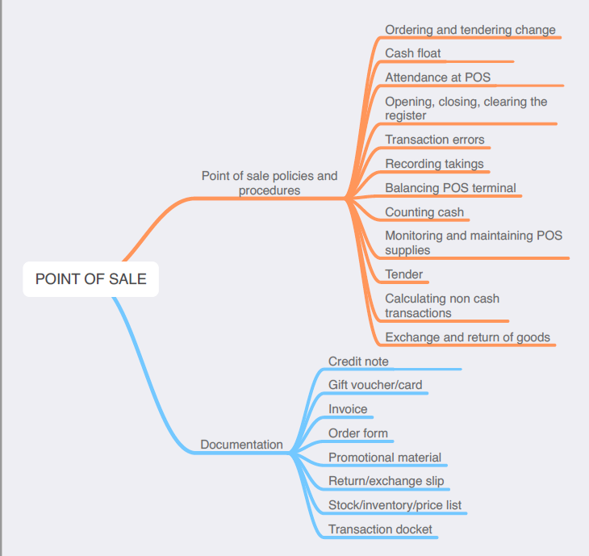
The following information is taken directly from page 30 ff of Retail Services Curriculum Framework Stage 6 Syllabus (NSW Education Standards Authority) for implementation from 2020. © 2019 NSW Education Standards Authority (NESA) for and on behalf of the Crown in right of the State of New South Wales.

products and services
- knowledge of product and service range in a workplace
- product, service and workplace knowledge required by employees in a community pharmacy/retail work environment:
- product/service:
- brand options
- features, benefits, specifications and limitations
- use/application
- care, handling and storage
- warranty
- price
- workplace:
- complementary product(s) and/or services(s)
- promotions and special offers
- loyalty schemes
- stock availability
- procedures for taking orders
- payment methods
- return/refunds
- after-sales service
- trading hours
- where and how to source information regarding products, services and the workplace
- legislative requirements that are applicable to particular product(s) and/or service(s)
sell products and services
- selling products and services in accordance with:
- legislative requirements, including:
- Australian Consumer Law
- confidentiality and privacy (in relation to recording and storing customer details)
- industry codes of practice
- workplace policy and procedures
- approaching a customer:
- methods, including:
- greeting
- merchandise
- service
- timing of approaches
- opening techniques
- customer buying behaviour, including emotional and rational motives
- determining customer buying behaviour through questioning, listening and observation
- sales approaches appropriate when making a sale:
- face-to-face
- over the telephone
- online

sell products and services cont/d
- matching customer preferences, needs and expectations to appropriate product(s) and service(s)
- interpreting sale price information and answering routine customer questions when making a sale
- selling techniques, including:
- cross-selling
- offering alternatives
- selling benefits to customer
- suggestive selling
- top down
- up-selling
- a range of strategies to overcome customer objections, including those related to:
- price
- time
- product/service characteristics
- dissatisfaction with product/service
- solution(s) to customer objections within scope of responsibility/level of authority
- customer buying signals or cues leading to sale
- closing a sale:
- techniques, including:
- direct order (using a closed question)
- active (helping the customer decide)
- steps (allowing the customer to decide one step at a time)
- alternative (offer a choice)
- difficulty (apply deadlines)
- assumptive (assume customer is making a purchase)
- direct customer to designated point-of-sale
- farewell the customer
- personal sales performance:
- review:
- customer and supervisor feedback
- personal evaluation
- strategies to improve and maximise future sales
- importance to employer and employee
minimise security risks and theft
- importance of acting within scope of responsibility/level of authority
- potential security risks within the community pharmacy/retail workplace, including those related to:
- cash
- merchandise/stock
- work areas (such as selling floor, back dock and storeroom)
- customers
- team members/employees
- visitors, sales representatives, contractors and vendors

minimise security risks and theft cont/d
- categories or types of theft that are common to retail services industries:
- internal and external
- professional
- amateur
- opportunist
- medical (eg kleptomania)
- how, when and where workplace theft occurs
- strategies to minimise and prevent theft:
- prevention
- detection
- apprehension
- workplace policy and procedures for:
- bag checks
- dealing with suspicious behaviour and actual theft
- reporting theft
- recording of stolen items
- key principles and intent of legislation and industry codes of practice and guidelines in relation to theft minimisation and prevention
minimise loss of stock
- meaning of shrinkage
- types of shrinkage:
- known
- unknown
- causes of shrinkage including error, waste and theft
- workplace policy and procedures to minimise loss of stock, including those related to:
- counting, measuring and weighing stock
- handling and storage of stock
- stock rotation
security
- meaning of security breach and examples in a retail services industry and workplace
- overt and covert security measures common to retail services:
- alarm system
- electronic article surveillance (EAS), security tags, pedestals and labels
- mirrors
- secure areas
- security person
- surveillance device
- for a range of security measures:
- features, benefits and limitations
- location and operation
- reporting faulty security equipment

security cont/d
- workplace security procedures in relation to:
- cash and non-cash transactions
- keys
- people:
- staff
- customers
- visitors, sales representatives, contractors and vendors
- point-of-sale equipment
- premises:
- secure areas
- general access areas
- records
- stock
- security and loss prevention measures for online retailing:
- transactions
- packaging and delivery
- personal information protection
- key principles and intent of:
- legislative requirements applying to security in a community pharmacy/retail workplace
- retail services industries codes of practice and guidelines applicable to security
- workplace security policy and procedures
- potential impact of security breaches on individuals and the workplace, including:
- emotional distress
- financial loss
- commercial loss
- strategies to deal with breaches in security:
- within scope of responsibility
- outside scope of responsibility
- reporting breaches in security to appropriate personnel
point-of-sale
- point-of-sale operations in accordance with:
- legislative requirements, including Australian Consumer Law
- industry codes of practice
- workplace policy and procedures
- point-of-sale documentation commonly used in retail services, including:
- credit note
- gift voucher/card
- invoice
- order form
- promotional material
- return/exchange slip
- stock/inventory/price list
- transaction docket

point-of-sale cont/d
- functions, operational features and working knowledge of equipment used during point-of-sale including:
- calculator
- cash drawer
- cash register
- EFTPOS terminal
- electronic scales
- numerical display board
- point-of-sale terminal
- scanner
- security detacher
- importance of accuracy in relation to point-of-sale equipment and handling procedures
- workplace policy and procedures in relation to the following:
- attendance at point-of-sale
- opening, closing and clearing register/terminal
- monitoring and maintaining point-of-sale supplies
- transference of tender
- maintenance of cash float
- cash and non-cash transactions
- transaction errors
- counting cash
- calculating non-cash documents
- ordering and tendering change
- recording takings
- balancing point-of-sale terminal
- exchange and return of goods and/or services
- numerical calculations common to a community pharmacy/retail workplace:
- addition
- subtraction
- multiplication
- division
- percentages
- reasons for delay at point-of-sale area or operation
- when completing the sale:
- merchandise handling techniques
- range of delivery methods
- customer delivery requirements
- use of wrapping/packaging materials for:
- protection of merchandise:
- fragile/delicate items
- perishable items
- bulk items
- security of merchandise
- point-of-sale marketing/promotion
- workplace promotion
- gift/special wrapping
- wrapping and/or packing merchandise:
- materials
- techniques

