RETAIL SERVICES

Stream Focus Area: General Selling
Welcome. This module will assist you to review and revise the content of the Stream focus area ‘General Selling’. Each focus area prescribes the scope of learning for the HSC and is drawn from associated units of competency.

You will have studied these two competencies, which together address the scope of learning:
SIRRMER001 Produce visual merchandise displays
SIRXPDK001 Advise on products and services

This module is broken up into:
- Important notes
- Key terms and concepts
- Activities
- Putting the theory into practice
- HSC focus areas

How to use the resource
Work through the notes and the suggested activities in any order. Great revision techniques include working through how a problem is solved, explaining the concept, testing yourself and retrieving information from your memory. Spread your revision over a number of sessions rather than sitting at one subject for lengthy periods. Discuss your responses with your teacher, fellow students or an interested family member.

All images, apart from those acknowledged, are © NSW Department of Education.

Important notes
You should use the information here as a prompt and guide when revising your study notes or text-book information or other resources provided by your teacher. You can also access industry specific information at ACCC, Australian Consumer Law, NSW Fair Trading and Australian Retailers Association.

You will have studied BOTH of the following competencies:
The unit SIRRMER001 Produce visual merchandise displays describes the performance outcomes, skills and knowledge required to display retail merchandise. It requires the ability to prepare, produce and maintain merchandise displays in accordance with visual merchandising requirements.

The unit SIRXPDK001 Advise on products and services describes the performance outcomes, skills and knowledge required to develop product and service knowledge and provide information to customers.

The outcomes of the Retail Services HSC stream focus area ‘General Selling’ require that the student:
- understands the techniques and workplace procedures for merchandising products
- develops knowledge required to advise on products and services
- understands the importance and application of legislative requirements, industry standards and workplace policy and procedures for merchandising and advising in a retail work environment.

Key terms and concepts
You can use the following information to revise the key terms and concepts from this unit of competency. Perhaps you could:
- Copy the table into your own file, remove all the key terms, then fill in the blanks (without peeking at the original file) with your own answers.
- Copy the table into your own file and remove the definitions. Write a definition in your own words – it doesn’t have to word perfect but should show you understand the concept.
- You could add an example of this term or concept which is relevant to the retail environment. If the key term was ‘seasonality’ your retail example might be ‘more staff are employed in the pre-Christmas period in retail to meet additional seasonal demand.’
Key term or concept | and Definition
Asymmetric | Having two sides or halves that are not the same.
Barcode | A method of representing data in a visual, machine-readable form. Initially, barcodes represented data by varying the widths and spacings of parallel lines.
Benefits | The ‘benefits’ answer a customer’s question – ‘what can it do for me?’ Benefits are often non-tangible and appeal to the emotions and rationale of the customer.
Code of practice | A document prepared to provide practical guidance on how to comply with a general duty or specific duties.
Discount | Selling goods or services for less than their regular or list price.
Display | A setting or presentation of something in open view.
Display area | The space where something is placed in open view.
Fixtures | In retail, fixtures refer to any piece of equipment or furniture used to display products.
Handling | Coordination and integration of operations such as un-packing, repacking, packaging, and movement of materials or goods over short distances.
Header board | A type of signage that communicate important brand, category and product messages.
High-risk | Likely to result in failure, harm, or injury.
Loyalty scheme | Loyalty programs offer rewards, discounts or other special incentives and are designed as a reward for brand loyalty.
Merchandise | Commodities or goods that are bought and sold in business.
Merchandising | The activity of trying to sell goods or services by advertising them or displaying them attractively.
Pricing structure | A construct which organises prices across different products and categories, so the company avoids overcharging or undercharging customers.
Seasonality | Periodic, repetitive, and generally regular and predictable pattern in the levels of business activity, where most or all sales originate in a particular season, quarter, or month.
Shelf talker | Also known as a shelf wobbler this is an in store marketing and point of sale display tool that allows a brand to stand out on the shelf by attracting the attention of customers as they walk past.
Stock rotation | A company positions older items, so they sell more quickly than newer inventory.
Storage | Space or a place for storing goods
Swing ticket | An informational text attached to a garment for sale by a thread or plastic joiner.
Symmetric | An object is symmetrical when one half is a mirror image of the other half.
Workplace policy and procedures | Policies and procedures outline the requirements for complying with both external and internal compliance requirements.

Activities
- Handling merchandise comes with risks and the need for correct handling, security and storage. Provide an example of each of the following and give examples of correct handling. Focus beyond just the illustrations.
  - General items
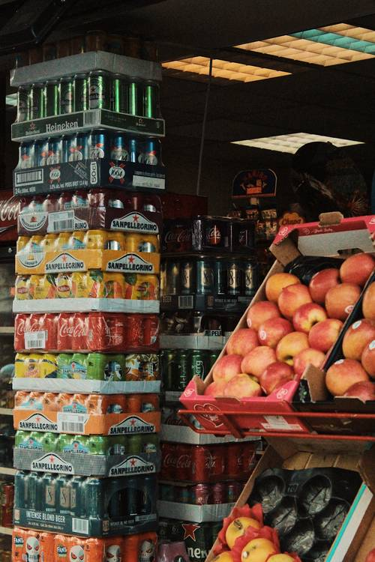
Image licenced under CC0. The original version can be found on pexels
Example:
Handling:
Security:
Storage:

  - Speciality items
Image licenced under CC0. The original version can be found on pexels

Example:
Handling:
Security:
Storage:

  - Restricted items
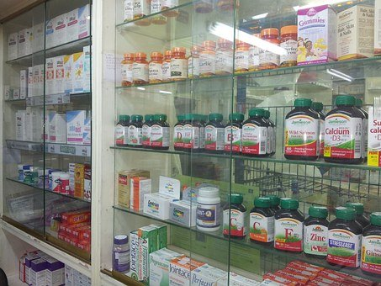
Image licenced under CC0. The original version can be found on pixabay

Example:
Handling:
Security:
Storage:

  - High Risk merchandise
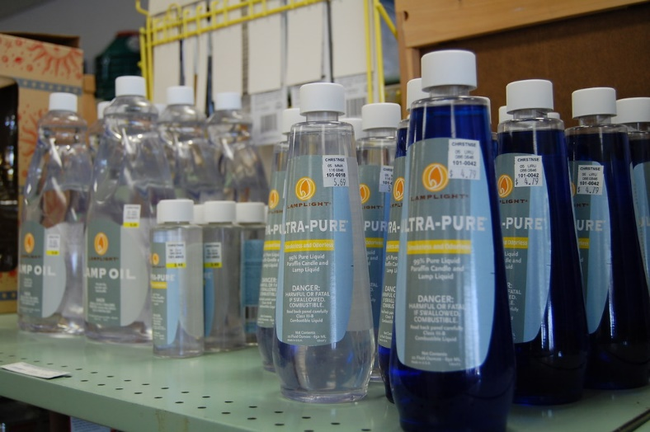
‘hdwe subset - 19.jpg’ by bwc is licensed under CC BY-NC-ND 2.0

Example:
Handling:
Security:
Storage:

- Displaying merchandise is quite a specialist field. Access this link and/or summarise notes you already have, to identify how to make best use of placement, arrangement and presentation of merchandise.
- One previous HSC question asked the student to ‘Explain the principles of display. In your answer, include appropriate diagrams’. Practice drawing up some diagrams to illustrate your answer to the question. Consider using a range of display and/or promotional areas in your diagrams.
- You’ve started working in the ‘health and lifestyle’ section of a local store where a range of sports equipment is sold. Where would you find more out about the products (treadmills, trampolines and bike helmets) mentioned below? List at least three sources.

- Research the products below at the Australian Competition and Consumer Commission (ACCC) and identify at least two safety concerns in each category. Use the table below.
Product | Where could I find out more about products? | Safety Concerns identified
Treadmills
Trampolines
Bike helmets

- The two cartoons below comment on aspects of stock control. Use them to create some notes regarding merchandising and sales/markdowns.
Photo by Artem Beliaikin from Unsplash
Photo by cottonbro from Pexels

- Collect illustrations of the range of labels and tickets used in a retail workplace. Make sure you watch out for copyright.
Labels and tickets
Barcode | Electronic | Header board | Price board
Shelf talker | Shelf ticket | Swing ticket | Written label

- Australian Consumer Law has developed a guide for business on ‘Sales Practices’. Open this document and research if the following are legal practice in relation to ‘pricing’:
- A supplier advertises lounge suites for sale. At the point of sale consumers can pay extra for fabric protection, which does not form part of the advertised price.
- An electrical goods retailer advertises a 60cm LCD television for $1990**. In fine print at the bottom, it states this price excludes commission and warehouse retrieval fees. The commission is $100 and warehouse retrieval fee is $50. These are known costs and part of the total cost.
- Each shirt on a sale table has a tag stating the cost is $25. The sign on the table says ‘SALE SHIRTS $15’. At POS, the customer is charged $25 per item.

- Organisations develop policies and procedures for dealing effectively with customers. Watch the clip from T&M Cabinets and use the information here to create a summary of the components of effective, positive and efficient customer service which might be included in such a policy.

- Legislation is applicable to a range of retail products. Have a look at the facts and myths around consumer purchasing at Fair Trading NSW.

- Investigate at least five products in the ‘Product and service safety’ area of Fair Trading NSW and identify some of the risks of using these goods.

- Working safely in a retail environment involves a range of duties. Investigate safe retail work practices here.

- Listening plays a vital role in any interaction with a customer. Add more explanation and an example to each of the following five steps to effective listening.

Stop what you are doing and give your full attention:
Let the customer do most of the talking:
Accept what the customer is saying:
Put yourself in the customer’s shoes:
Understand the depth of feeling in emotive words:

- Fill in the blanks, using the words provided.

Use these words
avoid | maximise | market | business
high | right | lower | research
products | customers | relationship | costs

Pricing products and services

Setting the ( ) price for your ( ) or services helps you ( ) profits while maintaining a good ( ) with your customers. Effective pricing can help you ( ) the serious financial problems that may occur if your prices are too ( ) or low - if you charge too much you may price yourself out of the
( ) but if you charge too little you may be underpaid for your work.
Pricing your products or services does not have to be a stressful process. Remember:
- you are in ( ) to make a profit
- it is much easier to ( ) your prices than to raise them
- thorough ( ) will help you to establish the right price.
The right price is fair to your ( ) (i.e. they are willing to pay it) and your business (i.e. you cover ( ) and make a profit).

- Match the parts of each sentence. Draw a line between each or rewrite (or cut and paste) the correct sentences, in full, below the table.

Match the sentence parts
Customers need information | that a customer may ask
Sales staff must gain information | is from the product itself
You should be able to answer questions | to help them make a buying decision
If you cannot answer questions like this | can also give you a wealth of information about a product
The most valuable and easiest source of information | is to communicate this information
Other staff members and customers | about the products they are selling
The essence of selling | your ability to sell the product is severely limited

Putting the theory into practice
The following questions are from past years’ Retail HSC examination papers. HSC exams are intended to be rigorous and to challenge students of all abilities. If you have difficulty understanding a question you should look for key words and identify the aspect of the course to which these relate. You are then in a position to formulate your answer from relevant knowledge, understanding and skills.
All questions in ‘Putting the theory into practice’ are acknowledged © 2019 NSW Education Standards Authority (NESA) for and on behalf of the Crown in right of the State of New South Wales.

Multiple Choice, Section II and Section III
Keep in mind that the Retail General Selling stream is one of three ‘streams’ that a student might study. Questions in the Multiple Choice section and in Sections II and III are not directly based on this stream content. However, there is plenty within the stream that will enhance your ability to answer the questions from other mandatory focus areas in all sections.

Questions from Section IV
The stream focus area is examined in Section IV. In this section:
- There will be three structured extended response questions, one for each of the stream focus areas: General selling, Food selling and Community pharmacy.
- Candidates will be required to answer the question on the stream they have studied.
- Each question will consist of two or three parts, with one part worth at least 8 marks.
- Each question will have an expected length of response of around four pages of an examination writing booklet (approximately 600 words) in total.

You should allow about 25 minutes for a question in Section IV in the exam.
While the focus in Section IV will be on the stream content, these questions usually allow you to bring together knowledge from several areas of study/competencies to do justice to the answer and to:
- demonstrate knowledge and understanding relevant to the question
- communicate ideas and information using relevant workplace examples and industry terminology
- present a logical and cohesive response
For each of the following, map out your answer using post-it notes or a sheet of paper.
Pay particular attention to incorporating a variety of aspects of your retail curriculum into the plan. Consider what other areas of study you would need to draw upon.

Question 1
- Outline strategies that an employee could use to source information to advise on products in a retail environment. (3 marks)
- Recommend product, service and workplace knowledge that would help an employee to advise customers in a retail environment. (12 marks)
Justify your answer with relevant retail general selling examples

Question 2
The instructions for this question asked the student to answer each part (a) and (b) in a SEPARATE writing booklet.
- Justify the importance of monitoring stock when selling merchandise. (5 marks)
- Explain housekeeping practices that a retailer could implement when considering the environment and work health and safety. (10 marks)

Question 3
- Why would a retail worker deliver additional levels of service beyond a customer’s immediate request? (3 marks)
- How can a retail worker match customer needs and expectations to products and services? (4 marks)
- Explain the practice of retailers reviewing competitors’ products and/or services and pricing structures. (8 marks)

Question 4
- Describe the principles of display in a retail environment. (5 marks)
- Explain how a retail employee should select stock, monitor stock and perform housekeeping to maintain merchandise displays. (10 marks)
Support your answer with relevant workplace examples.

Question 5
- Why are trends and seasonality important to consider when building displays? (5 marks)
- Explain the principles of display. In your answer, include appropriate diagrams. (10 marks)

Question 6
- Outline legislative requirements that need to be considered when labelling and ticketing merchandise. (3 marks)
- Describe workplace strategies that could assist a retail employee to develop product knowledge. (4 marks)
- Explain how both general items and restricted items should be handled and stored in a retail general selling environment. Support your answer with relevant workplace examples. (8 marks)

HSC Focus Areas
For the purposes of the HSC, all students undertaking the 240 HSC indicative hours course in Retail Services must address all of the mandatory focus area content.
The scope of learning describes the breadth and depth of the HSC Content and has been grouped together into key ideas/areas. The scope of learning describes the minimum content that must be addressed, and the underpinning knowledge drawn from the associated unit(s) of competency.
The (four) Retail Services Curriculum Framework mandatory focus areas are:
  - Customer service
  - Safety
  - Sales and security
  - Working in the industry
Check to make sure which one of the stream focus areas you are studying. The three Retail Services Curriculum Framework stream focus areas are:
  - General selling
  - Food selling
  - Community pharmacy
You will have studied both these units of competency associated with the stream focus area of ‘General Selling’.
SIRRMER001 Produce visual merchandise displays and
SIRXPDK001 Advise on products and services

In this focus area a student:
- understands the techniques and workplace procedures for merchandising products
- develops knowledge required to advise on products and services
- understands the importance and application of legislative requirements, industry standards and workplace policy and procedures for merchandising and advising in a retail work environment.

How to use the scope of learning for ‘General Selling’ (which follows over).
- draw up your own mind map showing the connection between the various concepts listed; examples appear on the last page of this module
- use the key terms and concepts to add to your mind map
- add examples or case study prompts to show how the concept is applied in the retail working environment
Creating a mind map is a great way to organise your knowledge and understanding of the content of a topic. You could use software such as a hierarchy chart, download ‘MindNode’ or similar or use several A4 sheets taped together. Try to make the connections which allow you to provide a nuanced answer to questions.
It’s important to try to include all the detail you can, so add definitions, case studies or examples to prompt your memory. Include the information downloaded from the unit of competency and also from the Scope of Learning and Key Terms and Concepts. At times you may need to construct several maps to achieve a good summary of a topic area.
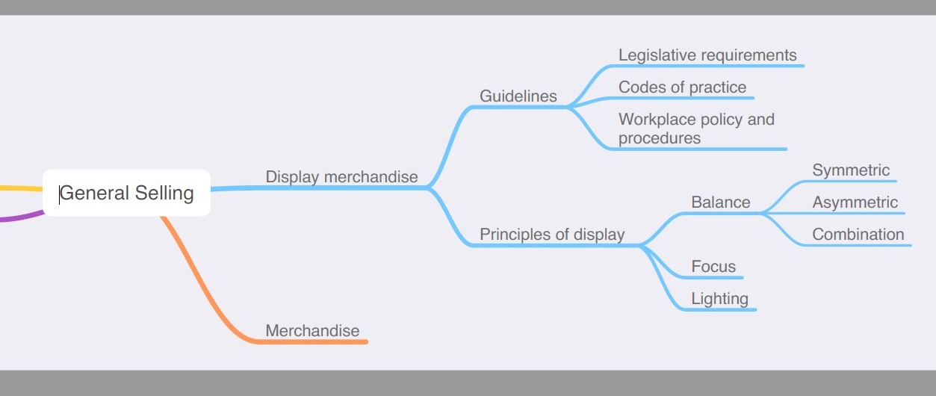
The following information is taken directly from page 43 ff of Retail Services Curriculum Framework Stage 6 Syllabus (NSW Education Standards Authority) for implementation from 2020. © 2019 NSW Education Standards Authority (NESA) for and on behalf of the Crown in right of the State of New South Wales.
