RETAIL SERVICES
Mandatory Focus Area: Customer Service
Welcome -
This module will assist you to review and revise the content of the mandatory focus area: Customer Service. Each focus area prescribes the scope of learning for the HSC and is drawn from associated units of competency.
You will have studied one of these competencies, both of which address the scope of learning:
SIRXCEG001 Engage the customer or
SIRCCCS001 Interact with pharmacy customers
This module is broken up into:
- Important notes
- Key terms and concepts
- Activities
- Putting the theory into practice
- HSC Focus Areas
How to use the resource
Work through the notes and the suggested activities in any order. Great revision techniques include working through how a problem is solved, explaining the concept, testing yourself and retrieving information from your memory. Spread your revision over a number of sessions rather than sitting at one subject for lengthy periods. Discuss your responses with your teacher, fellow students or an interested family member.
All images, apart from those acknowledged, are © NSW Department of Education.

Important notes
You should use the information here as a prompt and guide when revising your study notes or text-book information or other resources provided by your teacher. You can also access industry specific information at ACCC, Australian Consumer Law, NSW Police, NSW Fair Trading and Australian Retailers Association.
You will have studied ONE of the following competencies.
The unit SIRXCEG001 - Engage the customer (Release 1) describes the performance outcomes, skills and knowledge required to interact and communicate with a diverse range of customers to assist with basic enquiries and contribute to a service culture.
or
The unit SIRCCCS001 - Interact with pharmacy customers (Release 1) describes the performance outcomes, skills and knowledge required to deliver fundamental customer service to community pharmacy customers. It requires the ability to greet and serve customers and cover a range of customer service enquiries including routine customer problems.

The outcomes of the Retail Services HSC mandatory focus area ‘Customer Service’ require that the student:
- explains the fundamental principles of quality customer service
- proposes appropriate responses to customer inquiries, dissatisfaction, problems and complaints
- applies knowledge of workplace policy and procedures and industry standards to ensure quality customer service.

Key terms and concepts
You can use the following information to revise the key terms and concepts from this unit of competency. Perhaps you could:
- Copy the table into your own file, remove all the key terms, then fill in the blanks (without peeking at the original file) with your own answers.
- Copy the table into your own file and remove the definitions. Write a definition in your own words – it doesn’t have to word perfect but should show you understand the concept.
- You could add an example of this term or concept which is relevant to the retail environment. If the key term was ‘open questions’ your retail example might be ‘What brought you into the store today?’
 | Key term or concept | and Definition
Active listening |  | A structured way of listening and responding to another person to ensure they have understood what was said.
Add-on selling |  | Suggesting that a customer purchase additional product/s to increase sales. For example, asking a customer if they would like to purchase socks with shoes.
Allocated duties and responsibilities |  | The general tasks and expectations of a person working in a particular position.
Benefits of good customer service |  | Include repeat sales, loyal customers and increased sales and profits.
Closed questions |  | Require the customer to give specific information. These questions can be answered with a yes/no or one-word answer.
Communication |  | The process of transferring information from one person to another.
Customer dissatisfaction |  | Occurs when a customer is unhappy with a product or the level of customer service received.
Customer expectations |  | Refers to the benefits the customer wants from the product or service.
Customer needs |  | Are the requirements that a customer has of a product.
Customer preferences |  | Refers to the order of choice a customer places on a product(s).
Customer satisfaction |  | The customer’s positive impression from the service they received from the retail store.
Customer special needs/requirements |  | When customers have a special request for a particular purchase.
Establishing and maintaining contact with customers |  | This occurs when the sales assistant approaches the customer and builds rapport by assisting them throughout the sales process.
Etiquette |  | Proper behaviour in the workplace, making the environment where people work a polite, respectful, pleasant place to be.
External customers |  | People who do not belong to your workplace that use your services. They include shoppers, visitors, tradespeople and contractors.
Follow-up action |  | May take the form of formal documentation or be as simple as a phone call to check the customer is happy.
Handling customer complaints |  | The process followed to resolve customer complaints effectively and efficiently.
Internal customers |  | Internal customers are employees who purchase goods from your store. They include employees, supervisors and managers.
Level of authority |  | The structure of the management hierarchy in the store.
Lines of reporting |  | This specifies who is responsible for each department within the organisation. For example, manager, supervisor, employee etc.
Non-verbal signs |  | Include body language, signs and symbols used to communicate such as folding arms, gesturing etc.
Open questions |  | Open questions gather detailed information from the customer. They begin with words such as what, when, where, why and how.
Personal attributes and work ethics |  | A range of skills and qualities required of a sales assistant to interact effectively in the workplace.
Processing exchanges and returns |  | Exchanges refer to swapping goods that are unsuitable. Returns can be processed by giving a customer a refund or store credit.
Reflective questions |  | Reflective questions are asked to clarify what the customer has said and to ensure that the message has been understood.
Sales documentation |  | Documentation that records sales, such as a receipt, invoice, refund slip etc.
Sales orders |  | Orders made by the business to a supplier for goods.
Scope of responsibility |  | Specific work duties that are the responsibility of the employee.
Seeking assistance |  | Asking someone for help or advice
Workplace policy and procedures |  | Policies and procedures outline the requirements for complying with both external and internal compliance requirements.

Activities
- Click on the link to ‘The ABCs of Customer Service’ and list as many fundamentals of customer service as you can.
You should be able to find 24 in this clip!
- Read the passage (from The Retailer’ (Issue 66, 2019, p 22) then answer the questions below.
‘Customer service involves identifying the most efficient and cost-effective solution for the customer’s problem. This involves demonstrating strong listening skills, empathy, and focus, along with the ability to maintain the customer’s confidence. Customers won’t necessarily complain to management about vague inattentive service or incorrect information – but there is a high chance that they won’t come back.
However, they will come back if the retail assistant can knowledgably discuss the best options, give them accurate price information and for retail staff in higher positions, customer service is a more delicate operation, dealing with serious complaints by coming up with a solution that makes the customer feel validated and heard.’

  - Retail workers need knowledge, skills and attributes.
Give examples of each.
Knowledge | Skills | Attributes (the way you do things)

  - What staff training could your employer provide to improve customer service?
  - What is the value to the organisation of good customer service?

- The Perfect Little Wedding company has identified strategies which allow them to meet customer needs. Watch the video and identify the key methods.

- Try this exercise. Put each phrase into the correct column of the table.
- Hi, how may I help you?
- Good morning. Those tops are great value at $9. Were you looking for one to go with something?
- What can I help you with today?
- Hello. That's a nice jumper you have on (only if you are sincere).
- Hi! That jacket is fully lined which makes it really comfortable to wear. Would you like some help with the sizes?
- Good Morning. How are you today?
- Good morning. What size are you looking for?

- Write a definition of each of the following:
  - Closed question
  - Open question
  - Reflective question
- Canity.com provide a free video clip about exceptional customer service.
NO need to sign up. Watch the clip then write examples of how it applies to a retail environment. Remember you may be able to enhance an HSC response with good examples from the workplace. Practice a conversation without using ‘please’, ‘thank you’ and other simple courteous phrases, and the same conversation including these words.

- Have a break by completing this find-a-word activity. You may need to print this page.
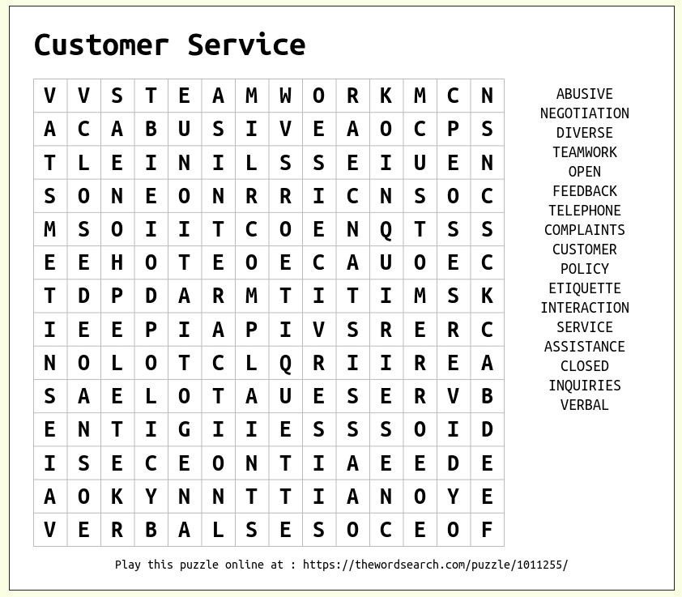

- Find tips for managing complaints from customers, Make your own table with examples from the retail environment.
Managing complaints
General tips for managing complaints | Interpersonal approaches to managing complaints | Organisational approaches to managing complaints

- List TWO examples of each of the following methods of communication used in the retail environment.
Methods of communication
 |  | Verbal communication | Non-verbal communication | Written communication
Example 1
Example 2

- Provide a workplace scenario which shows how the following can be used well or poorly.
Communication strategies
 | Verbal communication | Non-verbal communication | Written communication
Used well in the workplace
Used poorly in the workplace

- Research ‘tips for assisting customers with disability’ and make your own checklist or poster. Include other pertinent information from your own notes.

- a) Indicate if the following are ‘open’, ‘closed’ or ‘reflective’ questions.
 | Open | Closed | Reflective
Who are you buying for today?
Were you satisfied with your last purchase?
What have you been up to today?
Can you tell me about the [product being replaced]?
What is the most important feature you are looking for?
Does this make sense?
Can you come in again on Monday?
How was work today?
What brought you into the store today?
What are your first thoughts about the product?
What do you have planned for the weekend?
Are you ready to move forward on purchasing this product?
What are you looking/browsing for?
What’s the one thing you are most interested in?
What time is it?
Do you have any questions I can answer?
What made you choose your last product?

- Can you give an example of where using a ‘closed’ question might be of use in a retail environment?

- Match the two halves of each sentence. Draw a line between each or write (or cut and paste) the correct sentences, in full, below the table.
Correctly match each half of the sentence
If your work involves being away from the floor for part of the time | you need to look up from your computer, stop stocking shelves or whatever else you're doing as soon as possible
Remember, you want to treat customers | smile and say something such as, "Hello. How may I help you today?"
Allow the customer to respond | in a professional manner
The first way that you make your customer feel valued | you need to have some system that alerts you when a customer enters
when someone enters your store or office | is by acknowledging her or him as soon as possible
Be courteous and respectful to all your guest | with the same respect you would anyone else.
Make eye contact | and listen to what the customer may request
Treat people with a disability | how you would want to be treated.

- Fill in the blanks, using the words provided.

Use these words
people | opinions | social | negative
mass | positive | potential | blogs
Amazon | internet | reviews | work

Managing online customer reviews
Customer opinions have always had the ( ) to influence other people's attitudes towards a business. In the past, these ( ) were communicated mostly by word of mouth.
But the ( ) has given customer opinions ( ) exposure. Millions of customers now post reviews of goods and services on websites, blogs and other ( ) media. And millions of ( ) read them.
Research shows that ( ) online reviews increase the likelihood of customers using your business, while ( ) reviews reduce it.
Customer reviews are posted on:
- general review sites (e.g. Yelp, Product Review)
- specialised review sites (e.g. Zomato, TripAdvisor)
- retailers' websites (for example )
- personal ( )
- other social media (e.g. Twitter, Facebook).
This guide explains who reads and writes online ( ) their potential impact on your business, and how reviews can ( ) for you - even when they're negative.

- These three cartoons all make a comment about customer service. Consider how you might use each one as part of staff training.
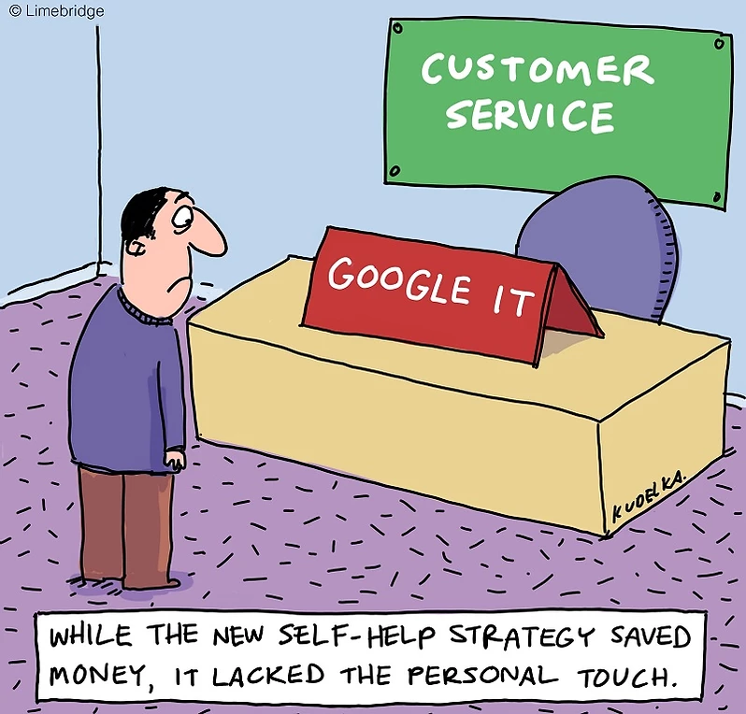
Image licenced under CC0. Original versions can be found on LimeBridge Australia Pty Ltd
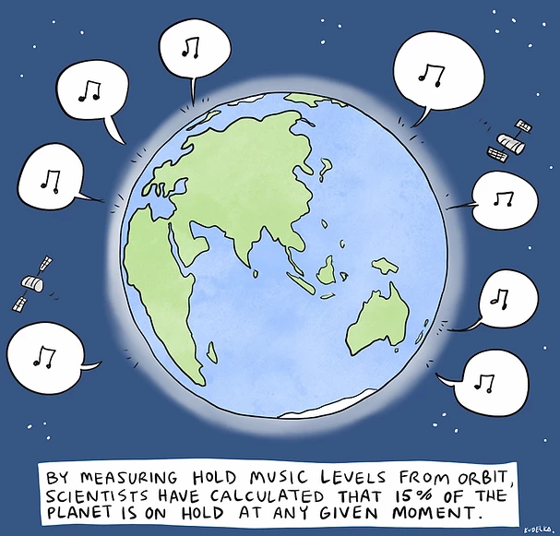
Image licenced under CC0. Original versions can be found on LimeBridge Australia Pty Ltd
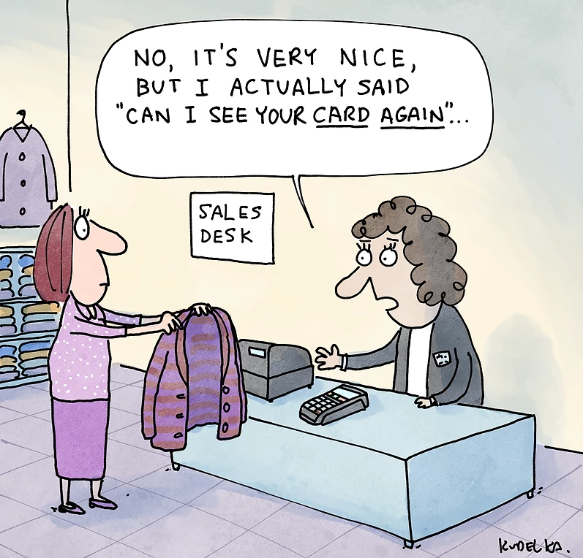
Images licenced under CC0. Original versions can be found on LimeBridge Australia Pty Ltd

Putting the theory into practice
The following questions are from past years’ Retail HSC examination papers. HSC exams are intended to be rigorous and to challenge students of all abilities. If you have difficulty understanding a question you should look for key words and identify the aspect of the course to which these relate. You are then in a position to formulate your answer from relevant knowledge, understanding and skills.
All questions in ‘Putting the theory into practice’ are acknowledged © 2019 NSW Education Standards Authority (NESA) for and on behalf of the Crown in right of the State of New South Wales.

Multiple Choice
- Which of the following is the best procedure to establish the details of a customer inquiry?
  - Reiterating → questioning → summarising
  - Reiterating → summarising → questioning
  - Summarising → reiterating → questioning
  - Questioning → summarising → reiterating

- A customer picks up a pre-ordered cake and finds that it is smaller than they had expected. The customer is dissatisfied. Which of the following responses from the sales assistant is the best initial step in an effective problem-solving strategy?
  - I will give you a discount.
  - I will supply an additional cake.
  - I will check the original order form.
  - I will ring my manager who is at lunch.

- A woman informs a sales assistant that her friend wants to buy a pair of shoes. She explains to the sales assistant that her friend does not speak English very well and she has come to help him. Which of the following would be the best way for the sales assistant to establish a relationship with the customer buying the shoes?
  - Speak loudly and clearly so as to be heard
  - Direct questions to the friend who understands English
  - Use non-verbal communication such as smiling and eye contact
  - Apologise for not being able to help them and direct them to another sales assistant.

- Which of the following is a feature of active listening?
  - Writing notes about what you are hearing
  - Making eye contact and nodding your head
  - Ensuring you have turned down any background noise
  - Turning your ear towards the person you are speaking to
- A sales assistant advises the manager that a co-worker has complained about the lack of hygiene in the store. Which of the following best describes the action of the sales assistant?
  - Acting within the line of authority
  - Promoting collegial working relationships
  - Reinforcing the concept of customer focus
  - Operating outside their scope of responsibility
- Which of the following is the main limitation of using social media to provide recall information on a faulty product?
  - It sends recall information through multiple devices.
  - It relies on the customer accessing recall information.
  - It may be seen as anti-social to provide recall information.
  - It provides minimal space for recall information to be presented.
- A customer complains to a retailer when a table that they have ordered is not available for delivery until next year. What is this complaint in relation to?
  - Time
  - Price
  - Quality
  - Product
- Kim and Ken work in a library. Every Friday, they shop at a supermarket inside a shopping centre. What type of customers are they to the supermarket?
  - Open
  - Closed
  - Internal
  - External

- A salesperson says to a customer, ‘You mentioned that you wanted an elegant dress. Is it for a special occasion?’ Which combination of questioning techniques is being used by the salesperson?
  - Active and open questioning
  - Active and closed questioning
  - Reflective and open questioning
  - Reflective and closed questioning
- How could a salesperson best provide good customer service when obtaining information from a customer?
  - Speaking clearly and politely
  - Following industry codes of practice
  - Asking questions to determine the needs of the customer
  - Displaying knowledge of the latest trends in product development
- What is the purpose of using reflective questions when dealing with customers?

  - To receive a response from the customer
  - To gather information about the customer
  - To check if the customer has been listening to you
  - To show the customer that you have been listening
- A customer approaches a salesperson in a retail store and makes an inquiry. Which set of strategies would the salesperson use to best establish the details of the inquiry?
  - Questioning, visualising and reiterating
  - Questioning, visualising and documenting
  - Questioning, summarising and reiterating
  - Questioning, summarising and documenting
- While serving customers, a retail services worker answers a phone call from a customer with a product complaint. In order to respond to this complaint, what is the first step the worker should take following the phone call?
  - Ask the manager to call the customer back
  - Tell a relevant colleague about the conversation
  - Record the conversation according to workplace procedures
  - Apologise to and continue serving customers who have been waiting in line

- A retailer instructs staff to open more point-of-sale terminals when there are two or more customers lined up. This is an example of a workplace procedure for:
  - increasing customer sales.
  - decreasing staff workload.
  - establishing quality customer service.
  - directing customers to relevant personnel
- A large chain of clothing stores has a loyalty card scheme. The store’s management wants to inform the customers who are part of the loyalty scheme about an exclusive upcoming sale. Which communication technology is most appropriate to carry out this task?
  - Fax
  - Email
  - Voice call
  - Social media

Questions from Section II
These questions should be answered in the suggested number of lines (handwritten in the exam) as it gives a guide to the length of your response.
Plan out your answer and key points before you commence writing.
Question 1
- Identify ONE characteristic of a salesperson delivering quality customer service. (1 mark)

- How could quality customer service benefit a retailer? (2 marks)

- Describe how teamwork can help deliver quality customer service.
(3 marks)

Question 2
- Identify TWO non-verbal signs that would indicate to a salesperson that a customer is ready to purchase. (2 marks)

- Using an example, outline the concept of a customer-focused workplace.
(2 marks)

Question 3
- A customer wants to purchase an item that is currently out of stock. The sales assistant offers to contact the customer when the product becomes available but forgets to ask for the customer’s phone number. Outline a procedure that could be followed by sales staff to prevent this type of mistake. (2 marks)

- Explain the features of good telephone etiquette in a retail environment.
(3 marks)

Question 4
- Recommend TWO strategies that a community pharmacy or retail workplace could use to assist customers with special needs. (3 marks)

- Using an example other than assisting a customer with special needs, explain how a sales assistant can contribute to the service culture of a workplace.
(3 marks)

Question 5
- Outline the relationship between customer service and business success.
(2 marks)

- Using examples, explain the role of communication in providing quality customer service. (6 marks)

Questions from Section III

There will be one extended response question in Section III. This will provide you with the opportunity to
- demonstrate knowledge and understanding relevant to the question
- communicate ideas and information using relevant workplace examples and industry terminology
- present a logical and cohesive response
The expected length of response for questions in Section III and IV is around four pages of an examination writing booklet (approximately 600 words).
You should allow about 25 minutes for a question in Section III in the exam.

You will note that these questions usually require you to bring together knowledge from several areas of study/competencies to do justice to the answer.
In each of the following, map out your answer using post-it notes or a sheet of paper. Pay particular attention to incorporating a variety of aspects of your retail curriculum into the plan. Consider why we have included this question within this module and what other areas of study you would need to draw upon.

Question 1
Explain how effective teamwork can benefit employers, employees and customers in retail services industries.

Question 2
Explain policies and procedures that can be implemented to provide quality service in the retail environment.
In your response, consider how the policies and procedures address the needs of a range of customers.

HSC Focus Areas
The (four) Retail Services Curriculum Framework mandatory focus areas are:
- Customer service
- Safety
- Sales and security
- Working in the industry
Check to make sure which one of the stream focus areas you are studying. The three Retail Services Curriculum Framework stream focus areas are:
- General selling
- Food selling
- Community pharmacy
For the purposes of the HSC, all students undertaking the 240 HSC indicative hours course must address all of the content included in the scope of learning for the focus area.
The scope of learning describes the breadth and depth of the HSC Content and has been grouped together into key ideas/areas. It describes the minimum content that must be addressed, and the underpinning knowledge drawn from the associated unit(s) of competency.
Two units of competency are associated with the focus area of ‘Customer service’.
You may have studied either SIRXCEG001 Engage the customer or SIRCCCS001 Interact with pharmacy customers
In this HSC mandatory focus area, a student:
- explains the fundamental principles of quality customer service
- proposes appropriate responses to customer inquiries, dissatisfaction, problems and complaints
- applies knowledge of workplace policy and procedures and industry standards to ensure quality customer service.

How to use the scope of learning for ‘Customer Service’ (which follows over).
- draw up your own mind map showing the connection between the various concepts listed; examples appear on the last page of this module
- use the key terms and concepts to add to your mind map
- add examples or case study prompts to show how the concept is applied in the retail working environment
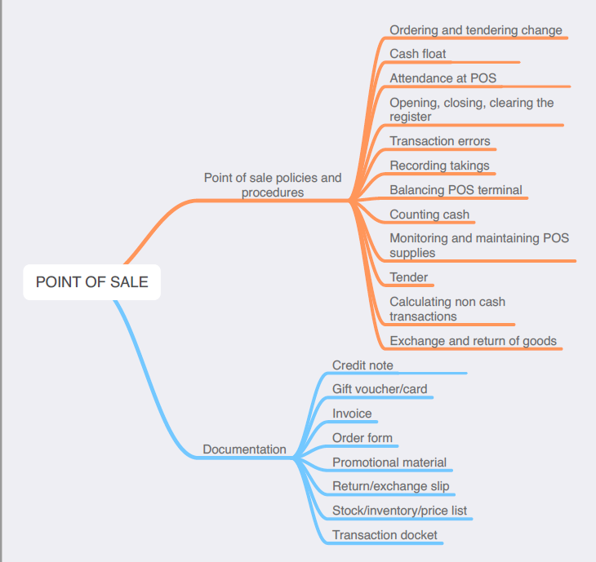
Creating a mind map is a great way to organise your knowledge and understanding of the content of a topic. You could use software such as a hierarchy chart, download ‘MindNode’ or similar or use a large sheet of paper (or several A4 sheets taped together)!
Try to make the connections which allow you to provide a nuanced answer to questions. At times you may need to construct several maps to achieve a good summary of a topic area.
It’s important to try to include all the detail you can, so add definitions, case studies or examples to prompt your memory. Include the information downloaded from the unit of competency and also from the Scope of Learning and Key Terms and Concepts.
The following information is taken directly from page 20 ff of Retail Services Curriculum Framework Stage 6 Syllabus (NSW Education Standards Authority) for implementation from 2020. © 2019 NSW Education Standards Authority (NESA) for and on behalf of the Crown in right of the State of New South Wales.

customers
- types of customers:
- internal
- external
- new
- repeat or regular
- customers with special needs and implications for customer service
- a range of customers with different service requirements
- difference between customer needs, preferences and expectations
- the differing needs, preferences and expectations of internal and external customers and new and repeat customers
- establishing customer needs, preferences and expectations through:
- active listening
- open, closed and reflective questions
- observation and recognition of non-verbal signs
- communicating effectively with customers:
- verbal, written and non-verbal communication
- face-to-face, over the telephone and electronically
- importance of being accurate, clear, concise and courteous
quality customer service
- industry approaches to service delivery:
- standards of customer service for industry personnel
- how work is organised and undertaken
- timing and designated response times for service to workplace and industry standard
- the relationship between customer service and business success
- concept of service culture and a ‘customer focused’ workplace
- characteristics and benefits of quality customer service
- role of communication in the provision of quality customer service
- establishing quality customer service:
- detailed knowledge of a range of products and services offered at a community pharmacy/retail workplace
- matching customer needs, preferences and expectations to appropriate product(s) and/or service(s):
    - meet customer need, preference and/or expectation
    - seek assistance from others as necessary in order to meet the customer need, preference and/or expectation

quality customer service cont/d
    - refer to appropriate person where unable to meet the customer need, preference and/or expectation
- seeking opportunities to deliver additional level of service beyond a customer’s immediate request or expectation
- developing collegial working relationships with others involved in the provision of customer service
- using/adopting a teamwork approach
- dealing with problems and/or delays in the delivery of product(s) and/or service(s)
- seeking feedback on customer service practices:
    - the value of feedback from staff and customers
    - its use in improving and enhancing service delivery
workplace policy and procedures for customer interaction
- workplace policy and procedures for customer interaction through all stages of service and sale
- workplace policy and procedures for establishing contact with customers:
- techniques for approaching a customer
- developing rapport
- workplace policy and procedures for dealing with:
- customers from diverse backgrounds
- customers with special needs
- difficult and abusive customers
- workplace policy and procedures for directing customers to relevant personnel and/or more experienced staff
customer inquiries
- a range of customer inquiries common to a community pharmacy/retail workplace
- establishing the details of the inquiry by questioning, summarising and clarifying
- paper-based and electronic methods for recording customer inquiries
- sources of information that can be used when handling customer inquiries
- effective response(s) to a range of customer inquiries common to community pharmacy/retail within appropriate timeframes
communication technology
- features, purpose and limitations of a range of communication technologies common to retail services industries including:
- telephone (landline and mobile)
- email
- social networking
- other

communication technology cont/d
- selection of communication technologies appropriate to work tasks
- working knowledge of a range of communication technologies
- ‘good’ telephone etiquette
- workplace procedures for message-taking
customer complaints and feedback
- reasons for customer dissatisfaction, problems and complaints
- examples of dissatisfaction, problems and complaints common to community pharmacy/retail
- complaints-handling policy and procedures
- skills required for handling complaints, including:
- problem-solving
- conflict-resolution
- negotiating
- decision-making
- using conflict-resolution techniques when handling customer dissatisfaction, problems and complaints
- effective responses to a range of instances of customer dissatisfaction, problems and complaints
- importance of:
- community pharmacy/retail staff offering a range of viable solutions in accordance with workplace policy and procedures
- community pharmacy/retail staff and the customer agreeing on what is to be done in regard to the problem or complaint
- implementing solution(s) within acceptable timeframes
- acting within scope of responsibility/level of authority when handling customer dissatisfaction, problems and complaints
- identify when it is appropriate to seek assistance and/or refer customer to other appropriate personnel for issues that cannot be resolved effectively
- the importance of recording and/or reporting instances of customer complaints and feedback
- workplace practices for recording and reporting customer complaints and feedback:
- formal and informal
- verbal and written
- recognition of the value of customer complaints and feedback

