Primary Industries
Mandatory Focus Area: Weather

Welcome.
This module will assist you to review and revise content in the area of ‘Sustainability’ in the NSW HSC Primary Industries syllabus.

You will have studied either:
AHCWRK201 Observe and report on weather or
AHCWRK302 Monitor weather conditions
both of which address the scope of learning (at the end of this document).

This module is broken up into:
- Important notes
- Key terms and concepts
- Syllabus requirements (this section includes revision activities)
- Putting the theory into practice
- HSC Focus Areas
How to use the resource
Work through the notes and the suggested activities in any order. Great revision techniques include working through how a problem is solved, explaining the concept, testing yourself and retrieving information from your memory. Spread your revision over a number of sessions rather than sitting at one subject for lengthy periods.
Discuss your responses with your teacher, fellow students or an interested family member.
All images, apart from those acknowledged, are © NSW Department of Education.

Important Notes
You should use the information in this module as a prompt and guide when revising your study notes or text-book information or other resources provided by your teacher. You can also access industry specific information at SafeWork NSW, Farmsafe Australia (National Farmers Federation) or NSW Department of Primary Industries,

The unit AHCWRK201 Observe and report on weather describes the skills and knowledge required to observe and report on weather and climate conditions.
The unit AHCWRK302 Monitor weather conditions describes the skills and knowledge required to monitor and interpret weather and climate conditions and assess the likely impact on work functions and activity.

The outcomes of the HSC Primary Industries mandatory focus area ‘Weather’ require that the student:
- understands the concepts of weather and climate
- interprets weather and climate information
- evaluates the impact of weather and climate on farming operations and work practices

Key terms and concepts
You can use the following information to revise the key terms and concepts from this unit of competency. Perhaps you could:
- Copy the table into your own file, remove all the key terms, then fill in the blanks (without peeking at the original file) with your own answers.
- Copy the table into your own file and remove the definitions. Write a definition in your own words – it doesn’t have to word perfect but should show you understand the concept
- Go to The Australian Government Bureau of Meteorology Glossary page website to find even more weather related words.
- You could add an example of this term or concept relevant to the Primary Industries environment. If the key term was ‘environmental hazard’ your PI example might be ‘Fumes, emissions and spills from chemicals must be managed so as to avoid an environmental hazard’.
Key term or concept | and definition
Bureau of Meteorology | Federal government agency responsible for observing, monitoring, recording, forecasting and reporting information about the climate and weather across Australia and the surrounding region.
Climate | The sum of all the weather recorded over a long period of time and reported as long-term records, trends and averages.
Enterprise | A business unit characterised by the production of a particular type of product or service, eg beef cattle enterprise, cropping enterprise, vegetable-growing enterprise.
Forecasting techniques | Methods used to predict probable future weather conditions.
Forecasts | Statements of probable future weather conditions calculated from meteorological data.
Grazier alert | A warning issued to farmers when cold, windy and rainy conditions increase the risk of death in newborn lambs and recently shorn sheep.
Meteorological conditions | The situation in the weather at a point in time.
Monitor weather and climate | Observe and record short and long term atmospheric conditions and access current meteorological information.
Preventative action | Something done as a precaution or to minimise a risk.
Regular updates | Reports given at set intervals about weather conditions.
Relevant personnel | People who might need to be contacted such as other staff and colleagues, owners, managers and government or regulatory officers.
Reporting and recording | Providing information to others about an event (reporting) and preparing a written account (recording).
Weather | The description of atmospheric conditions such as wind, temperature, cloudiness, precipitation and air pressure over a short period of time.
Weather and climate conditions | Short and long term situations relating to the atmosphere experienced over a given region.
Weather maps | Charts of a country or region showing weather systems, high and low pressure cells, isobars (lines of equal atmospheric pressure), cold and warm fronts and potential precipitation.
Weather station | Site equipped with meteorological instruments that measures data related to the weather that is recorded manually or automatically.
Weather updates | Reports about changes to current or probable future weather conditions.
Weather warning | Notification issued by the Bureau of Meteorology on a state by state basis of impending or actual weather that has the potential to cause loss of life or damage to property.
Wind chill | The phenomenon where increasing wind speed causes the apparent temperature to drop.
Wind chill factor | Calculated temperature that represents the ‘feel’ of a wind on exposed human skin in terms of an equivalent temperature in still air.
Wind shear | The variation in wind speed (speed shear) and/or direction (directional shear) between two layers of air sliding over one another.
Work programs | Schedules of tasks planned to be done at work.
Work tasks | Specific jobs to be done at work.

Syllabus requirements
This module is broken up into theory summaries as per the syllabus requirements dot points to give you basic background information. Use the questions which follow each section to test yourself. Practice questions from previous years’ HSC examinations can also be found in ‘Putting the theory into practice’.

Weather and climate

The difference between weather and climate
Climate refers to the long term pattern of an area and includes seasonal variation and patterns. It generalises the rainfall patterns and temperatures range and includes tendency for frosts, snow, storms, heatwaves and intensity of rain. Are the winters long and very cold and summers hot and dry like inland Australia regions or are the winters mild and summers hot, humid and moist like eastern coastal regions. These trends make up the climate of an area. Climate affects long term planning for farmers more so.
Weather refers more to the short term behaviour and the likelihood of rain and what the temperatures will be like for those few days and winds, humidity and frostiness. The weather affects farmers weekly plans and activities.
Climate and weather have a major impact on agricultural and horticultural enterprises and land management practices. The climate of a region will determine the plants and animals that can be successfully grown or raised there. Many districts have a history of enterprises that have failed because they were not suited to the climate.
Add words to the ‘Key terms and concepts’ table as you locate additional ideas.

Elements of weather and climate:
- temperature:
  - heat
  - cold
- humidity
- wind:
  - wind chill
  - wind shear
- precipitation
- atmospheric pressure
- atmospheric particle count

Temperature is a very important factor in plant and animal production.
High temperatures:
- increase evaporation rates from soil, especially in windy conditions
- cause wilting which may kill plants if the soil is already dry
- reduce growth rates of pastures and crops
- lead to sunburn of fruit crops that are directly exposed to the sun
- increase problems with pests and diseases, especially if there is high humidity
- reduce feed intake in livestock as they seek shade rather than graze.
Low temperatures:
- may prevent germination of summer crops
- can reduce the growth rate of pastures and crops
- can kill plants if temperatures are low enough to produce a severe frost
- may be needed by fruit crops to produce fruit of the required quantity and quality
- increase the feed requirements of livestock as they use energy reserves to keep warm
- increase the risk of death of newborn livestock and recently shorn sheep from wind chill in rainy, windy and/or snowy weather.
Temperature is measured using a thermometer and is recorded in degrees Celsius (°C).
Maximum-minimum thermometers record the hottest and coldest temperatures experienced and should be reset on a regular basis. Thermometers are usually mounted on a post or veranda wall that is shaded all day and out of the rain. At weather stations, thermometers are placed in a specially designed wooden box called a Stevenson screen.
Temperature will vary over a region and depend on amount of cloud cover - plays a big role in moderating minimum temperatures. Through the day the earth absorbs heat from the sun, in the evening a cloud cover will trap that heat and stop it from being lost from the atmosphere, so temperatures will be moderate.
- altitude - for every 300m metres above sea level the temperature will drop by 2° C, all else being equal
- topography - aspect of slope, east and south slopes are cooler than west slopes. North facing slopes are warmer in the winter.
- exposure to prevailing wind
- distance from the ocean or large body of water - water, evaporating cools the surrounding area
- vegetation density - plants transpire releasing water vapour, large trees more than grass colour of the surroundings which affects how well solar radiation is reflected back into the atmosphere- light coloured mulch will reflect heat, dark coloured soil absorbs heat, bitumen is always hotter than cement
- type of surface - those that absorb heat take longer to cool, eg water, dark soil, brick walls and rocks. Surfaces that are insulated, eg mulched gardens, and insulated chicken sheds have less temperature variation through the day and evening.

Humidity is the amount of moisture found in the air and affects plant and animal production by encouraging disease especially moulds and fungal diseases and ability of an animal to cool down can be restricted by high humidity which can affect productivity.
Relative humidity is measured using a wet bulb thermometer and is recorded as a percentage (%).
The wet bulb thermometer is placed in a shady position with free flowing air. The bulb of the thermometer is wrapped in muslin that is kept damp. The temperature recorded is compared with that of a normal (dry bulb) thermometer and the relative humidity calculated from a table of figures.
Wind is produced from high and low pressures and is moving air. Wind patterns are very changeable and can change through the day, seasons and the year. Wind associated with falling or rising temperatures can result in hazardous weather.
Windshear is the direction and angle of a wind and in extreme weather events can chop and change and cause stress to animals trying to seek shelter or protection and to boats and aquaculture enterprises.
Windchill is the drop in temperature of the air associated to a wind blowing over very cold terrain or off snow and results in the air temperature of an area being much colder than if the wind isn't blowing. Wind chill has implications for animals, particularly shorn sheep and lambs (have no wool to insulate them), but also during lambing and calving periods (wet at birth, have no fat cover or wool to insulate them) are more vulnerable to windchill. Animals experience cold much more severely in wet and windy conditions. The combination of cold, wet and wind is known as chill factor.
Wind direction is measured using a weather vane or wind sock and is recorded as a compass direction. Weather vanes are usually mounted on tall posts or roof tops where they can catch the prevailing winds. A wind sock is mounted on a tall post beside an airstrip.
Wind speed is measured using an anemometer and is recorded in knots. One knot approximately equals two kilometres per hour (1 knot » 2 km/hr).
Anemometers are specialised pieces of equipment usually only found in weather stations. Wind speeds can be estimated and described using terms such as calm, light, moderate, strong and gale force.
Wind at a given location is affected by:
- the time of day
- topography -hills and mountains influence wind velocity and direction
- altitude - affects wind temperature.
Wind from the ocean will be cool and moist, whereas wind blowing over large landmasses is generally warm and dry.
Wind is produced from high and low pressure. Wind patterns are very changeable and can change through the day, seasons and the year. Wind associated with falling or rising temperatures can result in hazardous weather.
Rainfall and precipitation - a major factor in plant and animal production.
Lack of rain is the major limiting factor for plant growth and associated animal production in Australia. Large areas of the country are unsuited to most agricultural enterprises because of low rainfall. In these regions only plants and animals adapted to dry conditions can be successfully raised without irrigation.
Too much rain, rain falling at the wrong time and high humidity can also limit some types of production. For example, sheep are not suited to the eastern coast of Australia where the high humidity increases the risk of foot and fleece rot.
Precipitation can include mist, fogs, snow, sleet, hail, rain. Any moisture condensing from the atmosphere is known as precipitation.
Rainfall is measured with a rain gauge and recorded in millimetres (mm). The gauge is usually mounted on a post on relatively flat ground. It should be in the open, away from trees, buildings and other shelters. Unlike temperature, rainfall can be very localised. This is one of the reasons so many people in all areas of Australia record it.
Precipitation can be determined by low pressure systems as well as:
- topography- prevailing warm moist air is forced upward over mountains and cooled due to altitude, clouds form and rain falls.
- a rain shadow is an area on the lee side of this high terrain where very little rain falls.
- altitude - as air is cooler at altitude precipitation may fall as snow. If rain does fall it will be colder than at sea level.
- world weather patterns - El Nino and La Nina. These are associated with changes in the Pacific Ocean temperatures.

Air (atmospheric) pressure is the pressure exerted by the earth's atmosphere at any given point, being the product of the mass of the atmospheric column of the unit area above the given point. It is measured with a barometer and is recorded in hectopascals (hPa). They are written on highs and lows and commonly used to help decide if a pressure system is a high or low.
Barometers are usually kept inside and hung on a wall or placed on a sideboard or cabinet as a feature.
Atmospheric particle count refers to airborne particles and are sometimes referred to as 'particulate matter' or 'PM'. They include dust, dirt, soot, smoke, and liquid droplets.

Revision questions: weather and climate
- Write a definition of ‘temperature’
- How is temperature measured?
- Maximum temperatures are measured using:
- Minimum temperatures are measured using:
- Write a definition of ‘humidity’
- How is humidity measured?
- Atmospheric pressure is:
- How is atmospheric pressure measured?
- Write a definition of ‘precipitation’
- How is precipitation measured?
- Define ‘Wind’
- How is wind measured?
- Write a definition of ‘wind chill’
- How is wind chill measured?
- Why does the air particulate count matter?

- Use the windchill chart to answer this question.
On a cold day with air temperature 5 degrees Celsius, what is the effective temperature when a wind of 60km/hr is blowing?
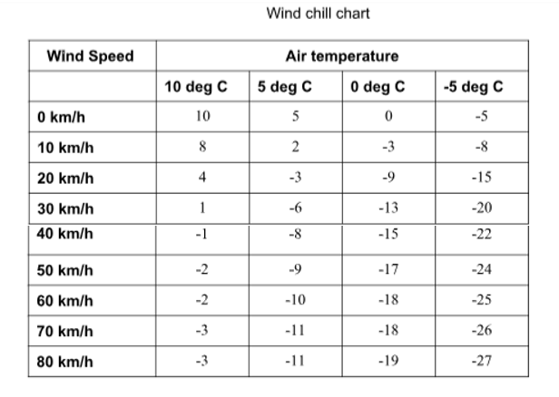
- What animals are more vulnerable to windchill?

Meteorological conditions
Meteorological conditions - the prevailing environmental conditions as they influence the prediction of weather where environmental condition refers to the state of the environment. For example, ‘el nino’ is linked to drought, ‘greenhouse gas’ is linked to warming of the atmosphere, hot dry winds and lightning strikes are linked to bushfires.

The chief factors comprised in the science of meteorology are temperature, barometric pressure, humidity, sunlight and the interactions of each variable, as well as their variability. An example of meteorology would be the BOM, who study the ocean and the atmosphere.

Six weather instruments - wind vane, anemometer, barometer, thermometer, hygrometer, and rain gauge help monitor weather conditions.

Identification of weather and climate conditions:

These terms are used to describe the state of the weather and climate
Likely - this means a high chance of it eventuating
Current - this means how the conditions are presently
Changes - refers to how conditions will alter
Signs - refers to ways we will know that conditions will vary
Extreme - this means an extraordinary variation to the condition eg extreme heat or winds

Revision
Outline how meteorological conditions can influence a primary industries workers seasonal activities using a specific industry example.

Monitoring conditions

Access and use of a range of sources of weather and climate information:
- Australian Bureau of Meteorology
- media
- technology:
  - internet
  - interpretive tools
  - weather station
- word of mouth

Bureau of Meteorology
The Australian Government Bureau of Meteorology (also referred to as the BOM) began operation in 1908, taking over national responsibility for meteorological services from the Australian states. Since its establishment nearly a century ago, the Bureau has become a leader in meteorological services in the southern hemisphere and one of the more technologically advanced in the world.
The main roles of the Bureau are to observe and understand Australia’s weather and climate and to provide services in three main areas:
- Meteorology – the study of the earth’s atmosphere, especially weather forming processes, weather forecasting and the climate.
- Hydrology – the study of the properties, distribution, use and conservation of water on the earth’s surface, underground and in the atmosphere.
- Oceanography – the study of the world’s oceans.
The functions of the Bureau of Meteorology relating to the weather and forecasting include:
- maintaining a network of surface and space-based observing systems
- observing, collecting, recording, analysing and providing meteorological data and information
- forecasting the weather and the state of the atmosphere
- issuing warnings about gales, storms, floods, bushfires and other weather-related events that could harm life or property
- publishing meteorological reports and bulletins.
The Bureau also carries out a number of other functions such as monitoring the climate on a long-term basis, carrying out research, providing advice about Australia’s weather and climate and cooperating with other meteorological services around the world.
The Bureau of Meteorology collects data every day from hundreds of weather stations, thousands of volunteer rainfall observers, ocean buoys, weather balloons in the upper atmosphere, radar and satellites. The data is processed by supercomputers and analysed by meteorologists who send thousands of weather forecasts and updates to newspapers, radio and television stations, emergency services and other users every day. The public can access this information via radio, television, newspapers, internet, email, fax and telephone. The Bureau of Meteorology provides comprehensive weather and climate information on its own website.

Media
This can include
- digital media like apps on mobile phones and iPad for instant access anywhere
- social media like Facebook and Instagram as ways of people sharing weather events and conditions
- newspaper media and journal articles on long range predictions as well as immediate weather events
- radio and TV for reports and updates and talkback shows discussing weather and climate conditions

Technology
This includes all those media listed tools plus diagnostic and predictive software used by the BOM. It can be communicated by the internet, apps, media and word of mouth
Knowing where storms are now can help forecasters predict where storms will be tomorrow and the next day. Technology, such as weather satellites and Doppler radar, helps the process of looking over a large area, as does the network of weather observations.

Word of mouth
A very frequent discussion topic amongst outdoor workers and especially farmers is the weather and climate. It drives daily activities and productivity and ultimately profitability and is very important in daily lives and welfare of all. It is a popular conversation topic.
It is important to always consider the validity of the words you hear verses looking at a weather map yourself and forming your own opinions on the coming events and making up tour own mind because you need to live by the decisions you make.

Revision questions: monitoring conditions

- Open the Bureau of Meteorology (BOM) website.

  - Click on Warnings Current for NSW. See if there any weather warnings current for your region eg Northern tablelands. Give one example of how this information might be of use to farmers.

  - Repeat the exercise for various other sections of the BOM web site. Complete all sections of the tables below:

Section | What information does it contain? | How might this information be useful to a farmer?
Rain radars

Satellite Images

Weather Maps

  - Now scroll down the home page to Agriculture.

Section | What information does it contain? | How might this information be useful to a farmer?
Forecast Rainfall

Forecast wind

Forecast frost

  - Click on Our Weather and Climate, then Australian Climate Influences.
You should be able to see a number of familiar terms such as fronts, troughs, highs, lows, tropical cyclones, and East Coast low.

  - Now click on El Nino/La Nina. Read through and make notes concerning
    - the term ‘El Nino’
    - the three stages of ENSO (the oscillation between El Niño and La Niña conditions)
    - the effect of each stage on Australian climate.

  - Locate the current climate model summary; describe the forecasted summary for the rest of the year and state how this might affect a farmer’s decisions.

  - Traditional sources of weather information include TV, radio and newspapers. Make a comparison of the weather information that is available on-line to the information provided by TV, radio or newspapers. Use dot points.

The range of different types of weather and climate information relevant to primary industries:
- data
- grazier alerts
- reports
- updates
- warnings

Data
The BOM makes available much information and data for people to read and make their own decisions about impending weather and climate events. eg reading the ENSO and looking at the SOI allows farmers and workers to anticipate seasons and likelihood of rain and thus plan accordingly. Go to The BOM webpage ‘Information for students and teachers’ and explore all the data available. The Bureau holds a vast archive of weather observations, analyses and statistics.
Data includes highs and lows in temperatures collected either by the property weather station or other means, rainfall amounts, wind speeds and directions. These types of data can influence production and activity on the farm. For example, high wind speeds could delay spraying of crops, previous rainfall may mean no need to irrigate. Or this may be data that is required to be recorded during activities for legal purposes, for example recording wind speed and direction when spraying.

Grazier alerts
These are issued to farmers when cold, windy and rainy conditions increase the risk of death in newborn lambs and recently shorn sheep. They are often broadcast on the radio or updated as warnings on weather apps. Click here to see a sample alert from the BOM
The BOM will issue a Graziers Alert to warn farmers of an oncoming cold front so that they can take action to protect susceptible livestock from the effects of the weather.
This may mean:
- Moving flocks of lambing ewes into well sheltered paddocks, such as those containing dense tree cover and/or tree lots. This will significantly reduce the effect of the wind/chill factor. Ideally, the slope these paddocks would also face away from the south (which is where the wind will come from), further reducing the effect of the wind. It may be part of Farm Planning to ‘set aside’ a good sheltered paddock especially for this purpose.
- Providing additional feed in the form of leafy hay or grain if available (to help the sheep maintain energy levels)
- Providing additional supervision to lambing flocks.

Reports and Updates
These can come in many styles. Full weather reports on the daily news channel give farmers a week’s outlook on temperatures, rain and any extremes so they can plan workload to suit the likely conditions. Short updates usually heard on the radio or brief news ads are usually focussed on certain events like rainfall or extreme temperatures and heat waves being experienced in areas. These keep farmers updated on immediate events that can affect certain enterprises or activities, so they can plan alternative days to perform tasks, or plan to minimise risks (for example checking water troughs more often in extreme heat).
There are many of these on the BOM ranging from weather events for rain, temperature, frosts, snowfalls and winds through to climatic events related to la Nina and El nino, drought, flood, monsoon, bushfires. Scroll down to locate a range of services on the home page of BOM.

Weather warnings
A weather warning generally refers to an alert issued by a meteorological agency to warn citizens of approaching dangerous weather.
Farmers rely on these to put their risk management plans into action with enough time that they minimise damage to crops and stock and keep profit loss to a minimum.
The Bureau of Meteorology issues a number of different warnings about weather that could cause loss of life or damage to property. These warnings include:
- Tropical cyclone warnings – issued to northern coastal areas of Australia during the warmer months. They detail the movement and severity of each cyclone and its possible effect on coastal communities.
- Fire weather warnings – issued in conjunction with state fire agencies. These are a measure of fire danger based on current and forecast temperature, wind, humidity, rainfall and available fuel levels.
- Total fire bans – issued on authority from the relevant state fire agency.
- Severe weather warnings – issued when severe weather is expected such as squalls, land gales, flash flooding and dangerous surf or tides.
- Severe thunderstorm warnings - issued when thunderstorms are expected to produce dangerous or damaging conditions such as severe lightning, hail, squalls, gales and flash flooding.
- Flood warnings – can be issued for most major rivers in Australia providing an alert of possible flooding, minor, moderate, major and generalised flood warnings and predictions of expected river heights.
- Frost warnings – issued when cold, windless conditions are likely to produce significant frosts.
Take time to explore the huge variety of weather updates and reports available on the BOM NSW Weather and warning summary page.

Revision exercises: monitoring weather and climate
- Using the weather station shown here
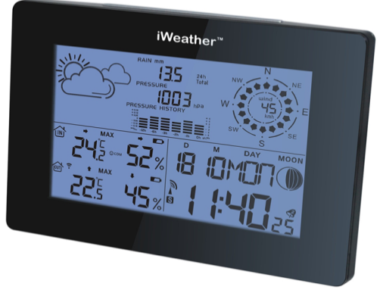
  - what is the temperature range?
  - what is the humidity range?

- Weather terms – mix and match.
The weather terms listed below have become separated from their definition.
Select a term from the column on the left, match it to the correct definition and write it in the correct box on the right hand side.

Weather Term | Definition | Correct Term
Bureau of Meteorology | Methods used to predict probable future weather conditions.
Climate | Advice to farmers on conditions dangerous to newborn lambs and recently shorn sheep.
Forecasting techniques | Notification issued by the Bureau of Meteorology on a state by state basis of impending or actual weather that has the potential to cause loss of life or damage to property.
Forecasts | The sum of all the weather recorded over a long period of time and reported as long-term records, trends and averages.
Grazier alert | Statements of probable future weather conditions calculated from meteorological data.
Weather | Federal government agency responsible for observing, monitoring, recording, forecasting and reporting information about the climate and weather across Australia and the surrounding region.
Weather maps | The phenomenon where increasing wind speed causes the apparent temperature to drop.
Weather station | The description of atmospheric conditions such as wind, temperature, cloudiness, precipitation and air pressure over a short period of time.
Weather updates | Site equipped with meteorological instruments that measures data related to the weather that is recorded manually or automatically.
Weather warning | Charts of a country or region showing weather systems, high and low pressure cells, isobars (lines of equal atmospheric pressure), cold and warm fronts and potential precipitation.
Wind chill | Reports about changes to current or probable future weather conditions.

Forecasting techniques for monitoring weather conditions:

- interpreting weather maps
- taking local measurements:
  - temperature
  - precipitation
  - air pressure
- interpreting weather and climate information
- importance of maintaining current information

Interpreting weather maps
Weather maps (synoptic maps) appear daily on TV and in the newspapers. These maps are very useful in providing information on cloud and weather patterns as well as wind. They are basically a summary of the current weather situation.
The main features seen on the synoptic map are:
- isobars
- highs (or anticyclones)
- lows (or cyclones)
- fronts
- ridges and troughs
Weather maps are drawn by meteorologists on a daily basis from the data collected at weather stations around Australia and the wider region. There are two main types of weather maps. Synoptic charts provide a visual synopsis or summary of current weather patterns. Prognostic charts predict weather that will occur in the future.
A basic understanding of weather systems and patterns and the key features of weather maps will enable anyone to read a weather map. Accurate reading of weather maps, in conjunction with forecasts and other weather information, allows farmers and horticulturalists to plan for expected weather events.

Key features of the weather and weather maps.
Pressure cells
Weather patterns are driven by the sun’s radiation. Latitude, season and cloud cover contribute to the amount of heat reaching the earth’s surface. Varying amounts of heat are reflected back into the atmosphere. This depends both on cloud cover and the type of surface such as ocean, grassland, forest and bare earth or sand.
The layer of air that surrounds the earth is held close to the surface by gravity. As the earth’s surface heats and cools unevenly so does the air above it. Large masses of hot air rise, spread, cool and fall back to earth creating convection currents. A low pressure cell is formed where air is rising and therefore becoming less dense. A high pressure cell occurs where air is sinking and becoming denser.
Air pressure is caused by the motion of billions of gas molecules in the atmosphere. These molecules move randomly in all directions bouncing against anything they meet. The more gas molecules there are in a certain space, the more collisions there will be and therefore the higher the air pressure.
It is very difficult to measure these collisions in an open space. Therefore, air pressure, also called atmospheric or barometric pressure, is actually measured as the weight of the column of air above a point on the earth’s surface. The more molecules of air there are and the greater the weight of the column of air, the higher the pressure is. Air pressure is measured in hectopascals (hPa).
Air moves out of high pressure cells and into low pressure cells in a spiral fashion as shown below in Figure 1. The high pressure cell is marked ‘H’ and the low pressure ‘L’. In the southern hemisphere air circulates clockwise around a low pressure cell and anticlockwise around a high pressure cell. The opposite occurs in the northern hemisphere.
Figure 1: Circulation of air around and between pressure cells
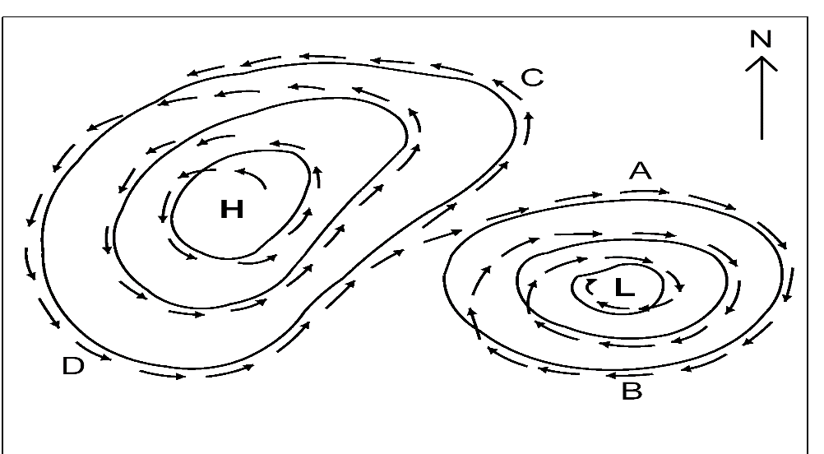
The concentric lines around the high and low pressure cells are called isobars and indicate places of equal air pressure.
Winds are caused by the flow of circulating air out of high pressure and into low pressure systems. Wind speed is indicated by the distance between the isobars. The closer the isobars are together, the stronger the winds will be. Where isobars are drawn relatively far apart there are only light winds or the weather is calm.
Wind direction is also indicated by the isobars. The arrows drawn on the isobars in Figure 1 show the change in wind direction as the air circulates around the pressure cells. The wind is named according to the direction from which it comes, using points of the compass as a reference.
For example, Point A to the north of the low pressure cell in Figure 1 is experiencing a westerly wind. To the south of the low at point B the wind is an easterly. The compass points are also subdivided to provide wind directions such as south-easterlies at Point C or north-westerlies at point D.
Reading weather maps
All weather maps use a standard set of symbols to portray features of the weather. Figure 2 below shows some of the more commonly used symbols.
Figure 2: Symbols used on weather maps
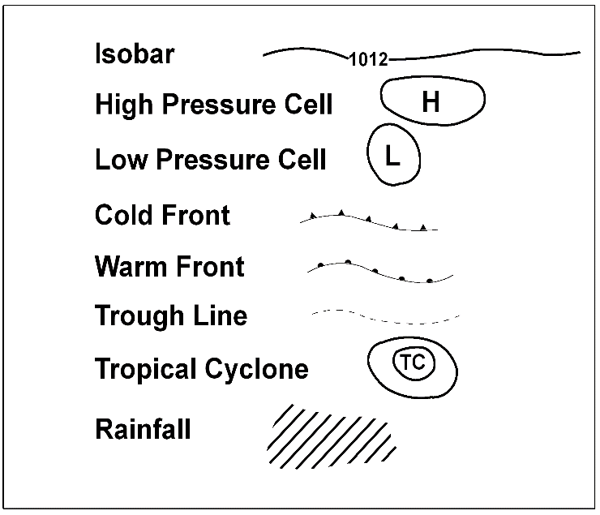
Isobars
Isobars are lines on a weather map that join locations of equal air pressure. The number written on an isobaric line is the atmospheric pressure for that isobar measured in hectopascals (hPa). Air pressure readings at ground level typically range from 980 hPa to 140 hPa. The lower the air pressure is, the more likely the chance of an extreme weather event such as a cyclone.
On weather maps, concentric isobars are usually drawn increasing or decreasing by an increment of 4 hPa. The weather map in Figure 3 below shows the isobars increasing in pressure from north to south across Australia.

Figure 3: Weather map featuring a tropical cyclone over north-western Australia
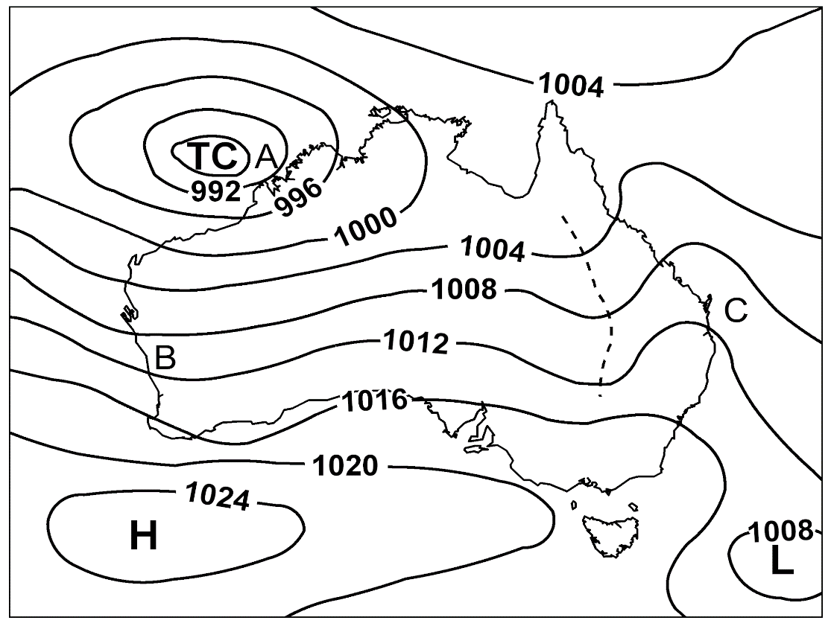
Pressure cells
Where isobars are drawn as closed curves, they surround a pressure cell. High pressure cells are indicated by ‘H’ on a weather map. They indicate the location of the highest air pressure measured in a region at a particular point in time. Similarly, low pressure cells indicate the point of lowest air pressure and are indicated by an ‘L’.
On the weather map in Figure 3 above a high pressure system is located to the south of Western Australia. A low is developing to the east of Tasmania.
Fronts
Cold and warm air masses are moved around the earth by winds. When an air mass arrives in a region it pushes the existing air mass out. The boundary between two air masses is called a front.
A cold front usually forms out of a low pressure cell where a cold mass of air is moving towards warmer air. In Australia, cold fronts bring southerly winds and sudden decreases in temperature. They are often associated with thunderstorms. Cold fronts are drawn on weather maps as a line with solid triangles. The triangles point in the direction that the front is moving.
The cold front shown on the weather map in Figure 4 below developed out of the low off the east coast of Tasmania. As it moves north through New South Wales it will bring cold south-west winds with the chance of thunderstorms.
Warm fronts occur when a mass of warmer air moves towards cold air. The warm air slides up and over the cold air forming clouds with the possibility of precipitation. Warm fronts are drawn on weather maps as a line with solid semicircles.
Figure 4: Weather map featuring a cold front over south-eastern Australia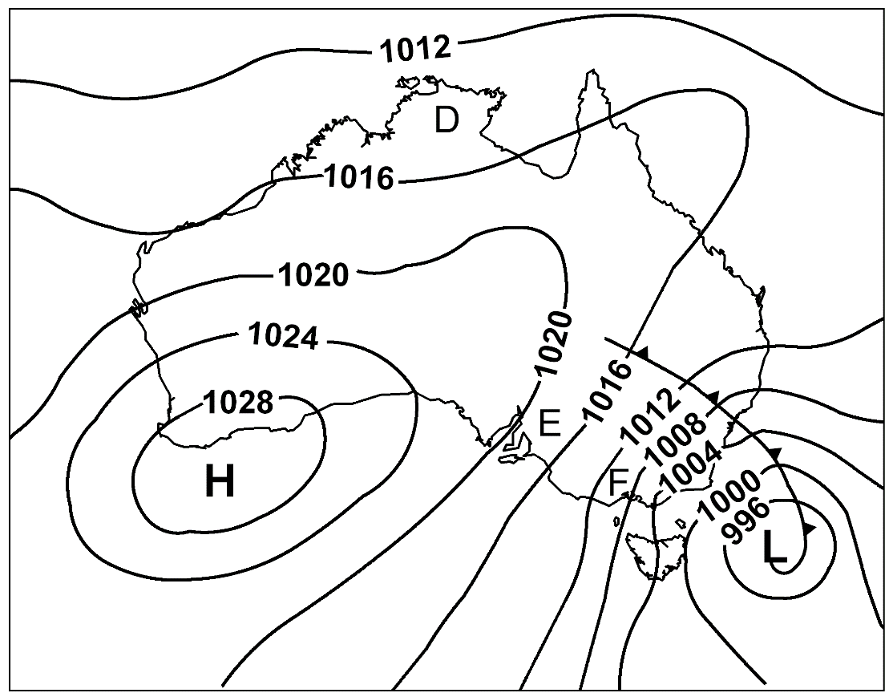
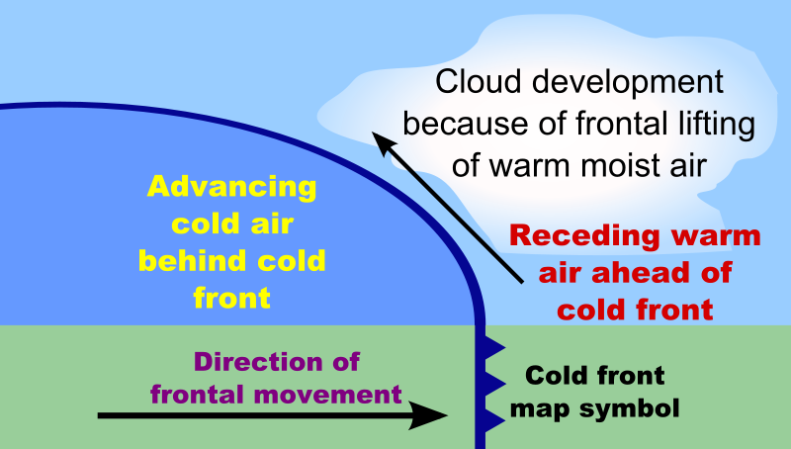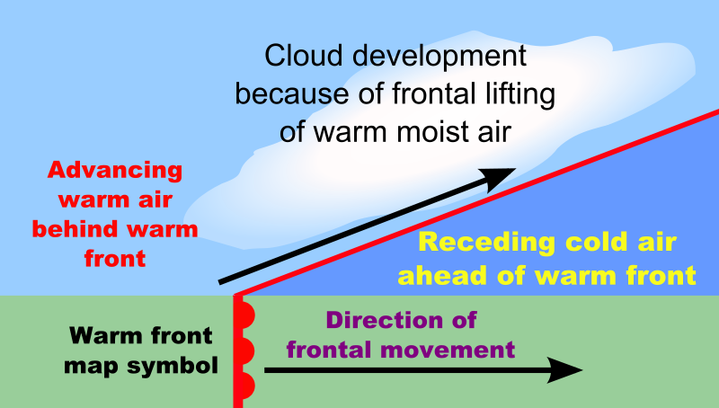

Ridges and troughs
When air from a high pressure cell pushes into a region of lower pressure, a ridge forms. Ridges are shown as protrusions in the isobars out from the high pressure cell. A ridge has formed from the high pressure cell in Figure 4 over central Australia and northern Queensland. Fine weather is usually indicated by ridges.
A trough appears when a region of lower pressure appears in the air circulation around a high pressure cell. Troughs also occur at the junction between two highs. Troughs are drawn as ‘U’-shaped fluctuations in the isobars. Meteorologists and weather reporters describe troughs as ‘a dip in the isobars’.
A dashed line is often drawn along the central line of a trough. The weather map in Figure 3 shows a trough in eastern Australia. The trough line runs north from central New South Wales to northern Queensland. Troughs are usually associated with unsettled weather and precipitation.
Cyclones
A cyclone is a relatively small but intense low pressure cell. Most cyclones that occur in Australia develop over warm oceans to the north and are called tropical cyclones. They usually occur from November to April. In the North Pacific Ocean cyclones are called typhoons and in the North Atlantic Ocean they are referred to as hurricanes.
Cyclones are drawn on weather maps as a series of tight circles. They have the letters ‘TC’ with the name of the cyclone in the centre. Both male and female names are selected alphabetically. Cyclones are rated from category one to five, with five being the most severe. The weather map in Figure 3 shows a tropical cyclone approaching the coast of north-west Australia.
A cyclone is an intense low pressure storm, with gale force winds rotating clockwise around the centre or ‘eye’. Winds of over 100 km/hr are common at the leading edge of a cyclone, with wind gusts of up to 300 km/hr. The gales can produce high seas with waves over 30 metres in height. Torrential rains always accompany cyclones.
It is hard to predict where and when cyclones will cross the coast due to their erratic movement. When they do reach land, they can cause severe damage, flooding and loss of life. Once they have moved inland cyclones weaken to become rain depressions. Despite the damage they cause, cyclones contribute substantially to the much needed rainfall in northern Australia.
Winds
Meteorologists have a series of symbols that they use to indicate wind speed and direction. They use the data gathered from the hundreds of weather stations located around Australia. Most weather maps available on internet sites, in newspapers and on television do not show these symbols.
However, wind direction and relative speed can be determined from the isobars. Remember that air circulates clockwise around a low pressure cell and anticlockwise around a high pressure cell. The closer the isobars are together, the stronger the winds. The wind direction is given as the compass point from which the wind is blowing.
Table 1 below gives a summary of the wind direction and relative speed from points around Australia on the weather maps in Figures 3 and 4.

Table 1 - Wind speed and direction
Weather map | Location | Wind direction | Relative wind speed
Figure 3 | A | Northerly | Gale
Figure 3 | B | Easterly | Moderate
Figure 3 | C | South-easterly | Light
Figure 4 | D | Easterly | Calm to light
Figure 4 | E | South-westerly | Strong
Figure 4 | F | Southerly | Strong to gale

Rainfall
Rainfall is indicated on weather maps as a series of diagonal lines (Figure 2). This symbol is used to show both potential and current rainfall.
Rainfall can also be predicted from the isobars and pressure cells on a weather map. Intense low pressure cells coming off the ocean, such as cyclones, always bring heavy rain to coastal areas. The rain may also extend inland. Troughs are often associated with unstable weather and precipitation.
Winds blowing from the ocean onto the land are called onshore winds. These winds can bring rain if they are associated with clouds containing moisture picked up as the wind blows across water. Onshore winds also bring cooler weather.
Offshore winds blow from the land out to sea. They are usually associated with fine weather. In summer, high pressure cells over inland Australia bring hot, dry winds and the risk of bushfires.

Interpreting weather and climate information
The weather patterns that move across Australia are part of a complex system of air masses that circulate the earth. These air masses follow a pattern that varies with the seasons. Large bands of air thousands of kilometres wide circumnavigate the globe. Massive convection currents move air between the equator and the poles.
Weather systems slowly move from west to east across southern Australia. A weather pattern crossing over Perth will reach New South Wales in a modified form approximately three to four days later. In northern Australia, the weather systems tend to move from east to west except for cyclones.

Summer weather patterns
Figure 5 shows the typical summer weather pattern occurring over Australia. High pressure systems migrate from west to east across southern Australia and the Great Australian Bight. They are associated with a cycle of hot, dry weather followed by cooler, moister southerly changes.
A series of low pressure cells develops to the north of Australia. They bring summer rainfall to northern and eastern Australia. In the tropical north this season is known as ‘the wet’. The low pressure cells may develop into cyclones.
Figure 5: Typical summer weather pattern over Australia
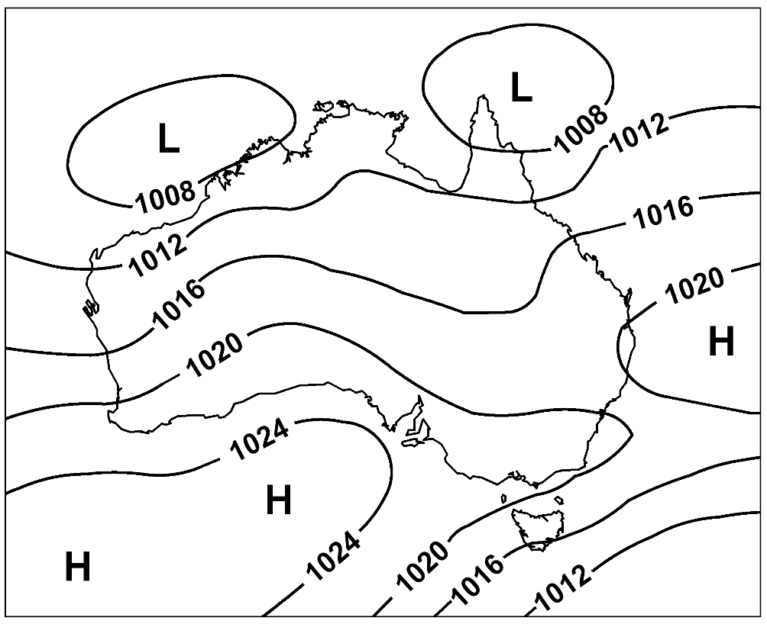

Winter weather patterns
In winter, the air masses over Australia move north. Figure 6 shows a high pressure system now lying over central Australia. The highs again move slowly from west to east, punctuated by cold fronts.
These cold fronts develop out of intense low pressure cells in the Great Southern Ocean to the south of Australia. They bring cold weather and rain to south-west and southern Australia, with regular snow falls in the high country of Tasmania and south-eastern Australia.
The low pressure cells that were a feature of the summer weather pattern in the northern part of Australia also move even further north during winter. Northern Australia usually experiences cooler, drier weather during winter known as ‘the dry’.

Figure 6: Typical winter weather pattern over Australia
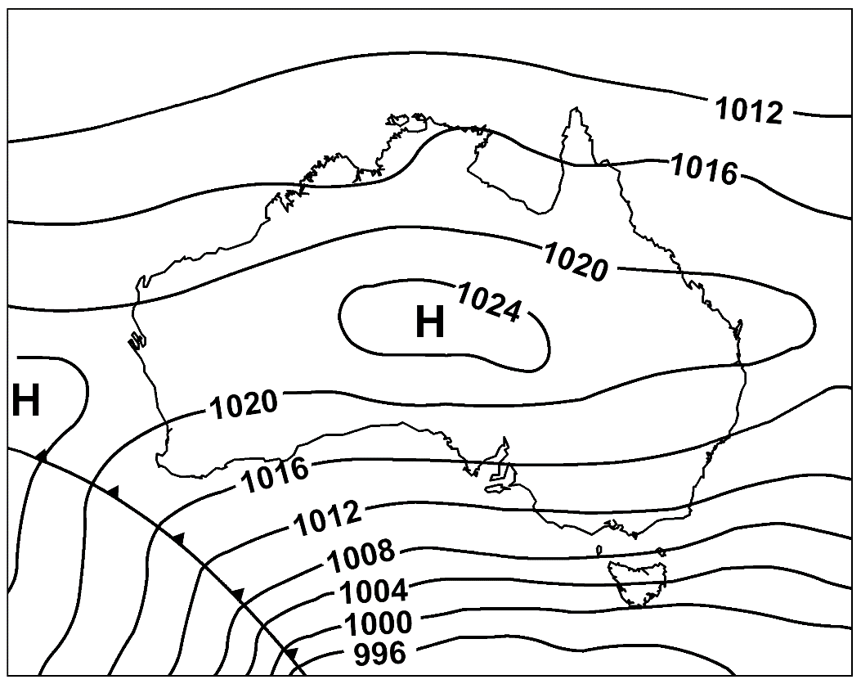
The weather can often be unpredictable and changeable and wide variations from expected weather patterns can occur at any time throughout the year.

Revision exercises; interpreting weather maps
Activity 1
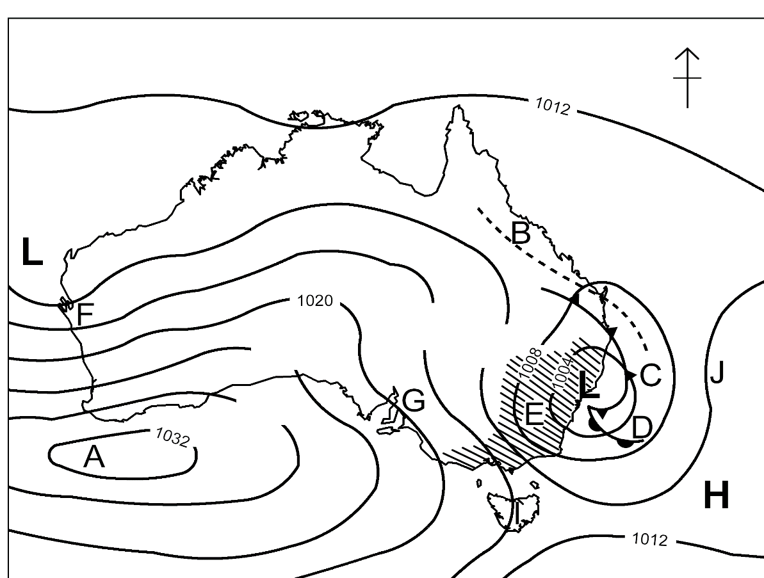
Print a copy of this page and mark the answers to the questions on the weather map and in the spaces provided below.
- Some of the isobars on the weather map are missing their air pressure readings. Write the correct reading in the gap in each isobar.
- Label the pressure cell at Point A:
- In which direction is air circulating around the pressure cell at Point A?
- In the spaces provided below name the weather features represented by symbols at the following points on the map:
  - Point B:
  - Point C:
  - Point D:
  - Point E:
- Use appropriate letters to label the four points of the compass in the top right hand corner of the map.
- Draw an arrow on the map to indicate the wind direction at each of the following points. Write each wind direction in the space provided below.
  - Point F:
  - Point G:
  - Point I:
  - Point J:

Activity 2
Use the weather map below to answer the following questions.
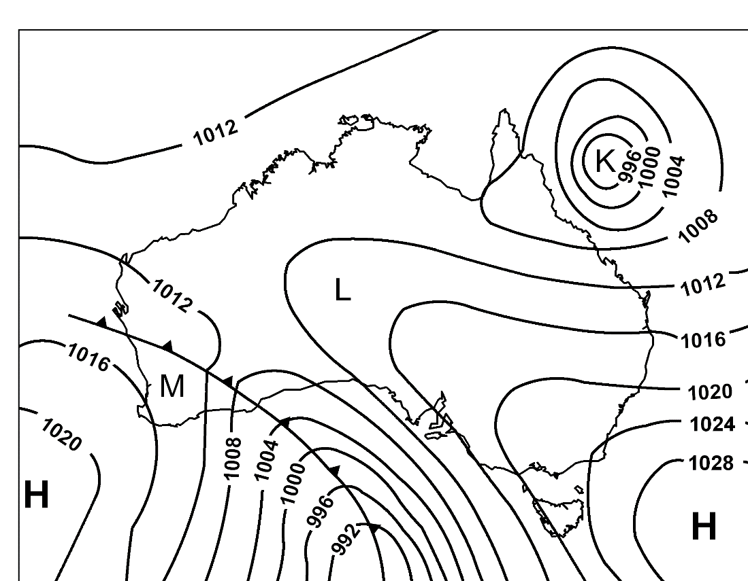
- The following questions refer to the weather feature at Point K on the map above.
  - Describe the weather feature occurring at Point K.
  - Is this feature a high or low pressure system?
  - In which direction is air circulating around this system?
  - What weather would be expected if the pressure system at Point K moves west onto the North Queensland coast?
  - Outline three strategies that should be put in place on farms to prepare for the weather described in the previous answer.
- The following questions refer to the weather occurring at Point L on the map above.
  - Describe the weather that you would expect at point L.
  - What features of the weather map did you use to answer the previous question?
  - List two precautions that a farm worker should take when working in these conditions?
- The following questions refer to the weather occurring at Point M on the map above.
  - What weather feature has recently passed over Point M?
  - What changes to the weather would have occurred in the region around Point M?
  - Name the warning that the Bureau of Meteorology might issue to farmers if this change occurs during the cooler months.

Managing conditions

Potential implications of weather and climate changes for a primary industries workplace on the following:
- crops
- commercial decisions and activities
- environment
- livestock/grazing
- natural resources
- property
- safety
- work tasks

crops
Most farming activities are reliant on the weather.
- planting crops
- spraying and other tractor work.
Weather will affect immediate decisions regarding crops such as when to plough, sow , fertilise or spray crops depending on if it is about to rain which will let the soil soften to plough or encourage a good moisture profile to sow into for seed germination or dissolve the urea if its broadcast on the prediction of at least 12mm rain or not to spray a crop if it will rain within the effective drying period for instance. Weather predictions and patterns will affect timing of sowing a crop, for example sowing too early for an oats crop to make hay from will affect it being able to dry properly in the cooler winter months to make good hay or sowing a crop for harvest too early will affect seedset and quality if it gets early frosts on it. These are ways weather affects crop decisions.
Climate change may affect the type or variety of crop chosen to grow, for instance with warmer longer summers an area normally unable to grow tropical pastures may now be able to grow tropical grasses. The timing of sowing and growth may change with longer summers allowing soybean crops (that used to need to be sown before the Christmas period) able to be sown until mid-January and still produce a summer crop for forage or harvest. Such climate change may lengthen the growing period as frost (which stop the growth period) arrive later.

Changes in temperature, atmospheric carbon dioxide (CO2), and the frequency and intensity of extreme weather could have significant impacts on crop yields:

- Effects of increased temperature will depend on the crop’s optimal temperature for growth and reproduction. In some areas, warming may benefit the types of crops that are typically planted there or allow farmers to shift to crops that are currently grown in warmer areas. Conversely, if the higher temperatures exceed a crop’s optimum temperature, yields will decline.
- Rising CO2 levels can stimulate plant growth however it can also reduce the nutritional value of most food crops. Rising levels of atmospheric carbon dioxide reduces the concentrations of protein and essential minerals in most plant species, including wheat, soybeans and rice.
- Dealing with drought could become a challenge in areas where rising summer temperatures cause soils to become drier. Although increased irrigation might be possible in some places, in other places water supplies may also be reduced.
- Extreme events, especially floods and droughts can harm crops and reduce yields.
- Many weeds, pests and fungi thrive under warmer temperatures, wetter climates and increased CO2 levels.

commercial decisions and activities
The type of enterprises to grow on a farm can be impacted by both weather and climate. For instance, weather can affect growth of a crop that needs frost free days if the area gets a high number of frosts then the farmer will need to protect the crop if he chooses to grow that crop. For example, tomatoes are killed by frost so if they are to be grown in a cold climate with frequent weather patterns including frosts they will need to be kept in a glasshouse for successful production (like the Guyra tomato farm).
The type of cattle to be grown is affected by the weather and climate with British breeds often being seen on the Tableland regions where the winters are longer than the less harsh regions as these breeds are able to mature quicker and weaners finish on cereal crops compared to coastal regions being able to run cattle with more Indicus content to help them cope with heat and ticks.
Therefore, the types of commercial decisions made by primary industries workers is affected by weather and climate.

Case Study - Frost
Take Action:
- The best protection against frost is bare, damp compact soil. This ensures the maximum amount of heat is absorbed by the soil through the day. However, this is not always feasible to achieve.
- Be aware cold air will sink and fill hollows and low lying ground, and that windbreaks and vegetation such as cover crops and weeds can hold back air movement that can create localized frosts. Opening gaps in windbreaks, mowing weeds, leaving soil fallow can direct frost to lower areas.
- Irrigation of foliage through the evening when frosts are predicted can eliminate or moderate damage in some instances, for example, overhead sprinklers in vineyards and some orchards. This method is mainly used for spring frosts as frost can damage shoot and buds.
- Energy is needed to cool water, so as water cools it releases heat, and as it freezes to form ice it releases a large amount of heat. The ice covering prevents the internal temperature of the plant cells falling any further. It is temperatures below freezing point that damages plant tissues.
- Be aware root rot can be a problem due to waterlogging from prolonged watering for frost prevention. Ice too can be quite heavy and break stems of plants.

Answer the following questions:
- What causes frost?
- Where would you expect frost to form and why?
- In the table below, list ways to prevent frost and the advantages and disadvantages of each suggestion.

Technique | Advantages | Disadvantages

environment
Environment includes everything in an area - the soil, climate and vegetation types. We talk about farming zones in agriculture which are typically a reflection of the climate zones and these have a major impact on types of activities occurring in these areas. The soil type and climate have biggest effect on type of farming that can occur as it influences, disease, growth periods (to name a few).
The frequency and intensity of storms is likely to increase, more areas will be affected by drought, and there will be hotter and more frequent heat waves in temperate zones.
In some areas climate change will alter entire ecosystems (including agricultural systems), with grave consequences for biodiversity.
Low lying coastal regions, deltas (which tend to hold large population concentrations and productive agricultural and natural systems) and coastal fisheries are particularly at risk.
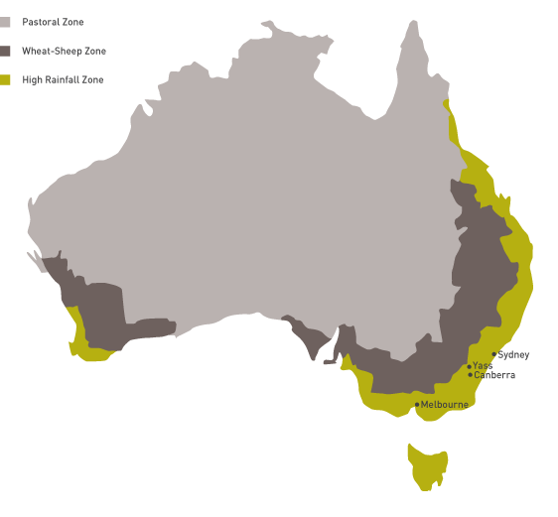
The image above shows three different ‘zones’ related to agriculture in Australia.

Answer the following questions:
- What landform separates the wheat/sheep zone and the high rainfall zone?
- What two climatic factors determine the placement of the wheat/sheep zone?
- Identify a climatic factor that would make it difficult to grow wheat or raise merino sheep on the coast of Eastern Australia

livestock/grazing
Animal production is reliant on the weather:
- providing shelter eg grazier alerts for newborns and sheep off shears in times of cold and wet or the need for shade in heat extremes
- minimising disease - wet conditions can increase incidence of parasites (internal like worms and external like flystrike in sheep), fungal diseases and fleece-rot.

Animal production is also reliant on the climate:
- Heat stress affects animals both directly and indirectly. Over time, heat stress can increase vulnerability to disease, reduce fertility, and reduce milk supplies. Heat waves, which are projected to increase under climate change, could directly threaten livestock.
- Providing feed for stock. Drought may threaten pasture and feed supplies. Drought reduces the amount of quality forage available to grazing livestock. Some areas could experience longer, more intense droughts, resulting from higher summer temperatures and reduced precipitation. For animals that rely on grain, changes in crop production due to drought could also become a problem.
- Climate change may increase the prevalence of parasites and diseases that affect livestock. The earlier onset of spring and warmer winters could allow some parasites and pathogens to survive more easily. In areas with increased rainfall, moisture-reliant pathogens could thrive.
- Potential changes in veterinary practices, including an increase in the use of parasiticides and other animal health treatments, are likely to be adopted to maintain livestock health in response to climate-induced changes in pests, parasites and microbes. This could increase the risk of pesticide resistance in some animals.
- Increases in carbon dioxide (CO2) may increase the productivity of pastures but may also decrease their quality. Increases in atmospheric CO2 can increase the productivity of plants on which livestock feed. However, the quality of some of the forage found in pasturelands decreases with higher CO2. As a result, cattle would need to eat more to get the same nutritional benefits.

Answer the following question:
- Provide at least three examples of how weather helps us make decisions for livestock

natural resources
Weather can affect our natural resources, including waterways and soils.
Farmers can minimise long term damage through when particular weather events are predicted.
- minimise runoff and erosion in paddocks during rainfall events with rollover banks, good soil health and increased infiltration and maintaining ground cover
- protecting water resources by maintaining riparian zones and not allowing stock to access or not allowing stock to access during wet weather

property
This includes infrastructure and buildings on your property like sheds, yards and fences.
Day to day work activities on property can be affected by the weather with the time of day being selected wisely for carrying out activities to avoid heat stress or frost bite.

work tasks and safety
Understanding the weather and its effects can also help us to prepare for extreme weather events such as:
- extreme heat and cold and strong winds
- storms and heavy rainfall
- drought, fire and flood
The effect of climate and prevailing weather conditions is greater on people who work in primary industries than those whose place of work is largely indoors. It is important to monitor the weather on a daily and sometimes hourly basis and communicate warnings to others where relevant.
Extreme weather conditions may affect work tasks and require strategies to prevent harm to staff. Extreme weather conditions include:
Extreme heat
Extreme heat usually occurs in summer when winds move air that has been heating up in the dry interior of Australia towards the coast. If abnormally hot weather continues for several days it is called a heat wave. Extreme heat may also coincide with high humidity especially in the northern and coastal regions of Australia.
Possible risks and suggested strategies to reduce harm:
- Sunburn - Wear long-sleeved shirt, trousers, broad-brimmed hat, sunscreen and sunglasses.
- Dehydration - Ensure availability of adequate supplies of cool, fresh drinking water.
- Heat exhaustion - Reschedule outdoor work tasks to cooler times of the day.

Extreme cold
Extreme cold usually occurs in winter when a mass of cold air from the Antarctic region moves north over Australia. This air mass often brings cold, southerly winds and rain. Tasmania, the Victorian Alps, the Snowy Mountains and the New South Wales tablelands may also receive sleet and snow. Fine cold nights without a wind can lead to severe frosts. A prolonged period of very cold weather is often called a cold snap.
Possible risks and suggested strategies to reduce harm:
- Chilling leading to hypothermia
- Wear adequate warm clothing, including beanie and gloves, a wind-proof coat in dry weather and a waterproof coat in wet conditions.
- Cold, stiff fingers leading to accidents with tools
- Wear gloves.
- Reschedule tasks to warmer parts of the day.

Heavy rainfall
The pattern of rainfall in each region of Australia is determined by the season and the proximity to the coast. In general, the north of Australia receives most of its rain in the summer with the south having a winter dominant rainfall. The coast receives more rain than inland areas when moist air masses move onshore. Most of the rainfall occurs on the coastal side of mountainous terrain due to the cooling and condensation of the air mass as it rises up over the mountains. Occasionally rainfalls will be extremely heavy.
Possible risks and suggested strategies to reduce harm:
- Getting wet and chilled leading to hypothermia
- Wear waterproof coat, trousers, hat and gumboots.
- Accidents due to wet slippery conditions
- Reschedule all but urgent outdoor tasks.
- Ensure good grip on the soles of boots.

Floods
Heavy rainfall leading to flash flooding is usually associated with thunderstorms. More extensive rain will cause floods in New South Wales when a low pressure system develops off the coast or a cyclone moves down the Queensland coast. Inland New South Wales receives heavy rain when a low pressure system, called a monsoon depression, brings wet weather across the centre of the country from the north west.
Possible risks and suggested strategies to reduce harm:
- Vehicles and people washed off low level crossings
- Check water height and velocity before crossing.
- DO NOT drive or walk through floodwater.
- Avoid travel except in emergencies.
- Working in rising floodwaters: access regular weather reports and flood warnings to allow sufficient time to move stock, fodder and property to higher ground.

Strong winds
Winds are caused by the movement of air as it circulates out of high pressure cells and into low pressure cells. On a weather map the distance between the isobars indicates wind strength. An isobar is a line that joins points of equal air pressure. A region showing isobars drawn closely together will be experiencing strong winds. Where the isobars are far apart there will be only light winds or calm weather.
Cyclones and tornadoes produce the strongest winds. Thunderstorms are usually accompanied by strong wind gusts. The ‘southerly buster’ is a feature of south-eastern Australia bringing cold south-westerly winds that accompany the northern movement of a cold front. Strong westerly winds are common across south-east Australia in late winter.
Possible risks and suggested strategies to reduce harm:
- Accidents from wind-borne objects
  - Ensure all potential missiles (eg iron sheets) are secured.
  - Avoid working at heights.
- Eye and respiratory irritation due to dust
  - Wear protective clothing.
  - Reschedule all but urgent outdoor tasks.

Storms
Thunderstorms develop when air masses become unstable. In summer, late afternoon storms result from the uneven heating of air masses near the earth’s surface. The hot air rises, forming typically shaped clouds called ‘anvil heads’.
Water droplets in the cloud are moved up and down and may freeze forming hail. Massive static electric charges build up in the cloud. The electricity is discharged as lightning. Super heating and expansion of air as lightning passes through it produces thunder.
Thunderstorms also occur when cold fronts lift warm moist air and when air masses are forced over mountains. In south-eastern Australia thunderstorms are more common in spring and summer.
Snowflakes are water droplets that have frozen into ice crystals. If the air temperature is cold enough to prevent them melting, they fall as snow. Cold fronts bring snowstorms to mountainous regions in southern Australia.
Possible risks and suggested strategies to reduce harm:
- Lightning strike - if possible, shelter in a house, shed or vehicle.
If not, move to low ground. DO NOT shelter under trees or stand on high ground.
- Hail - shelter under a permanent structure or remain in the vehicle.
- Snow - remain indoors during blizzards. Wear adequate warm clothing, including beanie and gloves and a wind-proof coat.
Drought
A region is considered to be in drought when rainfall is significantly low for at least three months. Because of the wide range of average rainfalls across Australia, the rainfall recorded during a drought in a coastal area may be higher than the average rainfall recorded at an inland location.
There is a strong correlation between droughts in Australia and the El Niño effect. The Southern Oscillation Index (SOI) is used to predict rainfall in eastern Australia. A prolonged negative SOI reading is related to drought and a positive SOI reading indicates higher than average rainfall.
Possible risks and suggested strategies to reduce harm:
- Dehydration due to failure of watering points - carry additional water supplies for staff, vehicles, horses and dogs.
- Manual handling accidents moving stock feed and rescuing dehydrated/bogged stock - DO NOT attempt to lift/move objects that are too heavy. Seek assistance. Use machinery or vehicles where appropriate. Consider the animal’s welfare if moving weak or bogged stock.

Revision exercise: Weather and workplace activities
Use this table showing the weather predictions for the next week to answer the questions.
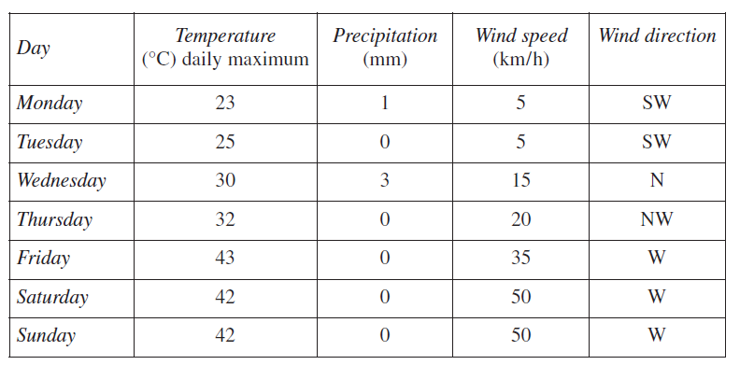
- What weather conditions (temperature, rain and wind) are forecast for:
Days | Weather conditions
Monday and Tuesday
Wednesday and Thursday
Friday, Saturday and Sunday

- The following jobs need to be completed this week. Allocate each to the best days and briefly explain why you have chosen that time (the table will grow as you add information)
Jobs to be done
Service the tractor | mark calves | spray weeds | weld new gates
crutch ewes | water trees | update chemical usage records | check water troughs
on-line studies for Certificate IV | fencing | Plough | muster and drench sheep

Monday - Tuesday | Wednesday - Thursday | Friday- -Saturday - Sunday

Primary industries workplace planning (long-term and contingency) for climate and weather conditions:
- workplace operations
- work practices
- schedule of work tasks

Workplace operations and practices
Extreme weather can also cause loss and damage to livestock, crops, fodder and property. A number of strategies can be used to minimise or prevent harm.
Livestock
- Provide temporary shade in very hot weather.
- Plant additional shade trees and windbreaks/shelter belts.
- Move stock to higher ground in response to flood warnings.
- Move stock to timbered, less exposed paddocks if extremely cold or snow conditions are forecast.
Crops
- Use glasshouses, igloos, and tunnel or shade houses to maintain suitable temperatures for plants.
- Net fruit crops to reduce hail damage.
- Use fans or sprinkler/spray systems to reduce frost damage.
- Plant windbreaks and shelter belts.
Fodder
- Cover fodder or store it in a shed to keep it dry.
- Move stored fodder to higher ground in response to flood warnings.
Property
- Secure equipment, buildings and materials (eg sheets of iron) before storms arrive.
- Ensure auxiliary power systems are in good working order.
- Lift pumps and irrigation equipment to higher ground in response to flood and flash flood warnings.
- Stockpile supplies in response to flood warnings that may result in the isolation of the property for a period of time.
- Prepare for the bushfire season by conducting careful, authorised hazard reduction burning during the non-fire restriction period.
- Prepare for bushfires by clearing firebreaks, ensuring a good water supply and installing and maintaining firefighting equipment in a state of readiness.

Contingency planning
Strong winds
Strong winds cause wind chill, evaporate soil water, dehydrate foliage and young shoot buds.
Take action:
- Shelterbelts are multi-row wind barriers of living trees to protect farms. The shelter greatly reduces wind speed and is important for protecting sheep and lambs. The wind that blows beyond a dense shelter can be very turbulent and so is unsatisfactory for plant protection.
- Windbreaks are planted to reduce damaging wind speed to crops, pastures, orchards and other outdoor enterprises.
Tall grass may protect low growing crops and pasture. Trees protect taller crops, orchards, nursery stock and plant communities.
Windbreaks for plants generally have 50% porosity because it is better to slow down the wind than to cause turbulence on the leeward side of the windbreak.
Severe storms associated with wind
There are two types of severe storms:
- severe thunderstorms
- land gales.
Thunderstorms
Severe thunderstorms produce any combination of the following:
- Flash flooding.
- Damaging hailstones of 2 cm or more.
- Destructive wind gusts of 90 km/h or greater.
- Occasionally tornadoes.
Thunderstorms that do not produce any of the above are not considered severe but may produce electrical activity.
Severe thunderstorms can occur throughout the year, with the majority between September and March. They will last for one hour or less and have a diameter of less than 10kms. Because of their small size they are difficult to monitor and predict. Capital cities with radar coverage aim to give at least half an hour’s notice of severe storms. Warnings contain information about what is to be expected, ie large hail, high winds, heavy rain also places likely to be affected and recommended protective actions.
These storms are more common than any other natural hazard and occur Australia wide. Severe storms account for more damage (as measured by insurance costs) than tropical cyclones, earthquakes, floods or bushfires.
Take action:
If you hear on the radio a severe storm is approaching or you observe a sudden build-up of dark clouds or a change in cloud colour to dark gray or green, be prepared for a storm. Report this information to your supervisor and co-workers
- Listen to the radio for updates, warnings, information and advice. Storms can change speed, direction and intensity in a short time. Have a battery radio in case of power failure.
- Secure any loose items that are outdoors, tools, pots, rubbish bins, food containers etc as quickly as possible.
- Park vehicles under shelter or secure a blanket over the vehicle to protect from hail damage
- If animals have shelter available, lock them in and secure the shed or yard.
- Take shelter under a solid structure, away from windows, doors and skylights.
- If driving, stop clear of trees, power lines and natural or artificial watercourses.
- Listen for reports of damage, danger areas and disruption of services.
- After the storm beware of fallen power lines, trees and tree limbs, flooded watercourses and damaged buildings.

Floods
With the exception of flash flooding, flooding is associated with heavy rain over a prolonged period.
Generalised flood warnings will be heard through the media and certainly locals will gauge potential flooding from the amount of rain that has fallen and various water levels of creeks, drains and low lying areas. Unlike bushfires, floods develop a similar pattern each time, low-lying areas always being the first to go under water.
Because most flooding follows a similar pattern each time, damage from floods can be minimised.
Take action:
- Know where the high ground is if stock, vehicles or machinery need to be moved.
- Listen to the radio about potential heights of water in your region and understand what areas will be underwater.
- Don’t allow yourself to be cut off if you are working away from town.
- Ensure fence designs allow easy movement of stock so floods will not trap them.
- Know where all weather access tracks are.
- Ensure fodder storage is accessible.
- Switch off electricity supply to buildings that may be flooded.
- Do not attempt to cross swollen rivers and creeks in vehicles or on foot. Rushing water is a huge force and your life can be at risk.
- Keep in touch with your supervisor and co-workers.

When drainage patterns are changed or levy banks have been built since the last flood, the pattern may not be so clear. Houses, buildings, sheds, nurseries and other storage facilities that were once at risk may now be safe. However, areas that were safe may now be at risk. Be aware of these as much as possible and do not take risks.
Flood warnings as well as being generalized can be qualitative. These warnings identify the river basin, the location expected to be flooded the severity and when it will occur. In a large river basin, the peak of the flood may occur well after the rain has stopped. This information indicates severity of a flood by the terms ‘minor’, ‘moderate’ and ‘major’ flooding.
Minor flooding: possible closure of minor roads and submergence of low level bridges
Moderate flooding: low-lying areas are inundated; stock needs to be moved to higher ground; houses may need to be evacuated. Main traffic bridges may be covered.
Major flooding: extensive rural areas are flooded with properties and towns isolated, large urban areas are inundated.
Flash floods: associated with very heavy rain as a result of a severe thunderstorm. The strong updrafts of air within thunderstorms can suspend huge amounts of water before releasing a deluge. The intensity of rain can be greater than 100mm per hour.

Heat and heatwaves
Heat waves can occur any time from November to February in Australia, although most occur in January.
There is no official definition of a heat wave in Australia, but describing it as being ‘a prolonged period of excessive heat and humidity’ is generally accepted.
Be aware that heat stress is very likely if you are working outdoors in heat waves or on hot days. It is important you are aware of the symptoms, and particularly that you are aware of symptoms in other people working around you. Heat stress is a life threatening condition.
Warning signs of heat stress:
- Heat rash – hives, sunburn
- Heat cramps – painful muscle spasms, heavy sweating
- Blurred vision
- Dizziness, exhaustion
- Slurred speech
- Difficulty in thinking clearly
If any one of these symptoms are experienced or observed in others, stop work and look for shade. Report this situation to your supervisor.
Take action:
- Frequent drinks of water to replace lost fluids need to be consumed all day. Drink regularly even if you don’t feel thirsty.
- Rest frequently if the job cannot be put off until another day
- Wear light coloured, loose fitting clothing and a wide brimmed hat. Apply sunscreen. But keep your protective clothing on.
- Avoid high protein meals as they will raise body heat and increase fluid loss.
Heat and Agriculture
Animals and plants are also prone to heat stress.
- Ensure shade is available all day for all animals and that freshwater is available.
- Be aware of hot weather predictions and avoid moving or transporting animals on those days.
- Animals in sheds are at particular risk, keeping air circulating will provide some protection from heat stress as will insulation or protective coatings on structures. These will need to be installed or applied well before heat wave conditions occur.
If watering plants is an option, water early in the morning or as the sun is setting. Water on leaves and fruit through the heat of the day can scald. Damage to plants may be unavoidable eg fruiting trees, grapes, vegetables.
Heat and Horticulture
- Potted plants are likely to become heat stressed quicker than those planted in soil. They need frequent watering to prevent the pots from drying out completely. Water the pot mix not the leaves. Plant roots can get very hot in black plastic pots and be damaged.
- Rewetting potting mix is time consuming and expensive.
- Move sensitive plants to a shaded area or provide temporary shade
- Avoid planting out on very hot days.
- Water new plantings in the morning or evening, a small amount of water will assist survival.
- Provide some temporary shade for young plants, eg shade cloth, old sheets tied to trees or stakes, branches off trees to protect them from the hottest part of the day.
- Plant short-lived fast growing nursery trees to provide protection.

Scheduling of work tasks
When undertaking work tasks, it is always important to schedule the activities for animal welfare and other reasons like the need for vehicle sharing and time taken to do tasks.
Another equally important reason is the type of weather to be experienced that day. For instance, don't be out fencing in the middle of a very hot summers day where the workers are more likely to suffer from heat stress or similarly go fencing and using metal items when there is a heavy frost in the early winters morning and your fingers are frozen cold.
Similarly, watering stock is essential or checking troughs when it is very hot.

Revision activities: scheduling work tasks
- Heatwave conditions are forecast for the next two days in your area.
What is the first action you should take to prepare your livestock enterprise for this forecast?
- Brainstorm the possible impacts to a wheat cropping and cattle farm (one farm two enterprises run concurrently) if a large rain event was predicted to bring 125mm in 6 hours?
  - Consider the possible impacts short and long term on crops, livestock, natural resources, worker safety, property damage and work conducted on the farm.
  - Describe preventative actions that could be taken by a primary industries worker to minimise loss, damage or harm resulting from the weather event.
- The following table shows the weather predictions for the next week. Use the information in the table to answer the questions below.
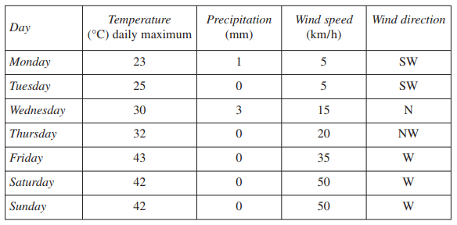
You are the supervisor on a mixed cropping/animal production enterprise. You have two employees under your supervision.
  - Outline a prioritised work program for your enterprise for this particular week.
  - Outline the different lines of communication appropriate within a primary industries workplace for distributing the tasks above.

Revision activities: working with weather
- Read each of the following situations and decide whether the statements made are true or false
Statement | True? | False?
It is mid-winter and most of the pasture has been burnt off by frosts. It is a good time to burn off stumps and windrowed timber.
It is early spring and a thunderstorm brought a good fall of rain. Tomorrow would be a good day to plant out seedling trees for a windbreak.
A cold front is due to hit your district after lunchtime. You should make sure that you have a warm coat and wet weather gear in the ute before going back to continue fence repairs.
It is an extremely hot day. It would be a good day to dig the post-holes for the steep, back boundary by hand.
It has been a long, hot morning mustering sheep on horseback. You should take a break as soon as possible to rest and water the animals and have a drink and bite to eat yourself.
It has been pouring rain for two days. The property where you work is 30 kilometres from the nearest town on a road with several low-level creek crossings. The weather forecast is for more rain. It would be wise to go to town today to buy supplies.
You are ploughing to prepare for late autumn sowing of a broad acre wheat crop. The weather is hot, dry and dusty. The oil and water levels on the tractor should be checked and the air filters cleaned every day.
Snow is forecast for the tablelands property where you work and the merino ewes have commenced lambing. It would be a good time to ask your boss for a few days off to visit your family.
It is raining steadily this morning following heavy rain last night. The ploughing should be started today while the rain is about.
Gale force winds are forecast. You have to go to town to pick up parts for the tractor. Before leaving you should spend a few minutes checking around the farmhouse and sheds for items that need to be put away or secured, such as sheets of iron, plastic and fertiliser bags.

- Scenario: thunderstorms
Read the scenario below carefully and select the most correct answer from the four choices given for each question.
A severe thunderstorm has swept over the property where you live and work, with large hailstones and fierce squalls. An empty grain silo was blown over and rolled into the home paddock dam. There is a blackout but the telephone still works. Large branches, blown out of the surrounding trees, litter the yard.
- About two hours before the storm struck you heard a storm warning broadcast on the local radio station. You should have:
  - Immediately stopped work and had lunch.
  - Rung the neighbours to tell them they might be getting some good rain.
  - Informed all farm staff of the storm warning and checked that items of property were stored or secured safely.
  - Left the homestead to check the stock.

- At the height of the storm the farmhouse guttering overflowed, blocked by hail and leaves. The lightning, with loud thunder, was very close and the rain was blowing almost horizontally. The most important thing to do at that point was to:
  - Get a ladder and climb up to clean out the blocked guttering.
  - Stay inside away from windows and electrical items and avoid using the phone.
  - Ring the local radio station to tell them about the bad storm.
  - Put on rainwear and rubber boots to go outside and take photos of the spectacular lightning.

- During the storm, a sheet of iron was torn off the roof of the chicken house. A workmate went to check the chickens and received a severe gash to the arm trying to remove the iron. The immediate course of action to deal with this situation would be to
  - Tell your workmate how stupid it was to go out during the storm.
  - Bring the workmate inside and apply a compression bandage.
  - Telephone for an ambulance.
  - Check that no chickens have escaped and give them fresh pellets to eat.

- After the storm you are shocked to see the grain silo partly submerged in the dam. You should:
  - Carefully assess the damage now that the storm has passed.
  - See if the rain gauge survived the hail and measure the rain.
  - Get the tractor out and tow the silo back to its site.
  - Ring up the neighbours to find out how much rain they had.

- The storm has moved away. It will be dark in two hours and there is still no electricity. The best course of action is to:
  - Light the barbecue.
  - Hope another storm comes soon with lots of lightning.
  - Drive into town to stay with a friend.
  - Telephone the electricity provider to tell them you have a blackout, check the power generator is ready to start and find torches and batteries.

- Scenario: heavy rain and flooding
Read the scenario below carefully and select the most correct answer from the four choices given for each question.
The property where you live and work has low hills, a couple of creeks and river flats that are irrigated in dry weather. Steady rain has fallen over the past three days. You wake in the night to hear much heavier rain on the iron roof. In the morning sheets of water cover the paddocks, the creeks are running swiftly and the nearby river is rising rapidly with flood debris being swept along in the swirling currents.
The beef herd have been grazing the long paddock between the river and a creek. The lower parts of this paddock are already flooded including the gateway.
- This is the third time heavy rain has fallen in the past two months. On each occasion the weather bureau has issued flood warnings for your river and local streams. When the latest rain began the best course of action would have been to:
  - Take annual holidays and travel to sunny Queensland.
  - Open all the paddock gates in case the herd became stranded.
  - Move the herd to higher grazing areas of the farm.
  - Not worry because each previous flood didn’t affect the herd.

- Before checking the beef herd, you notice that the rising floodwaters are getting close to the irrigation pump and motor. The irrigation plant is mounted on a slide, which is towed by the tractor. The best course of action is to:
  - Immediately take the tractor and move the irrigation plant to higher ground.
  - Check the beef herd and move them to safety first and then return to move the irrigation plant.
  - Quickly take a rope and a large, heavy-duty plastic sheet down to cover the pump and motor.
  - Start the pump to keep the floodwater from covering the farm.

- You drive the farm 4WD ute down to the long paddock and find the gateway blocked by rising flood waters. The herd is standing on a small rise in the paddock. You should:
  - Drive quickly through the flooded gateway to get to the herd.
  - Send your two best dogs to swim across and round up the herd.
  - Leave the ute above flood reach and assess the situation on foot.
  - Go back to the homestead and get the camera to record the scene for the boss.

- The herd is standing near a partly submerged barbed wire fence. Further up the paddock the fence goes over a low grassy ridge. The safest way to move the herd is to:
  - Force the herd through the flooded gateway.
  - Drive to the hay shed and bring back a ute-load of hay to leave a feed trail for the herd.
  - Leave the herd to swim out over the fences when the flood gets high enough.
  - Cut the fence wires on the ridge, fold the wires back carefully and quietly walk the herd to higher ground through the opening.

- As you herd the last of the cattle out of the paddock you see a cow and a newborn calf standing on their own near the river bank. You should:
  - Walk the cow and calf to the ute, tether the calf in the ute and slowly drive back to the homestead checking that the cow is following.
  - Get the dogs to round up the cow and calf and drive them through the opened wires.
  - Drive the ute into the flooding paddock to escort the cow and calf to safety.
  - Leave the cow to spend more time bonding with the calf.

- Scenario – Severe cold
Read the scenario below carefully and select the most correct answer from the four choices given for each question.
You are employed on a tablelands property that grows cherries, wool and prime lambs. It has been a cold winter with many frosts and one light snowfall. The Bureau of Meteorology has issued a Sheep Grazier’s Alert for the next 48 hours and the severe cold weather is expected to continue.
- You use the farm 4WD ute each day to cart hay and monitor the lambing Merino ewes. This morning it was hard to start and later the temperature gauge was in the hot zone. As you are responsible for maintaining the farm vehicles the best course of action is to:
  - Write a note to remind yourself to give the ute a thorough service next week.
  - Blame the very cold weather for the ute not going as well as usual.
  - Not worry about it – farm utes are wonderful work horses.
  - Reschedule today’s tasks so that you have time to check the water and oil levels and tyre pressures and to put the battery on an overnight charge.

- The next morning you find five dead lambs and the ewes and lambs are huddled against the fence in the exposed paddock. You should:
  - Leave the flock where they are in the lambing paddock as it still has enough green feed.
  - Move the flock to a more protected paddock that has longer dry feed and a timbered hillside.
  - Muster the flock and move them to the river paddock that can be seen distantly from the homestead.
  - Ring the neighbours to find out how many lambs they lost in the night.

- Snow falls for three days and then heavy frosts turn the snow to ice. Many of the ewes have given birth, there are a number of twins and some lambs have not bonded with their mothers. Foxes or wild dogs, which are common in the area, have killed two ewes. The most appropriate course of action is to:
  - Check the flock twice daily and bring home abandoned lambs to be hand-reared.
  - Separate the ewes from the lambs and put them in different paddocks.
  - Set up a gas-fired scare gun in the lambing paddock to frighten away the dogs and foxes.
  - Telephone your city relatives to come and see the snow.

- It is early spring and the cherries are starting to flower. Frosts are still common at this time of year and can damage the crop. The boss has ordered a new frost protection fan for the cherry orchard. You receive a phone call from a truck depot in town to say that the fan has arrived. The most appropriate action is to:
  - Tell the depot manager that you will pick up the fan next week.
  - Leave a note among the piles of papers on the farm office desk saying that the fan is at the depot.
  - Arrange to collect the fan that day and assist the boss to get it set up in the cherry orchard.
  - Tell your workmate the boss is getting a new fan.

- Scenario – Heat wave and extreme fire danger
Read the scenario below carefully and select the most correct answer from the four choices given for each question.
The summer has been particularly hot and dry. Very little hazard reduction burning was carried out due to winter and early spring rains. Pasture growth has been excellent. The property where you work has retained eucalypt bushland and established a native revegetation area. Fuel loads are very high. The property runs steers and is watered by permanent creeks and dams.
- The fire danger has been high all summer. The appropriate procedure to minimise the fire risk to stock, pasture and farm buildings should be to:
  - Tell the local bushfire brigade how hot and dry it has been.
  - Start planting autumn pasture so that the property will green up when it rains.
  - Undertake a range of property protection measures including the maintenance and construction of firebreaks and the preparation of firefighting equipment.
  - Listen each day for bushfire warnings on the radio.

- It is now early February and the other states are experiencing serious bushfires as a heatwave crosses the country from west to east. Extremely high temperatures and hot north-westerly winds are forecast to reach your district over the next three days. You should:
  - Ensure that the stock have sufficient water and shade and check firebreaks and firefighting equipment.
  - Light the heaps of logs and stumps in the back paddock now that they have dried out.
  - Take a few days off to visit friends on the coast.
  - Begin constructing a very big dam.

- After breakfast on the second day of the heatwave a pall of smoke appears in the timbered country to the west of the property. The smoke is blowing towards you on the hot westerly wind. The best course of action is to:
  - Be thankful the fire is not burning on your property.
  - Contact the local bushfire brigade to inform them about the fire and move the steers to a ploughed paddock.
  - Drive out to the western boundary of the property and begin back burning on your own.
  - Telephone the neighbours to suggest a meeting to discuss the problem of arsonists in the area.

- Within two hours the fire is burning along a two-kilometre front and threatening the western boundary. Good firebreaks have so far stopped its progress. Three fire fighting vehicles and teams are patrolling this area. A cool southerly change is expected later in the day. Your main concern should be to:
  - Continue to patrol the firebreaks, watch for spot fires and keep in communication with all personnel on the property.
  - Make sure the swimming pool is clean for the fire fighters to have a swim after the barbecue.
  - Muster all the steers.
  - Photograph the fire damage to the boundary fence for insurance purposes

- By sunset, the fire moved to the north away from the property. It has been a very difficult day assisting the fire fighters and coordinating property communications. You are feeling very tired, thirsty and a bit giddy and sick. Your water bottle is empty. You should:
  - Get a drink out of the hose of the one remaining bushfire tanker.
  - Do nothing and wait till you get back to the homestead.
  - Walk into the burnt out forest and get a drink from a creek.
  - Ask for a drink of fresh water and help from one of the fire fighters as you may be suffering from dehydration.

Preventative action to minimise loss, damage or harm as a result of changes in weather and climate conditions, including revision and adjustment of work program and work tasks
To undertake preventative action to help prepare for and reduce losses from sudden weather changes and climate conditions primary industries workers can create a methodical approach to planning by considering
1. infrastructure like sheds, yards, water pumps. This may involve closing windows and doors on sheds, making sure gateways are accessible for yards in case of boggy conditions for animal treatments and removing water pumps from rivers in the event of flooding
2. livestock this may require opening gates so they can seek shelter from high winds or cold nights or rising waters. Stock may need extra feed provided for more energy in extreme cold snaps or high waters or after bushfires when they are unable to graze
3. crops this may involve timing of sowing, harvest or haymaking to avoid wet weather by selecting time to do these work practises. Also by selecting the better variety of plant a farmer can help reduce losses from climatic tendencies like late frosts affecting seesdset on a cereal crop and thus harvest yield or choosing a variety that has less tendency to lodge (fallover in high winds or rains) if planning to strip it for seed by choosing a lower growing variety
4. personnel this includes all people in a workplace. This can be the employees and also the family. It is a good idea to ‘have a plan’ where all essential phone numbers are handy, a first aid kit and emergency supplies are on standby, if floods are predicted and you know there are creeks that tend to rise between your place and town, then stock up on essential supplies in case you can't get to town for shopping and animal vaccines etc. REMEMBER PLANNING TO HAVE A PLAN IS NOT A PLAN.
5. equipment and machinery like tractors, sower/combines, slashers and fencing tools, welders and other valuables or electrical items. These all need to be put away or moved to shelter if possible and possibly cover the sower and fertiliser in the case of sudden wet weather to try and protect it.

Revision activities: preventative action
- You are a sheep grazier preparing for shearing and hear on the radio there is wet weather coming for about 3-4 days, what are your possible work plans to take to allow shearing to proceed?
- Bushfires, droughts, floods and storms cause widespread loss and devastation. Select one of these issues and discuss how planning (both long-term and contingency) for climate and weather conditions can affect workplace operations, practices and the scheduling of work tasks.
- Name a weather condition and complete the following table outlining the risks associated with this condition for a primary industries workplace, and corresponding actions that could be taken to reduce these risks. The table will grow as you enter text.
Weather condition:
Risk | Action

- A heavy rainstorm has caused floodwaters to move swiftly down the river valley towards your farm. More rain is predicted. How could you reduce the risk of damage to your property? In your answer include:
  - relevant sources of weather and climatic information.
  - the information you need to receive and convey and a justification of your choice of communication methods.
  - likely impacts of weather changes.

Reporting and recording

Lines of communication to appropriate personnel within a primary industries workplace
Communication between workers is vital for safe effective workplace operations and also family members if the workplace is the family farm
This will involve day to day workplace operations as well as what to do in the event of an emergency. Communication of safety points, meeting places, location of first aid and emergency numbers are examples of vitals to be communicated. This can occur through verbal communications like face to face meeting or if necessary, by phone or two way radio. It can also occur non-verbally with text messages, emails or written notes in the meeting room/staffroom whiteboard or mail tray for staff. The processes involved will vary depending on the size of the enterprise and business.

Industry and workplace requirements for documentation in relation to recording and reporting weather and climate conditions and changes
Some workplaces will have a weather station or data logger of sorts which record daily temperature variations, rainfall frost free days, humidity, windspeed and more. A chemical contractor for instance will need very accurate weather records to ensure no liability occurs from chemical spray drift.

Purpose and importance of disseminating information to supervisors, colleagues and others
The daily reading of weather reports and printouts of this is vital in some workplaces like fishing trawlers going out on the seas for knowing winds and any drop in the barometer heralding air pressure change and thus a weather change.
The main purpose is for communication and efficient safe workflow.

Revision exercises: Reporting and recording
- What lines of communication are appropriate for personnel within a primary industries workplace?
- What are the industry and workplace requirements for documentation in relation to recording and reporting weather and climate conditions and changes?
- What other records are useful within a primary industries enterprise?
- Why is communication important within primary industries workplaces?

Putting the theory into practice
The following questions are from past years’ NSW HSC examination papers for this subject. HSC exams are intended to be rigorous and to challenge students of all abilities. To better understand a question, you should look for key words and identify the aspect of the course to which these relate. You are then in a position to formulate your answer from relevant knowledge, understanding and skills.
All questions in ‘Putting the theory into practice’ are acknowledged © 2019 NSW Education Standards Authority (NESA) for and on behalf of the Crown in right of the State of New South Wales.

Multiple Choice
- Which device is used to measure air pressure when monitoring weather?
  - Anemometer
  - Barometer
  - Hygrometer
  - Thermometer

- Heatwave conditions are forecast for the next two days in your area. What is the first action you should take to prepare your livestock enterprise for this forecast?
  - Check shade structures
  - Inspect the water troughs
  - Monitor the weather patterns
  - Continue with your current task

- The Bureau of Meteorology is likely to issue a grazier’s alert when there are strong winds and rain and which of the following?
  - A slight drop in temperature
  - A slight rise in temperature
  - A large drop in temperature
  - A large rise in temperature

- Which of the following best defines the term climate?
  - The weather patterns that occurred in the last year
  - The weather patterns that occurred in the last five years
  - The weather records kept by the primary industries workplace
  - The weather conditions prevailing in an area over a long period
- In Australia, the air around a low pressure system moves
  - in a clockwise direction and away from the Earth’s surface.
  - in a clockwise direction and towards the Earth’s surface.
  - in an anticlockwise direction and away from the Earth’s surface.
  - in an anticlockwise direction and towards the Earth’s surface.

- Major flooding has occurred 252 kilometres upstream from a flood-prone property. The peak water level is moving downstream at a rate of 9 kilometres per day.
How long will it take for the floodwaters to reach this property?
  - 3 weeks
  - 4 weeks
  - 5 weeks
  - 6 weeks

Refer to the following weather map of NSW to answer Questions 7 and 8.

- On the weather map the symbol H indicates weather that is
  - stable
  - cyclonic
  - unstable
  - monsoonal

- Which of the following shows the expected weather conditions for Murra in the next 24 hours?
  - Cool and calm
  - Cool and windy
  - Warm and calm
  - Warm and windy

Refer to the following weather map of Australia to answer Questions 9 and 10.
- The pressure system labelled X is a
  - low
  - high
  - trough
  - cold front

- Which is the term for the line labelled Y on the weather map?
  - An isobar
  - An isohyet
  - An isocline
  - An isotherm

- The following table shows the total annual rainfall measured over six years on a property on the mid-north coast of NSW.
Year | 2002 | 2003 | 2004 | 2005 | 2006 | 2007
Total annual rainfall (mm) | 806 | 895 | 1280 | 1077 | 834 | 1309

Based on the information provided in the table, what was the average annual rainfall for the property over this period?
  - 806 mm
  - 895 mm
  - 1034 mm
  - 1179 mm

- A primary industries worker has received an alert from the Bureau of Meteorology predicting a change in weather conditions overnight with a dramatic drop in temperature and an increase in wind speed.

What kind of weather warning is associated with these conditions and how should this be best communicated to co-workers?
 | Weather warning | Communication method
a) | Wind chill | Email
b) | Wind chill | Phone call
c) | Grazier’s alert | Email
d) | Grazier’s alert | Phone call

Questions from Section II
These questions should be answered in the suggested number of lines (handwritten) as it gives a guide to the length of your response.
Plan out your answer and key points before you commence writing. You may need to bring together knowledge from several areas of study/competencies to do justice to the answer.
Question 1

  - Outline the possible impact of ONE weather event on crops, livestock OR property. (3 marks)
Named weather event:

  - Describe preventative actions that could be taken by a primary industries worker to minimise loss, damage or harm resulting from the weather event named in part a). (4 marks)

Question 2
Weather conditions can have a major impact on a primary industries workplace.
  - Name the weather condition represented by the symbol. (1 mark)

  - Name a weather condition. Complete the following table outlining the risks associated with this condition for a primary industries workplace and corresponding actions that could be taken to reduce these risks. (6 marks)
Weather condition:

Risk | Action

Question 3

  - What is the difference between the terms ‘weather’ and ‘climate’? (2 marks)

  - Compare television and the internet as sources of weather information for a primary industries workplace. (4 marks)

Questions from Section III
In the HSC –
- there will be one structured extended response question (15 marks)
- the question will have an expected length of response of around four pages of an examination writing booklet (approximately 600 words)
Your answer will provide you with the opportunity to:
- demonstrate knowledge and understanding relevant to the question
- communicate ideas and information using relevant workplace examples and industry terminology
- present a logical and cohesive response
You will note that these questions usually require you to bring together knowledge from several areas of study/competencies to do justice to the answer. You should allow about 25-30 minutes for a question in Section III and the same for Section IV of the exam.
Question 1
Explain how weather and climate affect planning and production in the primary industries.
Question 2
Evaluate the effectiveness of a range of communication strategies used in primary industry enterprises for both routine and emergency situations.

Questions from Section IV
In the HSC –
- there will be two structured extended response question in Section IV, one for each of the stream focus areas (15 marks).
- You will answer the question on the stream you have studied
- each question will have two or three parts, with one part worth at least 8 marks
- the question will have an expected length of response of around four pages of an examination writing booklet (approximately 600 words) in total.
Section IV is based on the stream focus areas (Livestock health and welfare, and Plant pests, diseases and disorders) and can also draw from the mandatory focus areas.

HSC Focus Areas
For the purposes of the HSC, all students undertaking the 240 HSC indicative hours course in Primary Industries must address all of the focus areas plus one stream focus area.

Primary Industries Mandatory Focus areas
- Chemicals
- Safety
- Sustainability
- Weather
- Working in the industry
Primary Industries Stream focus areas (you will study one of the following)
- Livestock health and welfare
- Plant pests, diseases and disorders

The scope of learning describes the breadth and depth of the HSC Content, the minimum content that must be addressed, and the underpinning knowledge drawn from the associated unit(s) of competency. The units of competency associated with the mandatory focus area ‘Weather’ in Primary Industries is AHCWRK201 Observe and report on weather or AHCWRK302 Monitor weather conditions.

How to use the scope of learning for ‘Weather’
- draw up your own mind map showing the connection between the various concepts listed; examples appear on the last page of this module
- use the key terms and concepts to add to your mind map
- add examples or case study prompts to show how the concept is applied in the Primary Industries working environment

The following information is taken directly from page 46 ff ‘Primary Industries Curriculum Framework Stage 6 Syllabus for implementation from 2020’ © 2019 NSW Education Standards Authority (NESA) for and on behalf of the Crown in right of the State of New South Wales.

weather and climate
- the difference between weather and climate
- elements of weather and climate:
- temperature:
- heat
- cold
- humidity
- wind:
- wind chill
- wind shear
- precipitation
- atmospheric pressure
- atmospheric particle count
- delta T
- dew point
- meteorological conditions
- identification of weather and climate conditions:
- likely
- current
- changes
- signs
- extreme

monitoring conditions
- access and use of a range of sources of weather and climate information:
- Bureau of Meteorology
- media
- technology:
- internet
- interpretive tools
- weather station
- word of mouth
- range of different types of weather and climate information relevant to primary industries:
- data
- grazier alerts
- reports
- updates
- warnings
- forecasting techniques for monitoring weather conditions:
- interpreting weather maps
- taking local measurements:
- temperature

monitoring conditions cont/d
- precipitation
- air pressure
- interpreting weather and climate information
- importance of maintaining current information

managing conditions
- potential implications of weather and climate changes for a primary industries workplace on the following:
- crops
- commercial decisions and activities
- environment
- livestock/grazing
- natural resources
- property
- safety
- work tasks
- primary industries workplace planning (long-term and contingency) for climate and weather conditions:
- workplace operations
- work practices
- schedule of work tasks
- preventative action to minimise loss, damage or harm as a result of changes in weather and climate conditions, including revision and adjustment of work program and work tasks

reporting and recording
- lines of communication to appropriate personnel within a primary industries workplace
- industry and workplace requirements for documentation in relation to recording and reporting weather and climate conditions and changes
- purpose and importance of disseminating information to supervisors, colleagues and others
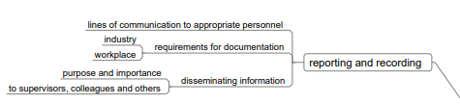
Example of mind map being developed

