Primary Industries
Safety
Welcome.
This module will assist you to review and revise content in the area of ‘Safety’ in the NSW HSC Primary Industries syllabus.
You will have studied one of these competencies, which address the scope of learning:

AHCWHS201 Participate in work health and safety processes
OR
AHCWHS301 Contribute to work health and safety processes

This module is broken up into:
- Important notes
- Key terms and concepts
- Activities
- Putting the theory into practice
- HSC focus areas
How to use the resource
Work through the notes and the suggested activities in any order. Great revision techniques include working through how a problem is solved, explaining the concept, testing yourself and retrieving information from your memory. Spread your revision over a number of sessions rather than sitting at one subject for lengthy periods.
Discuss your responses with your teacher, fellow students or an interested family member.
All images, apart from those acknowledged, are © NSW Department of Education.

A. Important Notes
You should use the information in this module as a prompt and guide when revising your study notes or text-book information or other resources provided by your teacher. You can also access industry specific information at SafeWork NSW, Farmsafe Australia (National Farmers Federation) or NSW Department of Primary Industries,

The unit AHCWHS201 Participate in work health and safety processes describes the skills and knowledge required to recognise and report hazards in the workplace. It also describes the skills and knowledge required to follow workplace safety procedures and directions.
The unit AHCWHS301 Contribute to work health and safety processes describes the skills and knowledge required to carry out enterprise work health and safety policies and procedures.

The outcomes of the HSC Primary Industries mandatory focus area ‘Safety’ require that the student
- demonstrates an understanding of work health and safety (WHS) compliance, participation and consultation in primary industries
- explains workplace policy, procedures and practices that ensure the safety of the primary industries worker and their colleagues and clients
- applies risk management in a primary industries workplace
- proposes appropriate responses to emergency situations.

Key terms and concepts
You can use the following information to revise the key terms and concepts from this unit of competency. Perhaps you could:
- Copy the table into your own file, remove all the key terms, then fill in the blanks (without peeking at the original file) with your own answers.
- Copy the table into your own file and remove the definitions. Write a definition in your own words – it doesn’t have to word perfect but should show you understand the concept.
- You could add an example of this term or concept relevant to the Primary Industries environment. If the key term was ‘safe work practices’ your relevant example might be ‘leather work gloves and safety glasses reduce the risks when working with barbed wire’.

Key term or concept | and Definition
Breach | Failure to follow requirements.
Bullying | Workplace bullying is repeated and unreasonable behaviour directed towards a worker or group of workers that creates a risk to health and safety. Examples include abusive or offensive language or comments, aggressive and intimidating behaviour, belittling, or humiliating comments, practical jokes or initiation and/or unjustified criticism or complaints.
Compensation | The cost of workplace injuries is enormous to our society through both compensation monies and lost production time. Compensation monies may be paid to make up for someone's loss, damage, or injury, giving the injured party an appropriate benefit.
Consultation | Consultation is a statutory requirement of most WHS legislations around the world. The aim is to gather information from all stakeholders in the organisation and allow effective participation in the establishment of meaningful health and safety policies and procedures.
Control measures | The steps required to keep a hazard from causing injury, illness and/or damage.
Dangerous goods | Dangerous Goods are substances or articles that are hazardous to people and property. They may be explosives, gases, chemicals, flammable solids or liquids or toxic substances.
Emergency | An emergency is an incident or a situation which endangers, or may endanger, the health, safety and welfare of persons in the workplace, and which requires urgent action to control.
Emergency Plan | An emergency plan is a written set of instructions that outlines what workers and others at the workplace should do in an emergency.
Evacuation | All organisations and businesses must have an Emergency Evacuation Plan that guides people inside the building, out to an assembly area, as quickly as possible. Procedures for fire and other emergencies should always include provisions for the evacuation of people including those with a disability. It is compulsory by law to have evacuation diagrams at relevant places.
Feedback | Response to a query or reaction to something, used to facilitate future discussions and decisions.
Harassment | Harassment can be against the law when a person is treated less favourably on the basis of certain personal characteristics, such as race, sex, pregnancy, marital status, breastfeeding, age, disability, sexual orientation, gender identity or intersex status. Harassment can include behaviours such as: telling insulting jokes about particular racial groups; sending explicit or sexually suggestive emails or text messages; displaying racially offensive or pornographic posters or screen savers; making derogatory comments or taunts about someone’s race; asking intrusive questions about someone’s personal life, including his or her sex life.
Hazard | Standards Australia defines a hazard as ‘a source or a situation with the potential for harm in terms of human injury or ill-health, damage to property, damage to the environment, or a combination of these.’
Health | Includes both physical and psychological health.
Health and Safety Representative | A worker who has been elected by their work group under the WHS Act to represent them on health and safety matters.
Industry Safety Guidelines | These are developed with a particular industry to provide safety advice relevant to that industry. In Primary Industries in Australia, for example, safety guidelines have been developed by SafeWork NSW and other industry organisations.
Legislation | The NSW Work Health and Safety Act 2011 (WHS Act) and the NSW Work Health and Safety Regulation 2017 (WHS Regulation) define the obligations both employers and workers have to health and safety in the workplace.  The WHS legislation is supported by a Compliance policy and prosecution guidelines, which supplements the National compliance and enforcement policy.
Managing risk | A process set out in the WHS regulations to eliminate health and safety risks so far as is reasonably practicable, or if this is not reasonably practicable, minimise the risks so far as is reasonably practicable. Includes identifying hazards, assessing and implementing control measures, and reviewing and maintaining the control measures to ensure ongoing effectiveness.
Manual Handling | Manual handling is any activity where the use of force physically, by a person, is exerted to push, pull, lift, lower, extend, restrain, carry, move or hold a stationary or moving, or animate or inanimate object.
Mental health | A person’s mental health affects how they feel, think, behave and relate to others.
Noise | Usually rated in decibels (dB), noise is the phenomena associated with sound pressure on the human ear drum.
Occupational Overuse Syndrome (OOS) | Sometimes referred to as repetitive strain injury (RSI), OOS is a malady affecting bones, muscles, and ligaments, usually arising from repetitive stressing of those body parts, such as repetitive movement. It can be exacerbated by such mental pressures as dislike of the task, or pressure to get the job finished.
Pain and suffering | ‘Pain and suffering’ is the legal term for the physical and emotional stress caused from an injury.
Participation | Participation is the act of sharing in the activities of a group; encouraging involvement and engagement and action. The Work Health and Safety Act aims to provide for fair and effective workplace representation, consultation, co-operation and issue resolution in relation to work health and safety.
PCBU | A PCBU is an umbrella concept which intends to capture all types of working arrangements. A ‘person conducting a business or undertaking’ (PCBU) might be a company, a partnership conducting a business, an unincorporated body or association, a sole trader or self-employed person.
PPE (personal protective equipment) | Used to describe protective equipment that is worn to being protected someone from hazardous situations. PPE includes such things as hats and hair nets, aprons, gloves, overalls, safety shoes and boots, eye and face protection such as goggles, face shields and masks; ear protection such as ear-muffs and ear plugs and breathing equipment.
Productivity | A link has been identified between WHS and productivity. Poor work, health and safety has been linked to lower levels of workplace productivity and performance.
Reporting | WHS reporting, like any other business intelligence, needs to provide management with relevant, robust and timely information that can inform the decisions that influence ongoing business performance. Reporting of incidents and concerns contributes to a safe workplace.
Representation | The Work Health and Safety Act (the WHS Act) aims to provide for fair and effective workplace representation, consultation, co-operation and issue resolution in relation to work health and safety.  Worker representation provides a means for facilitating consultation, involving workers and giving them a voice in health and safety matters.
Risk | The likelihood of a hazard becoming a danger. The possibility that harm (death, injury, illness) might occur when exposed to a hazard.
Risk management | The holistic approach to looking after health, safety and welfare of all people; a systematic process for addressing hazards in the workplace.
Safe Work Practices | These include identifying potential hazards, training and inducting staff, ensuring all staff use the appropriate Personal Protective Equipment and ensuring that all equipment is properly maintained
Safety Data Sheet (SDS) | The (Material) Safety Data Sheet is a document that describes the chemical and physical properties of a material and provides advice on safe handling and use of the material.
Significant Injury | Sometimes called ‘serious injury’ or ‘notifiable injury’, generally a significant injury is any injury likely to lead to a person being unable to perform their pre-injury functions for seven days or more.
Standard Operating Procedures (SOP) | A set of step-by-step instructions compiled by an organisation to help workers carry out complex routine operations
Visitor | Basically, under the conditions of the WHS Act, a visitor is considered to be anyone who is not doing ‘work’ on behalf of the organisation, sometimes described as ‘others’. This will include door-to-door salespeople, relatives, and friends of employees, and so on.
WHS Policies and Procedures | WHS policies and procedures outline the requirements for complying with both external and internal WHS compliance requirements.
Work Health and Safety Management System | A system that includes all the programmes, policies, procedures, organisational structures, planning activities, responsibilities, processes, practices and resources for developing, implementing, achieving, reviewing and maintaining the Work Health and Safety of all persons in, or affected by, the workplace.
Worker’s responsibilities | All workers are responsible for the WHS impact of their own actions. They also have a duty to make sure their work is carried out in line with WHS procedures and any applicable legislation. More specifically, workers must take reasonable care for their own health and safety.

Activities
- Watch the three minute video clip explaining how Hassad has reduced on-farm injuries.
  - Identify the three components (tiers) of safety they have implemented and provide an example of each.
  - Why is ‘workplace specific induction training’ required on the property? List the topics which are included in this induction training.
  - What are the benefits to the organisation – think beyond ‘fewer accidents’.

- The NSW Work Health and Safety Act 2011 (WHS Act) and the NSW Work Health and Safety Regulation 2017 (WHS Regulation) define the obligations that both employers and workers have to health and safety in the workplace.
List at least five obligations of the employer and at least five obligations of the employee.

- Access SafeWork Australia and answer the following questions:

  - How many workers died as a result of contact with electricity between 2003 and 2015?
  - What was the main cause of these deaths?
  - Which industry appears the riskiest for electrical deaths? Does this mean you only have to take care if you work in this particular industry? Why would you need to take greater care?
  - What types of equipment involve greater risk to workers? What electrical equipment is of concern in a Primary Industries environment.
  - Explain ‘inspect, test, tag’.

- SmartMove is a Work Health and Safety online educational program for senior high school students and young workers entering the workforce for the first time. Registering to use the resources and quizzes and work towards achieving a SmartMove Certificate is free and only takes a few minutes. Access SmartMove and undertake the ‘General’ and ‘Farming, forestry and fishing’ modules.
- Research the following from SafeWork NSW and make notes explaining:
  - Consultation (scroll down to this heading)
  - A fair and just workplace
  - Your safety responsibilities as a worker

- Click on the link to AgHealth and answer the following.
  - Complete the following using Table 1 information
In 2018 – 2019 a significant number of on-farm injuries were reported.
Fatalities were made up of:
 | 2018 | 2019
Young people less than 15 years
People aged over 15 years
Total
Dam fatalities (all ages)
Quad bike fatalities (all ages)
Tractor fatalities (all ages)
Trees being felled (all ages)

  - Complete the following using Table 2 information
In 2019, the 67 non-fatal injuries included such agents (causes) as:
Total
Horse
Quad bike
Utility
Tractor
Chainsaw
Ladder

  - Write at least 200 words explaining ‘being prepared for farm emergencies’. Research this topic at Farmsafe Australia and AgHealth Australia.

- Have a break by completing this activity – find the words, then sort them into the five categories listed at the bottom. You may need to print this page.
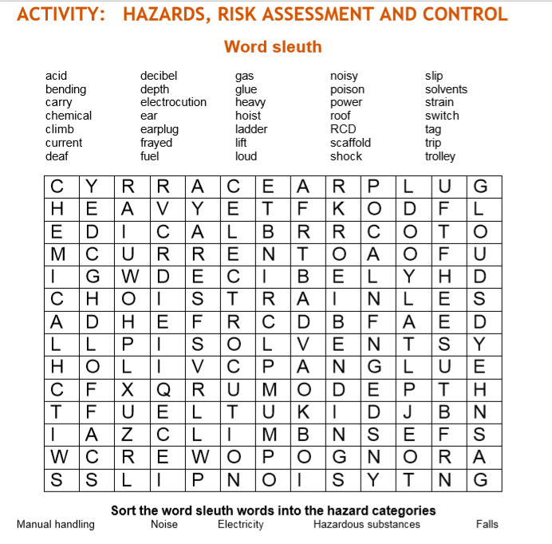

- Find examples of the type of safety signs you would see in a Primary Industries environment. Try to find at least three in each category. Look for signs which:
- indicate you must not do something (prohibition/stop signs: white background, red circle with cross bar)
- warn you of a danger (caution signs: yellow background, black symbol)
- provide emergency information (green and white)
- indicate what you must do (mandatory signs: circle with a blue background and white symbol)
- Describe how you could implement control measures when using farm chemicals. Refer to this Farm Chemicals information from University of Sydney AgHealth Australia (page 7).

- Construct a chart with the following headings, showing the safe level of exposure for various decibels. Find examples between 0 and 140 dB.
Safe levels of exposure
Sound pressure level | Example of sound source | Safe exposure time | Hearing protection measures
85 dB | Front end loader | 8 hours

- The SafeWork Australia A-Z of Farm Safety provides practical guidance on how to achieve the standards of work health and safety required under the WHS Act and the Work Health and Safety Regulations (the WHS Regulations). It aims to assist in identifying the main elements of risk on a farm – and what can be done to make improvements. Refer to this publication to answer the following:
  - List the tips for safe handling of animals
  - Define bullying
  - Give examples of ‘confined space’
  - Why are alcohol and drugs dangerous in a primary industries environment?
  - List how to work safely with electricity
  - What safety measures can be used when working from a height?
  - List the basic rules for safety guards
  - 40% of quad bike accidents involve traumatic brain injury. What is one way to reduce quad bike fatalities?
  - Look through the rest of the pamphlet to find examples which you could use in your HSC responses; add these to your mind map (below) or notes.

- The Department of Industry, Innovation and Science provides guidance on how to manage risks in the workplace using a systematic process.
  - Provide a definition for each step in the process.
A systematic process for managing risks in the workplace
Step in the process | Definition
Identify hazards
Assess risks
Control risks
Review control measures
Record and report safety issues
Support return to work
Make your workplace healthier
  - The same government department lists examples of WHS in agriculture. Scroll down to ‘workplace health and safety’. Choose two and give examples relevant to your course.

- SafeWork Australia has produced a Model Code of Practice: How to manage work health and safety risks. Investigate:
- Who has a duty in managing work health and safety risks? (1.1) Hint: 5 dot points.
- What are the four steps in risk management (1.2)?
- List the hierarchy of control measures from highest level of protection and reliability, to lowest (4.1)
- What is the difference between a risk and a hazard? Provide two examples of risks and two examples of hazards in Primary Industries.
- Find at least five examples of risk control measures (4.1) to add to your mind map (Part E at the end of this module). Make sure you understand ‘substitution’, ‘isolation’, ‘engineering controls’, ‘administrative controls’ and ‘PPE’.
- Match the two halves of each sentence.
Draw a line between each or write (or cut and paste) the correct sentences, in full, below the table.
Match the sentence parts
An employer | is the responsibility of an employer.
Hazards | law must provide workers with training and supervision and a safe and healthy workplace.
Safety Signs | employers and employees to consult and cooperate (work together) to make their workplace safe.
The title of the NSW safety legislation (laws) that protect workers is | should follow safety procedures, work safely and not put the safety and health of others in the workplace at risk.
The control of hazards | warn people of danger and provide safety information.
NSW safety and health laws encourage | The NSW Work Health and Safety Act 2011 (WHS Act) and the NSW Work Health and Safety Regulation 2017 (WHS Regulation).
An employee (worker) | is available from SafeWork NSW.
Information on safety and health at work | must be controlled by the employer, manager or supervisor.

- Consider the following two Primary Industries environments. For each one, develop a list of three safety topics to be discussed at a WHS Safety meeting. The ‘Use of PPE Guide’ from NSW Department of Primary Industries may assist.
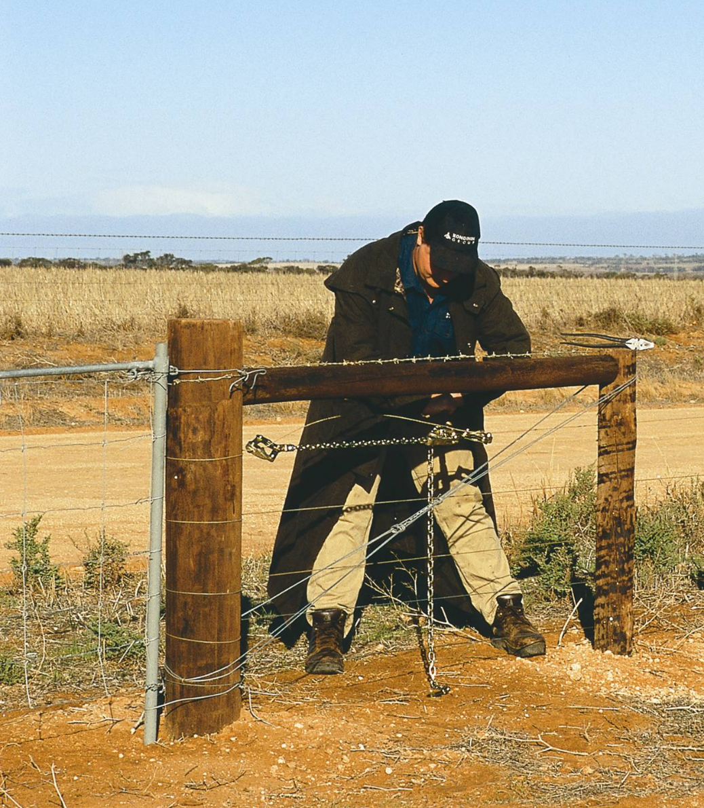
Fencer © Western Australian Agriculture Authority, 2013–2018

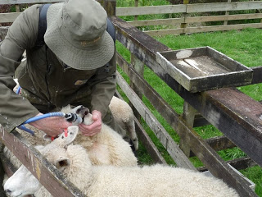
Illustration from Woolshed 1 Blog by Dr Clive Dalton is licensed under Creative Commons Attribution-Noncommercial 3.0 Unported License.

- Access websites http://www.whitecardsafety.com/fire-safety.html and https://www.fireequipmentonline.com.au/6-fire-extinguisher-classes-in-australia to complete the following:
Fire is a chemical reaction requiring what three components?
The way to extinguish a fire is to remove any, or all, of the components of the fire triangle. List four:
The type of alarm needed can range from a simple shout of 'fire', to sophisticated automatic systems. Whatever system is chosen, make sure it:
There are six classes or types of fires in Australia. List them below providing an example and indicating what extinguishing agent should be used on each.
Class A
Class B
Class C
Class D
Class E
Class F
- Fill in the blanks, using the words provided.
Use these words
effective | communication | implementing | frequency
hazardous | earliest | instructions | activity
emergency | procedures | storage | workers
What is an emergency plan?
An emergency plan is a written set of ( ) that outlines what ( ) and others at the workplace should do in an ( ). An emergency plan must provide for the following:
- emergency procedures, including: an ( ) response to an emergency
- evacuation ( )
- notifying emergency service organisations at the ( ) opportunity
- medical treatment and assistance, and
- effective ( ) between the person authorised to coordinate the emergency response and all people at the workplace
- testing of the emergency procedures—including the ( ) of testing, and
- information, training and instruction to relevant workers in relation to ( ) the emergency procedures.
What types of emergencies should be covered?
The types of emergencies to plan for may include fire, explosion, medical emergency, rescues, incidents with ( ) chemicals, bomb threats, armed confrontations and natural disasters.
The emergency plan should be based on a practical assessment of hazards associated with the work ( ) or workplace, and the possible consequences of an emergency occurring as a result of those hazards. External hazards should also be considered in preparing an emergency plan, for example a chemical ( ) facility across the road.
In developing the plan, consideration should be given to the application of all relevant laws, including public health ( ) (for example, workplaces that are also public places) and state or territory disaster plans.

Putting the theory into practice
The following questions are from past years’ NSW HSC examination papers for this subject. HSC exams are intended to be rigorous and to challenge students of all abilities. To better understand a question, you should look for key words and identify the aspect of the course to which these relate. You are then in a position to formulate your answer from relevant knowledge, understanding and skills.
All questions in ‘Putting the theory into practice’ are acknowledged © 2019 NSW Education Standards Authority (NESA) for and on behalf of the Crown in right of the State of New South Wales.

Multiple Choice
- A primary industries worker has been seriously injured in a tractor accident. As the first person to arrive on the scene, what action should you take first?
  - Check for danger
  - Contact a supervisor
  - Call emergency services
  - Check for a response from the injured worker
- Health and safety laws, regulations and codes of practice are important for the control and regulation of health and safety in the workplace. Which of these statements is NOT correct?
  - Regulations are legally enforceable.
  - Codes of Practice are legally enforceable.
  - An Act sets out requirements ensuring that workplaces are healthy and safe.
  - A Code of Practice provides advice on how to meet regulatory requirements

- A workplace has purchased a new piece of equipment. Who is responsible for the development of Standard Operating Procedures for its use?
  - WorkCover
  - The employee
  - The employer
  - The equipment manufacturer

- The first step in risk control is to
  - reduce the risk.
  - eliminate the risk.
  - modify the risk factor.
  - find an engineering solution

- An employee has discovered a fresh oil spill which has leaked from a piece of machinery onto the workplace floor. The oil spill represents an example of
  - unsafe work practices.
  - poor workplace cleanliness.
  - an immediate workplace risk.
  - an immediate workplace hazard.
- A ladder to be used in a primary industries workplace should be specifically manufactured for
  - industrial use.
  - non-sloping ground.
  - general outdoor use.
  - domestic property use.
- Under work health and safety (WHS) legislation, who has primary responsibility for organising training to occur in the workplace?
  - Employees
  - Employers
  - Trainers
  - WorkCover
- Which row of the table identifies a hazard and an INCORRECT associated risk for workers on a primary industries work site?
 | Hazard | Risk
a) | Sun exposure | Sunburn
b) | Noise exposure | Deafness
c) | Falling object | Seizure
d) | Chemical spill | Contamination

- Which of the following is an example of substitution as a procedure for minimising risk?
  - Using only pre-mixed chemicals
  - Separating chemicals from all food products
  - Using a modified mechanical sprayer to spray crops
  - Using a product in pellet form rather than as a dust or powder

- Which pair of extinguishers should be used to fight a fire in a chemical store where there are both flammable and combustible liquids?
  - Foam and powder
  - Powder and water
  - Wet chemical and foam
  - Water and wet chemical

- Which of the following is the best source of information about the hazards of using a specialist piece of equipment in the workplace?
  - The supplier of similar types of specialist equipment
  - The manufacturer of that specialist piece of equipment
  - The employer who has provided the specialist equipment
  - The workers who operate that specialist equipment at your workplace

- What is the colour of a mandatory safety sign on a primary industries worksite?
  - Red
  - Blue
  - Green
  - Yellow

- In accordance with WHS regulations, who is ultimately responsible for ensuring that a risk management assessment is undertaken in a primary industries enterprise?
  - WorkCover
  - The supervisor of the enterprise team
  - The owner of the primary industries enterprise
  - Workers on the job who have first-hand knowledge of the enterprise
- What is the shape of a mandatory blue safety symbol in the workplace?
  - Circle
  - Rectangle
  - Square
  - Triangle
- A chemical package is incorrectly labelled if it has
  - instructions written in English.
  - a signal word and precautionary statement(s).
  - words consistent with the classification of the chemical.
  - an overseas address for either the manufacturer or importer
- A sign on a storage shed in the workplace displays a yellow triangle with a black border.
This sign indicates
  - emergency.
  - hazard.
  - prohibition.
  - restriction.

- The appropriate personal protective equipment (PPE) that must be worn when mixing a chemical is determined by
  - using existing chemical records.
  - using the same PPE that was used in the past.
  - reading the chemical label after mixing the chemical.
  - reading the material safety data sheet (MSDS) before mixing the chemical.

- Following a workplace audit, your supervisor has put in place a risk minimisation program using the hierarchy of controls.
Risk minimisation strategy
W | Eliminate the risk
X | Other controls
Y | Monitor and review
Z | Minimise the risk
In what order should the above strategies be applied?
  - W, Z, X, Y
  - W, X, Y, Z
  - W, X, Z, Y
  - W, Y, X, Z

Questions from Section II
These questions should be answered in the suggested number of lines (handwritten) as it gives a guide to the length of your response.
Plan out your answer and key points before you commence writing.
You may need to bring together knowledge from several areas of study/competencies to do justice to the answer.

Question 1

A farmer plans to install a water pipeline from the farm shed to the farm residence. The pipeline will be laid 600 mm underground and is 200 metres long. A pipe-layer will be attached to a tractor via the three-point linkage system.
  - Identify TWO hazards associated with this activity. (2 marks)

  - Describe the risks associated with ONE of the hazards identified in part (a). (2 marks)

Question 2
At your primary industries workplace, chemicals are stored in a secure chemical store.
Justify procedures that will need to be implemented to minimise the risks associated with a chemical spill. (6 marks)

Question 3
A primary industries worker has been asked to apply two different sprays on the one day using an open cabin tractor.
  - In the morning, the worker will be spraying a crop with a chemical that has a signal heading POISON (S6 chemical).
Complete the following table listing TWO pieces of PPE appropriate for the task and give ONE reason for selecting each piece of equipment. (2 marks)
Appropriate PPE | Reason for use
1

2

  - In the afternoon, the worker will be applying a non-selective herbicide near a neighbouring property, a wildlife habitat and a waterway.
Complete the following table listing TWO potential impacts of the non-selective herbicide on this environment and provide valid strategies to reduce the impact.
(6 marks)
Potential impact of chemical use | Strategies to reduce the impact
1

2

Question 4
  - Outline the key stages in risk control. (3 marks)

(b) Identify TWO hazards for a worker in a primary industries workplace. For each hazard, suggest a potential risk and provide an appropriate method of risk control.
Hazards | Potential risk | Risk control
1

2

Question 5
  - Identify a common primary industries workplace injury and describe the appropriate basic first aid response. (6 marks)

  - Describe safety strategies that could be put in place to prevent workplace injuries from occurring. (4 marks)

Questions from Section III
In the HSC –
- there will be one structured extended response question (15 marks)
- the question will have an expected length of response of around four pages of an examination writing booklet (approximately 600 words)
Your answer will provide you with the opportunity to:
- demonstrate knowledge and understanding relevant to the question
- communicate ideas and information using relevant workplace examples and industry terminology
- present a logical and cohesive response

Questions from Section IV
In the HSC –
- there will be two structured extended response question in Section IV, one for each of the stream focus areas (15 marks).
- You will answer the question on the stream you have studied
- each question will have two or three parts, with one part worth at least 8 marks
- the question will have an expected length of response of around four pages of an examination writing booklet (approximately 600 words) in total.
Section IV is based on the stream focus areas (Livestock health and welfare, and Plant pests, diseases and disorders) and can also draw from the mandatory focus areas.
You will note that these questions usually require you to bring together knowledge from several areas of study/competencies to do justice to the answer. You should allow about 25-30 minutes for a question in Section III and the same for Section IV of the exam.
In each of the following, map out your answer using post-it notes or a sheet of paper. Pay particular attention to incorporating a variety of aspects of your Primary Industries curriculum into the plan. Consider why we have included this question within this safety module and what other areas of study you would need to draw upon.

Question 1
Explain how chemical labels and material safety data sheets (MSDS) assist in identifying hazards and risks when developing safe work practices. (15 marks)

Question 2
Using examples, explain why it is important for employers and employees to commit to following work health and safety (WHS) principles in a primary industries workplace. (15 marks)

Question 3
Evaluate a range of weed control methods for a named weed in terms of their effectiveness, environmental impacts and risks to people. (15 marks)

Question 4
Describe the potential environmental and WHS hazards and risks associated with the construction of a fence across a creek. Evaluate a range of measures that could be implemented to minimise these hazards and risks. (15 marks)

Examples of Section IV stream questions incorporating ‘safety’:
Questions for Livestock Health and Welfare
Example 1
a) Name ONE livestock disease, parasite or disorder and describe in detail ways to prevent or treat this named disease, parasite or disorder. (3 marks)
(b) Describe the advantages of ONE method of prevention or treatment of this livestock disease, parasite or disorder. (3 marks)
(c) Justify safe work practices that should be followed when treating livestock diseases, parasites or disorders. (9 marks)
Example 2
(a) Name and outline the purpose of ONE piece of equipment used in the treatment of livestock. (2 marks)
(b) Explain the importance of safe work practices when working with livestock. (5 marks)
(c) Evaluate methods used to reduce stress and discomfort to livestock during handling. (8 marks)
Questions for Plant Pests, Diseases and Disorders
Example 3
(a) Name ONE plant pest, disease or disorder and describe in detail ways to prevent or treat this named pest, disease or disorder. (3 marks)
(b) Describe the advantages of ONE method of prevention or treatment of this plant pest, disease or disorder. (3 marks)
(c) Justify safe work practices that should be followed when treating plant pests, diseases or disorders. (9 marks)
Example 4
(a) Name and outline the purpose of ONE piece of equipment used in the treatment and control of plant pests, diseases and disorders. (2 marks)
(b) Explain the importance of safe work practices in the treatment and control of plant pests, diseases and disorders. (5 marks)
(c) Evaluate methods used for the treatment and control of plant pests, diseases and disorders. (8 marks)

HSC Focus Area: Safety
For the purposes of the HSC, all students undertaking the 240 HSC indicative hours course in Primary Industries must address all of the focus areas plus one stream focus area.
The scope of learning describes the breadth and depth of the HSC Content, the minimum content that must be addressed, and the underpinning knowledge drawn from the associated unit(s) of competency.
Primary Industries Mandatory Focus areas
- Chemicals
- Safety
- Sustainability
- Weather
- Working in the industry
Primary Industries Stream focus areas (you will study one of the following)
- Livestock health and welfare
- Plant pests, diseases and disorders
The units of competency associated with the focus area ‘Safety’ in Primary Industries are:
AHCWHS201 Participate in work health and safety processes
OR
AHCWHS301 Contribute to work health and safety processes
How to use the scope of learning for ‘Safety’
- draw up your own mind map showing the connection between the various concepts listed; examples appear on the last page of this module
- use the key terms and concepts to add to your mind map
- add examples or case study prompts to show how the concept is applied in the Primary Industries working environment

The following information is taken directly from page 33 ff ‘Primary Industries Curriculum Framework Stage 6 Syllabus for implementation from 2020’, © 2019 NSW Education Standards Authority (NESA) for and on behalf of the Crown in right of the State of New South Wales.

work health and safety (WHS)
- meaning of health and safety
- implications of the cost of workplace injury:
human
social
economic
organisational
- acknowledge that WHS is everyone’s responsibility in the workplace and the implications of this responsibility
- concept of ‘participation’ and ‘consultation’ in relation to WHS
- primary role/function of key bodies involved in WHS:
SafeWork NSW
Safe Work Australia
local councils
unions
professional associations
- internal and external sources of workplace WHS information
- importance of acting within scope of responsibility/level of authority in relation to WHS in the workplace:
taking initiative
problem-solving
decision-making

WHS compliance
- difference between an act, regulation, code of practice and standard (Australian, industry and workplace)
- purpose and intent of WHS legislation and codes of practice and their application to primary industries and a primary industries workplace and job role:
WHS legislation:
- Work Health and Safety Act 2011 (NSW) (as amended)
- Work Health and Safety Regulation 2017 (NSW) (as amended)
codes of practice related to:
- hazardous substances and dangerous goods, including chemicals
- manual handling
- risk management
- WHS consultation
- WHS rights, duties and responsibilities of the person conducting a business or undertaking (PCBU), officer and worker (as defined in the legislation)

WHS compliance cont/d
- consequences of failure to observe (non-compliance) WHS workplace policy and procedures and legislative requirements
- safety signs, symbols and barricades used in primary industries and their use in the workplace:
legislative requirements
meaning of colour and shape
placement and positioning
- industry and workplace requirements for monitoring and reporting in relation to workplace safety
- describe how, when and to whom to report:
types of reports:
- formal and informal
- written
- verbal
reporting to appropriate person(s)
- purpose and importance of monitoring and reporting
- application of workplace policy and protocols and regulatory requirements when recording and reporting in relation to WHS

WHS consultation and participation
- opportunities for workers to provide input into WHS consultation and participation processes:
formal and informal discussion
meeting
survey
training
WHS audit
WHS inspection
- requirements (including election/formation) of a health and safety committee or health and safety representative (HSR) and their role and responsibilities in the workplace
- role and responsibilities of relevant personnel in WHS consultation and participation:
PCBU
manager/supervisor/team leader
self
other workers
union
- importance of identifying and reporting:
WHS issues and concerns

WHS consultation and participation cont/d
workplace hazards
unsafe work practices
breaches of health and safety
and examples of each for the industry and workplace

risk management
- difference between a hazard and a risk
- risk management and its application in the primary industries workplace:
hazard identification:
- potential hazards to self, colleagues, other people, animals and the environment
- range of hazards:
- human factors (self, colleagues and others)
- manual handling
- materials
- plants and animals
- tools, equipment and machinery
- work environment
- work processes and practices
risk assessment
risk control (hierarchy):
- eliminate the risk
- minimise the risk:
- substitution
- modification
- isolation
- engineering control
- other controls:
- administration
- safe work practices
- personal protective equipment (PPE)
- monitor and review

safe work procedures and practices
- safe work procedures and practices for a primary industries workplace and their purposes, including:
WHS induction training (general, work activity and site-specific)
adherence to:
- safe systems of work
- standard operating procedures (SOPs)
- work instructions and documentation
- workplace policy
selection, use, maintenance and storage of PPE

safe work procedures and practices cont/d
manual handling techniques:
- when working individually, in pairs and with a team:
- bending and twisting
- moving, lifting, carrying and placing items down
- working with tools, equipment and machinery
- loading and unloading
- transferring hazardous materials
- using mechanical aids/lifting equipment
- undertaking repetitious tasks
- working at heights
- recommended weight limits
hazardous substances and dangerous goods:
- correct handling, application, labelling, transport and storage
- safety data sheet (SDS)
tools and equipment:
- selection appropriate to task/work activity
- pre-operational checks and correct use
- regular maintenance and correct storage
access to appropriate communication processes and devices
housekeeping:
- clean-up procedures
- storage and disposal of waste
- consideration of WHS and the environment
- importance of safe work procedures and practices
- propose safe work procedures and practices for a primary industries workplace and job role

incidents, accidents and emergencies
- meaning of incident, accident and emergency
- a range of incidents, accidents and emergencies common to primary industries
- distinguish between a manageable first aid situation and an emergency situation
- range of potential injuries common to a primary industries workplace, their cause(s) and basic first aid for these injuries
- strategies to reduce workplace accidents, injury and impairment
- responding to incidents, accidents and emergencies:
emergency situations
seeking assistance
emergency contact numbers

incidents, accidents and emergencies cont/d
emergency signals, alarms and exits:
- location
- use
procedures to follow:
- notification
- workplace policy and procedures:
- evacuation
- security
- reporting
basic process of fighting a fire and use of firefighting equipment:
- fire blanket
- fire extinguishers
- fire hose and reel
role of personnel in an emergency
first aid:
- basic principles
- personnel responsible
- application of workplace policy and protocols and regulatory requirements when recording and reporting in relation to incidents, accidents and emergencies
Creating a mind map is a great way to organise your knowledge and understanding of the content of a topic.
You could use software such as a hierarchy chart, download ‘MindNode’ or similar or use a large sheet of paper (or several A4 sheets taped together)! It is important to try to include all the detail you can, so add definitions, case studies or examples to prompt your memory. Include the information downloaded from the unit of competency and also from the Scope of Learning and Key Terms and Concepts.
Example of mind map being developed
