Chemicals – mandatory focus area
This revision module will assist you to review and revise the content of the mandatory focus area: Chemicals. Each focus area prescribes the scope of learning for the HSC and is drawn from the associated unit of competency.
You will have studied one of these competencies, both of which address the scope of learning:
AHCCHM201 Use chemicals under supervision
or
AHCCHM307 Prepare and apply chemicals to control pests, weeds and diseases

This module is broken up into:
A. Important notes
B. Key terms and concepts
C. Activities
D. Putting the theory into practice
E. HSC Focus Areas

How to use the resource
Work through the notes and the suggested activities. Great revision techniques include working through how a problem is solved, explaining the concept, testing yourself and retrieving information from your memory. Spread your revision over a number of sessions rather than sitting at one subject for lengthy periods.
Discuss your responses with your teacher, fellow students or an interested family member.

A Important notes

You should use the information here as a prompt and guide when revising your study notes or resources provided by your teacher.
AHCCHM201 Use chemicals under supervision
This unit of competency describes the skills and knowledge required to handle, transport, and apply chemicals under supervision using workplace specified chemicals and application equipment.
A student must be able to demonstrate the knowledge required to perform the tasks outlined in the elements and performance criteria of this unit. This includes knowledge of:
• various handling and transport techniques and requirements for chemicals
• structure and content of chemical labels and safety data sheets and their use and purpose for safe chemical application
• principles and methods of measuring, mixing and applying chemicals
• features and functions of a range of application equipment relevant to the workplace their operations, and maintenance requirements
• risk factors to be taken into account for human and animal health, spillage and environmental impact relevant to chemical use before, during and following chemical application
• basic chemical groupings and types used in the workplace, including:
- the of mode of action
- the impact on chemical safety
- application methods
• paths of entry of poisons into the body and the methods of limiting exposure through practices and personal protective clothing
• maintenance practices for chemical application related equipment and PPE and disposal procedures for chemical contaminants and containers
• assessing weather conditions and the impact on safe application of chemicals
• components of a workplace chemical application plan
• chemical related records and reports and their purpose.

AHCCHM307 Prepare and apply chemicals to control pests, weeds and diseases
This unit of competency describes the skills and knowledge required to safely prepare and apply chemicals for the control of pests, weeds and diseases, using general application equipment.
A student must be able to demonstrate the knowledge required to perform the tasks outlined in the elements and performance criteria of this unit. This includes knowledge of:
- control options when selecting chemicals for pests, diseases and weeds infestations, including:
  - chemical
  - mechanical
  - cultural
  - biological
  - integrated pest management including resistance management principles
- types of pest, diseases and weed their treatment and resistance
- legal implications and requirements of chemical labels and SDS
- stakeholders and required notifications including, neighbours, staff and statutory notifications
- impact of weather factors on the safe and effective application of chemicals
- characteristics of chemicals, their mode of action and relevance to chemical selection and use, including:
  - translocated/systemic
  - contact
  - ingested poison
  - protectant
  - eradicant
  - knock-down
  - residual
  - selective/non selective
- factors that contribute to off target damage, including:
  - physical movement of chemicals (e.g. animals moving baits or soil movement)
  - chemical formulation
  - wind speed and direction
  - temperature and relative humidity
  - temperature inversions
  - controlling off target damage
  - rainfall
  - buffer zones and barriers
- hazards of chemical application, including:
  - human and animal health
  - environmental contamination
  - residues in environment, plants and animals
  - withholding/re-entry periods
- safety requirements when applying chemicals, including:
  - procedures
  - PPE
  - signage
- safe handling, transporting and storage of chemicals
- preparing chemicals including preparation, compatibility, adjuvants and water quality
- requirements for disposal of excess chemicals, clearing spillages and equipment clean up
- selecting and operating suitable application equipment
- features, functions and calibration techniques for powered and hand held application equipment, including:
  - pressure and volume of chemical
  - travel speed
  - nozzle identification, selection, operation
- legislation, regulations and licensing requirements in relation to chemical use.

B Key terms and concepts

You can use the following information to revise the key terms and concepts from this unit of competency. Perhaps you could:

1) Copy the table into your own file, remove all the key terms, then fill in the blanks (without peeking at the original file) with your own answers.

2) Copy the table into your own file and remove the definitions. Write a definition in your own words – it doesn’t have to word perfect but should show you understand the concept
Key term or concept | Definition
Active constituent | The substance in a chemical that is primarily responsible for giving the chemical its effect
Application rate | The amount of pesticide applied over a specified area
Batch Number | Combination of letter and/or numbers that the manufacturer uses to identify each production batch through all stages of manufacture and distribution.
Beneficial insect | Insects that feed on plant pests
Biological control | A method to control pests using organisms such as predators, parasites and pathogens instead of pesticides
Buffer zone | A strip of land between an area being sprayed and sensitive non-target areas
Bunding | A ridge around a chemical storage area in a building or on soil that is used to contain chemical in the event of chemical spillage.
Calibrate | To check an applicator is delivering the correct dose
Eradication | Complete elimination of a pest from an area
Export slaughter interval (ESI) | The minimum period of time that should elapse between the last treatment of an animal with a veterinary chemical product and the slaughter of the animal for export, OR the minimum period of time that should elapse after the removal of grazing livestock to clean pasture or feed and slaughter, where the livestock have been grazing the crop or pasture prior to expiry of the export animal feed interval.
Fungicide | A substance used to prevent, kill, destroy, repel or control fungi
Herbicide | A substance used to prevent, destroy, or control any unwanted plant
Host | The living plant or animal that a pest depends on for survival
Integrated Pest Management (IPM) | Uses a variety of control measures to keep pests from reaching harmful levels. Options could include exclusion, managerial/cultural, physical, genetic, biological and/or chemical
Maximum | The maximum concentration of a chemical residue that is legally permitted
Maximum residue level (MRL) | The maximum concentration of a chemical residue that is legally permitted in, or on, a food or food commodity or animal feedstuff when that chemical is applied.
Noxious weeds | A plant considered by law to be especially undesirable, unwanted or troublesome and difficult to control.
Parasite | An organism living in or on another organism (the host) and getting its food from its host.
Pest | A living organisms that causes loss, damage or injury to crops, livestock, stored produce of the environment.
Pesticide | A substance intended to prevent, destroy or control any pest.
Resistance | The ability of a pest to tolerate the label rate of application of a chemical
Safety Data Sheets | Information produced by a manufacturer that provides the information needed to allow the safe handling of hazardous substance
Spray drift | The movement of airborne spray droplets or particles from the spray nozzle beyond the intended target area by wind and/or air currents to an area not intended to be treated.
Toxicity | The degree to which a substance can cause harm
Weed | A plant that is growing where it is not wanted
Withholding period | The minimum period that must elapse between  - The last use of a chemical on a crop, pasture or animal, and  - The harvesting, cutting or grazing of animals on the crop or pasture. It also includes shearing or slaughtering the animal, collecting mlk or eggs for human consumption

C Activities
- View this video on the Safe use of Agricultural Chemicals and make a list of the main points.
https://youtu.be/PUsJENJK524
________________________________________________________________________________________________________________________________________________________________________________________________________________________________________________________________________________________________________________________________________________________________________________________________________________________________________________________________________________________________________________________________________________________________________________________________________________________________________________________________________________________________________________________________________________________________________________________________________________________________________________________________________________________________________________________________________________________________________________________________________________________________________________

- Use this link to answer the following questions about the chemical label
https://apvma.gov.au/sites/default/files/publication/67436-understanding_labels_poster_2020.pdf
If you have trouble answering the questions, use this link which will explain how to find the information on the label.
https://apvma.gov.au/sites/default/files/publication/67431-understanding_labels_booklet_2020.pdf
- What is the product name?
___________________________________________________________________

- What is the signal heading for this product?
________________________________________________________________

c) This signal heading identifies the toxicity of the product as :
High Moderate
Slight Low

d) What is the product’s active constituent(s) and concentration(s)? Also list solvents if applicable.
________________________________________________________________________________________________________________________________________________________________________________________________________________________________________________________________________________________________

e) What is the chemical type and its mode of action grouping?
________________________________________________________________________________________________________________________________________________

f) What are the broad claims for use of this product?
________________________________________________________________________________________________________________________________________________________________________________________________________________________

g) Are there any RESTRAINTS on the use of this product?

Yes No

h) If you answered YES to the above question, list one restraint.
________________________________________________________________________________________________________________________________________________

i) Name a pest or problem referred to on the label.
________________________________________________________________________________________________________________________________________________
j) What is the situation or crop for this pest problem?
________________________________________________________________________________________________________________________________________________
k) What is the application rate of this chemical for problem you have identified above?
________________________________________________________________________________________________________________________________________________
l) What precautions may be needed for environment, livestock, wildlife, fish etc?
________________________________________________________________________________________________________________________________________________________________________________________________________________________________________________________________________________________________
m) How should this product be stored?
________________________________________________________________________________________________________________________________________________
n) How should you dispose of this chemical container?
________________________________________________________________________________________________________________________________________________________________________________________________________________________
o) If you received a splash on the skin or clothing with this product what action should you take?
________________________________________________________________________________________________________________________________________________________________________________________________________________________________________________________________________________________________
p) Is this product classified as a ‘Dangerous Good’?
________________________________________________________________________________________________________________________________________________
q) What is the Poisons Information Centre phone number?
________________________________________________________________________

- Identifying and controlling pests.
Complete the following table.
For each pest group, name 2 pests that belong to that group. Give brief description of the damage each pest causes and suggest one way each pest might be controlled without using chemicals.

Pest group | Name of pest | Damage caused | Method of control
Insects | 1.  2.
Weeds | 1.  2.
Diseases plants and animals | 1.  2.
Pest animals | 1.  2.
Internal and external parasites of animals | 1.  2.

- The Pest Triangle
Not all pests are a problem. Some pests only have a small impact on the environment, production or quality of life.
The Pest triangle can be used to help establish if a pest is a problem as it assesses the environmental conditions which help the pest to breed and grow; the presence of significant pest numbers; and whether the product (crop, animal or environment) is likely to be harmed by the pest (host susceptibility).

Determine a pest that is common in your local area.

Using the diagram below, work out a Pest Triangle for that pest.

The best way to control this pest would be to:
________________________________________________________________________________________________________________________________________________________________________________________________________________________________________________________________________________________________________________________________________________________________________________________________________________________________________________________________________________________________________________________________________________________________________________________________________________________________________________________________________________________________________________________________________________

- Chemical Classes
Name at least 3 chemical products that you know and list the chemical class to which each belongs.

Product name | Chemical Class

- Chemicals and the law
Legislation involving chemicals comes from three areas:
- Common law - Duty of Care. When handling and using farm chemicals it is your responsibility to know what you are doing and to carry out the task according go legislation, industry regulations and training programs
- Federal legislation
- State legislation

Complete the following questions.

- What is your responsibility under the Duty of Care or due diligence?
________________________________________________________________________________________________________________________________________________________________________________________________________________________

- What is the authority that approves labels for pesticides?

_______________________________________________________________________

- Are you required by law to read a pesticide label?

Yes No

- What is the name of the main legislative Act in NSW governing the use of pesticides?

_________________________________________________________________

- What authority makes sure you do the things you have to under the Act?

_________________________________________________________________

- You should not put a chemical into a food or drink container.

Yes No

- What does SDS mean?
______________________________________________________________________________________________________________________________________________________________________________________________________

- Under OH&S Hazardous Substance regulations are you required
to have SDSs?
Yes No
List three responsibilities you have when using chemicals.
______________________________________________________________________________________________________________________________________________________________________________________________________________________________________________________________________________________________________________________________________________________________________________________________________________________________
- Residue definitions
Match the following terms with their definitions by placing the ‘definition number’ in the space provided.

Definition | Term | Definition number
1. The maximum amount of a chemical that is allowed in a product when a chemical is used according to its label | Withholding Period (WHP)
2. the amount of a pesticide that can be consumed each day over a lifetime without adversely affecting health | Maximum residue Limit (MRL)
3. The time which must elapse between the last application of a pesticide and human consumption; or harvesting of products from treated plants; or grazing of treated pasture or cutting for stock food; or slaughter of treated animals for food. | Acceptable Daily Intake (ADI)

- Residue Monitoring
Look carefully at the information in the following table and then indicate in the next table whether the statements are true or false by circling true or false.

Chemical | Crop or animal | MRL mg/kg | WHP | ESI | Re-entry
Endosulfan | Cereals | 0.2 | 4 weeks | Not available | 48 hours
Diafenthiuron  Eg Pegasus | Cotton | 0.2  (cotton seed) | 5 weeks | Not applicable | 24 hours
Triflumuron  Eg Zapp | Sheep | 2.0  (in the fat) | 14 days | 102 days | Not applicable

Statements | Answer
You can re-enter a cotton crop sprayed with diafenthiuron after 12 hours | TRUE or FALSE
The meat of a sheep killed 120 days after treatment with triflumuron would be suitable for export | TRUE or FALSE
A cereal crop harvested 6 weeks after the application of endosulfan would have an acceptable residue level | TRUE or FALSE
Cottonseed with an Endosulfan residue of 2mg/kg would be in violation | TRUE or FALSE

- Transporting chemicals
You wish to collect 5 20 litre containers of several different chemicals form your local reseller. You also plan to collect some groceries. Place a tick in the space provided to indicate if you think the following actions are correct [yes] or incorrect [no].

When collecting and transporting the 5 drums, are these correct action to take | YES | NO
Labels and containers are checked to ensre they are in good condition
MSDSs for all products are obtained if available
Chemicals are checked to make sure they can be safely transported together
Chemicals are checked to see if they are a Dangerous Good and quantities are checked to see if the vehicle needs warning signs
Containers are transported in the back of the station wagon
Containers are transported in the back of the ute and not in the passenger compartment or with the groceries.
Unsecured vehicle (with chemicals in the ute tray) is parked in town car park while you have lunch
Containers are unloaded into the chemical store immediately on arriving home
Chemical storage records are updated
Store is locked after use
PPE should be carried when transporting the chemicals
If chemicals are spilt in transport, the vehicle must be hosed out immediately with water

- Environmental safety

- Describe the weather conditions (wind, temperature, humidity) under which spraying should occur to minimize the chance of spray drift.

________________________________________________________________________________________________________________________________________________________________________________________________________________________________________________________________________________________________________________________________________________________________________________________________________________________________________________

- How can you reduce the chance of spray drift by choice of nozzle height and type?

________________________________________________________________________________________________________________________________________________________________________________________________________________________________________________________________________________________________________________________________________________________________________

- List the 5 steps you should take to control and clean up a chemical spill.

________________________________________________________________________________________________________________________________________________________________________________________________________________________________________________________________________________________________________________________________________________________________________________________________________________________________________________________________________________________________________________________________________________________________________________________________________________________________________________________________________________________________________________________________________________

- Give two reasons for careful rinsing of used pesticides containers.

______________________________________________________________________________________________________________________________________________________________________________________________________________________________________________________________________________________________________________________________________________________________________________________________________________________________________________________________________________

- List some precautions you should take when transporting chemicals.
______________________________________________________________________________________________________________________________________________________________________________________________________________________________________________________________________________________________________________________________________________________________________________________________________________________________________________________________________________

- Does the school chemical storage area have the correct features? What improvements could you make?

____________________________________________________________________________________________________________________________________________________________________________________________________________________________________________________________________________________________________________________________________________________________________________________________________________

D Putting the theory into practice
The following questions are from past years’ Primary Industries HSC examination papers. HSC exams are intended to be rigorous and to challenge students of all abilities. If you have difficulty understanding a question you should look for key words and identify the aspect of the course to which these relate. You are then in a position to formulate your answer from relevant knowledge, understanding and skills.

Multiple Choice
- Why is it important to have correctly fitting personal protective equipment (PPE) when mixing chemicals?
A. It ensures that you do not spill the chemicals.
B. It ensures that you mix the chemicals correctly.
C. It ensures that you comply with relevant legislation.
D. It ensures that chemicals do not come into contact with your body.

2. Which of the following best describes integrated pest management (IPM)?
A. Breeding plants or animals that are pest resistant
B. Alternating the chemicals used in a pest control program
C. Encouraging or introducing natural enemies to control a targeted pest
D. Using the most appropriate control strategies from a range of available options
3. A chemical package is incorrectly labelled if it has
A. instructions written in English.
B. a signal word and precautionary statement(s).
C. words consistent with the classification of the chemical.
D. an overseas address for either the manufacturer or importer.

4. A primary industries employee should be protected from chemical absorption by
A. using a respirator.
B. wearing cotton gloves.
C. working in PVC gloves.
D. safely disposing of used needles.

5. In which list are all the items dry chemical formulations?
A. Pour-ons, aerosols, dusts
B. Powders, pour-ons, dusts
C. Tablets, granules, aerosols
D. Tablets, powders, granules

6. When planning to spray for an insect infestation, what is the most effective way to
minimise the potential risk of damage to neighbouring crops?
A. Read the relevant Safety Data Sheet.
B. Inform neighbours of your intention to spray.
C. Ensure all livestock are removed from the area.
D. Monitor, record and respond to weather forecasts and conditions.

7. A farmer used the following chemical to spray a paddock on 29 May 2019.
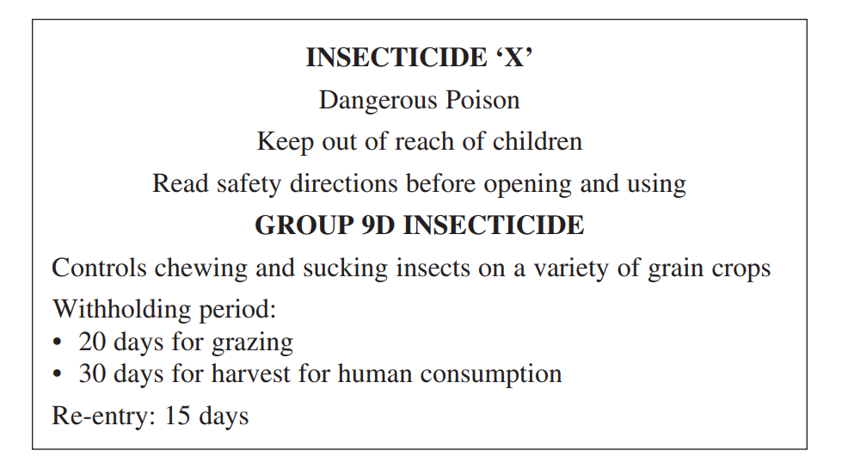

What would be the earliest date that the farmer could safely inspect the crop?
A. 11 June 2019
B. 14 June 2019
C. 18 June 2019
D. 29 June 201

8. The table shows steps for calibrating chemical application equipment. The steps are not in order.

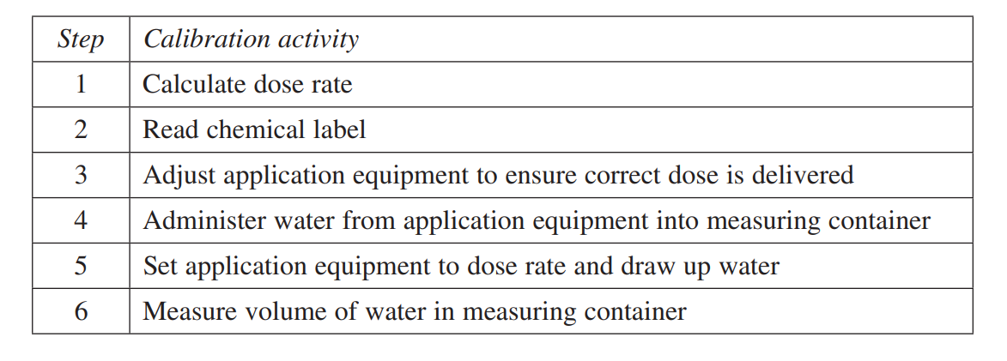
What is the correct order for these steps?
A. 2, 1, 5, 6, 4, 3
B. 2, 1, 3, 5, 4, 6
C. 2, 1, 5, 4, 6, 3
D. 1, 2, 3, 5, 4, 6

9. A chemical is being used for the first time at your workplace. It has been spilt on your
work colleague. They do not appear to be in distress or badly injured.
What should your first action be?
(A) Call for an ambulance
(B) Check with your supervisor
(C) Use current first aid principles
(D) Review the MSDS for appropriate treatment

10. How would you determine the chemical output for a hand operated spray unit?
(A) Read the label for that chemical
(B) Carry out a pre-operation calibration check
(C) Read the operator’s instructions for the spray unit
(D) Mix the chemical and water in the correct proportions

11. The chemical label shown is on a bottle of herbicide.
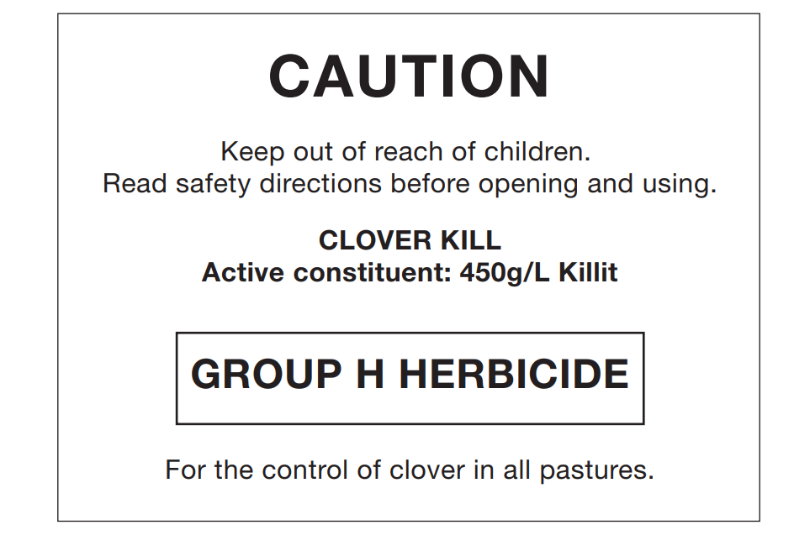
What type of herbicide is CLOVER KILL?
(A) Selective
(B) Glyphosate
(C) Non-selective
(D) Broad spectrum

12. A farmer is spraying a 300 hectare paddock. The spray unit holds 500 litres. The
application rate is 10 litres per hectare.
How many tankfuls will be used to completely spray the paddock?
(A) 3
(B) 5
(C) 6
(D) 10

13. An insecticide is only supplied in 1 litre bottles. The mixing rate is 12 litres per 100 litres.
The application rate of the mixture is 30 litres per hectare.
How many bottles of insecticide must be purchased to spray half a hectare?
(A) 1
(B) 2
(C) 3
(D) 4

14. The chemical concentrate of a herbicide needs to be mixed at a rate of 200 mL per 100 L of water.
How many litres of the chemical concentrate are required to spray a five­hectare block if
the herbicide is applied at a spray volume of 200 L per hectare?
(A) 2 L
(B) 5 L
(C) 20 L
(D) 50 L

15. Chemicals are absorbed through the skin at different rates for different parts of the body.
In which of the following are the body parts listed from highest to lowest rates of
absorption?
(A) Forehead, upper foot, abdomen, forearm
(B) Abdomen, forehead, forearm, upper foot
(C) Forehead, abdomen, upper foot, forearm
(D) Abdomen, forearm, forehead, upper foot

Questions from Section II
These questions should be answered in the space provided as it gives a guide to the length of your response. Plan out your answer and key points before you commence writing.

Question 1 (9 marks)
(a) Explain why pre-operative processes are necessary when using chemical
application equipment. 3

...............................................................................................................................
...............................................................................................................................
...............................................................................................................................
...............................................................................................................................
...............................................................................................................................
...............................................................................................................................
(b) Explain why post-operative processes are necessary when using chemical
application equipment. 3

...............................................................................................................................
...............................................................................................................................
...............................................................................................................................
...............................................................................................................................
...............................................................................................................................
...............................................................................................................................
(c) Justify the need for keeping accurate chemical records. 3
...............................................................................................................................
...............................................................................................................................
...............................................................................................................................
...............................................................................................................................
...............................................................................................................................
...............................................................................................................................
- A worker has been asked to spray the following paddocks with Herbicide X to
eradicate weeds.
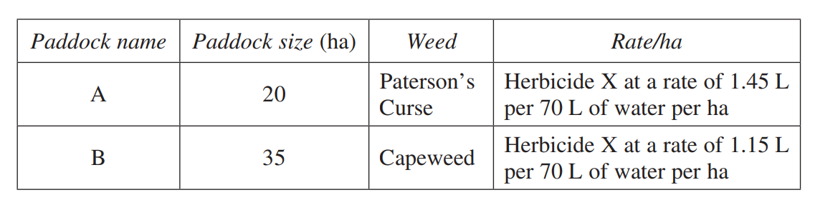
(a) Calculate the total amount of Herbicide X required to spray the two paddocks. 1

...............................................................................................................................
...............................................................................................................................
(b) What percentage of a full 150-litre drum of Herbicide X would be required to
treat the two paddocks? 2

...............................................................................................................................
...............................................................................................................................
...............................................................................................................................
...............................................................................................................................

(c) Explain why it is important to prepare chemicals according to the manufacturer’s
label. 4
...............................................................................................................................
...............................................................................................................................
...............................................................................................................................
...............................................................................................................................
...............................................................................................................................

- You are required to spray a 1000 m2 block of turf using a selective herbicide. It is to be applied at a rate of 100 mL in 15 L water per 150 m2. The spray pack holds 15 litres.
- How much herbicide will be required for this task (to the nearest whole mL)? 2
- Why would you use a selective herbicide on the turf? 2 ............................................................................................................................... ............................................................................................................................... ............................................................................................................................... ...............................................................................................................................
- Outline the steps that should be followed to dispose of any surplus mixture and to clean the spray pack. 4 ............................................................................................................................... ............................................................................................................................... ............................................................................................................................... ............................................................................................................................... ............................................................................................................................... ............................................................................................................................... ............................................................................................................................... ...............................................................................................................................

4.
(a) What is the meaning of the term integrated pest management (IPM)? ............................................................................................................................... ............................................................................................................................... 1

(b) Outline THREE valid strategies that could be used in an integrated pest management program in a primary industries enterprise. 3 ............................................................................................................................... ............................................................................................................................... ............................................................................................................................... ............................................................................................................................... ............................................................................................................................... ...............................................................................................................................

5.
A primary industries worker has been asked to apply two different sprays on the one day using an open cabin tractor.
(a) In the morning, the worker will be spraying a crop with a chemical that has a
signal heading POISON (S6 chemical).
Complete the following table listing TWO pieces of PPE appropriate for the task
and give ONE reason for selecting each piece of equipment. 2

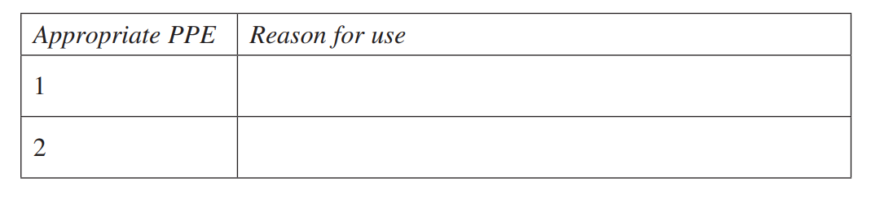
(b) In the afternoon, the worker will be applying a non-selective herbicide near a
neighbouring property, a wildlife habitat and a waterway.
Complete the following table listing TWO potential impacts of the non-selective
herbicide on this environment and provide valid strategies to reduce the impact. 6

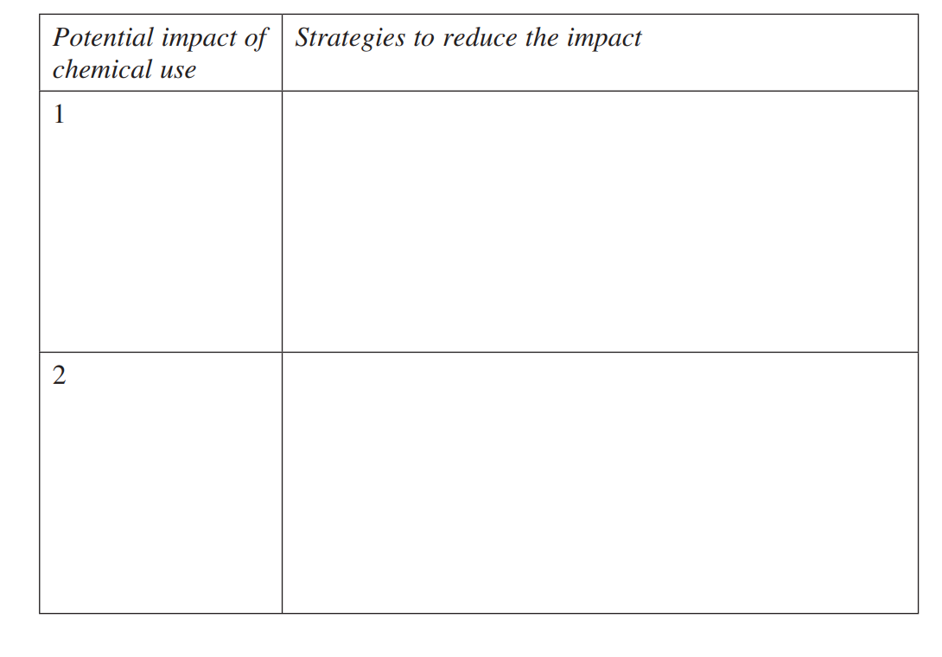

Questions from Section III
There will be one extended response question in Section III. This will provide you with the opportunity to
- demonstrate knowledge and understanding relevant to the question
- communicate ideas and information using relevant workplace examples and industry terminology
- present a logical and cohesive response
The expected length of response for questions in Section III and IV is around four pages of an examination writing booklet (approximately 600 words). You should allow about 25 minutes for a question in Section III in the exam.

You will note that these questions usually require you to bring together knowledge from several areas of study/competencies to do justice to the answer.
In each of the following, map out your answer using post-it notes or a sheet of paper. Pay particular attention to incorporating a variety of aspects of your Primary Industries curriculum into the plan.

- Explain how the use of an Integrated Pest Management (IPM) program maximises production and ensures environmental sustainability. 15

- Explain how chemical labels and material safety data sheets (MSDS) assist in identifying hazards and risks when developing safe work practices. 15

E HSC Focus Area

Scope of learning for the HSC
For the purposes of the HSC, all students undertaking the 240 HSC indicative hours course must address all of the content included in the scope of learning for the focus area.

The scope of learning describes the breadth and depth of the HSC Content and has been grouped together into key ideas/areas. The scope of learning describes the minimum content that must be addressed, and the underpinning knowledge drawn from the associated unit(s) of competency.

The scope of learning for the HSC should be addressed in the context of at least two relevant types of chemicals used in primary industries.

types
- types of chemical formulations used in primary industries:
dry
liquid
- a range of types of chemicals commonly used in a primary industries workplace and their mode of action

equipment
- a range of chemical application equipment:
name and general features
purpose and limitations
considerations for selection:
task/job requirements
environmental factors
working knowledge:
pre-operational safety checks
prepare for use
safe work practices for operation
measures to minimise environmental impact
correct chemical output
fault identification:
signs of poor performance and inefficiency
common faults:
- malfunctions
- worn, broken or missing components
solutions to a range of common faults
maintenance:
operation and performance monitoring
cleaning and decontamination
scheduled servicing
operational records
storage

work health and safety
- risk management in relation to the use of chemicals
- personal protective equipment (PPE) used when handling chemicals:
selection:
correct for task/job requirements

work health and safety cont/d
importance of correct fit
use
application
cleaning and maintenance
storage
- minimising risk of poisoning to workers using chemicals:
path of entry:
inhalation
absorption
ingestion
injection
limiting exposure
first aid
- potential hazardous effects associated with the use of chemicals for humans, off-target organisms (animals and plants) and the environment

chemical compliance
- the handling and use of chemicals in a primary industries environment:
the purpose and intent of related legislative requirements
in accordance with workplace policy and procedures and manufacturer’s instructions
with consideration of safe work practices and the environment
- licensing requirements for chemical use

working with chemicals
- use and interpret chemical labels and Safety Data Sheets (SDS):
the information provided
the meaning of symbols
- methods and techniques for measuring and calculating chemical use:
importance of accuracy
units of measurement
measuring equipment used when handling chemicals
the calculations performed:
addition
subtraction
- division
- multiplication
percentages
ratios
volume

working with chemicals cont/d
an understanding of:
calibration
decimal points
estimations
‘rounding off’
mixing chemicals
- procedures for loading chemicals into application equipment
- safe and effective chemical application in a primary industries workplace:
assessing and recording meteorological conditions and forecasts
following an application plan
re-entry and withholding periods
- workplace procedures in the event of a chemical spill
- clean-up procedures related to working with chemicals:
requirements for disposal:
excess chemical
waste
containers
triple rinse
- purpose and importance of recording and reporting chemical use:
inventory
pre-treatment notification
application details
- storage of chemicals
- techniques and requirements when handling and transporting chemicals

integrated pest/resistance management
- an understanding of integrated pest/resistance management
- strategies for integrated pest/resistance management
- alternatives to chemicals for pest/resistance management

