Information and Digital Technology
Mandatory Focus Area: Operating System Software
Welcome: This module will assist you to review and revise the content of the mandatory focus area: Operating System Software. Each focus area prescribes the scope of learning for the HSC and is drawn from associated units of competency.
You will have studied ICTICT302 Install and optimise operating system software which addresses the scope of learning at the end of this package.

This module is broken up into:
- Important Notes
- Key terms and concepts
- Activities
- Putting the theory into practice
- HSC Focus areas

How to use the resource
Work through the notes and the suggested activities. Great revision techniques include working through how a problem is solved, explaining the concept, testing yourself and retrieving information from your memory. Spread your revision over a number of sessions rather than sitting at one subject for lengthy periods.
Constructing a mind map might be a great way to ensure you have covered all the concepts in the Mandatory Focus Area (see Part E).
Discuss your responses with your teacher, fellow students or an interested family member.
All images, apart from those acknowledged, are © NSW Department of Education.

Important notes
The outcomes of this mandatory focus area require that the student:
- explains the purpose and functions of an operating system
- demonstrates an understanding of the processes and procedures for installing, configuring, optimizing and testing an operating system.

You should use the information here as a prompt and guide when revising your study notes or text-book information or other resources provided by your teacher. You can also access industry specific information

Basic functions of an operating system

Definition
An operating system is a group of computer programs that coordinates all the activities among computer hardware devices. It is the first program loaded into the computer by a boot program and remains in memory at all times.

Functions of an operating system
The basic functions of an operating system are:
- Booting the computer
- Performs basic computer tasks eg managing the various peripheral devices eg mouse, keyboard
- Provides a user interface, eg command line, graphical user interface (GUI)
- Handles system resources such as computer's memory and sharing of the central processing unit (CPU) time by various applications or peripheral devices
- Provides file management which refers to the way that the operating system manipulates, stores, retrieves and saves data.

Booting the computer
The process of starting or restarting the computer is known as booting. A cold boot is when you turn on a computer that has been turned off completely. A warm boot is the process of using the operating system to restart the computer.
- Warm boot - also known as a 'soft boot'. It occurs when the machine is rebooted using the Ctrl + Alt + Del keys or when you need to start the computer immediately, such as when the computer freezes or when something isn’t working properly.
- Cold boot - when the computer has been switched off for a lengthy time, usually overnight.
The difference between the two is that, in a warm boot, not all parts of the system are checked for correct operation.
When you start a computer, it has to carry out a number of tests to ensure all components of the system are functioning correctly. This process is called booting, or booting up, the computer. No matter how good the computer system, if it can't complete the boot process, it's useless.
When you turn on the computer, nothing much seems to happen for a few seconds. In fact, your computer is performing a set of operations that will check that all the components are working correctly. This operation is called the Power On Self Test or POST. It is the first part of the boot process.
As the POST is doing its job, you will see and hear indications that something is happening. For example, you might see the keyboard lights flash on for a second, you might hear floppy disk drive activity, you may see activity on the monitor, or there might be printer activity. This is because all the system components are being tested, including the CPU, the RAM, and all other components.
If there are any errors or faults found during the POST, you might see error messages on the computer display and hear beeps coming from the PC’s internal speaker. The beeps are codes that can tell you what the problem is.
If no problems are encountered during the POST, then the Operating System is loaded into memory and the boot process can continue until all systems are operating correctly.

The boot up sequence
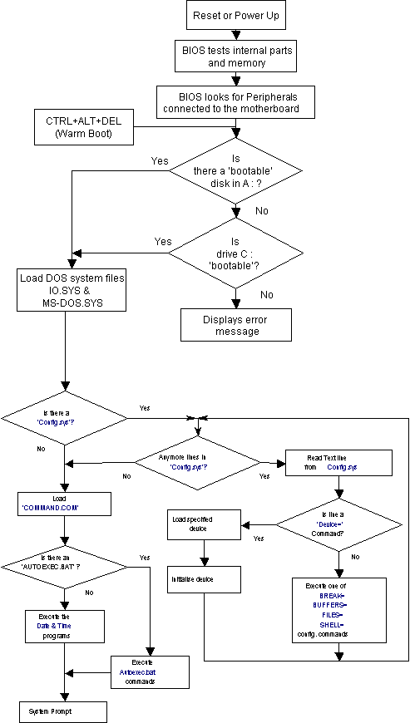

Performs basic computer tasks
The operating system performs basic computer tasks, such as managing the various peripheral devices such as the mouse, keyboard and printers. For example, most operating systems now are plug and play which means a device such as a printer will automatically be detected and configured without any user intervention.

Provides a user interface
A user interacts with software through the user interface. The two main types of user interfaces are: command line and a graphical user interface (GUI). With a command line interface, the user interacts with the operating system by typing commands to perform specific tasks. An example of a command line interface is DOS (disk operating system). With a graphical user interface, the user interacts with the operating system by using a mouse to access windows, icons, and menus. An example of a graphical user interface is Windows 10 or Mac OS.
The operating system is responsible for providing a consistent application program interface (API) which is important as it allows a software developer to write an application on one computer and know that it will run on another computer of the same type even if the amount of memory or amount of storage is different on the two machines.

Handles system resources
The operating system also handles system resources such as the computer's memory and sharing of the central processing unit (CPU) time by various applications or peripheral devices. Programs and input methods are constantly competing for the attention of the CPU and demand memory, storage and input/output bandwidth. The operating system ensures that each application gets the necessary resources it needs in order to maximise the functionality of the overall system.

Provides file management
The operating system also handles the organisation and tracking of files and directories (folders) saved or retrieved from a computer disk. The file management system allows the user to perform such tasks as creating files and directories, renaming files, coping and moving files, and deleting files. The operating system keeps track of where files are located on the hard drive through the type of file system. The type two main types of file system are File Allocation table (FAT) or New Technology File system (NTFS).

Types of file systems
- File Allocation table (FAT)
- New Technology file system (NTFS)
File Allocation table (FAT) uses the file allocation table which records, which clusters are used and unused and where files are located within the clusters.
NTFS is a file system introduced by Microsoft and it has a number of advantages over the previous file system, named FAT32 (File Allocation Table).
One major advantage of NTFS is that it includes features to improve reliability. For example, the new technology file system includes fault tolerance, which automatically repairs hard drive errors without displaying error messages. It also keeps detailed transaction logs, which tracks hard drive errors. This can help prevent hard disk failures and makes it possible to recover files if the hard drive does fail.
NTFS also allows permissions (such as read, write, and execute) to be set for individual directories and files.

Batch systems, real-time systems and multitasking system

Batch systems
Batch systems were introduced to reduce the computer's CPU idle waiting time for the operator to ask it to do something or waiting for other tasks to finish. To overcome this, the jobs that the computer was being asked to do were submitted in batches. An example of a batch system is when a computer system processes telephone bills to a number of customers and then sends them out all at once rather than individually.

Real time systems
A real time system (RTOS) is a computer operating system used to control machinery, scientific instruments and industrial systems. A real time system is designed to handle events as they occur. An example is an air traffic controller system where the radar shows the exact position of planes which is necessary otherwise the planes could crash into each other.

Multi-tasking system
A multi-tasking system is capable of executing multiple processes or tasks, at the same time. Multi-tasking systems use the time slicing approach to carry out their activities, where each of the processes are given a share of CPU time eg the new iPhone operating system allows the user to run several applications (apps) at the same time.

Optimise operating system software
When you optimise your computer, you are getting the computer to perform at its best. Over time your computer gradually slows down as you add more information. When you add new programs, it will add items to your system. Even if you uninstall programs, not everything is removed from the system. Windows users can do the following to speed up their computers:
- delete temporary files
- clear the history lists
- clean up temporary internet files
- defrag and scandisk the system
If your computer is still running slowly then it may be time to clean up your hard drive, upgrade your memory or buy a new computer.
You can monitor and optimise your Operating System using the following Windows utilities:
- Task Manager utilities
- System Monitor
- System Tools
- Performance Logs and Alerts
- Virtual Memory
- Event Viewer
- Task Scheduler.

Monitoring applications with task manager
The Task Manager utility provides information about the computer's performance and displays details about program and processes running. A process is an executable program such as Windows Explorer.
You can use the Task Manager to monitor:
- Applications
- Processes
- Performance

Applications
Some software applications put a huge demand on the operating system, eg video editing software uses huge amounts of memory. You can see if a particular program is using excessive CPU resources by accessing the Task Manager and clicking on the Application tab and viewing the CPU usage. In addition, the Application tab shows the status of the programs running on your computer. On this tab, you can end, switch to, or start a program.

Processes
The Processes tab in Task Manager shows the information about processes running on your computer. You can display information on CPU and memory usage, page faults, handle count and a number of other parameters.

Performance
The Performance tab displays a dynamic overview of your computer's performance, including:
- Graphs for CPU and memory usage
- Totals for the number of handles, threads and processes running on your computer.
- Total in kilobytes for physical, kernel and commit memory

System monitor
Is a Windows utility used to collect and display information about the computer's current configuration. It is one of the most important tools to help and detect and fix problems. It is like a window into the inner workings of just about every aspect of your operating system such as hard disks, memory, the processor, disk caching, active processes and the page file. With the system monitor utility, users can monitor the processor, disks, memory and network usage. This information can help users identify any problem with resources. For example, if your computer is running slowly, the system monitor can determine that the computer's memory is being used to its maximum. From this information, you might consider adding additional RAM, so that the computer runs faster.

System tools
Systems tools is available in Windows products to manage performance options for your computer. Processor scheduling allows you to optimise the processor time for running programs or background services. Your operating system can be tuned to change the performance of foreground or background programs. A foreground program is a program that runs in the active window and responds to commands issued by the user. A background program is a program that runs while the user is working on another task and the computer's CPU assigns fewer resources to these programs. For example, if the user selects the Background services option, this will ensure that all programs receive an equal amount of processor resources.
Using Performance options, you can also choose how to allocate system memory. Under Adjust for best performance choose either Programs or System cache. For example, if you use programs such as video editing software or multimedia programs that require large amounts of memory, then you should select the System cache option.

Performance logs and alerts
Performance logs and alerts is a Windows utility that monitors the use of operating system resources. Counter logs can be created (manually or on a defined schedule) to record data about hardware usage and the activity of system services, eg the CPU percentage being used.
Trace logs can also be created to record detailed system application events such as input/output operations or a page fault. An alert can be generated when a specific event exceeds or falls below or above a specified value. For example, when CPU usage goes over 20%, a message can be sent to the user.

Virtual memory
Virtual memory is using hard disk space to supplement Random Access Memory (RAM). For example, if you load several programs such as an email program, Internet, Word Processor and video software simultaneously there may not be enough RAM installed to hold all the programs. With virtual memory, the computer moves programs that have not been used recently to the hard disk which frees up memory to load the new programs. Moving data that is not immediately required onto a reserved area of the hard disk is known as paging or swapping.

Event viewer
The Event Viewer displays programs, security, or system events that are happening or happened on your computer system. This tool can help to diagnose problems that are occurring on your system. A message box indicates if a service fails to start during start up. In addition, the Event Viewer can be used to view and manage reports, gather information about hardware and software problems, and monitor Windows security events.
Event Viewer has three types of logs:
- Application Log, which shows information about applications programs.
- Security Logs, which can identify if any security breach has occurred.
- System Logs, which displays information about any specific system events that has happened on the computer.
You should check these logs on a regular basis to try to avoid any potential problems.

Scheduling tasks
Windows XP Professional includes a Task Scheduler utility which allows you to schedule tasks to occur at specified intervals. You can set any of your Windows programs to run automatically at a specific time and at a set interval such as daily, weekly or monthly. For example, you can schedule a program or document to run once the computer starts up.

Suse Linux
Suse Linux has similar tools to optimise operating system software such as the Linux shell environment which allows processes to run in either the foreground or background. Suse Linux utilities allow the user to prioritise the processes, view information about processes, and end a process. The KDE System Guard is the KDE desktop task manager and performance monitor. System Guard can be used to analyse processor utilisation, memory utilisation, hard disk utilisation and network utilisation. For example, if your system is running slowly then you could use System Guard to help diagnose problems.

Basic structure of a PC
A computer is an electronic device, operating under the control of instructions stored in its own memory unit that can accept data (input), process data arithmetically and logically, produce output from the processing, and save the results for future use (storage).
The most basic of all computers must have at least three parts:
- an input device – as simple as a keyboard
- a processing device – this is a microprocessor chip or a CPU
- an output device – as simple as a printer

The heart of every computer is the microprocessor chip (or integrated circuit) called the Central Processing Unit (CPU). The purpose of the microprocessor is to manipulate the data it receives by using a written set of instructions. Attached to the processor there must be at least one input device and one output device.
The input device accepts data from the operator, or the machine, using the computer and transmits it to the processing device.
The output device accepts the processed data from the processing device and presents it to the operator or machine in a usable form.

A computer has six basic functions:
- Storing whatever data is entered, so the data can be saved and used in future.
- Retrieving the stored data, this can then be used many times.
- Displaying the data you're working with on a screen or monitor, so you can see the actions that are taking place.
- Editing the data, allowing the user to change or alter data they are working on.
- Printing the data, allowing the user to obtain hard copy of the printed output.
- Sending and receiving data, allowing the user to transmit the information to another person anywhere in the world.

Hardware
The main component of any computer system is the hardware, that is, the parts of the computer that you can touch, including the:
- case (and the components inside the case)
- monitor
- keyboard
- mouse
- any other 'hard' devices attached to the system
The hardware heart of the computer is the microprocessor or CPU (Central Processing Unit). This silicon chip or integrated circuit is the part that does all the real work; this is the brains of the system.
Another very important hardware component is Random Access Memory (RAM). This is temporary storage space for the software currently being used and the data you are currently working with.
The six functions of the information processing cycle require specialised hardware devices:
- input devices
- output devices
- storage devices
- communication devices

Common input devices
The most common input device for a computer is the keyboard. Some other input devices include: the mouse, scanners, digital cameras and microphones.

Common output devices
The most common output devices for PCs are monitors, printers, web cams and speakers.
In addition to input, processing, and output devices, most computers have several other important parts. One of the most important devices are storage devices - these hold data on a permanent basis.

Common storage devices
The most common storage devices are USB sticks, removable hard disk drives, floppy disks, CDs and DVDs.
Other storage devices include magnetic tape drives, zip drives, magneto optical devices, juke boxes and RAID arrays.

Common communication devices
Communication devices also help to share data with other computer systems, allowing connection to the internet and sharing of data across networks. The most common communication devices are wireless (such as Bluetooth and Wi-Fi interfaces), modems and satellites.

Software
Software is the term used to refer to the programs which the computer needs to process data. A computer program is nothing more than a set of instructions that tell the computer what to do and how to do it.
The hardware is built to perform many different tasks; the software tells the hardware how to do each different task.

Features of the motherboard
Every PC has basically the same hardware. The differences in the size and power of microprocessors and memory capacity are the main factors that make one PC more expensive than another.

The motherboard
When you open the case of a computer, the large rectangular circuit board which you can see is the 'motherboard' (sometimes called the 'system board' or 'main board'). The motherboard forms the foundation of the computer system.
The motherboard, or main-circuit board, is the largest board located in the bottom or at the side (in a tower case) of the system case. All the hardware is connected to the motherboard in some way and is able to communicate with the CPU (Central Processing Unit). Bus lines, expansion slots and I/O ports allow the CPU to be connected to a variety of hardware, expanding the capabilities of a computer system.
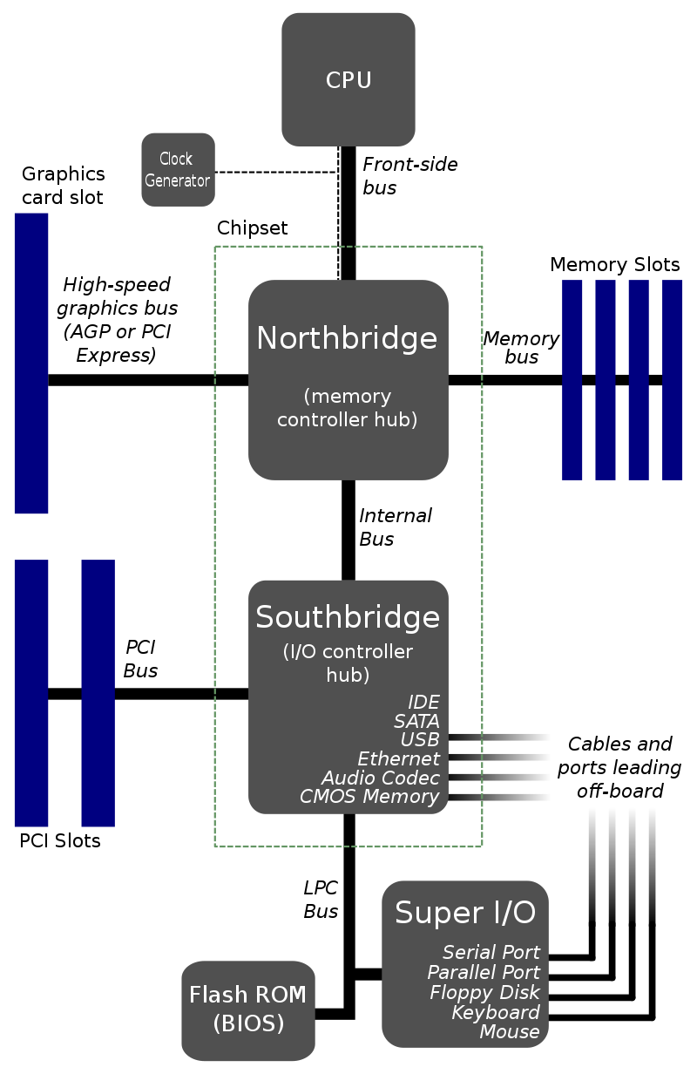
By Original: Gribeco at French WikipediaDerivative work: Moxfyre at English Wikipedia - This file was derived from: Diagramme carte mère.png, CC BY-SA 3.0, https://commons.wikimedia.org/w/index.php?curid=3789066

Identifying common parts of the motherboard
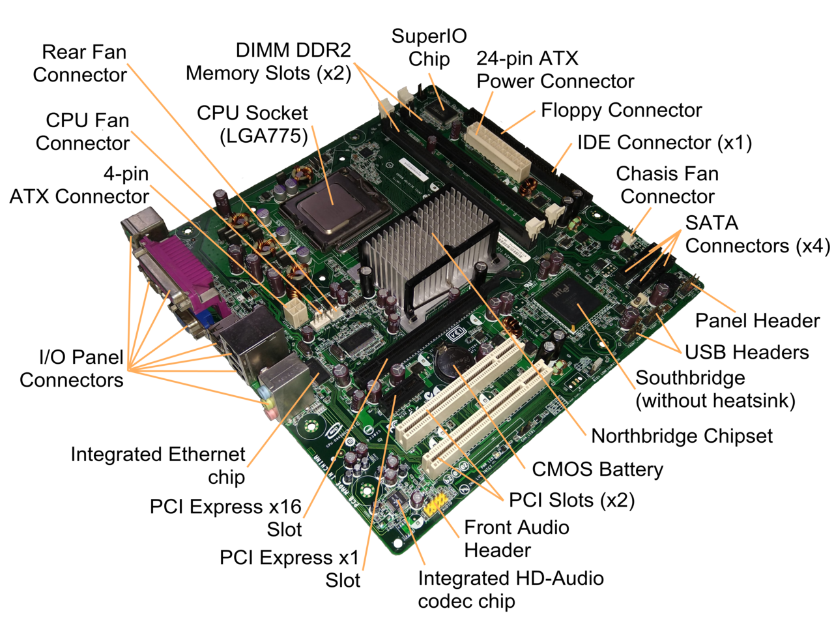
By JulianVilla26 - Own work, CC BY-SA 4.0, https://commons.wikimedia.org/w/index.php?curid=8422571

The CPU
The Central Processing Unit, or CPU, is the brains of the computer and is responsible for controlling the flow of data throughout the computer and for executing program instructions.
The microprocessor, or CPU, is a computer chip which plugs into a special socket on the motherboard and can be removed or replaced easily.
There are several manufacturers of microprocessor chips, the major two being INTEL and AMD. In general, most motherboards can accept chips from either manufacturer; however, some boards are designed specifically for one type of chip only.
The operating speed of the CPU is one of the most critical factors in the computer's processing power.

The Speed of a CPU
All microprocessors are not created equal. They vary in the speed at which they carry out their tasks and the volume of tasks they can do.
The speed of the CPU is controlled by the electronic clock that is connected to it on the motherboard. This clock generates electrical 'ticks' millions of times every second. The number of ticks is called the clock speed of the computer.
Because one tick is actually an electrical cycle, clock speeds are measured in millions of cycles per second—megahertz (MHZ), or 1 thousand million cycles per second—gigahertz (GHZ). The faster the clock speed, the faster the computer can process data.

Memory
Memory is a critical component of all computer systems and comes in the form of blocks of integrated circuit chips. Although there are two types of memory in all computers (RAM and ROM), the term 'memory' is used to indicate the amount of temporary storage (RAM) that the computer has installed. More RAM can be easily added to the system to increase its temporary storage capacity, and consequently, its processing power.
- RAM (Random Access Memory)
- ROM (Read Only Memory)
NOTE: There is also a third type of memory known as 'Read/Write memory'. This is the type of memory used to store and retrieve data.

RAM
Random Access Memory (RAM) is the CPU's memory or workspace. Software you want to work with is loaded from the hard disk drive into RAM. RAM is short term memory. When the power is turned off, any data in RAM is lost. Because of this loss of data, RAM is said to be 'volatile' memory.
RAM is measured in terms of how many characters it can contain. The technical term for this character is a byte.
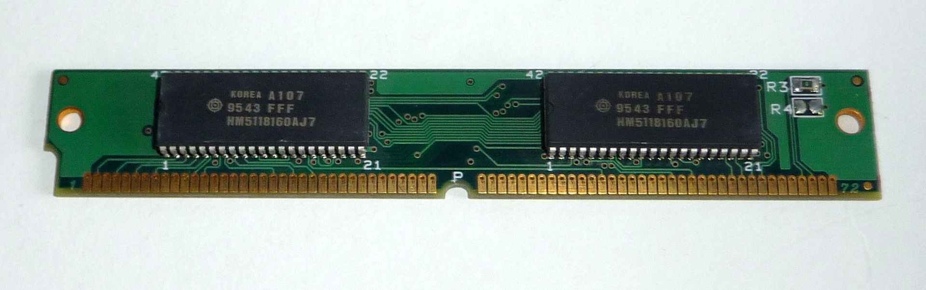
By Pavel Ševela, CC BY-SA 3.0, https://commons.wikimedia.org/w/index.php?curid=18309858
The amount of RAM installed in a computer is usually stated in megabytes for older computers that had limited amounts of memory or in gigabytes for more modern computers.
The amount of RAM in the computer affects the size and number of programs that it can execute. Additional RAM can be added into a computer by directly inserting additional memory chips, or by installing a circuit board containing additional memory chips. On most new PCs, 512 MB of RAM should be sufficient, and 1 GB is the best for graphics/video editing. The most common type is DDR RAM, while RD (Rambus) memory is gaining popularity.

ROM
Read Only Memory (ROM) is a form of memory which could be said to be 'locked'. With ROM, data or programs are written to the component at the time of manufacture, and are retained permanently, even if the power to the computer is turned off. For this reason, ROM is called non-volatile memory.
The BIOS (Basic Input and Output System) chips on the motherboard are an example of ROM.
At start up, the system memory is empty. The computer needs instructions from the BIOS chip to tell it what processes need to be initiated to make the computer operate.

Bus
A bus is a pathway of wires and connectors which provides the link between the input, output, processing and storage and control devices. That is, the bus allows the CPU to transport data to and from memory, receive input from external devices, and send output to external devices. In addition to the data, a bus also carries the addresses of the source and destination of the data.
On the motherboard, they are fine, metallic strips etched on to the board. At the place at which they leave the motherboard, they are replaced by a ribbon, or cable, of fine wires in order to connect to other devices, such as a disk drive.

Expansion slots and cards
When PC users need to increase their computer's functionality, they can add new features to the processing hardware through expansion slots on the motherboard. Expansion slots are designed to link the processor and existing memory to circuit boards or expansion cards, which support new computing options. Expansion cards are available for increasing memory, adding 3D graphics, connecting to a fax machine, providing multimedia capabilities like sound and video I/O and installing cache memory. Personal computers will have from three to eight expansion slots on the motherboard. Installation of new expansion cards is quite easy. For example, users wishing to add 3D graphics need only purchase a 3D graphics adaptor board and slip it into an expansion slot. New expansion boards are often accompanied by a disk containing a related device driver. The driver must be installed on the system disk. The new graphics capabilities become immediately available after rebooting the computer, although related software packages sometimes need to be installed again.

Cache memory
Cache memory is information from recently accessed data that is stored so other computers which need the same data can access it immediately. For example, proxy servers cache recent downloads from the internet. When you want to access this information at a later time the same downloads come instantly from the proxy server, rather than having to be slowly downloaded again from the original site.

External connectors

I/O ports
To accommodate different types of input and output hardware, a computer has several places where the input/output, as well as storage-hardware is connected to the processing unit. These places, connected to the motherboard, are called I/O (Input/Output) ports.
Three types of I/O ports are available: serial, parallel and USB. Serial ports have been around for decades. Parallel ports are a more recent invention and are much faster than serial ports. USB ports are only a few years old and will likely replace both serial and parallel ports completely over the next several years.

Serial and parallel ports
Considered to be one of the most basic external connections to a computer, the serial port has been an integral part of most computers for more than 20 years. Although many of the newer systems have done away with the serial port completely in favour of USB connections, most modems still use the serial port, as do some printers, PDAs and digital cameras. Few computers have more than two serial ports.
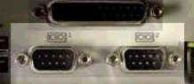
Data is sent between the computer and the attached hardware one bit at a time with a serial port. When a parallel port is used, the entire bit pattern for a single character is sent at the same time.
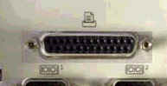
The advantage to using a parallel port is that it is faster than a serial port, as it sends several bits simultaneously. However, the I/O and storage hardware must be physically close to the computer. While serial ports do not provide as high a transmission speed, the peripherals can be further away. Serial ports are used to help send data over telephone and other communication lines.
While USB is becoming increasingly popular, the parallel port is still in use to connect a range of peripherals.
When a PC sends data to a printer or other device using a parallel port, it sends eight bits of data (one byte) at a time. These eight bits are transmitted parallel to (beside) each other, as opposed to the same eight bits being transmitted serially (all in a single row) through a serial port.

USB ports
All computers today come with one or more Universal Serial Bus connectors. These USB connectors let you attach everything from mice to printers to your computer quickly and easily. Connecting a USB device to a computer is simple; find the USB port on your machine and plug the USB connector into it.
The Universal Serial Bus allows you to connect up to 127 devices to a computer. Each device can consume up to a maximum of 6 megabits per second of bandwidth.
Just about every peripheral made now comes in a USB version. These include printers, scanners, mice, joysticks, flight yokes, digital cameras, webcams, scientific data acquisition devices, modems, speakers, telephones, video phones, storage devices and network connections.
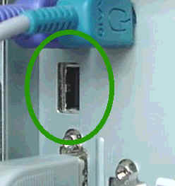
If it is a new device, the operating system auto-detects it and asks for the driver disk. If the device has already been installed, the computer activates it and starts talking to it. USB devices can be connected and disconnected at any time.
Many USB devices come with their own built-in cable, and the cable has an "A" connection on it. If not, then the device has a socket on it that accepts a USB "B" connector.
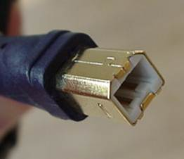
The USB standard uses ‘A’ and ‘B’ connectors to avoid confusion. ‘A’ connectors head ‘upstream’ toward the computer, while ‘B’ connectors head ‘downstream’ and connect to individual devices.
Most computers that you buy today come with one or two USB sockets. With so many USB devices on the market today, you easily run out of sockets very quickly. The easy solution to the problem is to buy an inexpensive USB hub which can support up to 127 devices.
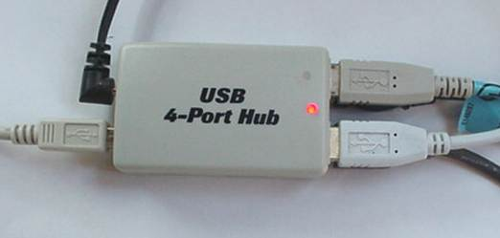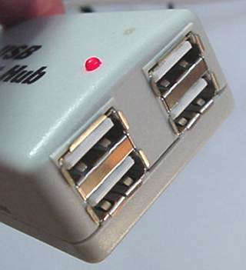
A hub typically has 4 new ports but may have many more. You plug the hub into your computer, and then plug your devices (or other hubs) into the hub. By chaining hubs together, you can build up the number of available USB ports on a single computer.

Key terms and concepts
This unit defines the competency required to install operating system software and to make adjustments as a means of optimising the system to accommodate business and client needs. Make sure you have a good grasp of the following terms and concepts.
Key term or concept | and definition
Active listening | A way of listening and responding to another person using both verbal and nonverbal feedback, eg paraphrasing, questioning and gestures such as nodding.
Adjustment recommendations | Recommending changes to the system.
Application software | Programs designed to assist the user with particular tasks, eg MS Office for word processing, spreadsheets, etc.
Batch system | A type of operating system that processes a number of jobs together, eg phone bills sent out all together.
Client evaluation/feedback | Clients appraisal and comments of the operating system in terms of usability of the system.
Client/user | The customer or end user of the computer system.
Commit memory | Memory being currently accessed.
Cross platform | Is a program that runs the same on multiple operating systems (compatibility), eg a Microsoft Word document created on a Macintosh computer can be viewed and modified on a Windows computer.
CPU | The central processing unit is the component in a computer that interprets instructions and processes data contained in computer programs.
Customise desktop and viewing options | Arranging the desktop interface to suit the needs of the user.
Default settings | The original settings of the computer system.
Diagnostic tools | Tools to help the user determine if a computer system is working correctly.
Evaluation and selection of operating systems | The method by which an operating system is chosen to run a computer system.
FAT | The file allocation table is the part of the hard disk where information is stored about the location of each piece of information on the disk and the location of unusable areas of the disk.
Features and functions of operating systems | The tasks that an operating system perform, eg starting the computer and managing memory.
Feedback mechanism | A method for determining information about the result of an event eg feedback on new operating system from the user.
File system | Organises the file system on hard disks, eg FAT or NTFS.
GUI | The graphical user interface is a user interface that uses windows, icons, and menus.
Handles | A value that uniquely identifies a resource such as a file so that a program can access it.
Hardware | Computer hardware refers to the physical parts of a computer and related devices, eg monitor, mouse, motherboard.
Implementation plan | A detailed plan on how a new system will be installed, setup, and changed over from the old system. It includes the tasks involved, time frame, resources needed and cost.
Install and configure application software | Installing software then arranging it to meet the needs of an organisation or user. Eg Installing Windows Vista and then putting shortcut icons on the desktop that the user would frequently access.
Install, configure and optimise operating system | Installing the operating system and then configuring the system to suit the needs of the organisation or user (eg user accounts). Optimising the operating system means using different system tools which can improve an operating system's performance. Eg installing service packs to fix problems, using the disk defragmenter tool to reorganise files and unused space on the hard drive.
Installation options | Options available when installing software, eg full, typical, portable, custom.
Interoperability | The ability of a system to work with other systems.
Kernel | Manages the basic operations of the operating system and the computer's processor.
Licenses | Is the legal right to use the software
Managing new technology | The methods by which users are coping with the new systems put in place, eg user training.
Memory management | Operating system activity that manages memory requirements of the computer by making best use of RAM.
Minimum and recommended system requirements | The bare minimum specifications that are required for a system to run and the suggested requirements.
Multi-tasking system | Capable of executing multiple processes or tasks, simultaneously. Eg new iPhone operating system allows the user to run more than one app at the same time.
NTFS | New technology file system - provides security, reliability and advanced functions such as encrypting a file that was not available in FAT (file allocation table).
One-to-one instruction | Providing individual instruction.
Open source software | Is software provided for use, modification and redistribution and can be downloaded from the internet at no cost. This software has no restrictions from the copyright holder regarding modification of the software's internal instructions and redistribution of the software.
Operating system software | Manages the overall operation of various computer tasks such as monitoring the computer's status, handling executable programs, interruptions and scheduling of operations.
Operating system vendors | Are the suppliers of operating systems.
Operating systems | A group of computer programs that coordinates all the activities among computer hardware devices, eg Windows Vista, Windows 7 and Linux.
Process scheduling | Allows you to make the best use of the processor time for running program or background services.
Purpose of the operating system | The functions or tasks that an operating system performs, eg starts the computer.
Questioning technique | A method of asking questions in order to gather the required information. Eg open, closed or reflective.
RAM | Random access memory is the temporary memory used for the storage of programs and data.
Real time system | Is a system that guarantees to receive, analyse and produce output in an agreed time frame.
Sources of information | Product information on computers, eg magazines, internet, manufacturer's and vendors.
System functionality | How the current computer system operates.
System security | Protection of the operating system including user accounts, passwords and firewalls etc.
Technical specifications | Specifies the manufacturers technical specifications for their products, eg features included in a software application.
Thread | Allows the programs to run many actions sequentially or all at once.
Virtual memory | A portion of a storage medium allocated to function as additional RAM by the operating system.
Workplace documentation | Documentation available in the workplace on the operation and use of various systems, eg the operating system.

Activities

Activity 1: Questions
- Define operating system and name two different operating systems?
- What is the purpose of an operating system?
- Describe two functions of the operating system?
- Describe how an operating system may be optimised?
- What are the features of each of the following?
  - batch system
  - real-time system
  - multi-tasking system
- What is virtual memory and when would you use it?
- What is the difference between minimum and recommended system requirements for the installation of vendor products?
- What are the differences between single-user, network and site licences?
- What is the difference between operating system software and application software?
- What are the benefits and limitations of the following operating systems?
  - single-user/single task
  - multi-user/multitasking
  - network
- What are some of the features of an open source operating system? Eg Linux
- What is meant by technical specifications?

- Define the following power management settings
- hibernate
- sleep timers
- standby
- suspend
- wake-on-LAN (local area network)
- Outline the steps involved in installing an operating system.
- Describe file management functions that need to be implemented to ensure that a confidential document can only be accessed by authorised users and that the document is up to date.
- A company carries out a full backup on Tuesday and Friday nights and a differential backup on Monday, Wednesday, Thursday, Saturday and Sunday nights. On Monday morning, the file server failed and caused all files to be destroyed. Explain which backups need to be restored and in what order.
- Access to a document needs to be restricted to a small group of users. Explain how this could be achieved.

- Explain the difference between a full installation, typical installation, and a custom installation.
- Explain each of the following installation methods:
  - boot media
  - factory recovery partition
  - install from image
  - network installation
  - recovery disk
- A company’s operating system needs to be upgraded. How will you identify when the best time to do this will be? Explain when you think the best time to upgrade the computers will be and why?

Activity 2: Multiple choice
These questions are acknowledged as from past HSC examinations and © 2019 NSW Education Standards Authority (NESA) for and on behalf of the Crown in right of the State of New South Wales.
- Which of the following is an example of an open source operating system?
  - Windows
  - Mac OS X
  - Unix
  - Linux

- Which is an example of virtual memory?
  - allocating a section of RAM only for the operating system
  - using disk space to supplement RAM
  - using memory exclusively for network connectivity
  - giving applications running on the server priority to RAM access

- Which of the following are steps that you can take to tune performance?
  - processor scheduling
  - memory usage
  - virtual memory
  - all of the above

- The technique for swapping items between memory and storage is called:
  - swap file
  - paging
  - thrashing
  - all of the above

- A computer network in a business that provides data processing services for its employees is an example of:
  - a real time system
  - a multi-tasking system
  - a batch system
  - an online system

- What type of computer system performs one task at a time and updates a central database instantly?
  - a real time system
  - a multi-tasking system
  - a batch system
  - an online system

- An operating system manages:
  - computer memory requirements
  - communication between the various computer devices
  - storing and retrieving files for your computer
  - all of the above

- When an operating system spends much of its time paging, instead of executing application software this is known as:
  - formatting
  - swapping
  - spooling
  - thrashing

- What stores configuration information about the computer? Eg the amount of memory, keyboard, etc.
  - ROM
  - CMOS
  - POST
  - RAM

- What is a EULA (end-user license agreement)?
  - a single user license agreement
  - a site license
  - a network license
  - none of the above

- A computer appears to be switched off. When the mouse is moved, the monitor immediately displays the active desktop and is available for use. Which of the following power management configurations has been used?
  - Standby
  - Hibernate
  - Wake-on-LAN
  - Scheduled shutdown

- Which row of the table correctly describes the features of open source operating systems and proprietary operating systems for a single-user machine licence?
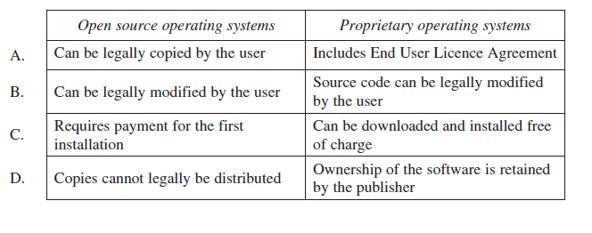
- A full system backup is done every Friday night and a differential backup every night Monday to Thursday.
All files were damaged on Wednesday from a malicious software attack.
Which nightly backup(s) should be used to restore the files?
  - Tuesday
  - Tuesday and Friday
  - Monday and Tuesday
  - Monday, Tuesday and Friday

- Which of the following should be used to determine if a service on a computer has stopped?
  - Defragment
  - Boot manager
  - Registry editor
  - System configuration

- Why would driver signature enforcement be disabled?
  - To install an unofficial driver
  - To allow a driver to be uninstalled
  - To stop automatic updates of drivers
  - To enable all drivers to load during safe-mode startup
- Which of the following is managed by a computer’s operating system?
  - BIOS
  - CPU usage
  - Power supply
  - CMOS battery

- Which of the following is the best method for safely removing a portable flash media device from a computer?
  - Pull the device out gently
  - Hibernate the computer then remove the device
  - Close any open windows then remove the device
  - Stop all related processes then remove the device

- A DVD is inserted into a computer then the computer is restarted. The computer connects to the network and retrieves a task sequence to install an operating system image.
Which installation method is described above?
  - Boot media installation with a recovery disk
  - Recovery disk installation with a network image
  - Network installation using boot media
  - Install from an image using a network boot

- Which of the following is permitted under the licence of an open-source operating system software?
  - Sell the software
  - Download the software for free
  - Change the name of the software
  - Place a copyright on the software
- The diagram represents the results of running a diagnostic utility before and after performing a process on a hard drive. 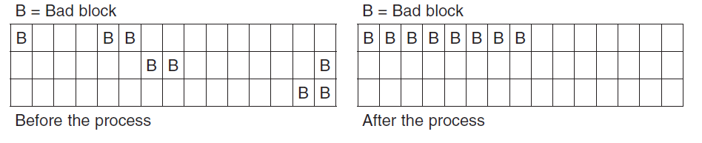
Which of the following processes has been performed on the hard drive?
  - File sharing
  - Optimisation
  - System backup
  - File compression

Activity 3: example HSC Examination questions
These questions are acknowledged © 2019 NSW Education Standards Authority (NESA) for and on behalf of the Crown in right of the State of New South Wales.

These questions should be answered in the suggested number of lines (handwritten) as it gives a guide to the length of your response.
Plan out your answer and key points before you commence.
Question 1
  - Explain how a business can be affected by malicious software. (2 marks)

  - A user reports that they cannot log on to the network. What troubleshooting steps should be taken to resolve this issue? (3 marks)

Question 2
  - What are TWO functions of an operating system? (2 marks)

  - Describe how an operating system may be optimised. (3 marks)

Putting the theory into practice

Exercise 1: Viewing virtual memory windows
This exercise will allow you to display the current paging file. The paging file is an area on the hard disk which Windows uses as if were RAM.

- Click Start-Control Panel
- Click the System icon
- Click the Advanced tab
- Under Performance options click Settings
- Click the Advanced tab
- Click Change button
- What is the current paging file size?
- Is it set at the recommended initial size?

Exercise 2: Viewing event viewer
This exercise will allow you to use the Event Viewer to view valid and invalid Log in attempts as well as events logged by Windows XP components. For example, the failure of a driver or other system component to load during start up is logged in the System log.

- Log on as administrator
- Start-Administrative Tools-Event Viewer
- Click on the Security Log
- Is there any Failed Audit? If so, why do you think the failed audit has occurred? Click on the System Log
- Are there any Errors? If so, record the Source and Event ID?
- Go to the Microsoft site and find out what the errors mean?

Exercise 3: Using task manager to view applications
You can use the Task Manager to view applications, processes and performance. In this next activity, you will be using CTRL+ALT+DEL to view the applications currently in use.

- Open a few applications
- Press CTRL+ALT+DEL
- Click the Task Manager button
- Click the Application Tab
- What applications are currently running?

Exercise 4: Using task manager to view processes
This exercise will allow you to use the Task Manager to view processes that are running. A process is an executable program such as Windows Explorer.

- Press CTRL+ALT+DEL
- Click the Task Manager button
- Click the Processes Tab
- List the first three processes and information on each.

Exercise 5: Using task manager to view performance
This exercise will allow you to use the Task Manager to view your computer's performance.

- Press CTRL+ALT+DEL
- Click the Task Manager button
- Click the Performance Tab
- Record the CPU usage.
- Record the Page File usage.
- What is the total available Physical Memory?
- What is the available Physical Memory?
- What is the Physical Memory for System Cache?
- What are the Totals for the following items?
  - Threads
  - Handles
  - Processes

Exercise 6: Using task manager to view networking
This exercise will allow you to use Task Manager to view the network adapter installed on our computer, network utilisation, speed of network card and whether it is operational or not.

- Press CTRL+ALT+DEL
- Click the Task Manager button
- Click the Performance Tab
- View the results of the Wi-Fi or Ethernet adapter

Exercise 7: Using task manager to set a process priority setting
You can use the Task Manager to view applications, processes and performance. In this next activity you will be using CTRL + ALT + DEL to view the applications currently in use. You will then configure a process priority for explore.exe to Above Normal. Configuring the process to Above Normal will assign more central processing resources to the resource.

- Open the following applications: My Computer, Notepad, Paint
- Press CTRL + ALT + DEL
- Click the Task manager button
- Click the Applications Tab
- What applications are currently running?
- Click the Processes tab
- Right click the process explorer.exe
- List the options available
- Select Set Priority
- Click Above Normal
- Record the Task Manager warning that appears
- Click No to disregard the changes

Exercise 8: Check for processor bottlenecks
In this next activity you will be using System Monitor to monitor the processor for bottlenecks. The purpose of monitoring the processor for bottlenecks is it tells you whether the current central processing unit (CPU) is adequate to handle computer tasks. If the reported processor time is consistently greater than 80% then you need to upgrade the central processing unit (CPU).

- Log on as administrator
- Start-Administrative Tools-Performance
- Ensure the Performance console is open
- Click the Add button (+)
- Using the drop down list box, Select counters from computer, select your computer
- For the Performance Object, select, Processor
- Select as the counter, % Processor Time. Leave Total as the default for instances.
- Click Add button (+)
- Monitor the system for several minutes to determine if there are any processor problems. You may wish to start several applications on your client to see if this has any effect.
- Click on the View Report icon
- Record the % Processor Time
- Once you are finished click on the Delete button to undo your changes.

Exercise 9: Creating a scheduled task
In the following activity you will create a scheduled task which will open notepad every day at a specific time that you select.

- Start-All Programs-Accessories-System Tools
- Double click Scheduled Tasks
- Double click Add Scheduled Task icon, Next
- To start a task not on the default list, click Browse
- Enter the string: c:\Windows\system32\notepad.exe in the File windows
- Click Open
- Provide a name for the scheduled task, select the option, When I logon
- Next
- Click Finish to complete the task creation
- Test your system by logging out then logging in

Exercise 10: Deleting a scheduled task
In the following activity you will delete the scheduled task you created in Exercise 9.

- Start-All Programs-Accessories-System Tools
- Double click Scheduled Tasks
- Right click on the task you created in Exercise 9
- Select Delete
- Select Yes to send the task you created to the Recycle Bin

HSC Focus Areas
For the purposes of the HSC, all students undertaking the 240 HSC indicative hours course in Information and Digital Technology must address all of the mandatory focus area content plus one stream focus area.
IDT Mandatory focus areas
- Working in the industry
- Operating system software
- Diagnostic testing
- Safety
IDT Stream focus areas (know which one of the stream focus areas you are studying)
- Web and software applications
- Networking and hardware
- Digital animation

The scope of learning describes the breadth and depth of the HSC Content and has been grouped together into key ideas/areas. The scope of learning describes the minimum content that must be addressed, and the underpinning knowledge drawn from the associated unit(s) of competency, in this case ICTICT302 Install and optimise operating system software .
How to use the scope of learning for ‘Operating System Software’ (which follows over).
- draw up your own mind map showing the connection between the various concepts listed; examples appear on the last page of this module
- use the key terms and concepts to add to your mind map
- add examples or case study prompts to show how the concept is applied in the information technology working environment

The following information is taken directly from page 29 ff of Information and Digital Technology Curriculum Framework Stage 6 Syllabus (NSW Education Standards Authority) for implementation from 2020. © 2019 NSW Education Standards Authority (NESA) for and on behalf of the Crown in right of the State of New South Wales.

operating systems
- purpose of an operating system:
- as a computer’s foundation software
- to manage:
- all software applications running in a computer
- allocation and use of a computer’s resources:
- access and security
- central processing unit (CPU) time
- hard disk space
- memory
- peripheral devices
- to provide a user interface
- basic function of an operating system related to:
- file system structures
- memory management, including the role of virtual memory
- management of process schedules
- features and capabilities of different types of operating systems:
- batch operating systems
- real-time operating systems
- multi-tasking systems
- examples of commonly used operating systems for desktop and mobile devices and the differences between them in relation to:
- licensing:
- proprietary
- open source
- hardware requirements

selecting an operating system
- how a range of requirements affects the choice of an operating system:
- workplace
- hardware and software:
- vendor specifications
- type and/or number of software licenses
- security
- accessibility for users with special needs
- making recommendations for an upgrade to, or a new, operating system:
- steps involved
- methods of documenting
- provision of documented recommendations to the workplace and/or clients

selecting an operating system cont/d
- importance of communication with the client/system users, supervisor/manager and suppliers when selecting an operating system

installing an operating system
- steps involved in installing an operating system:
- identify suitable compatibility
- importance of compatibility
- difference between minimum requirements and recommended requirements
- check compliance with vendor specifications
- implement strategies to minimize disruption to the system user and/or the workplace
- apply knowledge of the required installation components:
- configuration of power management
- hibernate
- sleep timers
- standby
- suspend
- wake-on-LAN (local area network)
- safe removal of peripherals
- device manager:
- driver signing
- installation and updating of device drivers
- verification
- disk preparation order:
- backup existing data
- formatting the drive
- partition
- starting the installation
- file systems
- user data migration
- range of options for installing an operating system:
- boot media
- factory recovery partition
- install from image
- network installation
- recovery disk

configuring an operating system
- how to correctly configure an operating system:
- choice of a relevant operating system user interface
- in accordance with workplace requirements
- to meet the needs of users

configuring an operating system cont/d
- a range of common configuration utilities for one operating system:
- creation of folders and navigation of the directory
- file attributes, creation, extensions and permissions
- administrative tools, including:
- system settings (control panel or system preferences)
- computer management
- event viewer
- performance monitor
- services
- task manager
- command line utilities, including ipconfig/ifconfig and Ping
- graphical user interface utilities
- location of basic network settings between operating system versions

optimising an operating system
- importance of optimising an operating system to meet workplace requirements and user needs
- impact of workplace requirements on how and when system adjustments are made:
- times when the system can be made available
- whether the work is performed in-house or by the system vendor
- contracting arrangements relating to ICT purchasing
- ICT policy and procedures for service levels and installing software
- importance of providing instructions for users of a new operating system
- purpose and importance of documenting action taken in relation to installing, configuring and optimising an operating system:
- handover documentation
- user support documentation
- methods that may be used to obtain client/user feedback on a new system:
- interview
- meeting
- questionnaire
- survey

