Entertainment Industry
Mandatory Focus Area: Vision
Welcome.
This module will assist you to review and revise the content of the mandatory focus area ‘Vision’.
The focus area prescribes the scope of learning for the HSC and is drawn from the unit of competency CUAVSS302 Operate vision systems.
.
This module is broken up into:
- Important notes
- Key terms and concepts
- Activities
- Putting theory into practice
- HSC focus areas

How to use the resource
Work through the notes and the suggested activities. Great revision techniques include working through how a problem is solved, explaining the concept, testing yourself and retrieving information from your memory. Spread your revision over a number of sessions rather than sitting at one subject for lengthy periods.
Discuss your responses with your teacher, fellow students, or an interested family member.
All images, apart from those acknowledged, are © NSW Department of Education.

Important notes
You should use the information here as a prompt and guide when revising your study notes or text-book information or other resources provided by your teacher.
You can also access industry specific information at SafeWork NSW, Live Performance Australia and Media Entertainment and Arts Alliance.

The unit CUAVSS302 Operate vision systems describes the performance outcomes, skills and knowledge required to operate a range of standard vision system equipment during live productions or events. At this level, individuals are required to use some discretion and judgement and operate under broad supervision within an established framework of plans and procedures.

The outcomes of the HSC mandatory focus area ‘vision’ required that the student:
- demonstrates knowledge of vision system equipment and accessories used in the entertainment industry
- demonstrates an understanding of techniques used to plot and operate vision system cues
- interprets documentation and applies this information to set up and operate vision system equipment to meet production requirements
- describes the relationship between vision systems and other technical and creative aspects of live performances and events
- applies the troubleshooting process to solve common faults and problems in vision system equipment and operations

1. Sources and devices

There are a variety of Vision Systems components. The most frequently encountered include video and still picture cameras, presentation software, video players, projectors, monitors, video monitors and screens.

Cameras
The variety of formats and storage media for both video cameras and still cameras is vast. Digital photos and digital video are stored on digital storage cards such as SD cards, compact flash cards etc and are then stored on computer hard drives or up on The Cloud’

Presentation software
Software packages designed to produce animations and slides. They organise data for presentations. They usually use templates or styles, which provide backgrounds, colours, textures, borders and fonts into which data is inserted. The software usually provides a selection of transitions or crossfades between screens, slides or animations and a variety of data presentation modes. The most frequently encountered version of this type of package is PowerPoint or Prezi.

Video players
VHS (Video Home System) video players are now obsolete and DVD (Digital Versatile Disc) are almost obsolete. Video is recorded on memory cards or bigger hard drives.

Monitors
There are two main types of monitor that most people are familiar with: television (TV) monitors. CRT (cathode ray tube displays) have now become obsolete in most cases except for small monitors used for vision systems operations. Monitor types include LCD (Liquid Crystal Display) LED (Light Emitting Diode) and plasma monitors, are most commonplace. Each of these types of monitor screen has benefits and drawbacks, but each is ideally suited to its purpose. LCD monitors are excellent flat panel for small monitor situations whereas plasma screens are excellent for large home theatre type or clubs and pubs displays. If, however, the presentation is intended for a large audience, a projector and screen combination or large LED wall displays are much better.

Screens
Some projection screens can be used for both front and rear projection and others are designed only for front projection so the presentation requirements must be considered first when setting up a system.
Screens can be made from different fabrics which affect the quality of the images being projected. If a screen is going to be set up in a venue where there is a lot of ambient light, a high gain screen will be required. If the same screen were used in a low light venue, it would be too bright and distracting for the audience. A cinema would require a low gain screen as the venue is darkened for the show.
Screens are not always the traditional white. Grey screens are often used in a high ambient light situation. But a grey screen must be paired with a very bright projector to ensure a good white.

Projectors
Projectors have many variations. A projector must be matched to the lighting conditions in the venue, the rigging point in the venue, the amount of uncontrolled ambient light in the venue and the screen being used in the venue. The amount of light a projector projects is measured in Lumens.

Projection distances
Projectors designed to be rigged very close to the screen are called short throw projectors. A short throw projector can be mounted on the top of the screen. They have a very wide angled lens to throw a wide beam.
Long throw projectors are used where the projector cannot be rigged close to the screen. Consider ‘Vivid’, the annual Sydney projection and light show. Projectors are often hundreds of metres away for the object they are projecting onto. They have a lens which projects a very tight beam of light.

Rear Projection
A rear projector is set up behind the screen. It requires a screen suitable for this type of projection. Quite a useful technique when there are going to be people walking in front of the screen, or there is not enough room to set up a front projector.

Control Equipment
All signals being recorded need to be processed and sent back out to an output, usually a screen a monitor or a recording device. Before this happens, the images need to be processed.

Vision Mixers and Vision Switchers
Vision mixers and Vision Switchers are often different names for the same piece of equipment. Although Vision Mixers characteristically have the ‘T-Bar’ (Transition Bar) or swiping device which allows manual control of switching between sources, they usually have the option of a button for a ‘hard’ switch or the T-bar for a gradual switch. A Vision mixer looks like a console.
A Vision Switcher is often found installed in a venue and will only provide push button control of vision feeds, although higher end ones will have some additional options available for the speed of transitions. A vision switcher often just looks like a box with lots of buttons on it.
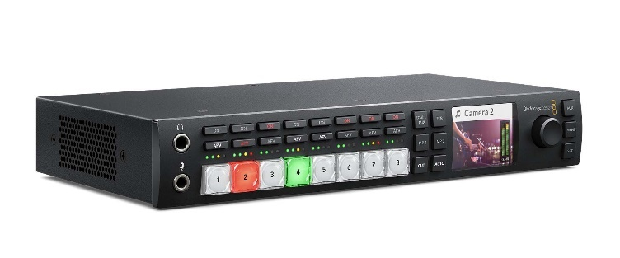
Vision switcher illustration used with permission Videocraft.com.au

Some vision switchers are very simple, just a few buttons to push to select which feed is being projected to the ‘live feed’, also known as the ‘program’. High end Vision switchers have many complex functions, often more than a Vision mixer.
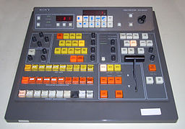
Sony BVS-3200CP vision mixer.jpg licensed at CC BY-SA 3.0

Camera Control Units
A CCU (Camera Control Unit) is a common way of controlling camera functions in television production and large production events. The CCU grades the brightness and colour of camera pictures ensuring that each camera feed has the same colour and brightness level. It allows the camera operator to concentrate on focusing and framing the required content.

2. Signal types
The best way to understand which components can be hooked together is to understand what kind of signal is running through the line. If you have two pieces of equipment, one putting out and the other receiving the same signal type, they can ‘communicate’ with each other if joined by an appropriate cable. The following descriptions of the common signal types are a helpful reference. Some of the signal types can be found on almost every piece of gear, whereas others are not so common.

RF (Radio Frequency) modulated television
RF is the type of signal that comes through the air by antenna or through a cable TV connection. In standard-definition broadcast and analogue cable, a composite video signal and accompanying audio are mixed at the transmitting end with high-frequency radio waves and are broadcast through the air or distributed through a cable system. RF is used as a distribution medium because it propagates through the air very well, making it suitable for over-the-air broadcast. As many video signals can be modulated at different frequencies, it is possible to have many ‘channels’ available simultaneously without them interfering with one another.

Analogue
Analogue equipment is being replaced by digital equipment and is expected to eventually be phased out. But some analogue equipment is still used in industry and in-home theatre applications.

Composite video
Composite video is a single signal which carries both the chrominance (colour) and luminance (brightness) components of a video signal, along with sync information, on a single wire. Unlike an RF signal, a composite video signal does not need to be demodulated to be understood by a video display. Composite video signals do not carry any audio content. This must be handled separately.

S-video
S-video is a format which splits the chrominance and luminance out onto two separate lines, ‘C’ and ‘Y,’ each requiring its own cable. The sync pulses are carried on the luminance line.

Component video
This ordinarily refers to ‘Y/Pb/Pr,’ also known as ‘YUV,’ video. In Y/Pb/Pr component video, there is a luminance channel, ‘Y,’ which carries the luminance along with the sync pulses, and two colour-difference channels, which carry signals representing blue minus luminance (B-Y, or Pb) and red minus luminance (R-Y, or Pr). From these signals, the display device separates out the sync information and reconstitutes the red, green and blue components of the picture. Similar to s-video, which requires two signal-carrying wires instead of one, component video requires three signal-carrying wires to convey the whole signal.

RGB and its variants: RGBHV, RGBS, RGsB
The original ‘component video’ was RGB, which appears in three principal varieties, each requiring a different number of connections:
- The most common type is RGBHV, with five lines: one for red, one for green, one for blue, one for the horizontal sync and one for the vertical sync. RGBHV is the standard used in VGA and other analogue PC computer monitors.
- RGBS has four connections and differs from RGBHV by having the vertical and horizontal sync combined on a single channel.
- RGsB, or ‘sync-on-green’ places the sync information on the green channel. Although this is similar to Y/Pb/Pr component video they are not compatible.

Digital
DVI and its several flavours: DVI-D, DVI-A, DVI-I.
DVI is somewhat confusing because the term is identified both with more than one signal type and more than one connector type.
DVI-A is nothing but RGBHV in a strange connector and isn't digital at all.
DVI-I isn't really a signal type but refers to a connector type which combines DVI-A and DVI-D.
DVI-D is a parallel digital standard: a nasty little tangle of wires in a nasty little plug which consists of up to seven balanced lines (all other common video standards are run unbalanced) carrying the video itself, and five miscellaneous conductors carrying other information. Because this is a digital rather than an analogue signal, it can only be converted to another format through a device that is equipped to decode the digital bitstream and render it in analogue form.

HDMI
HDMI is similar to DVI and is a standard intended to be backward compatible with DVI and employing the same encoding/decoding scheme.

SDI
SDI is serial digital video. Unlike DVI, it is run in an unbalanced line. It is used primarily in professional production environments.

3. Cables and connectors
All of the unbalanced analogue and digital standards, from RF down through SDI, are run in 75-ohm coaxial cables. This fact, in itself, seems to confuse people. It is widely assumed that ‘coax’ is something used for RF, or for SPDIF digital audio, and that composite video or component video are run in a different type of cable suited particularly for those formats. In fact, the differences are minor: RF is frequently, but not always, run in cables using copper-coated steel conductors for higher strength and lower cost; SDI is generally run in ‘precision’ video cables because its wide bandwidth requires very tight impedance tolerance; but these cables are all "coax." Even s-video is only apparently an exception. A round s-video cable is just a round jacket over two miniature coaxes, one carrying luminance and the other chrominance. DVI and HDMI are run in cables which are particular to their own applications.
Here are some common connector types, and what they are mostly used for:
The RCA (phono) plug and jack is the most common connector type on consumer equipment for composite and component video, as well as for both digital and analogue audio.
RCA jacks colour-coded yellow on a device are usually composite video inputs or outputs. Where there is a single RCA jack on the back panel, labelled ‘video’ or something similar, it is almost certainly composite.
Component video is usually represented by three RCA connections colour-coded green (Y, or luminance), blue (Pb) and red (Pr). RGBHV will usually, though not always, be colour-coded red, green, blue, yellow (horizontal sync) and white (vertical sync).
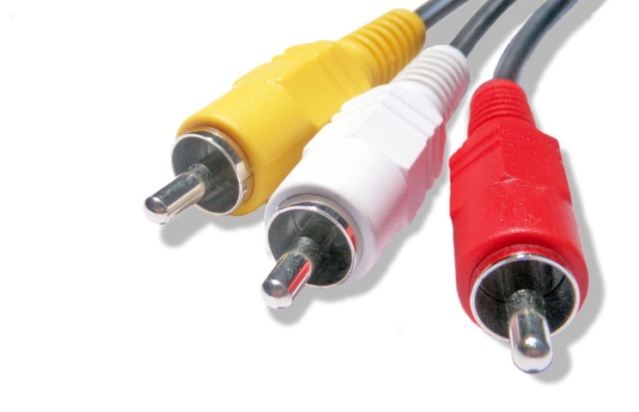
RCA Connector (photo).jpg Public Domain

The BNC plug and jack is the standard connector for most video signals on professional gear and is appearing increasingly on high-end consumer gear as well.
It will be labelled similarly to the RCA, indicating composite video (one connection), Y/C s-video (two connections), Y/Pb/Pr (three connections), or one form or another of RGB.
The most common confusion with BNCs, is that people often assume the female connector is a male; the problem is that both the male and female connectors have what looks like a pin in the centre. On closer inspection, however, it is clear that a female BNC's ‘pin’ is actually a receptacle for the male pin. A panel-mounted BNC will ALWAYS be female; a cable-mounted BNC will almost always be male. Click here to examine a range of BNCs.
The F-connector is the screw-on type connection used for most antenna and cable TV connections. F-connectors are rarely used for anything other than RF; the one notable exception being that they were used as digital audio connectors on some laser disk players.
The 4-pin mini-DIN plug is the common s-video plug on consumer gear and is often considered a poor choice for video as it tends to unplug itself at the slightest urging.
The HD15/mini dSub 15/VGA connector: An increasing number of devices are appearing with 15-pin connectors. There are about as many names as pins for this connector, which is well known as the plug used with most PC computer monitors and consequently is often called a "VGA" plug. Since VGA is an RGBHV-type video signal, however, this usage is a bit confusing. This same plug is used not only for RGBHV, but also for RGBS, RGB sync-on-green, and Y/Pb/Pr Component video. Because the plug can be used with so many different video standards, it's very important to know before using a 15-pin connector on a device, what sort of video it can put out or take in.
DVI Connectors come in a few types; the most important, in general, are DVI-I and DVI-D. The difference between the two is that a DVI-I connector has extra pins at one end, which carry most of the analogue video signal. A DVI-I cable can be used for either a digital or analogue signal, because it contains both the digital and analogue pins. A DVI-D socket, however, which is designed to take a DVI-D plug, will not normally have anywhere for the analogue pins on a DVI-I plug to plug into. It is therefore important when buying a cable to be sure that it will actually plug into the equipment it is intended for. Click here to examine DVI connectors.
HDMITM (High Definition Multimedia Interface) was created as a digital interface standard for the consumer electronics market. The HDMI protocol combines high-definition video, multi-channel audio and inter-component control in a single digital interface. This lone interconnect has the ability to transmit uncompressed digital video and up to eight channels of audio from source to display. Click here for more HDMI illustrations.

SDI (Serial Digital Video) signal format
SDI is the broadcast industry standard for digital video and the method it uses is similar to analogue component video. It is available in both standard definition and high definition. SDI is useful as it not only handles video but can transmit 16 channels of audio.
Cat 5
Category 5 cable (Cat 5) is a ‘twisted pair’ cable for computer networks. Since 2001 most commonly used is the Category 5e specification (Cat 5e). The cable standard provides performance of up to 100 MHz and is suitable for most varieties of Ethernet over twisted pair up to 1000BASE-T (Gigabit Ethernet). Cat 5 is also used to carry other signals such as telephony and video. Cat 6 is also available. It has four twisted wires and is capable of carrying a much greater band width.
USB
There are a variety of different USB cables, each with an initial after its name. They also come in mini and micro versions as well. When using USB (Universal Serial Bus) peripherals the preferred cable length is up to 5 metres, before there is a chance of data loss and slowed down response speeds. Using a Cat5e extender over long distances or a passive cable extender for much shorter distances can assist with this problem.

4. Guidelines for presentations
While the proper layout of a presentation room or multimedia theatre can involve complex geometry, there are some simple guidelines that can be used.
For optimum viewing, the audience should be seated within the shaded area indicated in this diagram.
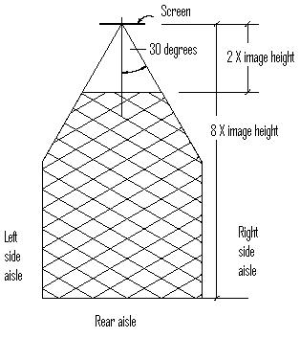
The audience should be within ±30º of a line perpendicular to the screen’s centre. They should be seated no closer than twice the image height. If a room is too wide to allow all viewers to fall within these guidelines, consider multiple displays. The distance to the furthest viewer depends on the content of the presentation. For general purpose (e.g. entertainment) the last row should be no further than eight times the image height. This should be adjusted to six times the image height for corporate or data presentations (e.g. spreadsheets), or four times the image height for critical applications (e.g. control rooms, CAD drawings, very fine detail, etc.
To prevent obstruction of the screen by the heads in front, the bottom of the screen should be 1200mm above the floor. This can be adjusted somewhat if the seating is staggered, or if the floor is raked. Allow a minimum of 150mm between the top of the screen and the ceiling. The screen should never be positioned too high – bear in mind ergonomic figures regarding comfortable head tilt and vertical eye movement range: no viewer should have to rotate their head more than ±30° from straight ahead, or tilt their head more than 25° from horizontal.

Choosing the type of projection

Front projection
Front projection can generally provide a wider viewing angle than rear projection. Controlled lighting is important and ambient light must be kept off the screen to eliminate a reduction in contrast ratio. Front projection requires either a projection room at the rear of the theatre, or a platform or mount for the projector(s) in the theatre. It is important to remember that having the projection equipment in the theatre is a potential noise source.

Rear Projection
Rear projection generally has a narrower viewing angle than front projection and is better for long, narrow rooms. Material can be viewed with higher levels of room illumination and is less immune to ‘wash out’ by ambient lighting. Rear projection is available in both flexible and rigid materials although a rigid screen is more expensive than a front projection screen and has size restrictions. It also requires space behind the screen. Mirrors may be used to reduce the required depth.

When choosing the type of projection, it is necessary to determine the purpose of the presentation. If it is a ‘canned’ presentation either front or rear projection can be used. If a live talker is interacting with the presentation, rear projection is best so that the speaker can interact with the images without being in the projector’s light path. In addition, the higher allowable room illumination allows for note taking, etc

5. Live Production Roles

Role | Duties
Director | Overall, in charge of all artistic content
Producer | Employs crew, manages budgets, liaises with venues etc
Vision Director | The Vision Director decides which ‘feed’ is to go to the screens.
Vision Designer | Designs the layout of the equipment such as screens, selects which projectors are to be used and where they will be positioned, specifies rigging points for projectors. Specifies cameras and camera positions
Vision system technician | Bumps in/out equipment, may operate equipment such as camera, CCU (Computer Control unit), vision mixer/switcher
Production electrician | The production electrician is responsible for all lighting elements of production, including (but not limited to) tech tables, running lights and any other elements as defined by the L&S Supervisor
Technical manager  (Technical Director) | The TD (Technical Director) is the person responsible for supervising set up and maintaining the technical parameters of the production's video images.
Venue manager | In charge of the venue overall. Oversees bookings, venue security, venue staff
T.O.D. (Technician On Duty) | Employed by the Venue Manager to assist technicians hired for the event with their knowledge of the venue and its technical equipment
Camera Operator | Sets up and operates camera. The camera may be on a tripod or shoulder mounted
CCU Operator | Operates the CCU (Camera Control Unit). This device controls colour and brightness from each camera
Vision Switcher/Mixer Operator | Operates the Vision Mixer/Switcher. Sometimes this person will be the Vision Director, but in a large event, the Vision Switcher/Mixer operator will be a person who will be taking direction from the Vision Director

6. Communication Protocols
The client usually communicates with the director, producer or technical director, rather than with the crew members. The technical director communicates with the crew supervisor eg Vision Director of in larger events, the Vision team supervisor. If there is a technical issue, a crew member should report directly to their supervisor, rather than the technical director (the technical director’s role is more ‘big picture’ overseeing role, not dealing with a broken lead.
At all times, the client must be treated respectfully and made feel confident in the ability of the crew.
Prior to the production meeting, the client will have supplied a document outlining their requirements A Pre-production meeting with the client and the director, producer and technical director will occur where the client will discuss their requests and any issues pertaining to these requests will be discussed. In some events, the client is also the director.
During the live production, communication between crew is usually over comms or ‘cans’ as they are known in Entertainment Industry jargon. During the live production, the stage manager is in charge and will give cues to lighting, audio and vision. In corporate events, the stage manager is called the ‘show caller’.
Post production, the client has a meeting with the director, producer and technical directors. This is where the production is evaluated and improvements for the next event are discussed. In corporate work, the client may not attend the meeting. They may provide feedback to the director instead.
Meetings are held within production areas pre-production and post-production, these are usually run by the Head Technician of each area, eg Lighting director.

7. Workplace Procedures and practices
Prior to a live event taking place the client contacts a production company to produce and provide technical support for their event. Budget, venue, audience size, technical requirements are discussed. The event producer then employs a production company to manage the live production for the event. One such Australian Company is Encore Technologies, formerly known as staging Connections.
Once the budget and other details are agreed upon, the production company proceeds to take over running the technical production side of the event.
Prior to the day of the event, crews bump in and test the equipment. Equipment is set up according to the plans that have been provided by the Vision Designer.
In some cases, there will be a technical rehearsal if there are performers involved. This allows all systems to be checked, camera angles modified, sound and lighting checks and the performers to be comfortable on the stage.
When the event has finished, the equipment is bumped out and returned to storage where it will be checked for damage. Equipment logs will also be checked through as technicians may have noticed faults with the equipment and noted it in the log. At this time equipment is also cleaned so it is ready for the next production. Inventory is checked to ensure that all equipment is accounted for. Equipment maintenance logs are completed at this time.

8. Trouble shooting and problem solving
If equipment is not working correctly, troubleshooting procedures need to take place. Often the problem will be a damaged lead or connector which can usually be quickly rectified.
If this is not the case, check the company equipment log to see if this piece of equipment has any know faults and fixes. If that does not help, check the equipment manual, sometimes a problem may be a simple thing that has been overlooked. You can also look online to see if other’s have had the same problem with the equipment. Also check with workplace colleagues. Some equipment can be a little ‘temperamental’ and other colleagues may be able to show you how to fix it.

Equipment malfunctions can cost a lot of time at a bump in and can cause considerable stress to the technician. Sometimes, if it is within your level of authority, it is just quicker to get another piece of equipment from stores to substitute the malfunctioning piece of equipment. It is important to log any equipment faults, otherwise, you may be facing the same problem at the next event. If a piece of equipment gives you an electric shock, do not continue using it, label it and log it and find a substitute piece of equipment.

9. Industry Jargon
Every industry has its own jargon, it is important to learn the jargon so that you can communicate easily with other crew members. Some examples include:

‘The Talent’
This refers to anyone performing or presenting – the reason for the event. So, the talent might be a person giving a speech or someone doing a dance. It is not meant to be judgemental.

The ‘Gig’
The ‘gig’ is the event, whether it be a wedding, a corporate event or a major musical event, it is referred to as the ‘gig’
Bump In/Bump Out
This refers to setting up and packing up of the event
Throw
Throw is the distance a projector needs to be able to project light to fit the screen.
The ‘Engineer’
The CCU (Camera Control Unit) operator is known as the ‘Engineer’
Bubble
This is industry specific jargon for a lamp, which non industry people would call a globe.
PGM
An abbreviation of program
Super
A super is a graphic overlaid on the picture.
HD
High-definition video (HDTV Video or HD video) is video of higher resolution and quality than standard-definition
4K
The current standard for HD is 1080p, measured by the number of vertical pixels. 4k measures the horizontal pixels instead. Any TV described as 4K will have a resolution of at least 3840 x 2160. The result is a picture with about 8.3 million pixels, or about four times as many as a standard HDTV.
UHD
Ultra-high-definition television (also known as Ultra HD television, Ultra HD, UHDTV, UHD and Super Hi-Vision) today includes 4K UHD and 8K UHD, which are two digital video formats with an aspect ratio of 16:9.
8K
8K resolution refers to an image or display resolution with a width of approximately 8000 pixels.8K UHD (7680 × 4320) is the highest resolution defined in the Rec. 2020 (UHDTV) standard.8K display resolution is the successor to 4K resolution. TV manufacturers pushed to make 4K a new standard in 2017.

Key terms and concepts
You can use the following information to revise the key terms and concepts from this unit of competency. Perhaps you could:
- Copy the table into your own file, remove all the key terms, then fill in the blanks (without peeking at the original file) with your own answers.
- Copy the table into your own file and remove the definitions. Write a definition in your own words – it doesn’t have to word perfect but should show you understand the concept.
- You could add an example of this term or concept which is relevant to the entertainment environment. If the key term was ‘safety hazard’ your Entertainment Industry example might be ‘double adaptors, piggy-back plugs, un-switched power boards and the daisy chaining of power boards is prohibited’.

Key term or concept | and Definition
Cables | Electrical components in Vision systems system are interconnected with cables - wiring which has been temporarily rigged to carry an electrical current such as Power, DATA and RF (Radio Frequency) Signals.
Circuit State | Circuit state means the state of the circuit. You might think it can really only be ON or OFF, but the terms energised and de-energised give a stricter meaning.  - Energised state means a circuit or piece of equipment is ON, and therefore has electricity running though it and it should be working. Battery powered items, like torches are usually portable. A mains powered amplifier it will have dangerous levels of electricity in it.  - De-energised state means a circuit or piece of equipment is not only OFF, but it is totally without electric power and is safe. So, it means more than just turned OFF.
Common problems and solutions | These would include the consideration of workplace requirements and decisions to ensure correct cabling, correct connectors, correct data transfer protocols, key stoning, focusing, operating distances, screen sizes, screen format and quantity of screens in relation to number of guests/clients.
Cue Sheets/Run Sheets | All the actions that will be performed during the production are recorded on the cue sheet/run sheet. In Corporate work it is called a run sheet, in theatre, a cue sheet. The stage manager’s Prompt Copy Book has all the cues required in the production.
Current resistance | Resistance is a measure of how something limits the amount of electrical current flowing through it. Good conductors have a very low resistance. Good insulators have a very high resistance. Electronic circuits often require materials between these two extremes to make electrons perform in certain ways. The unit of resistance is the Ohm. It is calculated from Ohms law: the resistance (Ohms) of something is the voltage (volts) drop across it divided by the current (amps) passing through it.  Ohms = Volts / Amps
Electrical measurements | This relates to the use of equipment with corresponding or appropriate voltages, current, resistance and other electrical features. (In Australia we use 240 VAC (Volts Alternating Current) power and most domestic fuses are 10 to 15 amps).
Features, purpose and basic operating procedures for vision system equipment | This relates to the appropriate selection of vision system equipment as needed for each situation. Using correct size screens with matched projectors to suit venue. Smaller venues for meeting may only require Plasma or LCD screens, rather than projectors.
Legal issues | These may include display of material that does not breach copyright or break privacy laws, display in appropriate venues, and use of equipment as intended by the manufacturer or supervisor.
Power | Power types include three phase industrial power 240VAC or 415VAC, standard 240VAC domestic power or DC (Direct Current) battery power and should be appropriate to the venue or equipment. With power ratings from 10Amps up to and beyond 400Amps.
Power insulation | An insulator is something that does not allow electrons to be conducted (flow) through it. Rubber and plastics are generally good insulators. Air is an insulator but would not stop conductors touching each other. Insulators around cables provide both electrical insulation and physical protection.
Production plans | This relates to the understanding and interpreting of technical notes, vision system plans, stage plans, rigging, audio and lighting plots, production schedules, ground plans etc.
Rigging and positioning points | Rigging (hanging) or positioning of projectors, screens, source devices and cables must be appropriate to the audience size, position, angle of head lift and rotation, and must take all safety issues into account. (ie weight limits of the points or structure that the equipment is being attached to.)
Safe work practices | There are a number of safe work practices which should be considered when using vision systems. These include following all WHS procedures for the use of appropriate personal protection equipment and taking care when lifting and working at height. Electrical safety procedures must also be followed, basic things such as checking electrical leads are tagged and doing a physical inspection on them prior to use.
Safety issues | These may include electrical hazards, extreme heat, heights, weight, lifting, cabling and trip hazards, extreme light exposure hazards and operating hazards such as excessive head rotation or lift angle.
Set-up sequences/procedures | It is essential to follow schematics, signal flow diagrams and production plans to ensure correct set up and operating sequences for each particular item of equipment.
System checks | This entails testing all of the equipment pre and post set-up. Each device should be tested both separately and as part of a system once interconnected. Including all cables and connectors.
Version Control | As cue sheets/run sheets are constantly modified from the start of rehearsals through to the final performance. Version control is very important. If a technician is using an older version of e cue sheet, mistakes will be made. The stage manager is in charge of modifying and updating the cue sheets. In previous times cue sheets were handed out and then updated after each rehearsal or performance. Modern software allows the stage manager to update and distribute modifications in real time.
Vision systems | Were previously called ‘A/V (audio-visual) systems’ in the past, now known as ‘vision systems. This term refers to groups of devices which are interconnected to provide visuals, including data, still photos, graphs or other still images, animations, IMag (image magnification) or video. From the simplest computer and monitor combination to multiple cameras, computers, DVDs, vision mixer/switchers, data projector, monitors and screen combination, each group of interconnected devices is called a vision system
Vision system plans/instructions | This refers to things such as schematics, physical layout of equipment and guests, signal flow diagrams and production plans which enable the vision system to be used for the optimal effect.
Vision Systems technician | A person with the knowledge, skill and expertise to set up, operate and bump out vision systems equipment.
Voltage | Voltage does not move or flow along conductors, but it is the force or pressure making electrons move or even jump. Imagine a circuit made of water pipes, then the force or pressure making the water move is measured in or kilopascals (or pounds per square inch). In an electric circuit the unit for measuring electric pressure is the Volt. A battery might use a 1.5 volt (tiny spark), a house has 230 Volts (big spark), lightning flash a billion volts (giant spark).

Activities
- Create a table summarising the uses for each of the following. Include a short description or an illustration.
Name | Use | Description
VGA Cable
DVI Cable
HDMI Cable
Audio cable
USB Cable
Display port
BNC plugs
SDI cable

- You are in charge of Vision Systems for a large event in your school hall or community centre. Vision will be a big part of this event.
  - Draw a diagram of the layout of the Vision System that you would use for a large event at your school.

  - Some of the items you may like to include would be Video Cameras, Vision Mixer/Switcher, Video Foldback, Projection Screens, Projectors, laptops and operator monitors.

  - Using the equipment in your layout, draw a signal path diagram for the set up you have drawn.
  - Write up a Vision Systems packing list for the bump in for the gig.

- Customer brief
You have been asked to provide a vision system for a small corporate style information evening.
You are preparing to meet with the client to discuss the event and its requirements. Write a list of at least 10 questions.

- Client Relations
Your company is bumping in a small vision system for an event. The client is not happy with the position of the projector as it is on a table in front of the screen. The customer does not like the idea of the public walking in between the screen and the projector as it will cause shadows on the important information that must be displayed at all times.

- What solutions can you offer the client?

- Explain the options the client has and the advantages and disadvantages of each solution.

- Cue Sheet/Run Sheet
- Explain what a Cue Sheet/Run Sheet is and why you would need one in a production.

- Explain why it is important to ensure the currency of your cue sheet/run sheet.
- Who oversees Version Control on the Cue Sheet/Run Sheet?

- Name five roles and the associated responsibilities of personnel working in Vision System Operations.

- Before using an electrical lead, what should you do to check it is safe?

- A camera is not sending its live feed back to the vision mixer. Outline the steps you would follow to troubleshoot the problem.
- You are preparing to send your hired Vision Systems equipment back to the hire company. What would you do to ensure the company did not give you additional charges on return of the equipment?
- TDC (Technical Direction Company) is one of Australia’s most successful Vision Systems production companies. Follow the link to their website.
- In a few sentences, summarise TDC’s role in two of the projects on the project page.
- Mention the technology that they used.

Putting the theory into practice
The following questions are from past years’ Entertainment Industry HSC examination papers. HSC exams are intended to be rigorous and to challenge students of all abilities. If you have difficulty understanding a question you should look for key words and identify the aspect of the course to which these relate. You are then in a position to formulate your answer from relevant knowledge, understanding and skills.
All questions in ‘Putting the theory into practice’ are acknowledged © 2019 NSW Education Standards Authority (NESA) for and on behalf of the Crown in right of the State of New South Wales.

Multiple Choice
- A vision technician for a convention centre has been offered a second job as a part-time sales consultant for the company that supplies equipment to the convention centre. What document should the vision technician consult in regard to this potential conflict of interest?
  - Work Health and Safety (WHS) policy
  - Code of conduct
  - Position description
  - Enterprise agreement

- What is measured in lumens?
  - Sharpness of the image
  - Throw distance of the projector
  - Amount of power used by the projector
  - Amount of light produced by the projector
- During pre-show checks the vision technician notices that the projector is not functioning. The technician replaces it and sends the malfunctioning projector to be repaired. What type of maintenance is this?
  - Non-routine
  - Regular
  - Standard
  - Sustainable

- Who is responsible for coordinating the planning and budgeting of all aspects of a production to ensure that the creative vision is met?
  - Stage Manager
  - Artistic Director
  - Technical Director
  - Production Manager

- A technician has been asked to run vision for an event. Which of the following should be the first task of the technician?
  - Power up the projector and peripherals
  - Acquire vision equipment and accessories
  - Determine technical requirements for the event
  - Position and connect vision equipment and accessories

- A projector is shown. What is the part labelled X on the projector?
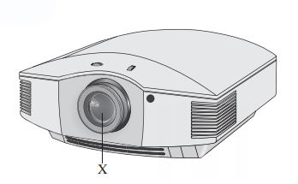
  - Fan
  - Lamp
  - Lens
  - Power supply

- A live, roving camera vision feed is required to move through the audience. What is the best way to ensure that the camera cable does not cause trip hazards?
  - Use cable trays
  - Employ a cable assistant
  - Tape the entire cable down
  - Allocate the camera to a fixed position

- What does the abbreviation LED stand for?
  - Light-emitting diode
  - Lux-electronic diode
  - Lux-energy distributor
  - Light-energy distributor

- Which of the following shows the correct signal flow for a vision system?
A | Mixer ⇒ | Camera ⇒ | Monitor ⇒ | Projector ⇒ | Screen ⇒
B | Camera ⇒ | Mixer ⇒ | Monitor ⇒ | Screen ⇒ | Projector ⇒
C | Camera ⇒ | Monitor ⇒ | Mixer ⇒ | Projector ⇒ | Screen ⇒
D | Mixer ⇒ | Camera ⇒ | Monitor ⇒ | Screen ⇒ | Projector ⇒

- What is the main reason for maintaining updated versions of production documents?
  - To assist operators to perform their task
  - To enable the production manager to conduct a briefing
  - To provide the stage manager with information for the prompt copy
  - To ensure all production personnel are working with the latest information

- A projected image fills the width but not the height of the screen. What should be adjusted to amend this?
  - The zoom
  - The keystone
  - The aspect ratio
  - The projector position

- The diagram shows people at a dance party. 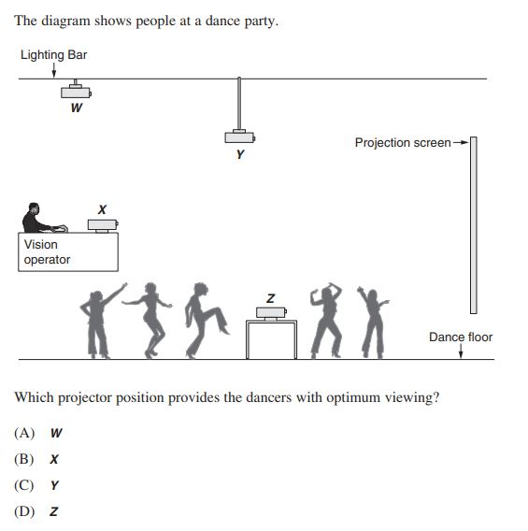

- Which of the following statements best describes a technical rehearsal?
  - Lighting and audio cues and scene changes are rehearsed.
  - Vision and staging cues and scene changes are rehearsed.
  - All production elements are coordinated entirely by the director.
  - All production elements are coordinated entirely by the stage manager
- While a DVD is being played through a projector, the video signal is lost but the audio continues to play. What should be checked first to identify the problem?
  - The projector signal inputs
  - The DVD player signal inputs
  - The power supply to the projector
  - The power supply to the DVD player

Questions from Section II
These questions should be answered in the suggested number of lines (handwritten in the exam) as it gives a guide to the length of your response.
Plan out your answer and key points before you commence writing.

Question 1
A vision system is required by a touring guest speaker. The presentation will include
a slide show and video footage. The speaker will be presenting at various venues of
differing sizes.
- Explain how the set up and equipment would vary from a 25 seat venue to a
400 seat venue. (4 marks)

Question 2
The diagram shows a vision system plan for a school environment. It does not include the cable information.
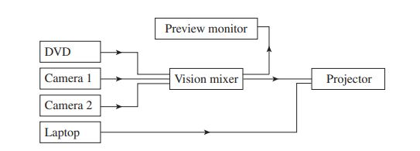

- Identify and justify the cabling needed to operate this vision system. (3 marks)

- Recommend additional vision equipment that could be required to effectively operate this system for a large scale outdoor event. (3 marks)

Question 3
A vision system technician is required to set up a digital media exhibit in a small art gallery.
- How would the vision system technician determine the vision equipment requirements for this exhibit? (3 marks)

- Outline the technical considerations the vision system technician should take into account when installing the equipment for this event. (3 marks)

Question 4 - Refer to the following image to answer the questions (and over)
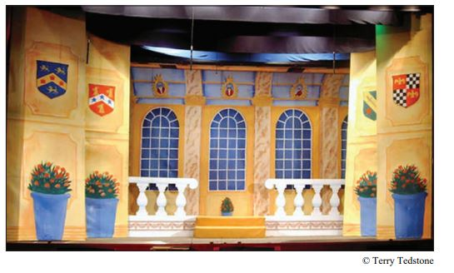
Original illustration from NSW HSC Entertainment examination

- Outline the benefits of using vision technology instead of the scenic elements shown in the image. (3 marks)

- Describe the technical requirements of replacing the scenic elements shown with vision technology. Use terminology specific to vision technology in your response. (4 marks)

Question 5
- Describe the roles and responsibilities of a Vision Systems technician working in a conference centre. (4 marks)

- How can employees working in the entertainment industry increase their skills in and knowledge of emerging Vision Systems technologies? (4 marks)

Questions from Section IV
There will be one extended response question in Section IV. This will provide you with the opportunity to
- demonstrate knowledge and understanding relevant to the question
- communicate ideas and information using relevant workplace examples and industry terminology
- present a logical and cohesive response
The expected length of response for questions in Section IV is around four pages of an examination writing booklet (approximately 600 words). You should allow about 25 minutes for a question in Section IV in the exam.

You will note that these questions usually require you to bring together knowledge from several areas of competencies to do justice to the answer.
In each of the following, map out your answer using post-it notes or a sheet of paper. Pay particular attention to incorporating a variety of aspects of your Entertainment Industry curriculum into the plan. Consider why we have included this question within this module and what other areas of study you would need to draw upon.

Question 1
An industry trade show is to be held in a convention centre with a 1000 person capacity. The event includes keynote speakers on the main stage, audio-visual displays and supplier stands. Describe the technical requirements and safety considerations for this event.

Question 2
Pre-match entertainment is scheduled to be held on the field at a major sporting event. The match cannot commence until the main stage and all related technical equipment are safely removed.
Propose communication and teamwork strategies that will enable the match to begin on time.

HSC Focus Areas
For the purposes of the HSC, all students undertaking the 240 HSC indicative hours course in Entertainment Industry must address all of the mandatory focus area content.
The scope of learning describes the breadth and depth of the HSC Content and has been grouped together into key ideas/areas. The scope of learning describes the minimum content that must be addressed, and the underpinning knowledge drawn from the associated unit(s) of competency.
Entertainment Mandatory Focus Areas include:
- Audio
- Customer service
- Lighting
- Safety
- Staging
- Vision
- Working in the entertainment industry

The focus area prescribes the scope of learning for the HSC and is drawn from the unit of competency CUAVSS302 Operate vision systems
How to use the scope of learning for ‘Vision’ (which follows over).
- draw up your own mind map showing the connection between the various concepts listed; examples appear on the last page of this module
- use the key terms and concepts to add to your mind map
- add examples or case study prompts to show how the concept is applied in the entertainment working environment

The following information is taken directly from page 49 ff of Entertainment Industry Curriculum Framework Stage 6 Syllabus (NSW Education Standards Authority) for implementation from 2020.
© 2019 NSW Education Standards Authority (NESA) for and on behalf of the Crown in right of the State of New South Wales.

production context
- industry-accepted terminology and commonly used jargon in the entertainment industry:
- specific to vision systems
- variations:
    - between analogue and digital vision systems
    - across production environments/contexts and workplaces
- general scope of vision system operations across different production contexts
- role and responsibilities of personnel in relation to vision system operations:
- director
- producer
- designer
- vision system technician
- production electrician
- technical manager
- venue manager
- protocols for communicating with the customer/client, colleagues, a performer/presenter and a supervisor about vision system operations:
- pre-production
- during production
- post-production
- documentation commonly used in vision system operations:
- vision system cue sheet
- vision system plan
- vision system running sheet
- for each of these documents:
- purpose
- standard format(s) and common features
- content
- abbreviations, terms and conventions
- modifying/updating documentation:
- personnel with authority to modify/update
- processes
- importance of ensuring currency of version and the status of any amendment
- application of documentation for vision system operations to specific job roles and work tasks
- read and interpret documentation for vision system operations to obtain and convey information
- how vision system requirements vary across different:
- live performances and events
- indoor and outdoor venues
production context cont/d
- interrelationship between vision system operations and other technical and creative areas in the production of live performances and events
basic electrical theory
- meaning of:
- circuit state:
    - energised
    - de-energised
- current resistance
- power insulation
- voltage
- application of electrical theory to the set-up and operation of vision systems
equipment
- analogue and digital vision system equipment commonly used in the entertainment industry including:
- cables and connectors
- camera
- mixer
- monitor
- playback/recording device
- projector
- screen
- for a range of vision system equipment:
- name and general features
- purpose/function
- capacities and limitations
- operation/use during live performances and events
vision system cues
- purpose/function of vision system cues
- standard procedures used in the entertainment industry to plot, record, modify and operate vision system cues
- sequencing, timing and speed of vision system cues in accordance with production requirements
- how vision system information is recorded and used within the prompt copy
- use of documentation for vision system operations, including the cue sheet, during a technical rehearsal
safe work procedures and practices
- safe work procedures and practices when:
- positioning and rigging equipment
- working with:
    - cables and electricity
    - hazardous substances
- dealing with unexpected situations or unplanned events
- risk management when undertaking vision system operations
workplace procedures and practices
- workplace procedures and practices for vision system operations:
- determining and confirming technical and performance/event requirements for vision systems
- assembling, installing and disassembling vision system equipment and accessories
- positioning and cabling vision system equipment and accessories
- power-up and power-down of vision system equipment and accessories
- checks, functionality tests and routine maintenance of vision system equipment and accessories
- packing, storing and transporting vision system equipment and accessories
- security of vision system equipment and accessories
- dealing with hired, lost and damaged vision system equipment and accessories
troubleshooting and problem-solving
- sources of information for reference when troubleshooting and solving problems:
- manufacturer/supplier
- equipment manual
- workplace documentation
- colleagues and supervisor(s)
- typical issues and challenges and common faults and problems that arise during vision system operations for a live performance or event
- importance of considering:
- potential effect on production and performance schedules
- level of authority and approval to proceed
- work health and safety
- troubleshooting and problem-solving process:
- identify the fault or problem:
    - investigate likely cause(s)
    - eliminate unlikely options
    - conduct tests
- consider possible solutions
- take remedial action:
    - in accordance with:
    - manufacturer/supplier recommendations
    - colleague and/or supervisor instructions
troubleshooting and problem-solving cont/d
- within scope of responsibility:
    - rectify
    - refer to appropriate personnel
- evaluate effectiveness of action taken
- known solutions to a range of common/predictable problems in relation to vision system operations for live performances and events
- workplace practices for recording and reporting
Creating a mind map is a great way to organise your knowledge and understanding of the content of a topic.
You could use software such as a hierarchy chart, download ‘MindNode’ or similar or use a large sheet of paper (or several A4 sheets taped together)!
It is important to try to include all the detail you can, so add definitions, case studies or examples to prompt your memory. Include the information downloaded from the unit of competency and also from the Scope of Learning and Key Terms and Concepts.
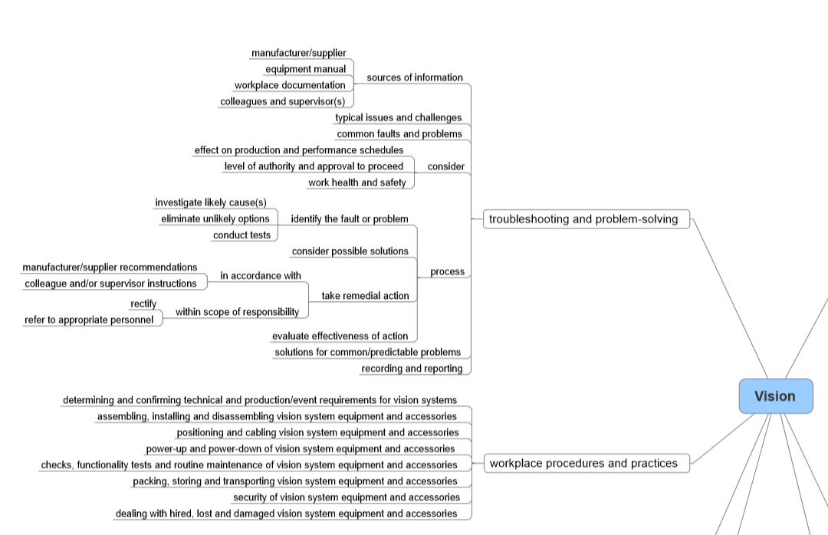
Portion of Entertainment mind map for ‘vision’ © 2019 NSW Education Standards Authority (NESA) for and on behalf of the Crown in right of the State of New South Wales.

