Entertainment Industry
Mandatory Focus Area: Lighting

Welcome. This module will assist you to review and revise the content of the mandatory focus area ‘Lighting’. Each focus area prescribes the scope of learning for the HSC and is drawn from associated units of competency.

You will have studied the competency CUALGT301 Operate basic lighting.

This module is broken up into:
- Important notes
- Key terms and concepts
- Activities
- Putting the theory into practice
- HSC focus areas

How to use the resource
Work through the notes and the suggested activities in any order. Great revision techniques include working through how a problem is solved, explaining the concept, testing yourself and retrieving information from your memory. Spread your revision over a number of sessions rather than sitting at one subject for lengthy periods.
Discuss your responses with your teacher, fellow students or an interested family member.
All images, apart from those acknowledged, are © NSW Department of Education.

Important Notes
You should use the information here as a prompt and guide when revising your study notes or text-book information or other resources provided by your teacher.

You can also access industry specific information at SafeWork NSW, Live Performance Australia and Media Entertainment and Arts Alliance.

The unit CUALGT301 Operate basic lighting describes the performance outcomes, skills and knowledge required to plot, record, modify and operate standard lighting cues on lighting consoles typically used in small-scale productions and events.

The outcomes of the HSC mandatory focus area ‘Lighting’ require that the student:
- demonstrates knowledge of lighting equipment and accessories used in the entertainment industry
- demonstrates an understanding of techniques used to plot and operate lighting cues
- interprets documentation and applies this information to set up and operate lighting equipment to meet production requirements
- describes the relationship between lighting and other technical and creative aspects of live performances and events
- applies the troubleshooting process to solve common faults and problems in lighting equipment and operations

Lighting system information
- Equipment
- Light mixing
- Lighting control
- Personnel – Live Production Roles
- Lighting Contexts
- Lighting Cues
- Electricity
- Safety
- Communication Protocols
- Workplace procedures and Practices
- Troubleshooting and Problem Solving
- Industry Jargon

1. Equipment
Types of lanterns
Traditionally stage lights were called lanterns or luminaires. With the advent of programable consoles and intelligent lights, lights are now usually referred to as ‘Fixtures’. In some areas of the Entertainment Industry, traditional incandescent lights are still called lanterns and intelligent lights are called either ‘lights’ or ‘Fixtures’ or sometimes just called ‘movers’.
There are many names for lighting devices used in theatres and concert halls, including lighting unit, lighting instrument, light fitting, lighting fixture, luminaire and lantern. These terms are all synonymous and refer to a complete lighting package, consisting of the housing (or casing), lamp (or bubble), socket, reflector, electrical cord and connector, and often a lens, mounting clamp and colour frame.
Lanterns designed for theatre, film and television lighting come in two main types: spotlights and floodlights. Most of these spotlights and floodlights are designed as lighting fixtures to be mounted on overhead bars (pipes), vertical bars or floor stands, and as such are fitted with a mounting yoke and usually a pipe hook clamp. The yoke and clamp allow for the lantern to pan, tilt or rotate into (almost) any position and then lock into place.
Most lanterns are also fitted with colour frame clips to hold a square metal frame (for holding colour filters/gels) or other accessories, including barn doors, top hats, doughnuts, and colour wheels.
Stage lighting fixtures are available for either 120 volt or 240 volt operation (240 volt in Australia). Most use an incandescent (or electric filament) lamp or bubble. By changing the amount of electricity passing through the filament (the metal wire inside the lamp) it is possible to change the intensity or luminescence of the beam produced.
Lanterns range in wattage from 50 watts to over 10 000 watts. Display lighting, of the kind used in shops and museums for example, uses 50–300 watt fixtures. Theatre lighting employs mostly 500–2000 watt lanterns and film and television lighting uses 1000–10 000 watt fixtures.
The two main types of theatre lanterns, floodlights and spotlights, have a major difference: spotlights use a lens whereas floodlights do not. Spotlights are differentiated by the type of lens they use.
Lanterns
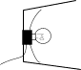 | 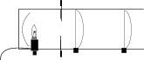 | 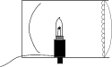
Section view of a floodlight | Section view of a profile spotlight | Section view of a PC (pebble convex)
Floodlights are the simplest of all theatre lanterns, consisting simply of a light source (and reflector) in a box with one open side. As floodlights do not use lenses, they provide a wide, unfocussed and even distribution of light over a large area. There are several types of floodlight, defined according to their use.
A single unit which is hung or floor mounted is simply called a flood. Floods are often used in rows or battens. A row of floods sitting on the ground to light a set are called a groundrow and a row of floods hung behind a border above stage are called borderlights or batten lights. A row of floods along the very front downstage edge of the stage are called footlights and a row of lights at the back of the stage to light the cyclorama are called cyclights. In almost all of these cases the strip of lights are in groups of three or four units, each with their own colour (red, blue, green and yellow).
Three different styles of floodlight, all doing the same job, providing broad, even light.
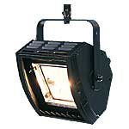 | 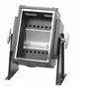 | 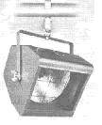
Spotlights
There are many different spotlights. The most significant difference between them is the type and number of lenses installed. Here are some lenses:
Plano convex lens side view | Plano convex lens front view | Pebble convex lens front view
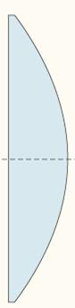 |  | 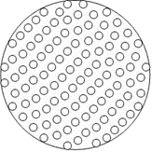

PC used to stand for Plano Convex and refer to a lens with one completely flat side and one convex side. PC now refers to a number of different lenses: Plano Convex, Prism Convex and Pebble Convex. Prism Convex lenses have a prism cut out of the plano side of the lens and therefore create a softer-edged beam. Pebble Convex lenses are the most frequently encountered type of PC in modern lanterns and have a pebbled surface on the plano side of the lens, again creating a more diffused light with a softer edge.
While an older PC has a very hard edge to the beam (due to the clear plano convex lens), a modern PC usually has a Pebble Convex lens and therefore a softer edge to the beam. This is due to the many different angles of the edges the light passes through. Because it is directed in so many ways it is therefore not as concentrated as a standard plano convex lantern.
PCs are used to provide acting area lighting and localised lighting for specific areas on stage. The beam can be varied from spot to (almost) flood. While the plano convex lens produces a hard-edged beam, the prism and pebble convex lenses produce a softer edged circular beam.

A standard profile spot | A typical PC pebble convex or plano convex with an amber colour filter (gel) attached
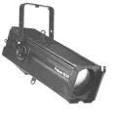 | 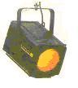
The extra length of the profile is because there are two lenses inside the housing and the extra movement required of the lenses for more specific focussing.
Fresnel spotlights are becoming one of the most frequently used lanterns in theatre lighting. The Fresnel (pronounced fren-ell) lens has a significant amount of material cut out of the convex side of the lens, with many angles built into the cuts (see the figure below). This creates a very diffused, yet still controllable beam. Fresnels are used to provide soft-edged wash lighting to acting areas or important set areas, or to provide a colour wash to a particular area. Fresnels can create a beam width ranging from spot to (almost) flood. Some fresnels even have a pebbled or stippled plano side to diffuse the light further. Many fresnels require barndoors to control or minimise spill light.

Fresnel lens – side and front views | Two typical Fresnels
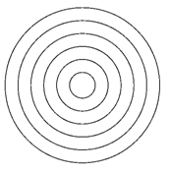 | 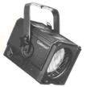  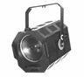
PAR (Parabolic Aluminised Reflectors) lanterns, often called PARs, PAR cans, or just cans, use a sealed beam lamp like an old car headlight. The filament, reflector and lens are combined into a single unit. The housing (or can) merely holds the lamp and any external hardware. They produce an elliptical (oval shaped) beam. PAR cans are a very efficient alternative to Fresnels if spill light is not a problem, as there is no control over a PAR’s beam. In fact, the beam spread and softness of edge are determined by the design of the lamp and the facets moulded into its lens.
A typical PAR 64
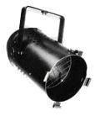
PAR cans are very well suited to use in the general acting area, as well as for wash and colour wash lighting where flare and spill are not a problem.
Pin spots and beam lights are designed to provide a very narrow beam of light. Pin spots use a five to ten degree beam spread and beam lights have an almost parallel beam. This is achieved by using a parabolic reflector and no lens (or a flat lens). Pins and beams are useful for providing accents or highlights, tight lighting on actors or objects, and for ‘searchlight’ effects.
Profile spots or ellipsoidal reflector spotlights use either one or two plano convex lenses to create a narrow, directional beam that can be varied and focussed. Profile spotlights often incorporate internal metal shutters and/or an iris and can accept a projection template or gobo, which enables them to project light patterns or designs. Modern profile spots can vary the beam angle by several degrees and a zoom profile can vary the spread angle by 20 – 25 degrees. Profiles are also able to adjust the beam edge from very hard to quite soft.
Profile spots are used to provide concentrated light on specific areas, actors or important features of a set, as they can project intense light over long distances.
These two section views show how the two plano convex lenses in a profile spot work together to alter the width of the beam produced.
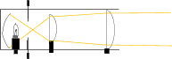 | 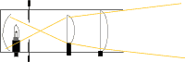

The followspot is simply a specialised, powerful profile spotlight which is mounted on a stand and usually fitted with its own dimmer, iris, colour magazine and shutters. It is situated in or above the auditorium and worked by a followspot operator. The light beam can be varied between one and ten degrees, have its size, edge and focus altered, and be moved around the stage to follow an actor.
A typical profile spotlight | Two different types of followspots
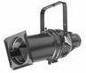 | 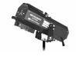 | 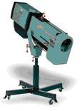

LED Lights
LED lights are also called LED Fixtures.
LED (Light Emitting Diode) Lights are gradually replacing incandescent lights in all areas of lighting production. As the technology improves and becomes more affordable, they are expected to totally replace incandescent lights. They have the advantage of being running at a lower temperature, using a substantially smaller amount of electricity and each light is able to produce different colours, reducing the need have having multiple lights focussed on the same area to provide different coloured lighting. Their greatest limitation is the intensity of the beam and the distance the light can throw. But every year improvements are being made and their beam intensity and throw range increases.
One of the big advantages of LED lighting that colours can be calibrated to suit film and television quite easily. Colour temperatures can be selected to best suit the needs of the recording
LED Lights are controllable by DMC (Digital Multiplexing). The intensity and the colour of the light can be controlled at the console. Each light or fixture is given an address in binary and that address allows it to be individually controlled by the console. If multiple LED lights are given the same address, they will all be controlled by the same channels on the console.
LED lights come in three main types
Flood Lights – often a single colour, but some are available with colour mixing capabilities. Often used outdoors as security lighting or coloured ones are used as cyclorama lights for stage work.
PAR Lights – these are used to produce a wash of light on stage. Usually RGB, but sometimes RGBW or RGBAW (red, green, blue, amber, white). The beam is not commonly adjustable, but you can get zoom versions. Sometimes silk filters are used to spread and soften the light.
Profile - these are a newer development and are the lights that will eventually replace standard incandescent theatre lanterns. They have the same functionality of a traditional incandescent zoom profile with the added bonus of being programable and have full colour mixing. Plus, they need a lot less electricity to power them.
Intelligent lighting
Intelligent lighting is any type of lighting that has automated colour and intensity control or has motion capabilities or both. It is sometimes called automated lighting, moving lights or moving heads. The lights are connected by DMX (Digital Multiplex). It is the standard digital communication protocol that is used to remotely control intelligent lighting fixtures. Intelligent lighting is used extensively in live music events, televised performing arts events, in television studios, ballets, Ice Skating Spectaculars, stage musicals and to a lesser extent in theatre. A light can be intelligent light, but not necessarily a moving light. LED pars have colour and intensity controls and are controlled by DMX, but are not moving lights.
Moving Lights
The lighting fixture (the light) can move around and changing colours and lighting effects all from remote commands or a preprogramed sequence. The fixtures are controlled by a master control system known as the lighting console. This console sends out control signals to the fixtures.
The lighting control console transmits instructions to each lighting fixture in the system and gives it direction in one or all of the following areas:
- Colour
- Pattern (produced by a Gobo)
- Focus
- Prism
- Horizontal movements (Pan)
- Vertical Movements (Tilt)
- Rotation speed
- Animation
Dimmer Racks
Dimmer Racks are used to increase or decrease voltage to a dimmable lighting fixture to adjust its intensity up or down. Usually used with incandescent halogen or specific kinds of fluorescent fixtures, dimmers provide the flexibility to set the mood and/or focus attention on a specific section of the stage. By adjusting the voltage sent to the light fixture, a dimmer can turn the light on, off or anywhere in between.
Dimmers can be portable (touring racks) or installation racks. Touring racks are more robust and have an external casing to allow for ease of transportation. Installed racks are more streamlined, designed to attached to a wall in a building.
Dimmer Racks can have a number of socket outlets common types are 6 channel, 12 Channel, 15 channel, 24 channel and 48 channel. Common amperages are 10 amp 3 phase, 32 amp 3 phase and 40 amp 3 phase.
Lantern Accessories
Filters
Filters, also known as Gels, are used to filter out unwanted colours. Therefore, if a red filter or gel is used, all colours except that exact shade of red are filtered out allowing the lantern to project a red beam of light. The darker the gel colour, the less light it transmits. A dark Gel blocks a lot of heat and burns out faster than a light coloured Gel.
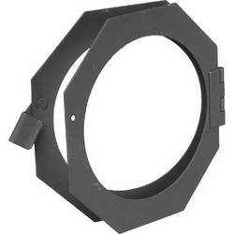
Gels are attached to lanterns using ‘Gel Holders’ which are a folded frame made of metal in which the gel rests. Depending on the type of lantern, the gel holder may be attached to the outside of the lantern or inserted into a specially made space in the body of the lantern
GOBOs
GOBO is an acronym for Goes Before Optics or Goes Between Optics.
A GOBO is a template placed inside or in front of a light source to control the shape of the emitted light. Lighting designers typically use for breakup patterns, to produce a patterned dark and light effect, to produce a pattern on a stage floor, to produce a pattern on the venue walls roof, proscenium arch or cyclorama. They can also produce a crisp, sharp edged pattern or design (of logos, fine detail, architecture, etc). They can be constructed from steel, glass, or heat resistant plastic (only for certain lanterns)
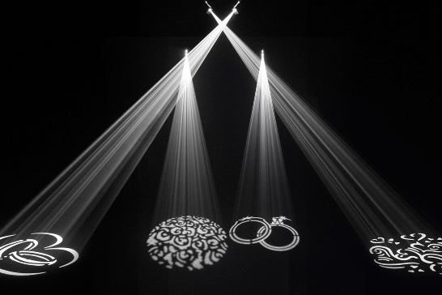
Barn Doors
Barn doors are fitted on the front on lanterns to shape the beam of light. They are very useful if you are projecting from Front of House and there is a light spill on the proscenium arch.
Example of barn doors
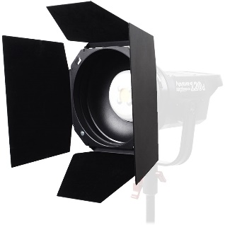
Knives
Profiles use knives instead of Barndoors to shape the bean. Whereas Barndoors are attached in front of the housing, Knives are insert into the body of the lantern.
Special Effects
Atmospheric effects - some of the atmospheric effects used are:
Dry Ice - Is frozen Carbon Dioxide. It creates a heavy low lying ‘fog’ that will flow downstairs. Dry Ice is not used as often now as it is dangerous, there is a risk of suffocation if people breath too much of it. Heavy fog has replaced it in many places.
Haze - Is a fine mist that is suspended in the air for a period of time. It cannot be seen except when there is a beam of light projecting through it. Television studios use a lot of haze.
Fog - A fog machine projects dense cloud of ‘smoke’. It is used to show the beams of light and to create more colour on stage.
Heavy Fog: A heavy fog machine uses a chiller to cool the fog down so that it stays low to the floor, rather than rising through the air like regular fog. It also uses a different fog fluid to regular fog machines.
Lasers - (Light Amplification by stimulated Emission of Radiation) produce a very high energy beam that remains parallel throughout its length.
UV Light - Ultraviolet Light: Also called UV or Black Light is a short wave light which makes certain material fluoresce (Glow in the dark effect).

2. Light mixing
There are some important things to remember when determining the lighting mix. It firstly, light acts differently to pigment colours. While the primary colours of pigments are red, yellow and blue, the primary colours of light are red, green and blue.
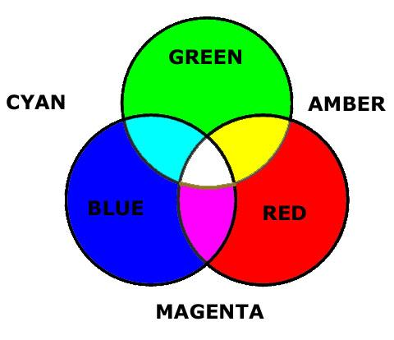
As the three primary colours of light are mixed, they tend towards white light and so it is obviously pointless to mix them equally as they cancel each other out. Also, as green light creates a ghoulish colour on skin, tending to make everyone appear sick, it is a less frequently used colour, particularly on its own.
How light mixes to create new colours is very important, but equally important is how coloured light reacts to the pigments in the set and costumes, or in the actors’ faces.
Subtractive and additive colour mixing
Colour mixing is combining the effects of two or more lighting gels and can be either subtractive or additive:
- Subtractive - placing two different gels in front of the same lantern. Subtractive mixing is used to obtain a colour effect that is not available from stock or from manufacturers, although the wide range of available colours is so wide that the need for subtractive mixing is reducing. Combining colours in this way reduces the light towards blackness. The three primary colours of light (Red, Green and Blue) mix subtractively to form black (or to block all the light).
- Additive - focusing two differently coloured beams of light onto the same area (for example Cyc Floods). Combining colours in this way adds the colours together, eventually arriving at white. The three primary colours additively mix to form white, as do the complementary colours.

3. Lighting Control
Despite the differences between lighting consoles, dimmer racks, lanterns and communication protocols between devices, there are a few general rules that can be applied to all incandescent (electric filament) lanterns. Firstly, individual faders on a lighting desk (board/controller) are connected to individual dimmers in a rack. Individual dimmers in a rack are connected to individual lanterns or groups of lanterns that will work together. By raising the level of a fader on the lighting desk you are increasing the amount of electricity passing through its dimmer and therefore the amount of light produced by the lantern/s. Whether the controller is an analogue desk, or a digital one transmitting DMX512 signals to a DeMUX converter and then to the dimmer racks, the concept is the same: one fader controls one dimmer, which controls the intensity of light produced. Of course, modern digital lighting desks can group (or gang) several faders together to enable them to be controlled by one ‘memory’ or ‘preset’ fader, making plotting an entire production much more convenient for the operator.
With the advent of more moving lights and LED (Light Emitting Diode) lights, consoles have to control so much more information. No longer is the only thing a console has to do is to increase and decrease the intensity of a lantern. Now there are more parameters, such as colour, pan and tilt, strobing effects, Gobo control etc. Many modern consoles do not have faders. Each fixture (light) has a template made which is added to the console. Entire lighting scenes and often shows are pre-recorded and each lighting state is activated by the click of a button. Even up and down times for each fixture is programmed. Older consoles may have had one or two DMX universes, modern consoles have multiples of DMX universes. The Jands ETC GIO-4K GIO 4K Lighting Console has 16 000 control channels. A computer monitor is essential for operating this type of console.
Computer programs are being used more frequently for lighting control. Computer software that emulates a lighting console such as the GranMA2 for PC which allows you to control the lighting for the production from a computer.
Visualisation software has replaced the scale models that were used by earlier generations of lighting designers. Products such as MA3D (for grand MA consoles), Capture, Clarity, ChamSys MagicVis and many more allow you to design your show with the fixtures that you have available. You input the parameters such as the stage dimensions, rigging points, lighting fixtures etc and this allows you to design the lighting and run trial simulations of your lighting. This information can then be transferred to your console and you have a basic lighting design for your production.

4. Personnel – Live Production Roles
Role | Responsibilities/duties
Director | Overall, in charge of all artistic content
Producer | Responsible for the financial and contractual side of a production. Employs crew, manages budgets, liaises with venues etc
Lighting Director | A lighting designer for television is known as a lighting director
Lighting Designer | Member of the production team for a show who is responsible for the overall look of the lighting. They may have an Assistant Lighting Designer who concentrates on the necessary paperwork for the lighting design. The Lighting Designer (or LD) is responsible for liaising with the director about style and with the set and costume designers about colour and decides on the position, type, focus direction and colour of every lighting instrument in the rig. They draw a lighting plan to communicate this to other members of his team (and to the theatre staff who are rigging the lighting). During a lighting plot, the lighting states are built.
Lighting technician | Lighting technicians are involved with rigging stage and location sets and controlling artificial, electric lights for art and entertainment venues (theatre or live music venues) or in video, television, or film production.
Production electrician | The production electrician is responsible for all lighting elements of production, including (but not limited to) tech tables, running lights and any other elements as defined by the L&S Supervisor
Technical manager  (Technical Director) | The TD (Technical Director) is the person responsible for supervising set up and maintaining the technical parameters of the production's video images.
Venue manager | In charge of the venue overall. Oversees bookings, venue security, venue staff
Technician On Duty (TOD) | Employed by the Venue Manager to assist technicians hired for the event with their knowledge of the venue and its technical equipment
Follow Spot Operator | Sets up and operates camera. The camera may be on a tripod or shoulder mounted

5. Lighting Context
Lighting has wide and varied contexts in many different areas of the Entertainment Industry. Traditionally we think of lighting in the context of a rock concert or theatre, but it is used in many more commercial contexts.
Corporate lighting
Corporate events are one of the largest areas of employment in the Entertainment Industry. Businesses use lighting in their product launches, trade shows, public meetings and large corporate celebrations. Political parties employ lighting companies to light their campaign speeches and public announcements. Corporate events are often as lavish as major rock concerts with moving and effects lights, haze, fog and pyrotechnics used to increase the excitement for the new product.
Film
Lighting plays an integral part of the film industry. Whether the film is be being shot (filmed) indoors or outdoors, lighting is used. An outdoor scene requires consistent lighting. Often the parts of an outdoor scene will be shot on different days, natural lighting will not be consistent, so additional lighting is provided to ensure that the natural light does not cause inconsistencies in the final scene. Large Reflectors are used to provide a diffuse light over the scene.
TV (Television)
A large percentage of TV is shot indoors. Therefore, lighting is required to enable a clear and consistent footage of the scenes being filmed. As per outdoor film production, lighting is required to assist in the production of a consistent, well distributed final film. Television studios use a lot of haze when they are producing music shows, the haze allows the beams of light to be seen moving around the studio.

Theatre and Opera
Lighting is used in theatre and opera for the following reasons
- Illumination: Required so that the audience can see the actors
- Attention: The audiences’ attention is drawn to where the director wishes it to be
- Mood: To set the mood of the scene. Is it a happy or a sad scene? Lighting is used to affect the audience’s mood
- Time/Place: It sets a time and place for the scene to occur (season, time of day, indoor/outdoor)
- Enhance: The work of the set and costume designers is enhanced by enabling the costumes and set to be seen as the designers intended. It can also help with making the set appear realistic.
- Extend: Can be used to add to the set. In collaboration with the set designer, effects to extend their work (for example, window gobos, cyclorama, skylight moving shadows etc).
Concert Lighting
Lighting for Theatre and Opera is designed to subtly enhance the set, the scene and to make the actors visible. It is not intrusive. Live concert lighting is different, the lighting effects need to be seen. Fog and haze are used to allow the beams of light to be seen as they illuminate the stage. Lights and beams of light are projected back into the audience to create greater excitement and effect. Often the performers are not perfectly lit for the audience to see them, sometimes they are only partially lit for effect. Moving lights have become an expectation at a live music event. Pyrotechnics are also regularly used at live music concerts.
Ballet
The lighting for Ballet is more subtle than the lighting for concerts, but more obtrusive than theatre lighting. In Ballet, the focus is on the form and movement of the dancers. Lighting is used to focus the audiences’ attention on the principal dancers and to create mood and atmosphere. Haze and fog are often used to create a more interesting atmosphere.
Interrelationship with other technical and creative areas in live production
Lighting is used to assist setting the mood of production. It may be flashing exciting lights for a live rock concert, beautiful gentle colours for a classical ballet or setting a mood and time of day for a theatrical production.
Costume
During the production process, the lighting designer will be consulted regarding costume colours. The colour of costumes will be affected by the lighting used. For example, if designing the lighting for Grease, the pink ladies’ jackets must look pink. Using lanterns such as parcans on a lower power in the scene where the jackets are worn would result in the jackets having a more salmon appearance.
Filming
If the production is going to be filmed lighting colours should be selected which are compatible with camera’s sensors. LED Lights can be programmed for different colour temperatures to assist with this process. Often beautiful vibrant purples can become blue on the video, whites can be too harsh. Often it has to be decided whether the appearance of the live production is more important than the filmed of the production. If a filmed product is the priority, the lighting designer will have to work closely with the Vision Designer to ensure a suitable colour palette for the production.
Screens
Lighting Designers have to take into consideration the placement of the screens for the production. While projectors are bright, follow spots and moving lights are usually brighter and a spot or gobo moving across a screen can be very distracting for the audience. Additionally, if the screens are positioned above the stage, lighting will need to ensure that there is no spill from the Front of house bar lights. This is often solved by using Barn Doors or Knives to cut out any light spill to the screens.
Electricity
Lighting is the biggest consumer of electricity in a live production event. Available power needs to be carefully allocated. In large venues which regularly hold events. Lighting usually has its own dedicated circuits and the Lighting Designer needs to work within the power available. Big outdoor events use generators and Lighting usually have their own generators, separate to Vision and Audio. The most difficult events are events where there is not a lot of power available and there are no allocated circuits for Lighting Audio and Vision. For this type of events, the three areas must discuss their needs and negotiate the allocation of power. LED lighting uses a lot less power than incandescent lighting, so this may be the solution needed for the event. But, if the venue only has incandescent lights available and the budget does not allow for the hire of LED lights, creative planning must be made. If the event is in a small hall, the power requirements for dressing rooms for example hair straighteners, blow dryers etc can easily take up an entire circuit. The kitchen may also have urns, which also take up a circuit each.
Audio
Discussions between Lighting and Audio need to be held to decide where the cable runs will be. If the audio cables are run too close to the lighting cables, every time the lighting changes state there will be a buzz through the speakers. Lighting and Audio must never be on the same circuit unless you want buzzes coming out of your speakers

6. Lighting Cues
A lighting cue is an instruction to change the lighting ‘state’ in a pre-defined way.
For example, LX1 Full Stage Wash at 30%
Lighting - Words & phrases
Build - to increase the intensity (brightness) of a lighting state or individual lantern.
For example: OK - can you go to blackout and we'll build a new state for the next scene’
‘At the end of the song, the state should build over 4 seconds’
‘Build the lectern as the presenter approaches’.
Restore - return to the previous level.
‘After the blackout restore to the state for scene two’
‘After the villain exits, restore to the afternoon at the fair state’
Check - reduce the intensity either of the whole state or down to a particular area of the stage.
‘Check the state slightly when the hero exits’
‘At the end of the song check to downstage right for the final note’
‘Check stage left as he moves to the right’
Crossfade - a lighting state which completely replaces the current state on stage with a new state. As one fades down the other fades up.
‘At the end of the scene crossfade to the downstage right special’
Special - a lantern used for a specific moment during the performance.
‘The downstage centre special needs to be refocussed onto the painting’
‘The special at the top of the stairs must be cut to only light the ghost’
DBO – Dead blackout. This means cut all the stage lights immediately. It is important that if a DBO is called for, that performers and crew are aware it will be happening and that there is still some working light available side and backstage. Emergency exit lights should be checked prior to the event as they must be working for an event to take place and are particularly important if a DBO is going to be used. Most commonly a DBO only lasts for a few seconds and then the lights come up on the next scene.

In and Out times for cues
Lighting cues will often have an in or out time. This means how long you have to take to fade the lights up to their desired intensity or how long to fade them down. This can be performed manually on an old style desk, but currently, this is a programable function on the digital console. You can also program the console to ‘snap’ to the cue which brings the lights straight up.
Line of Sight and Visual Cues
Sometimes a cue must be performed manually (no programming). It may be a cue that is actioned on a certain event on stage that may vary from each performance.
For example:
  - when the winner is announced bring up the special on the photo of the prize
  - whenever an actor turns a lamp on, bring up the special over the lamp.
For this to work successfully, the lighting operator must have a clear line of sight to the stage.
Busking
In live music events sometimes there may be a variety of bands, each with their own preferred look or colour palette. Apart from having pre-programmed scenes, the lighting operator may choose to ‘busk’ which means changing lighting states, colours and their intensity as the performance happens.

7. Electricity
Electrical problems may come from two areas: supply of electricity; and interference with signals.
Lighting consoles, dimmers, intelligent lights, and LED fixtures are all involved with both 240 volt supply and digital control signals. Lighting technicians more than others need to be aware of these two functional requirements. Lighting frequently runs numerous electric circuits operating at mains voltages, with amperages capable of causing blackouts from overloads, electric shocks, and even fires
Supply of Electricity
Lighting consoles, dimmers, intelligent lights, LED luminaires are usually 240 volt systems. Some equipment may use separate plug in power supplies. If so, be careful that the correct power supply is being used. Too high a voltage will fry the electronics, insufficient power (volts × amps) may end up in an un-scheduled blackout when the supply fails. Occasionally lights operating at 120 volts (for example, USA 1000 watt Par Cans) may be found. Some modern dimmers can control these, or special connector units may be required.
Ohms Law
Ohms law shows the relationship between the three important electrical parameters of Voltage, Current and Resistance.
Quality | Measurement unit | Abbreviation | Equation symbol
Current | Ampere (Amp) | A | I
Voltage | Volt | V | E or V
Resistance | Ohm | Ω | R

The algebraic expression for the ohms law relationship is:
V = IR
Voltage = Current × Resistance

This equation is seldom used other than in design of low voltage DC circuits, but if two values are known than the third can be calculated.
For example, if a car 12 volt battery runs a lamp with a resistance of 3 ohms, what current will flow in the circuit?

V = IR (rearrange to get unknown current on left side)
I = V/R
= 12 ÷ 3
= 4 Amps

While not often required for lighting calculations, when related to other electrical parameters Ohms law helps to explain electrical effects such as inrush current, and why poor connections may escalate exponentially in temperature to cause hot terminations and potential fires.

Calculations about electricity.
You are required to know the formula for calculating power and know the Ohms law equation.
You must know these basic facts:
- A standard power outlet in Australia supplies electricity at 240 volts.
- A standard power outlet in Australia is rated to carry 10 Amps maximum.
- A standard power outlet in Australia can supply a maximum of 2400 Watts.

Calculation of power.
Power, or work (watts) is arrived at by multiplying electrical pressure (volts) by current (amps) That is: Watts = Volts × Amps

From these basic facts:
Australian outlets work at 240 volts and can legally supply 10 Amps.

So maximum available Power is
= Volts × Amps
= 240 × 10
= 2400. (This is the maximum to be drawn from a standard domestic power point.)

8. Safety
Electrical Safety
Prior to using any piece of equipment, complete a physical inspection of the equipment, look for damaged cables and connectors and any evidence of external damage. Then check the test tag is in date. Do not use any equipment if it is damaged or the test tag is out of date. Do not attempt to repair any damaged electrical equipment unless you are a licenced electrician.
General Safety
When preparing for rigging lights the following things must be taken into consideration
All lights must have safety chains
Height Safety –
How high you are allowed to work without a fall arrest system
Training in using a fall arrest system
Using scaffolding
Using a telescoping lifter – are licenses required for the height you are going to?
Clearing the area around you, not having items in your pocket etc
Safe lifting -
Know the maximum you can lift as an individual or in a team lift
Using pulleys and block and tackle – both manual and automatic
Using the correct posture when you lift
Venue Safety -
Know your venue fire and evacuation procedures
Ensure that security is provided in the venue for both you and your equipment.

9. Communication Protocols
The client usually communicates with the director, producer or technical director, rather than with the crew members. The technical director communicates with the crew supervisor eg Lighting Director in larger events, the Lighting team supervisor. If there is a technical issue, a crew member should report directly to their supervisor, rather than the technical director (the technical director’s role is more ‘big picture’ overseeing role, not dealing with a broken lead.
At all times, the client must be treated respectfully and made feel confident in the ability of the crew.
Prior to the production meeting, the client will have supplied a document outlining their requirements. A pre-production meeting with the client and the director, producer and technical director will occur where the client will discuss their requests and any issues pertaining to these requests will be discussed. In some events, the client is also the director.
During the live production, communication between crew is usually over comms or ‘cans’ as they are known in Entertainment Industry jargon. During the live production, the stage manager is in charge and will give cues to lighting, audio and vision. In corporate events, the stage manager is called the ‘show caller’.
Post-production, the client has a meeting with the director, producer and technical directors. This is where the production is evaluated and improvements for the next event are discussed. In corporate work, the client may not attend the meeting. They may provide feedback to the director instead.
Meetings are held within production areas pre-production and post-production, these are usually run by the Head Technician of each area, for example Lighting director.

10. Workplace Procedures and practices
Prior to a live event taking place the client contacts a production company to produce and provide technical support for their event. Budget, venue, audience size, technical requirements are discussed. The event producer then employs a production company to manage the live production for the event. One such Australian Company is Encore Technologies, formerly known as Staging Connections.
Once the budget and other details are agreed upon, the production company proceeds to take over running the technical production side of the event.
Prior to the day of the event, crews bump in and test the equipment. Equipment is set up according to the plans that have been provided by the Vision Designer.
In some cases, there will be a technical rehearsal if there are performers involved. This allows all systems to be checked, camera angles modified, sound and lighting checks and the performers to be comfortable on the stage.
When the event has finished, the equipment is bumped out and returned to storage where it will be checked for damage. Equipment logs will also be checked through as technicians may have noticed faults with the equipment and noted it in the log. At this time equipment is also cleaned so it is ready for the next production. Inventory is checked to ensure that all equipment is accounted for. Equipment maintenance logs are completed at this time.

11. Troubleshooting and problem solving
If equipment is not working correctly, troubleshooting procedures need to take place. Often the problem will be a damaged lead or connector which can usually be quickly rectified.
If this is not the case, check the company equipment log to see if this piece of equipment has any know faults and fixes. If that does not help, check the equipment manual, sometimes a problem may be a simple thing that has been overlooked. You can also look online to see if other’s have had the same problem with the equipment. Also check with workplace colleagues. Some equipment can be a little ‘temperamental’ and other colleagues may be able to show you how to fix it.
Equipment malfunctions can cost a lot of time at a bump in and can cause considerable stress to the technician. Sometimes, if it is within your level of authority, it is just quicker to get another piece of equipment from stores to substitute the malfunctioning piece of equipment. It is important to log any equipment faults, otherwise, you may be facing the same problem at the next event. If a piece of equipment gives you an electric shock, do not continue using it, label it and log it and find a substitute piece of equipment.

12. Industry Jargon
Every industry has its own jargon, it is important to learn the jargon so that you can communicate easily with other crew members.

Some examples
‘The Talent’
This refers to anyone performing or presenting – the reason for the event. So, the talent might be a person giving a speech or someone doing a dance. It is not meant to be judgemental.
The ‘Gig’
The ‘gig’ is the event, whether it be a wedding, a corporate event or a major musical event, it is referred to as the ‘gig’
Bump In/Bump Out
This refers to setting up and packing up of the event
Throw
Throw is the distance a lantern projects a beam of light.
Bubble
This is industry specific jargon for a lamp, which non industry people would call a globe.
Dome
Industry jargon for a Followspot
Cans
Industry jargon for a communication system
Gel
A filter put in front of a light to change the colour of the beam of light. Originally made of gelatine.
Mover
An intelligent light that can move

Key terms and concepts
You can use the following information to revise the key terms and concepts from this unit.
You could add an example of this term or concept which is relevant to the entertainment environment. If the key term was ‘lighting components’ your Entertainment Industry example might be ‘lanterns, dimmers, patch bays, lighting desks or boards’.
Search for more terms and their meanings at theatrecrafts.com.
3 phase power
Electricity is generated and supplied to large installations in three phases. The Red, Yellow and Blue phases are all supplied down one cable to the building but effectively give three separate supplies. This is usually the power supply for dimmer racks in a theatre lighting system.
Cables
All electrical components in a lighting, sound or AV system are interconnected with cables - wiring which has been temporarily rigged to carry electrical current. Depending on the size of the cable (current carrying capacity), cables are used to supply individual lanterns, whole dimmer racks, or carry signals from a microphone etc.
Career pathways
the different areas of production and the levels of responsibility/creativity in each area. The main areas of work in lighting include live theatre and events such as rock concerts etc. and television and film lighting. The levels of responsibility range from lighting hand and lighting technician to lighting operator and lighting designer.
Cleaning, maintenance and storage of light equipment and accessories
Obviously maintenance and storage of lighting equipment is critical to its efficient use. Lanterns and their accessories should be cleaned regularly as dust build-up on the lens is one of the most frequent reasons for inefficient light operation. Lanterns and accessories should be stored in a clean and dry place and all items should be tested regularly.
Colour call sheets
lists compiled from the lighting plan of all the colours needed for the rig, and their size. This term also applies to the act of preparing colour filters and frames from these lists.
Communication
Usually referred to as ‘Comms’, communication systems used by lighting personnel are usually two-way ‘radio’ or wired systems designed so that each person can listen and speak to every other person using the system. Wired systems are often called a ‘Comms ring’ as they are set up in a series or a loop of devices connected one after the other.
Dimmers
the electrical or electronic devices which control the amount of electricity passed to a lantern, and therefore the intensity of the lamp. Dimmers are like active transformers, responding to the levels sent to them from lighting consoles and passing those levels on to lanterns. Dimmers are often grouped together into a cabinet or housing of some sort and called a ‘dimmer rack’.
Documentation
examples include:
- Lighting Schedule - a list of available lanterns
- Colour Call Sheets- a list of required colours
- Lighting Plan– a scale drawing detailing the exact location of each lantern used in a production as well as any other relevant information (for example its dimmer number, focus position and colour number). This is often drawn from the theatre’s ground plan.
Effects of colour
Depending on the context, this could refer to special lighting effects (gobos or strobe), special visual effects (fog machine or pyrotechnics) or sound effects (thunder, vocoder, smashing glass). It could also be audio devices designed to treat (effect) audio signals such as compressors, reverb units or equalisers.
Electrical safety
refers to the precautions and safety measures taken when using electricity or electrical devices, so as to avoid danger, damage, injury or death. Wearing insulated shoes (with rubber soles) or using fibreglass or plastic ladders are two examples of precautions which can be taken.
Lamp types
There are several different types of lamp (domestically called a light bulb): incandescent bulbs, fluorescent bulbs, LEDs (Light Emitting Diodes) but all of them turn electrical energy into light (and almost invariably heat as well).
Licensing requirements
Licensing requirements most often refers to the ‘hire’ of the performance rights to a written/composed work for a set period of time and the strict adherence to obligations with regard to advertising, copyright and intellectual property. There are similar conditions applied to lighting devices.
Light beam accessories
devices added onto a lantern or inserted into a lantern that are used to alter or manipulate the beam of light emanating from the lantern.

Light theory
Light theory includes both the physics of light waves/beams/particles and additive and subtractive method of mixing of pigments or paint. While the primary colours of paint and pigments are RED, YELLOW, BLUE, which, when mixed, tend towards black, the Primaries of Light are RED, GREEN, BLUE, which, when mixed tend towards white. Secondaries of Light are Magenta (Purple), Cyan (Light Blue) and Amber (Yellow).
Lighting components
There are a variety of common components in a lighting system including lanterns, dimmers, patch bays, lighting desks or boards. Other lighting components may include lighting bars, stands and accessories.
Lighting control systems
These include lighting boards, lighting desks, light controllers, DMX Controllers and any other device that is used to control the lanterns being used.
Lighting desk (board, controller)
the main control for the stage lighting. Originally known as the switchboard or dimmerboard, it is now usually remote from the dimmers. The lighting operator for a show is often said to be ‘on the board’ and is sometimes known as the ‘board op’. In the U.S., the lighting desk is referred to as the light board.
Lighting equipment
includes everything from the lanterns to dimmers, controllers, accessories such as colour frames, donuts, barn doors and gobos, cables, stands, lighting bars, safety chains, hooks, clamps, gels and bubbles.
Lighting operations
refers to preparing for or undertaking the job of illuminating objects or changing lighting states.
Lighting personnel
includes all people involved in lighting operations: lighting hands, lighting technicians, lighting operators, lighting designers and lighting directors.
Lighting plan
a scale drawing detailing the exact location of each lantern used in a production, as well as any other relevant information, such as its dimmer number, focus position and colour. The lighting plan is often based on the theatre’s ground plan.
Lighting schedule
a list of lanterns (and other components and accessories) available for use at a particular theatre or venue.

Lighting technician
a person with the knowledge, skill and expertise to rig, set up, replace lamps, focus and basically operate professional lighting equipment.
Organisational procedures
procedures specific to an organisation which are used to ensure its proper running and appropriate administration. They may include safety audits, fire drills, maintenance audits, staff meetings, production meetings, bump in/bump out, technical rehearsals etc.
Patch location
the specific position or location of a device with particular reference to the patch panel or bay to which it is connected (usually a number).
Patching
the act of interconnecting devices in a (lighting) system, especially connecting lanterns to dimmers. Lighting circuits around the stage area can be cross-connected to a chosen dimmer, often using a cross-connect panel (sometimes called a patch bay or patch panel), which enables any stage lighting channels on the control desk to control any dimmer or group of dimmers. Some large lighting boards have the facility for soft patching - a totally electronic way of patching. Some rock desks have a pin patch which allows groups of dimmers to be allocated to a particular control channel.
Positioning point
the actual physical position in which a lantern is hung or placed in a theatre or venue, whether on bars, stands or on the stage or floor.
Production plan documentation
documents related to the preparation and planning of a production, including schedules, rosters, ground plans, site plans etc.
Reporting
the lines of communication and hierarchy of reporting within a team, crew, production company and/or enterprise or organisation. All workers should report to their immediate supervisor.
Rigging
the construction or arrangement of lighting equipment for a particular production as well as the act of installing lighting, (sound equipment and scenery etc.) for a particular show.
Safe work practices
Safe work practices require following correct WH&S procedures to ensure the safety of all workers doing their job. These include turning off power and disconnecting lanterns when installing or repairing units, using correct lifting techniques, wearing protective clothing, harnesses, shoes, gloves etc., as required, and ensuring appropriate noise, light and platform levels when working at height.
Subtractive and additive colour mixing
Colour mixing is combining the effects of two or more lighting gels and can be either subtractive or additive
Work health and safety (WHS)
The relevant health and safety considerations for (in this case) lighting technicians include heat, height, weight, position and the electrical current of lanterns, their installation and operation.

Activities
- You are employed as Lighting Director.
During the technical rehearsal, the Vision Director asks you to change your colour palette as the video recordings show the whites as too bright and the purples as too blue.
How would you respond if:
  - This is an event that will be televised live to millions of people
  - This is a very big live event and the video from this event will be recorded and may possibly be shown to the parents at a later date.

- Name two advantage and two disadvantages of using LED Lights rather than Incandescent lights.

- The client has specified that they want a lot of ‘smoke’ in their rock band event at a local community hall.
  - What equipment are you going to use as Smoke machines have been outlawed since last century?
  - Before filling the venue with Fog, what precautions should be taken?

- Name two types of cables used extensively for stage lighting.

- You have set up your LED lights. When you bring the first one up to 80% intensity and Blue colour, all the lights do the same thing.
  - What might you have done wrong in your set up?
  - How will you rectify the problem?

- Complete the following find-a-word. You may have to print this page.
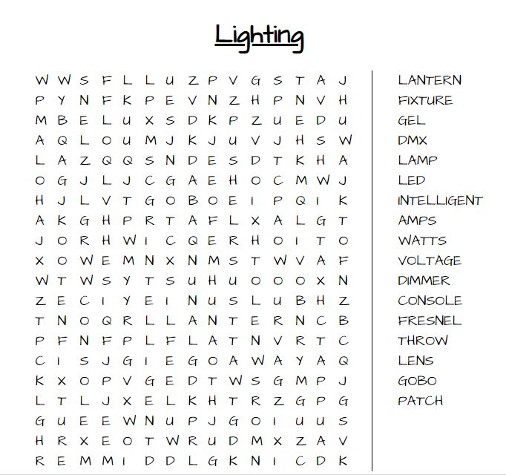

- Identify each of the following illustrations of fixtures, using answers from the list below.

Choose from these fixtures
Profile Spot | Parc Can | Moving Light | Fresnel
Flood Light | Pin Spot | PC
Name:
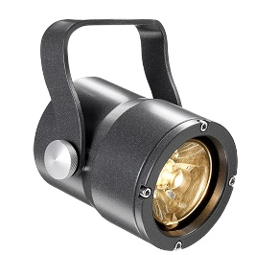
Name:
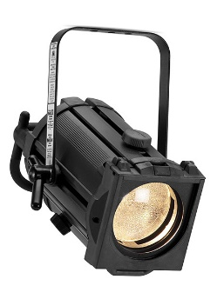
Name:
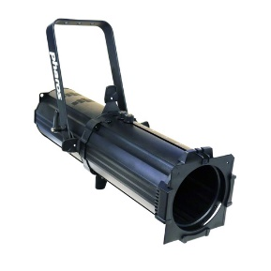
Name:
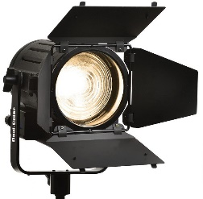
Name:
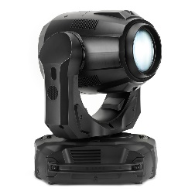
Name:
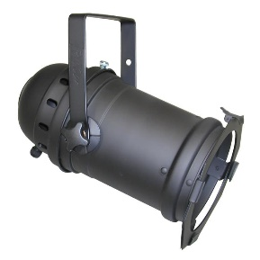
Name:

- What is this accessory called and what function does it perform? What alternative materials can it be made from?
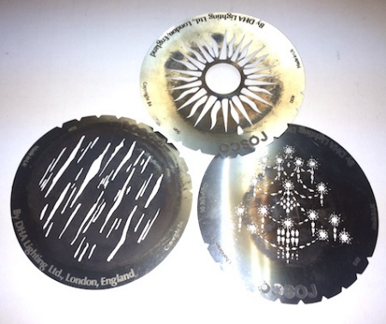

- Identify the type of lantern and label the following items: filter holder, knives, yoke.
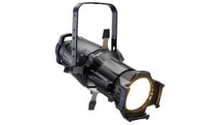
- Identify the type of lantern and label the following items: filter holder, barn doors, yoke.
. 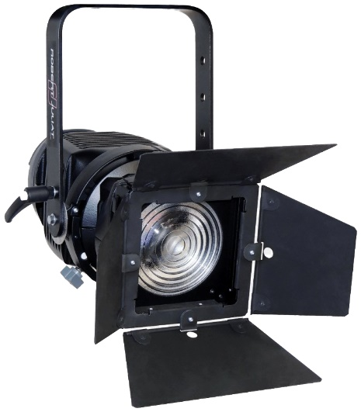

- You have to design a small indoor lighting setup in a classroom.
You have available eight PAR 56 lights with hook clamps and two stands, and two small ground row/cyclorama lights on floor stands to light the rear wall. Each of these ten lights has a 300 watt globe in it.
You have a high quality ‘power board’ with four standard power outlets to supply the lights you decide to use. [‘Power boards’ are called Extension Power Outlet Devices – EPODs for short]. The EPOD has a standard Australian 3 pin plug on it, and a circuit breaker button labelled 10 Amps maximum on its end.

  - How many of these ten 300 watt lights could you run from the EPOD at the same time?

Some info to help you answer the question
A standard Australian power outlet will supply 10 amps at 240 volts.
This EPOD has a circuit breaker limiting it to 10 amps at 240 volts.
  - So, the EPOD connected to the wall outlet can deliver 10 amps.
Maximum power available = Amps × Volts
  - Each lamp has a 300 watt globe, so:
  - Number of lamps to run = Maximum watts available ÷ watts for each lamp
Another way to work it out from knowing the basic fact a power outlet supplies 2400 watts is
  - One lamp requires 300 watts.
  - Eight lamps would require 8 × 300 = 2400 watts
  - This would be the maximum on at one time.
Knowing the basic facts that 2400 watts or 10 amps are available from a power outlet means you should never overload and trip a circuit. Practise adding up how much power is being drawn from wall sockets as you come across them.

  - You are asked to use the same ten lanterns as above but have a JANDS 4 Pak lighting controller. Each of its four channels has a standard power outlet labelled at Maximum 10 Amps. There is a fader for each channel, a grand master fader for over-all control, and some ability to run chases. The unit has one 10 amp plug inlet labelled as 10 amps maximum, so you are still limited to 2400 watts or 10 amps to run everything.

  - How can you be more creative with using all the 10 available lights by using the 4 Pak?

Putting the theory into practice
The following questions are from past years’ NSW HSC examination papers for this subject. HSC exams are intended to be rigorous and to challenge students of all abilities. To better understand a question, you should look for key words and identify the aspect of the course to which these relate. You are then in a position to formulate your answer from relevant knowledge, understanding and skills.
All questions in ‘Putting the theory into practice’ are acknowledged © 2019 NSW Education Standards Authority (NESA) for and on behalf of the Crown in right of the State of New South Wales.

Multiple Choice
- What does soft patching refer to in the lighting department?
  - Connecting lighting fixtures on a lighting bar
  - Assigning lighting fixtures on a lighting console
  - Connecting lighting fixtures directly to a dimmer
  - Assigning lighting fixtures to different rigging points
- What does the abbreviation LED stand for?
  - Light-emitting diode
  - Lux-electronic diode
  - Lux-energy distributor
  - Light-energy distributor
- Which of the following sets of requirements is always necessary when rigging lights above the stage?
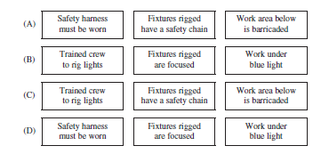
- What is the measurement between a lantern and the stage known as?
  - Beam angle
  - Lantern spread
  - Throw distance
  - Lantern intensity
- A Fresnel with a red gel and a Fresnel with a green gel are overlapped on a cyclorama to create a yellow wash. This is an example of which type of colour mixing?
  - Additive
  - Impossible
  - Split
  - Subtractive
- Before rigging lanterns for a performance you check the patch plan below to ensure that none of the circuits will be overloaded. Which patch in the plan will overload its circuit?
 | Patch number | Lanterns
a) | 1 | 2 x 1000-watt profiles
b) | 2 | 6 x 350-watt par cans
c) | 3 | 2 x 1000-watt Fresnels  1 x 500-watt Fresnel
d) | 4 | 4 x 300-watt cyc lights  1 x 1000-watt Fresnel

- In which of the following is it important to know about Ohm’s law?
  - WHS legislation
  - Electrical circuits
  - Staff to audience ratio
  - Test and tag procedures

- What action should a lighting technician take when a fuse keeps blowing for no apparent reason?
  - Report the fault
  - Notify an electrician
  - Tape over the patch point
  - Replace the fuse each time it blows

- Which of the following diagrams represents three-phase power?
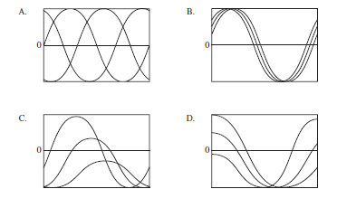
- What is the most likely long term consequence of hanging a lantern upside down?
  - Gel burnout
  - Shorter lamp life
  - Accessories may fall out.
  - Risk of lantern falling off the bar
- What sequence of procedures is undertaken during a lighting focus session?
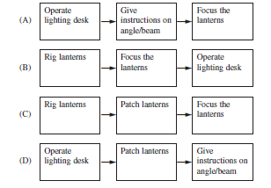

- The most appropriate use for a fresnel lantern is to create
  - a general wash on stage.
  - effects using a mirror ball.
  - a pin spot on a staging element.
  - a patterned image using a gobo.

- How is electricity supplied to automated lighting?
  - Direct power
  - Dual systems
  - Distributed patching
  - Distributed dimming
- A lighting designer using a profile wants to create a square of light on the stage.
Which lighting accessory would be most effective?
  - Iris
  - Top hat
  - Shutters
  - Barn doors
- What is the correct order of steps when rigging a fresnel lantern onto a lighting bar?
  - Attach the safety chain, patch the lantern, focus the lantern, adjust the barn doors
  - Patch the lantern, attach the safety chain, adjust the barn doors, focus the lantern
  - Adjust the barn doors, patch the lantern, focus the lantern, attach the safety chain
  - Focus the lantern, patch the lantern, attach the safety chain, adjust the barn doors
- What is the list of all of the lights to be used in a production called?
  - A cue sheet
  - An inventory
  - A lighting plan
  - A lantern schedule

Questions from Section II
These questions should be answered in the suggested number of lines (handwritten) as it gives a guide to the length of your response. Plan out your answer and key points before you commence writing
Question 1
  - Outline possible consequences on employees of poor stage lighting equipment maintenance. (2 marks)

  - Describe the possible consequences of poor maintenance of stage lighting equipment on an employer. (3 marks)

Question 2
  - One LED lighting fixture in a chain of LED fixtures is receiving power but not responding. What technical steps should be taken to rectify this issue? (2 marks)

  - A tungsten lighting fixture is not functioning. Describe the troubleshooting procedures that should be undertaken to identify possible causes. (4 marks)

Question 3
  - Explain how different lantern accessories can be used to change the shape of a light beam. (2 marks)

  - Explain how the internal components of a lighting fixture affect the focus of the light beam. (3 marks)

Question 4

  - Describe the technical requirements a lighting technician must consider when installing moving light fixtures. (3 marks)

  - A lighting technician is seriously injured by a falling light fixture. Describe the reporting procedures required of the PCBU following this injury. (4 marks)

Question 5
A lighting designer has been employed for a school formal at a function centre.
The preliminary site visit reveals:
  - The dance floor is located in the centre of the room
  - There are no available rigging points
  - There is a single 3 phase power outlet
  - There are TWO 240 volt circuits available

  - What are the technical considerations in providing lighting for the event? (5 marks)

  - Describe the lighting equipment and accessories that can be used to create effects and mood for this event. (3 marks)

Question 5
Use the lighting plan shown to answer parts a) and b).
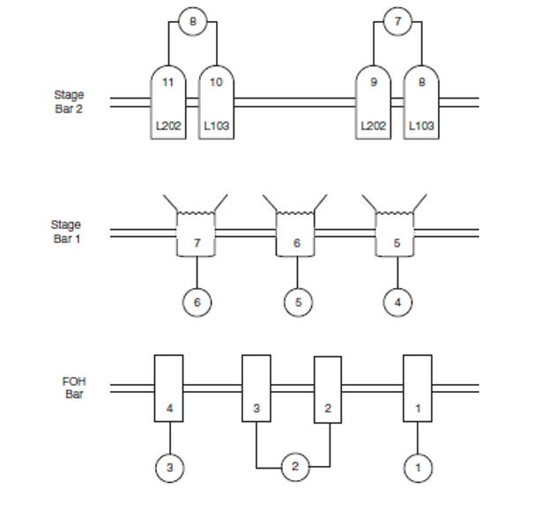
  - Describe how channel 4 differs from channel 8. (3 marks)

  - The lighting plan is for a touring production.
Using lighting-specific terminology, describe how the information on the lighting plan could be incorporated into lighting systems in different venues. (4 marks)

Questions from Section III
The Section III question in the HSC is worth 15 marks -
- there will be one structured extended response question.
- the question will have two or three parts, with one part worth at least 8 marks.
- the question will have an expected length of response of around four pages of an examination writing booklet (approximately 600 words) in total.
You may be guided to answer different parts of a question in SEPARATE writing booklets.

Questions from Section IV
There will be one extended response question in Section IV (15 marks) of the HSC. This will provide you with the opportunity to:
- demonstrate knowledge and understanding relevant to the question
- communicate ideas and information using relevant workplace examples and industry terminology
- present a logical and cohesive response
The expected length of response for questions in Section IV is around four pages of an examination writing booklet (approximately 600 words).
You should allow about 25 minutes for a question in Section III and the same for Section IV of the exam.
You will note that these questions usually require you to bring together knowledge from several areas of study/competencies to do justice to the answer.

In each of the following, map out your answer using post-it notes or a sheet of paper. Pay particular attention to incorporating a variety of aspects of your Entertainment Industry curriculum into the plan. Consider why we have included this question within this Lighting module and what other areas of study you would need to draw upon.

Question 1
A lighting designer has been approached to work on two different productions. The first is a small drama production in a 200-seat theatre with a thrust stage; the second is a musical in a 2000-seat theatre with a proscenium arch stage.
Compare the lighting techniques, personnel and equipment that the lighting designer would use to light both productions effectively.

Question 2
Discuss current and emerging technologies used in different areas of the production of a live, televised talent quest.

Question 3
An industry trade show is to be held in a convention centre with a 1000 person capacity. The event includes keynote speakers on the main stage, audiovisual displays and supplier stands.
Describe the technical requirements and safety considerations for this event.

HSC Focus Areas
For the purposes of the HSC, all students undertaking the 240 HSC indicative hours course in Entertainment Industry must address all of the mandatory focus area content.
The scope of learning describes the breadth and depth of the HSC Content and has been grouped together into key ideas/areas. The scope of learning describes the minimum content that must be addressed, and the underpinning knowledge drawn from the associated unit(s) of competency.
The unit of competency associated with the mandatory focus area ‘Lighting’ is CUALGT301 Operate basic lighting

Entertainment Mandatory Focus Areas include:
- Audio
- Customer service
- Lighting
- Safety
- Staging
- Vision
- Working in the entertainment industry

How to use the scope of learning (which follows over):
- draw up your own mind map showing the connection between the various concepts listed; examples appear on the last page of this module
- use the key terms and concepts to add to your mind map
- add examples or case study prompts to show how the concept is applied in the entertainment working environment

The following information is taken directly from page 31 ff of Entertainment Industry Curriculum Framework Stage 6 Syllabus (NSW Education Standards Authority) for implementation from 2020. © 2019 NSW Education Standards Authority (NESA) for and on behalf of the Crown in right of the State of New South Wales.

production context
- industry-accepted terminology and commonly used jargon in the entertainment industry:
- specific to lighting
- variations:
    - between analogue and digital lighting systems
    - across production environments/contexts and workplaces
- general scope of lighting operations across different production contexts
- role and responsibilities of various personnel in relation to lighting operations:
- director
- producer
- lighting designer
- lighting technician
- followspot operator
- lighting operator
- production electrician
- technical manager
- venue manager
- protocols for communicating with the customer/client, colleagues, a performer/presenter and supervisor about lighting operations:
- pre-production
- during production
- post-production
- documentation commonly used in lighting operations:
- lantern schedule
- lighting plan
- lighting cue sheet/plot
- for each of these documents:
- purpose
- standard format(s) and common features
- content
- abbreviations, terms and conventions (including notations, universal lighting symbols and scale)
- modifying/updating documentation:
- personnel with authority to modify/update
- processes
- importance of ensuring currency of version and the status of any amendment
- application of documentation for lighting operations to specific job roles and work tasks
- read and interpret documentation for lighting operations to obtain and convey information

production context cont/d
- how lighting requirements vary across different:
- live performances and events
- indoor and outdoor venues
- various media (such as film, television and theatre)
- interrelationship between lighting operations and other technical and creative areas in the production of live performances and events
basic theory
- electricity:
- Ohm’s Law:
    - principle (V=IR)
    - relationship between voltage, current and resistance
- calculation of power loadings
- electrical power (watts and kilowatts)
- electric current (ampere)
- three-phase and single-phase power
- lighting:
- beam angles and throws
- colour and colour mixing
- effect of colour on objects and mood
- key, fill and back light
- light sources:
    - tungsten-lamp
    - LED (light-emitting diode)
- positioning of lights for particular effects
- application of electrical and lighting theory to the set-up and operation of lighting
equipment
- consoles/desks:
- main types (analogue and digital)
- general features and functions
- controls and their function(s)
- peripherals and their function(s)
- operation/use during live performances and events:
    - channels:
- allocation
- inputs and outputs
- patching
    - digital multiplexing (DMX) distribution techniques, including allocation of channels on control desks
    - protocols
equipment cont/d
- lanterns/lamps/luminaires used in theatrical lighting:
- main types including:
    - digital moving (intelligent)
    - flood
    - fresnel
    - parabolic aluminised reflector (PAR)
    - pebble convex (PC)
    - profile
- for each type, general features, function(s) and operation/use (optical and mechanical)
- accessories used with different types of lanterns/lamps/luminaires and their function(s)
- cleaning
- dimmers:
- main types
- general features and function(s)
- operation/use
- for cables and connectors commonly used in lighting operations, the main types and their use(s)
- requirements for automated light systems
- special effects equipment commonly used in lighting operations
lighting cues
- purpose/function of lighting cues
- standard procedures used in the entertainment industry to plot, record, modify and operate standard lighting cues
- difference between in and out times in the context of recording and operating standard lighting cues
- line of sight and visual cues
- function and use of groups and sub-groups when recording cues for a range of production types
- executing lighting cues within agreed timeframes:
- industry-standards
- production/event-specific
- how lighting information is recorded and used within the prompt copy
- use of documentation for lighting operations, including the cue sheet/plot, during a technical rehearsal

safe work procedures and practices
- safe work procedures and practices when:
- undertaking lighting operations
- positioning and rigging lights
- working with cables and electricity
- dealing with unexpected situations or unplanned events
- risk management when undertaking lighting operations
workplace procedures and practices
- workplace procedures and practices for:
- determining and confirming technical and performance/event requirements for lighting
- positioning and cabling lighting equipment and accessories
- assembling and disassembling lighting equipment and accessories
- power-up and power-down of console/desk, peripherals and dimmers
- checks, functionality tests and routine maintenance of lighting equipment and accessories
- packing, storing and transporting lighting equipment and accessories
- security of lighting equipment and accessories
- dealing with hired, lost and damaged lighting equipment and accessories
troubleshooting and problem-solving
- sources of information for reference when troubleshooting and solving problems:
- manufacturer/supplier
- equipment manual
- workplace documentation
- colleagues and supervisor(s)
- typical issues and challenges and common faults and problems that arise during lighting operations for a live performance or event
- importance of considering:
- potential effect on production and performance schedules
- level of authority and approval to proceed
- work health and safety
- troubleshooting and problem-solving process:
- identify the fault or problem:
    - investigate likely cause(s)
    - eliminate unlikely options
    - conduct tests
- consider possible solutions
- take remedial action:
    - in accordance with:
    - manufacturer/supplier recommendations
    - colleague and/or supervisor instructions

troubleshooting and problem-solving cont/d
    - within scope of responsibility:
    - rectify
    - refer to appropriate personnel
- evaluate effectiveness of action taken
- known solutions to a range of common/predictable problems in relation to lighting operations for live performances and events
- workplace practices for recording and reporting

Creating a mind map is a great way to organise your knowledge and understanding of the content of a topic.
You could use software such as a hierarchy chart, download ‘MindNode’ or similar or use a large sheet of paper (or several A4 sheets taped together)!
It is important to try to include all the detail you can, so add definitions, case studies or examples to prompt your memory. Include the information downloaded from the unit of competency and also from the Scope of Learning and Key Terms and Concepts.

Example of mind map being developed
