Construction
Use construction tools and equipment
Welcome.
This module will assist you to review and revise content in the area of ‘Use construction tools and equipment’ in the NSW HSC Construction syllabus.
You will have studied the competency CPCCCM2005B Use construction tools and equipment which addresses the scope of learning.

This module is broken up into:
- Important notes regarding the HSC focus area
- Key terms and concepts; constructing a mind map
- Activities
- Putting the theory into practice

How to use the resource
Work through the notes and the suggested activities in any order.
Spread your revision over a number of sessions rather than sitting at one subject for lengthy periods.
Discuss your responses with your teacher, fellow students or an interested family member.
All images, apart from those acknowledged, are © NSW Department of Education.

Important Notes: HSC Focus Area
You should use the information in this module as a prompt and guide when revising your study notes or text-book information or other resources provided by your teacher. You can also access industry specific information at SafeWork NSW, Department of Industry, Innovation and Science, Anti-Discrimination Board of NSW, Industrial Relations NSW, and Australian Council of Trade Unions
The HSC examination in Construction is based on a set of examinable units of competency (see table below) from the Construction (240 indicative hours) course.

Unit code | Unit title
CPCCCM1012A | Work effectively and sustainably in the construction industry
CPCCCM1013A | Plan and organise work
CPCCCM1014A | Conduct workplace communication
CPCCCM1015A | Carry out measurements and calculations
CPCCCM2001A | Read and interpret plans and specifications
CPCCCM2005B | Use construction tools and equipment
CPCCWHS1001 | Prepare to work safely in the construction industry
CPCCOHS2001A | Apply OHS requirements, policies and procedures in the construction industry

This module helps revise the focus area ‘Use construction tools and equipment’ (based on CPCCCM2005B Use construction tools and equipment).
This unit of competency specifies the outcomes required to safely select and use construction tools and equipment. It includes hand tools, power tools, pneumatic tools, and plant and equipment.

The scope of learning describes the breadth and depth of the HSC Content, the minimum content that must be addressed, and the underpinning knowledge drawn from the associated unit(s) of competency.
The full scope of learning is available from Construction Curriculum Framework 2020 HSC exam and beyond, Syllabus Part B, Mandatory units of competency ‘Use construction tools and equipment

The following extract is taken from Syllabus Part B, Mandatory units of competency ‘Use construction tools and equipment. Acknowledged © 2019 NSW Education Standards Authority (NESA) for and on behalf of the Crown in right of the State of New South Wales.
Required knowledge for this unit is:
- construction terminology
- construction tool use techniques
- job safety analysis (JSA) and safe work method statements
- plans, specifications and drawings
- quality requirements
- relevant Acts, regulations and codes of practice
- safety manuals and instructions of tools and equipment
- types, characteristics, uses and limitations of plant, tools and equipment
- workplace and equipment safety requirements
© 2019 NSW Education Standards Authority (NESA) for and on behalf of the Crown in right of the State of New South Wales.

Key terms and concepts
You can use the following information to revise the key terms and concepts from this unit of competency. Perhaps you could:
- Copy the table into your own file, remove all the key terms, then fill in the blanks (without peeking at the original file) with your own answers.
- Copy the table into your own file and remove the definitions. Write a definition in your own words – it doesn’t have to word perfect but should show you understand the concept.
- You could add an example of this term or concept relevant to the construction environment. If the key term was ‘pre-operational checks’ your construction example might be ‘One of the pre-operation checks of a cordless drill is to check the amount of charge in the battery and check if your second battery is charged and ready to go’.

Constructing a mind map
Creating a mind map is a great way to organise your knowledge and understanding of the content of a topic.
- draw up your own mind map showing the connection between the various concepts listed
- use the key terms and concepts to add to your mind map
- add examples or case study prompts to show how the concept is applied in the construction working environment
You could use software such as a hierarchy chart, download ‘MindNode’ or similar or use a large sheet of paper (or several A4 sheets taped together)!
It is important to try to include all the detail you can, so add definitions, case studies or examples to prompt your memory. Include the information downloaded from the unit of competency and also from the Scope of Learning and Key Terms and Concepts.

Key term or concept | and definition
Cleaning, maintenance and storage of tools, plant and equipment | Keeping tools, plant and equipment clean and free of any dirt, grime, and material residue/waste after use.  Ensuring tools, plant and equipment are wiped or brushed down after use and then correctly stored to prevent damage in storage or during transport.
Efficiency | Undertaking and completing a task effectively and in the least possible time.
Environmental requirements | Laws and requirements relating to human, health, safety and protection of the environment.
Fault reporting | Reporting tool faults or damage to the appropriate people. Knowing the correct process.
Hand Tools | A tool held in the hand and operated without electricity or any other power source.
Hazards | A danger or risk.
Inefficiency | Not achieving maximum productivity; wasting or failing to make the best use of time and/or resources
Job Safety Analysis (JSA) | A JSA is a procedure which helps workers integrate WHS principles and practices into a task or job. A JSA identifies hazards and risks within each step of a task and then hazard controls are documented and applied to ensure each step of the task can be completed as safely as possible.
Licensing Requirements | Specific tools, and types plant or equipment require the user to undertake training and obtain a license before using or operating the piece of equipment. Workers must ensure they know what equipment requires a license before using it
Maintenance | The process of preserving the condition of a tool or piece of equipment, but cleaning, oiling, greasing, sharpening regularly servicing.
Modes of Communication | The variety of forms of communication used within the Construction industry – Verbal, Written and Non-Verbal
Personal Protective Equipment (PPE) | Protective equipment that is worn to protect one from hazardous situations. PPE includes such things as hats and hair nets, aprons, gloves, overalls, safety shoes and boots, eye and face protection such as goggles, face shields and masks; ear protection such as ear-muffs and ear plugs and breathing equipment.
Plant and Equipment | Equipment that provides the user with power (compressor, generator) as well as equipment that elevates the worker, moves the worker, such as working platforms and excavation equipment.  Plant and equipment can also include ladders, scaffolding and fixed machinery.
Pneumatic Tools | Tools powered by compressed air
Poor Performance | Tools and equipment not performing to their recommended level
Power Tools | A tool that is actuated by an additional power source and mechanism other than solely manual labour.
Pre-operational checks | Checking of tools, plant and equipment prior to using it. Checking leads, hoses, tool housing, oil, fuel levels and safety tagging.
Recording and Reporting | Give a spoken or written account of something.  Understanding the requirements and processes around recoding and reporting on the use of tools, plant and equipment as well as any damage or faulty equipment.
Regulatory Authorities | Are responsible for approving providers and services, assessing services and ensuring compliance of services.
Safe Operating Procedures (SOPs) | Written procedures outlining the safe operation of a tool, machine or piece of plant or equipment.
Safe Work Method Statements (SWMS) | These statements are prepared for high risk construction activities. They describe how you should perform the work in the safest possible manner as well as what control and safety measures you must follow in performing the task.
Safe work practices | These include identifying potential hazards, training and inducting staff, ensuring all staff use the appropriate Personal Protective Equipment and ensuring that all equipment is properly maintained
Safety / Instruction Manuals | Explains how to use/operate and maintain the product or service.
Selection and use of tools, plant and equipment | Selecting and using the correct tool or piece of plant or equipment for the job.
Site Safety Plan | A safety plan developed for a construction site or place of work.
Statutory authorities | A body set up by law which is authorised to enact legislation on behalf of the relevant state or country.
Tool, plant and equipment safety requirements | The specific safety requirements for each tools or piece of plant and equipment. This information is found in Safety / Instruction Manuals, as well as in SWMS, JSA’s and in training.
Work Instructions | Detailed instructions on how to undertake a task.

Types of Tools, Plant and Equipment
Hand Tools | Cordless (C),  Power (P) and Pneumatic (Pn) Tools | C | P | Pn | Plant and Equipment
Rule – Straight, Folding | Circular Saw | X | X | X | Bench Grinder
Measuring Tape | Jigsaw | X | X | X | Compressor
Square – Try, Combination, Builders | Sabre Saw / Reciprocating Saw | X | X | X | Drop Saw
Spirit Level | Planer | X | X |  | Panel Saw
Sliding Bevel | Angle Grinder | X | X | X | Generator
Chalk Line | Nibbler | X | X | X | High Pressure Water Cleaner
Hammer – Warrington, Claw, Lump, Sledge, | Shears | X | X | X | Impact Hammer
Wooden / Rubber Mallet | Drill | X | X | X | Jack Hammer
Nail Punch | Hammer Drill | X | X | X | Ladders
Hand Saw – Panel, Rip, Coping, Tenon, Hacksaw, | Impact Drill | X | X | X | Nail Gun
Chisel | Router | X | X | X | Optical / Laser Levels
Hand Plane – Smoothing, Jack, Block | Trimmer | X | X |  | Concrete Mixer
Files & Rasps | Sander | X | X | X | Concrete Vibrator
Pliers | Impact Wrench | X | X | X | Vacuum Cleaner – Wet/Dry
Pincers | Air Hoses |  |  | X | Working Platforms – Scissor Lift, Boom Lift
Safety Knife | Extension Leads |  | X |  | Front End Loaders (Bobcat)
Drill Bits – High speed, Spade, Auger, Masonry, Holesaw |  |  |  |  | Excavator
Tin Snips / Snips
Bolt Cutters
Allen Key
Screwdriver
Spanners – Socket, Ring, Open End, Combination, Adjustable (Shifter)
Caulking Gun
Rivet Gun
Trowels & Floats
Broom, Brushes
Crow Bar
Mattock, Pick
Pinch Bar
Scraper
Shovel - Square mouth, Round Mouth, Long Handle, Short Handle, Post Hole, Spade
Wheelbarrow

Activities
- Identify each of the tools shown below and describe a use for each one.
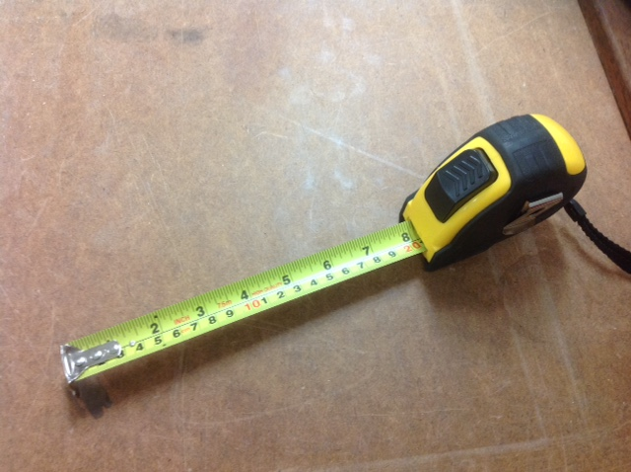
Name:
Use:

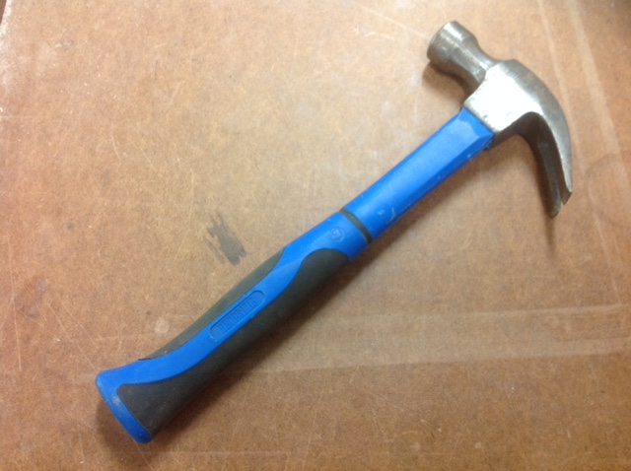
Name:
Use:

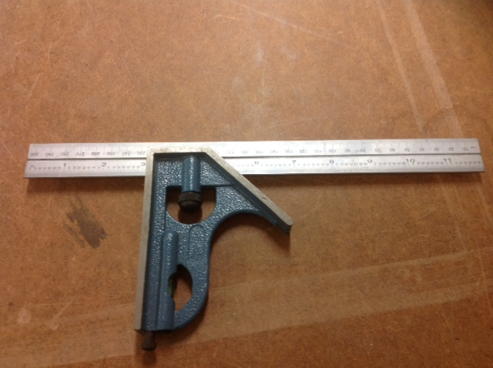
Name:
Use:

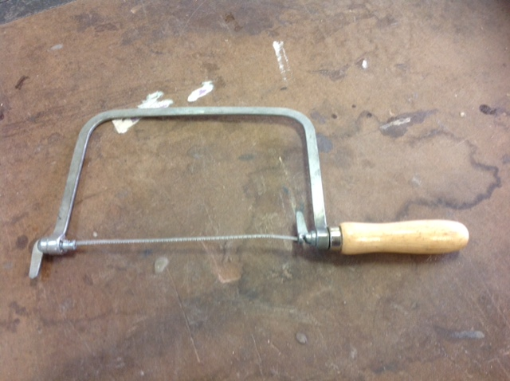
Name:
Use:

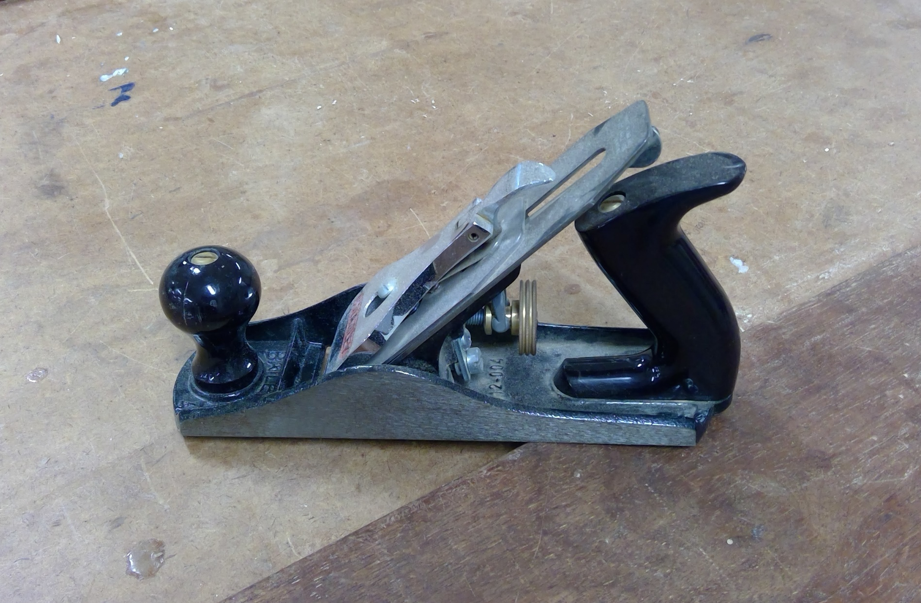
Name:
Use:

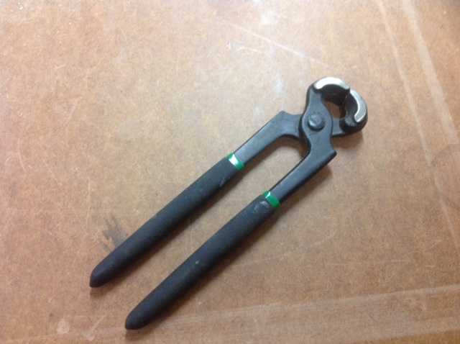
Name:
Use:

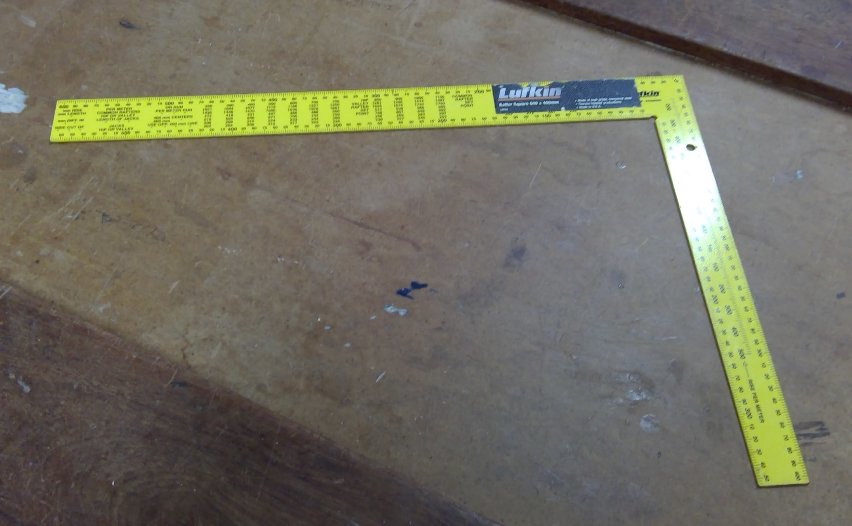
Name:
Use:

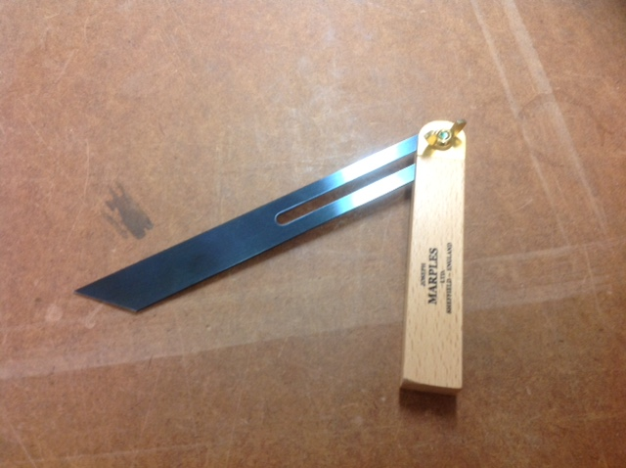
Name:
Use:

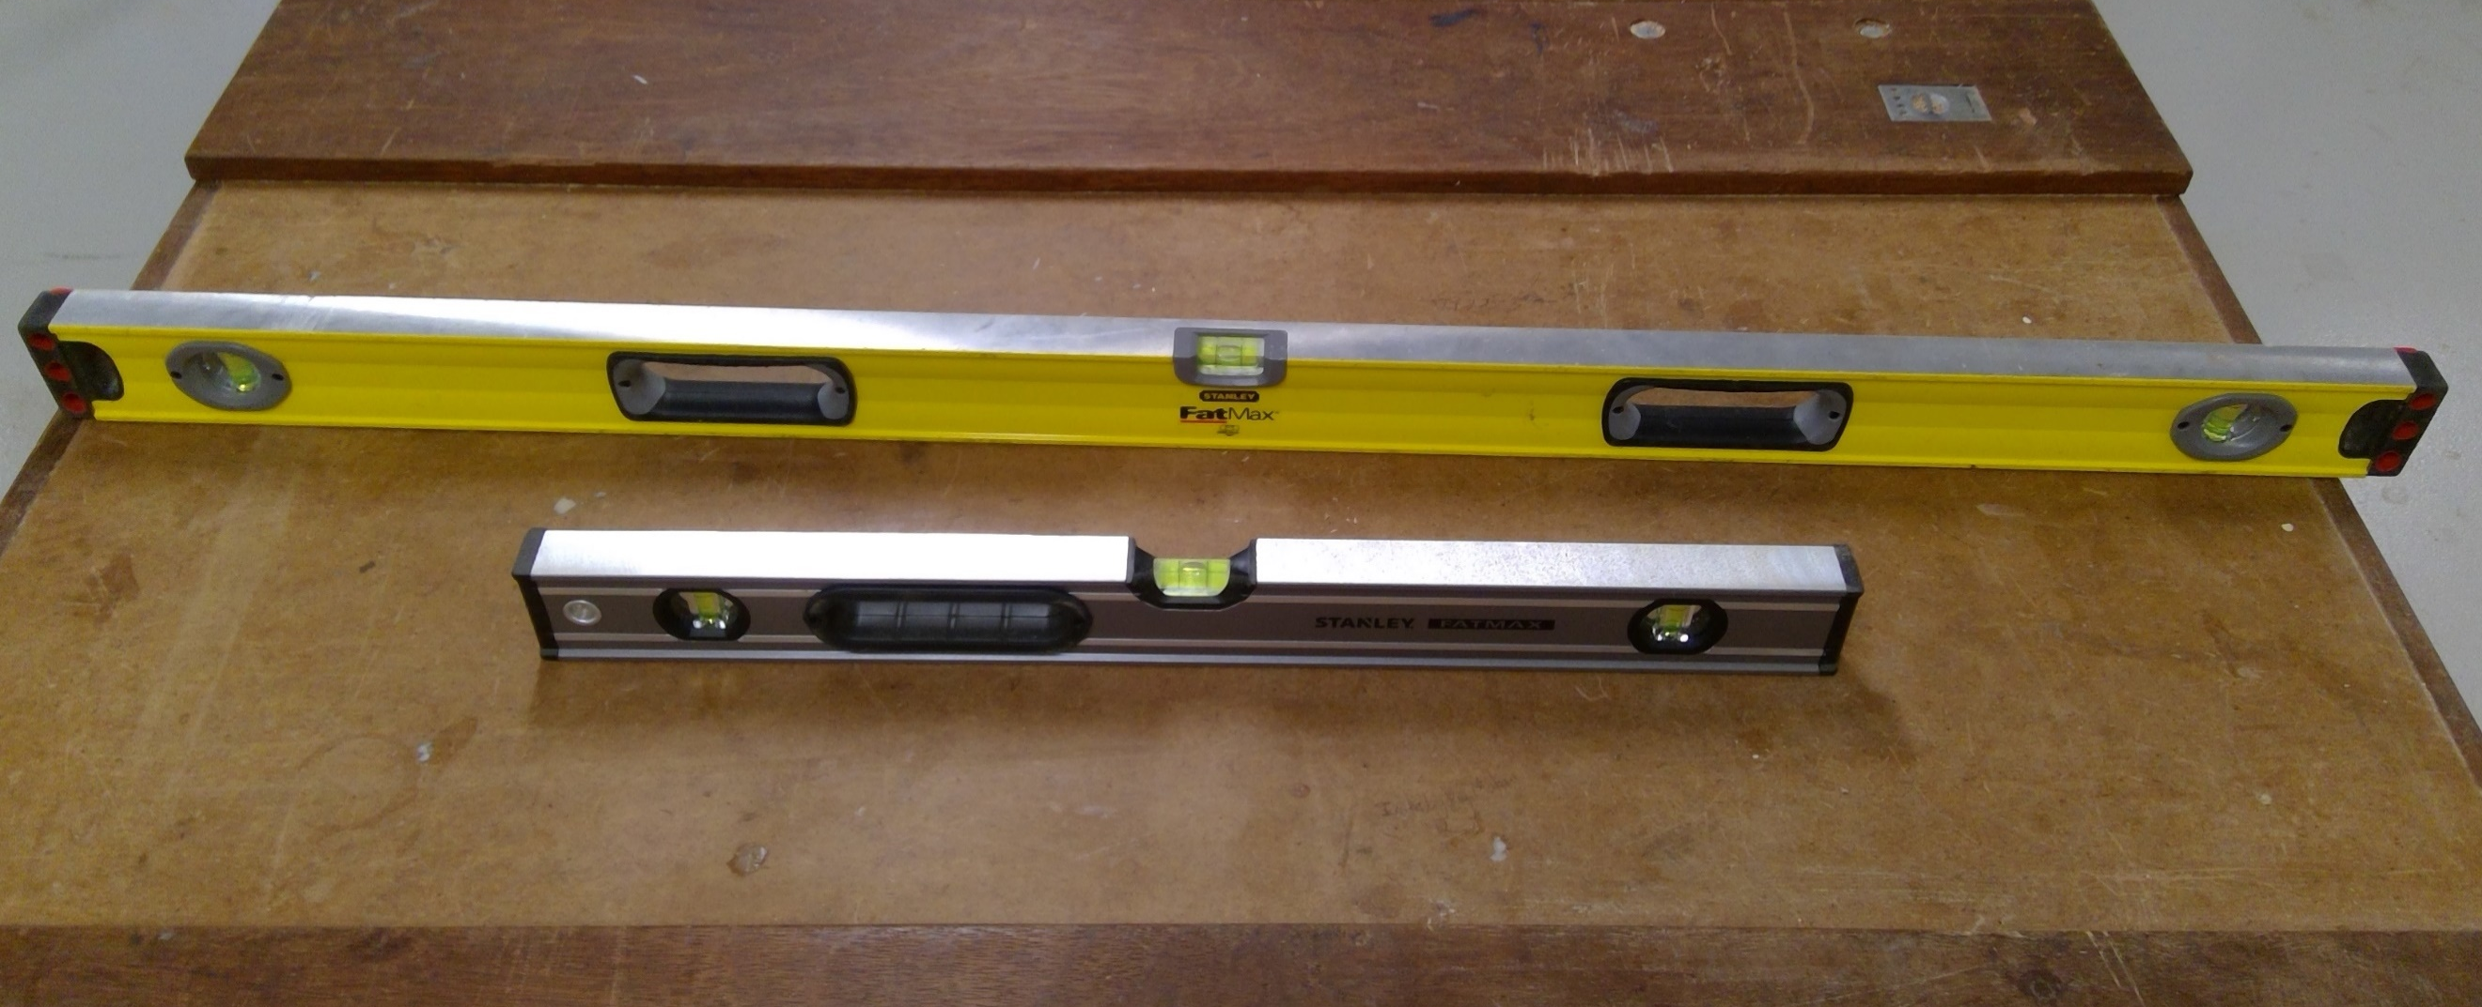
Name:
Use:

Name:
Use:

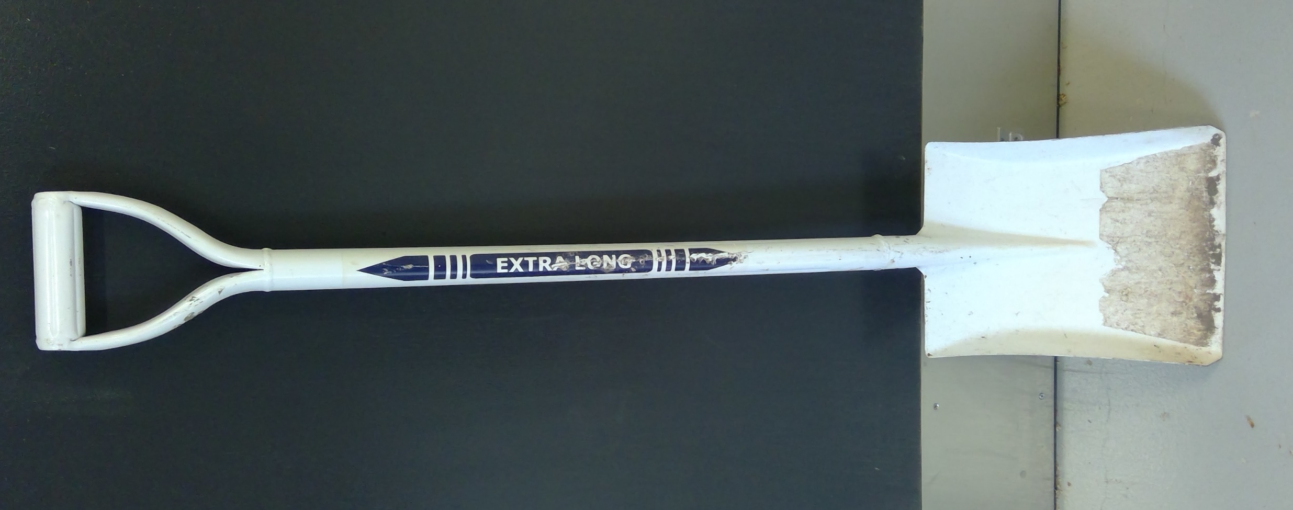
Name:
Use:

Name:
Use:

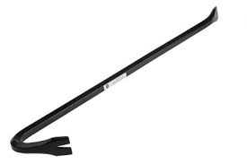
Name:
Use:

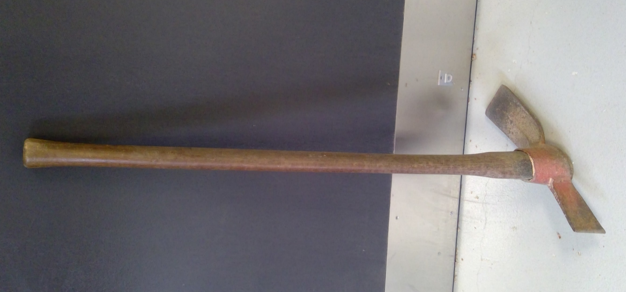
Name:
Use:

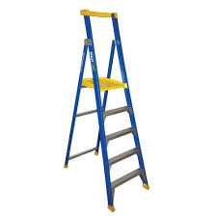
Name:
Use:

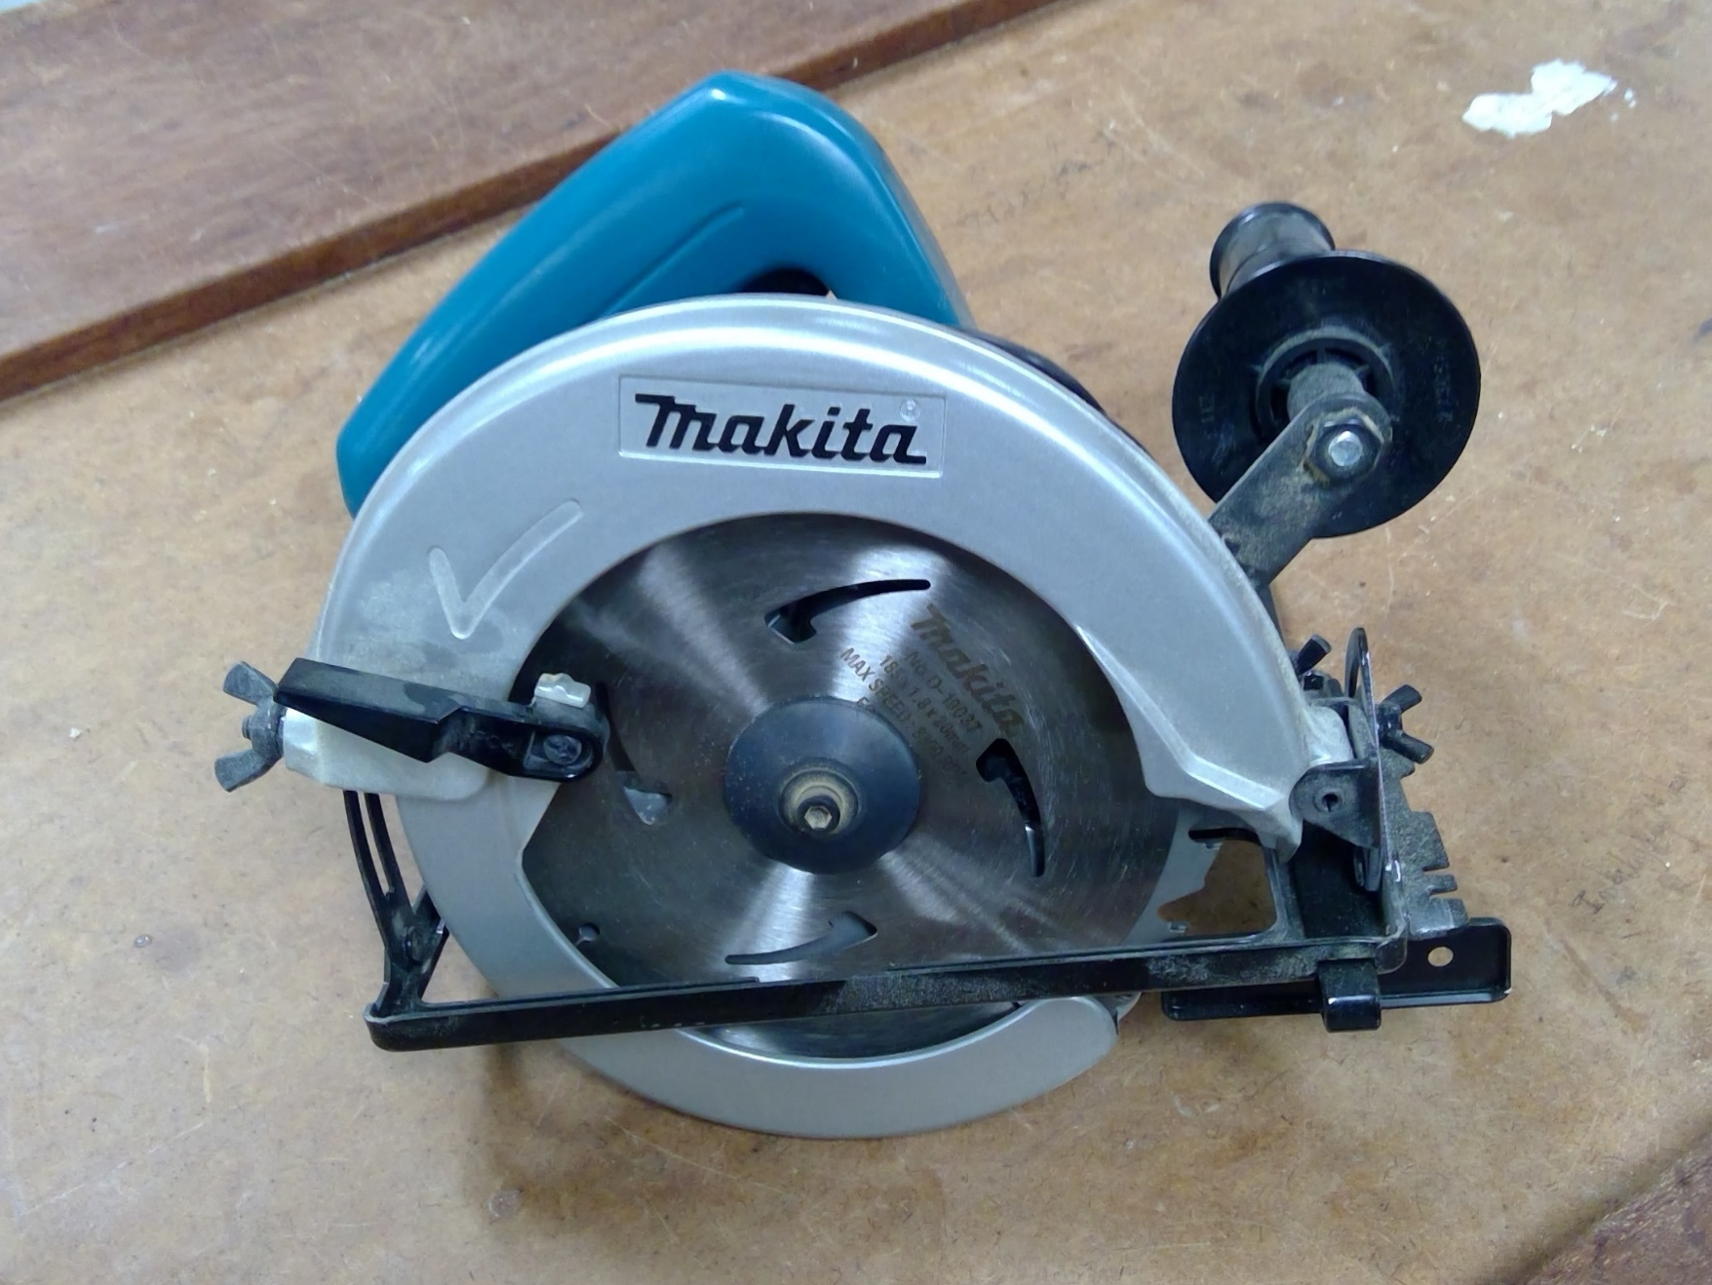
Name:
Use:

Name:
Use:

Photo by Bidvine from Pexels
Name:
Use:

Name:
Use:

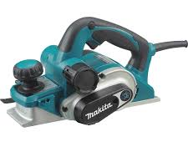
Name:
Use:

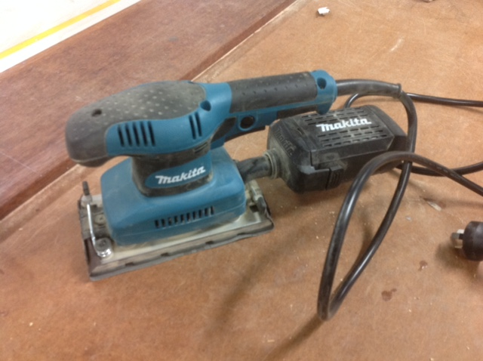
Name:
Use:

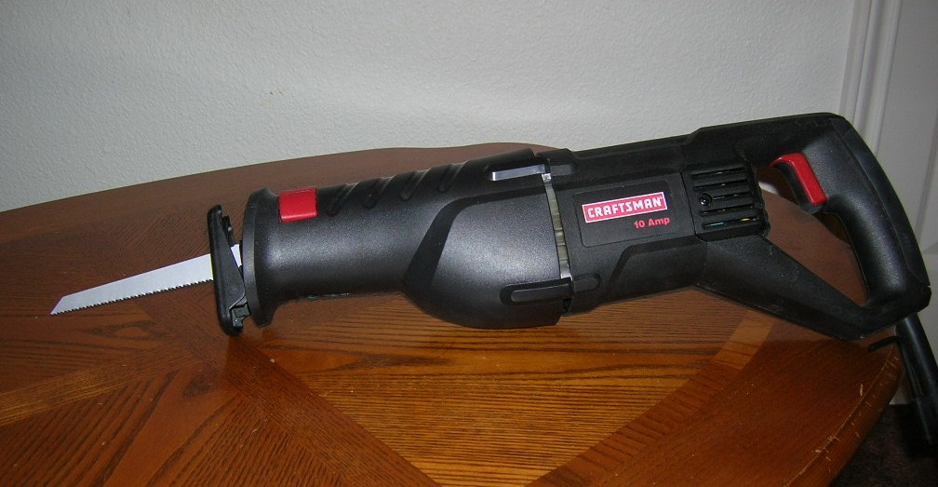
By Junglecat - Own work, Public Domain, https://commons.wikimedia.org/w/index.php?curid=3105890
Name:
Use:

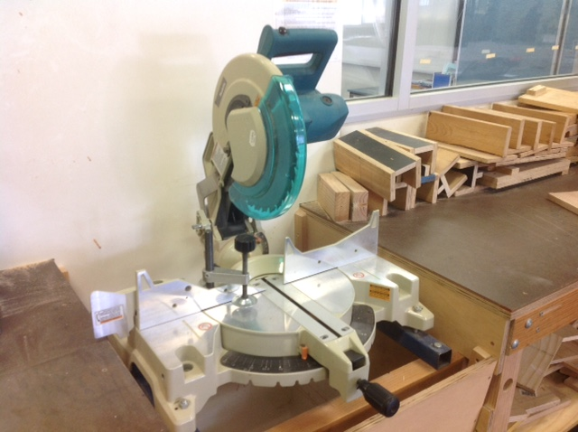
Name:
Use:

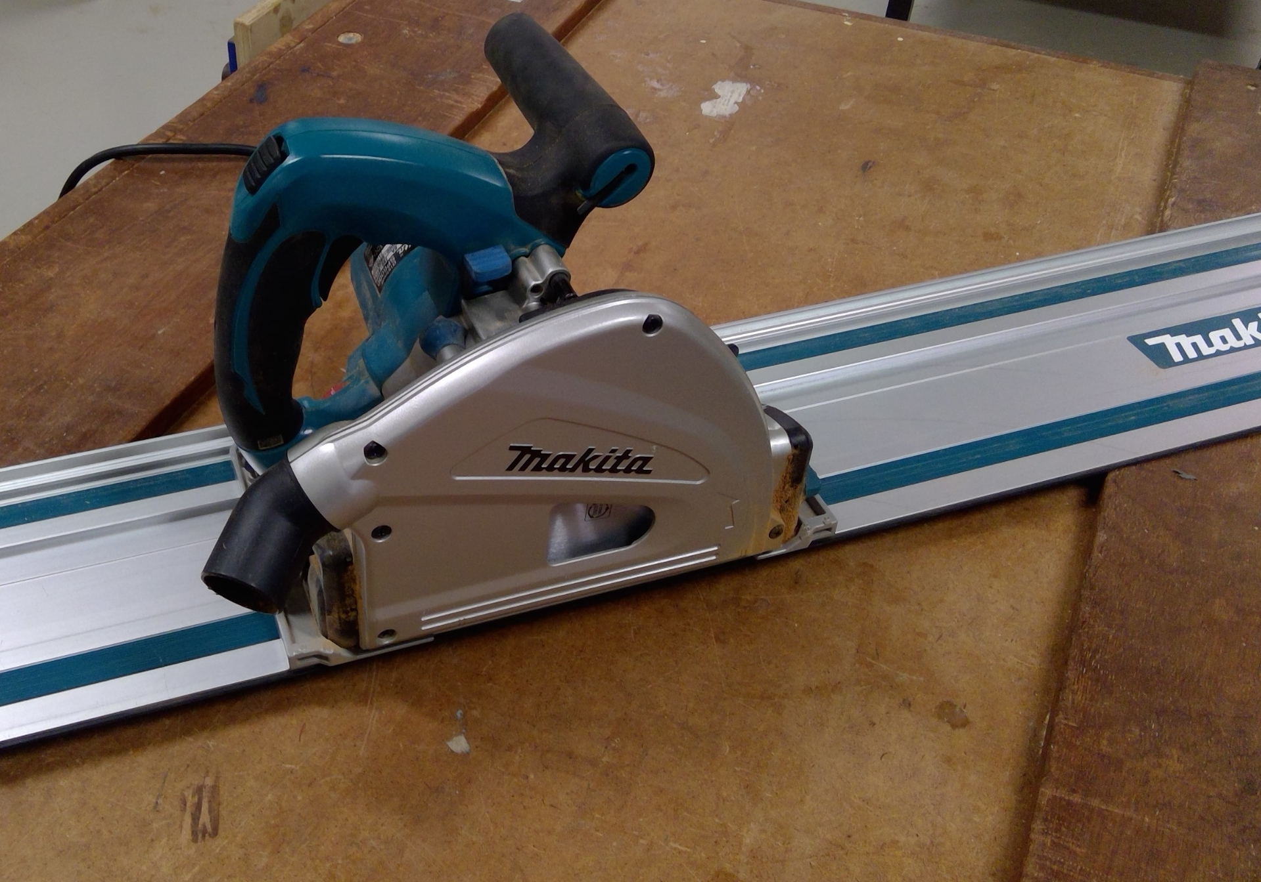
Name:
Use:

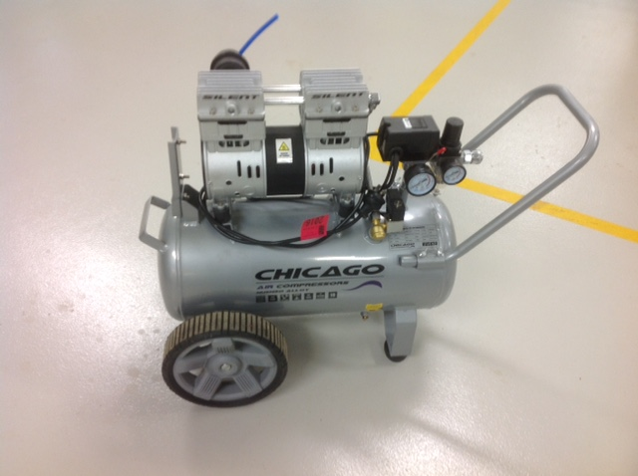
Name:
Use:

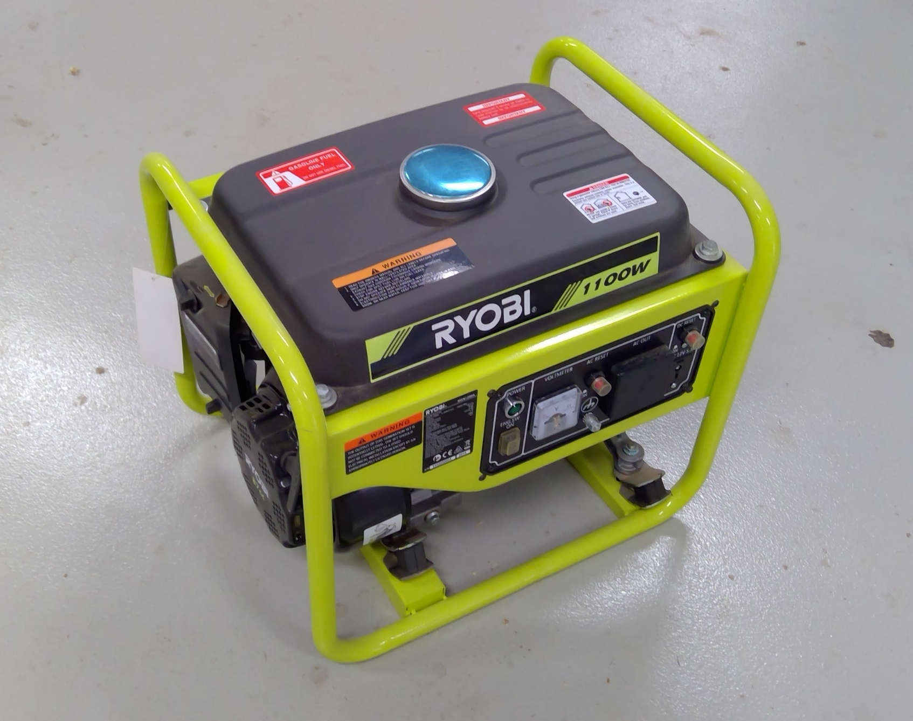
Name:
Use:

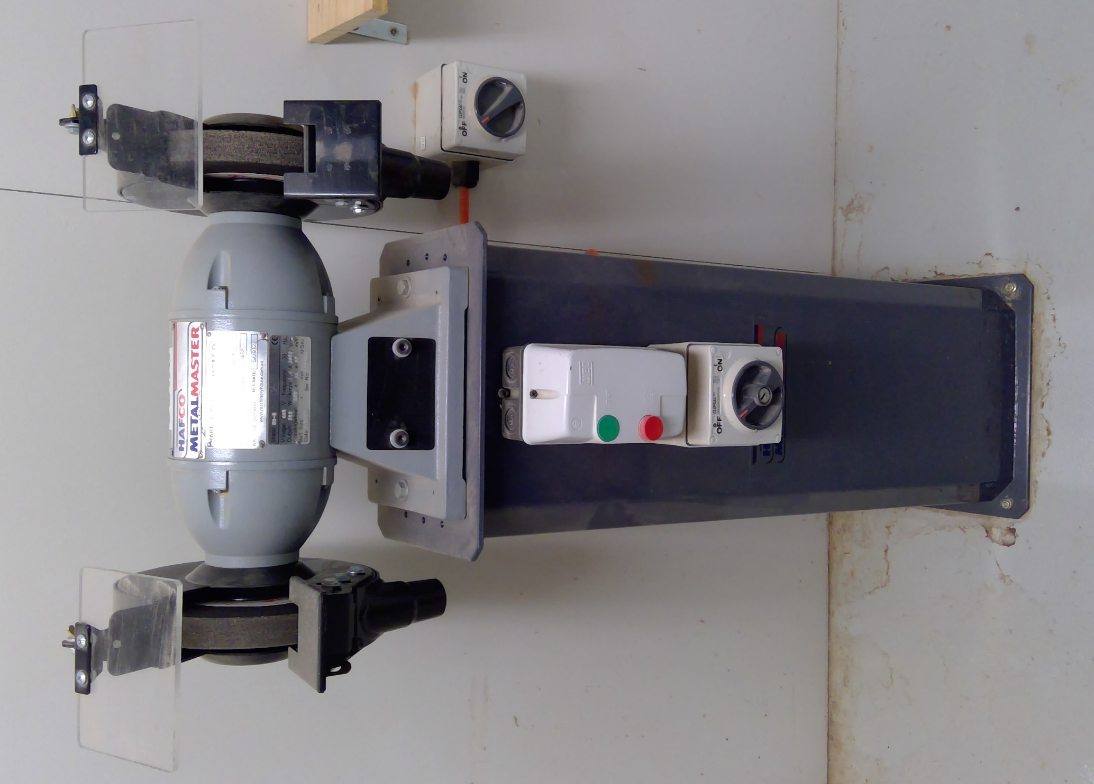
Name:
Use:

- What procedure do I need to follow to cut a piece of 90 x 45 to a length of 2310mm for a timber stud wall. (Include all tools and safety requirements).
- Name THREE documents or work instructions required when building a house.
- What is the procedure for sharpening and honing a chisel?
- What do you do if you discover a faulty power tool?
- What are FIVE possible signs of poor performance or inefficiency of a power tool?
- What safety requirements do you need to follow in the safe use of a nail gun?

- What pre-operational checks would you follow for the tools shown below?

Name:
Pre-operational checks:

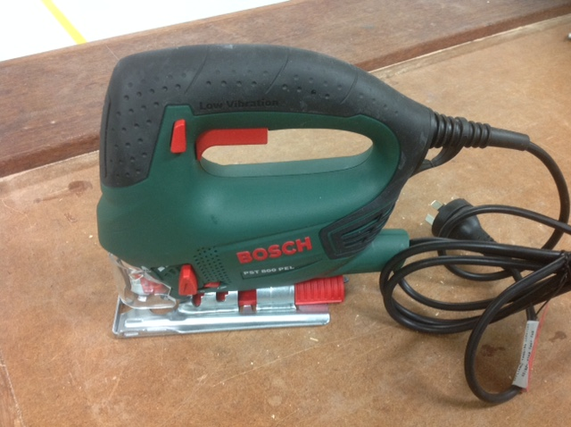
Name:
Pre-operational checks:

Name:
Pre-operational checks:

Name:
Pre-operational checks:

- What is the post-operational procedure you should follow when using the following tools?
Name:
Pre-operational checks:

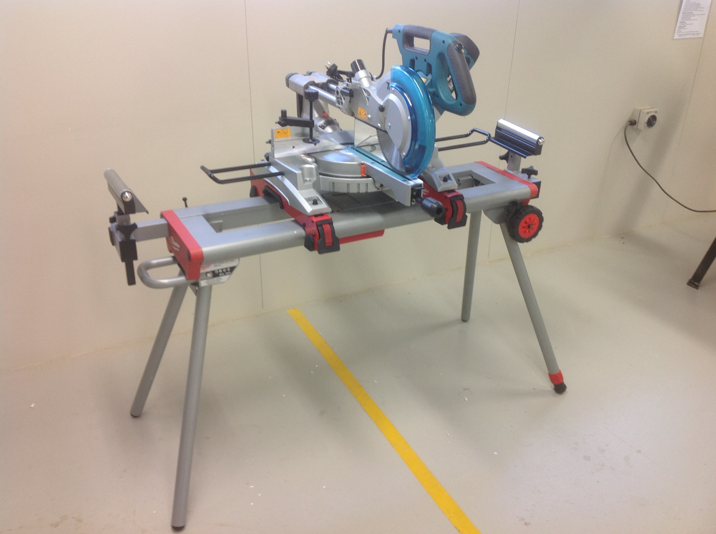
Name:
Pre-operational checks:

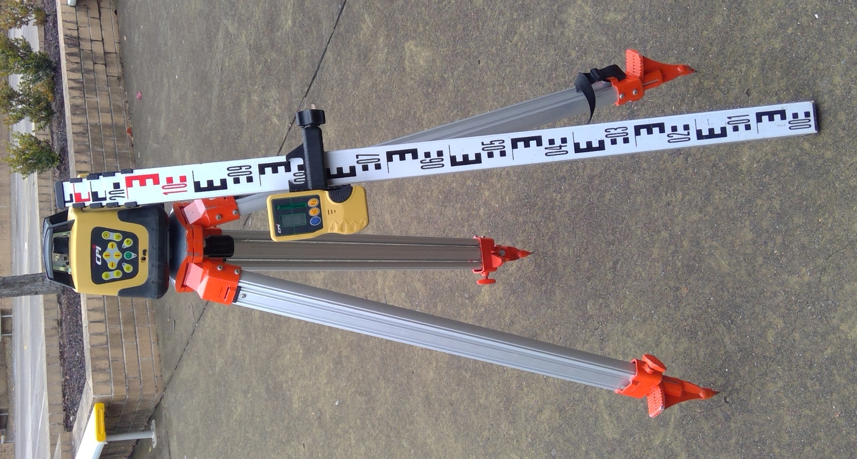
Name:
Pre-operational checks:

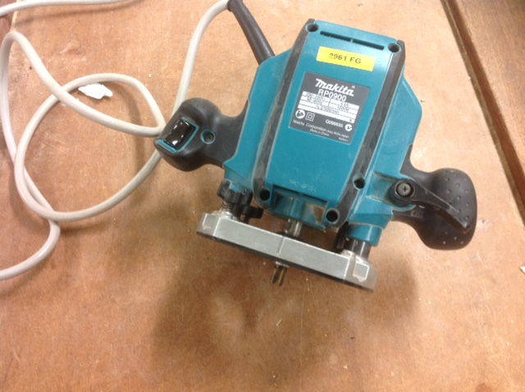
Name:
Pre-operational checks:

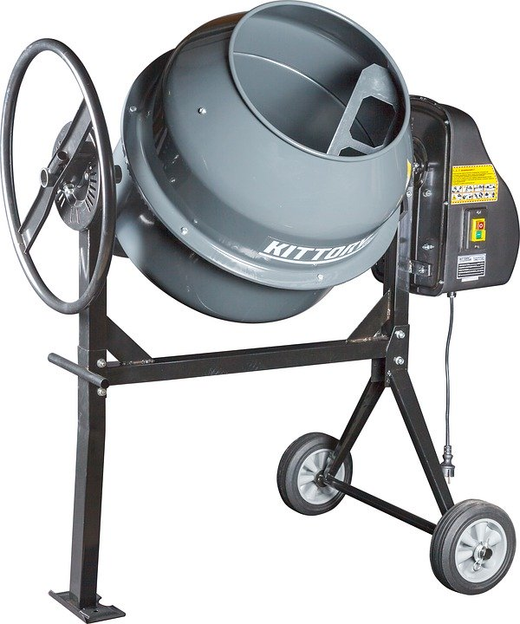
Image licenced under CC0. The original version can be found on Pixabay
Name:
Pre-operational checks:

- Identify each of the tools, plant and equipment below.
List what you need to consider when selecting if it is the correct tool, plant or equipment for the task you need to complete.
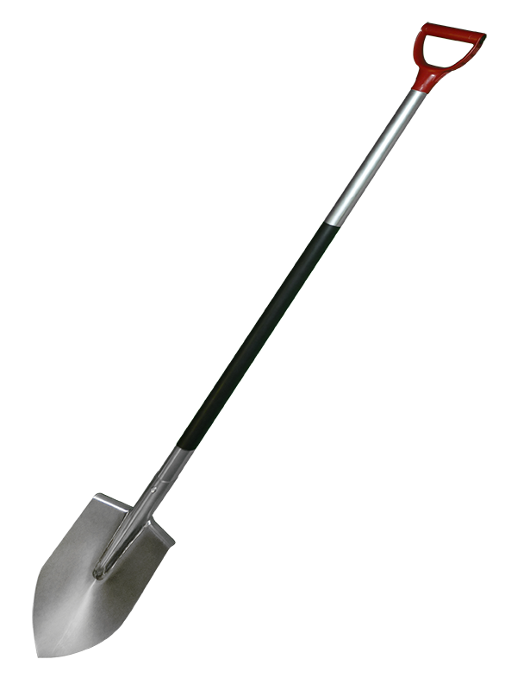
Picture from pngimg.com Creative Commons 4.0 BY-NC
Name:
Consideration:

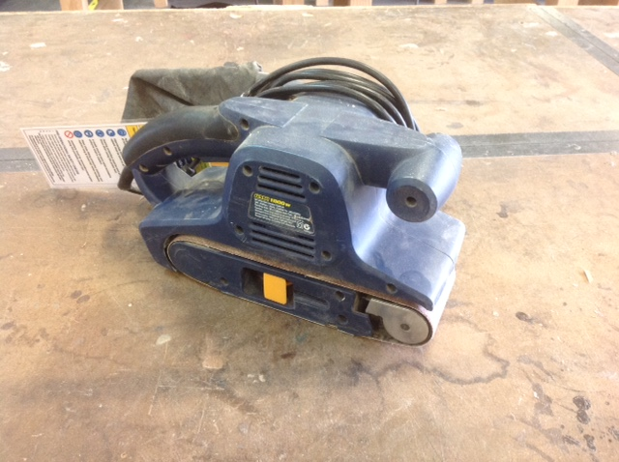
Name:
Consideration:

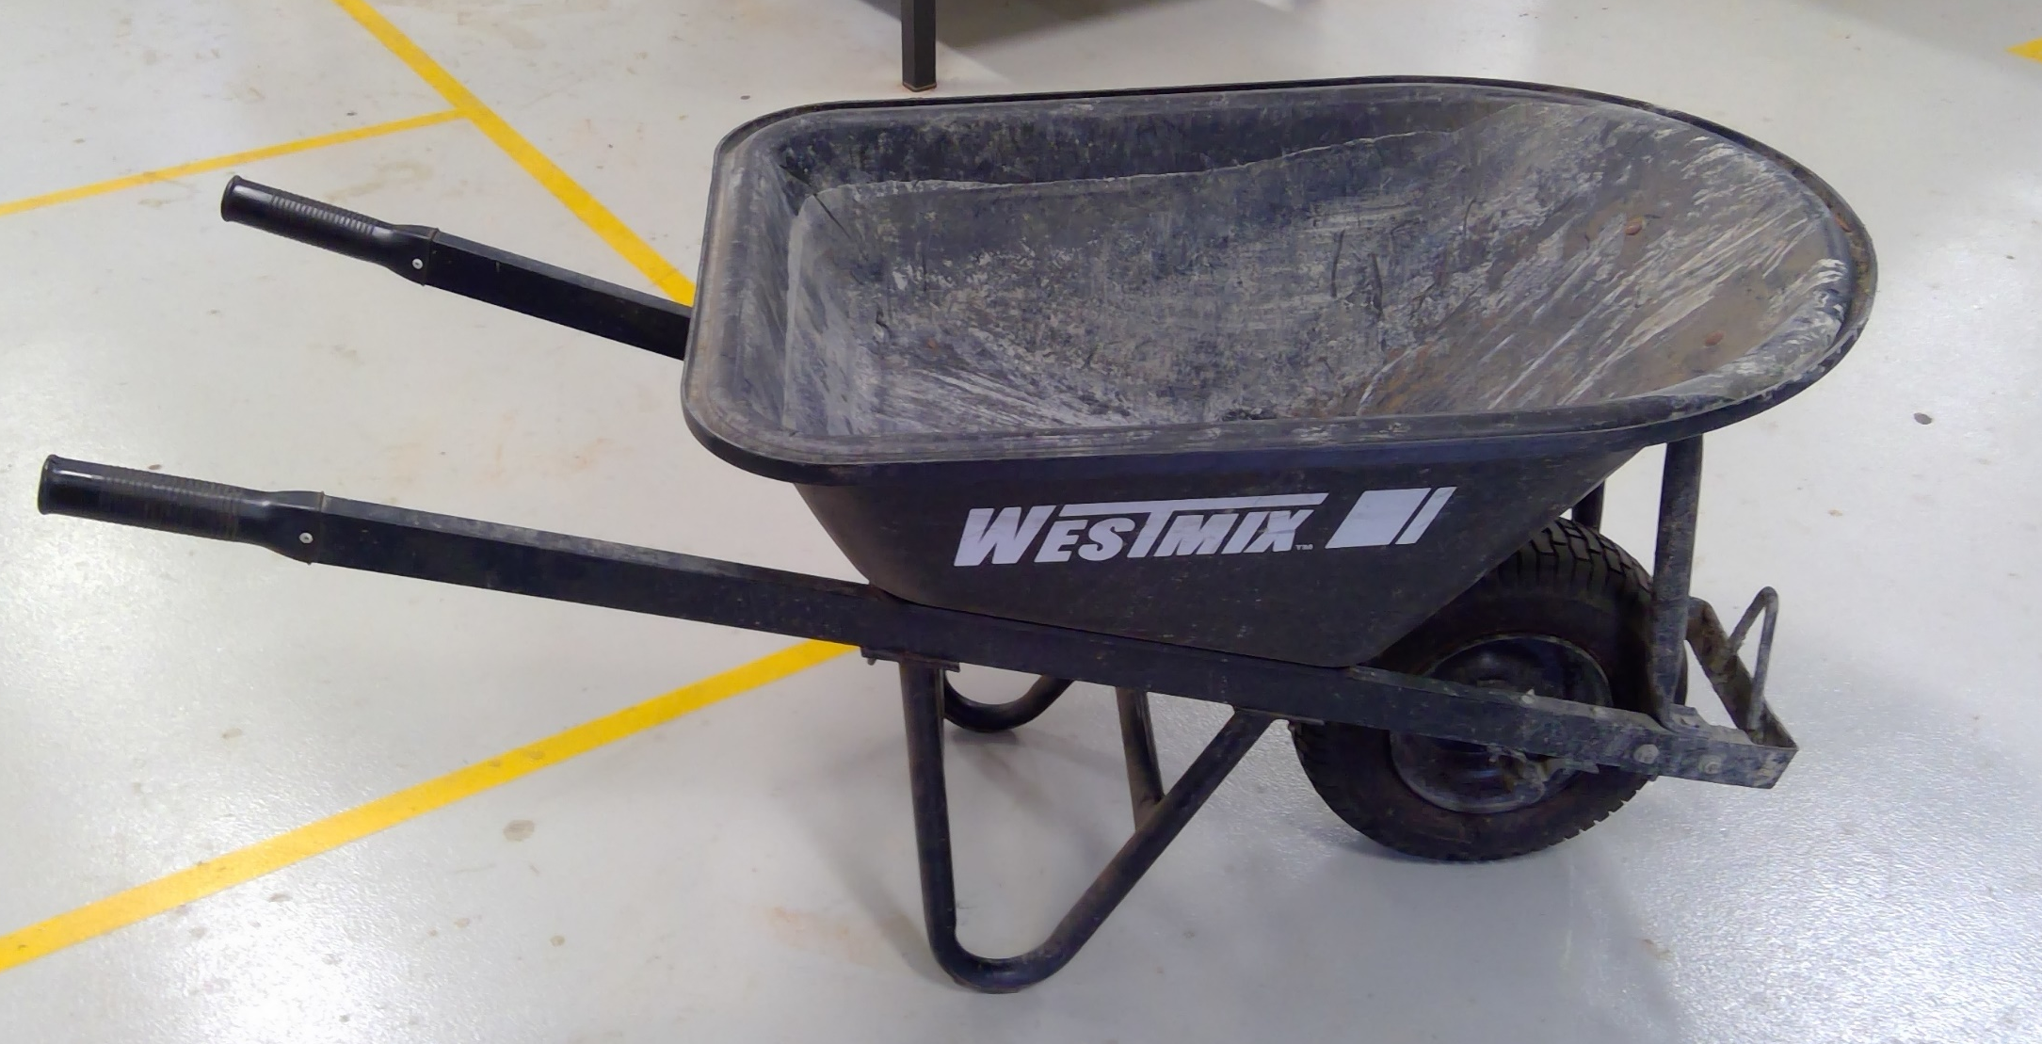
Name:
Consideration:

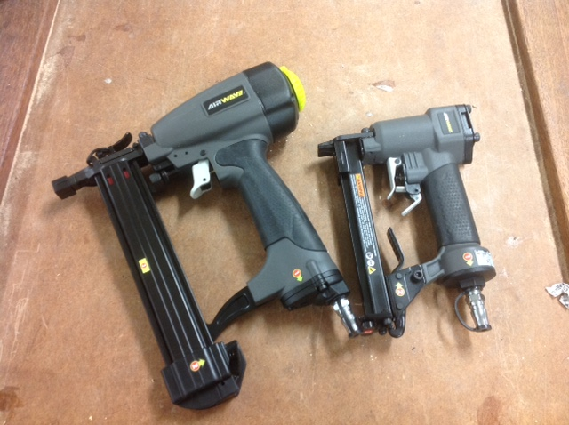
Name:
Consideration:

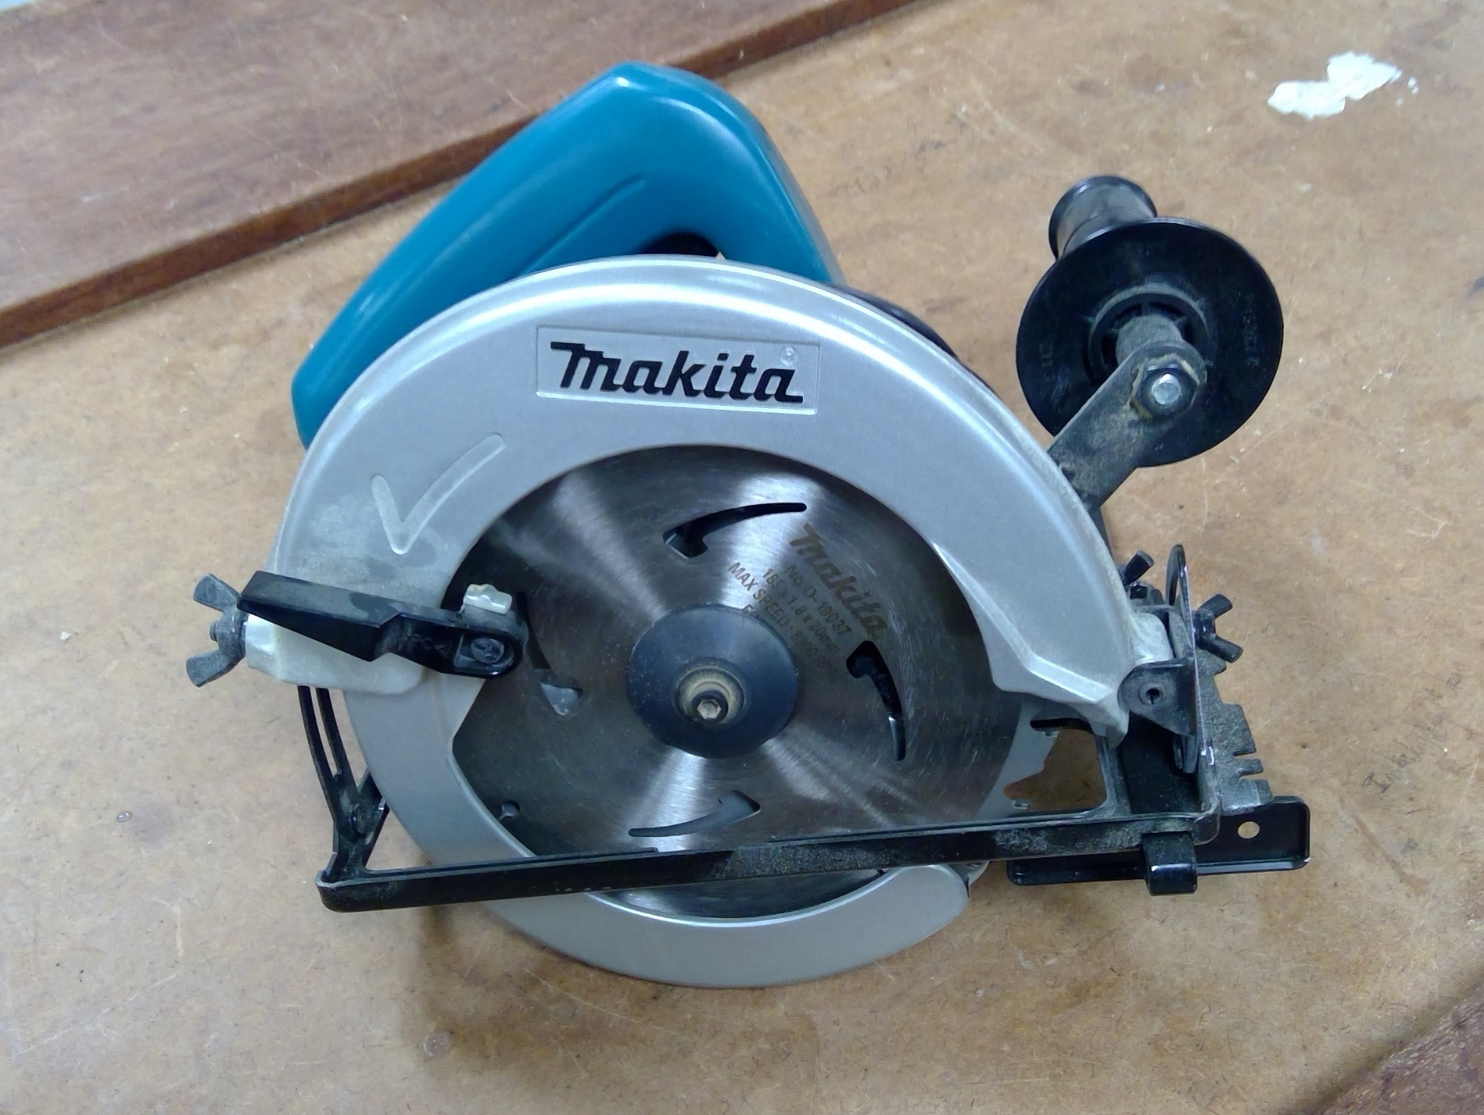
Name:
Consideration:

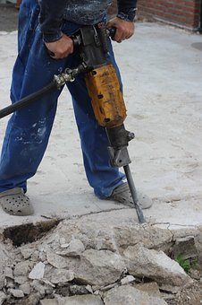
Image licenced under CC0. The original version can be found on Pixabay
Name:
Consideration:

Name:
Consideration:

- What hazards exist with the use of pneumatic tools?
- What safety considerations are needed when working with power tools?
- After using any type of hand, power or pneumatic tool in the completion of a task/job, what considerations are needed with the clean-up of the task. (Think about a task you completed at school and/or on work placement).
- What tools, plant or equipment can be used when cleaning up the following:
  - Your work bench at school
  - After erecting timber frames of a house
  - After a concrete pour
  - A dirty, muddy driveway
  - After excavating trenches and laying sewer pipes
  - A dirty, dusty floor
- Everyone’s experience on Work Placement is different. Consider two tasks that you completed (or that you observed) and describe the procedures that were followed. In each procedure, be as thorough as possible. List all the tools, plant and equipment that was used and consider why they were the best ones for the task.
List the safety requirements involved, the PPE required and the clean-up processes.

Putting the theory into practice
The following questions are from past years’ NSW HSC examination papers for this subject. HSC exams are intended to be rigorous and to challenge students of all abilities. To better understand a question, you should look for key words and identify the aspect of the course to which these relate. You are then in a position to formulate your answer from relevant knowledge, understanding and skills.
All questions in ‘Putting the theory into practice’ are acknowledged © 2019 NSW Education Standards Authority (NESA) for and on behalf of the Crown in right of the State of New South Wales.

Multiple Choice

- What material is added to a drill bit for masonry application?
  - Titanium
  - Tool steel
  - High speed steel
  - Tungsten carbide
- What indicates the inefficiency and poor performance of an electric plane?
  - Cracks to the outer casing
  - A faulty switch mechanism
  - Over consumption of materials
  - Excessive vibration through the hands
- What is a purpose of a chalk string line?
  - To mark a level line
  - To mark a line on sheeting
  - To check for plumb or level
  - To make the line smooth on sheetings

- What is the major reason for safety/lockout tagging?
  - To authorise use
  - As evidence of serviceability
  - To indicate a machine has been checked
  - As a category of safety and risk identification
- What is the main use of a sliding bevel?
  - To determine plumb
  - To determine a level surface
  - To transfer angles and draw lines
  - To measure the diameter of a circle
- What is the main consideration for selecting plant and equipment to be used on a
construction site?
  - The location of storage on site
  - The skill level or training of the employees
  - The consideration of environmental factors on site
  - The effectiveness of the plant or equipment to carry out the operation
- Which of the following is the reading on this staff to the nearest 5mm? 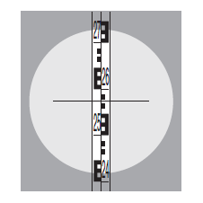
  - 2500
  - 2520
  - 2550
  - 2575
- Why is a licence required to operate some power and pneumatic equipment?
  - To ensure efficient use
  - To reduce operating costs of the job
  - To limit the number of workplace injuries
  - To restrict the number of workers able to operate the equipment
- An employee is required to use the correct posture when lifting a 20 kg bag of cement. The employee should stand with
  - a straight back and legs.
  - an arched back and bent knees.
  - a straight back and bent knees.
  - an arched back and straight legs.
- What is the first action a tradesperson should take when a power tool has a faulty guard?
  - Modify the guard
  - Remove the guard
  - Select another power tool
  - Report the fault to a supervisor
- Which of the following handsaws should be used to neatly cut a 16 mm plywood sheet in half?
  - Rip saw
  - Hacksaw
  - Panel saw
  - Coping saw
- Which setting-out tool would be most appropriate to set out the position of a 10-metre brick wall on a concrete floor?
  - Chalk line
  - Spirit level
  - Folding rule
  - Sliding bevel
- What is the purpose of an earth leakage device?
  - To increase power to tools
  - To provide temporary power
  - To switch the power off quickly
  - To prevent power tools burning out
- Which of the following is the most effective tool to remove a 100 mm nail from a piece of hardwood?
  - Pliers
  - Pincers
  - Pinch bar
  - Cross-pein hammer
- When a spirit level is used to check for plumb, what is it checking?
  - Radial
  - Vertical
  - Diagonal
  - Horizontal
- What is used to power a pneumatic tool?
  - Water
  - Diesel
  - Electricity
  - Compressed air

- Which tool is used to mark a line parallel to an edge and to check for 90°?
  - String line
  - Sliding bevel
  - Marking gauge
  - Combination square

Questions from Section II
These questions should be answered in the suggested number of lines (handwritten in the exam) as it gives a guide to the length of your response.
Plan out your answer and key points before you commence writing.
You may need to bring together knowledge from several areas of study/competencies to do justice to the answer.
Question 1
  - Outline the benefits of using saw stools to cut lengths of timber. (4 marks)

  - Name and outline the function of the tools shown. (3 marks)
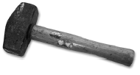

Question continued over

  - Describe the safety and maintenance procedures for using the machine tool shown. (4 marks)
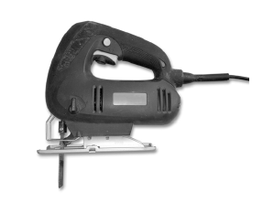

Question 2
  - What features of nails need to be considered when placing an order? (2 marks)

  - What safety steps need to be followed when using any type of nail gun? (2 marks)

  - Identify and outline the use of TWO different types of nail guns. (3 marks)

d) Outline the benefits of using a nail gun rather than using traditional fastening/fixing methods.
(2 marks)

Question 3
A photograph of a plane is shown.
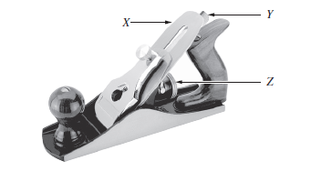
- Name the labelled components of the plane. (2 marks)
X -
Y -
Z -

- Outline the maintenance requirements of this plane. (3 marks)

Question 4
The picture shows a carpenter using a spirit level to set up a doorjamb.
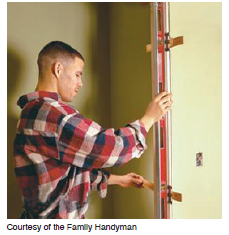
Illustration from NSW HSC Construction examination 2015

- Outline the correct process for using the spirit level in this situation. (2 marks)

- How can the door opening be checked for squareness? (2 marks)

Questions from Section III
In the HSC –
- there will be one structured extended response question (15 marks)
- the question will have an expected length of response of around four pages of an examination writing booklet (approximately 600 words)

Questions from Section IV
In the HSC –
- there will be one structured extended response question in Section IV (15 marks).
- the question will have two or three parts, with one part worth at least 8 marks
- the question will have an expected length of response of around four pages of an examination writing booklet (approximately 600 words) in total.

This will provide you with the opportunity to:
- demonstrate knowledge and understanding relevant to the question
- communicate ideas and information using relevant workplace examples and industry terminology
- present a logical and cohesive response

You will note that these questions usually require you to bring together knowledge from several areas of study/competencies to do justice to the answer. You should allow about 25-30 minutes for a question in Section III and the same for Section IV of the exam.

In each of the following, map out your answer using post-it notes or a sheet of paper. Pay particular attention to incorporating a variety of aspects of your Construction curriculum into the plan. Consider why we have included this question within this ‘Use construction tools and equipment’ module and what other areas of study you would need to draw upon.
Question 1 (15 marks)
Site supervisors have many tasks and responsibilities throughout the day.
Explain how these tasks and responsibilities allow for the smooth and safe operation of the job site.

Question 2 (15 marks)
Explain the environmentally sustainable work practices a builder should use on a construction site. In your answer, consider the following:
• materials
• equipment
• legislation and regulations.

Question 3 (Students were asked to answer Part a) and Part b) of this question in separate writing booklets)
You have been asked by a client to build a new timber fence 1.8 metres high and 15 metres long.
A typical fence panel and section are shown (NOT to scale).
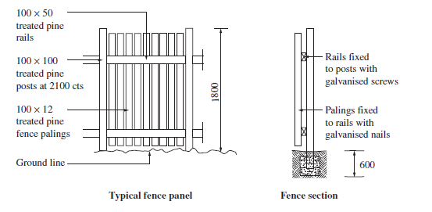
Illustration from NSW HSC Construction examination 2018

  - Outline the tools and equipment needed to construct the fence (5 marks)
  - Describe a method, from beginning to end, for constructing a high-quality fence. (10 marks)

