Construction
Read and interpret plans and specifications
Welcome.
This module will assist you to review and revise content in the area of ‘Read and interpret plans and specifications’ in the NSW HSC Construction syllabus.
You will have studied the competency CPCCCM2001A Read and interpret plans and specifications, which addresses the scope of learning.

This module is broken up into:
- Important notes regarding the HSC focus area
- Key terms and concepts; constructing a mind map
- Activities
- Putting the theory into practice

How to use the resource
Work through the notes and the suggested activities in any order.
Spread your revision over a number of sessions rather than sitting at one subject for lengthy periods.
Discuss your responses with your teacher, fellow students or an interested family member.
All images, apart from those acknowledged, are © NSW Department of Education.

Important Notes: HSC Focus Area
You should use the information in this module as a prompt and guide when revising your study notes or text-book information or other resources provided by your teacher. You can also access industry specific information at SafeWork NSW, Department of Industry, Innovation and Science, Anti-Discrimination Board of NSW, Industrial Relations NSW, and Australian Council of Trade Unions
The HSC examination in Construction is based on a set of examinable units of competency (see table below) from the Construction (240 indicative hours) course.
Examinable Units
Code | Title
CPCCCM1012A | Work effectively and sustainably in the construction industry
CPCCCM1013A | Plan and organise work
CPCCCM1014A | Conduct workplace communication
CPCCCM1015A | Carry out measurements and calculations
CPCCCM2001A | Read and interpret plans and specifications
CPCCCM2005B | Use construction tools and equipment
CPCCWHS1001 | Prepare to work safely in the construction industry
CPCCOHS2001A | Apply OHS requirements, policies and procedures in the construction industry

This module helps revise the focus area ‘Read and interpret plans and specifications’ (based on CPCCCM2001A Read and interpret plans and specifications).
This unit of competency specifies the outcomes required to read and interpret plans and specifications relevant to construction operations. It includes the identification of types of plans and drawings and their functions, the recognition of commonly used symbols and abbreviations, the identification of key features and specifications on a site plan, the comprehension of written job specifications and the recognition of document status and amendment detail.
The scope of learning describes the breadth and depth of the HSC Content, the minimum content that must be addressed, and the underpinning knowledge drawn from the associated unit(s) of competency.
The full scope of learning is available from Construction Curriculum Framework 2020 HSC exam and beyond, Syllabus Part B, Mandatory units of competency ‘Read and interpret plans and specifications

The following extract is taken from Syllabus Part B, Mandatory units of competency ‘Read and interpret plans and specifications. © 2019 NSW Education Standards Authority (NESA) for and on behalf of the Crown in right of the State of New South Wales.
Required knowledge for this unit is:
- basic calculations of heights, areas, volumes and grades
- commonly used construction symbols and abbreviations
- construction terminology
- drawing conventions
- features of plans and elevations, including direction, scale, key, contours, symbols and abbreviations
- job safety analysis (JSA) and safe work method statements
- key features of formal job specifications
- processes for application of scales in plan preparation and interpretation
- project quality requirements
- site and equipment safety (WHS) requirements
- techniques for orienting/confirming the orientation of a plan

Key terms and concepts

You can use the following information to revise the key terms and concepts from this unit of competency. Perhaps you could:
- Copy the table into your own file, remove all the key terms, then fill in the blanks (without peeking at the original file) with your own answers.
- Copy the table into your own file and remove the definitions. Write a definition in your own words – it doesn’t have to word perfect but should show you understand the concept.
- You could add an example of this term or concept relevant to the construction environment. If the key term was ‘specification’ your construction example might be ‘The material and colour details for the kitchen joinery can be found in the joinery section of the specification’.

Constructing a mind map
Creating a mind map is a great way to organise your knowledge and understanding of the content of a topic.
- draw up your own mind map showing the connection between the various concepts listed
- use the key terms and concepts to add to your mind map
- add examples or case study prompts to show how the concept is applied in the construction working environment
You could use software such as a hierarchy chart, download ‘MindNode’ or similar or use a large sheet of paper (or several A4 sheets taped together)!
It is important to try to include all the detail you can, so add definitions, case studies or examples to prompt your memory. Include the information downloaded from the unit of competency and also from the Scope of Learning and Key Terms and Concepts.

Key term or concept | and Definition
Amendments | A minor change or addition to the design of the building. It is communicated through drawings and are noted within the Title Panel of the drawing.
Australian Standard | Are published documents which set out specifications and procedures designed to ensure that a material, product, method or service is fit for its purpose and consistently performs the way it was intended.
Boundaries | A line which marks the limits of an area; a dividing line between two properties.
Construction Plans | The set of two-dimensional architectural drawings that explain the details of a project and provide a visual representation of what needs to be built.
Contours / Contour Lines | An outline representing a specific, identified height of the land. They show, usually on a site plan, and sometimes on a Floor Plan and/or an Elevation, the slope of the land
Contracts | A written (sometimes spoken) agreement between parties, usually based on the employment of a party to undertake a job/task within the construction of the project.
Cross-sectional Views | Are elevations cut though the building in the position and direction indicated on the floor plan. It usually includes everything from the bottom of the footings, through the floor and walls, through the ceiling and roof structure.
Datum Point | A reference point, line or surface from which elevations are measured from.
Detail Drawings | Are drawings of specific parts of the project that require a detailed view, as it is integral to the construction. They are usually drawn at a scale of 1:10 or 1:5
Dimensions | Are measurements recorded on a plan for a specific part of the project.
Document Status | Refers to the document’s status in the design and construction process
Drawing Conventions | Drawing Conventions are standard symbols and designs that represent an item or object within the design
Floor Plan | Is a horizontal section of the building as viewed from above. It contains most of the information for construction and many other drawings are based off or refer to this drawing.
‘For Construction’ | Is a standard phrase that is used to state that the design is approved for construction to start.
Key Features | Are important features of a drawing
Legend | Is located on a drawing and is used to explain or define a symbol or abbreviation from on the drawing
Longitudinal Plans | Are plans that show the length of the building. Usually refers to elevations and cross sectional drawings.
Orientation | Direction of North / North Point
Plans and Drawings | Is typically any diagram that details what is required to be constructed. Plans and drawings can include construction plans, cross-sectional plans, dimensions and notes, illustrations, longitudinal plans, project specifications, site plans, structural detail and specification providing illustrations and dimensions.
Project Documentation | Includes contracts, drawings, schedule of rates, specifications, standard procedures and practices, supplementary specifications and work schedules.
Project Plan | Refers to the planning process of the project. Concept drawings, initial planning, a rough timeline, major features of the project.
Quality Requirements | Outlines the required quality of the various elements of the project – material, contractors, work and the expectations of the customer.
Reduced Level (RL) | A level on the building or its surrounds that is compared to the Datum Point. The RL can be above or below the Datum.
Scale | A graduated range of values forming a standard system for measuring or grading something; the relative size or something
Schedule of rates | Are agreed upon rates for the provision of a service or good. Set rates for specific and regular tasks undertaken in the construction of a project.
Setback | The distance, usually from the boundary to the building itself or another key feature of the site.
Site Plan | Is a drawing that shows the building in relation to the entire site and surroundings. It includes features such as the boundary, the dimensions of the block, setbacks from the boundary, north point, the driveway, Lot number, contour lines and some service mains.
Specifications | A document outlining details relating to materials and quality of work, quality assurance, nominated subcontractors, provision of site access / facilities, material types, standards of work, tolerances, treatments and finishes
Symbols and Abbreviations | An image, symbol, character or a small group of letters that represent a feature on the drawing. These explanations can be found in the legend located on the drawing.
Title Panel / Title Block | Is a panel or block of information relevant to the drawing and the project. Components of the Title Panel / Block include date/version, drawing number, site location, architect, contractor, client, scale and number of pages.
Tolerances | An allowable amount of variation of a specified quantity
Work Schedules | Refers to a document used to schedule tasks for the entire project, for specific contractors, teams and also for individual employees. It provides information on how long a trade, contractor or employee is expected to undertake the task and also when they are expected to undertake the task.
Workplace documentation | Documents specific to the workplace or project

Activities
- What are the main features of the following drawings?
Types of drawings
Project / Development Plans
Site Plan
Construction Plans
Floor Plan
Longitudinal Plans - Elevations
Cross-Sectional Views - Sections
Details

- What information can be found in a Specification?

- What is the most common scale for the following drawings?
Drawings | Scale
Site Plan
Floor Plan
Elevation
Section
Detail

- Convert the following scaled measurements to their actual measurement.
Scaled Measurement | Scale | Actual Measurement
27mm | 1:100
45mm | 1:200
38mm | 1:250
64mm | 1:10
120mm | 1:5
75mm | 1:20
83mm | 1:50
98mm | 1:2
380mm | 2:1
118mm | 1:500

- What is a Waste Management Plan?

- Why are Waste Management Plans required to be reviewed for individual construction sites?

- What are Australian Standards and how do they impact on the design of a building?

- What information can be found in the Title Panel of a drawing?

- Identify the following information from the Title Panel below?
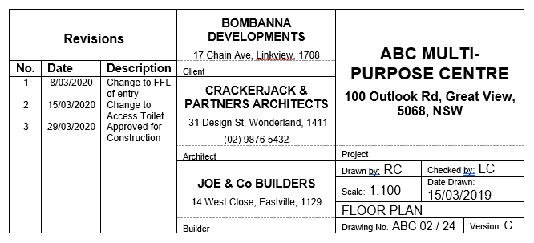
  - What is the project that is being constructed?
  - Where is it being constructed?
  - Who is the architect?
  - What drawing is it?
  - What is the drawing number?
  - What is the scale of the drawing?
  - Who checked the drawing?
  - What version is it?
  - What was the latest revision?
  - When and what was the first revision?
  - Who is the client?
  - Who is contracted to build this project?

- What is meant by the term “For Construction”?

- Draw in the following Construction Symbols. All symbols are in plan detail unless stated otherwise. You may have to print this page.
Item | Symbol | Item | Symbol
Bath |  | North Point
Brickwork |  | Rainwater Tank
Shower |  | Down Pipe
Double Bowl Sink |  | Water Closet
Cooktop |  | Dishwasher
Stud Walls |  | Hot Water Unit
Floor Waste |  | Hinged Swing Door (Elevation)
Smoke Alarm |  | Sliding Door (Elevation)
Hose Cock |  | Earth  (Elevation)
Power Box |  | Fill  (Elevation)
Cavity Sliding Door |  | Concrete (Elevation)
Existing Tree |  | Sliding Window (Elevation)
New Tree |  | Fixed Window (Elevation)
Tree to be removed |  | Double Hung Window (Elevation)
Swing Door |  | Awning Window (Elevation)

- Why are symbols and abbreviations used on construction drawings?

- What information can be found in a Legend?

- Fill in the abbreviation from the following words
Term | Abbreviation | Term | Abbreviation
Access Panel |  | Kitchen Sink
Average |  | Laundry Tub
Bench Mark |  | Main Switchboard
Brick Veneer |  | Maximum
Brickwork |  | Minimum
Building |  | North
Built-in |  | Not To Scale
Built-in Robe |  | Out Of
Ceiling Level |  | Over All
Centreline |  | Prefabricated
Clear Glass |  | Quantity
Countersink |  | Rangehood
Cupboard |  | Reduced Level
Damp Proof Course |  | Refrigerator
Diameter |  | Reinforced Concrete
Dishwasher |  | Retaining Wall
Distance |  | Safe Working Load
Door (number) |  | Sewer
Double Glazing |  | Shower
Downpipe |  | Softwood
Equal / Equal to |  | Temporary Bench Mark
Finished Floor Level |  | Tongue & Groove
Fixed Glazing |  | Typical
Floor Level |  | Underground
Floor Waste |  | Underside
Ground Floor |  | Universal Beam
Ground Level |  | Universal Column
Hand Left |  | Vent Pipe
Hand Right |  | Volume
Hardwood |  | Walk in Robe
Height |  | Wall Oven
Hosecock |  | Wardrobe
Hot Water Supply |  | Water Closet
Hot Water Unit |  | Water Meter
Include |  | Window (number)

- Refer to the Site Plan to answer following the questions.
Site plan (and floor plan snippet over) used with permission of the author
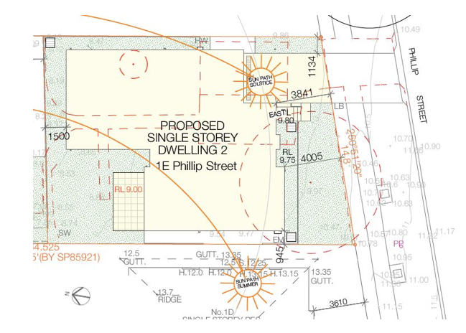
  - What is the setback of the house from the rear boundary?
  - What street is the house located on?
  - What is the Reduced Level of the tiled area at the rear of the house?
  - What was located in the south west corner of the site?
  - Where is the Hot Water Unit located?
  - Where is the Electricity Meter located?
  - What is the setback of the driveway off the eastern boundary?
  - What are the 2 measurements from the front boundary to the front of the house?
  - What is the image of the sun representing?
  - What is the RL at the South Western boundary corner of the site?
- Refer to the following Floor Plan Snippet to answer the questions on the next page.
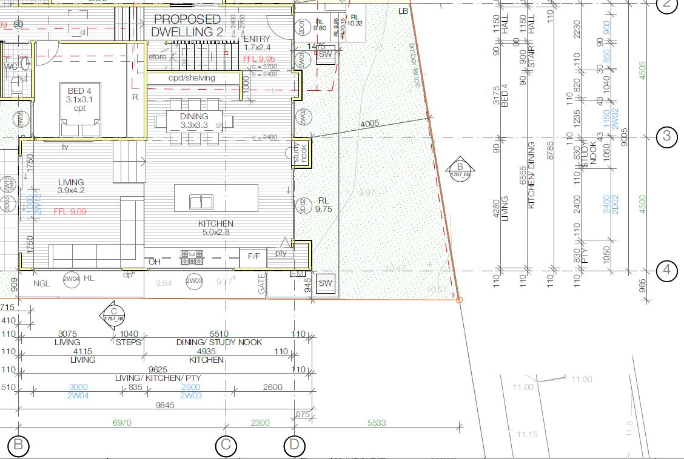

  - What is the distance between Grid Line 3 and Grid Line 4?
  - What is the area of the Living Room, excluding the steps?
  - How many sets of stairs are there in this section of the proposed dwelling?
  - What type of flooring is in the kitchen?
  - What type of floor is in Bed 4?
  - What is the distance from Grid Line B to the boundary corner?
  - What is the Finished Floor Level of the Living Room?
  - What is the Finished Floor Level of the Entry / Dining / Kitchen?
  - What is the height difference between the Living Room and the Kitchen?
  - What direction does the arrow on the stairs indicate?
  - On what drawing will I find Section B?
  - What is the RL of the ground level outside the Kitchen?
  - What type of fence will be constructed along the front boundary?
  - What is the length of 2W04?
  - What do the symbols and abbreviations in the Kitchen represent?
  - How thick are the external walls?
  - What is the house setback from the front boundary to the study nook?
  - What is the height difference between inside and outside at the entry door?
  - What is the width of the internal timber walls?
  - What does ‘pty’ represent on this plan?
  - What does ‘R’ represent on this plan?
  - If the carpet costs $57/m2 supplied and installed, what is the total cost? Allow 10% waste.

- Identify all of the items in the image below. Use the table and word bank below to help you name all parts of this subfloor section.
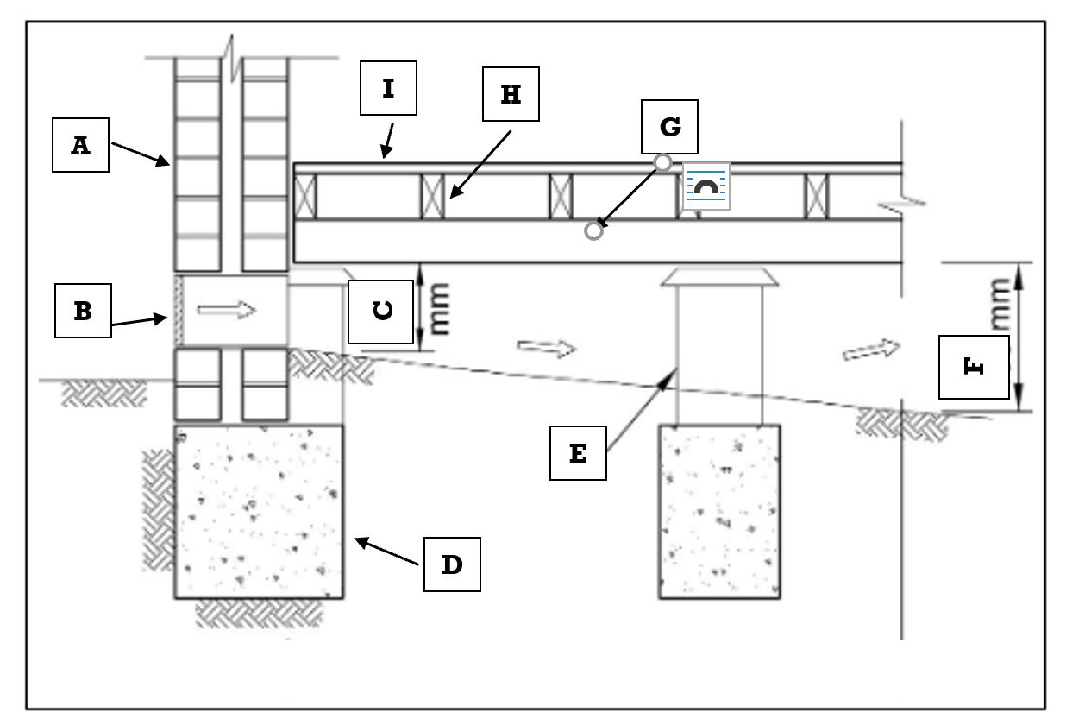
Subfloor A from Australian Building Codes Board Image licensed under Creative Commons 4.0 BY-NC

Word Bank
- Bearer | - Reinforced Concrete Strip Footing | - Sub-floor vent
- Brick wall | - Structural particle board sheet flooring | - 150mm
- Brick Pier | - Joists | - 400mm

Identify labelled parts of the subfloor

- Refer to the following section of a Specification to answer the questions which follow.
Carpenter and Joiner
1. Generally
The work undertaken by the carpenter and joiner shall be comply with residential timber frame construction AS 1684 and be of first-class materials and workmanship. All timbers shall be certified by the supplier and shall be to the stress grade scheduled. Allow for shrinkage, swelling and differential movement when unseasoned timber is used.
2. Workmanship
All joinery shall be joined in an approved manner and provide strong and neat connections. Spacing of members shown on the details are the maximum permissible. Finish all dressed timber surfaces smooth and even free of machine marks and finally hand sanded. All dressed timber shall be grain and colour matched throughout.
3. Timber Skirting
Provide 140 x 19mm dressed timber skirting with bevel edge, and finish with a paint finish. Mitre at corners & fix to walls close and straight with no gaps.
4. Architraves and sills
Architraves adjacent timber doors are to be 90 x 19mm dressed timber architrave with a bevel edge. Top timber neatly mitred at corners and fixed hard against the adjacent surfaces.
5. Timber Door Jambs
Door frames are to be dressed timber rebated frames to take standard sized doors as scheduled, fixed straight & true to timber stud walls and covered with full sized timber architraves to both sides. Paint finish as per schedule of finishes.
6. Sheet Flooring
Where required, cover top of floor joists with 19mm thick moisture resistant particleboard flooring equal to “Green tongue”, screw fixed to the top of the joists to the manufacturer’s instructions.
7. Ground Floor Joists
Where required, provide 100 x 50 floor joists at 450mm centres supported on 100 x 75mm HW Bearers at 1800mm max centres on brick piers with galvanized metal ant capping under. Provide at least 400mm clearance under floor timbers and ensure floors are level and solid on completion.
8. Timber Stud Walls
Construct new 90 x 45mm timber framed walls where shown with studs at 600mm centres, noggins at 1.200mm centres with housed 90 x 45mm top and bottom plates fixed to floor and ceiling members. Brace walls with rebated galvanized straps angles, install insulation and cover all walls with plasterboard.
9. Roof Construction
Frame up the metal roof with Hyspan timber rafters at 600mm centres or as shown on the engineer’s plans, and cover timber purlins at 1 metre centres with metal roof on sarking & insulation blanket, to the required fall.
10. Barge and Fascia Boards
Provide pressed metal fascia and barge boards. Colour and specification as nominated in the Schedule of Finishes.
11. Roof eave soffit
Install 4.5mm fibre cement sheeting with 4.5mm PVC Straight Jointer at soffit joins. Fix to the roof & ceiling rafters as recommended by the manufacturer.
Answer the following questions from the information within the Specification.
  - What Australian Standard does all carpentry and joinery work need to comply with?
  - What size skirting has been specified?
  - What size architrave has been specified?
  - Where do you find more information, such as the finish colour of a material?
  - What type of sheet flooring has been specified?
  - What sized timbers are specified in the sub floor construction?
  - What are the spacing requirements for the timber framed walls?
  - What are the spacing requirements for the bearers and joists?
  - What material is required for the eave soffit?
  - What insulation is required as part of the roof construction?

- What are contour levels and why are they important to refer to when planning the set out of the site?

- What is a Reduced Level and what is its importance in the construction of a dwelling?

Putting the theory into practice
The following questions are from past years’ NSW HSC examination papers for this subject. HSC exams are intended to be rigorous and to challenge students of all abilities. To better understand a question, you should look for key words and identify the aspect of the course to which these relate. You are then in a position to formulate your answer from relevant knowledge, understanding and skills.
All questions in ‘Putting the theory into practice’ are acknowledged © 2019 NSW Education Standards Authority (NESA) for and on behalf of the Crown in right of the State of New South Wales.

Multiple Choice

- What is the meaning of the term scale?
  - The ratio of a pictorial drawing
  - The ratio used when calculating the volume of concrete
  - The ratio of length on a drawing to the corresponding real length
  - The ratio to determine the volume of chemicals used to prevent hazards
- Which scale is most appropriate for a floor plan?
  - 1:2
  - 1:20
  - 1:50
  - 1:100
- What is the purpose of a construction work Code of Practice?
  - To meet union regulations
  - To meet industry standards
  - To reduce workplace hazards and risks
  - To comply with material safety data sheets (MSDS)

- The table shows a construction waste management plan.
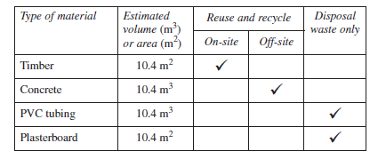
Which material has the greatest negative impact on the environment?
  - Timer
  - Concrete
  - PVC Tubing
  - Plasterboard

- Which information can be found on a floor plan?
  - Roof structure
  - Wall thickness
  - Window-sill height
  - Overhanging beams
- What is the most commonly used scale for a site plan?
  - 1:10
  - 1:20
  - 1:100
  - 1:200
- Which of the following fence types is used to prevent hazardous substances running off into nearby waterways from a construction site?
  - Brick
  - Sediment
  - Temporary
  - Fabric sheet

- What does this symbol used in building drawings represent?
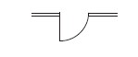
  - A bifold door
  - A single hinged door
  - A single sliding door
  - A double hinged door
- Which of the following drawing types contains information about boundary dimensions?
  - A site plan
  - An elevation
  - A floor plan
  - A cross-sectional plan
- The term RL on a site plan refers to a
  - reduced line.
  - reduced level.
  - reference line.
  - reference level.
- On which type of plan would the floor to ceiling height be shown?
  - Detail
  - Elevation
  - Floor
  - Site
- A cross-sectional view on a house plan is used to provide
  - a list of all construction materials used.
  - the location of a house on a building site.
  - the details of internal construction used in a wall.
  - an estimate of material requirements for the overall project.

Questions from Section II
These questions should be answered in the space provided as it gives a guide to the length of your response.
Plan out your answer and key points before you commence writing.
You may need to bring together knowledge from several areas of study/competencies to do justice to the answer.
Question 1
  - Name the labelled components in the timber frame shown. (2 marks)
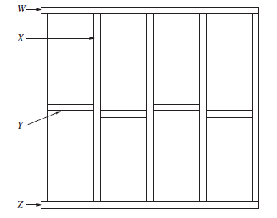

W
X
Y
Z

  - Outline a method to test the timber frame for squareness. (1 mark)

Question 2
Use the Floor Plan to answer Parts a) and b) on next page.
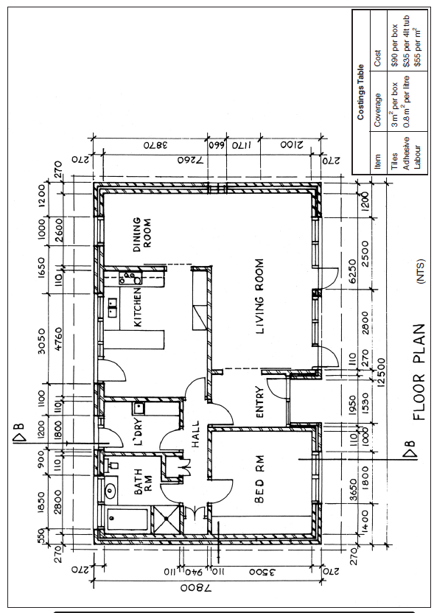

  - Calculate the combined floor area of the dining and living rooms. (3 marks)

  - Using the costings table and floor plan, calculate the total cost of tiling the kitchen area prior to installing the kitchen cabinets. (5 marks)

Question 3
The diagram shows a site plan of a proposed dwelling.
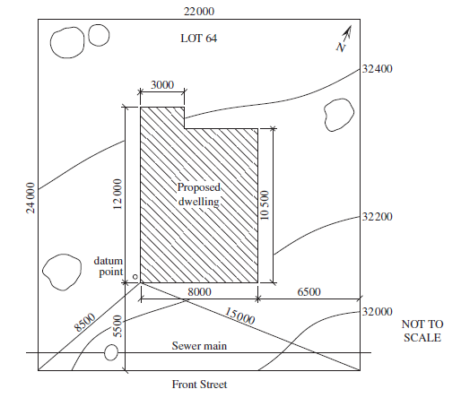
  - What features on the site plan indicate the position of the proposed dwelling? (4 marks)

Question continued over.

  - Calculate the amount of land on the site excluding the proposed dwelling. Show all working. (3 marks)

  - Explain why it is important to use accurate calculations when completing a project budget, work schedule and labour costs. Provide examples to support your answer. (3 marks)

Question 4
A construction site plan is shown.
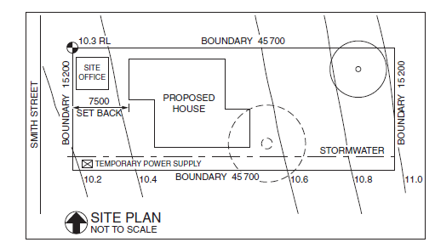
  - Identify ONE symbol or feature from the site plan and outline its purpose. (2 marks)

  - Using the table, calculate the total cost of labour to set up temporary fencing for the construction site. Show all working. (2 marks)
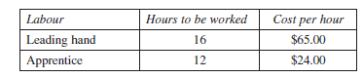

Questions from Section III
In the HSC –
- there will be one structured extended response question (15 marks)
- the question will have an expected length of response of around four pages of an examination writing booklet (approximately 600 words)

Questions from Section IV
In the HSC –
- there will be one structured extended response question in Section IV (15 marks).
- the question will have two or three parts, with one part worth at least 8 marks
- the question will have an expected length of response of around four pages of an examination writing booklet (approximately 600 words) in total.

This will provide you with the opportunity to:
- demonstrate knowledge and understanding relevant to the question
- communicate ideas and information using relevant workplace examples and industry terminology
- present a logical and cohesive response

You will note that these questions usually require you to bring together knowledge from several areas of study/competencies to do justice to the answer. You should allow about 25-30 minutes for a question in Section III and the same for Section IV of the exam.

In each of the following, map out your answer using post-it notes or a sheet of paper. Pay particular attention to incorporating a variety of aspects of your Construction curriculum into the plan. Consider why we have included this question within this ‘Read and interpret plans and specifications’ module and what other areas of study you would need to draw upon.

Question 1 [Students were asked to answer Part a) and Part b) in separate writing booklets]

You have been asked by a client to build a new timber fence 1.8 metres high and 15 metres long.

A typical fence panel and section are shown (NOT to scale).

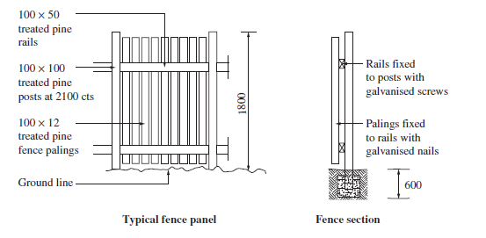

  - Outline the tools and equipment needed to construct the fence (5 marks)
  - Describe a method, from beginning to end, for constructing a high-quality fence. (10 marks)

Question 2
Use the following document to answer part (a) and (b).

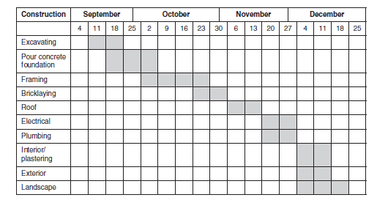

- Identify the type of document shown and describe its use in planning a large-scale construction project. (6 marks)
- Explain why it is necessary to use different modes of communication in the construction project described in the document above. (9 marks)

