BUSINESS SERVICES
Mandatory Focus Area: Financial records
Welcome.
This module will assist you to review and revise the content of the Mandatory focus area: Financial records. Each focus area prescribes the scope of learning for the HSC and is drawn from associated units of competency.
You will have studied either:
TLIP2029 Prepare and process financial documents or
BSBFIA301 Maintain financial records
This module is broken up into:
- Important notes
- Key terms and concepts
- Activities
- Putting the theory into practice
- HSC Focus Areas
How to use the resource
Work through the notes and the suggested activities. Great revision techniques include working through how a problem is solved, explaining the concept, testing yourself and retrieving information from your memory. Spread your revision over a number of sessions rather than sitting at one subject for lengthy periods.
Discuss your responses with your teacher, fellow students or an interested family member.
All images, apart from those acknowledged, are © NSW Department of Education.

Important notes
The unit of competency TLIP2029 Prepare and process financial documents describes the skills and knowledge required to prepare and process financial documents, including recording and balancing petty cash transactions, balancing all other transactions, rectifying discrepancies as directed, preparing invoices for debtors, and preparing and processing banking documents
The unit of competency BSBFIA301 Maintain financial records describes the skills and knowledge required to maintain daily financial records such as reconciling debtors’ and creditors’ systems, preparing and maintaining a general ledger and trial balance and includes activities associated with monitoring cash control for accounting purposes.

The HSC Content for this industry curriculum framework is organised into focus areas.
The outcomes of the mandatory focus area ‘Financial records’ require that the student:
- understands the principles for preparing, processing and maintaining routine financial records
- selects and applies appropriate methods and techniques to make financial calculations
- understands the importance of compliance with legislative, industry and workplace requirements.

You should use the following information as a prompt and guide when revising your study notes or text-book information or other resources provided by your teacher.
Make sure you check your understanding of all the content in the scope of learning (see HSC Focus Areas).

Key terms and concepts
You can use the following information to revise the key terms and concepts from this unit of competency. Perhaps you could:
- Copy the table into your own file, remove all the key terms, then fill in the blanks (without peeking at the original file) with your own answers.
- Copy the table into your own file and remove the definitions. Write a definition in your own words – it doesn’t have to word perfect but should show you understand the concept.
- You could add an example of this term or concept which is relevant to the retail environment. If the key term was ‘negotiation’ your business example might be ‘the finance team met to allocate tasks to ensure the end-of-year reporting was finalised in a timely manner’
Key term or concept | and Definition
ABN | Australian Business Number: an identifying number issued to a business by the Australian Taxation Office
Accounts Payable | balances of money owed to other individuals or businesses
Accounts Receivable | money owed to a company by its debtors
Accuracy | Correct preparation of all documents
Adjustment Note | A financial document which specifies the value of goods being returned, or an allowance or discount given
Audit | An independent check of the accuracy of financial records and accounting procedures
Authenticity | Accuracy and relevance
Balance | Making the necessary entries in an account so that both sides will be equal, for example balance the petty cash fund. The amount owing on an account, for example the balance due on my statement is $55
Banking | Financial transactions carried out with a bank eg deposit, withdraw
Business Activity Statement (BAS) | A form submitted to the Australian Taxation Office (ATO) by registered business entities to report their tax obligations, including GST.
Cheque | A written order (usually on a pre-printed form) directing a bank to pay a specified amount of money to a particular person
Credit | an entry recording a sum received; add (an amount of money) to an account.
Credit card statement | A record of all transactions of a credit card in a particular time period
Credit note | See Adjustment Note
Creditor | An organisation which is owed money for the provision of goods or services on credit. Creditors who are owed money are also known as Accounts Payable.
Debit | an entry recording a sum owed; an amount to be removed from an account
Debtor | An organisation which purchases goods or services on credit; money is owed to another business which may refer to debtors as Accounts Receivable.
Delivery docket | Accompanies the goods and lists what is in the delivery; used to check the goods received
Deposit | Money placed in a bank
Deposit book | Pre-printed slips in book form, provided by the bank and used to itemise the bank deposit
Expenditure | Spending funds: the amount of money spent
Expense | The cost incurred in or required for something
General Ledger | The main accounting record of a company or business
GST (Goods and services tax) | A 10% tax on the supply of most goods and services consumed in Australia.
Income | Money received, especially on a regular basis
Instalment Activity Statement (IAS) | A form used by taxpayers who are not registered for Goods and Services Tax (GST)
Invoice | An account sent indicating the goods or services provided, price, GST, freight and other charges and total amount payable. Must show ABN and include the words ‘Tax Invoice’
Order form | A written request for specified goods or services to be purchased or provided
Pay as you go (PAYG) | Regular payments made during the year (through an activity statements) to offset against any tax owed for the year.
Petty cash | A small fund of money kept for incidental everyday purchases
Purchase order | A written request for specified goods or services to be purchased; usually a numbered, accountable form
Receipt | Evidence that payment has been made; a receipt shows who has received the money, the date, what has been paid for, the total amount paid, any discount given and the amount of GST included.
Reconciliation | To bring into agreement or check the accuracy of calculations eg preparing a reconciliation of the bank deposit form with the total of cash receipts issued
Refund | To give back or repay
Reimbursement cheque | The cheque prepared and cashed to bring the petty cash fund back to its imprest amount
Remittance advice | A document attached to a cheque specifying what payment is being made. The remittance advice often forms the bottom part of the invoice; it can be detached and returned with payment.
Requisition | An official request or demand
Resolution | To fix or settle
Revenue | Income generated from normal business operations
Signature | A person’s name, written by hand, usually on a document
Source document | The original document containing the details of a business transaction and capturing the key information about the transaction
Tax invoice | A legal document which a seller provides to a customer in which the tax is clearly included. In Australia GST-registered customers need a tax invoice to claim a credit for the GST in the purchase price on any taxable sale of more than $82.50 (including GST)
Trial Balance | A trial balance is a bookkeeping or accounting report that lists the balances in each of an organisation's general ledger accounts.
Voucher | A document, receipt etc which itemises an expenditure
Withdrawal | To take money out of the bank or an account

Activities

Activity 1: Numeracy calculations
  - Complete the following without using a calculator, then check your answers with the calculator.
Question | Without calculator | Using calculator
10% of $55.60
50% of $92.00
25% of $856.00
One-third of $172.80
How much for 3 apples each costing 25c?
How much for two pairs of shoes each costing $95 (incl GST)?
The total cost of 12 exercise books each costing $1.25 (incl GST)
600 divided by 3
600 divided by 8
Round 45.759 to the nearest whole number
Round $1.0638 to the nearest cent
Round $24.38 to the nearest dollar
Three items each cost $75. Delivery of the package is an extra $15.
Calculate the GST component of a sale which totals (including GST) $990
How much GST should be added to a sale of $4250.00?

  - Compare the following two columns of figures and indicate any differences.

 | 32981.55 | 32881.55
 | 101001.00 | 101010.00
 | 13050.55 | 13050.50
 | 98.76 | $98.76
 | 29585.64 | 29585.64
 | 42014 | 42.014
 | $12095.67 | $12096.67

  - Total each row and column
Department | Jan  $ | Feb  $ | Mar  $ | Apr  $ | Total  $
Ladies’ Wear | 1370 | 880 | 1870 | 880
Men’s Wear | 1040 | 2130 | 1640 | 1620
Footwear | 3960 | 2240 | 2140 | 3120
Accessories | 1680 | 1160 | 2270 | 2680
Children’s Wear | 2160 | 1690 | 1260 | 1480

$ Total

Activity 2: Petty Cash
- Briefly explain what is a petty cash imprest system and why it is needed?
- Suggest three ways of ensuring the security of the petty cash fund in a small office.
- Explain ‘imprest amount’
- The steps below for balancing the Petty Cash at the end of the month are ordered incorrectly. Indicate the correct order 1, 2, 3, 4 in the space provided.
Order | Steps
 | Total and reconcile cash left in petty cash tin/box
 | Subtract payments from petty cash advance
 | Reconcile total of payments in columns with expenses
 | Add up all payments

- Find the errors and omissions (shaded boxes A-G) in the following Petty Cash extract and make corrections.
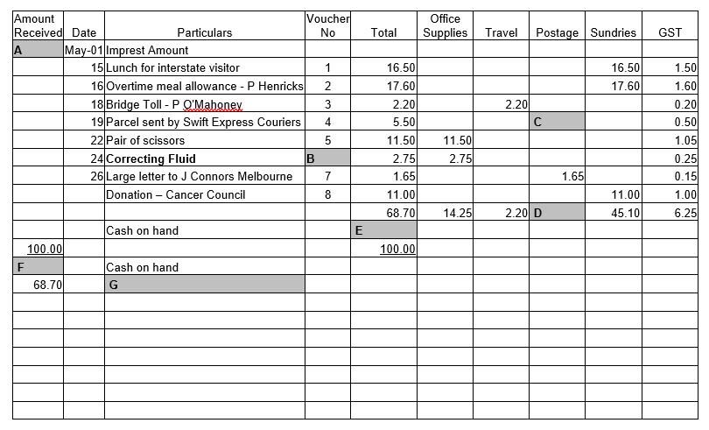

Activity 3: Source documents
- Find the errors and omissions in the following Tax Invoice and make corrections.
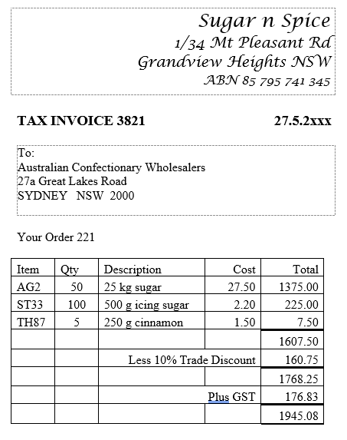
- Assuming Order 221 was for the following, what action should be taken?
Item | Qty | Description
AG2 | 50 | 25 kg sugar
ST33 | 150 | 500 g icing sugar
TH87 | 15 | 250 g cinnamon

Activity 4: Key terms
Match the words to the correct definition below.
Use these words
receipt | order form | statement
audit | tax invoice | GST
reconciliation | creditor/accounts payable | signature

Fill in the term or concept
An account sent indicating the goods or services provided, price, GST, freight and other charges and total amount payable. Must show ABN.
Evidence that payment has been made
A person’s name, written by hand, usually on a document
Making the necessary entries in an account so that both sides will be equal; for example, balance the petty cash
A written request for specified goods or services to be purchased; usually a numbered, accountable form
An independent check of the accuracy of financial records and accounting procedures
A 10% tax on the supply of most goods and services consumed in Australia.
An organisation which is owed money for the provision of goods or services on credit.
A record of all transactions of a credit card in a particular time period

Putting the theory into practice
The following questions are from past years’ NSW HSC examination papers for this subject. HSC exams are intended to be rigorous and to challenge students of all abilities. To better understand a question, you should look for key words and identify the aspect of the course to which these relate. You are then in a position to formulate your answer from relevant knowledge, understanding and skills.
Questions in ‘Putting the theory into practice’ are acknowledged as © 2019 NSW Education Standards Authority (NESA) for and on behalf of the Crown in right of the State of New South Wales.

Multiple Choice
- A company uses a set of accounts to keep track of its financial transactions and provide information for preparing financial reports. Which financial document would contain this set of accounts?
  - Receipt
  - Deposit form
  - General ledger
  - Petty cash book

- An invoice has a subtotal of $4500 before GST, including $300 for the cost of freight. GST needs to be applied to the invoice. What is the total invoice amount?
  - $4920
  - $4950
  - $5220
  - $5280.

- The total amount shown on an invoice, including GST, was $3597.
What was the amount of GST payable?
  - $32.70
  - $35.97
  - $327.00
  - $359.70

- Petty cash claims for the month total $68.80.
How much remains if the monthly petty cash fund is $100.00?
  - $31.20
  - $32.20
  - $168.80
  - $170.00

- What is the amount owed by a business if it receives 1.75% discount on an invoice for $5765.00?
  - $100.89
  - $5636.11
  - $5664.11
  - $5865.89

- The following is an example of a financial document used with a business. What type of document is it?
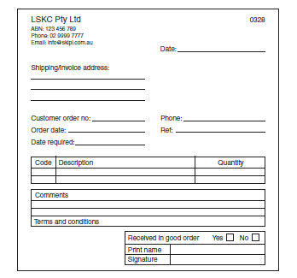
  - A receipt
  - An invoice
  - A purchase order
  - A delivery docket

- Consider the bank deposit slip shown.
There are four amount labelled W, X, Y and Z missing from the deposit slip.
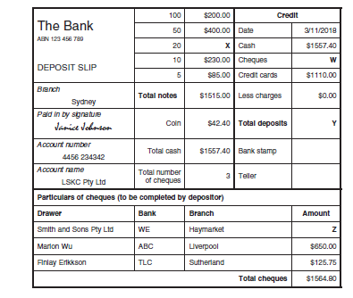
Which row in the table correctly identifies the missing amounts X and Y?
 | X | Y
A | $642.50 | $3122.20
B | $600.00 | $3122.20
C | $642.50 | $4232.20
D | $600.00 | $4232.20

Questions from Section II
These questions should be answered in the suggested number of lines (handwritten) as it gives a guide to the length of your response.
Plan out your answer and key points before you commence writing.
You may need to bring together knowledge from several areas of study/competencies to do justice to the answer.
Question 1
A delivery docket is shown.
- Identify ONE responsibility of the customer and ONE responsibility of the supplier in relation to this delivery. (2 marks)

Question continues over

Question 1
- On the following statement the amounts labelled Y and Z are missing.
Identify the missing values Y and Z (2 marks)
Y
Z
Explain an improvement LAMADI Pty Ltd could make to their cash management operations. (3 marks)

Question 2
- A credit note is shown.
Why has this credit note been issued (2 marks)

- What is the purpose of a Business Activity Statement (BAS)? (2 marks)

Question continued over

- Explain how petty cash is used in a business. (3 marks)

Question 3
- On the following purchase order, the values labelled X, Y and Z are missing. Identify the missing values. (3 marks)
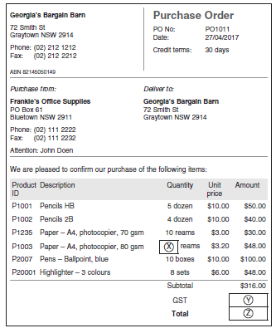
X
Y
Z

Question continues over
- This delivery docket contains errors.
Explain how these errors would affect Georgia’s Bargain Barn and Frankie’s Office Supplies (4 marks)

Questions from Section III
You will note that questions often require you to bring together knowledge from several areas of study/competencies to do justice to the answer. You should allow about 25 minutes for the question in Section III. Map out your answer using post-it notes or a sheet of paper before you start.

Questions from Section IV
In the Business Services HSC exam –
- there will be one structured extended response question in Section IV worth 15 marks.
- the question will have an expected length of response of around four pages of an examination writing booklet (approximately 600 words) in total.
This will provide you with the opportunity to:
- demonstrate knowledge and understanding relevant to the question
- communicate ideas and information using relevant workplace examples and industry terminology
- present a logical and cohesive response
You should allow about 25-30 minutes for a question in Section III and the same for Section IV of the exam. Pay particular attention to incorporating a variety of aspects of your Business Services curriculum into the plan.

HSC Focus Areas
The HSC Content for this industry curriculum framework is organised into focus areas. Each focus area prescribes the scope of learning for the HSC and is drawn from the associated units of competency.
Students undertaking the 240 indicative hour course from the Business Services Curriculum Framework must address all of the mandatory focus areas:
- Customer service
- Financial records
- Innovation
- Safety
- Sustainability
- Working in the business services industry and workplace
- Workplace information

How to use the scope of learning for ‘Financial records’ (which follows over).
- draw up your own mind map showing the connection between the various concepts listed; examples appear on the last page of this module
- use the key terms and concepts to add to your mind map
- add examples or case study prompts to show how the concept is applied in the information technology working environment

The following information is taken directly from page 29 ff of Business Services
Curriculum Framework Stage 6 Syllabus based on the BSB Business Services Training Package (version 5) for implementation from 2020. © 2019 NSW Education Standards Authority (NESA) for and on behalf of the Crown in right of the State of New South Wales

definitions
- key terms and their meaning:
  - accounts payable and receivable
  - credit
  - creditor/lender
  - debit
  - debtor/borrower
  - expenditure
  - expense
  - income/revenue

financial records typical to a business
- purpose and use of a range of financial records common to a business services workplace:
  - journal
  - general ledger
  - petty cash book
  - trial balance
  - source documents:
- credit note
- delivery docket/note
- invoice
- petty cash voucher
- purchase order
- receipt
- statement
- workplace documentation
- key provisions of legislation, codes of practice and standards that apply to:
  - financial record-keeping
  - taxation documentation:
- Australian Business Number (ABN)
- Business Activity Statement (BAS)
- Instalment Activity Statement (IAS)
- Pay as you go (PAYG) withholding
- tax invoices
- importance of compliance with regulatory and workplace requirements in relation to financial record-keeping

financial calculations
- techniques for completing a range of numerical operations common to the business services industry:
  - arithmetic operations and their symbols:

financial calculations cont/d
- addition
- subtraction
- division
- multiplication
  - understanding of mathematical concepts:
- whole numbers
- decimals
- fractions
- percentages
- performance of financial calculations using manual and electronic methods
- calculations for a range of business services work tasks of varying complexity, including calculation of Goods and Services Tax (GST)

business equipment and technology
- business equipment and technology commonly used in the business services industry to:
  - prepare, process and maintain financial records
  - perform financial calculations
- use/operation of a range of business equipment and technology and appropriate selection for tasks/job

ensuring quality outcomes
- importance of accuracy when transferring and recording financial data and completing financial transactions and the consequences of errors for the customer and the business
- examples of common discrepancies and errors that occur in daily transactions and financial records
- responding to a range of common discrepancies and errors:
  - known solutions that may be used to rectify problems
  - refer to designated personnel, as required

cash management
- how cash management operations within a business services workplace are undertaken in accordance with:
  - legislative requirements
  - workplace policy and procedures
  - designated timelines
- monitoring cash flow within a business services workplace:
  - making and receiving payments
  - following up outstanding accounts

cash management cont/d
- completion of payment documentation:
  - accuracy checks
  - authorisation/approvals
- despatch of payment documentation to debtors and creditors
- process related to bank deposits:
  - banking method
  - preparation of deposit forms and other documentation
  - reconciliation of:
- financial calculations with pay-in documentation
- internal records with totals recorded by bank
  - lodgement:
- deposit facility
- proof of lodgement
- processes related to petty cash transactions:
  - claims
  - vouchers
  - reconciliation

bookkeeping practice
- journals:
  - electronic and paper-based formats typical to a business services workplace
  - basic principles for maintaining journals
  - entering credit and debit transactions
- general ledger:
  - basic principles for maintaining a general ledger
  - practices for:
- posting transactions
- reconciling systems for accounts payable and receivable
- preparing a trial balance
.
Example of mind map being developed
