Stage 5 PDHPE: Get your hand off it, road safety
A sequence of 4 activities, duration 4-6 lessons (50-60 minutes in length)

Educative purpose
This set of activities has been designed for students to identify the:
- features of a variety of health, wellbeing and safety campaigns
- identify what makes a campaign successful,
- need for a campaign in relation to mobile phone use as a road user
- target audience
- key messages for the community.
Students work together collaboratively to develop a campaign that is targeted towards their local community and needs.
Required Resources and materials for preparation
Student activities are:
- whole group/ small group/ Individual activities
- offline and online
Equipment required:
- laptop/tablet/phone
- an online sharing and interaction space OneDrive, Google Classroom, Adobe Connect
- online access to
  - Slip, slop, slap, seek, slide
  - Healthy school canteens
  - QUIT
  - Crunch & sip
  - Stop it or cop it
  - Safety starts with you
  - It’s people like us documentary (first 8 minutes)
  - It’s people like us follow up videos about the documentary (1.53 minutes) and what’s it gonna take? (1.57 minutes)
  - Transport for NSW’s safe system approach
  - NSW Centre for Road Safety Know the rules , mobile phone road rules animated video clip (1:32 minutes) and common questions
  - Centre for Road Safety’s Sydney Swans Get your hand off it campaign (0:30minutes)
  - video clip Funny phone accidents – Texting while walking fail! (3:01 minute)
- Digital or hard copy of
  - Safe system sorting activity (appendix 1)
  - Drivers and pedestrians involved in recorded crashes: Hand held phone distraction (appendix 2)
  - Pedestrian self-reported exposure to distraction by smart phones while walking and crossing the road (appendix 2)
  - Passenger influence on driver safety (appendix 2)
  - Student worksheet 1 Purpose of the Get your hand off it campaign (appendix 3)
  - Student worksheet 2 Our Campaign (appendix 4)
  - Student worksheet 3 Peer SWOT analysis (appendix 5)
  - Student worksheet 4 health and Safety campaign self-assessment (appendix 6)
Learning experiences
Activity 1: Understanding health, safety and wellbeing campaigns
Learning intentions: by the end of this activity students will:
- understand what a health, safety and wellbeing campaign is
- be able to analyse a variety of health, safety and wellbeing campaigns and evaluate their effectiveness and what does or does not make them effective
- understand the need for a health, safety and wellbeing campaign in relation to mobile phone use as a road user
Suggested syllabus content:
Outcomes | Content
PD5-2: researches and appraises the effectiveness of health information and support services available in the community  PD5-6: critiques contextual factors, attitudes and behaviours to effectively promote health, safety, wellbeing and participation in physical activity | - evaluate strategies and actions that aim to enhance health, safety, wellbeing and physical activity levels and plan to promote these in the school and community  - identify major causal factors in road and traffic-related injuries and assess the strategies and actions to promote their own and others’ health, safety and wellbeing, eg minimising distractions such as music and mobile phones, identifying a designated driver, resting when tired, speeding, overcrowding of cars, following road rules S I  - critically analyse health information, products and services to promote health, safety, wellbeing and physical activity levels  - critique the appropriateness of health and support services that provide advice and support on health-related issues and propose strategies to encourage young people to access appropriate services S I  - develop and apply criteria to assess health information, products and services and propose actions that may assist young people to select credible sources of information and advice S

PDHPE skills focus:
Self-management skills | Interpersonal skills
- decision making and problem solving  - information gathering  - analysis | - communication  - verbal and nonverbal communication  - listening  - collaboration, inclusion and relationship building  - expressing respect for others contributions  - assessing their own abilities and reporting back to the group

Part 1: Introducing the concept
What is a campaign?
- students brainstorm answers to the following questions:
- what is a health, safety and wellbeing campaign?
- what is their aim or purpose?
- what health, safety and wellbeing campaigns are you aware of?

Part 2: Expanding the concept
Exploring current campaigns
- in small groups students explore current health, safety and wellbeing campaigns and record answers to the following questions:
- what public health, safety and or wellbeing issue was address?
- how was the issue addressed?
- who was the audience?
- was it effective? Why or why not?
Examples of campaigns:
- Slip, slop, slap, seek, slide (https://youtu.be/b7noclenCYg)

- QUIT (https://youtu.be/kf-jb7x_kUQ)

- Stop it or cop it (https://youtu.be/XgdVvK9U1tU)

- Healthy school canteens (https://vimeo.com/348965168)

- Crunch & sip (https://youtu.be/UogZp6lDrC4)

- Safety starts with you (https://youtu.be/EclfaNn1JoY)

- students watch the first 8 minutes of the It’s people like us documentary to identify the need for a mobile phone campaign, and takes notes on the following:
It’s people like us documentary

List people using their phone

Key messages of the documentary

Positives

Negatives

Things that shocked you

New information you learnt

- students discuss and answer the following in relation to the documentary:
- who the documentary is aimed at
- whose health the video is trying to improve
- how it tries to improve people’s health, safety and wellbeing
- the main issues and concerns highlighted in the documentary
- whether their thoughts have changed on the impact of mobile phone use on people’s health, safety and wellbeing
- if the campaign is effective or not and reasons for this
- what they would add or change?

Part 3: Reinforcing the concept
Safe Systems Approach
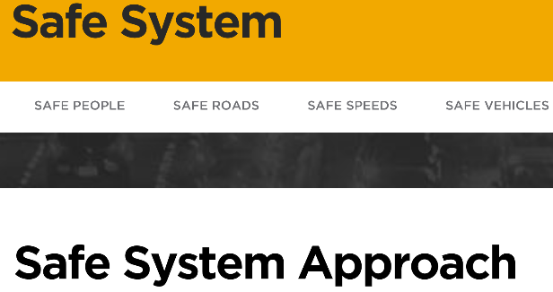
- students explore Transport for NSW’s safe system approach to understand how the It’s people like us documentary contributes to the NSW government’s Towards Zero campaign by reading the information in each of the following components:

(https://towardszero.nsw.gov.au/safesystem)

- safe system approach
- safe people
- safe roads
- safe speeds
- safe vehicles

- Students use the website to complete sorting activity (appendix 1). To demonstrate their understanding of the safe system approach, students cut and paste the suggested examples into the correct category.

- as a class discuss:
- which safe system components mobile phone usage fits into
- how they would campaign to encourage all road users – drivers, passengers, wheel users and pedestrians to be responsible mobile phone users

Activity 2: Developing a health, safety and wellbeing campaign
Learning intentions: by the end of this activity students will:
- know and understand the rules of mobile phone use as a road user
- propose strategies and actions that can help young people to make safer choices as a road user
- be an effective team member in planning, designing, creating and sharing a health, safety and wellbeing campaign on responsible mobile phone use
Suggested syllabus content:
Outcomes | Content
PD5-7  plans, implements and critiques strategies to promote health, safety, wellbeing and participation in physical activity in their  communities  PD5-8  designs, implements and evaluates personalised plans to enhance health and participation in a lifetime of physical activity  PD5-9  assesses and applies self-management skills to effectively manage complex situations | - plan, rehearse and evaluate options for managing situations where their own and others’ health, safety and wellbeing may be at short or long-term risk (ACPPS091)  - practise self-management and interpersonal skills to manage and respond to a variety of challenging or unsafe situations, eg sexual relationships S I  - formulate a safety plan to meet the particular needs of a challenging situation, listing choices and consequences and making a decision about the best choice for their own health, safety or wellbeing S I  - demonstrate and advocate appropriate strategies to keep themselves safe while supporting others in various situations, eg posting offensive material online, bullying, harassment S I

PDHPE skills focus:
Self-management skills | Interpersonal skills
- decision making and problem solving  - information gathering  - finding solutions to problems  - time management  - goal setting and tracking | - communication  - verbal and nonverbal communication  - listening  - giving and receiving feedback  - negotiation and conflict management  - collaboration, inclusion and relationship building  - expressing respect for others contributions  - recognising and using their own abilities and strengths and those of others  - assessing their own abilities and reporting back to the group

Part 1: Introducing the concept
Reviewing the purpose of health, safety and wellbeing campaigns
- to summarise understanding of irresponsible mobile phone use when travelling, and the need for advertising campaigns to address this, students watch and discuss two short supplementary clips from the It’s people like us documentary (from Activity 1, part 2):
Clip |  | Note | Web link
- about the documentary | (1.53 minutes) |  | https://youtu.be/FLy7rCqIEkU
- what’s it gonna take? | (1.57 minutes) the police officer does say the word porno |  | https://youtu.be/0LDNMgK16fA

Part 2: Expanding the concept
Knowing the rules of mobile phone use as a road user
- to raise road user awareness of mobile phone laws students visit NSW Centre for Road Safety’s Know the rules section (https://roadsafety.transport.nsw.gov.au/stayingsafe/mobilephones/know-the-rules.html)

Have students:
- watch the mobile phone road rules animated video clip (1:32 minutes)
(https://www.youtube.com/watch?v=HEcKg9I4yew&feature=youtu.be)

- read the know the rules information
(https://roadsafety.transport.nsw.gov.au/stayingsafe/mobilephones/know-the-rules.html)

- find answers to the following common questions about mobile phone road rules:
(https://roadsafety.transport.nsw.gov.au/stayingsafe/mobilephones/know-the-rules.html#questions)
- can I use my phone to make a call, use GPS or listen to music?
- can I use my phone to make a call, use GPS or listen to music if it’s in a cradle?
- can I use my mobile phone if it is on loudspeaker and in my lap?
- can I use my phone to text?
- what do I need to do to use my mobile phone?
- do I need to be parked with my ignition off to use my phone?
- if I have a Digital Driver Licence and I’m pulled over by NSW Police, when is it OK to pick up my phone to show my licence?
- am I able to access my mobile phone wallet functions if my vehicle is stationary and off the road?
- can I use a GPS device that is not a phone?
- will the introduction of mobile phone detection cameras affect me?
- was there a warning period for the start of the mobile phone detection camera program?
- how will I know if I’ve been caught using my phone illegally by a mobile phone detection camera?
- what is the penalty for being caught for illegal phone use?
- do double demerits apply for mobile phone offences detected by a mobile phone detection camera?

- read the following research extracts:
- Drivers and pedestrians involved in recorded crashes: Hand held phone distraction (Appendix 1)
- Pedestrian self-reported exposure to distraction by smart phones while walking and crossing the road (Appendix 1)
- Passenger influence on driver safety (Appendix 1)

- watch the video clip Funny phone accidents – Texting while walking fail! (3:01 minutes, https://youtu.be/nYgTM1pPjKQ) and discuss the following:
- why being distracted as a pedestrian is dangerous
- the value of humour in educating and informing others of unsafe behaviours

Part 3: Reinforcing the concept
Creating a safe driver mobile phone campaign
- students watch Centre for Road Safety’s Sydney Swans Get your hand off it campaign (0:30minutes) and record thoughts on worksheet 1, Purpose of get your hand off it campaign (Appendix 2)
(https://youtu.be/lvVARlkuBYA)

- linking back to the end of Activity 1 part 2, students remind the class of their ideas of how they would campaign to encourage drivers to be responsible mobile phone users

- in groups (teams) students work through the following considerations and summarise responses on worksheet 2, Campaign purpose and name (Appendix 3) to identify the scope of their safe road user mobile phone campaign:
- the goal of their campaign
- target audience
- age group of their target audience
- the impact they want the campaign to make on individuals and/or groups of people
- main messages
- format of the campaign, e.g. text, audio, live performance, video
- the platform on which the campaign is to be shared-
- print media, e.g. local paper, school newsletter, posters, signs, brochures
- social media, e.g. snapchat, instagram, facebook, blog, twitter, tictock
- instant messaging, e.g. SMS, MMS, school website banner
- online, e.g. school website
- promotional items, e.g. drink bottles, keyrings, clothing, hosting an event
Activity 3: delivering a health, safety and wellbeing campaign
Learning intentions: by the end of this activity students will:
- be able to inform a targeted audience about on the rules for use of mobile phones as a road user
- be able to create and deliver strategies that can support young people to make safer choices as road users
- work effectively in a team to create and deliver a health, safety and wellbeing campaign
- evaluate and critique their own and others campaigns
- self-assess their contribution as a member of a team to the creation and delivery of a health, safety and wellbeing campaign
Suggested syllabus content:
Outcomes | Content
PD5-7  plans, implements and critiques strategies to promote health, safety, wellbeing and participation in physical activity in their  communities  PD5-8  designs, implements and evaluates personalised plans to enhance health and participation in a lifetime of physical activity  PD5-10  critiques their ability to enact interpersonal skills to build and maintain respectful and inclusive relationships in a variety of groups or contexts | - plan, rehearse and evaluate options for managing situations where their own and others’ health, safety and wellbeing may be at short or long-term risk (ACPPS091)  - practise self-management and interpersonal skills to manage and respond to a variety of challenging or unsafe situations, e.g. sexual relationships S I  - formulate a safety plan to meet the particular needs of a challenging situation, listing choices and consequences and making a decision about the best choice for their own health, safety or wellbeing S I  - demonstrate and advocate appropriate strategies to keep themselves safe while supporting others in various situations, e.g. posting offensive material online, bullying, harassment S I  - evaluate strategies and actions that aim to enhance health, safety, wellbeing and physical activity levels and plan to promote these in the school and community  - identify major causal factors in road and traffic-related injuries and assess the strategies and actions to promote their own and others’ health, safety and wellbeing, eg minimising distractions such as music and mobile phones, identifying a designated driver, resting when tired, speeding, overcrowding of cars, following road rules S I
PDHPE skills focus:
Self-management skills | Interpersonal skills
- decision making and problem solving  - information gathering  - finding solutions to problems  - time management  - goal setting and tracking | - communication  - verbal and nonverbal communication  - listening  - giving and receiving feedback  - negotiation and conflict management  - collaboration, inclusion and relationship building  - expressing respect for others contributions  - recognising and using their own abilities and strengths and those of others  - assessing their own abilities and reporting back to the group  - leadership and advocacy  - influencing and persuading  - networking  - social awareness  - contributing to their community  - perspective forming  - perspective taking.

Part 1: Introducing the concept
Assigning roles and creating a campaign
- linking back to the end of activity 2 part students:
- revise their campaign scope
- allocate one or more roles to each team member (see list below)
- draft and finalise their campaign
Examples of team member roles
Leader | - organises the group  - makes sure everyone is on task and on time | Scribe | - takes and records accurate notes during discussions  - assists the reporter
Reporter | - reports on what the group has done and what they are working towards  - keeps notes on what the group has done | Ideas person | - thinks up ideas  - troubleshoots  - solves problems  - explains ideas to other team members
Challenger | - thinks of possible things that could go wrong  - asks questions to make team members think of all possibilities | Technician | - sources materials and supplies the group needs  - takes care of tools and materials that each group member needs
Maker | - makes things the group needs  - liaises with the leader to check product is progressing at an acceptable standard | Helper | - assists anyone in the group with their tasks  - helps any one that has too much to do
Reader | - reads instructions to inform the group  - explains instructions to group members | Coach | - finds ways to motivate and encourage team members  - helps team members work together
Researcher | - sources and analyses credible information  - checks facts
Part 2: Expanding the concept
Evaluating campaigns
- teams share their campaign with the class and/or a wider audience, e.g. teachers, year 11 students
- students critique the effectiveness of each team’s campaign and provide constructive feedback on ways to enhance and/or improve it using worksheet 3, SWOT analysis (Appendix 4)
- teams reflect on the feedback and make necessary changes

Part 3: Reinforcing the concept
Celebrating project completion
- teams share their finalised campaign via their selected platform or medium
- students reflect on their contribution to the project: what they did well, what they didn’t do well and how they could work differently in future. In teams students repeat this process giving feedback on each other’s contribution, using worksheet 4, Student feedback (Appendix 5).

Appendix 1: sorting task Safe System
Safe People | Safe Roads |  | Safe Speeds |  | Safe vehicles
ANCAP new car safety ratings |  | Fatality Free Friday |  | Shared pedestrian and vehicle zones |  | Overhead road electronic messaging
Roadside speed signs |  | National HPE Day |  | MDT |  | RBT
Bicycle paths |  | Local club mini buses |  | Council Road Safety Officers |  | ANCAP used car safety ratings
Self-parking vehicles |  | Department of Education WHS Officers |  | Roads and Maritime Services Road User Safety Officers |  | Airbags, ABS, rear cameras in vehicles
Roads and Maritime Services Aboriginal Project Officers |  | Parent permission notes for student travel |  | Free NSW school bus pass for all students  K-2 |  | Free NSW school Opal travel pass for eligible year 3-12 students
Fines and penalties for traffic offences |  | Department of Education Road safety education website |  | Graduated licencing scheme (GLS) |  | Centre for Road Safety Crash Lab
Driver reviver stops |  | Department of Education Road Safety Education Policy |  | School zones |  | Australian road rules
Point to point cameras |  | Assisted school travel program |  | Roadside parking signs |  | Double demerit periods
Public education campaigns |  | World Day of Remembrance for Road Traffic Victims |  | Traffic offenders driver program |  | Mandatory road safety education K-12
Safer drivers course |  | Walk to Work Day |  | Audio tactile (rumble) line markings |  | Stop look signage on footpath edges
Self-adjusting seatbelts |  | National Kidsafe Day |  | Australia/New Zealand standards for helmets, child restraints |  | Centre for Road Safety parent information in community languages
Mandatory alcohol interlocks for repeat offenders |  | Department of Education Assets management unit |  | Centre for Road Safety free community road safety resources |  | Camera based detection of driver mobile phone offenders
Kerb and guttering |  | Department of Education Excursions policy |  | Vehicle dash cam |  | Flexible road barriers
Community road safety grants |  | School out of bounds areas |  | Post-crash response initiatives |  | Integrated public transport network
Rapid response motorcycle paramedics |  | Duty of care and code of conduct for teachers |  | Speed inhibitors in trucks |  | Fixed and mobile speed cameras
Wider median strips |  | Designated school entry/exit points |  | Truck only lanes |  | Rest areas
Overhead pedestrian bridges and underpasses |  | Walk Safely to School Day |  | Shared bike/pedestrian paths |  | Planting of soft shrubs to dividing freeway roads
No stopping/parking zones |  | Kiss and drop zone |  | Transport for NSW social media platforms |  | Pedestrian crossing facilities
Wide shoulders |  | Ride 2 School Day |  | Council traffic engineers |  | 40 km/h school zones
Traffic calming devices |  | No stopping zones |  | Council parking rangers |  | Flashing lights outside schools
NSW Liquor Accord |  | PDHPE K-10 syllabus |  | Stop revive survive campaign |  | Pedestrian refuges
Government 5 star ANCAP fleet vehicles |  | Teachers on bus duty |  | School crossing supervisors |  | Free soft drinks to designated drivers
Black spot program |  | Department of Education Health and Safety Directorate |  | Bus zones |  | Dragon’s teeth
Compulsory third party vehicle insurance |  | Department of Education Sport and Physical Activity Policy |  | Police school/youth liaison officers |  | Council road safety committees
Subsidised Opal travel passes for eligible year 3-12 students |  | National Yellow Ribbon Road Safety Week |  | Parents and supervisors of learner driver workshops |  | Roads and Maritime Services Driver Licencing Access Program
Electronic stability control |  | Crash aversion  Guidelines for Managing School Student Behaviour on Buses (for bus drivers) |  | Local club buses for patrons |  | Pink slips for car registration
NSW Bike Week |  | Child restraint laws  Centre for Road Safety road safety education resources preschool-year 12 |  | Motocap |  | Police highway patrol
 |  |  |  |  |  | Lane assist

Appendix 2: research extracts

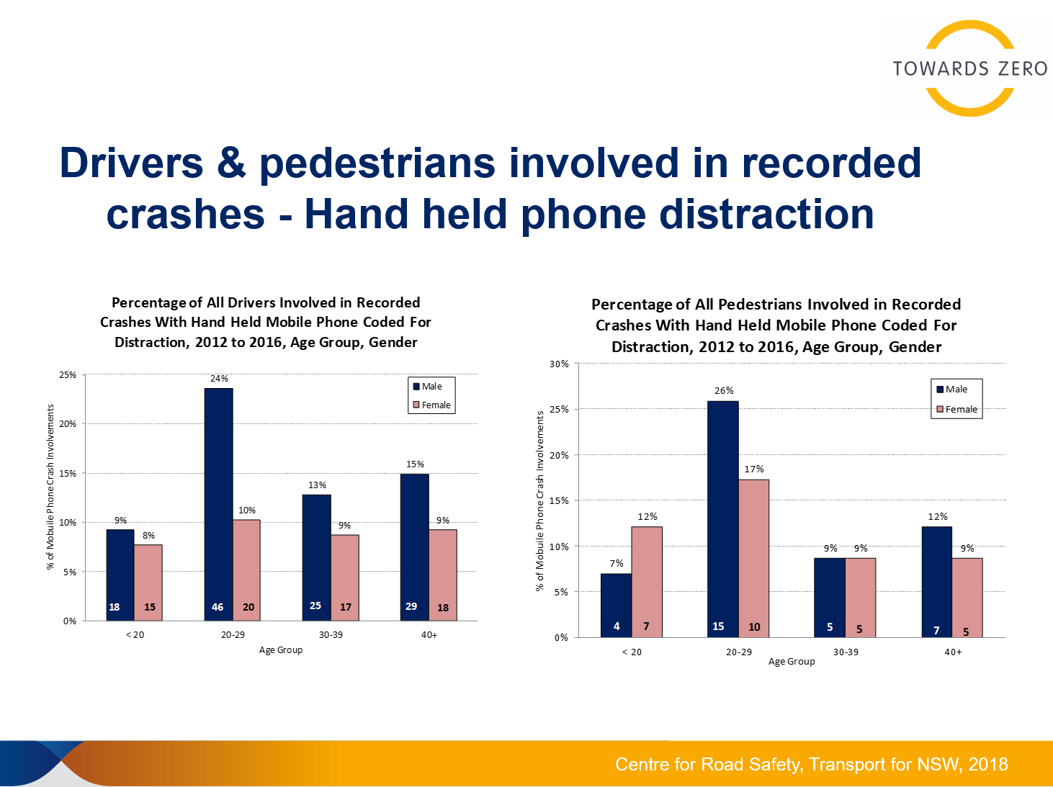
1. Drivers and pedestrians involved in recorded crashes: Hand held phone distraction

2. Pedestrian self-reported exposure to distraction by smart phones while walking and crossing the road
Pedestrian self-reported exposure to distraction by smart phones while walking and crossing the road, 2015, Williamson, Amy & Lennon, Alexia
Research extract:
- pedestrian crashes account for approximately 14% of road fatalities in Australia
- crossing the road, while a minor part of total walking, presents the highest crash risk because of potential interaction with motor vehicles
- crash risk is elevated by pedestrian illegal use of the road, which may be widespread and enforcement is rare
- effective road crossing requires integration of multiple skills and judgements, any of which can be hindered by distraction
- observational studies suggest that pedestrians are increasingly likely to ‘multitask’, using mobile technology for entertainment and communication, elevating the risk of distraction while crossing
- results indicate that smart phone use for potentially distracting activities while walking and while crossing the road was high, especially among 18-30 year olds, who were significantly more likely than 31-44 year olds or 45-65 year olds to report smart phone use while crossing the road
- 18-30 year olds and the higher risk activity of crossing the road, 32% texted at high frequency levels and 27% used internet at high frequency levels
- risky levels of distracted crossing appear to be a growing safety issue for 18-30yo, with greater attention to appropriate interventions needed

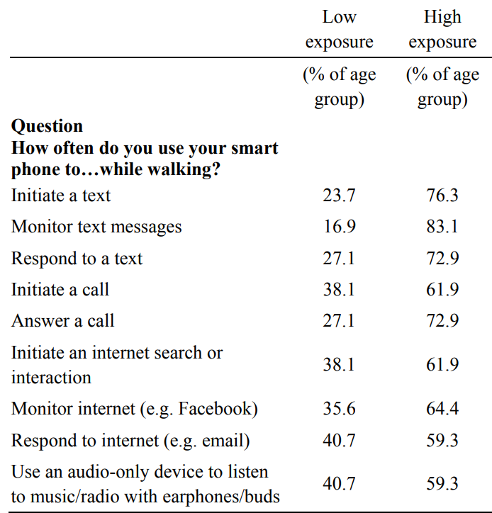
Table 2: Walking while using a smart phone by level of exposure, 18-30 year olds

18-30 year olds are a particular subgroup of pedestrians who should be targeted in interventions to address distracted crossing as they are high frequency smart phone users, as characterised by high use of various activities on their phones.
It’s interesting to note that since adolescents comprise a larger proportion of pedestrian activity and are also more likely to be high-frequency users of smart phones, we would expect that interventions should target this age group too.

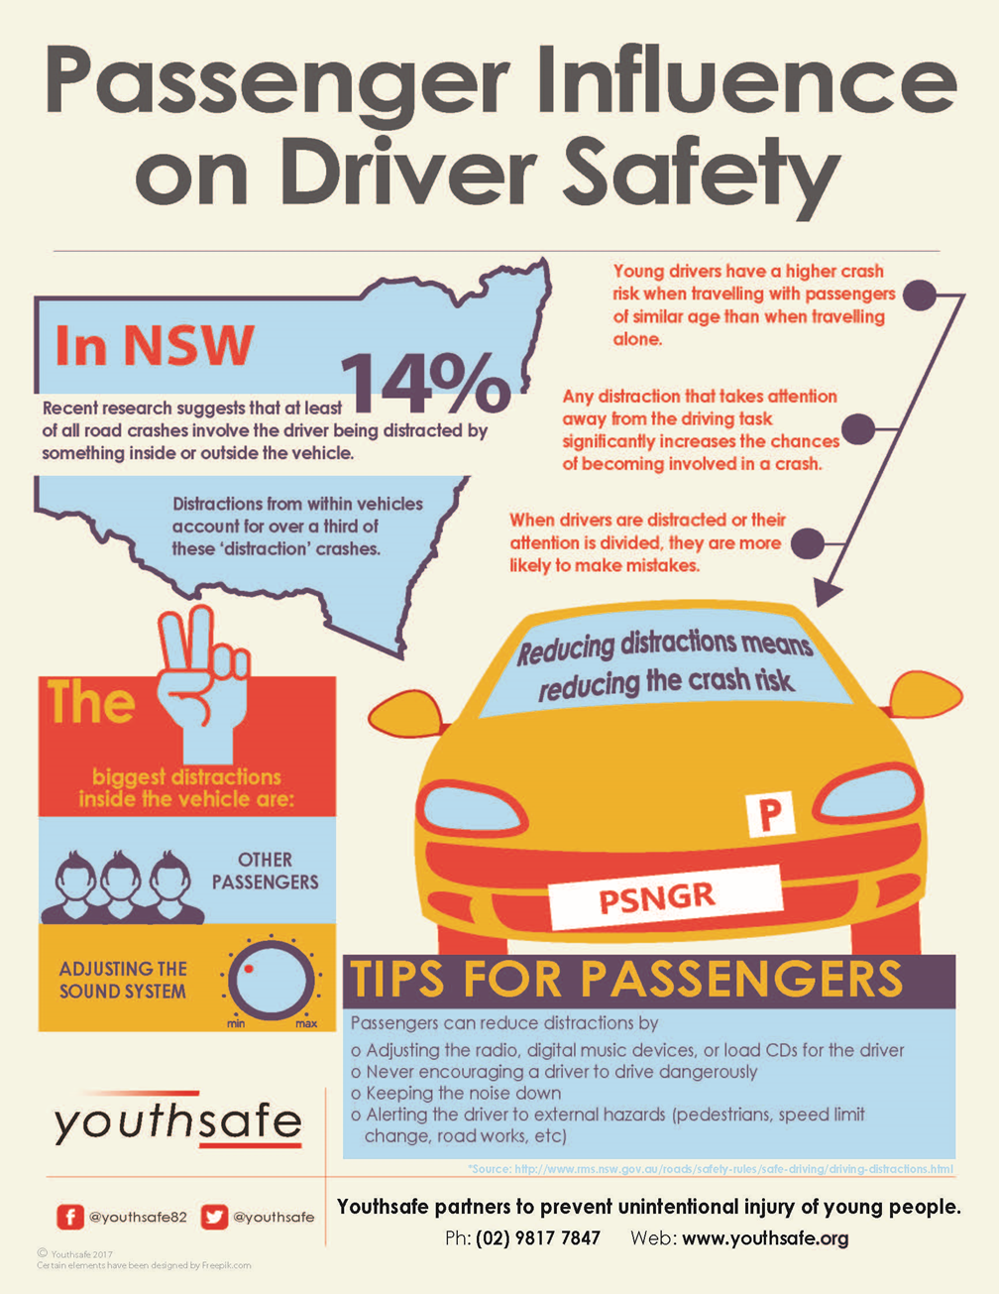

Appendix 3
Worksheet 1: Purpose of Get your hand off it campaign
- watch the Centre for Road Safety’s Sydney Swans get your hand off it campaign (0:30 minutes: https://youtu.be/lvVARlkuBYA)
- record your thoughts below

Purpose of get your hand of it campaign

Target audience

The need for the campaign

Main messages

Statistics that support need for campaign

How the campaign targets the audience

Appendix 4:
Worksheet 2: Our campaign
Campaign purpose and name

Target audience

Main messages

The need for the campaign

Statistics that support need for campaign

How the campaign will target the audience

Appendix 5
Worksheet 3: Peer SWOT analysis
- use the SWOT analysis to give constructive feedback about each group’s campaign.
Strengths | Weaknesses
- What is the group’s campaigns strengths?  - What do their campaign do better than other campaigns?  - What is unique about their campaign?  - Why do you think their campaign will be successful? | - What do you see as the weaknesses of their campaign?  - What might other campaigns do better?  - What do you think they need to improve?
Opportunities | Threats
- Is there anything missing from their campaign  - Would you include something else?  - Can you suggest any changes or improvements? | - Can you see something that may not make their campaign successful?  - Are there other campaigns that are already doing the same thing?  - Is the campaign cost effective?

Appendix 6
Worksheet 4: Health and safety campaign self-assessment
Name:
Date:
Campaign:
Team members:

My main roles:

Rank yourself based on your involvement and contribution to the work of your team by circling the number that best describes your input:
5 = always 4 = almost always 3 = sometimes 2 = once or twice 1 = never
I completed my tasks on time | 5 4 3 2 1  5 4 3 2 1  5 4 3 2 1  5 4 3 2 1  5 4 3 2 1
I contributed ideas to the group
I listened respectfully to the ideas of others
I used other people’s ideas in my work for the campaign
When I was stuck, I sought help from my group

Answer the following:
The things I most enjoyed about this learning experience were:

The things I least enjoyed about this learning experience were:

The strengths and skills I used include:

Skills that I can improve on are:
Suggestions to make this a better learning experience

